**EXPERIMENT NO. 1(A)**

**Aim:** To design an interface that can teach mathematics to children of 4-5 years.

**Theory:**

In this we are going to teach the kids about mathematical subject. The kids are more attracted towards bright colors and cartoon characters. So for this purpose we have used bright colors and cartoon to make the flash page attractive to the children.

Features of the system:

* Counting - Learn to count objects in this simple game of addition.
* Compare - Children can build their counting and comparing skills to see which group of items is bigger or smaller.
* Adding Puzzle - A fun mini-game where kids create math problems by dragging numbers on the screen.
* Adding Fun - Count the objects and tap on the missing number.
* Adding Quiz - Put your child's math and addition skills to the test.
* Subtracting Puzzle - Fill in the missing symbols in the math problem.
* Subtracting Fun - Count the items to solve the puzzle!
* Subtracting Quiz - See how much your child has improved in their mathematics skills for subtraction.

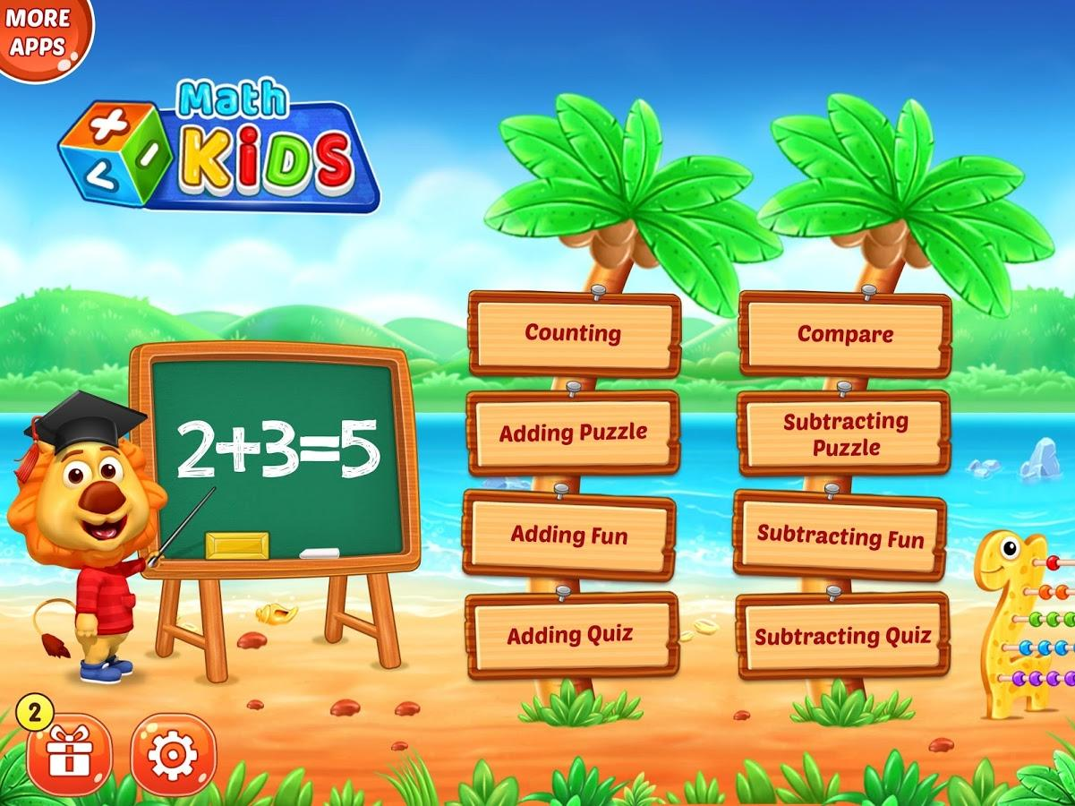

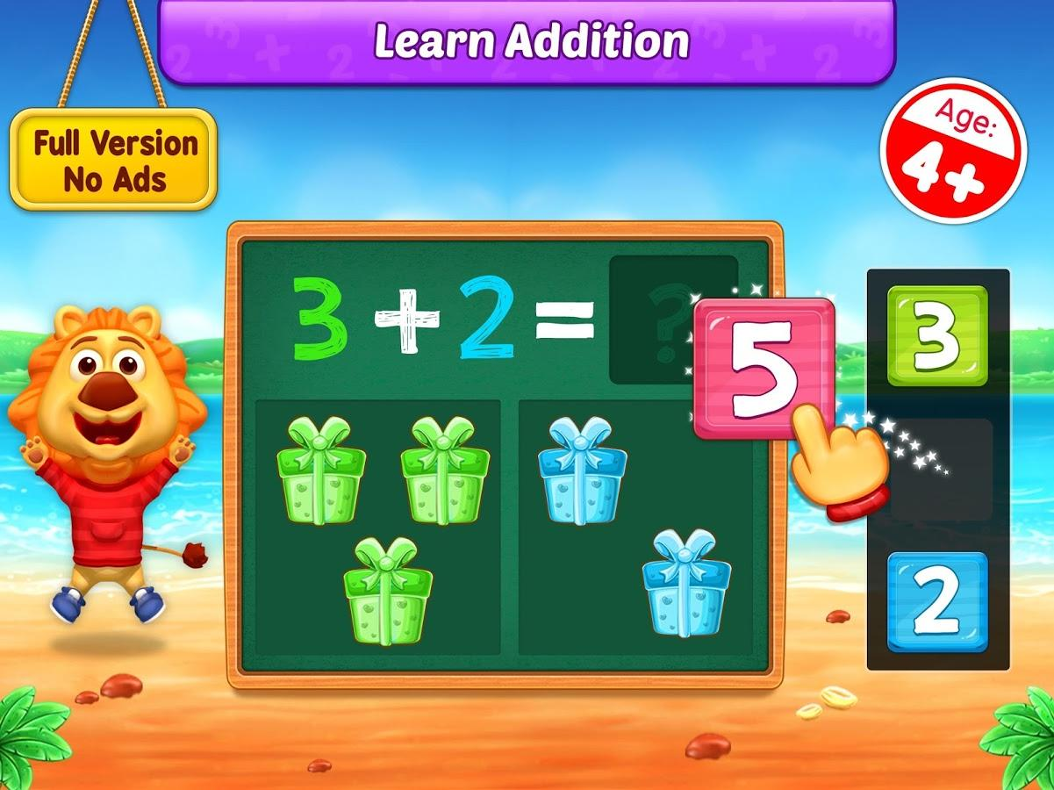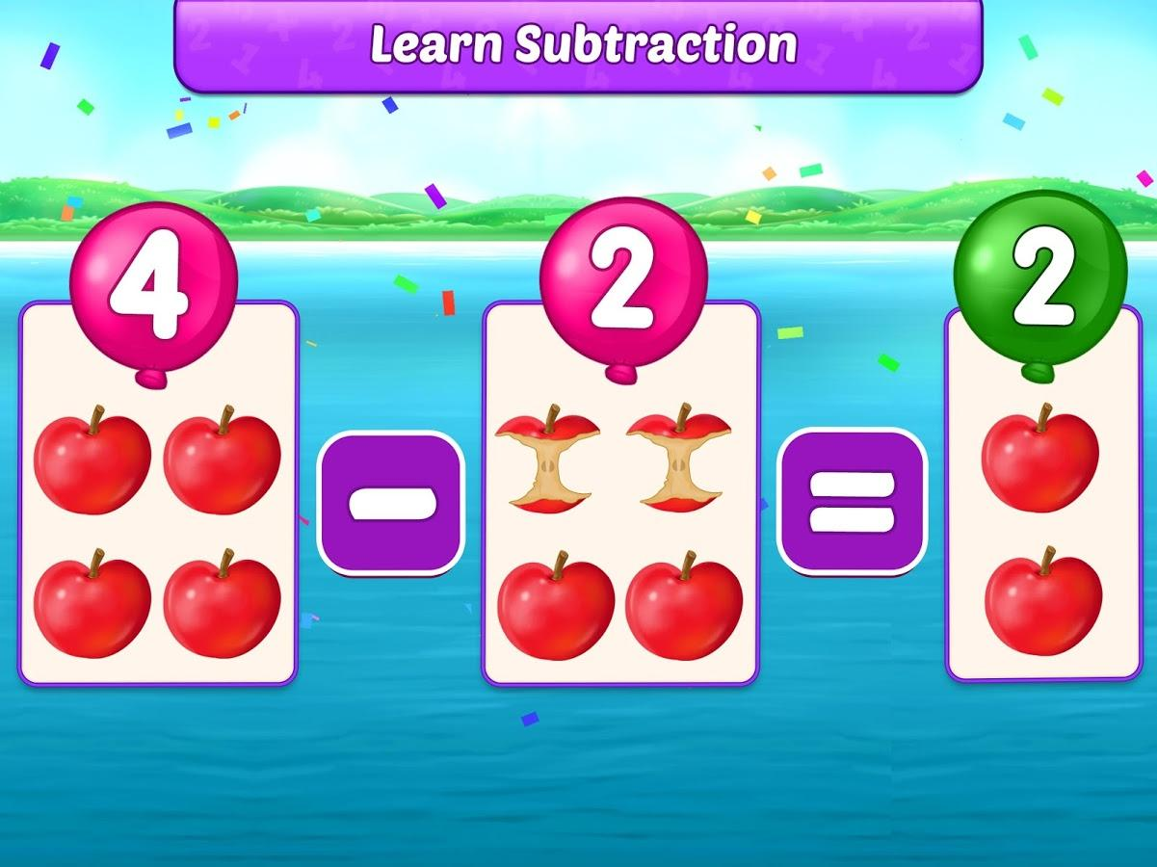

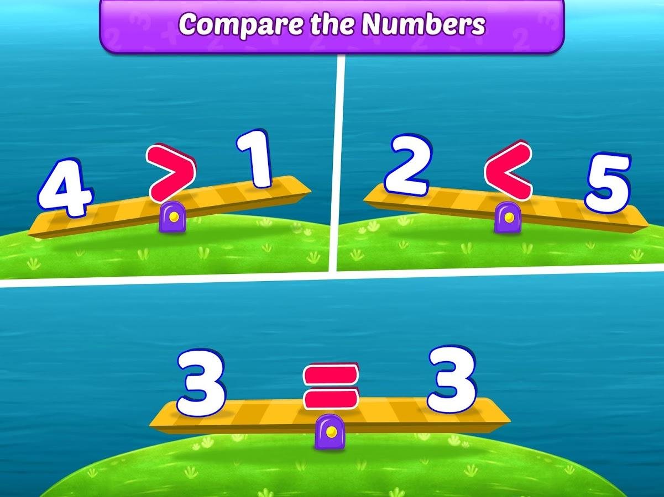

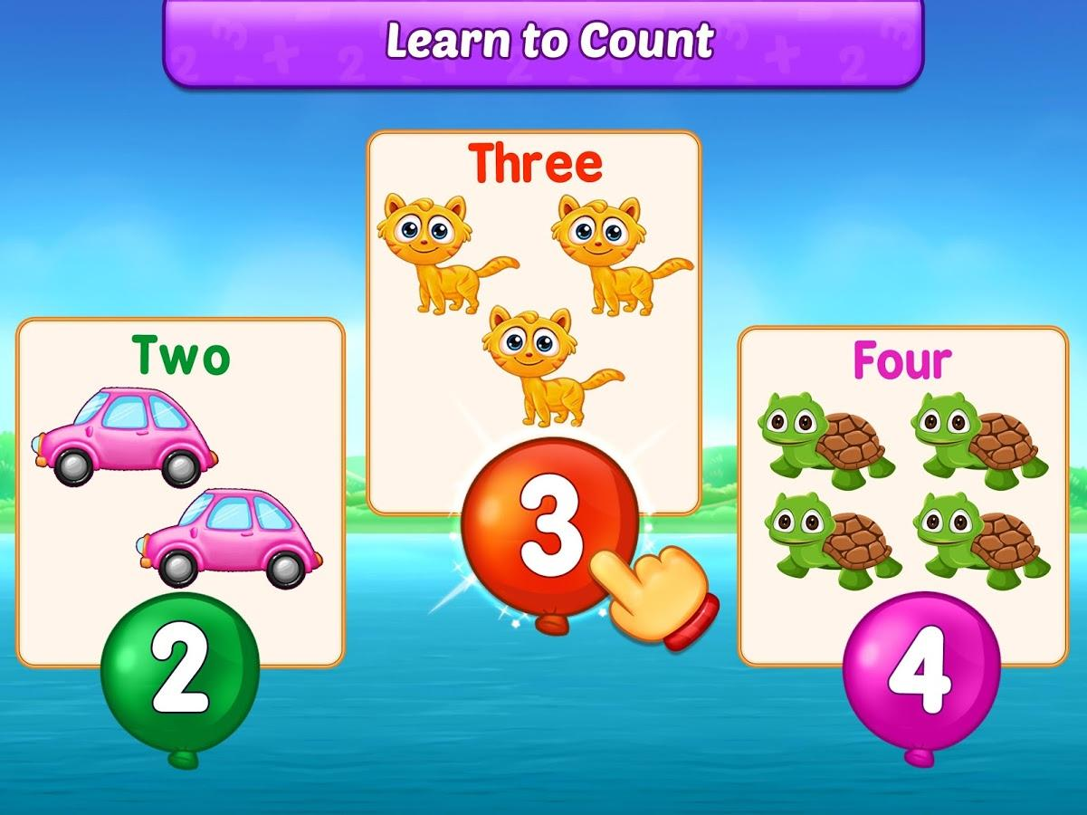

**Conclusion:**

With this application children can easily learn and understand maths while having fun.

**EXPERIMENT NO. 1(B)**

**Aim:** To design an interface for mentally disabled children.

**Theory:**

Mentally disabled children are unable to fulfill their intellectual potential, and have mental capacities that lag behind those of their peers. Moderately disabled individuals have a mental age of 5 to 8, and are considered "trainable," but not capable of learning academic subjects. Severely intellectually disabled people have a very limited capacity to learn. Many are institutionalized and require lifelong care.

intellectually disabled children are slow to learn, slow to process thought and have an impaired adaptive ability.

This GUI interface will help the children to learn alphabets. This GUI is more addictive in mentally disabled children. It contains max activity that will help them to learn new things. We have used all kinds of symbols that can understand by the kids who are mentally disabled.

Write My Name is for children with special needs to help them practice emerging writing skills in a fun and playful way. Children with name writing as one of their IEP(individual education program) goals will especially benefit from the Write My Name learning application as it makes this task accessible and achievable to children with fine motor delays and sensory processing issues.

Features of the system

* Alphabet book to practice writing uppercase and lowercase letters
* Word cards to practice tracing over 100 common sight/Dolch words
* Create 100 individualized name tags or phrases with pictures
* Fingerpaint mode to write with blue paint and see the letters exactly as traced
* Calm background music that can be turned off or on in the options screen
* Designed for school and home use
* Superb artwork, music and real voice files
* Educational discounts for volume purchases
* intuitive game design promotes independent play

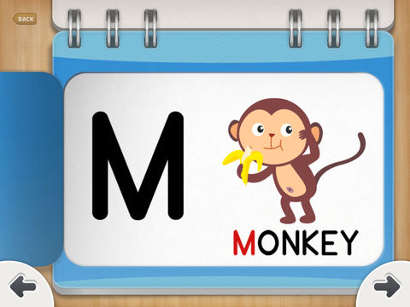

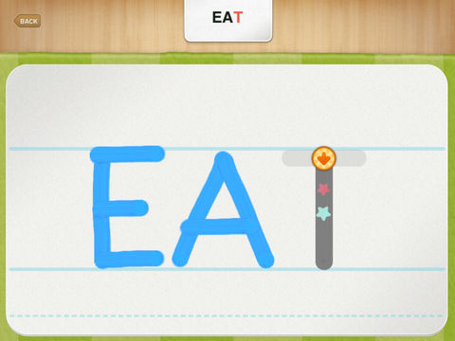

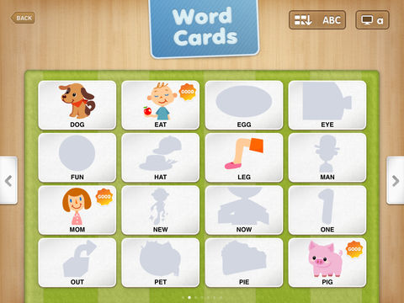

**Conclusion:** With this user interface mentally disabled children can easily learn some new things.

**EXPERIMENT NO. 1(C)**

**Aim:** To design a digital diary for teenagers.

**Theory:**

A digital diary is a software for people to keep track of the situations and choices a person goes through the day. In this time of competition to be the best in the world, people lose track of their lives and don't focus on themselves. This can be seen especially in teenagers. A diary helps keep track of the happenings in their lives on a daily basis.

A digital diary is an alternative to a hard copy that people used to have in the earlier days. Now in this age of technology, a better alternative will be to keep all of that inside your smartphone or an electronic device.

This diary should have the following characteristics.

* Should be offline.
* Easy to navigate.
* Sort contents on a daily basis.
* The design should be clear and consistent.
* The content should be easily editable.
* The diary should have a lock to prevent intruders from accessing it.

|  |  |
| --- | --- |
|  |  |
|  |  |
|  | |

**Conclusion:** This interface will help people and more importantly teenagers to keep track of their daily lives.

**EXPERIMENT NO.1(D)**

**Aim:** To design an online bill pay portal for the older generation.

**Theory:**

Ageing makes some things harder as well, and one of those things is using technology. While designing technology for older people, below are several key things we need to keep in mind.

* **Color** : Vision declines with age, and people become worse at distinguishing between similar colors.
* **Motor Skills** : Motor skills decline with age, which makes it harder to use technologies in various ways.
* **Cognition** : The science of cognition is a huge topic, and ageing changes how we think in unpredictable ways. Some people are razor-sharp in their 80s, while others decline as early as in their 60s.

Features of the system

* Minimalistic and clean interface and avoiding the usage of any unnecessary stuffs on the page.
* Using sober colors and less variety of it to avoid any confusion to the elderly.
* Keeping the required information sharp and to the point to avoid any hassle while doing payment.
* Less number of buttons to avoid any accidental button click due to declining motor skills.

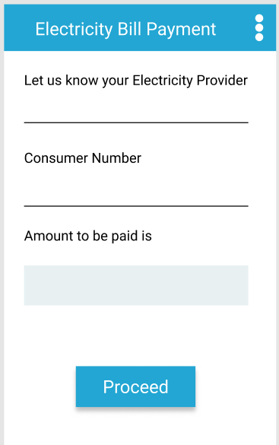 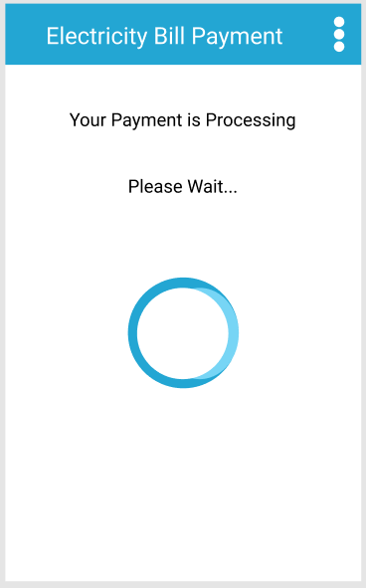

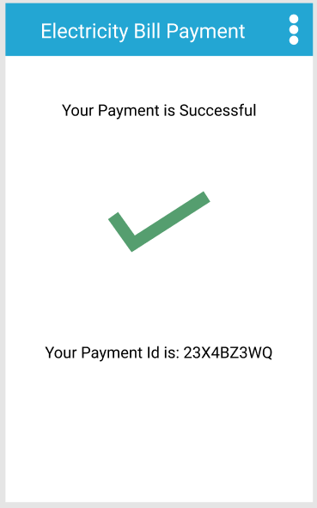

**Conclusion:** This clean interface will help the elderly to pay Electricity bill hassle free due to its clean interface and minimalistic design.