**Experiment No. 2**

**Aim:** To study various design principles and compare various shopping websites based on it.

**Theory:**

Principles are nothing but the abstract design rules. Where an interface should be easy to navigate. We follow some guideline to achieve the principles. Guidelines are advice on how to achieve principle and understanding theory which help helps resolve the conflict.

Norman’ design principles are:

* Use both knowledge in the world and knowledge in the head.
* Simplify the structure of tasks.
* Make things visible.
* Get the mappings right.
* Exploit the power of constraints, both natural and artificial.
* Design for error.
* When all else fails, standardize.

**Heuristic Evaluation Process**

Preparing the session:

* Select evaluators.
* Prepare or assemble:
  + A project overview.
  + A checklist of heuristics.
* Provide briefing to evaluators to:
  + Review the purpose of the evaluation session.
  + Preview the evaluation process.
  + Present the project overview and heuristics.
  + Answer any evaluator questions.
  + Provide any special evaluator training that may be necessary.

Conducting the session:

* Have each evaluator review the system alone.
* The evaluator should:
  + Establish own process or method of reviewing the system.
* Provide usage scenarios, if necessary.
  + Compare his or her findings with the list of usability principles.
  + Identify any other relevant problems or issues.
  + Make at least two passes through the system.
* Detected problems should be related to the specific heuristics they violate.
* Comments are recorded either:
  + By the evaluator.
  + By an observer.
* The observer may answer questions and provide hints.
* Restrict the length of the session to no more than 2 hours.

After the session:

* Hold a debriefing session including observers and design team members where:
  + Each evaluator presents problems detected and the heuristic it violated.
  + A composite problem listing is assembled.
  + Design suggestions for improving the problematic aspects of the system are discussed.
* After the debriefing session:
  + Generate a composite list of violations as a ratings form.
  + Request evaluators to assign severity ratings to each violation.
  + Analyze results and establish a program to correct violations and deficiencies.

**Flipkart**

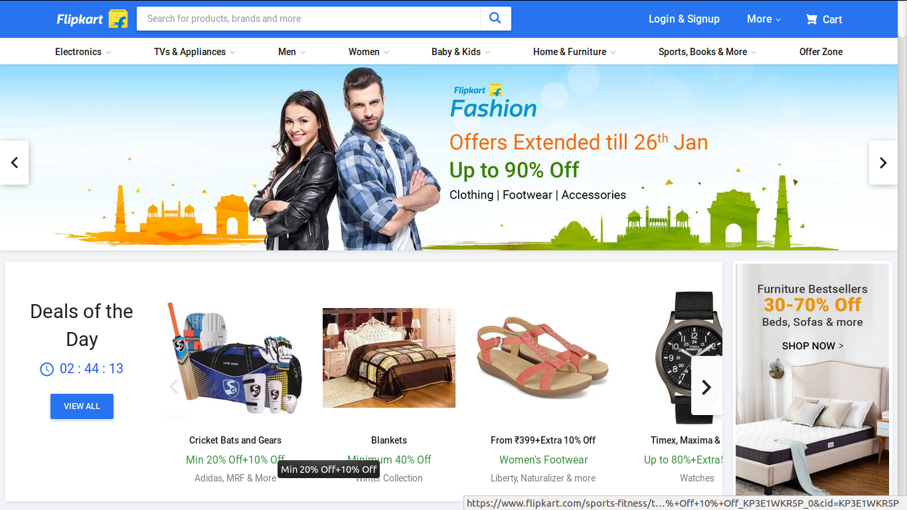

**Amazon**



**ebay**



**Snapdeal**

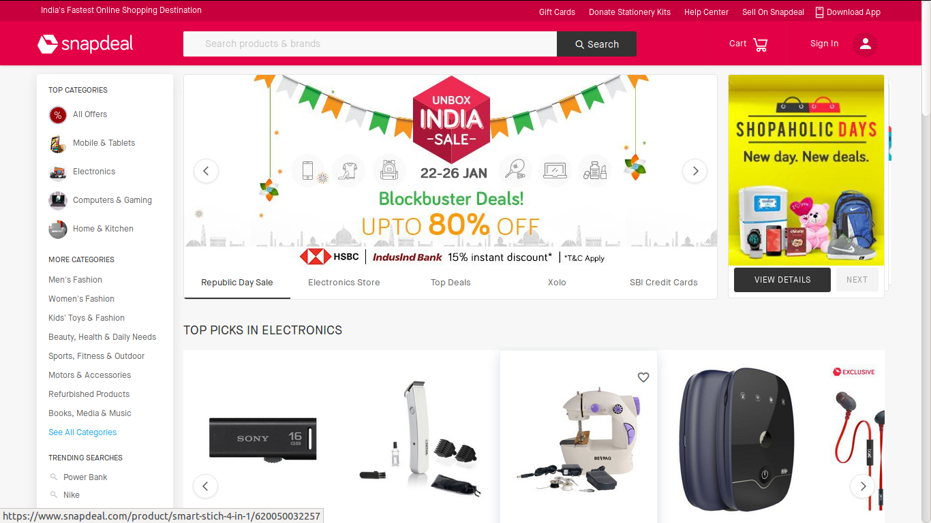

**Paytm**

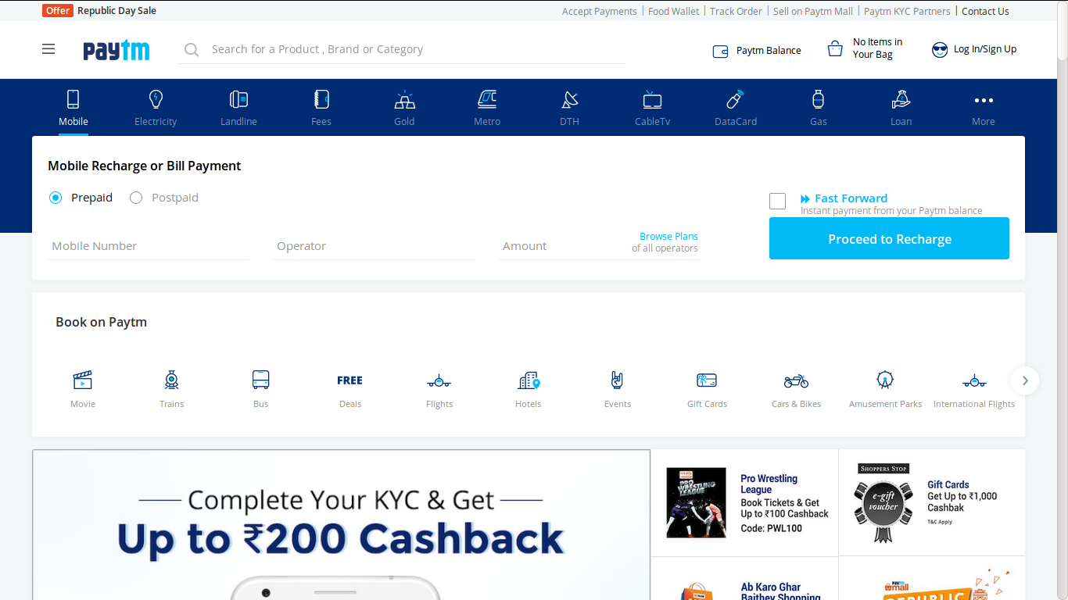

**1. Research-Based Set of Heuristics**

|  |  |  |  |  |  |
| --- | --- | --- | --- | --- | --- |
| Heuristics | Amazon | ebay | Flipkart | Paytm | Snapdeal |
| Automate unwanted workload | ✔ | ✔ | ✔ | ✔ | ✔ |
| Reduce uncertainty | ✔ | ✔ | ✔ | ✔ | ✔ |
| Fuse data | ✔ | ✔ | ✔ | ✔ | ✔ |
| Present new information with meaningful  aids to interpretation | ✔ | ✔ | ✔ | ✔ | ✔ |
| Use names that are conceptually related to  functions | ✔ | ✔ | ✔ | ✔ | ✔ |
| Limit data-driven tasks | ✔ | ❌ | ✔ | ❌ | ✔ |
| Group data in consistently meaningful ways  to decrease search time | ✔ | ✔ | ❌ | ✔ | ❌ |
| Include in the displays only that information  needed by a user at a given time | ❌ | ✔ | ✔ | ❌ | ✔ |
| Practice judicious redundancy | ✔ | ✔ | ✔ | ✔ | ✔ |

**2. Web Page Heuristics**

|  |  |  |  |  |  |
| --- | --- | --- | --- | --- | --- |
| Heuristics | Amazon | ebay | Flipkart | Paytm | Snapdeal |
| Speak the user’s language | ✔ | ✔ | ✔ | ✔ | ✔ |
| Be consistent | ✔ | ✔ | ✔ | ✔ | ✔ |
| Minimize the user’s memory load | ✔ | ❌ | ✔ | ✔ | ❌ |
| Build flexible and efficient systems | ✔ | ✔ | ✔ | ✔ | ✔ |
| Design aesthetic and minimalist systems | ❌ | ✔ | ❌ | ✔ | ✔ |
| Use chunking | ✔ | ❌ | ✔ | ❌ | ✔ |
| Provide progressive levels of detail | ✔ | ✔ | ✔ | ✔ | ✔ |
| Give navigational feedback | ✔ | ✔ | ✔ | ✔ | ✔ |
| Don’t lie to the user | ✔ | ✔ | ✔ | ✔ | ✔ |

**Conclusion:**

Therefore study of various websites on the basis of Design principles and Heuristics has been done and had been compared comprehensively on the basis of those principles.