Experiment No:3

**Aim:** Understand the Menus And navigation

**Theory:**

A system contains large amounts of information and performs a variety of functions. It should also provide some means to tell people about the information it possesses or the things it can do. This is accomplished by displaying listings of the choices or alternatives the user has at appropriate points while using the system. These listings of choices are commonly called menus. Menus are a major form of navigation through a system and, if properly designed, assist the user in developing a mental model of the system.

Providing the proper kinds of graphical menus to perform system tasks is also critical to system success. The best kind of menu to use in each situation depends on several factors. The following must be considered:

* The number of items to be presented in the menu.
* How often the menu is used.
* How often the menu contents may change.

**Menu Bar:**

A menu bar consists of a collection of descriptions that serve as headings or titles for a series of actions on an associated pull-down menu.

The menu is typically arrayed in a horizontal row at the top of a window. Occasionally a menu bar is referred to as a collection of menu titles. In reality it is a menu in itself, and it is appropriate to simply refer to it as a menu. A menu bar is the starting point for many dialogs. Menu bars often consist of a series of textual words, as represented in fig.



Fig: Menu bar Composed of Text

**Pull-Down Menu:**

Selection of an alternative from the menu bar results in the display of the exact actions available to the user.

These choices are displayed in a vertically arrayed listing that appears to pull down from the bar. Hence, these listings, as illustrated in fig, are typically referred to as pull-downs. Other identification terms may be used, such as drop-downs.

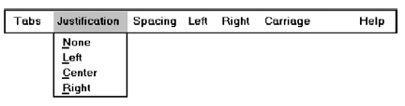

Fig: Menu bar pull – down

**Cascading Menu:**

A cascading menu is a submenu derived from a higher-level menu, most typically a pull-down.

Cascading menus are located to the right of the menu item on the previous menu to which they are related, as illustrated in fig.

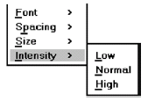

**Pop-up Menus:**

Choices may also be presented to the user on the screen through pop-up menus, vertically arrayed listings that only appear when specifically requested.

Pop-up menus may be requested when the mouse pointer is positioned over a designated or hot area of the screen (a window border or text, for example) or over a designated icon. In look, they usually resemble pull-down menus, as shown in figure.

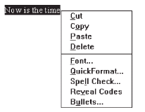

**Tear-off Menus:**

A tear-off menu is a pull-down menu that can be positioned anywhere on the screen for constant referral. As such, it possesses all the characteristics of a pull-down. It may also be called a pushpin, detachable, or roll-up menu. Its purpose is to present alternatives or choices to the screen user that are

needed infrequently at some times and heavily at other times.

**Outputs:**

**Bad design:**

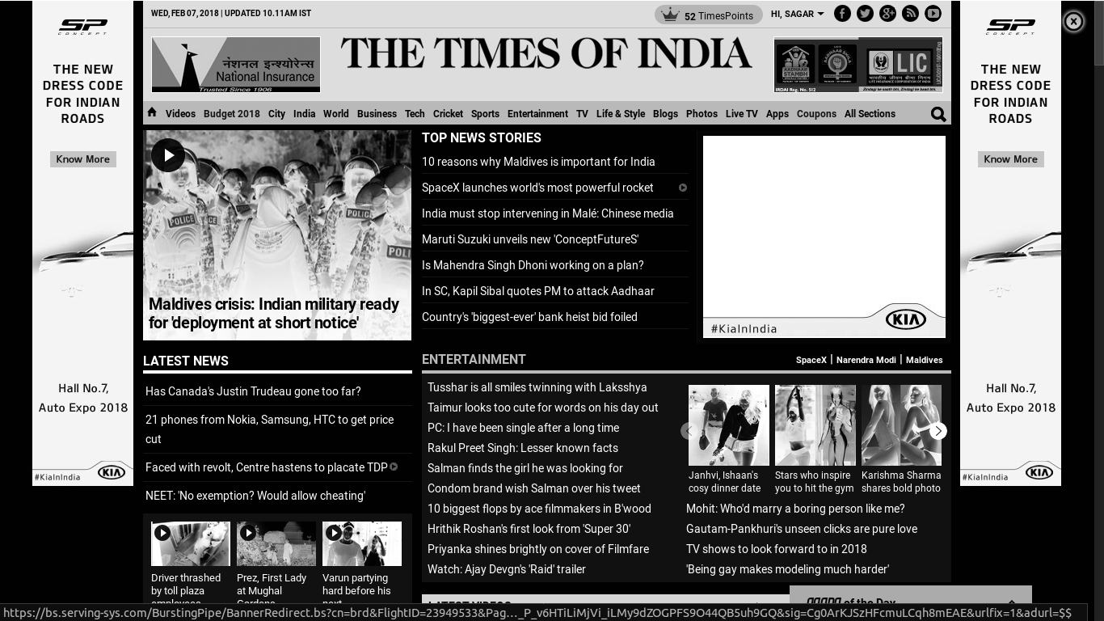

**Good Design:**

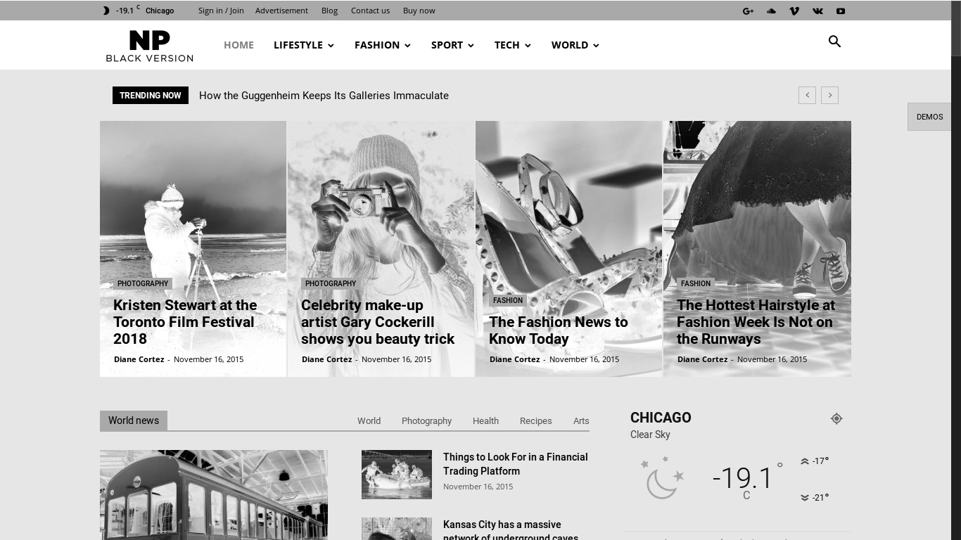

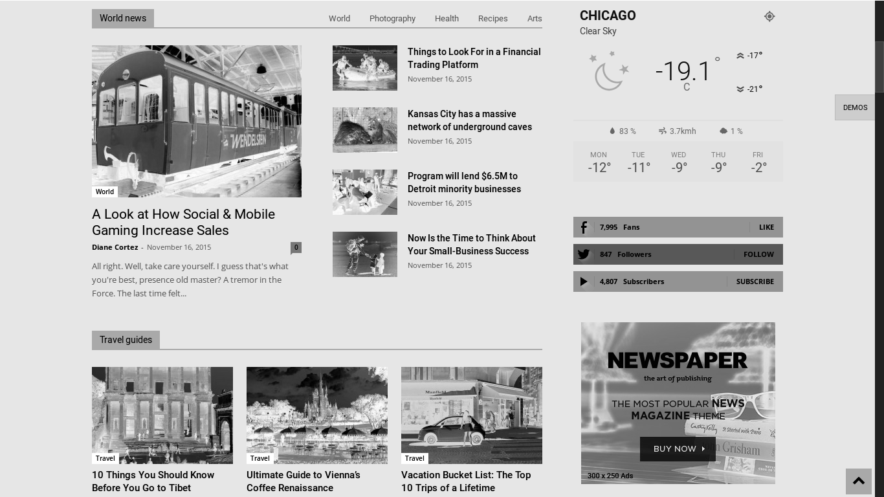

**Conclusion:**

Menus are effective because they utilize the more powerful human capability of recognition rather than the weaker capability of recall. Working with menus reminds people of available options and information that they may not be aware of or have forgotten.