Experiment No:4

**Aim:** To understand how to select appropriate windows, screen & device based controls.

**Theory:**

Screen controls, sometimes called widgets, are the elements of a screen that constitute its body. By definition, they are graphic objects that represent the properties or operations of other objects. A control may

* Permit the entry or selection of a particular value.
* Permit the changing or editing of a particular value.
* Display only a particular piece of text, value, or graphic.
* Cause a command to be performed.
* Possess a contextual pop-up window.

In the last decade, some platforms have expanded the definition of a control to include all specifiable aspects of a screen, including screen text, headings, and group boxes. For the purposes of this discussion, this broader definition of a control will be assumed. This step will encompass. Identifying the characteristics and capabilities of the various screen controls, including

* Buttons.
* Text entry/read-only controls.
* Selection controls.
* Combination entry/selection controls.
* Specialized operable controls.
* Custom controls.
* Presentation controls.
* Web controls.
* Selecting the proper controls for the user and tasks.

**Why selecting proper screen elements is necessary?**

Selecting proper screen elements describes the nature of the interface. It leads the mental attention of user towards the exploration of the interface. It guides the viewer toward for what user is searching for. Wrong screen elements may create conflicts for user to select and operate the interface properly.

* Failing to Use Responsive Design

Since over forty percent of modern searches are conducted on smartphones and tablets, having a website that can display properly on those devices is of paramount importance for businesses. However, recent estimates show that less than seventeen percent of the world’s 876 million websites have been created with responsive web design. Since Google introduced a search update that penalizes non-responsive sites in mobile searches, this is a major problem for those who generate leads online.

* Forgetting About Actual Design Elements

Some businesses are also guilty of either going completely overboard or flat-out ignoring the design elements of their website. Too many customizations can lead to the same issues talked about in the previous topic, plus it can distract the reader from the actual content. Minimalist websites with very few design features can also be a turn-off to visitors though, so finding a balance is essential.

This same concept applies to photos, videos, banners, and other types of graphics as well. For most websites, the entire page should be designed to lead the consumer’s eye towards making a favorable action (opting in, requesting information, making a purchase, etc.).

* Poor Use of Headers, Sidebars, and Footers

People often assume that heading areas, footers, and sidebars are designed exclusively for advertisements. However, it’s a big red flag when a webpage displays a high number of ads and banners, especially when there’s little content to go along with it. These areas can be much better utilized for additional navigation within the site. Now, that’s not to say that it’s wrong to place a banner across the top of the page advertising a special promotion. This only means to remember the importance of design and balance throughout the site.

* Bad Navigation.

Navigation within a website should be seamless. Users should be able to find their way around easily. While there is no standard for navigation within a website, especially now as more new web development technologies emerge, it is imperative to understand that navigation must be intuitive and consistent.

If text is used as navigation, it should be concise. Visual metaphors should not be re-invented. If hyperlinks are used, then they should stand out from the body of the text. Dead links should have no place on any web page whatsoever. This increases user confusion and wastes time. And one that is even just as worse is having a link on the homepage that links to the homepage.

* Where’s the search box?

The web is like an archive of information. Whether it’s a corporate website or merely a blog, a search box is essential. The visitor might be looking for something that is hidden within the website, with the search box, chances are, visitors will get what they want.

**Comparison of 2 institutional websites**

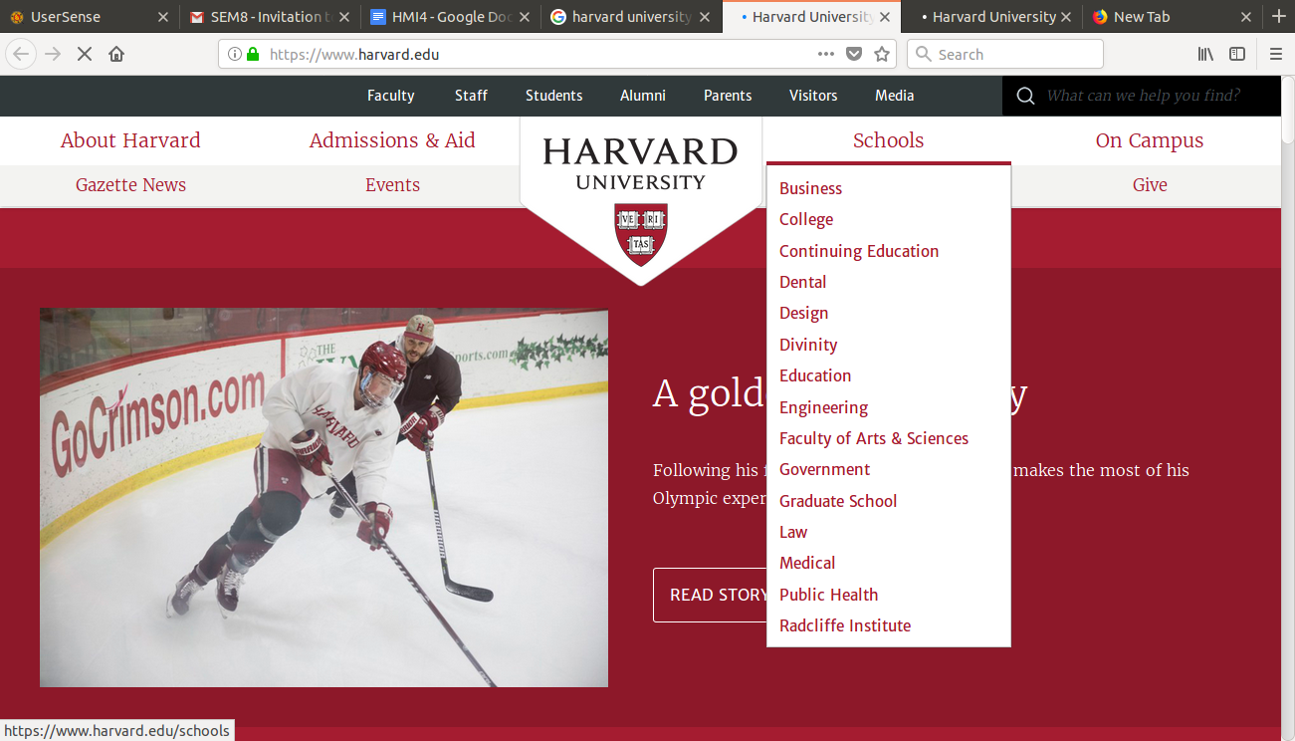

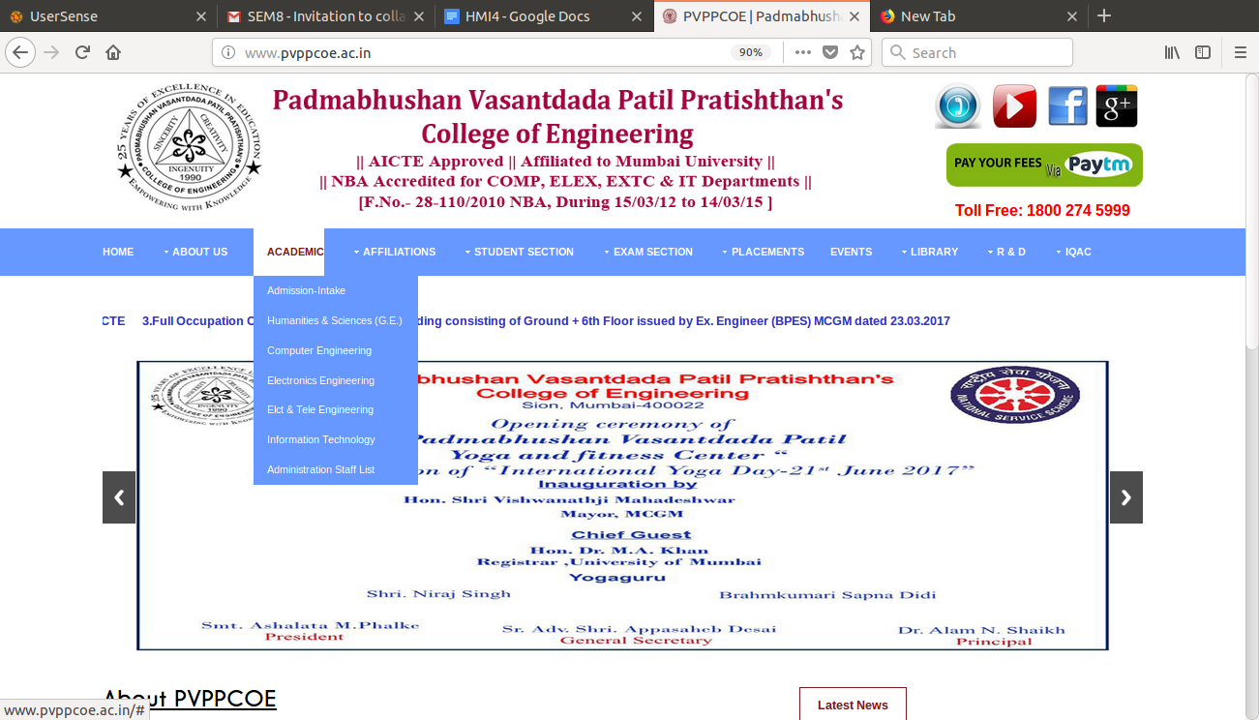

From the above two snapshots we can determine the following differences

* Harvard university looks more attractive and well designed on the other hand PVPP’s website looks more cluttered.
* The drop down list is properly implemented in harvard and not it pvpp.
* Harvard website looks more attractive than pvpp’s due to a decent color pallate.

**Conclusion:**

Thus we have studied about the choice and purpose of screen elements and their working.