Experiment No:5

**Aim:** Study of icon designing in HMI

**Theory:**

Icons are most often used to represent objects and actions with which users can interact with or that they can manipulate. These types of icons may stand alone on a desktop or in a window, or be grouped together in a toolbar. A secondary use of an icon is to reinforce important information, a warning icon in a dialog message box, for Example.

**Categories of Icon:**

* Icon: Something that looks like what it means
* Index: A sign that was caused by the thing to which it refers
* Symbol: A sign that may be completely arbitrary in appearance

**Kinds of Icon:**

* Resemblance: An image that looks like what it means
* Symbolic: An abstract image representing something
* Exemplar: An image illustrating an example or characteristic of something
* Arbitrary: An image completely arbitrary in appearance whose meaning must be learned
* Analogy: An image physically or semantically associated with something

**Characteristics of Icons:**

Icons should be:

* familiar
* clear and legible
* simple
* consistent
* direct
* efficient
* discriminable

**Choosing Icons:**

Icon design is an important process. Meaningful and recognizable icons will speed learning and recall and yield a much more effective system. Poor design will lead to errors, delays, and confusion. Looks different from all other icons.

* Is obvious what it does or represents.
* Is recognizable when no larger than 16 pixels square.
* Looks as good in black and white as in color.

**Icon Size:**

* Supply in all standard sizes.

-16 × 16 pixels.

* 16- and 256-color versions.

- 32 × 32 pixels

* 16- and 256-color versions.

- 48 × 48 pixels

* 16- and 256-color versions.

- Use colors from the system palette.

- Use an odd number of pixels along each side.

* Provides center pixel around which to focus design.

- Minimum sizes for easy selection:

* With stylus or pen: 15 pixels square.
* With mouse: 20 pixels square.
* With finger: 40 pixels square.

- Provide as large a hot zone as possible.

**Choosing Images:**

* Use existing icons when available.
* Use images for nouns, not verbs.
* Use traditional images.
* Consider user cultural and social norms.

**The Design Process of Icons:**

* Define purpose: To begin the design process, first define the icon’s purpose and use. Have the design team brainstorm about possible ideas, considering real-world metaphors.
* Collect, evaluate, and sketch ideas: Start by designing on paper, not on the computer. Ask everyone to sketch his or her ideas.
* Draw in black and white: Many icons will be displayed in monochrome. Color is an enhancing property; consider it as such.
* Test for expectation, recognition, and learning. Choosing the objects and actions, and the icons to represent them, is not a precise process, and will not be easy. So, as in any screen design activity, adequate testing and possible refinement of developed images must be built into the design process. Icon recognition and learning should both be measured as part of the normal testing process.
* Test for legibility. Verify the legibility and clarity of the icons in general. Also, verify the legibility of the icons on the screen backgrounds chosen. White or gray backgrounds may create difficulties. An icon mapped in color, then displayed on a monochrome screen, may not present itself satisfactorily. Be prepared to redraw it in black and white, if necessary.
* Register new icons in the system’s registry. Create and maintain a registry of all system icons. Provide a detailed and distinctive description of all new icons.

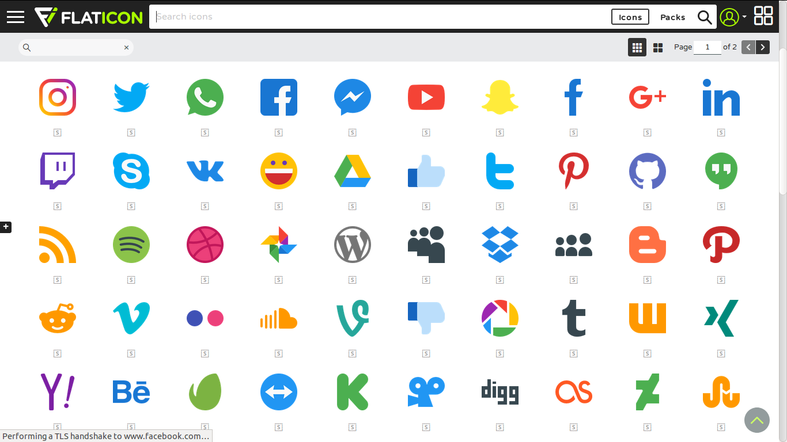

**Conclusion:**

Icons are the most often used to represent objects and actions with which users can interact with or that they can manipulate.