Experiment No:7

**Aim:** Make the use of statistical graphics.

**Theory:**

A statistical graphic is data presented in a graphical format. -A well-designed statistical graphic, also referred to as a chart or graph, consists of complex ideas communicated with clarity, precision, and efficiency. It gives its viewer the greatest number of ideas, in the shortest time, and in the smallest space, and with least possible clutter. It will also induce the viewer to think of substance, not techniques or methodology. It will provide coherence to large amounts of information by tying them together in a meaningful way, and it will encourage data comparisons of its different pieces by the eye. A well designed statistical graphic display also avoids distortions by telling the truth about the data.

***Components of a Statistical Graphic***

Most statistical graphics have at least two axes, two scales, an area to present the data, a title, and sometimes a legend or key.

***Types of Statistical Graphics***

* Curve and Line Graphs
* Surface Charts
* Scatter plots
* Bar Graphs
* Segmented or Stacked Bars
* Pie Charts

***Guidelines:***

While designing statistical graphics GUI application, students must consider following

* Choosing the emphasized data
* Minimize the non-data elements
* Minimize redundant data.
* Show data variation, not design variation.
* Provide the proper context for data interpretation.
* Restrict the number of information-carrying dimensions depicted to the number of
* Data dimensions being illustrated.
* Employ data in multiple ways, whenever possible.
* Maximize data density.
* Employ simple data-coding schemes.
* Avoid unnecessary embellishment of:
  + Grids.
  + Vibration.
  + Ornamentation.
* Fill the graph’s available area with data.

***Example:***

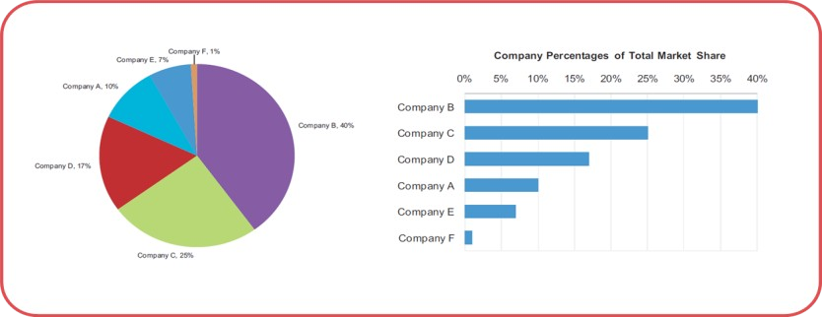

***Output:***

1. Click Start → All Programs → Microsoft Office → Microsoft excel

2. Choose an existing spreadsheet by clicking "Open" in the "File" menu. Create a new spreadsheet by clicking "New" in the document wizard or File menu.

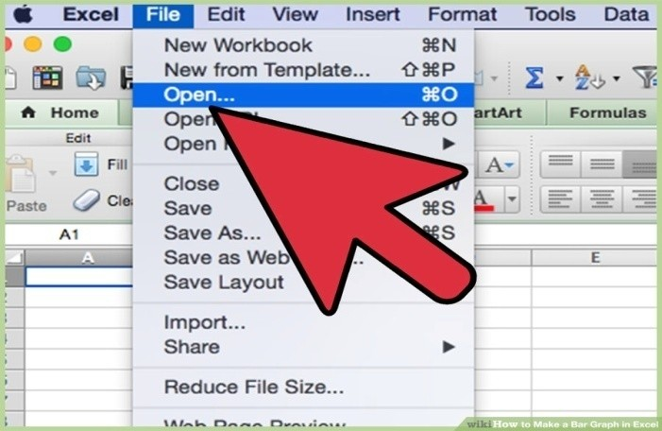

3. Create a data series with a single independent variable. Bar graphs are horizontal charts that show numbers or data from 1 variable.

Add the labels for the variable and the data at the top of the columns.

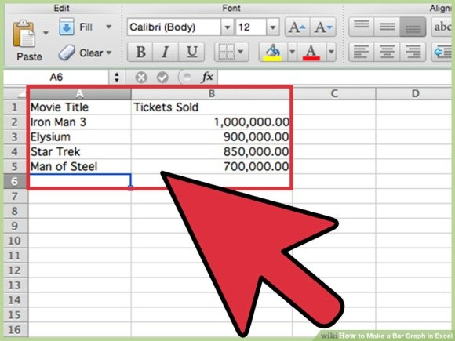

4. Consider adding a sub-data series in the third column. With the bar graph function, you can use a clustered or stacked bar graph that shows a second number that is identified with the variable.

Make sure that the sub-data series is labeled at the top of the third column. Also, ensure that the data is given using the same format, such as dollars or Numbers.

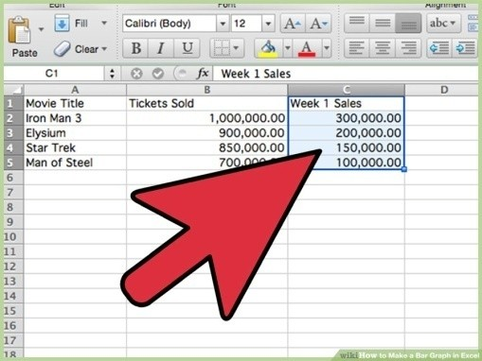

5. Highlight the entire series you have entered, including column titles. Microsoft Excel will use your columns to separate the X and Y axis.

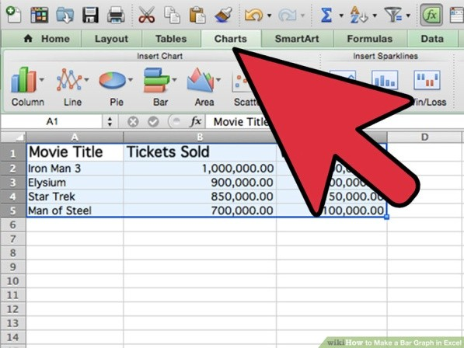

6. Click on the "Charts" tab of the horizontal user interface. If you do not see the "Charts" tab, go to the "Insert" menu and select "Charts" from the drop down menu. If you are using an older version of Microsoft Excel, you will need to go directly to the Insert menu and select "Charts" to access the chart wizard.

7. Click on the arrow next to the type of chart you would like to make. If you want a traditional bar graph, you will choose "Bar." If you want a vertical graph, click the arrow next to "Column."

8. Select the type of bar graph you want from the choices available in the Bar menu. You can choose 2-D, 3-D, Cylinder, Cone or Pyramid shaped bar graphs. You can also choose to cluster or stack your bar graph to highlight a second type of data in your data series.

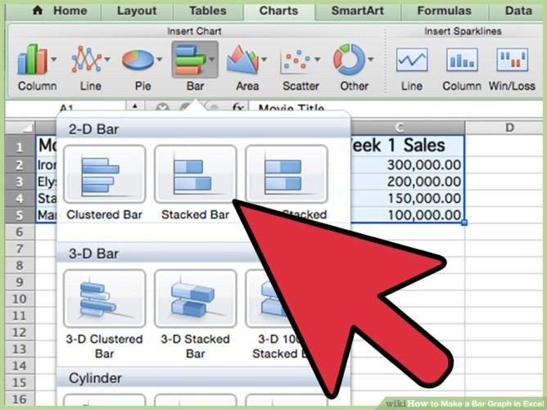

9. Wait for the image of your graph to appear in the middle of your Excel sheet.

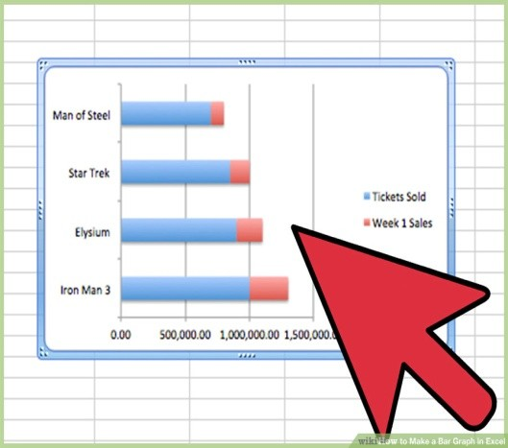

**Conclusion:**

The use of statistical graphics have been studied and implemented.