Experiment No: 8

**Aim:** Case study on various input methods available for interaction.

**Theory:**

**Human–computer interaction:**

Human–computer interaction commonly referred to as **HCI** researches the design and use of computer technology, focused on the interfaces between people (users) and computers. Researchers in the field of HCI both observe the ways in which humans interact with computers and design technologies that let humans interact with computers in novel ways. As a field of research, human-computer interaction is situated at the intersection of computer science, behavioral sciences, design, media studies, and several other fields of study. Humans interact with computers in many ways; the interface between humans and computers is crucial to facilitating this interaction. Desktop applications, internet browsers, handheld computers, and computer kiosks make use of the prevalent graphical user interfaces (GUI) of today.Voice user interfaces (VUI) are used for speech recognition and synthesising systems, and the emerging multi-modal and Graphical user interfaces (GUI) allow humans to engage with embodied character agents in a way that cannot be achieved with other interface paradigms.

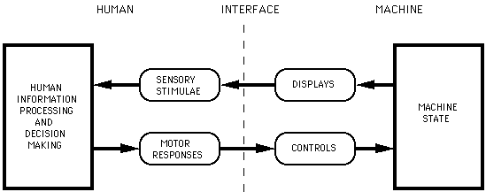

**Interaction technique:**

Interaction technique is a way of using a physical input/output device to perform a generic task in a human-computer dialogue.

An interaction technique is the fusion of input and output, consisting of all software and hardware elements, that provides a way for the user to accomplish a task.

1. The computing view

From the computer's perspective, an interaction technique involves:

* One or several input devices that capture user input,
* One or several output devices that display user feedback,
* A piece of software that:
  + interprets user input into commands the computer can understand,
  + produces user feedback based on user input and the system's state.

### 

### 2. The user's view

From the user's perspective, an interaction technique is a way to perform a single computing task and can be informally expressed with user instructions or usage scenarios. For example, "to delete a file, right-click on the file you want to delete, then click on the delete item".

### 3. The designer's view

From the user interface designer's perspective, an interaction technique is a well-defined solution to a specific user interface design problem. Interaction techniques as conceptual ideas can be refined, extended, modified and combined. For example, contextual menus are a solution to the problem of rapidly selecting commands. Pie menus are a radial variant of contextual menus. Marking menus combine pie menus with gesture recognition.

### 4. Level of granularity

One extant cause of confusion in the general discussion of interaction is a lack of clarity about levels of granularity.Interaction techniques are usually characterized at a low level of granularity not necessarily at the lowest level of physical events, but at a level that is technology-, platform-, and/or implementation-dependent. In contrast, viewed at higher levels of granularity, interaction is not tied to any specific technology or platform. The interaction of 'filtering', for example, can be characterized in a way that is technology independent Such an interaction could be implemented using any number of techniques, and on any number of platforms and technologies.

5. Multimodal interaction:

Multimodal interaction provides the user with multiple modes of interacting with a system. A multimodal interface provides several distinct tools for input and output of data. For example, a multimodal question answering system employs multiple modalities (such as text and photo) at both question (input) and answer (output) level.

6. Modality

In the context of human computer interaction, a modality is the classification of a single independent channel of sensory input/output between a computer and a human.A system is designated unimodal if it has only one modality implemented, and multimodal if it has more than one.When multiple modalities are available for some tasks or aspects of a task, the system is said to have overlapping modalities.

Computers utilize a wide range of technologies to communicate and send information to humans:

* Common modalities
  + Vision – computer graphics typically through a screen
  + Audition – various audio outputs
  + Tactician – vibrations or other movement
* Uncommon modalities
  + Gustation (taste)
  + Olfaction (smell)
  + Thermoception (heat)
  + Nociception (pain)
  + Equilibrioception (balance)

7. 3D Interaction

In computing, 3D interaction is a form of human-machine interaction where users are able to move and perform interaction in 3D space. Both human and machine process information where the physical position of elements in the 3D space is relevant

3D interaction techniques :

1. Selection and manipulation

### Navigation

### System control

### Symbolic input

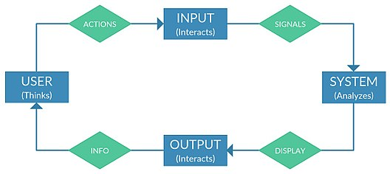

**Conclusion:**

Thus, we have successfully studied various input methods available for interaction in human machine interaction.