**EXPERIMENT NO:02**

***Aim:*** *To study Bluetooth protocol and application of Bluetooth.*

***Theory:***

**Bluetooth** is a wireless technology standard for exchanging data over short distances (using short-wavelength UHF radio waves in the ISM band from 2.4 to 2.485 GHz) from fixed and mobile devices, and building personal area networks (PANs). Invented by telecom vendor Ericsson in 1994 it was originally conceived as a wireless alternative to RS-232 data cables. It can connect up to seven devices, overcoming problems that older technologies had when attempting to connect to each other.

Bluetooth is managed by the Bluetooth Special Interest Group (SIG), which has more than 30,000 member companies in the areas of telecommunication, computing, networking, and consumer electronics. The IEEE standardized Bluetooth as **IEEE 802.15.1**, but no longer maintains the standard. The Bluetooth SIG oversees development of the specification, manages the qualification program, and protects the trademarks. A manufacturer must meet Bluetooth SIG standards to market it as a Bluetooth device. A network of patents apply to the technology, which are licensed to individual qualifying devices.

Bluetooth is that when the device is within the scope of a other devices automatically start the transfer information without the user noticing. a small network between the devices is created and the user can accessed as if there were cables.

**Architecture**

Bluetooth architecture defines two types of networks:

1. Piconet

2. Scatternet

### **1. Piconet**

* Piconet is a Bluetooth network that consists of one primary (master) node and seven active secondary (slave) nodes.
* Thus, piconet can have up to eight active nodes (1 master and 7 slaves) or stations within the distance of 10 meters.
* There can be only one primary or master station in each piconet.
* The communication between the primary and the secondary can be one-to-one or one-to-many.
* All communication is between master and a slave. Salve-slave communication is not possible.
* In addition to seven active slave station, a piconet can have up to 255 parked nodes. These parked nodes are secondary or slave stations and cannot take part in communication until it is moved from parked state to active state.

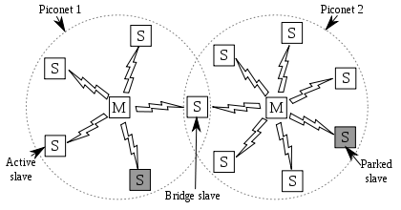

### **2. Scatternet**

* Scatternet is formed by combining various piconets.
* A slave in one piconet can act as a master or primary in other piconet.
* Such a station or node can receive messages from the master in the first piconet and deliver the message to its slaves in other piconet where it is acting as master. This node is also called bridge slave.
* Thus a station can be a member of two piconets.
* A station cannot be a master in two piconets.

## **Bluetooth layers and Protocol Stack**

* Bluetooth standard has many protocols that are organized into different layers.
* The layer structure of Bluetooth does not follow OSI model, TCP/IP model or any other known model.
* The different layers and Bluetooth protocol architecture.

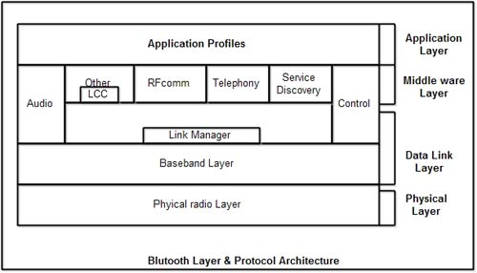

**Radio Layer**

* The Bluetooth radio layer corresponds to the physical layer of OSI model.
* It deals with ratio transmission and modulation.
* The radio layer moves data from master to slave or vice versa.
* It is a low power system that uses 2.4 GHz ISM band in a range of 10 meters.
* This band is divided into 79 channels of 1MHz each. Bluetooth uses the Frequency Hopping Spread Spectrum (FHSS) method in the physical layer to avoid interference from other devices or networks.
* Bluetooth hops 1600 times per second, *i.e.* each device changes its modulation frequency 1600 times per second.
* In order to change bits into a signal, it uses a version of FSK called GFSK *i.e.* FSK with Gaussian bandwidth filtering.

**Baseband Layer**

* Baseband layer is equivalent to the MAC sublayer in LANs.
* Bluetooth uses a form of TDMA called TDD-TDMA (time division duplex TDMA).
* Master and slave stations communicate with each other using time slots.
* The master in each piconet defines the time slot of 625 µsec.
* In TDD- TDMA, communication is half duplex in which receiver can send and receive data but not at the same time.
* If the piconet has only no slave; the master uses even numbered slots (0, 2, 4, ...) and the slave uses odd-numbered slots (1, 3, 5, .... ). Both master and slave communicate in half duplex mode. In slot 0, master sends & secondary receives; in slot 1, secondary sends and primary receives.
* If piconet has more than one slave, the master uses even numbered slots. The slave sends in the next odd-numbered slot if the packet in the previous slot was addressed to it.
* In Baseband layer, two types of links can be created between a master and slave. These are:

**1. Asynchronous Connection-less (ACL)**

* It is used for packet switched data that is available at irregular intervals.
* ACL delivers traffic on a best effort basis. Frames can be lost & may have to be retransmitted.
* A slave can have only one ACL link to its master.
* Thus ACL link is used where correct delivery is preferred over fast delivery.
* The ACL can achieve a maximum data rate of 721 kbps by using one, three or more slots.

**2.Synchronous Connection Oriented (SCO)**

* SCO is used for real time data such as sound. It is used where fast delivery is preferred over accurate delivery.
* In an sco link, a physical link is created between the master and slave by reserving specific slots at regular intervals.
* Damaged packet; are not retransmitted over sco links.
* A slave can have three sco links with the master and can send data at 64 Kbps.

**Logical Link, Control Adaptation Protocol Layer (L2CAP)**

* The logical unit link control adaptation protocol is equivalent to logical link control sublayer of LAN.
* The ACL link uses L2CAP for data exchange but sco channel does not use it.
* The various function of L2CAP is:

**1.Segmentation and reassembly**

* L2CAP receives the packets of up to 64 KB from upper layers and divides them into frames for transmission.
* It adds extra information to define the location of frame in the original packet.
* The L2CAP reassembles the frame into packets again at the destination.

**2.Multiplexing**

* L2CAP performs multiplexing at sender side and demultiplexing at receiver side.
* At the sender site, it accepts data from one of the upper layer protocols frames them and deliver them to the Baseband layer.
* At the receiver site, it accepts a frame from the baseband layer, extracts the data, and delivers them to the appropriate protocol 1 layer.

**3. Quality of Service (QOS)**

* L2CAP handles quality of service requirements, both when links are established and during normal operation.
* It also enables the devices to negotiate the maximum payload size during connection establishment.

**Bluetooth Frame Format**

The various fields of blue tooth frame format are:

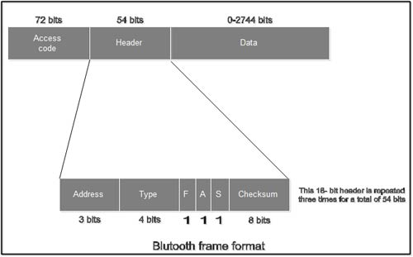

1.**Access Code**: It is 72 bit field that contains synchronization bits. It identifies the master.

2.**Header**: This is 54-bit field. It contain 18 bit pattern that is repeated for 3 time.

The header field contains following subfields:

(i) **Address**: This 3 bit field can define up to seven slaves (1 to 7). If the address is zero, it is used for broadcast communication from primary to all secondaries.

**(ii)Type**: This 4 bit field identifies the type of data coming from upper layers.

(iii) **F**: This flow bit is used for flow control. When set to 1, it means the device is unable to receive more frames.

(iv) **A**: This bit is used for acknowledgement.

(v) **S**: This bit contains a sequence number of the frame to detect retransmission. As stop and wait protocol is used, one bit is sufficient.

(vi) **Checksum**: This 8 bit field contains checksum to detect errors in header.

3.**Data**: This field can be 0 to 2744 bits long. It contains data or control information coming from upper layers.

**The Link Manager Protocol**

The link manager protocol is responsible for setting a link between two Bluetooth devices. This protocol layer is responsible for security issues like authentication, encryption, exchanging and checking the link and encryption keys.

Logical Link Control and Adaptation - Layer (L2CAP)

The Bluetooth logical link control and adaptation layer supports higher level multiplexing, segmentation and reassembly of packets and quality of service communication and groups. This layer is not responsible for reliability and uses ARQ to ensure it.

**Service Discovery Protocol (SDP)**

SDP is the basis for discovery of services on all Bluetooth devices. This is essential for all Bluetooth models because with SDP device information, services and the characteristics of the services can be queried and after that connection between two or more Bluetooth devices may be established .Other service discovery protocols such as Jini,UpnP etc. may be used in conjunction with the Bluetooth SDP protocol.

**Low Energy Attribute Protocol (ATT)**

Similar in scope to SDP but specially adapted and simplified for Low Energy Bluetooth. It allows a client to read and/or write certain attributes exposed by the server in a non-complex, low-power friendly manner.

In the protocol stack, ATT is bound to L2CAP.

**Audio/video control transport protocol (AVCTP)**

Used by the remote control profile to transfer AV/C commands over an L2CAP channel. The music control buttons on a stereo headset use this protocol to control the music player In the protocol stack, AVCTP is bound to L2CAP.

**Audio/video distribution transport protocol (AVDTP)**

Used by the advanced audio distribution profile to stream music to stereo headsets over an L2CAP channel. Intended to be used by video distribution profile. In the protocol stack, AVDTP is bound to L2CAP.

**Service discovery protocol (SDP)**

Used to allow devices to discover what services are supported by each other, and what parameters to use to connect to them. For example, when connecting a mobile phone to a Bluetooth headset, SDP will be used to determine which Bluetooth profiles are supported by the headset (headset profile, hands free profile, advanced audio distribution profile, etc.) and the protocol multiplexer settings needed to connect to each of them. Each service is identified by a Universally Unique Identifier (UUID), with official services (Bluetooth profiles) assigned a short form UUID (16 bits rather than the full 128). In the protocol stack, SDP is bound to L2CAP.

**Telephony Control Protocol Specification (TCS)**

Also referred to as telephony control protocol specification binary (TCS binary)

Used to set up and control speech and data calls between Bluetooth devices. The protocol is based on the ITU-T standard Q.931, with the provisions of Annex D applied, making only the minimum changes necessary for Bluetooth. TCS is used by the intercom (ICP) and cordless telephony (CTP) profiles.

**Bluetooth network encapsulation protocol (BNEP)**

BNEP is used for delivering network packets on top of L2CAP. This protocol is used by the personal area networking (PAN) profile. BNEP performs a similar function to Subnetwork Access Protocol (SNAP) in Wireless LAN. In the protocol stack, BNEP is bound to L2CAP

**Advantages :**

* It is cheap.
* Easy to install.
* It makes connecting to different devices convenient.
* It is wireless.
* It is free to use if the device is installed with it.

**Disadvantages :**

* It can be hacked into.
* If installed on a cellphone it is prone to receiving cell phone viruses.
* It only allows short range communication between devices.
* It can only connect two devices at once.
* It can lose connection in certain conditions.

**Limitations :**

* Slow Transfer Rate
* Distance Limitations
* Interference

**Application** **:**

1. It is used for providing communication between peripheral devices like wireless mouse or keyboard with the computer.

2. It is used by modern healthcare devices to send signals to monitors.

3. It is used by modern communicating devices like mobile phone, PDAs, palmtops etc to transfer data rapidly.

4. It is used for dial up networking. Thus allowing a notebook computer to call via a mobile phone.

5. It is used for cordless telephoning to connect a handset and its local base station.

6. It also allows hands-free voice communication with headset.

7. It also enables a mobile computer to connect to a fixed LAN.

8. It can also be used for file transfer operations from one mobile phone to another.

9. Bluetooth uses omnidirectional radio waves that can through walls or other non-metal barriers

***Conclusion:*** *Thus various Bluetooth protocol and applications studied successfully.*