### ***EXPERIMENT NO 8***

**AIM:**  To study and implement Mobile Network using NS2.

***THEORY:***

### **What is NS2**

NS2 stands for Network Simulator Version 2. It is an open-source event-driven simulator designed specifically for research in computer communication networks.

### **Features of NS2**

1. It is a discrete event simulator for networking research.

2. It provides substantial support to simulate bunch of protocols like TCP, FTP, UDP, HTTP and DSR.

3. It simulates wired and wireless network.

4. It is primarily Unix based.

5. Uses TCL as its scripting language.

6. Otcl: Object oriented support

7. Tclcl: C++ and otcl linkage

8. Discrete event scheduler

### **Basic Architecture**

NS2 consists of two key languages: C++ and Object-oriented Tool Command Language (OTcl). While the C++ defines the internal mechanism (i.e., a backend) of the simulation objects, the OTcl sets up simulation by assembling and configuring the objects as well as scheduling discrete events. The C++ and the OTcl are linked together using TclCL

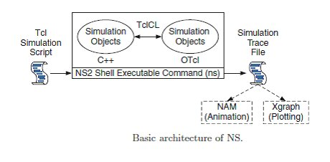

NS2 uses OTcl to create and configure a network, and uses C++ to run simulation. All C++ codes need to be compiled and linked to create an executable file.

**Use OTcl**

- For configuration, setup, or one time simulation, or

- To run simulation with existing NS2 modules.

This option is preferable for most beginners, since it does not involve complicated internal mechanism of NS2. Unfortunately, existing NS2 modules are fairly limited. This option is perhaps not sufficient for most researchers.

**Use C++**

- When you are dealing with a packet, or – when you need to modify existing NS2 modules.

This option perhaps discourages most of the beginners from using NS2. This book particularly aims at helping the readers understand the structure of NS2 and feel more comfortable in modifying NS2 modules.

#### **Steps is to install NS2**

1. Download NS2 from following link: http://www.isi.edu/nsnam/dist/ns-allinone-2.28.tar.gz

2. Decompress the file use winrar. Copy the decompressed folder the Cygwin installation directory under the subdirectory home. It will be C:\cygwin\home\system_name : where system_name is name of your system in above Cygwin installation this path will be C:\Cygwin\home\sys27

3. Run Cygwin from desktop and change the directory to folder you copied just now in step 2 command to change directory:

cd /home/sys27/ns-allinone-2.28

NOTE: please change sys27 to name of your system

4. To start installation type following command: "./install" (WITHOUT qoutes)

This will began the installation process if any Cygwin package is missing it will be reported to you if so the run Cygwin setu.exe and install the missing package and start again from step 2.

Installation is a long process and take quite some time once it is finished you will get a screen as shown below:

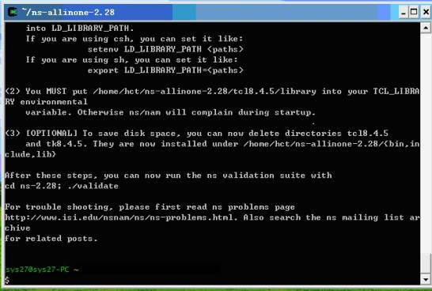

5. Add following lines to the .bashrc

export NS_HOME=/home/sys27/ns-allinone-2.28

export PATH=$NS_HOME/nam-1.11:$NS_HOME/tcl8.4.5/unix:$NS_HOME/tk8.4.5/unix:$NS_HOME/bin:$PATH

export LD_LIBRARY_PATH=$NS_HOME/tcl8.4.5/unix:$NS_HOME/tk8.4.5/unix:$NS_HOME/otcl-1.9:$NS_HOME/lib:$LD_LIBRARY_PATH

export TCL_LIBRARY=$NS_HOME/tcl8.4.5/library

NOTE: replace sys27 with your system name

6. To check if NS2 is installed correctly you can run one sample example given in ns-tutorials folder

To run the example change the directory to examples folder:

cd ./home/sys27/ns-allinone-2.28/ns-tutorial/examples

Then type following command:

ns example2.tcl

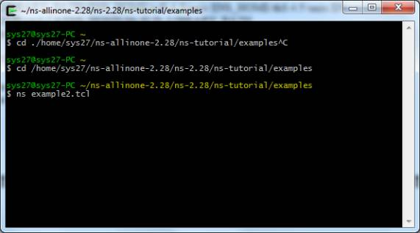

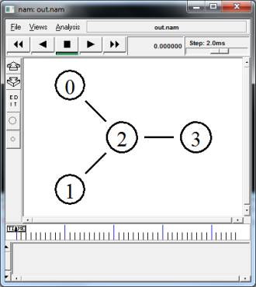

#### 

#### 

#### **Tools for generating TCL Script for NS2:**

NS2 a very common and widely used tool to simulate small and large area networks. Tcl scripts are widely used in NS-2 simulation tool. Tcl scripts are used to set up a wired or wireless communication network, and then run these scripts via the NS-2 for getting the simulation results.

Several tools are available

**I. NS2 scenario Generator (NSG):**

Its a java based tool that can run on any platform and can generate TCL scripts for wired and Wireless scenarios for NS2.Main features of NSG are:

1. Creating Wired and wireless nodes by drag and drop.

2. Creating Simplex and Duplex links for wired network.

3. Creating Grid, Random and Chain topologies.

4. Creating TCP and UDP agents. Also supports TCP

5. Tahoe, TCP Reno, TCP New-Reno and TCP Vegas.

6. Supports Ad Hoc routing protocols such as DSDV,

7. AODV, DSR and TORA.

8. Supports FTP and CBR applications.

9. Supports node mobility.

10. Setting the packet size, start time of simulation, end

**II. Visual Network Simulator (VNS):**

This tool is centered on capabilities of NSG. It also provides support to Differentiated Services (DiffServ) scenarios and simple and intuitive set of icons to represent the components of a network.

Some features of VNS are given below:

1. Adding and configuration of links, agents and traffic sources.

2. Modeling network scenarios with support to multicast.

3. Selection of a dynamic routing protocol.

4. Definition of the simulation output as an animation and/or graphics.

5. Edition of the Tcl script generated.

6. Saving the defined simulation scenario

### **Advantages of NS2:**

1. Cheap- Does not require costly equipment

2. Complex scenarios can be easily tested.

3. Results can be quickly obtained – more ideas can be tested in a smaller time frame.

4. Supported protocols

5. Supported platforms

6. Modularity

7. Popular

### **Disadvantages of NS2:**

1. Real system too complex to model. i.e. complicated structure.

2. Bugs are unreliable

***Conclusion:-*** Thus we have successfully studied mobile network using NS2.