# Experiment No - 2

***Aim:*** To create FTP server using VSFTPD.

***Theory:***

**File Transfer Protocol (FTP):**

The File Transfer Protocol (FTP) is a standard [network protocol](https://en.wikipedia.org/wiki/Network_protocol) used for the transfer of [computer files](https://en.wikipedia.org/wiki/Computer_file) from a server to a client using the [Client–server model](https://en.wikipedia.org/wiki/Client%E2%80%93server_model) on a [computer network](https://en.wikipedia.org/wiki/Computer_network).

FTP is built on a client-server model architecture and uses separate control and data connections between the client and the server. FTP users may authenticate themselves with a [clear-text](https://en.wikipedia.org/wiki/Clear_text) sign-in protocol, normally in the form of a username and password, but can connect anonymously if the server is configured to allow it. For secure transmission that protects the username and password, and encrypts the content, FTP is often [secured](https://en.wikipedia.org/wiki/File_Transfer_Protocol#Security) with [SSL/TLS](https://en.wikipedia.org/wiki/Transport_Layer_Security) ([FTPS](https://en.wikipedia.org/wiki/FTPS)). [SSH File Transfer Protocol](https://en.wikipedia.org/wiki/SSH_File_Transfer_Protocol) (SFTP) is sometimes also used instead, but is technologically different.

The first FTP client applications were [command-line programs](https://en.wikipedia.org/wiki/Command-line_interface) developed before [operating systems](https://en.wikipedia.org/wiki/Operating_system) had [graphical user interfaces](https://en.wikipedia.org/wiki/Graphical_user_interface), and are still shipped with most [Windows](https://en.wikipedia.org/wiki/Windows), [Unix](https://en.wikipedia.org/wiki/Unix), and [Linux](https://en.wikipedia.org/wiki/Linux) operating systems. Many FTP clients and automation utilities have since been developed for [desktops](https://en.wikipedia.org/wiki/Desktops), servers, mobile devices, and hardware, and FTP has been incorporated into productivity applications, such as [web page editors](https://en.wikipedia.org/wiki/HTML_editor).

**Very Secure File Transfer Protocol Deamon (VSFTPD):**

VSFTPD stands for "Very Secure FTP Daemon" is a GPL licensed FTP server for UNIX systems. It is licensed under the GNU General Public License. It supports IPv6 and SSL. vsftpd supports explicit (since 2.0.0) and implicit (since 2.1.0) FTPS. vsftpd is the default FTP server in the Ubuntu, CentOS, Fedora, NimbleX, Slackware and RHEL Linux distributions. It is secure and extremely fast. It is stable. VSFTPD is a mature and trusted solution which supports virtual users with PAM (pluggable authentication modules). A virtual user is a user login which does not exist as a real login on the system in /etc/passwd and /etc/shadow file. Virtual users can therefore be more secure than real users, because a compromised account can only use the FTP server but cannot login to system to use other services such as SSH or SMTP. Despite being small for purposes of speed and security, many more complicated FTP setups are achievable with vsftpd! vsftpd can handle:

* Virtual IP configurations
* Virtual users
* Standalone or inetd operation
* Powerful per-user configurability
* Bandwidth throttling
* Per-source-IP configurability
* Per-source-IP limits
* IPv6
* Encryption support through SSL integration.

**VSFTPD - FTP Server Installation:**

**1) Update System:**

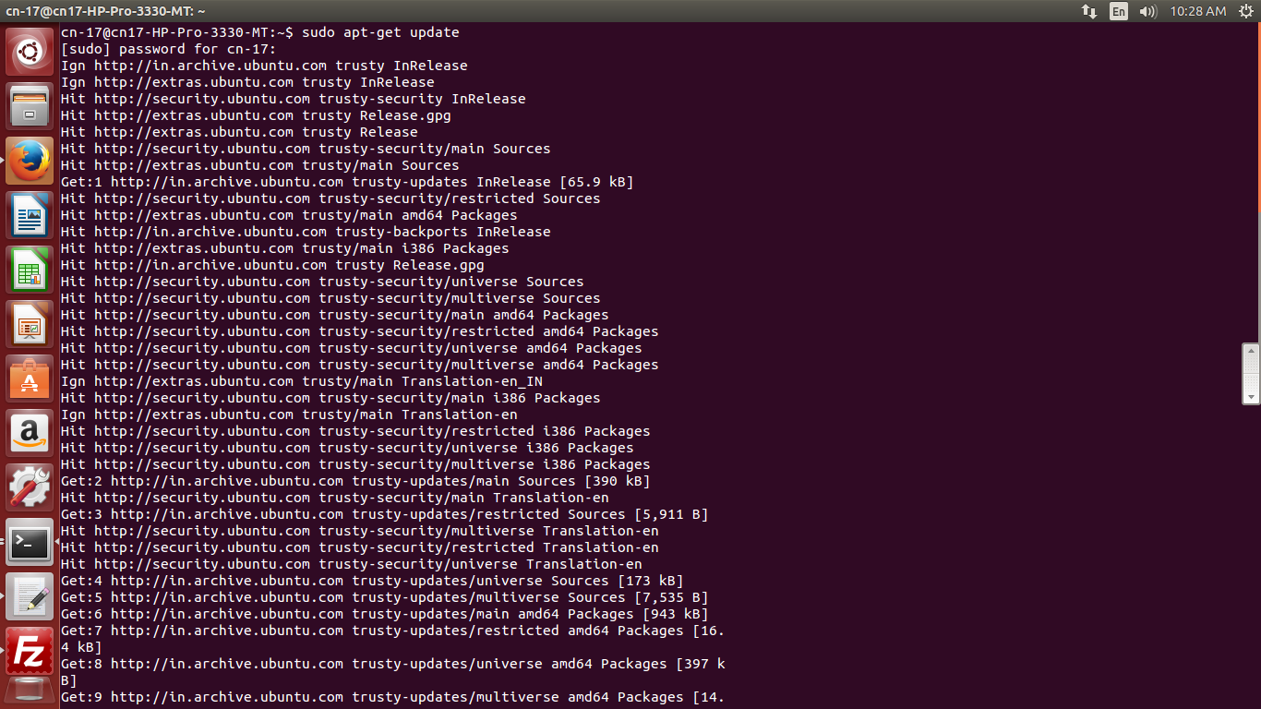

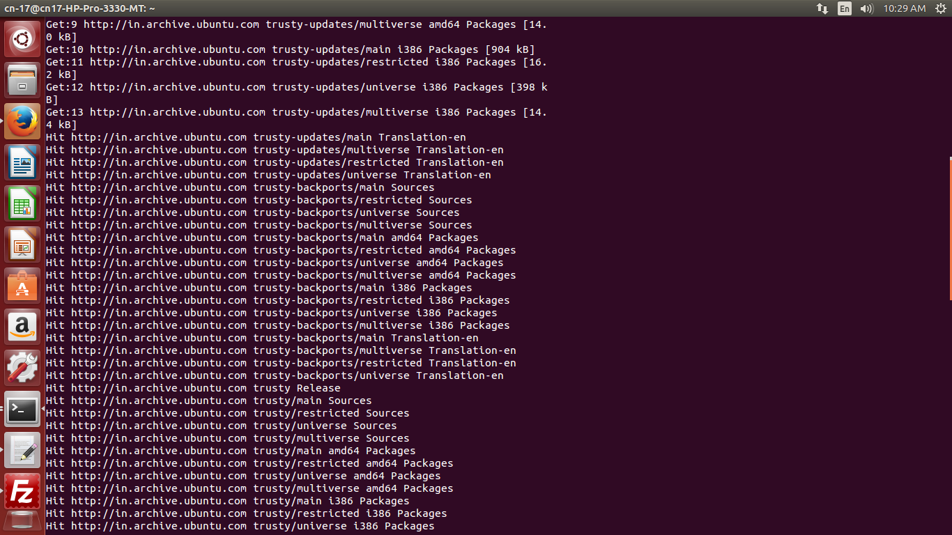

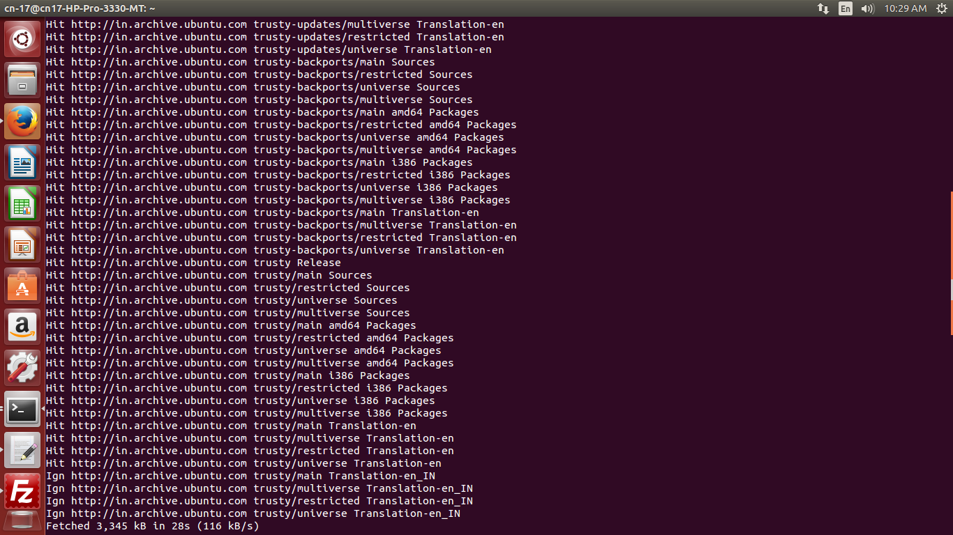

**2) Install VsFTPD package using the below command.**

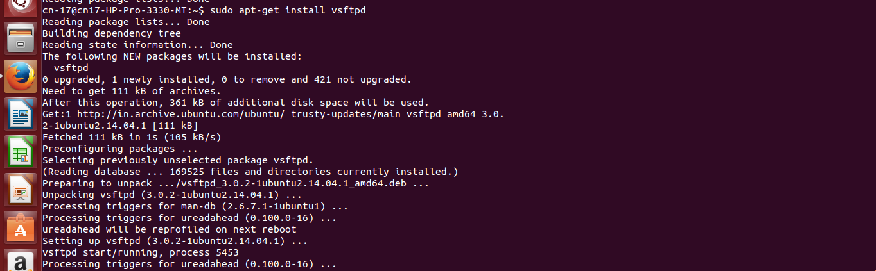

**3) After installation open** /etc/vsftpd.conf **file and make changes as follows.**

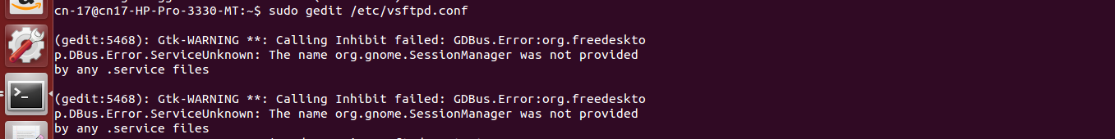

**a) Uncomment the below lines (line no:29 and 33).**

Line no: 29] write_enable=YES

Line no: 33] local_umask=022

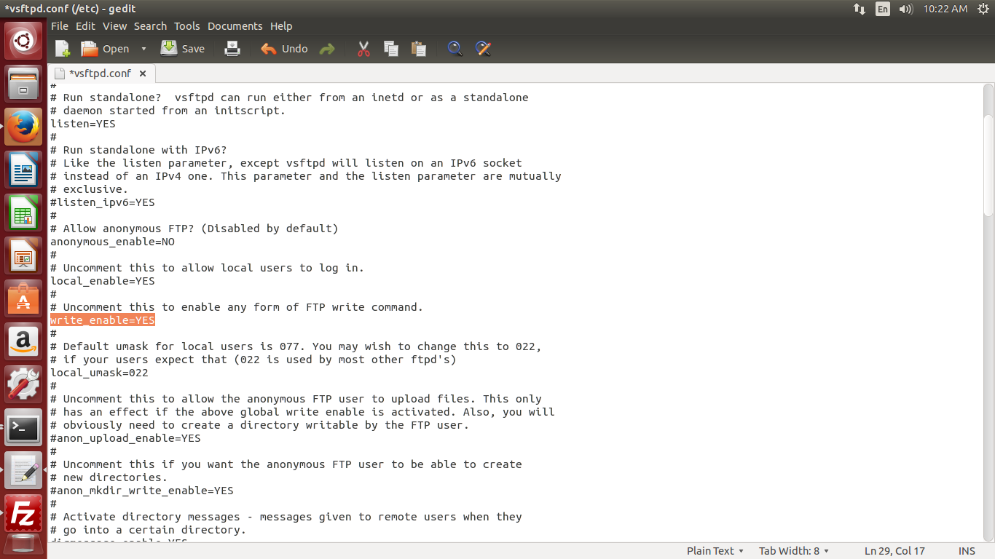

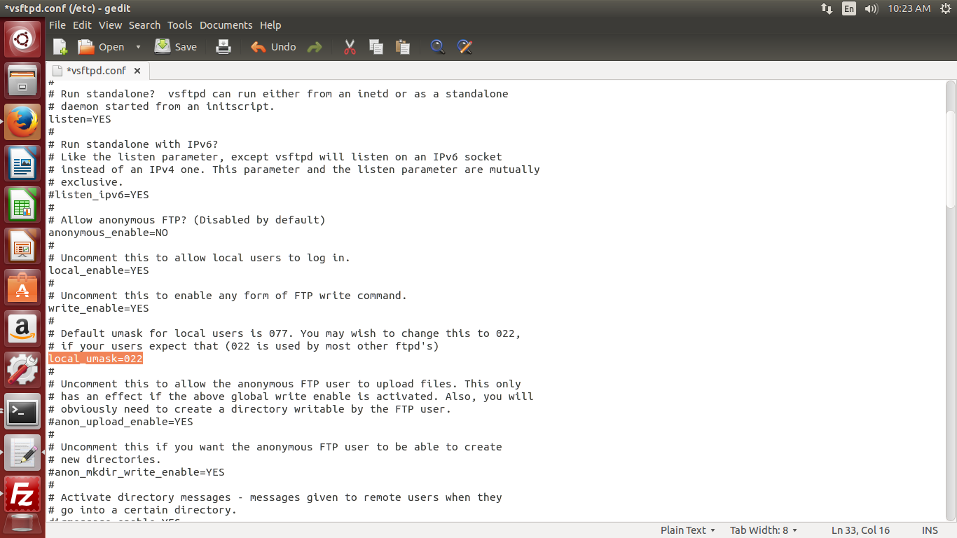

**b) Uncomment the below line (line no: 120 ) to prevent access to the other folders outside the Home directory.**

Line no: 120] chroot_local_user=YES

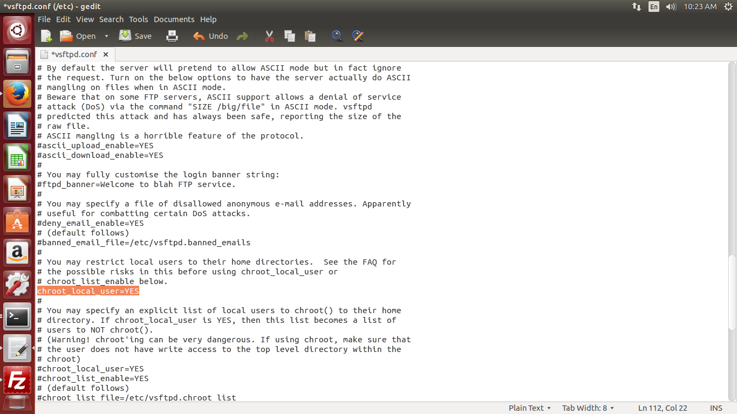

**c) and add the following line at the end.**

allow_writeable_chroot=YES

**d) Add the following lines to enable passive mode.**

pasv_enable=YES

pasv_min_port=40000

pasv_max_port=40100

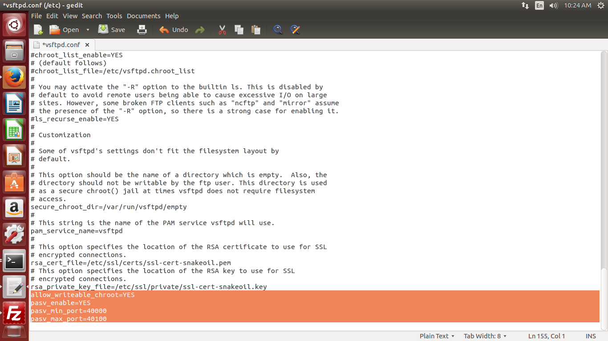

**4) Restart vsftpd service using the below command.**

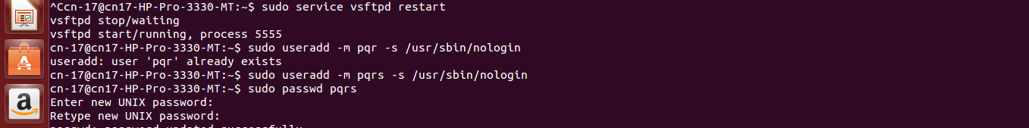

**5) Now ftp server will listen on port 21. Create user with the below command.Use** /usr/sbin/nologin **shell to prevent access to the bash shell for the ftp users .**

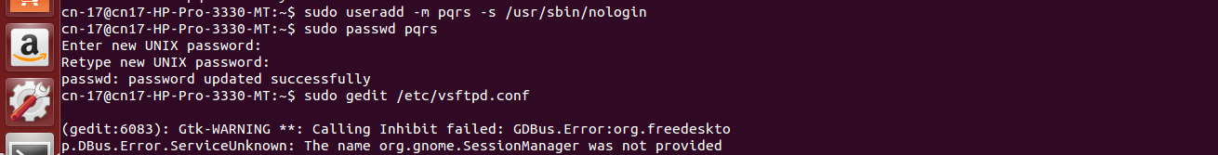

**6) Now try to connect this ftp server with the username on port 21 using** [**winscp**](http://winscp.net/eng/download.php) **or** [**filezilla**](https://filezilla-project.org/download.php?type=client) **client and make sure that user cannot access the other folders outside the home directory.**

**FileZilla:**

The FileZilla software program is a free-to-use (open source) [FTP](http://www.computerhope.com/jargon/f/ftp.htm) utility, allowing a user to transfer files from a local computer to a remote computer. FileZilla is available as a client version and a server version. FileZilla has dozens of features, including some of the below popular features.

* Site Manager (to create and store a list of FTP servers and associated connection data)
* Directory Comparison (allows a user to compare contents of a local and remote directory)
* File and Folder View (similar to a file manager, allowing a user to modify files and folders and providing a drag-and-drop capability between local and remote directories)
* Transfer Queue (displays status of file transfers in progress or waiting to process).

FileZilla is capable of running in Windows, Mac OS X, and Linux. It supports FTP, [SFTP](http://www.computerhope.com/jargon/s/sftp.htm), and FTPS protocols.

**To Install FileZilla:**

sudo apt_get install FileZilla

Setting the rights of a file may be necessary when uploading a script or non-traditional file to your web server. To set the rights of a file or chmod a file in an FTP client, follow the instructions below. In our example below we'll be using [FileZilla](http://filezilla-project.org/), our favorite free FTP client. Users who are using other clients should find the steps below similar to what they need to do.

1. Open FileZilla.
2. Connect to the server you're you are going to [upload](http://www.computerhope.com/jargon/u/upload.htm) the files.
3. On the left-hand side of FileZilla showing your files browse to the location containing the files you want to upload.
4. Next, on the right-hand side of the window, browse to the location of the upload files. If this location doesn't exist create it.
5. Upload the files by dragging and dropping or right-clicking the files and selecting upload.

**OUTPUT 1] Transferring File 'kvm_inst.docx':**

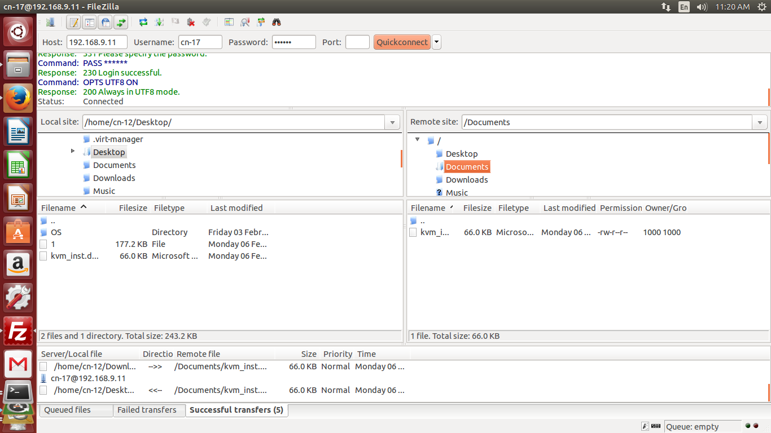

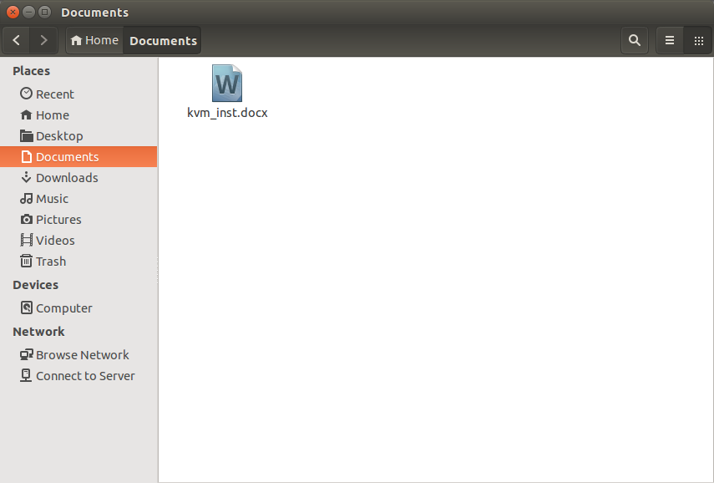

**OUTPUT 2] Transferring File 'bzless':**

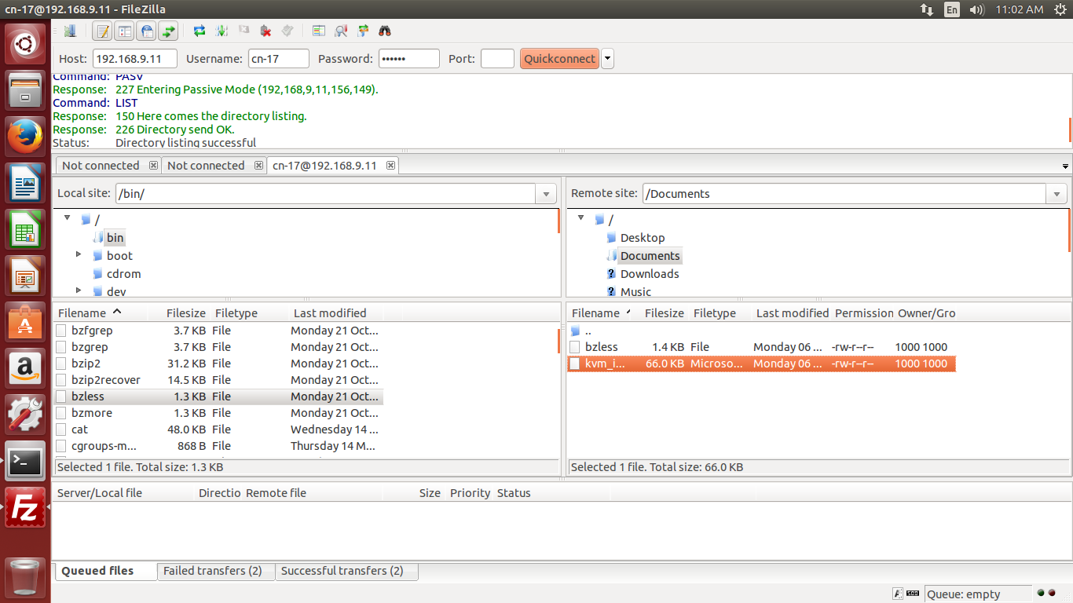

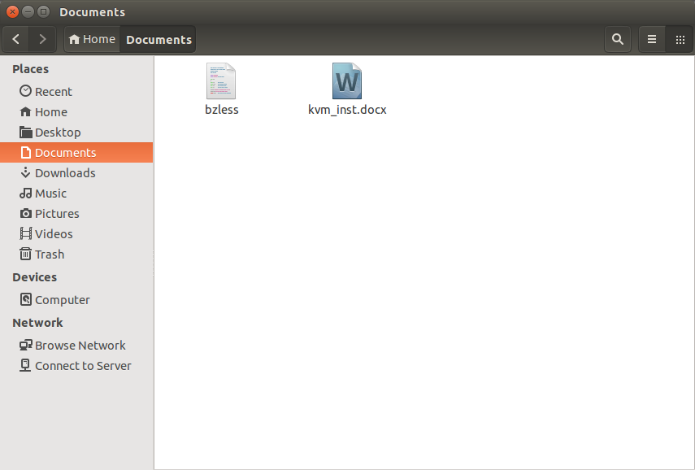

**OUTPUT 3] Transferring File 'bzip2':**

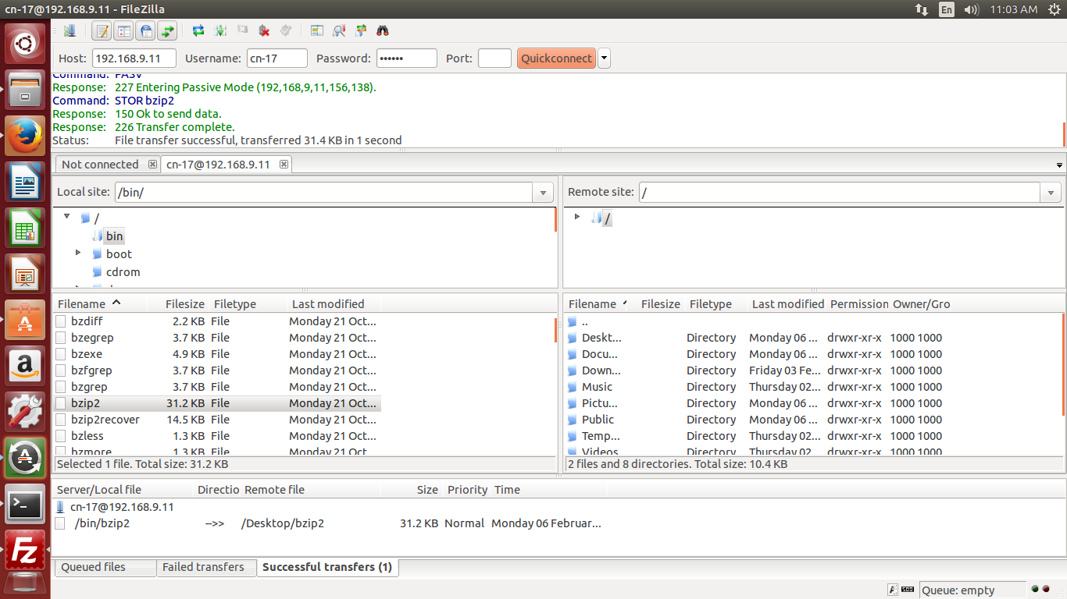

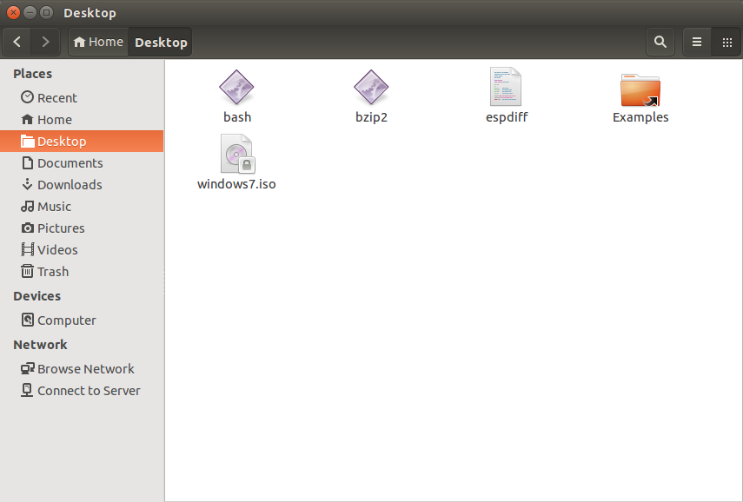

**OUTPUT 4] Transferring File 'busybox':**

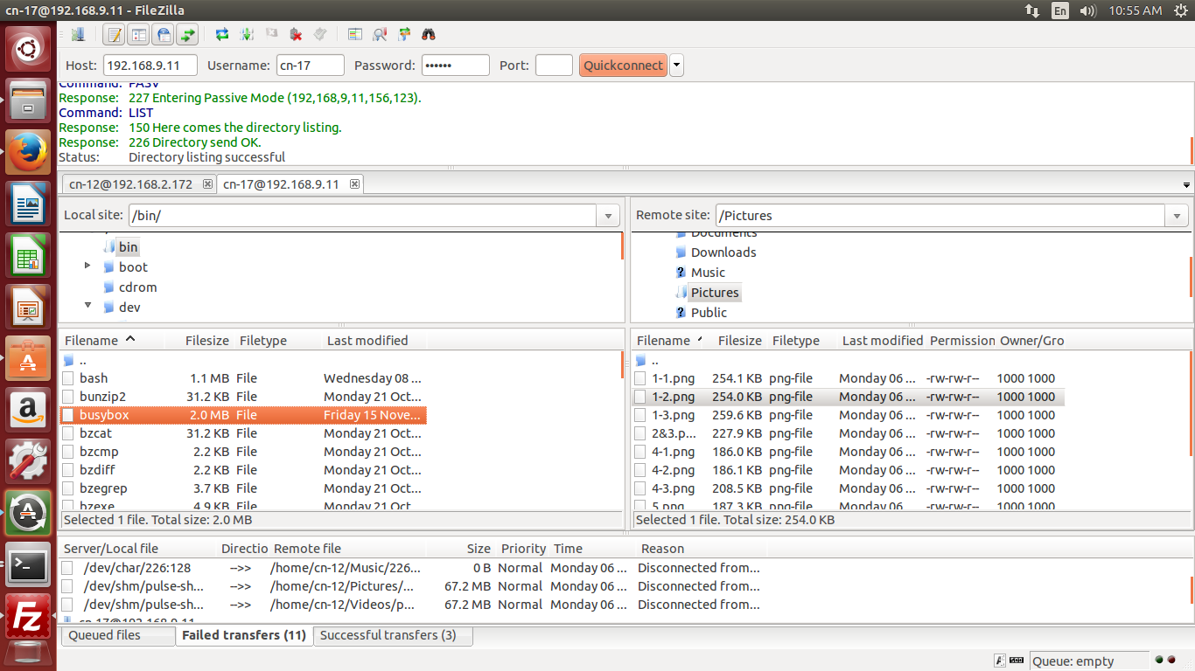

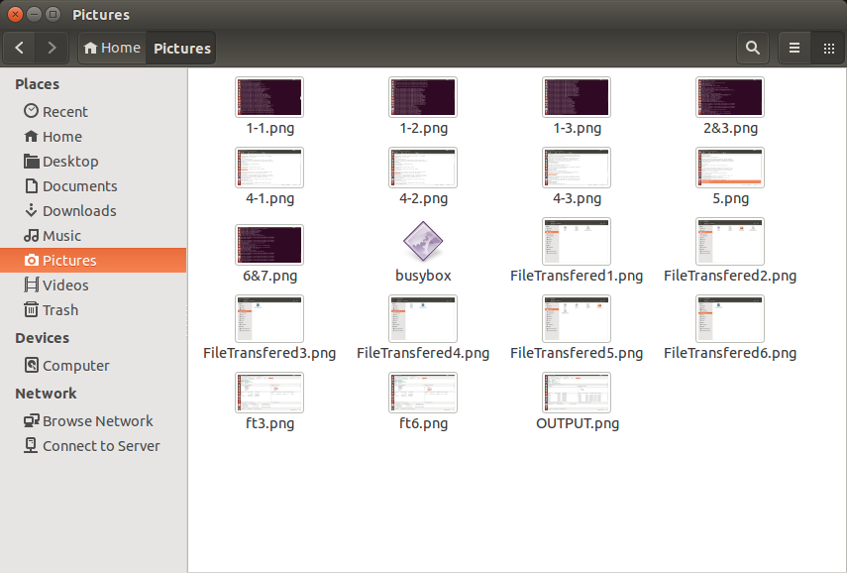

**Conclusion:** Thus File Transfer Protocol server has been successfully implemented using VSFTPD.