**Aim:** to study and implement Nessus Tool.

**Theory:**

Nessus is a vulnerability scanner which is very easy to deploy. It has more than ten million downloads and is offered in 1-, 2-, or 3-year subscriptions, as well as in bundled solutions. Do you want to perform security checks on your network? With the largest collection of network security checks Nessus will be your best friend in identifying hosts and vulnerability identifying in your network. Some features of the Nessus tools are listed below. A very good thing to mention is the fact that Nessus comes in two flavors, Home and Professional. The Home Feed is for personal usage and it does the job in a non professional environment. Professional Feed includes additional features and it is for commercial usage.

– Broad Asset Coverage & Profiling

– Mobile Device Auditing

– Botnet / Malicious Process / Anti-virus (AV) Auditing

– Patch Management Integration

– Sensitive Content Auditing

– SCADA / Control Systems Auditing

Before you install and configure Nessus you have to download it for your operating system.

1. Download Nessus . Choose the Ubuntu packages (or the Debian ones)
2. Open a Terminal and go to the download directory (cd)
3. Run sudo dpkg -i Nessus*.deb. Enter root password.
4. Start it sudo /etc/init.d/nessusd start
5. Then goto Tenable.io and create account.
6. Generate Linking keys By going to My Account>Api Keys copy keys for later use.

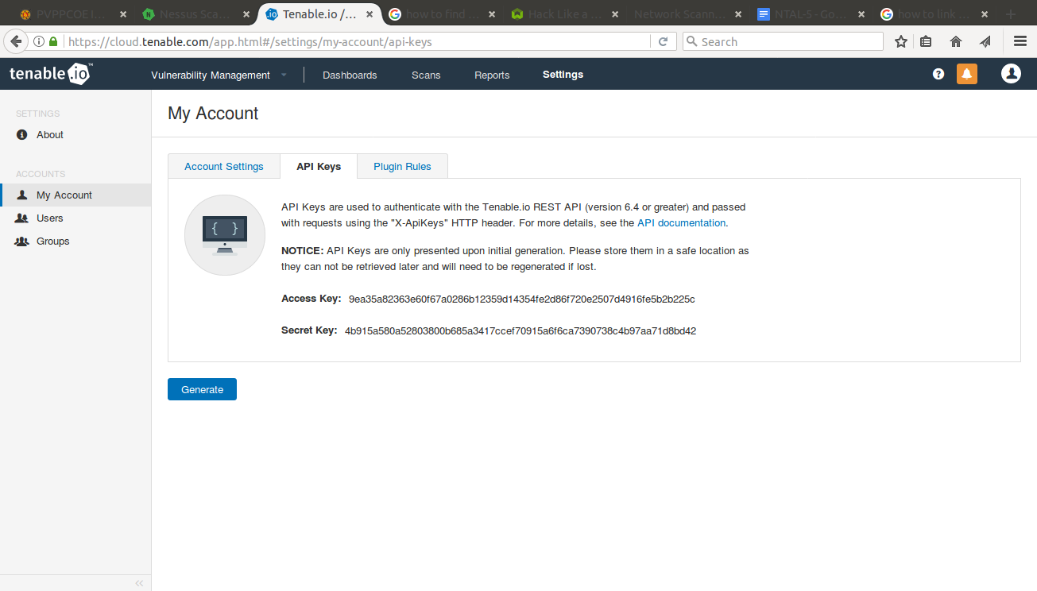

1. Open a browser and go to <https://localhost:8834/>

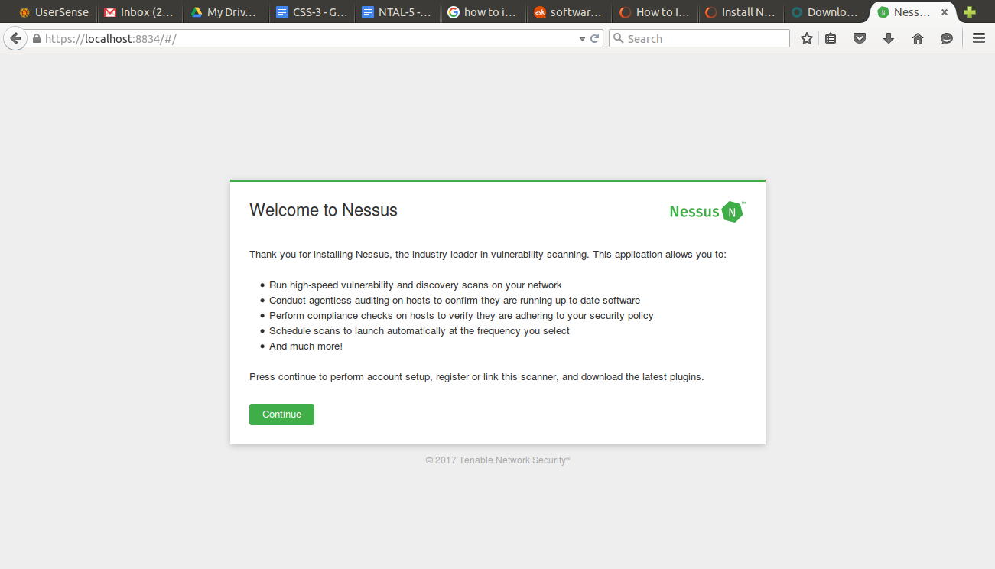

1. After Login Enter Credentials and Link With Tenable.io using generated Keys in step 6.

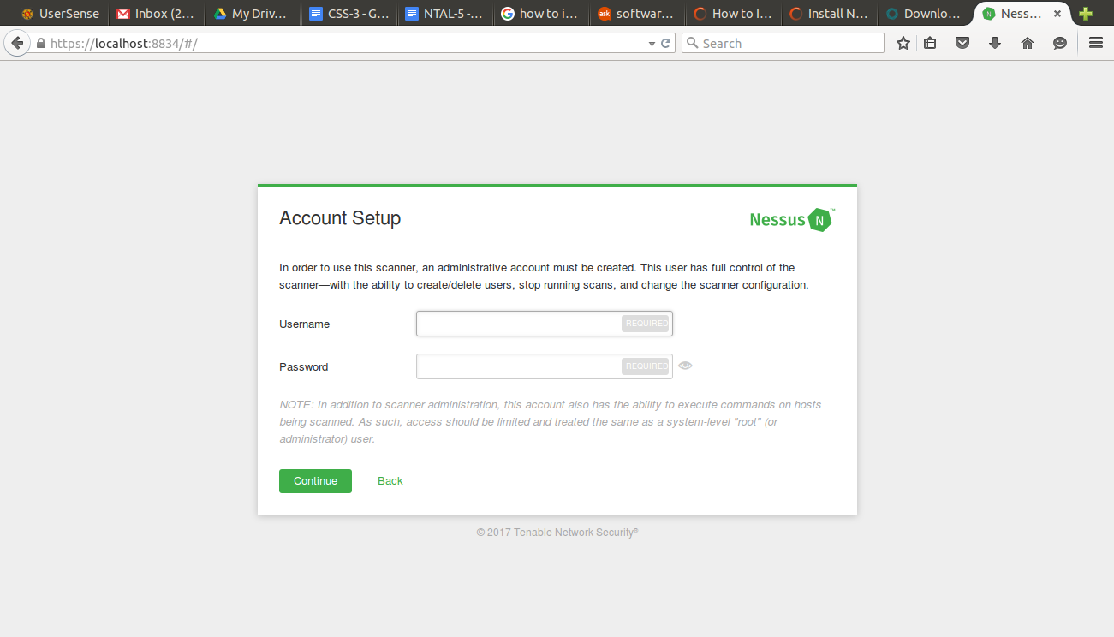

1. After entering write credential it will take some time to initialise and setting up background things.

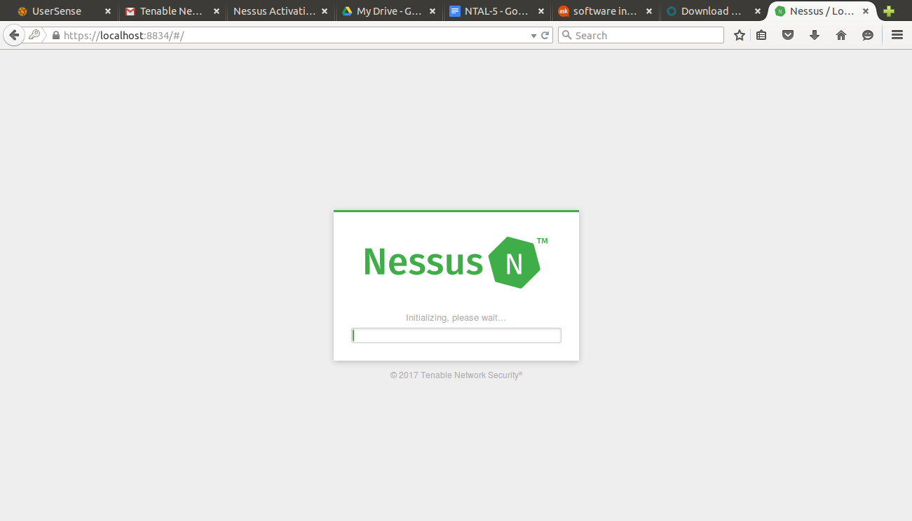

1. After initialization you will present to Nessus dashboard.

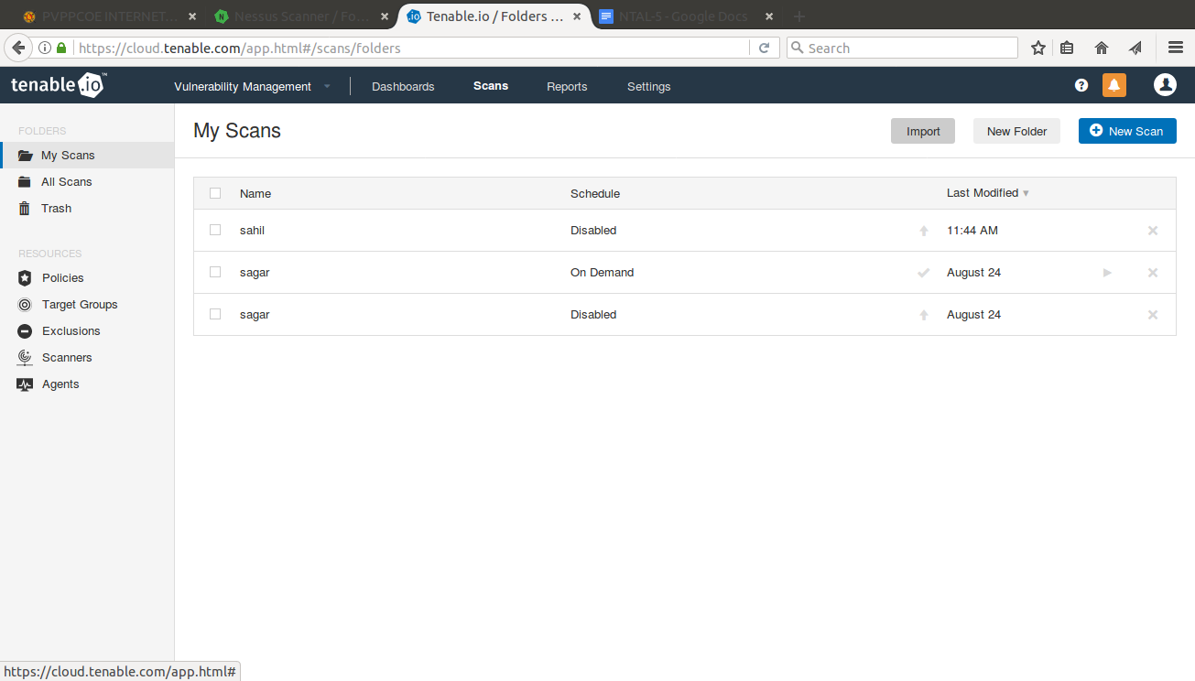

1. Now click on new scan in right hand side.Then select basic network scan. And then Enter scan name and ip address.

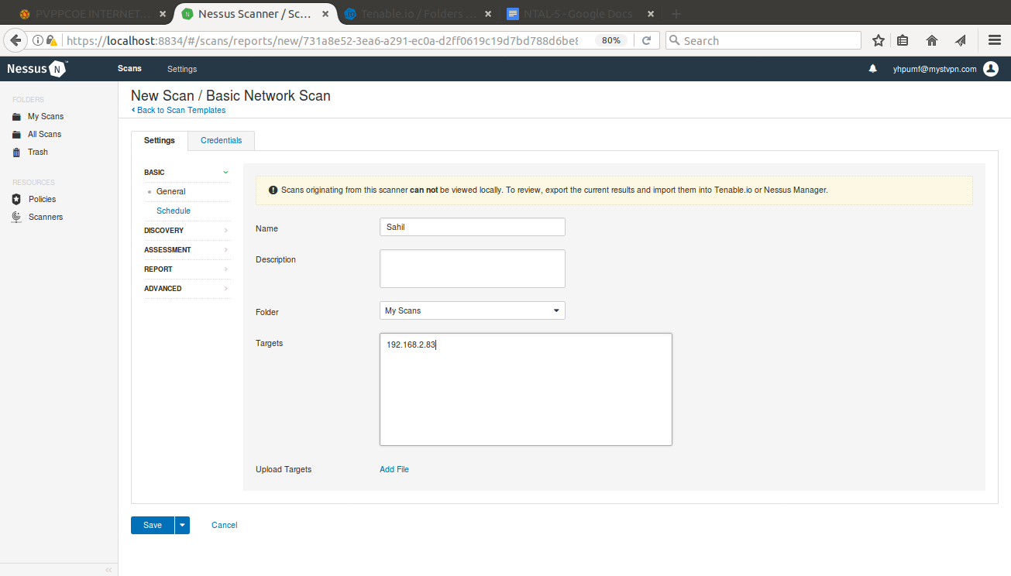

1. After saving scan go back to Myscan in dashboard and launch newly created scan. And Wait for some time till nessus scan the ip completely.

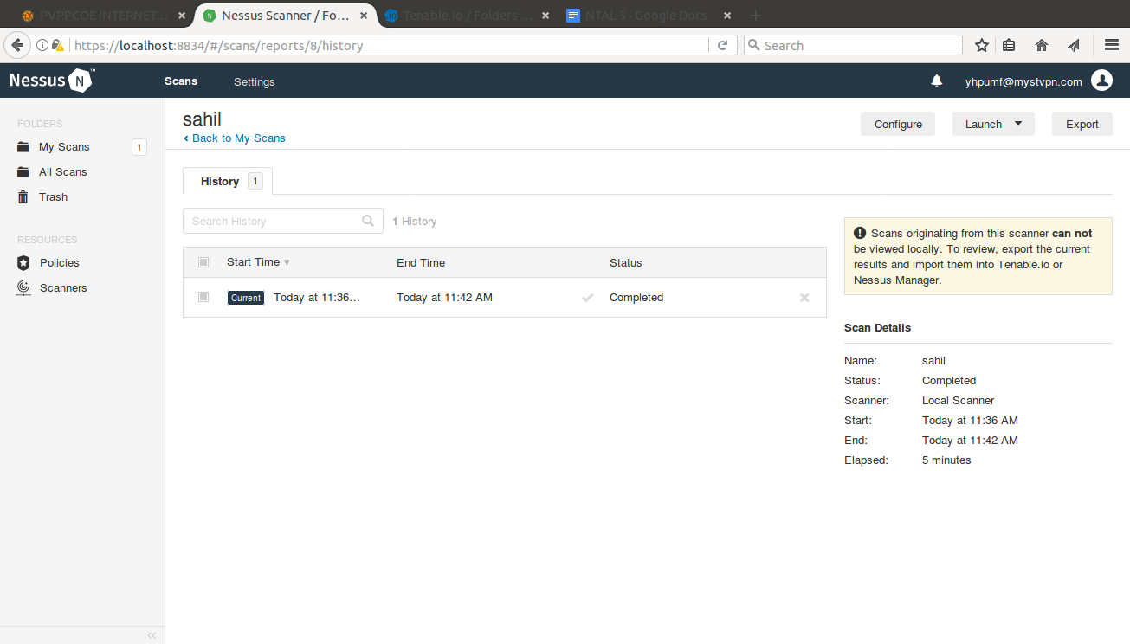

1. After that export the result and save to the safe location.
2. Now go to the Tennable.io and login with credentials. And goto the my scan tab in dashboard and import the result.

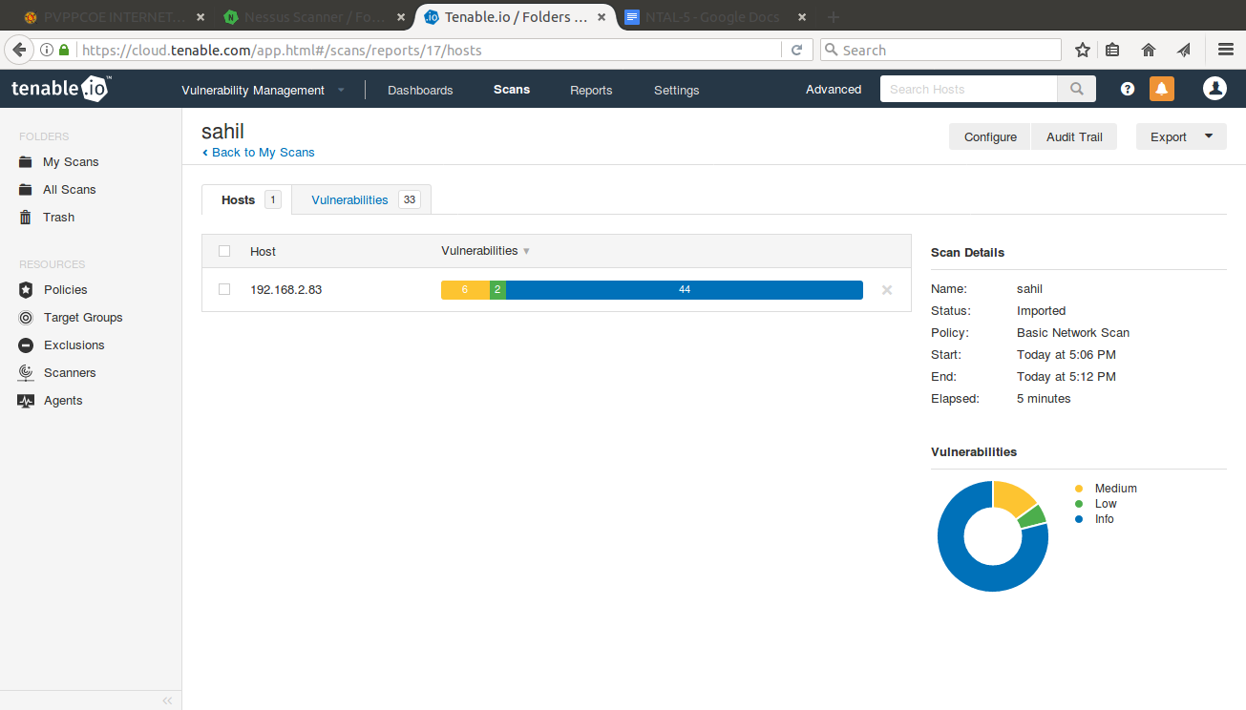

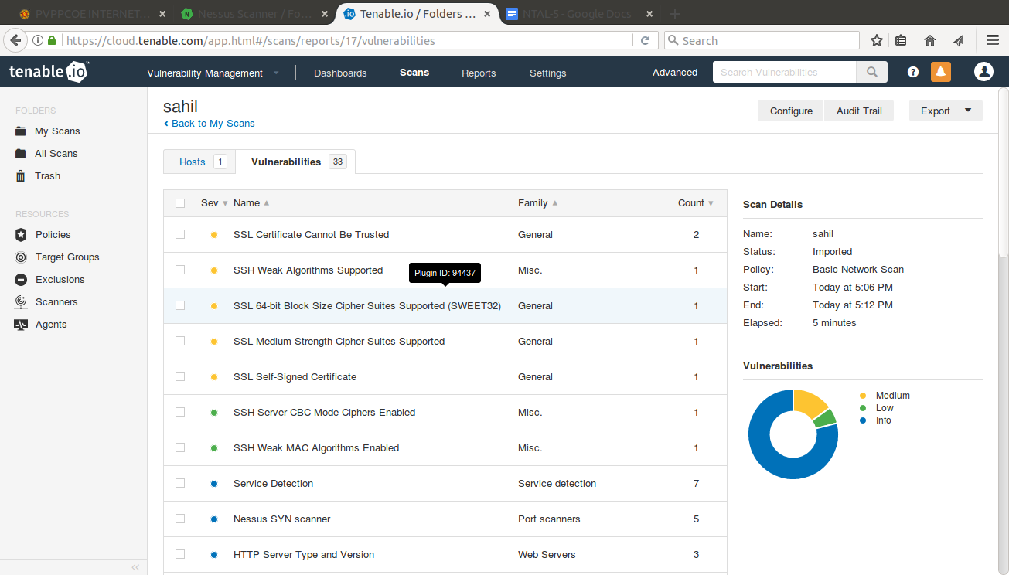

***Conclusion:*** Hence we Successfully studied and implemented Nessus Tool.