**SquareServer.java**

import java.net.*;

import java.io.*;

public class SquareServer {

public static void main (String args[]) {

try {

ServerSocket ss = new ServerSocket (10450); // 10450 = port number

Socket clientSocket = ss.accept();

DataOutputStream dos = new DataOutputStream(clientSocket.getOutputStream());

DataInputStream dis = new DataInputStream(clientSocket.getInputStream());

double result1 = Math.pow(dis.readDouble(),2);

double result2 = Math.sqrt(dis.readDouble());

dos.writeDouble(result1);

dos.writeDouble(result2);

clientSocket.close();

ss.close();

}

catch (Exception e) {

System.out.println("Exception: " + e);

}

}

}

**SquareClient.java**

import java.net.*;

import java.io.*;

public class SquareClient {

public static void main (String args[]) {

try {

Socket s = new Socket("localhost",10450);

DataOutputStream dos = new DataOutputStream(s.getOutputStream());

DataInputStream dis = new DataInputStream(s.getInputStream());

dos.writeDouble(16);

dos.writeDouble(225);

double result1 = dis.readDouble();

double result2 = dis.readDouble();

System.out.println("The square of 16 is " + result1);

System.out.println("The square-root of 225 is " + result2);

s.close();

}

catch (Exception e) {

System.out.println("Exception " + e);

}

}

}

**Output**

Server Side:

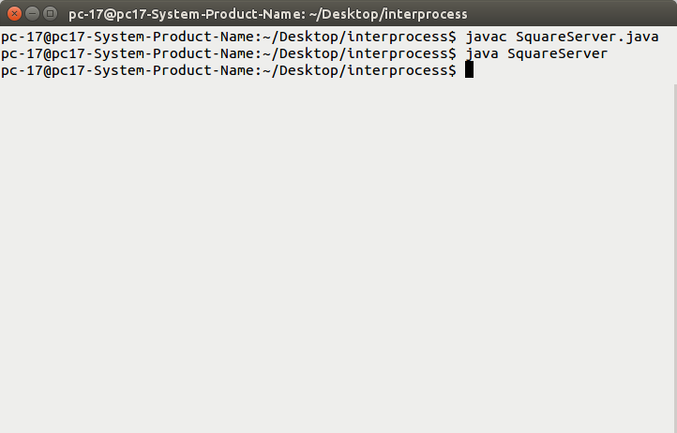

Client Side:

