**Experiment No:2(A)**

**Aim:** Write a program to implement basic fuzzy set operation (union, intersection, complement, set difference).

**Theory:**

Fuzzy logic is a superset of conventional(Boolean) logic that has been extended to handle the concept of partial truth- truth values between "completely true" and "completely false".

The essential characteristics of fuzzy logic as founded by Zader Lotfi are as follows.

* In fuzzy logic, exact reasoning is viewed as a limiting case of approximate reasoning.
* In fuzzy logic everything is a matter of degree.
* Any logical system can be fuzzified
* In fuzzy logic, knowledge is interpreted as a collection of elastic or, equivalently , fuzzy constraint on a collection of variables
* Inference is viewed as a process of propagation of elastic constraints.

**Fuzzy Set Operations**

**Union**

The membership function of the Union of two fuzzy sets A and B with membership functions and  respectively is defined as the maximum of the two individual membership functions. This is called the *maximum* criterion.



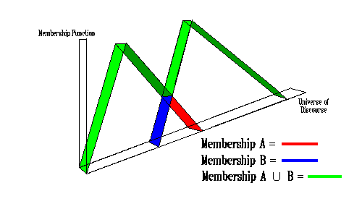

The Union operation in Fuzzy set theory is the equivalent of the **OR** operation in Boolean algebra.

### **Intersection**

The membership function of the Intersection of two fuzzy sets A and B with membership functions  and  respectively is defined as the minimum of the two individual membership functions. This is called the *minimum* criterion.



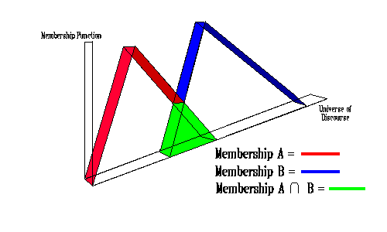

The Intersection operation in Fuzzy set theory is the equivalent of the **AND** operation in Boolean algebra.

### **Complement**

The membership function of the Complement of a Fuzzy set A with membership function is defined as the negation of the specified membership function. This is called the *negation* criterion.



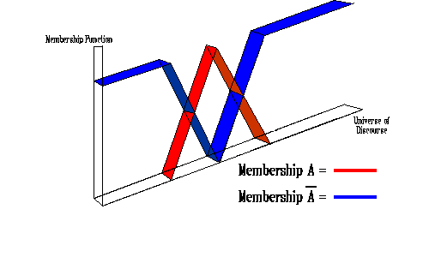

The Complement operation in Fuzzy set theory is the equivalent of the **NOT** operation in Boolean algebra.

The following rules which are common in classical set theory also apply to Fuzzy set theory.

### **Difference**

The membership function of the Difference of two fuzzy sets A and B with membership functions  and  respectively is defined as the minimum of the fuzzy set A and complement of fuzzy set B.

**-B= min(, C)**

**Program:**

import java.util.*;

class set {

public static void main(String []args) {

Scanner sc = new Scanner(System.in);

System.out.print("Enter the number of Elements in Set: ");

int n = sc.nextInt();

double a[][] = new double[n][2];

double b[][] = new double[n][2];

double c[][] = new double[n][2];

System.out.println("Enter the Numerator and denominator of elements of set A: ");

for (int i = 0; i < n; i++) {

a[i][0] = sc.nextDouble();

a[i][1] = sc.nextDouble();

}

System.out.println("Enter the Numerator and denominator of elements of set B: ");

for (int i = 0; i < n; i++) {

b[i][0] = sc.nextDouble();

b[i][1] = sc.nextDouble();

}

int ch = 0;

while(ch!=5)

{

System.out.print("\n1.Union\n2.Intersection\n3.Complement\n4.Difference\n5.Exit\nEnter your Choice: ");

ch = sc.nextInt();

switch (ch) {

case 1 : c = union(a, b, n);

System.out.println("\nUnion is: ");

print(c, n);

break;

case 2 : c = intersection(a, b, n);

System.out.println("\nIntersection is: ");

print(c, n);

break;

case 3: c = complement(a,n);

System.out.println("\nComplement of A: ");

print(c, n);

c= complement(b,n);

System.out.println("\nComplement of B: ");

print(c, n);

break;

case 4: c = intersection(a,complement(b,n),n);

System.out.println("\nA-B is: ");

print(c,n);

c = intersection(b,complement(a,n),n);

System.out.println("\nB-A is: ");

print(c,n);

break;

case 5: break;

default:

System.out.println("\nInvalid Choice\n");

break;

}

}

}

public static double[][] union(double a[][], double b[][], int n) {

double c[][] = new double[n][2];

for (int i = 0; i < n; i++) {

for (int j = 0 ; j < n; j++) {

if (a[i][1] == b[j][1])

c[i][0] = max(a[i][0], b[j][0]);

c[i][1] = a[i][1];

}

}

return c;

}

public static double[][] intersection(double a[][], double b[][], int n) {

double c[][] = new double[n][2];

for (int i = 0; i < n; i++) {

for (int j = 0 ; j < n; j++) {

if (a[i][1] == b[j][1])

c[i][0] = min(a[i][0], b[j][0]);

c[i][1] = a[i][1];

}

}

return c;

}

public static double[][] complement(double a[][], int n) {

double c[][] = new double[n][2];

for (int i = 0; i < n; i++) {

c[i][0] = 1.0 - a[i][0];

c[i][0] = Math.round(c[i][0]*100.0)/100.0;

c[i][1] = a[i][1];

}

return c;

}

public static void print(double a[][], int n) {

for (int j = 0; j < n; j++)

System.out.print(a[j][0] + "\t");

System.out.println();

for (int j = 0; j < n; j++)

System.out.print(a[j][1] + "\t");

System.out.println();

}

public static double max(double a, double b) {

if (a > b)

return a;

else

return b;

}

public static double min(double a, double b) {

if (a < b)

return a;

else

return b;

}

}

Output:

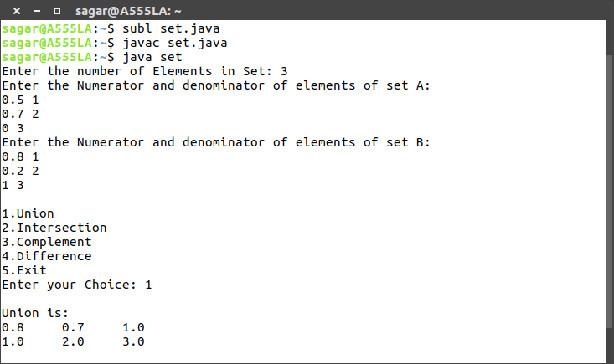

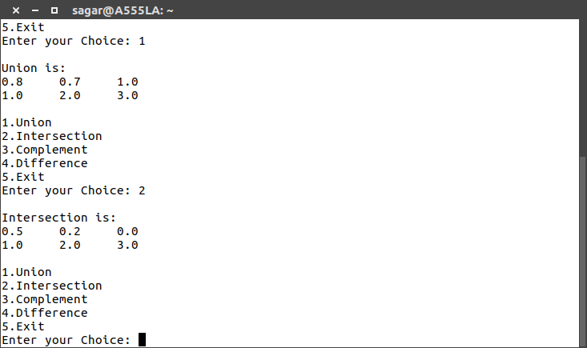

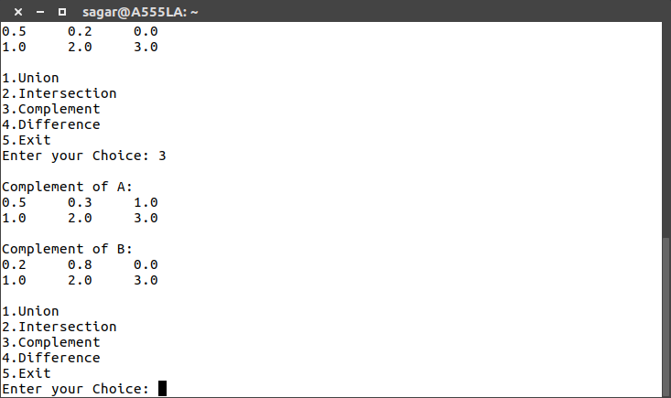

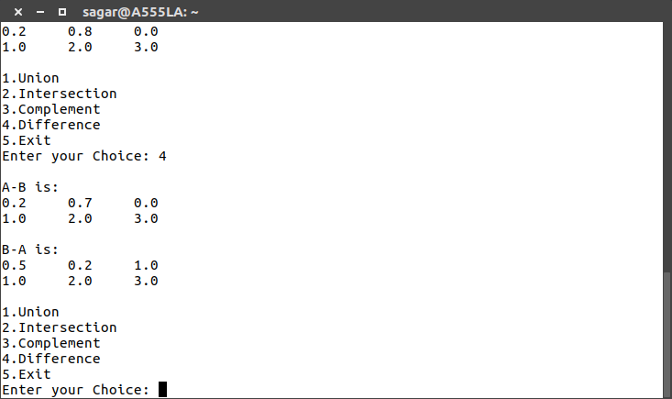

**Conclusion:** Thus, operation like union, difference, complement, intersection has been successfully performed and implemented.