**Experiment No: 2(B)**

**Aim:** Write a program to implement fuzzy set operation (Algebraic Sum, Algebraic Product, Bounded Sum, Bounded Difference).

**Theory:**

* **Algebraic Sum of two fuzzy sets:**

If A and B are fuzzy subsets of X, then the Algebraic sum of A and B is denoted by:

A + B.= mA(x)+mb(x)-mA(x)*mB(x)

* **Algebraic Product of two fuzzy sets:**

If A and B are fuzzy subsets of X, then the Algebraic Product of A and B is denoted by:

A * B=mA(x)*mB(x).

* **Bounded Sum of two fuzzy sets:**

If A and B are fuzzy subsets of X, then the bonded sum of A and B is denoted by:

A⊕ B

m AÅ B(x) = min(1,mA(x)+mB(x)) for all xÎ X

Example: Let X = {1,2,3,4}

and A = 0.4/1+0.9/2+¼

and B = 0.6/1+0.5/2

Then

AÅ B = 1/1+1/2+¼

Note:

AÅ B = min(1,mA(x)+mB(x))

= min(1,(0.4+0.6)/1)+min(1,(0.9+0.5)/2)+min(1,(1+0/4)

= 1/1 + 1/2 + 1/4

* **Bounded difference of two fuzzy sets**

If A and B are fuzzy subsets of X, then the bonded difference of A and B is denoted by:

A (-) B

And

mAé B(x) = 0Ú (mA(x)- mB(x)0/x

mAé B(x) = max(0,(mA(x)- mB(x)0/x

Example:

A = 0.4/1+0.9/2+¼

B = 0.6/1+0.5/2

A é B = max(0,(0.4-0.6)/1)+ max(0,(0.9-0.5)/2)+ max(0,(1-0)/4)

= 0.4/2 + ¼

**Program:**

import java.util.*;

public class Fuzzy {

public static void main(String[] args) {

Scanner sc = new Scanner(System.in);

System.out.print("Enter the number of Elements in Set: ");

int n = sc.nextInt();

double a[][] = new double[n][2];

double b[][] = new double[n][2];

double c[][] = new double[n][2];

System.out.println("Enter the Numerator and denominator of elements of set A: ");

for (int i = 0; i < n; i++) {

a[i][0] = sc.nextDouble();

a[i][1] = sc.nextDouble();

}

System.out.println("Enter the Numerator and denominator of elements of set B: ");

for (int i = 0; i < n; i++) {

b[i][0] = sc.nextDouble();

b[i][1] = sc.nextDouble();

}

int ch = 0;

while (ch != 5) {

System.out.print(

"\n1.Algebraic Sum\n2.Algebraic Product\n3.Bounded Sum\n4.Bounded Difference\n5.Exit\nEnter your Choice: ");

ch = sc.nextInt();

switch (ch) {

case 1:

for (int i = 0; i < n; i++) {

for (int j = 0; j < n; j++) {

if (a[i][1] == b[i][1])

c[i][0] = difference(sum(a[i][0], b[i][0]), multiply(a[i][0], b[i][0]));

}

c[i][1] = a[i][1];

}

System.out.println("\nAlgebraic Sum is: ");

print(c, n);

break;

case 2:

for (int i = 0; i < n; i++) {

for (int j = 0; j < n; j++) {

if (a[i][1] == b[i][1])

c[i][0] = multiply(a[i][0], b[i][0]);

}

c[i][1] = a[i][1];

}

System.out.println("\nAlgebraic Product is: ");

print(c, n);

break;

case 3:

for (int i = 0; i < n; i++) {

for (int j = 0; j < n; j++) {

if (a[i][1] == b[i][1])

c[i][0] = min(sum(a[i][0], b[i][0]), 1.0);

}

c[i][1] = a[i][1];

}

System.out.println("\nBounded Sum is: ");

print(c, n);

break;

case 4:

for (int i = 0; i < n; i++) {

for (int j = 0; j < n; j++) {

if (a[i][1] == b[i][1])

c[i][0] = max(difference(a[i][0], b[i][0]), 0.0);

}

c[i][1] = a[i][1];

}

System.out.println("\nBounded Product is: ");

print(c, n);

break;

case 5:

break;

default:

System.out.println("\nInvalid Choice\n");

break;

}

}

}

public static double sum(double a, double b) {

return (Math.round((a+b)*100.0)/100.0);

}

public static double multiply(double a, double b) {

return (Math.round((a*b)*100.0)/100.0);

}

public static double difference(double a, double b) {

return (Math.round((a-b)*100.0)/100.0);

}

public static double min(double a, double b) {

if (a < b)

return a;

else

return b;

}

public static double max(double a, double b) {

if (a > b)

return a;

else

return b;

}

public static void print(double a[][], int n) {

for (int i = 0; i < n; i++)

System.out.print(a[i][0] + "\t");

System.out.println();

for (int i = 0; i < n; i++)

System.out.print(a[i][1] + "\t");

System.out.println();

}

}

**Output:**

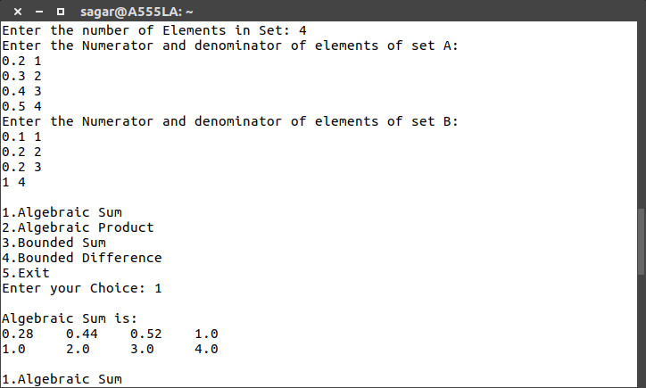

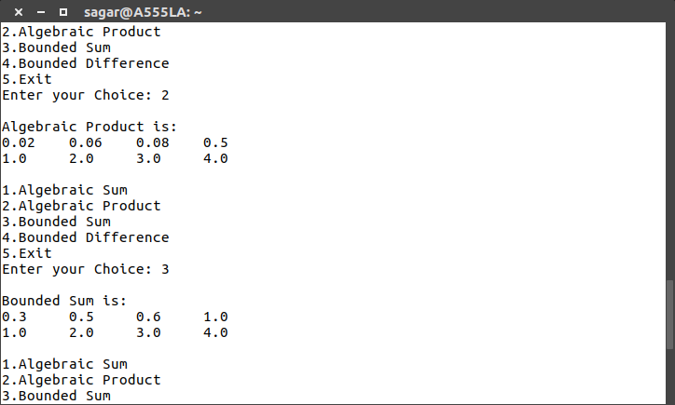

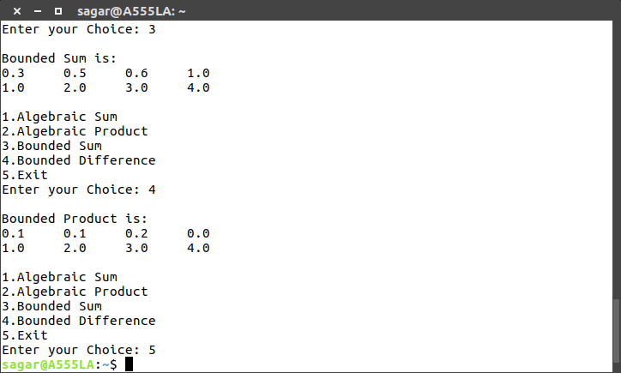

**Conclusion:** Thus, operation like algebraic sum, algebraic product, bounded sum and bounded difference has been successfully performed and implemented.