VU1F14150__

Experiment No-5

**Aim:**To implement any Supervised learning Algorithm.

**Theory:**

**Supervised learning:**

The learning here is performed with the help of a teacher. Let us take the example of the learning process of a small child. The child doesn't know how to read write. He/she is being taught by the parents at home and by the teacher in school. The children are trained and molded to recognize the alphabets, numerals, etc.Their each and every action is supervised by a teacher. Actually, a child works on the basis of the output thathe/She has to produce. All these real-time events involve supervised learning methodology. Similarly, in ANNs following the supervised learning, each input vector requires a cordinator vector, which represents

the desired output. The input vector along with the target vector is called training informed precisely about what should be emitted as output.

**Perceptron learning Rule:**

In machine learning, the perceptron is an algorithm for supervised learning of binary classifiers (functions that can decide whether an input, represented by a vector of numbers, belongs to some specific class or not).It is a type of linear classifier, i.e. a classification algorithm that makes its predictions based on a linear predictor function combining a set of weights with the feature vector. The algorithm allows for online learning, in that it processes elements in the training set one at a time.

In the modern sense, the perceptron is an algorithm for learning a binary classifier: a function that maps its input x(a real-valued vector) to an output value f ( x )(a single binary value):

f ( x ) =1 ; if W.X +b > 0

f ( x ) =0 ;Otherwise

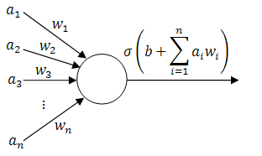

The value of f ( x ) (0 or 1) is used to classify *x* as either a positive or a negative instance, in the case of a binary classification problem. If b is negative, then the weighted combination of inputs must produce a positive value greater than | b | in order to push the classifier neuron over the 0 threshold. Spatially, the bias alters the position (though not the orientation) of the decision boundary. The perceptron learning algorithm does not terminate if the learning set is not linearly separable.

**Program:**

import java.util.*;  
class percept{  
 static void prnt(float A[]){  
 System.out.print("[");  
 for(int i=0;i<A.length;i++){  
 System.out.format("%.1f ",A[i]);  
 }  
 System.out.println("]\n");  
 }  
  
 static float net(float A[][],float wt[],int m){  
 float sum = 0;  
 for(int i=0;i<wt.length;i++){  
 sum = sum+A[m][i]*wt[i];  
 }  
 return sum;  
 }  
 public static void main(String [] args){  
 Scanner k = new Scanner(System.in);  
 System.out.println("Enter no. of weights: ");  
 int n = k.nextInt();  
 System.out.println("Enter no. of Training step: ");  
 int m = k.nextInt();  
 float wts[] = new float[n];  
 float d[] = new float[m];  
 float tset [][] = new float [m][n];  
 System.out.println("Enter weight Matrix: ("+n+"Elements)");  
 for(int i =0;i<n;i++){  
 wts[i] = k.nextFloat();  
 }  
 System.out.println("Enter Training Set: ");  
 for(int i =0;i<m;i++){  
 System.out.println("Enter Training Set "+(i+1)+"("+n+"elements)");  
 for(int j =0; j<n;j++){  
 System.out.println("Enter Element"+(j+1)+":");  
 tset[i][j] = k.nextFloat();  
 }  
 }  
 System.out.println("Enter Target output:");  
 for(int i =0;i<m;i++){  
 d[i] = k.nextFloat();  
 }  
 System.out.println("\nWeigth Array:\nW1");  
 prnt(wts);  
 for(int i =0;i<m;i++){  
  
 System.out.println("Tranning Set:\nX"+(i+1));  
 prnt(tset[i]);  
 }  
 System.out.println("\ntarget Array:");  
 prnt(d);  
 System.out.println("\nEnter value of alpha:");  
 float alpha = k.nextFloat();  
int t =0;  
 while(m-- >0)  
 float o = net(tset,wts,t);  
 if(o>=0){  
 for(int i =0;i<n;i++){  
 wts[i]= wts[i]+alpha*(d[t]-1)*tset[t][i];  
 }  
 System.out.print("W"+(t+2));  
 prnt(wts);  
 }  
 else{  
 for(int i =0;i<n;i++){  
 wts[i]= wts[i]+alpha*(d[t]+1)*tset[t][i];   
 }  
 System.out.print("W"+(t+2));  
 prnt(wts);  
 }  
 t++;

}

}

}

**Output:**

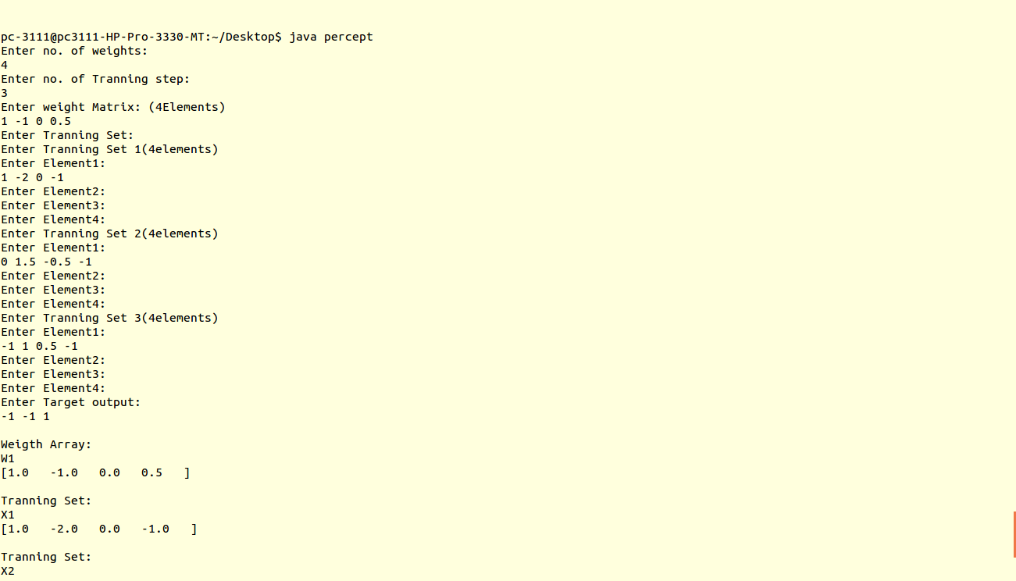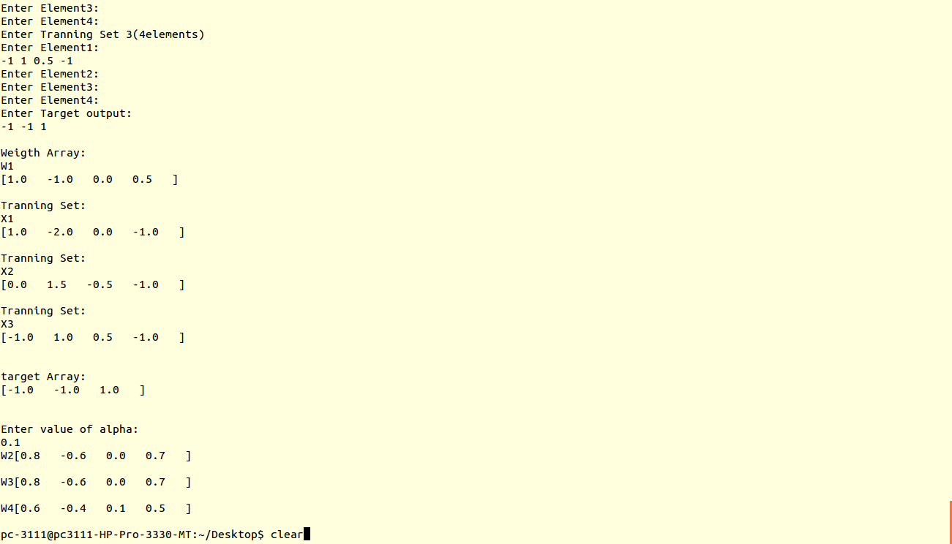

**Conclusion:**Thus,Supervised learning Algorithm using Perceptron model has been Successfully implemented.