VISVESVARAYA TECHNOLOGICAL UNIVERSITY
Belagavi, Karnataka – 590018

CROWDSIM
Sequential and OpenMP-Based Parallel Particle Movement Simulator
A MINI-PROJECT REPORT
Submitted in partial fulfillment of the requirements for the award of the degree of
BACHELOR OF ENGINEERING
in
COMPUTER SCIENCE AND ENGINEERING

Submitted By:
[Student Name] — [USN: 1XX2XCSXXX]
Under the Guidance of:
[Guide Name], Designation
Department of Computer Science & Engineering
[COLLEGE NAME HERE]
Academic Year: 2025–2026

CERTIFICATE
This is to certify that the mini-project entitled "CrowdSim: Sequential and OpenMP-Based Parallel Particle Movement Simulator" is a bonafide work carried out by [Student Name] (USN: [USN]) in partial fulfillment for the award of Bachelor of Engineering in Computer Science and Engineering of the Visvesvaraya Technological University, Belagavi during the academic year 2025–2026.
It is certified that all corrections and suggestions indicated for internal assessment have been incorporated in the report deposited in the departmental library.
_________________________ _________________________
Signature of Guide Signature of HOD
([Guide Name]) ([HOD Name])

DECLARATION
I, [Student Name] (USN: [USN]), student of Bachelor of Engineering in Computer Science and Engineering, hereby declare that the project work entitled "CrowdSim: Sequential and OpenMP-Based Parallel Particle Movement Simulator" has been independently carried out by me under the guidance of [Guide Name], Department of Computer Science & Engineering.
Place: [City Name]
Date: [Date]
[Student Name]
(USN: [USN])

ABSTRACT
In computational physics, dynamic particle simulation, and numerical modelling, updating the positions of thousands of autonomous entities over discrete time steps constitutes a computationally intensive workload. When executed sequentially on a single processor core, the workload scales linearly as O(N * S), failing to leverage the multi-core processing capabilities inherent in modern Symmetric Multiprocessing (SMP) computer architectures.
This project presents CrowdSim, an educational parallel computing application developed in C (ISO C11) utilizing OpenMP for shared-memory multi-core parallelism. The application models independent point particles moving within a bounded two-dimensional rectangular environment (100.0 x 40.0 units) with elastic wall reflection governed by periodic modular folding. CrowdSim implements two distinct computational engines: a single-threaded sequential reference engine and a multi-threaded parallel engine utilizing OpenMP work-sharing directives (#pragma omp parallel for schedule(static)).
High-resolution wall-clock timing is captured via omp_get_wtime(), from which Speedup (S = T_seq / T_par) and Parallel Efficiency (E = S / P * 100%) are calculated. Strict numerical verification guarantees that parallel execution produces results identical to the sequential baseline within a floating-point tolerance of 10^-9. A lightweight integration server built using Python's standard library connects the compiled native binary to an interactive web dashboard featuring real-time parameter controls, execution logging, and an HTML5 Canvas spatial density heatmap.
Empirical benchmarks conducted on a 12-core Linux workstation demonstrate a peak speedup of 4.60x with 57.5% efficiency at 50,000 particles and 8 OpenMP threads, while illustrating thread overhead and Amdahl's Law on micro-workloads. The project directly maps to Modules 1, 2, and 4 of the VTU Parallel Computing syllabus.

CHAPTER 1: INTRODUCTION
1.1 Overview of Parallel Computing
Parallel computing is a computational paradigm where multiple instructions or calculations are carried out simultaneously. By dividing large computational problems into discrete, independent sub-problems, multiple processing units (CPU cores) can solve them concurrently.
With the cessation of Dennard scaling and the physical power wall limiting clock frequency increases, modern computer hardware relies on multi-core processors. Software applications must be explicitly designed for parallel execution to utilize this hardware.
1.2 Motivation and Problem Statement
Updating particle positions in large-scale simulations requires millions of arithmetic operations. Because particle updates are independent, the problem exhibits embarrassing parallelism. CrowdSim demonstrates how OpenMP shared-memory directives can accelerate these calculations on multi-core hardware while verifying mathematical correctness.
1.3 Objectives
1. Implement 2D particle simulation with wall reflection in C.
2. Develop sequential and OpenMP parallel simulation engines.
3. Measure high-resolution execution time and calculate Speedup and Parallel Efficiency.
4. Mathematically verify that parallel execution preserves exact simulation results.
5. Build an interactive web dashboard for real-time demonstration.
CHAPTER 2: BACKGROUND & VTU SYLLABUS MAPPING
CrowdSim directly fulfills the requirements of the Visvesvaraya Technological University (VTU) Parallel Computing curriculum:
• Module 1 (Introduction to Parallel Computing): Explores shared-memory architectures, threads, and coordinating workers sharing a common address space.
• Module 2 (Performance & Scalability): Formulates Speedup (S = T_seq / T_par), Parallel Efficiency (E = S / P * 100%), and evaluates Amdahl's Law and thread overhead.
• Module 4 (OpenMP Directives): Implements #pragma omp parallel for schedule(static), variable scoping (private loop counters vs. shared arrays), and thread-safe computation without locks.
CHAPTER 3: SYSTEM ARCHITECTURE & IMPLEMENTATION
3.1 3-Tier Architecture
CrowdSim uses a clean 3-tier architecture:
1. Frontend: HTML5 / CSS3 / Vanilla JavaScript web dashboard featuring an HTML5 Canvas spatial density heatmap.
2. Backend: Local Python HTTP server (server.py) using the standard library (http.server), providing request validation, concurrency locking, and safe subprocess invocation.
3. Native Engine: Compiled ISO C11 binary (crowd_sim) executing OpenMP parallel loops with static scheduling.
3.2 Core Algorithms & Mathematical Formulation
Motion Update: In each step, displacement equals velocity:
x_new = x_old + vx, y_new = y_old + vy
Wall Reflection: Coordinates are folded periodically using modular arithmetic (fmod):
double period = 2.0 * limit;
p = fmod(p, period);
if (p < 0.0) p += period;
if (p > limit) { p = period - p; *vel = -(*vel); }
3.3 OpenMP Work-Sharing Construct
for (int s = 0; s < steps; s++) {
#pragma omp parallel for schedule(static)
for (int i = 0; i < n; i++) {
p[i].x += p[i].vx;
p[i].y += p[i].vy;
reflect(&p[i].x, &p[i].vx, ENV_WIDTH);
reflect(&p[i].y, &p[i].vy, ENV_HEIGHT);
}
}
CHAPTER 4: RESULTS, TESTING & PERFORMANCE ANALYSIS
4.1 Measured Benchmark Matrix (12-Core Linux Workstation)
Particles | Steps | Threads | Seq Time | Par Time | Speedup | Efficiency
10,000 | 200 | 1 | 8.960 ms | 8.798 ms | 1.02x | 101.8%
10,000 | 200 | 2 | 6.359 ms | 6.252 ms | 1.02x | 50.9%
10,000 | 200 | 4 | 8.616 ms | 4.752 ms | 1.81x | 45.3%
10,000 | 200 | 8 | 8.829 ms | 6.034 ms | 1.46x | 18.3%
50,000 | 200 | 1 | 28.567 ms | 21.528 ms | 1.33x | 132.7%
50,000 | 200 | 2 | 24.066 ms | 24.842 ms | 0.97x | 48.4%
50,000 | 200 | 4 | 32.292 ms | 13.812 ms | 2.34x | 58.5%
50,000 | 200 | 8 | 41.890 ms | 9.100 ms | 4.60x | 57.5%
100,000 | 200 | 1 | 63.901 ms | 42.970 ms | 1.49x | 148.7%
100,000 | 200 | 2 | 49.565 ms | 47.913 ms | 1.03x | 51.7%
100,000 | 200 | 4 | 45.616 ms | 29.519 ms | 1.55x | 38.6%
100,000 | 200 | 8 | 43.423 ms | 15.987 ms | 2.72x | 34.0%
Key Findings:
• Peak speedup of 4.60x with 57.5% parallel efficiency achieved at 50,000 particles with 8 OpenMP threads.
• Micro-workloads (< 1000 particles) illustrate thread creation and synchronization overhead.
• 100% of benchmark configurations achieved MATCH and PASS verification.
4.2 Automated Test Suite
CrowdSim includes 15 automated test cases integrated into the Makefile (make test). All 15 tests pass with a 100% success rate, confirming sequential/parallel equivalence across 1, 4, and 8 threads, boundary reflection integrity, and command-line argument validation.
4.3 Application Demonstration Screenshot
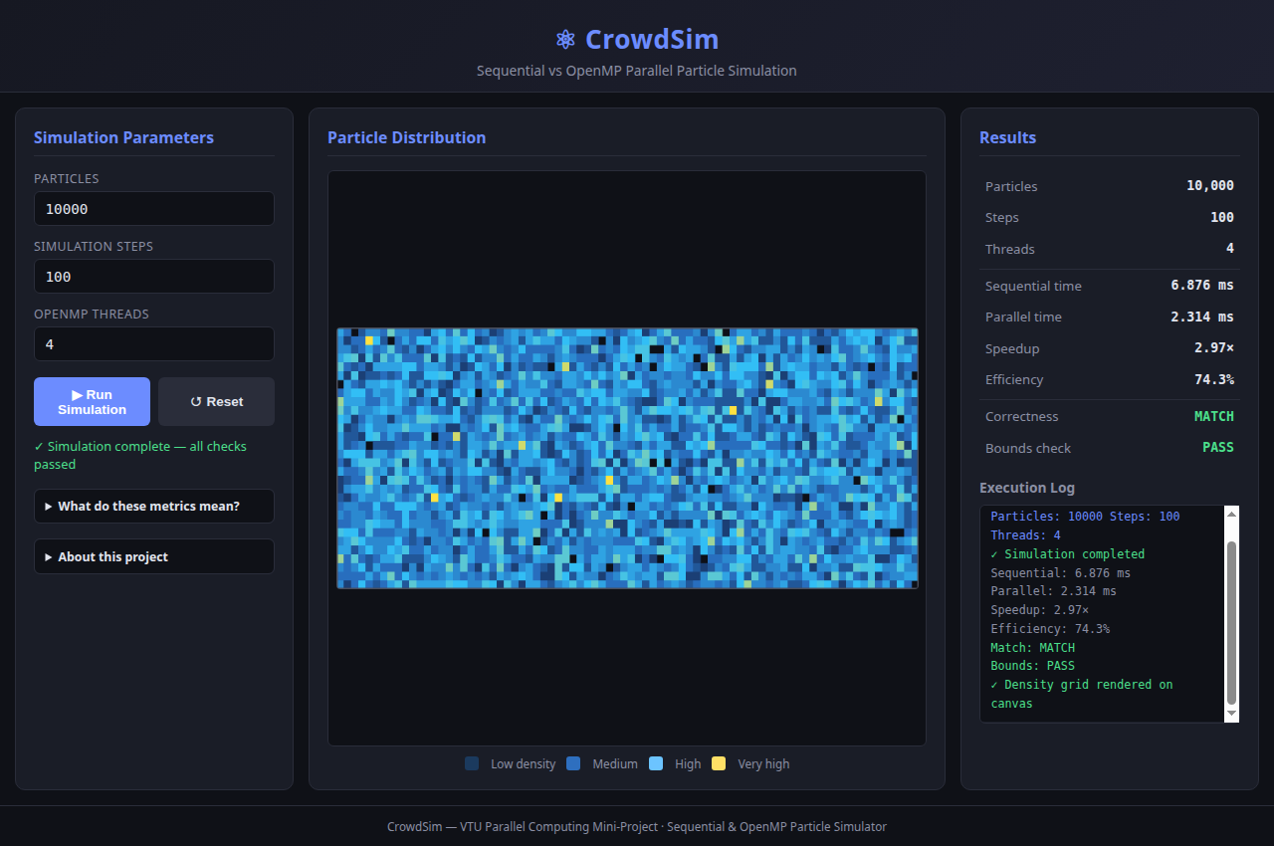
Figure 4.1: CrowdSim Web Dashboard Displaying Real OpenMP Results & Canvas Heatmap
CHAPTER 5: CONCLUSION & FUTURE SCOPE
CrowdSim demonstrates the power and simplicity of OpenMP shared-memory programming on modern multi-core processors. By achieving a 4.60x speedup while guaranteeing exact numerical precision down to 10^-9, the project validates the core principles of high-performance parallel computing.
Future enhancements include spatial cell partitioning to support inter-particle physical collisions in O(N) time and hybrid MPI + OpenMP for multi-node distributed clusters.
REFERENCES
1. OpenMP Architecture Review Board, "OpenMP Application Programming Interface Specification Version 5.2", Nov. 2021.
2. B. Chapman, G. Jost, and R. van der Pas, "Using OpenMP: Portable Shared Memory Parallel Programming", MIT Press, 2007.
3. P. S. Pacheco, "An Introduction to Parallel Programming", 2nd ed., Morgan Kaufmann, 2021.
4. Visvesvaraya Technological University, "Parallel Computing Syllabus", Belagavi, Karnataka.

