🎉 Welcome to the Session on MCP Server + Agent Mode in VS Code / GitHub Copilot 🎉

✅ Session Purpose:
- Explore the power of MCP Server and Agent Mode in Visual Studio Code (VS Code) / GitHub Copilot
- Learn how AI-powered tools boost development productivity, code quality, and collaboration
✅ Key Takeaways:
- Understand the role of MCP Server in managing intelligent coding assistance
- See how Agent Mode enhances developer workflows
- Watch practical demos of real-world use cases
- Get best practices for seamless integration
- Participate in an interactive Q&A to clarify your questions

🌟 Presented by Practitioners in AI-Driven Software Development Solutions:

- Rishikesh Kumar – Lead Software Engineer
- Pawan Mishra - Lead Software Engineer.

- Let’s begin this exciting journey toward smarter and faster development! 🚀

🚀 GitHub Copilot Agent Mode + MCP — Hands-On Workshop Guide
This guide helps you build a Task Tracker App (Spring Boot + React + MongoDB) and connect it with GitHub MCP + Mongo MCP servers using Copilot Agent Mode.
You’ll scaffold code, test APIs, run MCP servers, and automate workflows 🚦.

📑 Table of Contents
- ✅ Prerequisites & Environment Checklist
- ⚙️ Installations (Node, Java, Gradle, VS Code, Mongo) — Commands + Comments
- 📂 Create & Clone Workshop Repository
- 🤖 Enable GitHub Copilot Agent Mode in VS Code
- 🔧 MCP Setup — GitHub MCP & Mongo MCP Servers
- 💬 Practice MCP Prompts (GitHub & Mongo)
- 🔗 Combined Agent Workflow — End-to-End Automation
- 🛠️ Part A — Scaffold Spring Boot Backend (with Copilot Agent)
- 🎨 Part B — Scaffold React Frontend (with Copilot Agent)
- 🔎 Test Backend APIs (curl / Postman)

1️⃣ Prerequisites & Environment Checklist
👉 Make sure you have the following before the session:
- 🐙 GitHub account + Personal Access Token (repo scope)
- 💻 VS Code (latest) installed
- 🟢 Node.js v20+
- ☕ Java 17+ (JDK)
- 📦 Gradle (or Gradle wrapper)
- 🍃 MongoDB (local install)
- 🔧 Git
- Postman
- ✨ GitHub Copilot

2️⃣ Installations — Commands + Comments
Step | Installation | Commands / Actions | 💡 Comments
2.1 | Node.js (v20+) | node -v  npm -v | Required for React & MCP CLI tools
2.2 | Java 17+ | java -version javac -version | Needed for Spring Boot
2.3 | Gradle | Gradle | Installation | Use wrapper for consistency
2.4 | Git | Git - Downloads | Needed for repo cloning
2.5 | MongoDB | macOS: brew install mongodb-community@6.0 Cloud: MongoDB Atlas | Local is faster for workshops
2.6 | VS Code + Copilot | Install from Extensions marketplace | Ensure GitHub Copilot is active

3️⃣Create & Clone Workshop Repo
- Login to your Github account and create a repository with name “copilot-mcp-workshop”
- git clone https://github.com/<username>/copilot-mcp-workshop.git
- cd copilot-mcp-workshop
- Open the project in Visual Studio code

4️⃣ Enable Copilot Agent Mode in VS Code
  - Open VS Code
  - Go to Extensions → GitHub Copilot -> Install plugin -> Restart it
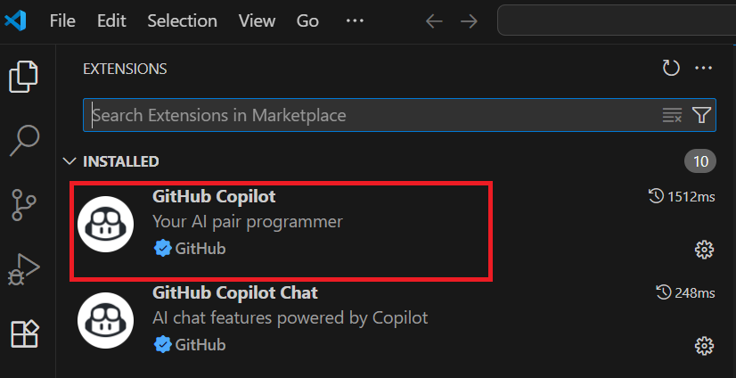

  - Sign in Github :

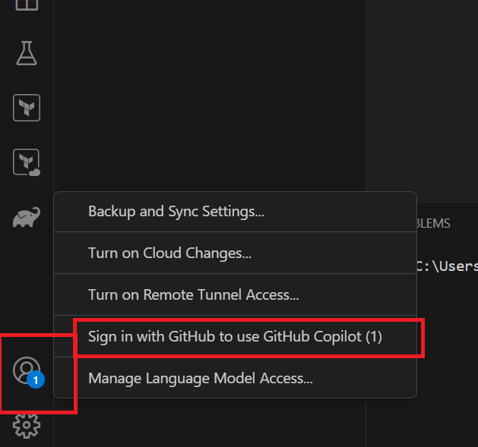

  - Login to GitHub using the email id
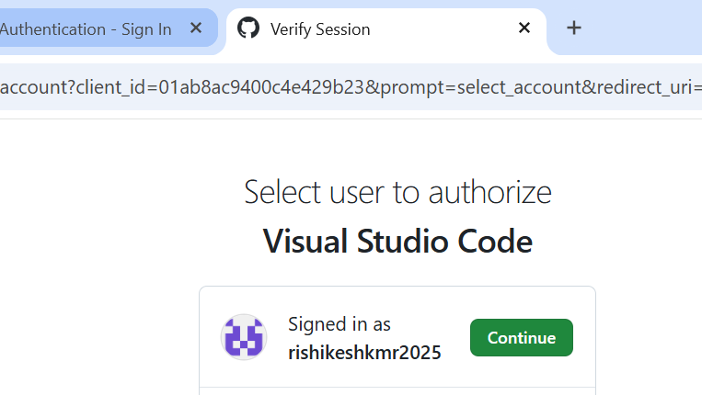
  - Authorize VS Code
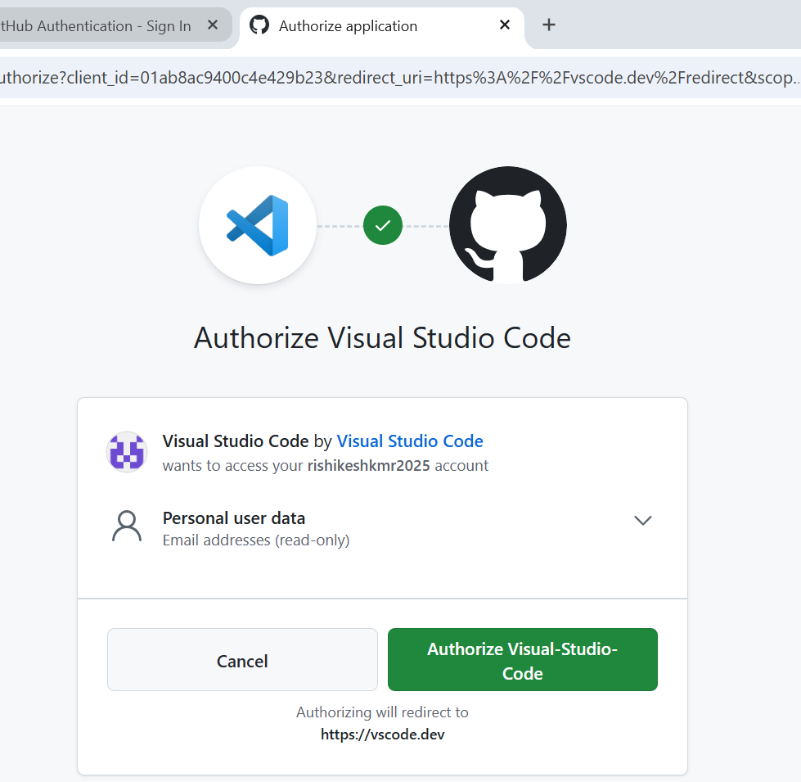
  - Click on Github icon(bottom right) to open the Github Copilot window:
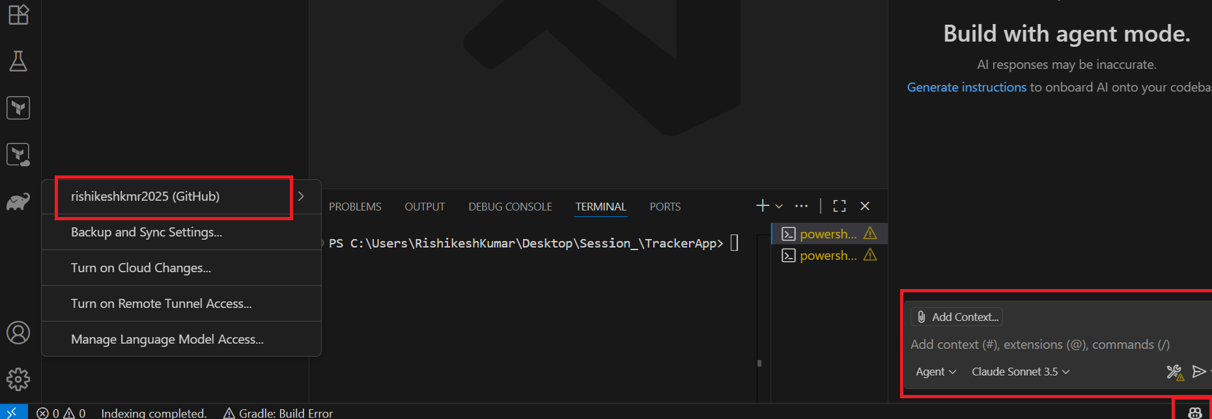

5️⃣MCP Setup
MCP is an open protocol that standardizes how applications provide context to large language models (LLMs).
- MCP Host: The AI application that coordinates and manages one or multiple MCP clients. MCP Host example - Visual Studio Code
- MCP Client: A component that maintains a connection to an MCP server and obtains context from an MCP server for the MCP host to use.
  - The Visual Studio Code runtime instantiates an MCP client object(based on configuration in mcp.json) that maintains the connection with mcp server
- MCP Server: A program that provides context to MCP clients. Can be Remote or Local. MCP servers are programs that expose specific capabilities to AI applications through standardized protocol interfaces.

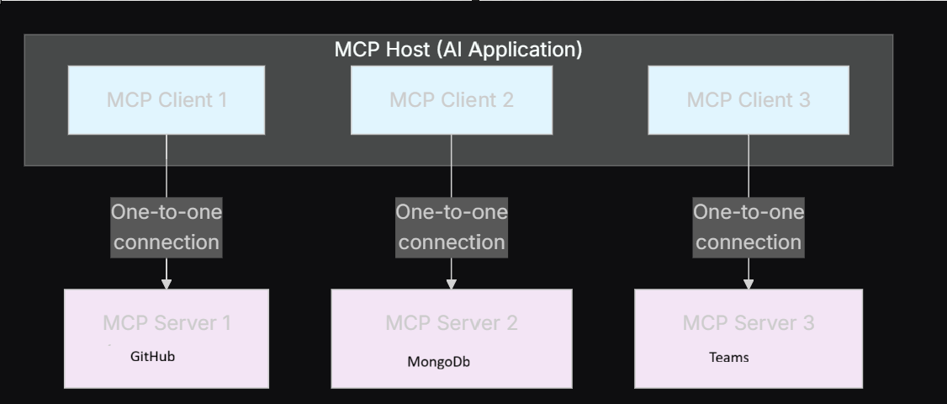

Configuring MCP server for Github(Remote MCP server)
Steps to Configure Remote GitHub MCP Server in VS Code
  - Open Visual Studio Code.
  - Run the Command Palette:
  - Press Ctrl+Shift+P (Windows/Linux) or Cmd+Shift+P (Mac).
  - Add the MCP Server:
  - Type mcp: add server and select it.
  - Choose the option HTTP (HTTP or Server-Sent Events).
  - For the Server URL, enter:
text
https://api.githubcopilot.com/mcp/
  - For Server ID, press Enter to accept the default or set a custom ID.
  - Choose where to save the configuration:
    - Select Workspace Settings to save in .vscode/mcp.json specific to the project.
    - Or select User Settings to save globally in your user mcp.json.
  - Authorize with GitHub OAuth:
  - A popup will appear to authorize the MCP server with OAuth.
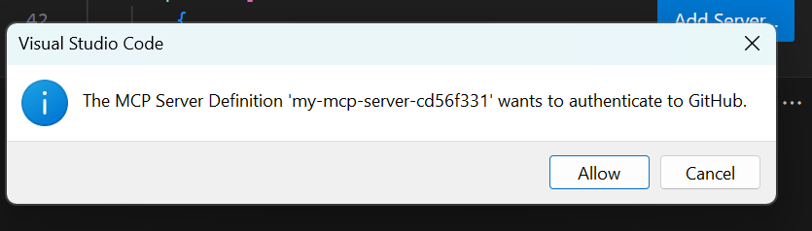
  - Click Allow and sign in with your GitHub account.
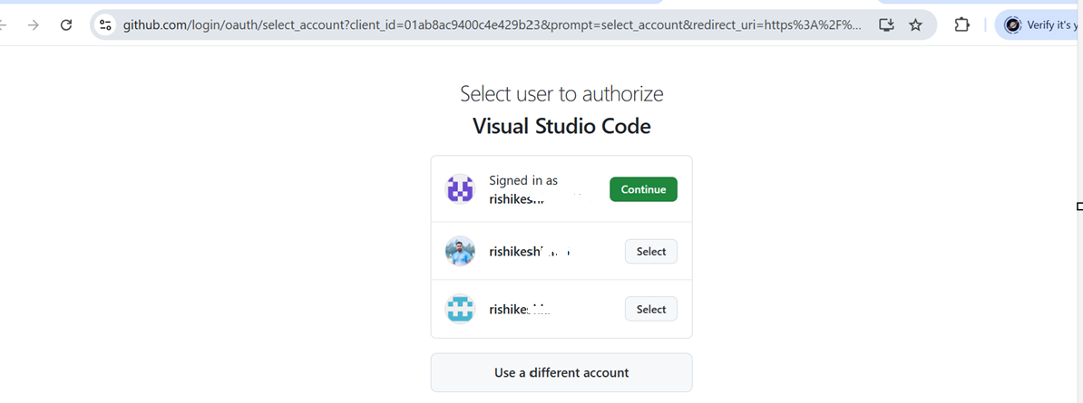

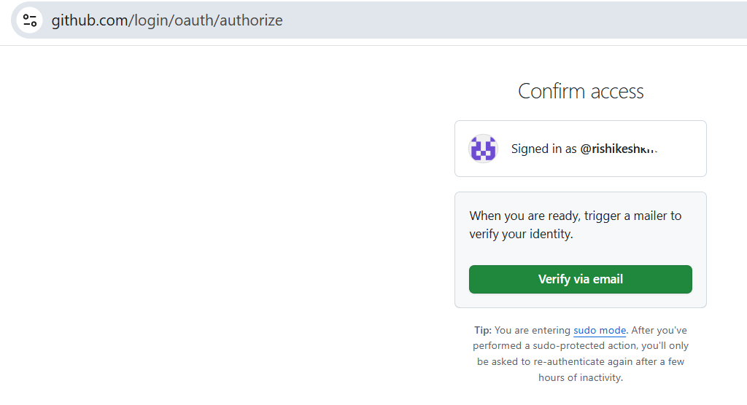
  - Use the MCP server via GitHub Copilot Agent:
  - Open the Copilot chat window.
In agent mode, the remote MCP server(icon) will enable GitHub-related tools and commands (like listing issues, PRs, creating comments).
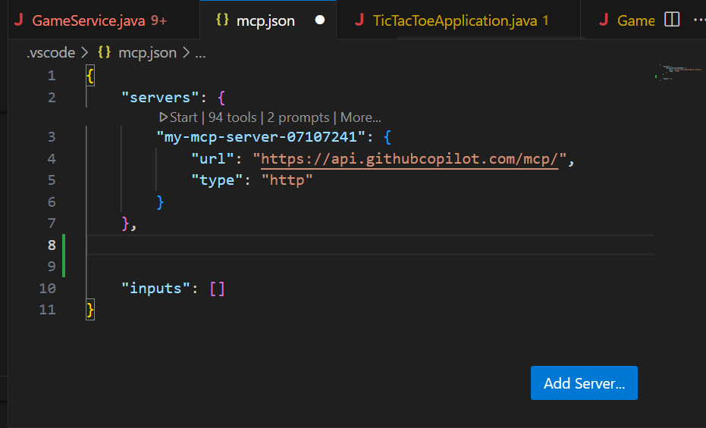
5.15 Add mongo db mcp server(Local)

Complete mcp.json in repo root:
{
"servers": {
"github-mcp": {
"type": "http",
"url": "https://api.githubcopilot.com/mcp/"
},
"MongoDB": {
"command": "npx",
"args": [
"-y",
"mongodb-mcp-server",
"--connectionString",
"mongodb://localhost:27017/myDatabase"
]
}
}
}
Explanation:

npx → runs the mongodb-mcp-server package
-y → auto-confirms prompts (skip interactive “yes/no”)
mongodb-mcp-server → the MCP server package from npm
--connectionString ... → passes the MongoDB connection details

6️⃣ MCP Practice Prompts
- GitHub MCP:
- "Create a new branch called feature-mcp-test in the repository myusername/myrepo."
- "List all pull requests in the repository myusername/myrepo."
- "Show the last five commits for myusername/myrepo."

- Mongo MCP:
  - Insert task:
[Action: Mongo MCP] Insert a document into 'tasks' collection with {title, description, dueDate, status}.
  - Find tasks:
[Action: Mongo MCP] Query tasks where dueDate = "YYYY-MM-DD".

7️⃣ Combined Workflow [For practice]
- Ask Copilot Agent:
- Query MongoDB (via Mongo MCP) for overdue tasks in 'taskdb.tasks'.
- For each overdue task, create a GitHub issue in "USERNAME/REPO-NAME"
- with title "Overdue Task: {title}" and body containing description + dueDate.
- Return a summary mapping taskId → GitHub issue URL.

8️⃣Part A — Backend (Spring Boot)
Goal
Build a Spring Boot app with MongoDB persistence and REST APIs:
- POST /api/tasks
- GET /api/tasks
- GET /api/tasks/{id}
- PUT /api/tasks/{id}
- DELETE /api/tasks/{id}
Copilot Prompt 🧑‍💻
Paste this into Copilot Agent:

I want to create a Spring Boot (Gradle) project named "task-tracker-backend"
using Java 21 and Spring Boot 3.x with Spring Web + Spring Data MongoDB.
Generate build.gradle, Task.java, TaskRepository.java, TaskController.java,
application.properties, and Application.java.
➡️ Copilot generates model, repository, controller, and config.

9️⃣ Part B — Frontend (React) [Optional]
cd frontend
npx create-react-app task-tracker-frontend
cd task-tracker-frontend
npm start
Copilot Prompt 🧑‍🎨
Create a React frontend for Task Tracker backend (http://localhost:8080).
It should list tasks, add/edit/delete tasks, and use axios/fetch.
Return App.js, TasksList.js, TaskForm.js.

🔗 10) Testing Backend APIs (curl)
# Create task
curl -X POST http://localhost:8080/tasks \
-H "Content-Type: application/json" \
-d '{"title":"Demo task","description":"Do workshop demo","dueDate":"2025-09-05","status":"OPEN"}'

# List tasks
curl http://localhost:8080/tasks

💡 Outcome: You now have a full-stack Task Tracker App + MCP-integrated automation where Copilot bridges Mongo and GitHub 🚀.

Appendix:
modelcontextprotocol/servers: Model Context Protocol Servers
MongoDB MCP Server : The Secret to Seamless MongoDB Integration !
You will never forget MCP after this

