**Chatbot For HR Department**

|  |  |  |
| --- | --- | --- |
| Ajaykumar Kushwaha  *IT Department*  *Atharva College of Engineering*  *(Mumbai University)*  *Mumbai, India*  *ajaykushwaha1215@gmai.com* | Rishikesh Nanaware  *IT Department*  *Atharva College of Engineering*  *(Mumbai University)*  *Mumbai, India*  [*rishikeshnanaware@gmail.com*](mailto:rishikeshnanaware@gmail.com) | Damini Pandare  *IT Department*  *Atharva College of Engineering*  *(Mumbai University)*  *Mumbai, India*  *Daminipandare98@gmail.com* |

***Abstract --*Chatbots are programs that mimic human conversation using Artificial Intelligence (AI). It is designed to be the ultimate virtual assistant. This chatbot can be used by HR department to find out answers for their queries in an interactive fashion. It is challenging task for HR people to find accurate data in huge databases regarding their queries. It is also tedious task to get for suggestions for their problems. To simplify these, problems, we have designed a Chatbot for HR department, which will be able to answer FAQs related to HR department. In, this paper we have proposed a chatbot which can give response in different patterns like tables, graphs, etc. It can understand the meaning of different queries searching for same response and gives response according to that.**

***Keywords – Chatbot, AIML, LSA, HR department***

**INTRODUCTION**

* 1. **NEED**

Today’s world is running very fast, so HRs don’t have much time to look personally into the database to find answers to their queries. They need some fast approach to do their work. There is a need for an assistant who can work faster. So, it is better if they have a virtual computer-based assistant which can answer fast to their queries. A simple virtual assistant is a Chatbot. In the past few years, Chatbots have been very popular because of their fast and accurate response capability and less need for any physical resources as they are not paid. Using Chatbot will reduce and make faster the work of HR people effectively increasing the productivity of them.

* 1. **PROBLEM STATEMENT**

HR department is not able to get quick response to most of their queries, related to their employees. Due to which the productivity and efficiency of the company is affected. There is a need of user-friendly virtual assistant that can make the HRs job easier.

* 1. **AIMS AND OBJECTIVES**
* **AIM**:

The Chatbot for HR department aims to provide efficient and accurate answers for queries asked by HRs from the database using Artificial Intelligence Markup Language (AIML) and Latent Semantic Analysis (LSA).

* **Objective:**

To give virtual assistance to HRs so their work could be simplified and productivity could be increased.

* 1. **APPLICATION AND SCOPE**
* **APPLICATION:**

A HR can ask queries related to employee details and Chatbot will give response to those queries.

* **SCOPE:**

This system answers to queries of HR people using AIML and LSA. Chatbot gives responses in different forms like texts, tables, graphs, etc. If chatbot doesn’t find a proper answer to the user’s query it gives suggestions.

**Literature Review:**

1. **Chatbot for University Related FAQs[1]**

Chatbots are programs that mimic human conversation using Artificial Intelligence (AI). Chatbot serves as a virtual assistant to users, it reduces human work required to answer frequently asked questions, as chatbots can be trained to answer FAQs. Chatbots are being very popular these days in business groups. Chatbots are being used for e-commerce, health-related, tourism-related, hotels, payment websites, and applications. This paper proposed a chatbot that is designed for students who have queries at the university. Chatbot uses AIML (Artificial Intelligence Markup Language) and LSA (Latent Semantic Analysis) technologies. Template-based queries such as welcome greetings will be responded using AIML, as AIML stores responses to these queries and other questions will be answered anytime using LSA.

User discussion starts with welcome greetings and general questions. When a user submits a query it is tested whether it has response stored in AIML format.

User post the query on chatbot

The user’s query is matched with the predefined format stored in the AIML file by the developer.

Pattern matching is performed between the user entered query and knowledge (pattern).

If the pattern is matched then stored string is given as response, otherwise, it is handled by LSA.

User can post their query on chatbot and response is generated based on pattern matching techniques presented in this paper[1].

1. **Automated Thai-FAQ Chatbot using RNN-LSTM[2]**

Users interact with businesses using emails and live chatbots. Though emails look formal in business environment users prefer to use chatbots as they are easy to use. Business needs to keep admins who can reply to customers' queries. This is a time-consuming process as admins need to type responses to each query manually and the customer has to wait for the response. Also, this is costly as admins need to be paid by businesses. Hence chatbots seem very efficient replacement to emails and gives interactive user experience. In this paper proposed chatbot uses Recurrent Neural Network (RNN) in the form of Long Short-Term Memory (LSTM) for text classification. The proposed chatbot automatically responds to customers to Frequently Asked Questions (FAQs). The experimental results have shown that chatbot could recognize 86.36% of the questions and answer with 93.2% accuracy.

Preparing data

Developers have used 2,636 pairs of questions and answers. These are then manually classified into 80 classes according to the number of FAQ types and numbered them.

Classification Model

NLP module. In these words are mapped to vectors of real numbers that learn representation for predefined To categorise questions classification model in neural network takes an input from pre-processing. It includes three layers. Embedding layer is the first layer int the fixed sized vocabulary from a corpus of text. Second layer is the long short-term memory (LSTM) layer. It is a particular kind of recurrent neural network (RNN). It is capable of learning sequential data such as text and video. With the help of LSTM RNN can remember inputs for a long period. Third layer is the Dense layer (Output layer) with softmax activation function is used in various multiclass classification methods. The softmax activation function in the output layer represents a categorical distribution over class labels and obtaining the probabilities of each input belonging to a label. Because of softmax activation function is used at the output layer, we have to encode the label of questions to one-hot format for the learning process of the model[2].

1. **A Pilot Study Integrating an AI-driven Chatbot in an Introductory Programming Course[3]**

In this research, the developer team developed an Intelligent chatbot interface for a computer programming course. The chatbot initially has a very limited dataset. It will be advanced by user interaction with the chatbot. This chatbot is capable of evolving with the needs of the student. This paper has discussed how the chatbot has developed and integrated into the course, how the dataset was developed, the usage during the pilot and future scope for the chatbot, like improving the user interface, improving error rate, etc. This paper has also detailed about mechanism to handle issues like false-positive responses.

The database for chatbot was populated with MATLAB functions. 21 unique users interacted with chatbot out of which six users interacted with the chatbot for more than one session and others interacted only once.

**PROPOSED MODEL**

In this paper, we have proposed a chatbot who will help the HR department to find answers to their queries by just typing in the chat window. Our system uses technologies Artificial Intelligence Markup Language(AIML) and Latent Semantic Analysis(LSA). The workflow of the proposed system is shown in Figure 1. Workflow of Chatbot for HR department.

First, the bot-user has to enter a query in the chatbox. After that AIML developed chatbot will match the pattern and will give a proper response. If the response is to be fetched from the database, it will be handled by LSA. LSA will catch query and try to identify the correct requirements of the user and after that, it will fetch results from the database using python. Once chatbot got the response for the user entered query it will show it as a response in the chatbox.

Section 1) Template based responses:

Template based queries like greetings would be handled by Artificial Intelligence Markup Language (AIML). AIML will match the user entered query with the pattern defined in the AIML files and if pattern matches it will give the stored response.

For example,

**Human: Hello**

**Bot: Hi**

Section 2) General queries:

General queries cannot be handled by only AIML, it needs the help of Latent Semantic Analysis (LSA), as we cannot store every pattern user can enter. So we generalize some part of query and other part will be handled by LSA.

For example,

**Human: Give me salary of Prakash Parmar**

**Bot: 65000 Rs.**

It can be seen that to get salary of employee different user can type various queries. So we store pattern for **Give** and **salary** by using LSA which will give same result for all salary requests.

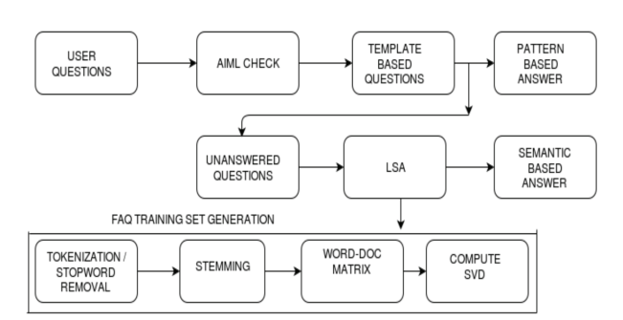

Figure 1. Workflow of Chatbot for HR department

**RESULTS**

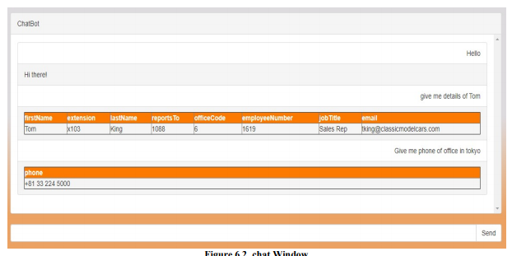

Figure 2 Chat Window

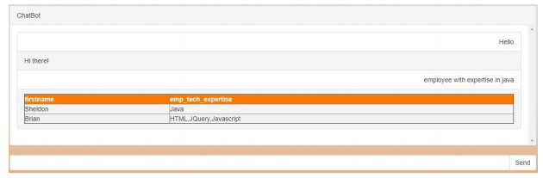

Figure 3 Employee Expertise

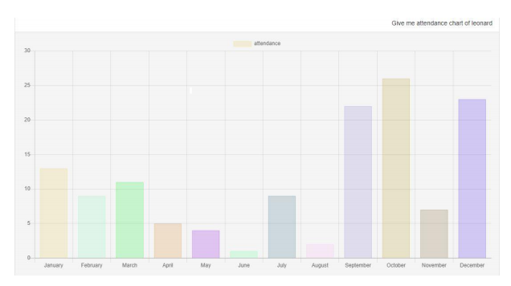

Figure 4 Attendance Chart

**CONCLUSION**

This project will definitely simplify the work of HR department by finding accurate answers to their questions. Chatbot developed will be continuously developing and learning from the data which is new to the system.

**REFERENCES**

1] “Chatbot for University Related FAQs”, Bhavika R. Ranoliya ,NidhiRaghuwanshi and Sanjay Singh, International Conference on Advances In Computing Communications and Informatics 2017

2] “Automated Thai-FAQ Chatbot using RNN-LSTM”, PanitanMuangkammuen, NarongIntiruk ,Kanda RunapongsaSaikaew , 22 nd International Computer Science and Engineering Conference 2018

3] “Intelligent Chatting Service Using AIML”,Saqib G, Faizan , Ghatte N , IEEE International Conference on Current Trends toward ConvergingTechnologies, 2018

4] "An Efficient Search for Context-Based Chatbots", Ayah Atiyah, Shaidah Jusoh, Sufyan Almajali, Computer Science and Information Technology (CSIT) 2018 8th International Conference on, pp

5] "Implementation of Chatbot for ITSM Application Using IBM Watson", Neha Atul Godse, Shaunak Deodhar, Shubhangi Raut, Pranjali Jagdale, Computing Communication Control and Automation (ICCUBEA) 2018 Fourth International Conference on, pp.

6] "AI Based Student Bot for Academic Information System using Machine Learning", Vijayakumar R, Bhuvaneshwari B, Adith S, Deepika M, International Journal of Scientific Research in Computer Science, Engineering and Information Technology, 2019.

7] “An e-business chatbot using AIML and LSA”, N T Thomas

Amrita Vishwa Vidyapeetham University, 2016 International Conference on Advances in Computing, Communications and Informatics (ICACCI)

8] “AI and Web-Based Human-Like Interactive University Chatbot (UNIBOT)”, Neelkumar P. Patel, Devangi R. Parikh, Darshan A. Patel, Ronak R. Patel, 2019 3rd International Conference on Electronics, Communications and Technology.

9] <https://www.ibm.com/blogs/watson/2017/10/how-chatbots-reduce-customer-service-costs-by-30-percent/>

10] <http://www.aiml.foundation/>