

Summer Internship Project Report:
Data Science and Analytics Applications and Learning Experience

Company: Future interns


Master of Business Administration

Submitted by: Submitted to :
Name : Mahika arora Faculty Mentor : Rishikesh Admission No:- 245677893

OFFER LETTER

FACULTY DECLARATION
This is to declare that the Summer Internship Project Report titled “Applications of Data Science & Analytics in Business Decision Making” is a bona fide work carried out by MAHIKA ARORA, student of
Master of Business Administration (MBA), Galgotias University, under my guidance.

This report is submitted in partial fulfillment of the requirements for the award of the degree of Master of Business Administration (MBA). To the best of my knowledge, the work reported herein is original and has not been submitted to any other university or institution for the award of any degree or diploma.

Signature of Faculty Guide

Name: RISHIKESH

Place: Greater Noida, Uttar Pradesh Date:

Galgotias University

Internship CERTIFICATE

STUDENT DECLARATION
I, mahika arora, hereby declare that the Summer Internship Project Report titled “Applications of Data Science & Analytics in Business Decision Making” is my original work carried out during my Summer Internship Program at Future Interns in the domain of Data Science & Analytics during July 2025, in partial fulfillment of the requirements for the degree of Master of Business Administration (MBA) from Galgotias University.

This report has been prepared under the guidance of my industry and faculty mentors and reflects the learning, understanding, and practical exposure gained by me during the internship period. The information, analysis, interpretations, and conclusions presented in this report are based on my own work and authentic sources.

I further declare that this project report has not been submitted earlier, either in part or in full, to any other university or institution for the award of any degree, diploma, or certificate. All the sources of information used in this report have been duly acknowledged wherever required.

Student Name:mahika arora

Enrollment No.:
Program: Master of Business Administration (MBA)
University: Galgotias University Internship Organization: Future Interns Internship Duration: July 2025

Date:
Place:

Signature of the Student:

EXECUTIVE SUMMARY
This Summer Internship Project Report titled “Applications of Data Science & Analytics in Business Decision Making” has been prepared in partial fulfillment of the requirements for the degree of Master of Business Administration (MBA) at Galgotias University. The internship was undertaken at Future Interns in the domain of Data Science & Analytics during July 2025.

The primary objective of the internship was to gain practical exposure to data analytics concepts and understand their real-world applications in supporting effective business decision-making. During the internship period, various analytical tasks were performed, including data collection, data cleaning, exploratory data analysis, basic visualization, and interpretation of results. These activities helped in developing a structured and analytical approach toward problem-solving.

The internship provided a strong foundation in understanding the role of analytics in modern organizations. It highlighted how data-driven insights can improve operational efficiency, reduce uncertainty, enhance customer understanding, and support strategic planning. Emphasis was placed on learning the analytics lifecycle and aligning analytical outcomes with business objectives.

This project report presents an overview of the organization, internship profile, tools and techniques used, market analysis of the data analytics industry, key learnings, and practical insights gained during the internship. The experience successfully bridged the gap between academic theory and industry practices, contributing significantly to both professional competence and career readiness.

Overall, the Summer Internship Program proved to be a valuable learning experience that enhanced analytical thinking, technical understanding, and professional discipline, thereby preparing the student for future roles in the field of Data Science & Analytics.

Table of Content

Chapter / Section | Title | Page No.
1. | Offer letter | 2
2. | Faculty declaration | 3
3. | Certificate | 4
4. | Student Declaration | 5
5. | Executive Summary | 6
6. | Introduction | 8
7. | Company Profile | 11
8. | Internship Profile | 15
9. | Market Analysis and Findings | 19
10. | Learning Outcomes and Value Addition | 22
11. | Best Practices and Recommendations | 24
12. | Conclusion | 28
13. | Limitation of the study | 29
14. | Biblography | 30
15. | Daily work report | 32
16. | Feedback | 34

INTRODUCTION

Overview of the Project
In the contemporary business environment, data has emerged as one of the most valuable strategic assets for organizations. The rapid advancement of digital technologies, widespread adoption of information systems, and exponential growth of data have significantly transformed the way businesses operate and make decisions. In this context, Data Science & Analytic s has become a crucial discipline that enables organizations to extract meaningful insights from large volumes of structured and unstructured data.

This Summer Internship Project focuses on the applications of Data Science & Analytic s in business decision making, emphasizing how analytical tools and techniques support managerial planning, performance evaluation, and strategic decision-making. The project was undertaken at Future Interns, where practical exposure was provided through structured learning modules, case-based analysis, and hands-on analytical exercises.

The internship aimed to bridge the gap between theoretical knowledge acquired during the MBA program and its practical implementation in real-world business scenarios. Through this project, emphasis was placed on understanding the analytics life-cycle, interpreting data-driven insights, and aligning analytical outcomes with organizational objectives.

Objectives of the Study
The objectives of this Summer Internship Project are as follows

To understand the fundamental concepts and scope of Data Science & Analytics in modern organizations.

To gain practical exposure to data handling, analysis, and interpretation techniques.

To examine the role of analytics in enhancing business decision-making processes.

To develop analytical thinking, problem-solving abilities, and professional competence.

To align academic learning with current industry practices and expectations.

Scope of the Study
The scope of the study is confined to the learning outcomes and practical exposure gained during the internship period at Future Interns. The study covers foundational and intermediate aspects of Data Science & Analytics, including:

Understanding data-driven decision-making frameworks.

Exposure to the analytics workflow, such as data collection, preprocessing, analysis, and reporting.

Study of business applications of analytics across functional areas such as marketing, operations, finance, and human resources.

The project does not involve large-scale industrial data but focuses on conceptual understanding and simulated datasets provided for learning purposes.

Methodology Adopted
The methodology adopted for this project is descriptive and analytical in nature and includes the following components:

Secondary Research: Review of online learning resources, academic articles, analytics blogs, and reference materials related to Data Science & Analytics.

Practical Exposure: Hands-on practice through datasets, exercises, and analytical assignments provided during the internship.

Analytical Approach: Interpretation of data patterns, trends, and results using logical reasoning and business context.

Documentation: Systematic recording of observations, learnings, and analytical insights in the form of this project report.

1.

Limitations of the Study
Despite providing valuable learning exposure, the study is subject to certain limitations:

The internship duration was limited to one month. Access to real-time industrial datasets was restricted.
Analysis was primarily conducted using sample or simulated datasets.

The scope of advanced analytics techniques was limited due to time constraints.

COMPANY PROFILE

About Future Interns
Future Interns is a skill development and internship-focused organization dedicated to providing industry-oriented training and practical exposure to students across various academic disciplines. The organization aims to bridge the gap between theoretical knowledge and real-world industry requirements by offering structured internship programs in emerging domains such as Data Science, Data Analytics, Artificial Intelligence, Business Analytics, and Digital Technologies.

Future Interns focuses on experiential learning through hands-on projects, guided mentorship, and practical assignments, enabling students to develop technical competencies, analytical thinking, and professional discipline. The organization collaborates with learners from universities and institutions across India, preparing them to meet current and future industry demands.

Vision, Mission, and Core Values

Vision:
To create future-ready professionals by delivering high-quality experiential learning and industry-relevant internship programs.

Mission:
To bridge the gap between academic education and industry expectations by providing practical training, mentorship, and project-based learning experiences.

Core Values:

Commitment to learning excellence Emphasis on practical and hands-on exposure Integrity and transparency in operations
Student-centric and outcome-oriented approach Continuous improvement and innovation

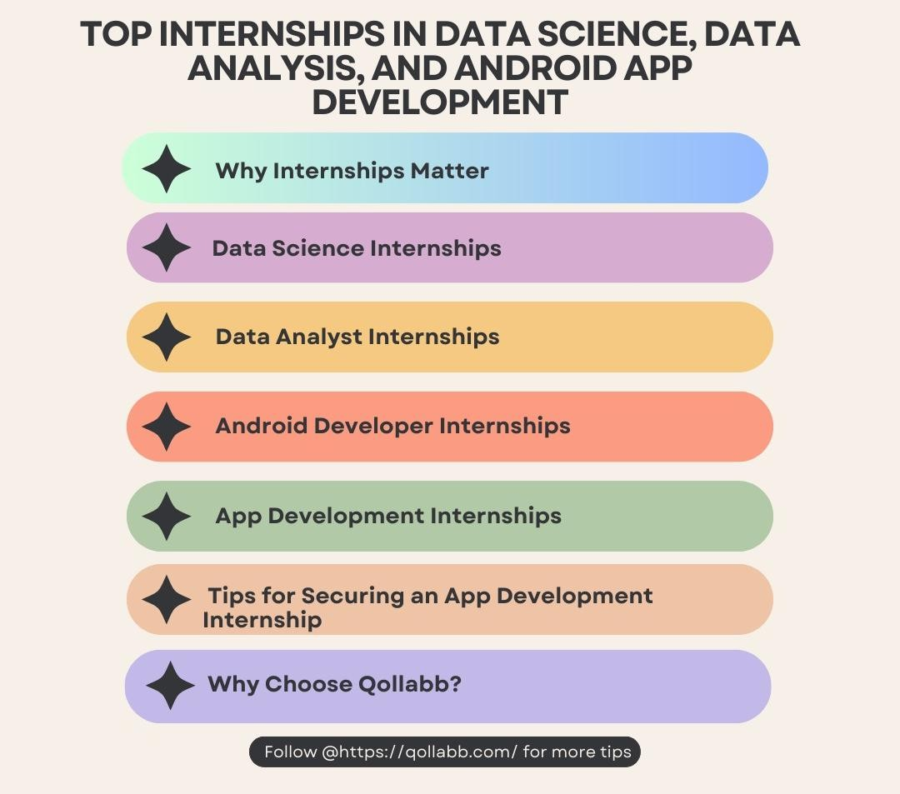

Services Offered
Future Interns offers a range of services aimed at enhancing students’ professional and technical skills:

Summer and winter internship programs Skill development and certification courses Project-based learning and case studies Industry mentorship and career guidance Online learning modules and assessments

Industry Presence
Future Interns has established a strong presence in the field of student training and internships by collaborating with learners from diverse academic backgrounds such as management, engineering, computer science, and data analytics. The organization emphasizes emerging and high-demand domains, supporting students in gaining relevant skills aligned with industry trends.

Organizational Structure
The organizational structure of Future Interns follows a mentor-led and learner-centric approach. It includes academic coordinators, industry mentors, technical trainers, and internship supervisors who collectively ensure effective program delivery and student support.

Department of Internship
The internship was undertaken under the Data Science & Analytics Department of Future Interns. This department focuses on developing analytical skills, data interpretation abilities, and practical understanding of analytics tools and techniques. The internship emphasized learning the analytics lifecycle and applying data-driven approaches to business problems.

Services Offered by Future Interns

Service Category Description Benefit to Students

Internship Programs Industry-oriented internships in
emerging domains
Practical exposure

Skill Development Training
Project-Based Learning
Technical and analytical skill training
Hands-on projects and assignments
Skill enhancement
Real-world learning

Mentorship Support Guidance from industry
professionals
Career clarity

Service Category Description Benefit to Students

Career Guidance Resume building & career
support
Employability

Domain-wise Focus of Future Interns (%)

Domain Percentage (%)
Data Science & Analytics 40% Business Analytics 25%
Artificial Intelligence 20% Other Emerging Domains 15%
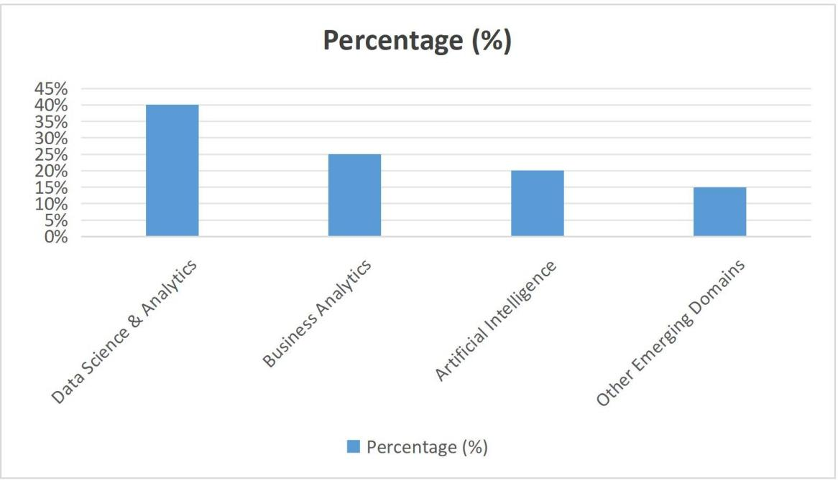

INTERNSHIP PROFILE

Nature and Objective of Work Assigned
The Summer Internship was undertaken in the Data Science & Analytics Department at Future Interns. The nature of the internship was learning-oriented and analytical, focusing on developing a strong foundation in data analytics concepts and their practical application in business decision-making.

The primary objective of the internship was to understand the analytics lifecycle and gain hands-on exposure to data handling, analysis, and interpretation. The internship aimed to enhance analytical thinking, problem-solving abilities, and professional discipline while aligning academic knowledge with industry practices.

Tasks and Responsibilities Handled
During the internship period, the following tasks and responsibilities were assigned: Understanding datasets and identifying relevant variable
Data collection and preprocessing

Data cleaning to improve data quality and accuracy Performing exploratory data analysis (EDA) Creating basic visualizations for data interpretation Interpreting analytical results in a business context Preparing reports and documenting insights
These activities helped in developing a structured and analytical approach toward problem-solving

Tool / Software Purpose
Python (Basic) Data analysis and interpretation

Spreadsheet Tools (MS Excel / Google Sheets)
Data handling and basic analysis

Visualization Techniques Graphical representation of insights
Online Learning Platforms Conceptual understanding and practice

.

Key Observations
The following key observations were made during the internship:

Data quality plays a crucial role in the accuracy of analytical outcomes. Structured analytical thinking is essential for effective problem-solving. Understanding the business context is critical while interpreting data insights. Visualization improves clarity and communication of analytical results.
Data-driven decision-making enhances efficiency and reduces uncertainty.

SWOT Analysis
A SWOT analysis was conducted to evaluate the internship experience and learning environment:

Strengths:

Structured learning modules Hands-on analytical exposure Supportive mentorship

Weaknesses:

Limited internship duration

Restricted access to large-scale real-time datasets

Opportunities:

Growing demand for data analytic professionals Expanding applications of analytics across industries

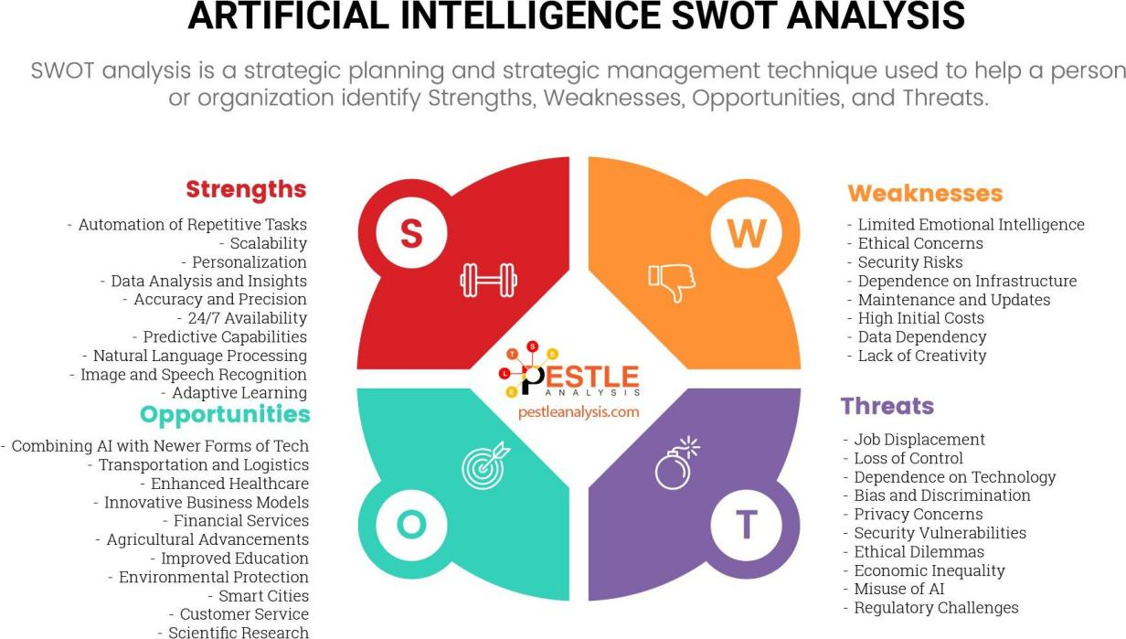

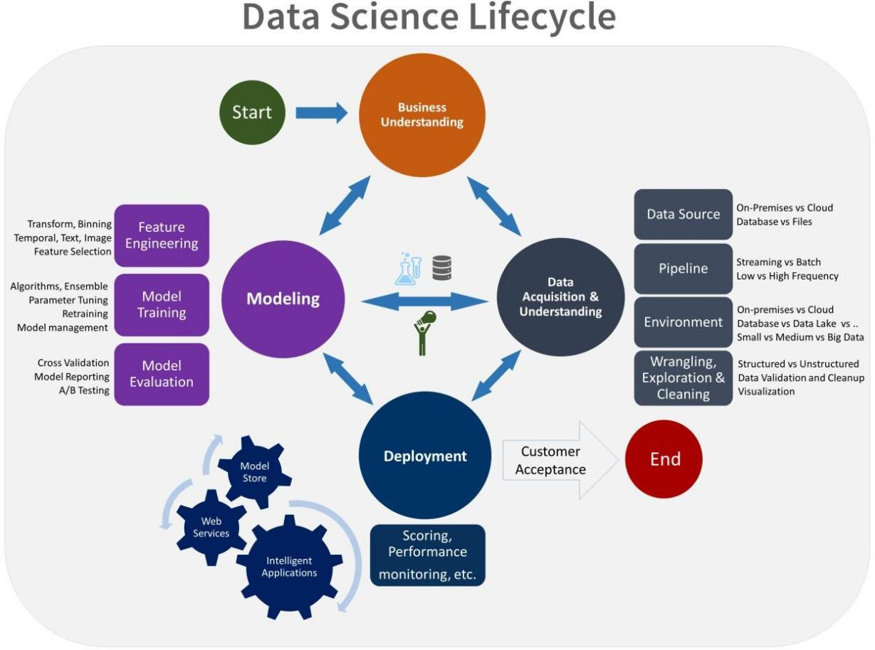

MARKET ANALYSIS AND FINDINGS
  - Overview of the Data Science & Analytics Market

The Data Science and Analytics industry has witnessed rapid growth over the past decade due to digital transformation, increasing data generation, and the adoption of advanced technologies such as Artificial Intelligence and Machine Learning.
Organizations across industries are increasingly relying on analytics to gain insights, improve operational efficiency, enhance customer experience, and support strategic decision-making.
The demand for data-driven solutions has grown significantly in sectors such as IT, finance, healthcare, retail, marketing, and human resources. Businesses are shifting from intuition-based decisions to evidence-based decision-making, making analytics a core component of modern management practices.

  - Industry Segmentation and Target Areas

The Data Science & Analytics market can be segmented based on application areas and functional domains. Major segments include:

Sales and Marketing Analytics: Customer behavior analysis, sales forecasting, and campaign performance evaluation

Operations Analytics: Process optimization, supply chain efficiency, and resource management

Financial Analytics: Risk assessment, fraud detection, and financial forecasting

Human Resource Analytics: Employee performance analysis, retention, and workforce planning

Future Interns focuses on providing foundational and practical exposure in these high-demand analytics domains, preparing students for industry-relevant roles.

  - Competitive Landscape

The analytics industry is highly competitive, with organizations striving to build strong analytical capabilities. Companies that effectively leverage data analytics gain a competitive advantage through improved decision accuracy, faster response times, and better strategic planning.

In the training and internship domain, organizations offering hands-on projects, mentorship support, and industry-aligned learning have a stronger impact on student skill development. Future Interns differentiates itself by emphasizing practical exposure, structured learning modules, and mentor guidance.

  - Applications of Data Science & Analytics in Business
    - Data Science & Analytics plays a crucial role in various business functions:
    - Sales Forecasting: Predicting future sales trends based on historical data
    - Customer Segmentation: Identifying and grouping customers for targeted marketing
    - Performance Analysis: Monitoring KPIs and organizational performance
    - Risk Analysis: Identifying potential risks and minimizing losses
    - These applications help organizations enhance efficiency, reduce uncertainty, and improve overall performance.
  - Findings and Insights

    - Based on the market study and internship exposure, the following findings were identified:
    - Analytics adoption has increased significantly across industries.
    - Organizations using data-driven decision-making achieve better accuracy and efficiency.
    - Visualization tools play a key role in simplifying complex data insights.
    - There is a growing demand for professionals with analytical and technical skills.
    - Practical exposure and hands-on learning are essential for developing analytics competency.

  - Graphical Representation of Analytics Applications

Figure 4.1: Application Areas of Data Analytics (%)
(Sales & Marketing, Operations, Finance, HR Analytics, Others)

Figure 4.2: Types of Data Analytics (Descriptive, Diagnostic, Predictive, Prescriptive)

(Graphs to be inserted here)

  - Summary of Market Analysis

The Data Science & Analytics market continues to expand as organizations increasingly rely on data for decision-making and strategic planning. Analytics has become a key driver of business success, enabling organizations to remain competitive in a dynamic environment.

The findings from this study highlight the importance of developing analytical skills and adopting data-driven approaches. The internship at Future Interns provided valuable exposure to these concepts, reinforcing the relevance of analytics in modern business management.

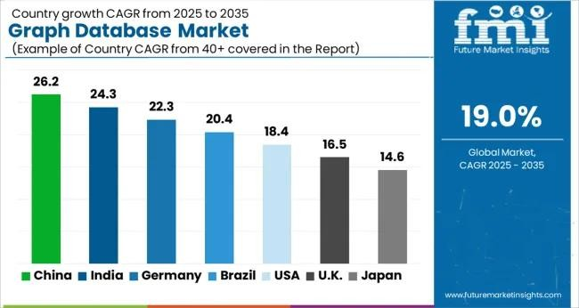

Figure 4.1

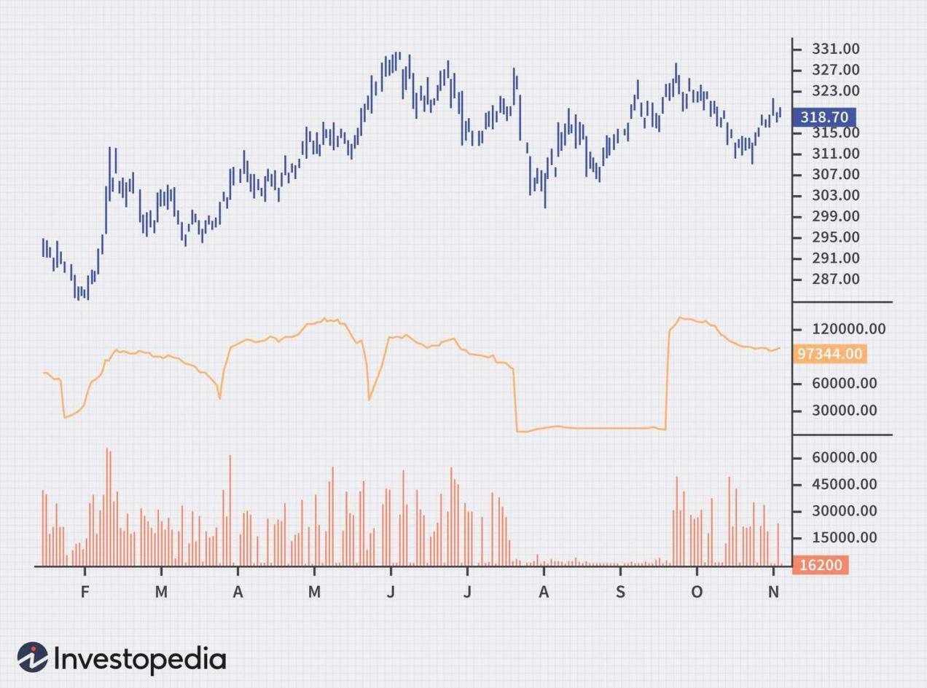
Figure 4.2

LEARNING OUTCOMES AND VALUE ADDITIO

  - Overview

The Summer Internship Program at Future Interns proved to be a valuable learning experience that significantly contributed to both academic development and professional growth. The internship provided practical exposure to the domain of Data Science & Analytics, enabling the application of theoretical concepts in real-world business scenarios.

Through structured learning modules, practical assignments, and guided mentorship, the internship helped in developing analytical thinking, technical understanding, and professional discipline. The experience strengthened the foundation required for pursuing a career in analytics-driven roles.

  - Key Learnings

The major learnings gained during the internship are summarized below: Understanding the complete analytics lifecycle, from data collection to interpretation Practical exposure to data cleaning, preprocessing, and exploratory data analysis Ability to interpret analytical results in a business context
Improved problem-solving and analytical thinking skills Familiarity with basic analytics tools and visualization techniques
  - Academic Relevance

The internship experience was closely aligned with various MBA subjects such as Business Analytics, Research Methodology, Strategic Management, and Management Information Systems. Concepts learned during classroom sessions were reinforced through practical applications, making academic learning more meaningful and effective.

This integration of theory and practice enhanced conceptual clarity and improved the ability to apply analytical tools to managerial decision-making.

  - Personal Development and Soft Skills

In addition to technical learning, the internship contributed significantly to personal and professional skill development:
Communication Skills: Improved clarity in presenting ideas and analytical findings Time Management: Enhanced ability to manage tasks and meet deadlines effectively Analytical Thinking: Developed a structured approach to problem-solving

Teamwork: Gained experience in collaborative learning environments Professional Discipline: Adapted to organizational ethics and work culture
  - Value Addition to Career
The internship added substantial value to career readiness by building a strong foundation in Data Science & Analytics. It increased awareness of industry expectations and enhanced confidence in handling analytical tasks.
The exposure gained during the internship strengthened career prospects by equipping the student with industry-relevant skills, a data-driven mindset, and practical understanding, thereby supporting future opportunities in analytics-oriented roles.

BEST PRACTICES AND RECOMMENDATIONS
  - Introduction

In a rapidly evolving data-driven business environment, organizations that follow structured analytical practices and continuous learning frameworks are better positioned to deliver accurate insights and sustainable value. During the internship at Future Interns, several best practices related to data handling, analytical workflows, and professional discipline were observed.
These practices not only ensured the quality and reliability of analytical outputs but also helped interns develop industry-relevant skills aligned with real-world Data Science and Analytics requirements. Based on practical exposure and observations, this chapter highlights the key best practices followed at Future Interns along with strategic recommendations for further improvement.

  - Best Practices Observed at Future Interns

    - Structured Data Analysis Workflow
Future Interns follows a systematic approach to data analysis, starting from data collection and cleaning to exploratory analysis, modeling, and interpretation. This structured pipeline minimizes errors and improves analytical accuracy.

    - Emphasis on Practical Learning
Rather than focusing only on theoretical concepts, the organization emphasizes hands-on project execution. Interns are encouraged to work on real datasets, enhancing problem-solving ability and applied learning.

    - Use of Industry-Relevant Tools
Tools such as Python, Excel, and data visualization techniques are actively used, helping interns gain familiarity with technologies currently demanded in the analytics industry.

    - Continuous Feedback and Evaluation
Regular feedback on task performance allows interns to identify mistakes early and improve analytical thinking, coding practices, and data interpretation skills.

    - Professional Discipline and Documentation
Maintaining proper documentation of datasets, code logic, and findings is strongly encouraged, ensuring clarity, reproducibility, and professional reporting standards.

  - Strategic Recommendations
Based on observations during the internship, the following recommendations are proposed to further strengthen the training and analytics delivery framework at Future Interns:

    - Advanced Project Exposure
Introduce more complex, industry-level case studies involving large datasets, predictive analytics, and real-time data handling.
    - Enhanced Focus on Data Visualization
Greater emphasis on storytelling through dashboards and visual tools such as Power BI or Tableau can significantly improve insight communication.

    - Version Control Practices
Incorporating tools like Git and GitHub would help interns understand collaborative analytics workflows and industry best practices.

    - Domain-Specific Analytics Training
Offering specialization tracks such as Finance Analytics, Marketing Analytics, or Healthcare Analytics would increase internship value and job readiness.

    - Soft Skill Integration
Regular sessions on presentation skills, analytical reporting, and business communication should be included to bridge the gap between technical output and stakeholder understanding.

Phase Time Frame Key Focus Areas
Phase 1 0–3 Months Tool enhancement, visualization training Phase 2 3–6 Months Advanced projects, version control adoption Phase 3 6–12 Months Domain specialization, industry collaboration
6.5 Expected Outcomes
Implementation of the above recommendations is expected to result in: Improved analytical accuracy and efficiency
Higher internship-to-employment conversion potential Stronger industry alignment of intern skill sets
Enhanced quality of project documentation and reporting

6.6 Summary

Future Interns demonstrates a strong commitment to practical, industry-oriented learning in Data Science and Analytics. By combining structured analytical processes, hands-on exposure, and professional discipline, the organization creates a solid foundation for aspiring data professionals.

With further enhancement in advanced analytics exposure, visualization tools, and domain-specific learning, Future Interns can significantly elevate its training ecosystem and produce highly competent, job-ready analytics professionals.

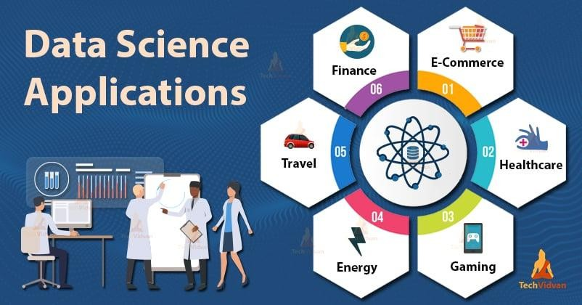

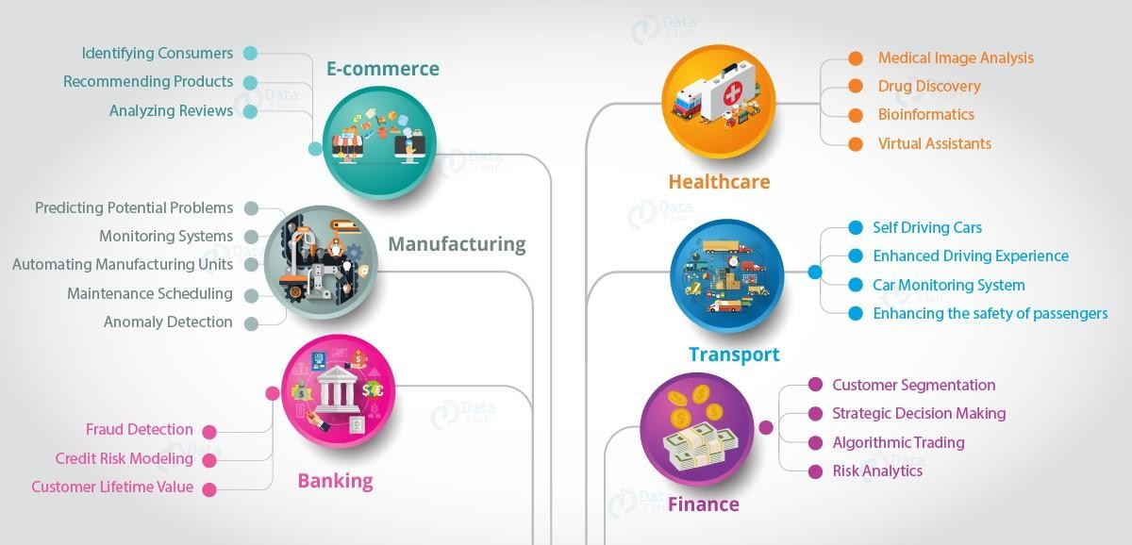

CONCLUSION

  - Conclusion
The Summer Internship at Future Interns provided valuable practical exposure in the field of Data Science and Analytics, bridging the gap between academic concepts and real-world analytical applications. The internship enabled a clear understanding of how data-driven approaches are used to extract insights, support decision-making, and solve business-oriented problems.
Throughout the internship, emphasis was placed on structured data analysis, use of analytical tools, and disciplined documentation practices. Exposure to real datasets enhanced analytical thinking, problem-solving ability, and technical proficiency. The experience also improved professional discipline, time management, and the ability to interpret and present analytical findings in a meaningful manner.

Overall, the internship served as a strong foundation for developing industry-relevant skills in analytics and has significantly contributed to career readiness in the data-driven domain.

Limitation of the study

Despite the valuable learning experience, the internship and study were subject to certain limitations:

    - Limited Duration
The one-month internship period restricted exposure to long-term projects and advanced analytical implementations.

    - Restricted Dataset Access
Access to large-scale, real-time, or confidential organizational datasets was limited, which constrained deeper analytical exploration.

    - Scope of Tools
The internship primarily focused on selected analytical tools and techniques; exposure to advanced platforms and enterprise-level analytics systems was limited.

    - Academic Dependency
Some aspects of analysis relied on predefined tasks and learning modules, limiting full independence in project selection and execution.

Despite these limitations, the internship provided meaningful insights and practical exposure relevant to the field of Data Science and Analytics.

7.3 Key Takeaways

Developed a clear understanding of the data analysis lifecycle Improved analytical thinking and problem-solving skills
Gained hands-on experience with data handling and interpretation Enhanced professional discipline and documentation practices Built a strong base for future learning in analytics and data science

7.4 Personal Reflection / Closing Note (optional but recommended)

This internship experience has strengthened my interest in Data Science and Analytics and reinforced the importance of continuous learning in a rapidly evolving technological landscape. The exposure gained during this period has motivated me to further enhance my technical skills and pursue advanced learning opportunities in the analytics domain.

Bibliography

Books & Academic References

Han, J., Kamber, M., & Pei, J. (2019). Data Mining: Concepts and Techniques. Morgan Kaufmann.
Provost, F., & Fawcett, T. (2013). Data Science for Business. O’Reilly Media. McKinney, W. (2018). Python for Data Analysis. O’Reilly Media.

Online Learning Resources

Analytics Vidhya – Data Science Learning Resources Kaggle – Datasets and Data Science Case Studies Towards Data Science – Medium Publications
IBM Data Science Documentation Websites
[https://www.kaggle.com](https://www.kaggle.com) [https://www.analyticsvidhya.com](https://www.analyticsvidhya.com) [https://towardsdatascience.com](https://towardsdatascience.com) [https://www.ibm.com/analytics](https://www.ibm.com/analytics)

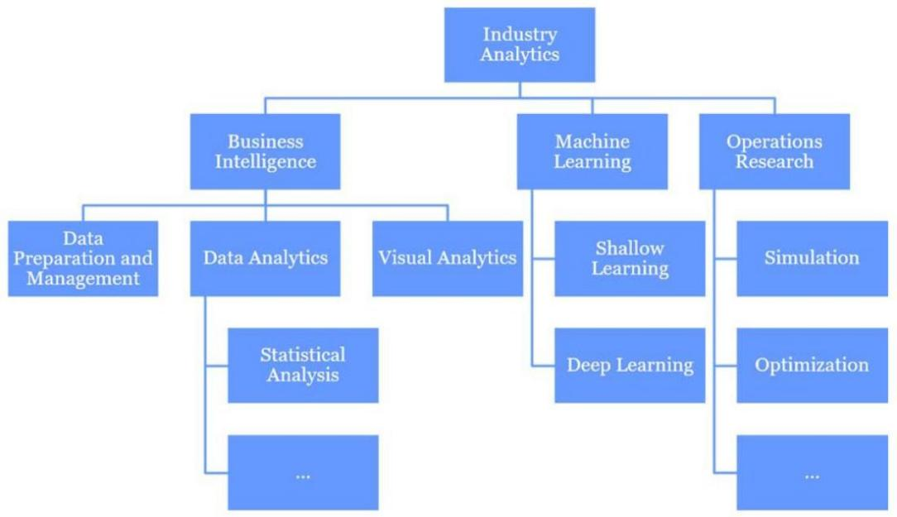

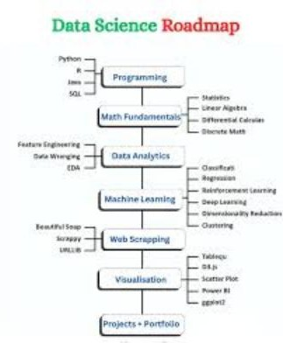

Student’s Daily Report
Tools / Day Task Assigned Activities Performed Techniques
Used

Learning Outcome

Day Orientation 1
Internship objectives, rules, workflow understanding
Discussion, Docs
Clarity about internship structure

Day 2
Introduction to Data Analytics
Basics of data analytics and real-world use cases

PPT, Notes
Conceptual understanding

Day 3
Dataset Understanding
Studied dataset structure and variables
Excel Data familiarity

Day 4
Day 5
Day 6
Day 7
Data Collection Collected sample
datasets
Data Cleaning Removed missing &
duplicate values
Data Formatting Standardized data
formats
Weekly Review Reviewed learning &
documented work
Excel Data sourcing skills

Excel Data accuracy
Excel Improved data consistency
MS Word Documentation skill

| Day 8 | Introduction to Python | Basics of Python for data analysis | Python | Programming foundation |
| Day 9 | Python Practice | Variables, loops, conditions | Python | Coding confidence |
| Day 10 | Data Handling in Python | Imported datasets | Python | Data manipulation |
| Day 11 | Exploratory Analysis | Analyzed trends & patterns | Python | Analytical thinking |
| Day 12 | Visualization Basics | Created charts & graphs | Python / Excel | Data presentation |
| Day 13 | Practice Session | Reworked analysis tasks | Python | Skill reinforcement |
| Day 14 | Weekly Review | Documented weekly learnings | MS Word | Structured reporting |

| Day 15 | Advanced Analysis | Worked on deeper data insights | Python | Problem-solving |
| Day 16 | Statistical Concepts | Mean, median, trends | Python | Analytical accuracy |
| Day 17 | Visualization Practice | Improved charts & visuals | Python | Insight communication |
| Day 18 | Case Study Analysis | Worked on sample case study | Python | Practical exposure |
| Day 19 | Data Interpretation | Interpreted results & outputs | Excel / Python | Decision-making |
| Day 20 | Documentation | Prepared interim report | MS Word | Professional reporting
|

| Day 21 | Weekly Review | Reviewed tasks & feedback | Docs | Continuous improvement |

| Day 22 | Final Project Work | Started final analysis task | Python | Project handling |
| Day 23 | Data Refinement | Cleaned and optimized dataset | Python | Data precision |
| Day 24 | Final Visualization | Created final charts & tables | Python / Excel | Presentation quality |
| Day 25 | Report Writing | Drafted findings & results | MS Word | Analytical writing |
| Day 26 | Review & Corrections | Improved errors and gaps | Python | Accuracy enhancement |
| Day 27 | Final Documentation | Compiled complete report | MS Word | End-to-end reporting |
| Day 28 | Submission Preparation | Checked formatting & flow | Word | Submission readiness |
| Day 29 | Mentor Review | Feedback discussion | Discussion | Improvement awareness |
| Day 30 | Final Submission | Submitted report & learnings | Documentation | Internship completion |

Evaluation Parameters

Excellent Very
Good

Feedback

Good Satisfactory

Understanding of Internship Objectives
✔ | ☐ | ☐ ☐
✔ | ☐ | ☐ ☐
✔ | ☐ | ☐ ☐
☐ | ✔ | ☐ ☐
✔ | ☐ | ☐ ☐
☐ | ✔ | ☐ ☐

Subject Knowledge & Concept Clarity

Quality of Work Performed

Analytical & Problem-Solving Skills

Initiative & Learning Ability

Communication Skills

Teamwork &  Coordination | ✔ | ☐ | ☐ | ☐
Professional Attitude & Discipline | ✔ | ☐ ☐ ☐
Time Management &  Punctuality | ✔ | ☐ ☐ ☐

Adaptability to Work Environment

✔ ☐ ☐ ☐

Use of Tools & Technology
☐ ✔ ☐ ☐

Presentation & Reporting Skills

✔ ☐ ☐ ☐

Overall Performance
✔ ☐ ☐ ☐

