Title: Deadlock Management in Distributed System
Theory: Deadlocks can occur in distributed computing systems when multiple processes or nodes compete for shared resources, leading to a situation where none of the processes can proceed further. Deadlocks can result in significant performance degradation, resource wastage, and system failure.
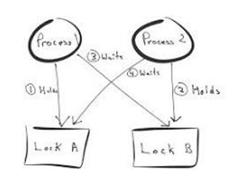
Deadlocks in distributed systems arise when a group of processes are each waiting for resources held by others, creating a cycle of dependency where none can proceed. This leads to blocked execution, wasted resources, and potential system slowdown or failure. Because processes are spread across different machines and communicate over networks, detecting and resolving deadlocks becomes more difficult than in centralized systems.
Mutual exclusion is a key technique used to manage access to shared resources. It ensures that only one process can use a resource at a time, typically through mechanisms like locks, semaphores, or tokens. When a process requests a resource, it must first acquire the lock; if the resource is already in use, the process waits until it becomes available. This controlled access reduces conflicts and helps maintain consistency.
To minimize deadlocks while using mutual exclusion, systems must carefully design how resources are requested and released. One common strategy is to enforce a global ordering of resources, where all processes request resources in the same sequence. This prevents circular waiting, which is a necessary condition for deadlock. Another approach is to ensure that processes release held resources if they cannot acquire all required ones, reducing the chance of indefinite waiting.
However, mutual exclusion alone cannot eliminate deadlocks. If processes hold some resources while waiting for others, deadlocks can still occur. Therefore, it is combined with additional techniques:
- Deadlock Prevention: Eliminates one or more necessary conditions for deadlock, such as preventing circular wait or hold-and-wait.
- Deadlock Avoidance: Makes decisions dynamically (e.g., only granting requests if the system remains in a safe state).
- Deadlock Detection: Uses algorithms (like wait-for graphs) to identify cycles indicating deadlocks.
- Deadlock Recovery: Resolves deadlocks by preempting resources, rolling back processes, or terminating selected processes.
In distributed systems, these methods may involve coordination between nodes, message passing, and maintaining global or partial system state. A robust deadlock management strategy typically combines mutual exclusion with prevention, detection, and recovery techniques to ensure efficient, safe, and reliable system performance.

