
GOVERNMENT WELFARE SCHEME AWARENESS GAP MINER
Natural Language Processing and Computational Linguistics (CSI4001)
PROJECT REPORT
Fall Semester 2026-2027
Submitted by
RISHI KETHAN REDDY (<<REG NO>>)
SANJAI (<<REG NO>>)
ABID (<<REG NO>>)
PURNA (<<REG NO>>)
in partial fulfillment for the award of the degree of
B. Tech
in
Computer Science and Engineering
<<Specialization>>
Vellore-632014, Tamil Nadu, India
School of Computer Science and Engineering
October, 2026

CONTENTS
Project Topic 3
Abstract 4
Introduction 5
Background Study 6
Methodology 8
Datasets 8
Pre-processing 8
Language and scheme detection 8
Sentence embeddings and similarity 9
Classification 9
Evaluation metrics 9
Handling uncertainty 9
Clustering and analytics 9
Proposed Model 10
Results and Discussion 13
Sample source code 13
Model evaluation 13
Results on collected data 13
Limitations 14
Screenshots of the modules 14
Conclusion 24
Future work 24
References 25

Project Topic
Government Welfare Scheme Awareness Gap Miner: identifying awareness-gap signals in public questions and comments about Indian government welfare schemes using text mining and NLP.
The system has four parts that work together: a collection engine that gathers public text from permitted sources, an ingestion pipeline that cleans and de-duplicates it, an NLP layer that labels each record, and a web dashboard that presents the results. It was built and tested on a single development machine with SQLite as the database.
Table 1: Team and areas of responsibility
Member | Area
RISHI KETHAN REDDY | System design, ingestion pipeline, integration and testing
SANJAI | Data collection engine and back-end API
ABID | Dashboard and user interface
PURNA | NLP models, training and evaluation

Table 2: Project at a glance
Item | Value
Schemes covered | 15 central government schemes
Languages handled | English, Hindi (Devanagari), romanized Hindi
Labelled training records | 632 (127 original + 253 translations + 252 live comments)
Unique live records analysed | 3,329
Automated back-end tests | 133 passing

Abstract
Eligible citizens often miss the benefits of government welfare schemes because they do not know how to apply, whether they qualify, or why a payment has not arrived. Such confusion is visible in public text: questions to the Kisan Call Centre, comments under scheme-guide articles and similar sources. This text is short, informal and often written in Hindi or romanized Hindi. This project builds a system that collects such text from permitted public sources or imported datasets and identifies records that show an awareness gap. Every record goes through one pipeline: normalisation, removal of personal identifiers, duplicate detection, language detection, rule-based detection of 15 schemes, and three classifiers for information intent, awareness gap and gap type. The classifiers use logistic regression on TF-IDF n-grams and on multilingual sentence embeddings. Uncertain predictions are marked unclear instead of being forced into a label, and each decision stores its most similar labelled examples. Records are grouped into recurring themes with HDBSCAN clustering and shown in a web dashboard. On a held-out test set of 101 records, the awareness-gap classifier obtained a macro-F1 of 0.65 against 0.34 for a majority baseline. Of 3,329 unique collected records, 385 were classified as gap signals, 2,170 as no gap and 482 as unclear. The labelled data set is small and partly AI-assisted, so the results are indicative and describe the analysed text, not awareness in the population.

Introduction
India runs a large number of central welfare schemes, including PM-KISAN (income support for farmers), PMAY (housing), Ayushman Bharat PM-JAY (health insurance), PMMY/Mudra (micro-credit), MGNREGA (rural employment), PMFBY (crop insurance) and NSAP (pensions). Each scheme has its own eligibility rules, documents and application steps. Field surveys in several states show that awareness of these schemes is uneven and that low awareness limits their use, particularly in rural areas (Shyam et al., 2013; Bogam, Chavan and Rani, 2023).
Surveys are slow and expensive, and they cover one village or district at a time. At the same time, people who are confused about a scheme leave a written trace. They call helplines, ask questions in comment sections and post complaints. This text is public and continuous, but it is unstructured, and much of it is in Hindi or Hinglish. Reading it manually does not scale.
Problem statement. Given a stream of public text about welfare schemes, identify which records indicate an awareness gap, what kind of gap it is and which scheme it concerns, and group recurring themes. Three distinctions are kept throughout. A question shows an information intent (for example, how to apply), but it is not automatically an awareness gap; a gap is evidence that information is missing or misunderstood. Location is used only when the source states it. All counts describe the analysed records, not the population.
Objectives.
- Collect text safely from permitted public sources and allow import of labelled datasets.
- Clean, de-duplicate and remove personal identifiers through one ingestion pipeline.
- Detect the scheme and language (English, Hindi, romanized Hindi) of each record.
- Train and evaluate classifiers for intent, awareness gap and gap type, and handle uncertain predictions explicitly.
- Group similar records with sentence embeddings and clustering, and present the results in a dashboard.
Scope. The system covers 15 central schemes and text that is public and allowed by the source's robots.txt. It does not bypass logins, does not use headless browsers, does not infer location and does not measure population-level awareness.

Background Study
Most existing work on welfare-scheme awareness in India uses field surveys of specific communities. Studies from Telangana, Meghalaya, Tamil Nadu, Odisha and Bihar report that awareness varies widely and that people who are aware of a scheme are not always able to access it. Work on farmers' information needs and on questions posted online shows that people's questions reveal what information they lack. On the technical side, sentence embeddings allow questions with the same meaning to be compared and grouped even when worded differently. Table 3 summarises the studies used in this project.
Table 3: Summary of related studies
No. | Author(s) & Year | Study / Focus | Key Finding / Relevance
1 | Bogam, Chavan & Rani (2023) | Awareness and utilisation of social welfare schemes among elderly villagers in rural Telangana. | Examined awareness and utilisation of welfare schemes and showed the need to strengthen awareness and access at the rural level.
2 | Jyrwa, Thabah, Khongtim & Kharbudon (2021) | Awareness of Central Government schemes in Sohbar village, Meghalaya. | Studied awareness of government schemes in a rural community and identified variation in knowledge and access.
3 | Moorthy & Jeyadevi (2023) | Awareness of Central Government schemes for sustainable development in rural India, with reference to Coimbatore. | Highlighted the importance of awareness of government schemes for rural development and access to benefits.
4 | Nikam, Ashok & Pal (2022) | Farmers' information needs, access and impact across cotton-producing regions of Maharashtra. | Showed that farmers have varied information needs and access patterns, supporting the need to analyse recurring information gaps.
5 | Reimers & Gurevych (2019) | Sentence-BERT for generating meaningful sentence embeddings. | Introduced an efficient method for comparing sentence meaning, relevant to grouping semantically similar welfare-scheme questions.
6 | Sethi & Biswal (2023) | Awareness of farmers towards agricultural government schemes in Dhenkanal, Odisha. | Examined farmers' awareness of agricultural schemes and demonstrated the relevance of studying scheme-specific knowledge gaps.
7 | Shyam et al. (2013) | Rural people's awareness and access to government schemes in six villages of Buxar, Bihar. | Provided baseline evidence on awareness and access to government schemes at village level.
8 | Tripathi & Panwar (2024) | Knowledge of rural women regarding selected government schemes. | Studied knowledge of selected schemes among rural women and emphasised differences in scheme awareness.
9 | Vidhate & Kundap (2016) | Awareness of newly launched social security schemes among rural population in India. | Investigated awareness of newly introduced social security schemes and the challenges of reaching intended beneficiaries.
10 | Zhao & Mei (2013) | Information needs expressed through questions on Twitter. | Analysed question patterns and information needs, supporting the use of real textual questions as signals for information-gap analysis.

The survey studies (1-3, 6-9) measure awareness directly but are limited to small areas and single points in time. Nikam, Ashok and Pal (2022) and Zhao and Mei (2013) show that the questions people ask are a usable record of their information needs. Reimers and Gurevych (2019) provide the technique needed to compare such questions by meaning. This project combines these ideas: it treats public questions and comments as signals of information needs and uses NLP to separate awareness gaps from ordinary questions at a scale that surveys cannot reach. It does not replace surveys, because it measures only the people who write.

Methodology

Datasets
Two data sets are kept separate. The dataset workspace holds an imported, manually labelled data set of 127 English records (29 of them synthetic augmentations). The live workspace holds text collected by the system. Table 4 lists the sources that contributed live records.
Table 4: Live records by source (unique records)
Source | Type | Records
SarkariYojana - latest posts (RSS) | RSS feed and reader comments | 2,453
Kisan Call Centre (data.gov.in open-data API) | Official API, filtered to government-scheme queries | 199
SarkariYojana - scheme guides | Reader comments on guide pages | 25
PM Vishwakarma portal and other registered sources | Official FAQ pages and HTML | 26

Kisan Call Centre records include state, district and call time. Web comments include their own publication time but no location. Some official portals could not be collected because they block automated requests, have broken TLS certificates or load content only through JavaScript. These failures are recorded, not bypassed.
For training, the 127 labelled records were extended with their Hindi (126) and romanized-Hindi (127) translations and 252 labelled live comments. The translations and the live labels were produced with AI assistance and follow written annotation guidelines. A record and its translations always stay in the same split, so the test set contains no translated copy of a training record. The test split has 101 records (51 for gap type, which is only defined when a gap exists).

Pre-processing
- Normalisation: Unicode NFKC, removal of invisible characters, whitespace cleanup. Model input is also lower-cased with URLs removed, using the same function at training and prediction time.
- Privacy: regular expressions replace phone, Aadhaar, PAN, e-mail, PIN-code and long ID numbers with tags before storage.
- Duplicates: an SHA-256 hash removes exact copies; a cosine similarity of 0.96 or more between embeddings marks near-copies. Call-centre records are de-duplicated by call ID instead, because different calls can share the same summary.

Language and scheme detection
Language is detected in three steps: the share of Devanagari characters, then a list of common romanized-Hindi words, then the langdetect library, whose answer is accepted only if it is plausible for Indian sources (it often labels Hinglish as Indonesian). Scheme detection is rule-based: each of the 15 schemes has strong and weak aliases matched as word-bounded regular expressions, where spaces and hyphens are interchangeable. Records that match no scheme are reported as Other / Unknown.

Sentence embeddings and similarity
Each record is encoded by the multilingual model paraphrase-multilingual-MiniLM-L12-v2 (Reimers and Gurevych, 2020) into a 384-dimensional unit vector. Sentences with the same meaning in English, Hindi or Hinglish map to nearby vectors. Because the vectors have unit length, cosine similarity is their dot product: sim(a, b) = a · b. This similarity is used for near-duplicate detection, semantic search (threshold 0.35), retrieving the three most similar labelled examples as evidence, and the out-of-distribution check described below.

Classification
Three labels are predicted: awareness gap (yes / no), intent (8 classes, e.g. application, eligibility, complaint, payment) and gap type (7 classes, e.g. application gap, eligibility gap, payment gap, misconception). For each task four candidates are compared: a majority-class baseline; TF-IDF (Salton and Buckley, 1988) on word 1-2 grams and character 2-5 grams with logistic regression; logistic regression on sentence embeddings; and an ensemble that averages the probabilities of the two. Character n-grams handle spelling variants in Hinglish (paisa / paise). Classes are weighted to balance rare labels. The best candidate on the validation set (macro-F1) is retrained on training and validation data and tested once on the test split.

Evaluation metrics
Because several classes are rare, accuracy alone would reward a model that always predicts the common class. The main metric is therefore macro-averaged F1, which gives every class equal weight. For each class c, precision P_c = TP_c / (TP_c + FP_c), recall R_c = TP_c / (TP_c + FN_c) and F1_c = 2 P_c R_c / (P_c + R_c); macro-F1 is the mean of F1_c over all classes. A majority-class baseline is reported next to every model so that the gain from learning is visible. Grouped five-fold cross-validation, in which a record and its translations always fall in the same fold, gives a second estimate that does not depend on one particular test split.

Handling uncertainty
An awareness-gap label is given only when three conditions hold. The text must be public voice (a question, comment or complaint); news, FAQ and article text is marked not applicable. Its nearest labelled example must have a similarity of at least 0.423; otherwise the text is unlike the training data. The model confidence max(p, 1 - p) must be at least 0.55, a threshold chosen on the validation set. Records that fail the last two checks are marked unclear. Intent and gap type always receive a label, but weak predictions are flagged as low confidence.

Clustering and analytics
Embeddings are reduced to 20 dimensions with PCA and grouped with HDBSCAN (Campello, Moulavi and Sander, 2013), which does not need the number of clusters in advance and leaves outliers unassigned. Keywords for each cluster are taken from class-based TF-IDF. The gap rate is computed only over decided records, yes / (yes + no), and is always shown with its denominator. State-level figures use only locations stated by the source.

Proposed Model
Figure 1 shows the proposed system. Text enters in two ways: a background worker collects public pages and API records, and operators upload data sets through the web interface. Both paths use the same ingestion pipeline, which stores the cleaned text, embeddings and NLP results in a database. A FastAPI back end serves the data and live progress updates to a Next.js dashboard.
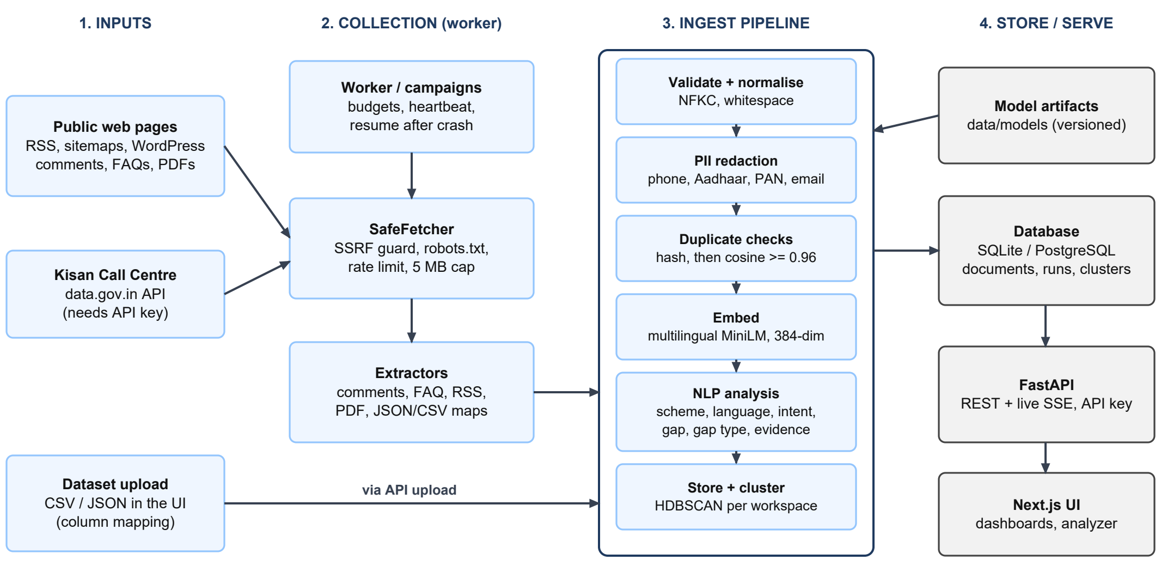
Figure 1: Architecture of the proposed system
Collection engine. A collection job is run by a separate worker, so slow network access does not block the dashboard (Figure 2). Before each request the fetcher checks that the address is public (preventing access to internal networks), that robots.txt allows the page, and that at least two seconds have passed since the last request to the same host. Responses are limited to 5 MB. Comments, FAQs, feed items and API records are extracted with their own publication dates. Progress is stored in the database and streamed to the browser.
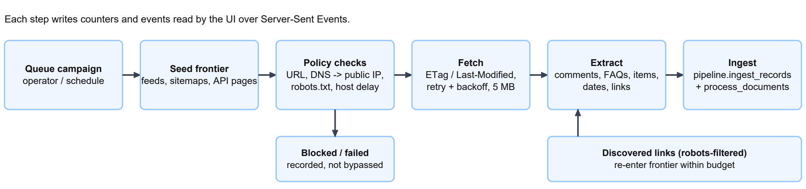
Figure 2: Live collection workflow
NLP pipeline. Figure 3 follows one romanized-Hindi comment through the pipeline; the probability values in it are illustrative. The classifier structure is shown in Figure 4 and the gap decision rules in Figure 5. Every stored record keeps the model's probability, its reason and its nearest labelled examples, so each label can be checked by a person. Labels corrected by an operator are never overwritten by later reprocessing.
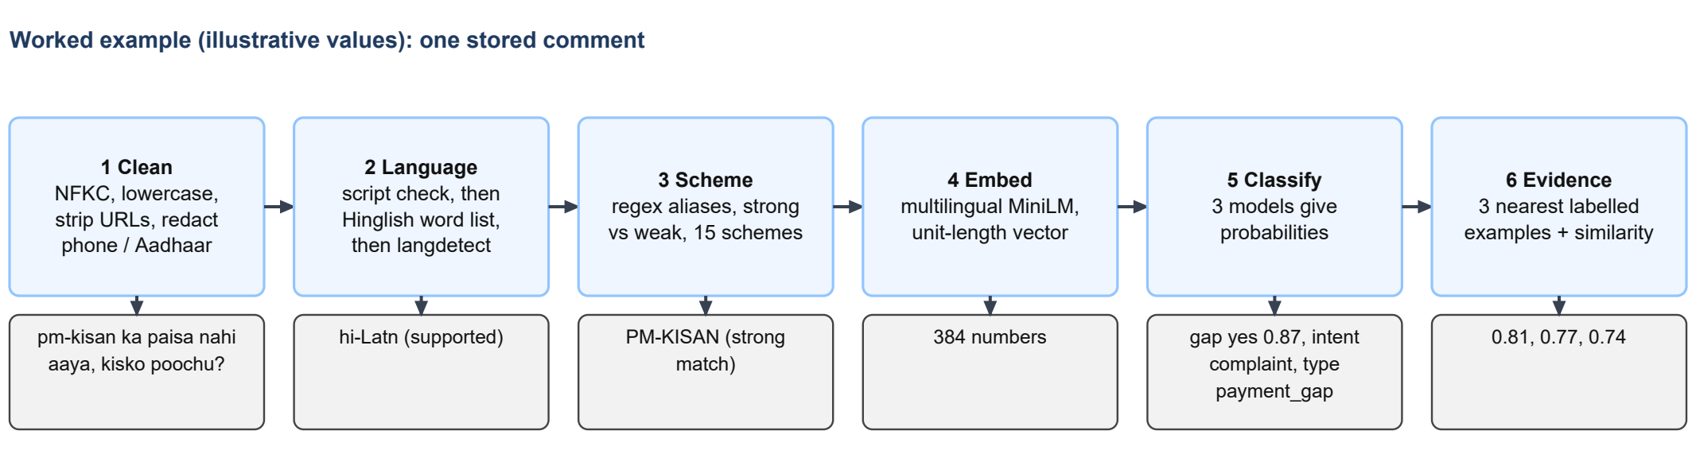
Figure 3: Processing of one record (illustrative values)
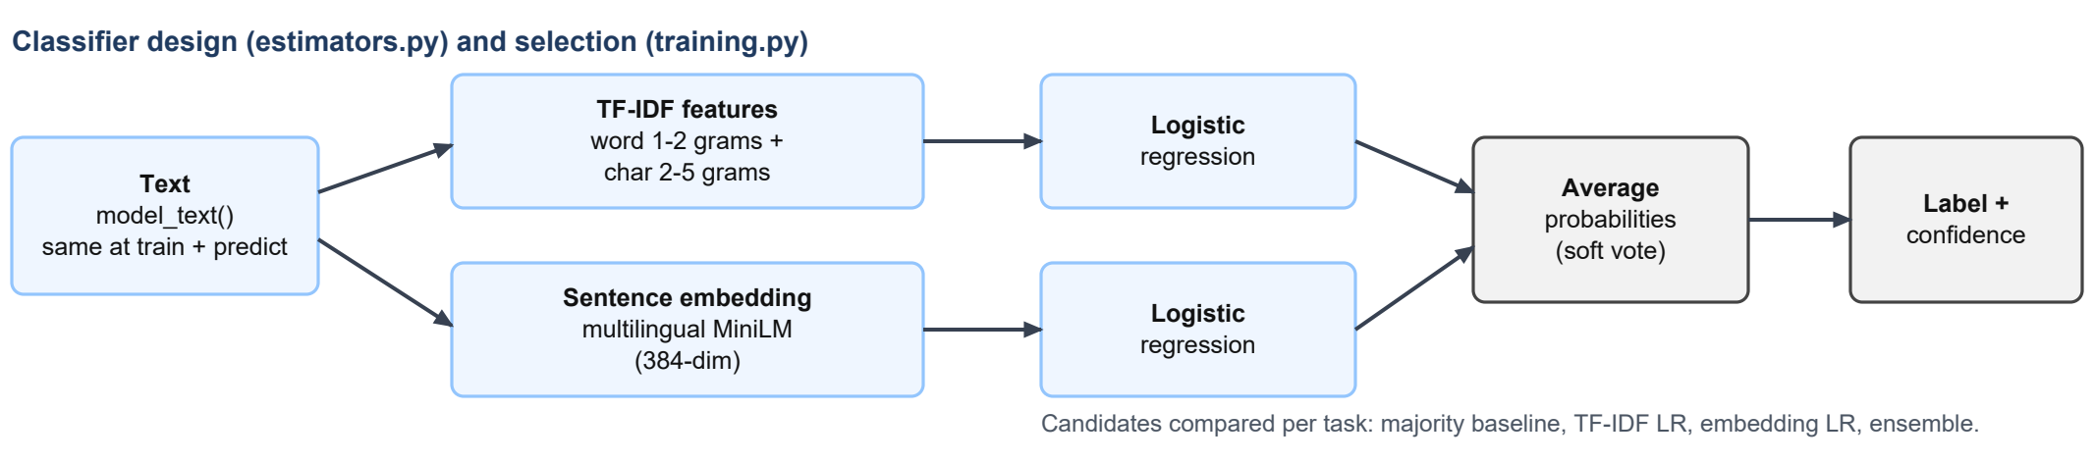
Figure 4: Classifier design
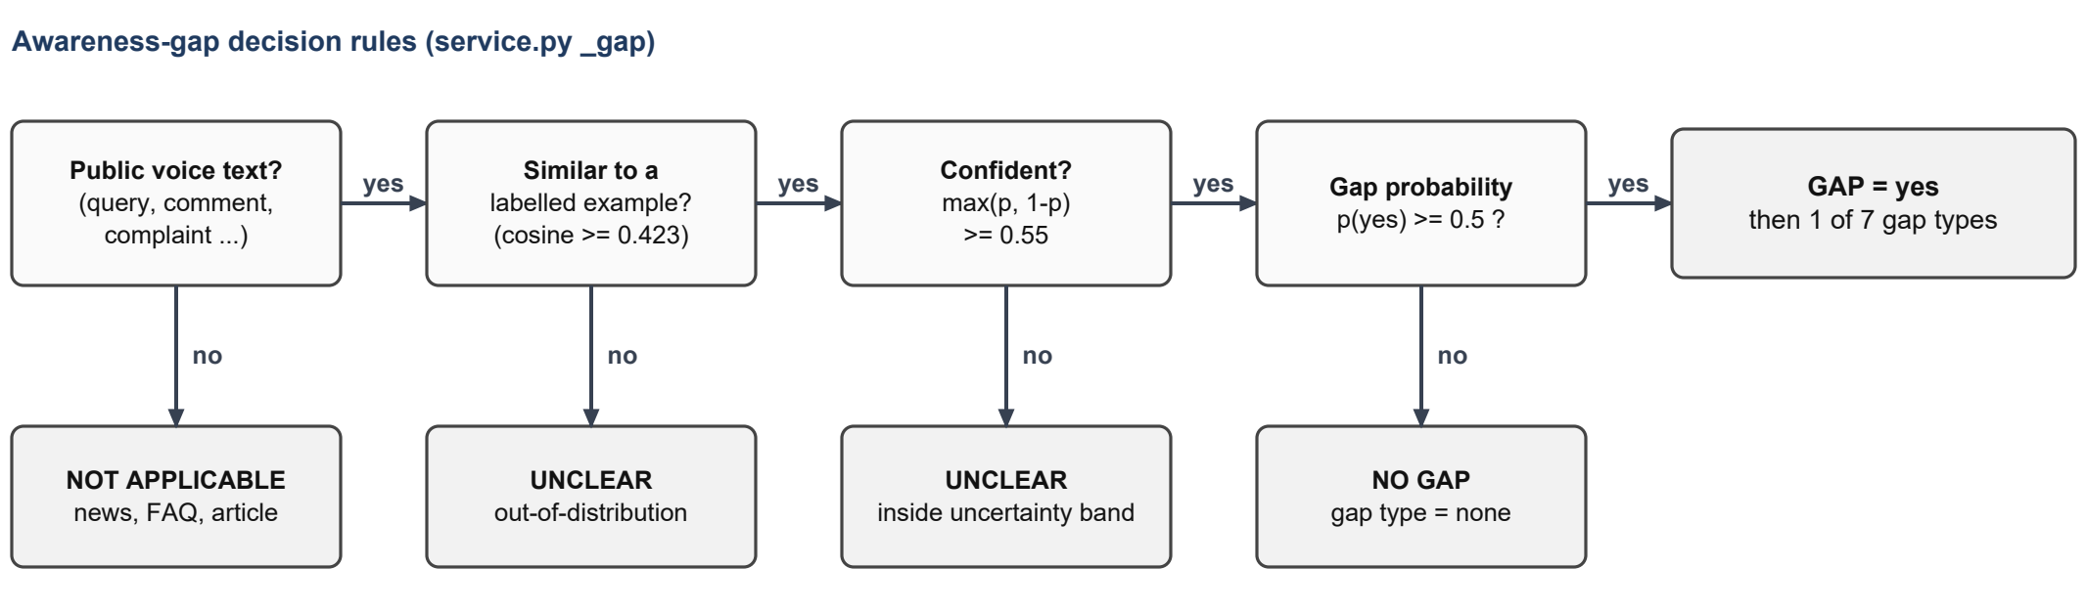
Figure 5: Awareness-gap decision rules
Data model. Figure 6 shows the main tables. The documents table is central: it holds the cleaned text, its source, timestamps, scheme, language, labels and evidence. Collection jobs, crawled pages, events, embeddings and clusters are linked to it. All timestamps are stored in UTC.
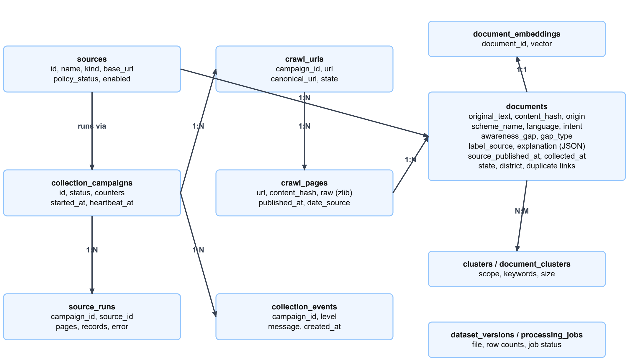
Figure 6: Main database tables
Table 5: Technology used
Part | Technology
Dashboard | Next.js 16, React 19, Tailwind CSS 4
Back end | FastAPI, SQLAlchemy 2, Alembic, SQLite (PostgreSQL configuration provided, not tested)
Collection | httpx, BeautifulSoup / lxml, feedparser, pypdf
NLP | sentence-transformers, scikit-learn, hdbscan, langdetect

Results and Discussion

Sample source code
The TF-IDF classifier (backend/app/nlp/estimators.py):
def tfidf_logreg(C: float = 4.0) -> Pipeline:
features = FeatureUnion([
("word", TfidfVectorizer(preprocessor=model_text, ngram_range=(1, 2), sublinear_tf=True)),
("char", TfidfVectorizer(preprocessor=model_text, analyzer="char_wb",
ngram_range=(2, 5), min_df=2, sublinear_tf=True)),
])
return Pipeline([("features", features),
("clf", LogisticRegression(C=C, max_iter=5000, class_weight="balanced"))])

The awareness-gap decision (backend/app/nlp/service.py, abridged):
if role not in PUBLIC_VOICE_ROLES:
return {"label": "not_applicable", ...}
p_yes = float(probs[i, yes_idx]); conf = max(p_yes, 1 - p_yes)
if not in_dist: # nearest labelled similarity < 0.423
return {"label": "unclear", "status": "out_of_distribution", ...}
if conf < m.threshold: # 0.55, chosen on validation data
return {"label": "unclear", "status": "uncertain", ...}
label = "yes" if p_yes >= 0.5 else "no"

Model evaluation
Table 6 gives the held-out test results produced by the training script. The models were selected on the validation set and tested once.
Table 6: Test results
Task | Selected model | Test n | Accuracy | Macro-F1 | Baseline macro-F1 | 5-fold CV macro-F1
Awareness gap | Embedding + LogReg | 101 | 0.653 | 0.652 | 0.336 | 0.595
Intent | Ensemble | 101 | 0.584 | 0.434 | 0.054 | 0.344
Gap type | Ensemble | 51 | 0.588 | 0.351 | 0.078 | 0.280

Table 7: Awareness-gap results by class (test, n = 101)
Class | Precision | Recall | F1 | Support | Predicted no | Predicted yes
no | 0.67 | 0.60 | 0.63 | 50 | 30 | 20
yes | 0.64 | 0.71 | 0.67 | 51 | 15 | 36

By test slice, awareness-gap macro-F1 was 0.53 on original English records, 0.74 on Hindi, 0.56 on romanized Hindi and 0.61 on live comments; each slice has only 21-38 records, so one record changes a score by several points. With the uncertainty rule applied, 81 % of test records received a decision, with 0.73 accuracy on those. The awareness-gap model is clearly better than the baseline but not highly accurate. Intent and gap type are harder because they have more classes and few examples of the rarer ones.

Results on collected data
Table 8: Awareness-gap outcomes for 3,329 unique live records
Outcome | Records
Gap signal | 385
No gap | 2,170
Unclear | 482
Not applicable (news, FAQ, article) | 292
Gap rate over decided records | 15 % (385 / 2,555)

Table 9: Records and gap rate by scheme (live)
Scheme | Records | Gap rate (decided records)
PMAY | 2,281 | 8 % (n = 1,908)
Ayushman Bharat PM-JAY | 258 | 32 % (n = 189)
PMMY (Mudra) | 205 | 18 % (n = 168)
PM-KISAN | 198 | 85 % (n = 119)
Other / Unknown | 302 | 18 % (n = 146)

Most PMAY records are application questions from one scheme-guide website and are classified as no gap, giving a low gap rate. PM-KISAN records come mainly from the Kisan Call Centre, where farmers call about missing instalments or unclear status, so most are gap signals. Application gaps (248) and eligibility gaps (100) form most of the gap types; payment, deadline and documentation gaps are rare in both the data and the training set. Romanized Hindi was the most common language (1,627 records), followed by English (913) and Hindi (313). Only 193 records (6 %), all from the call centre, state a location, across 17 states, which is too few for state comparisons. The latest clustering of live records produced 10 clusters (silhouette 0.43) with themes such as PMAY list status, Ayushman card eligibility and PM-KISAN instalment status.

Limitations
These figures depend on which sources could be collected and who chose to write; they describe the analysed text and should not be read as measures of awareness in the population. The main limitations are the small and partly AI-labelled training data, the dominance of one website in the live data, rule-based scheme detection that misses state schemes, and personal names that may remain in comments. The back end passes 133 automated tests, and the dashboard builds without errors.

Screenshots of the modules
The screenshots below were taken from the running application in dark mode, against the same database used for the results above.
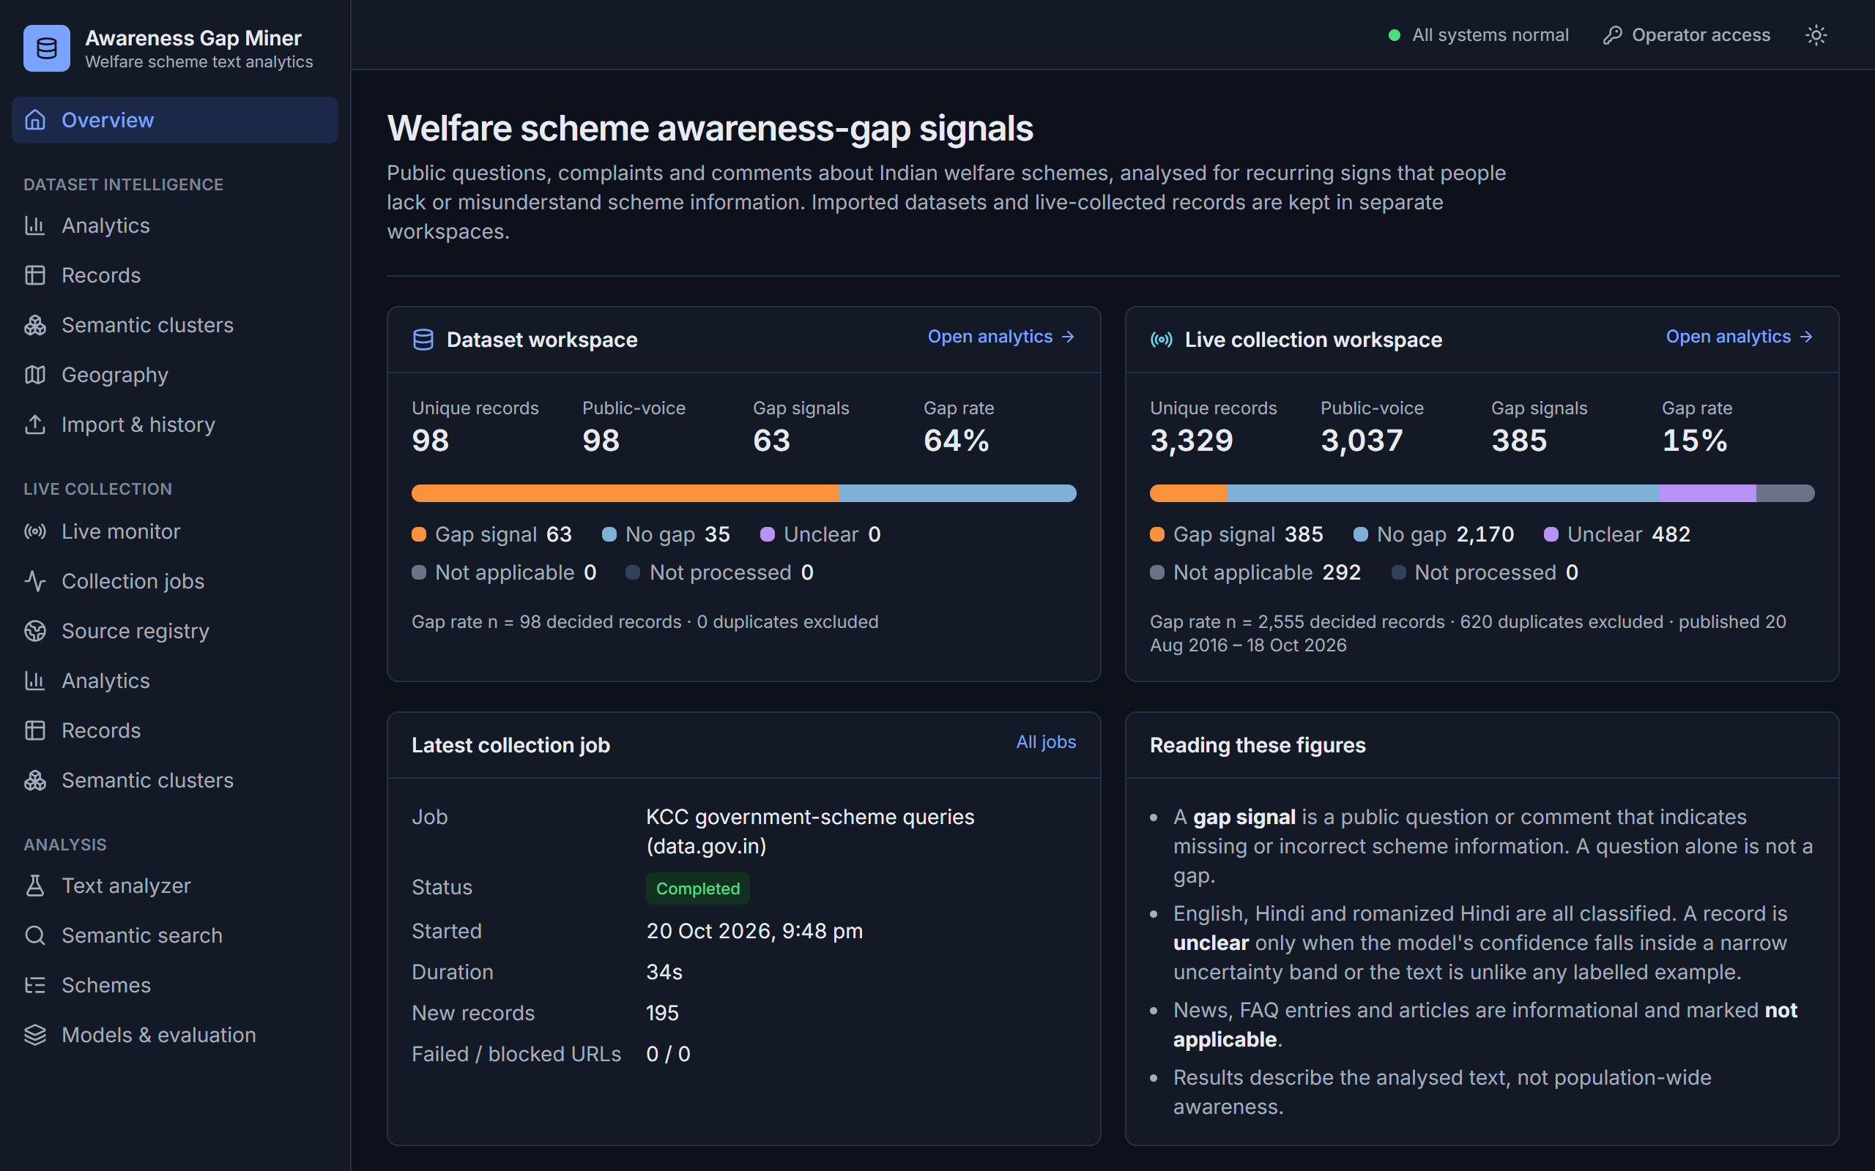
Figure 7: Overview page
Summary of both workspaces with record counts, gap rate and the outcome bar, plus the latest collection job.
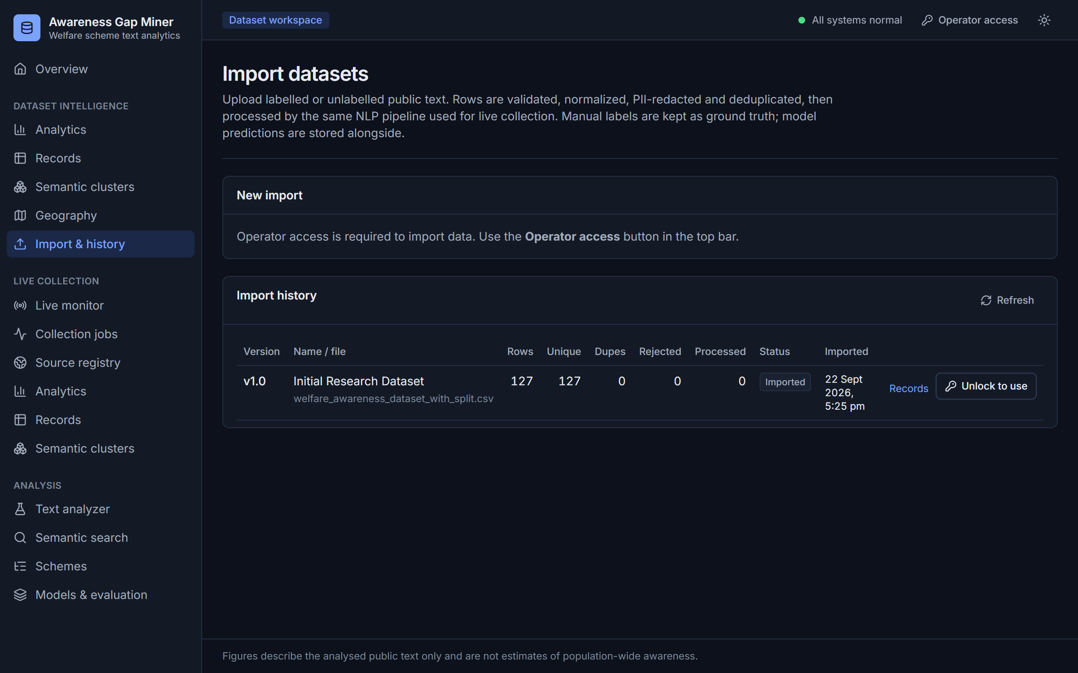
Figure 8: Dataset upload
CSV or JSON upload with a preview and column mapping before import.
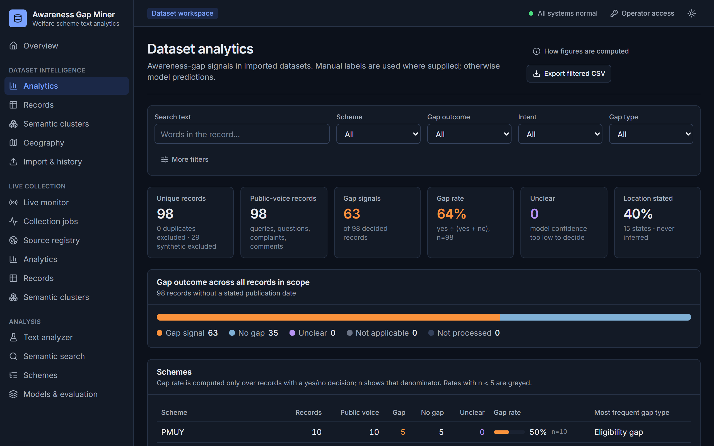
Figure 9: Dataset analytics
Gap outcomes and per-scheme figures for the imported, manually labelled data set.
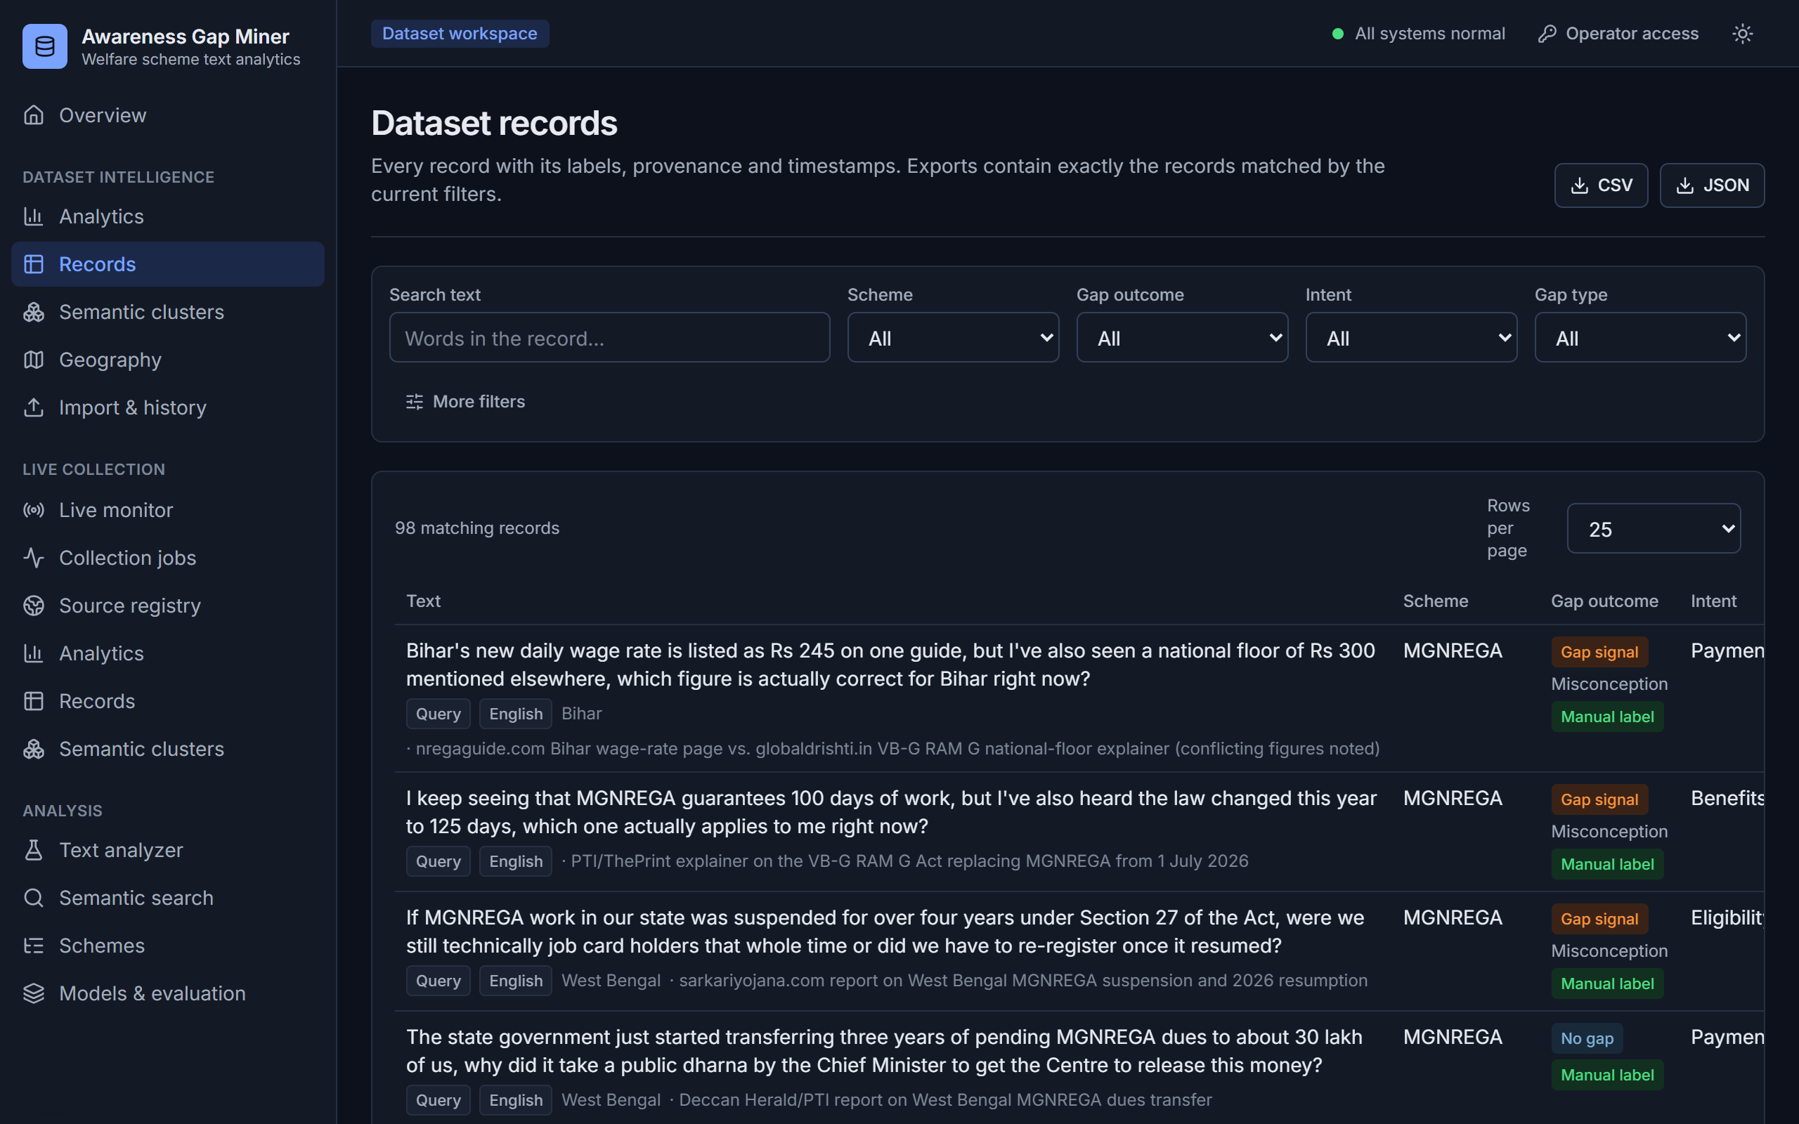
Figure 10: Record explorer
Filterable list of records with their scheme, intent, gap and gap type.
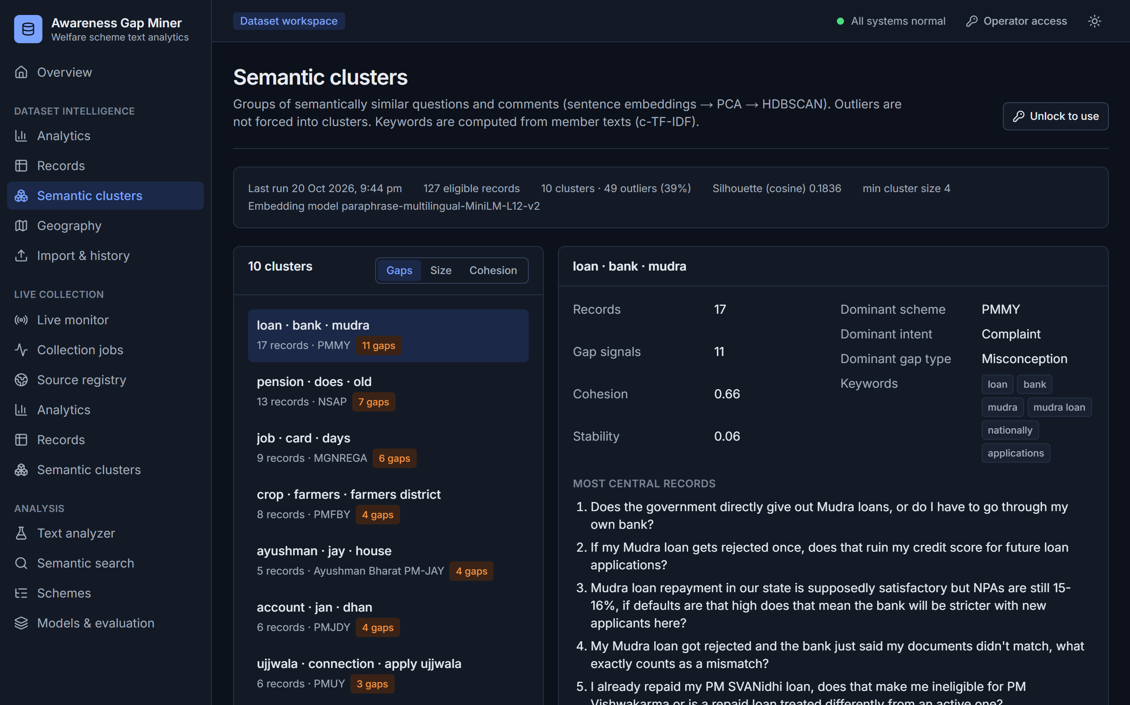
Figure 11: Semantic clusters
HDBSCAN clusters with keywords and example records.
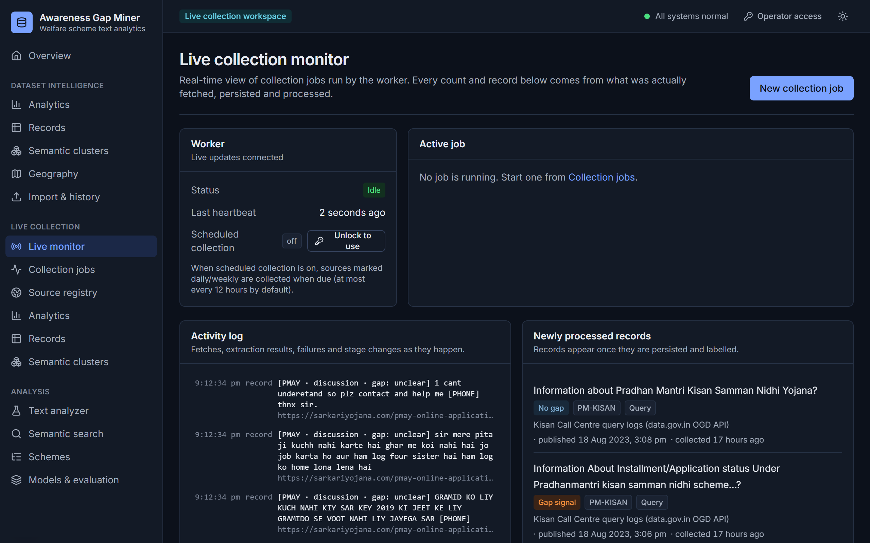
Figure 12: Live collection monitor
Real-time progress of collection jobs streamed from the worker.
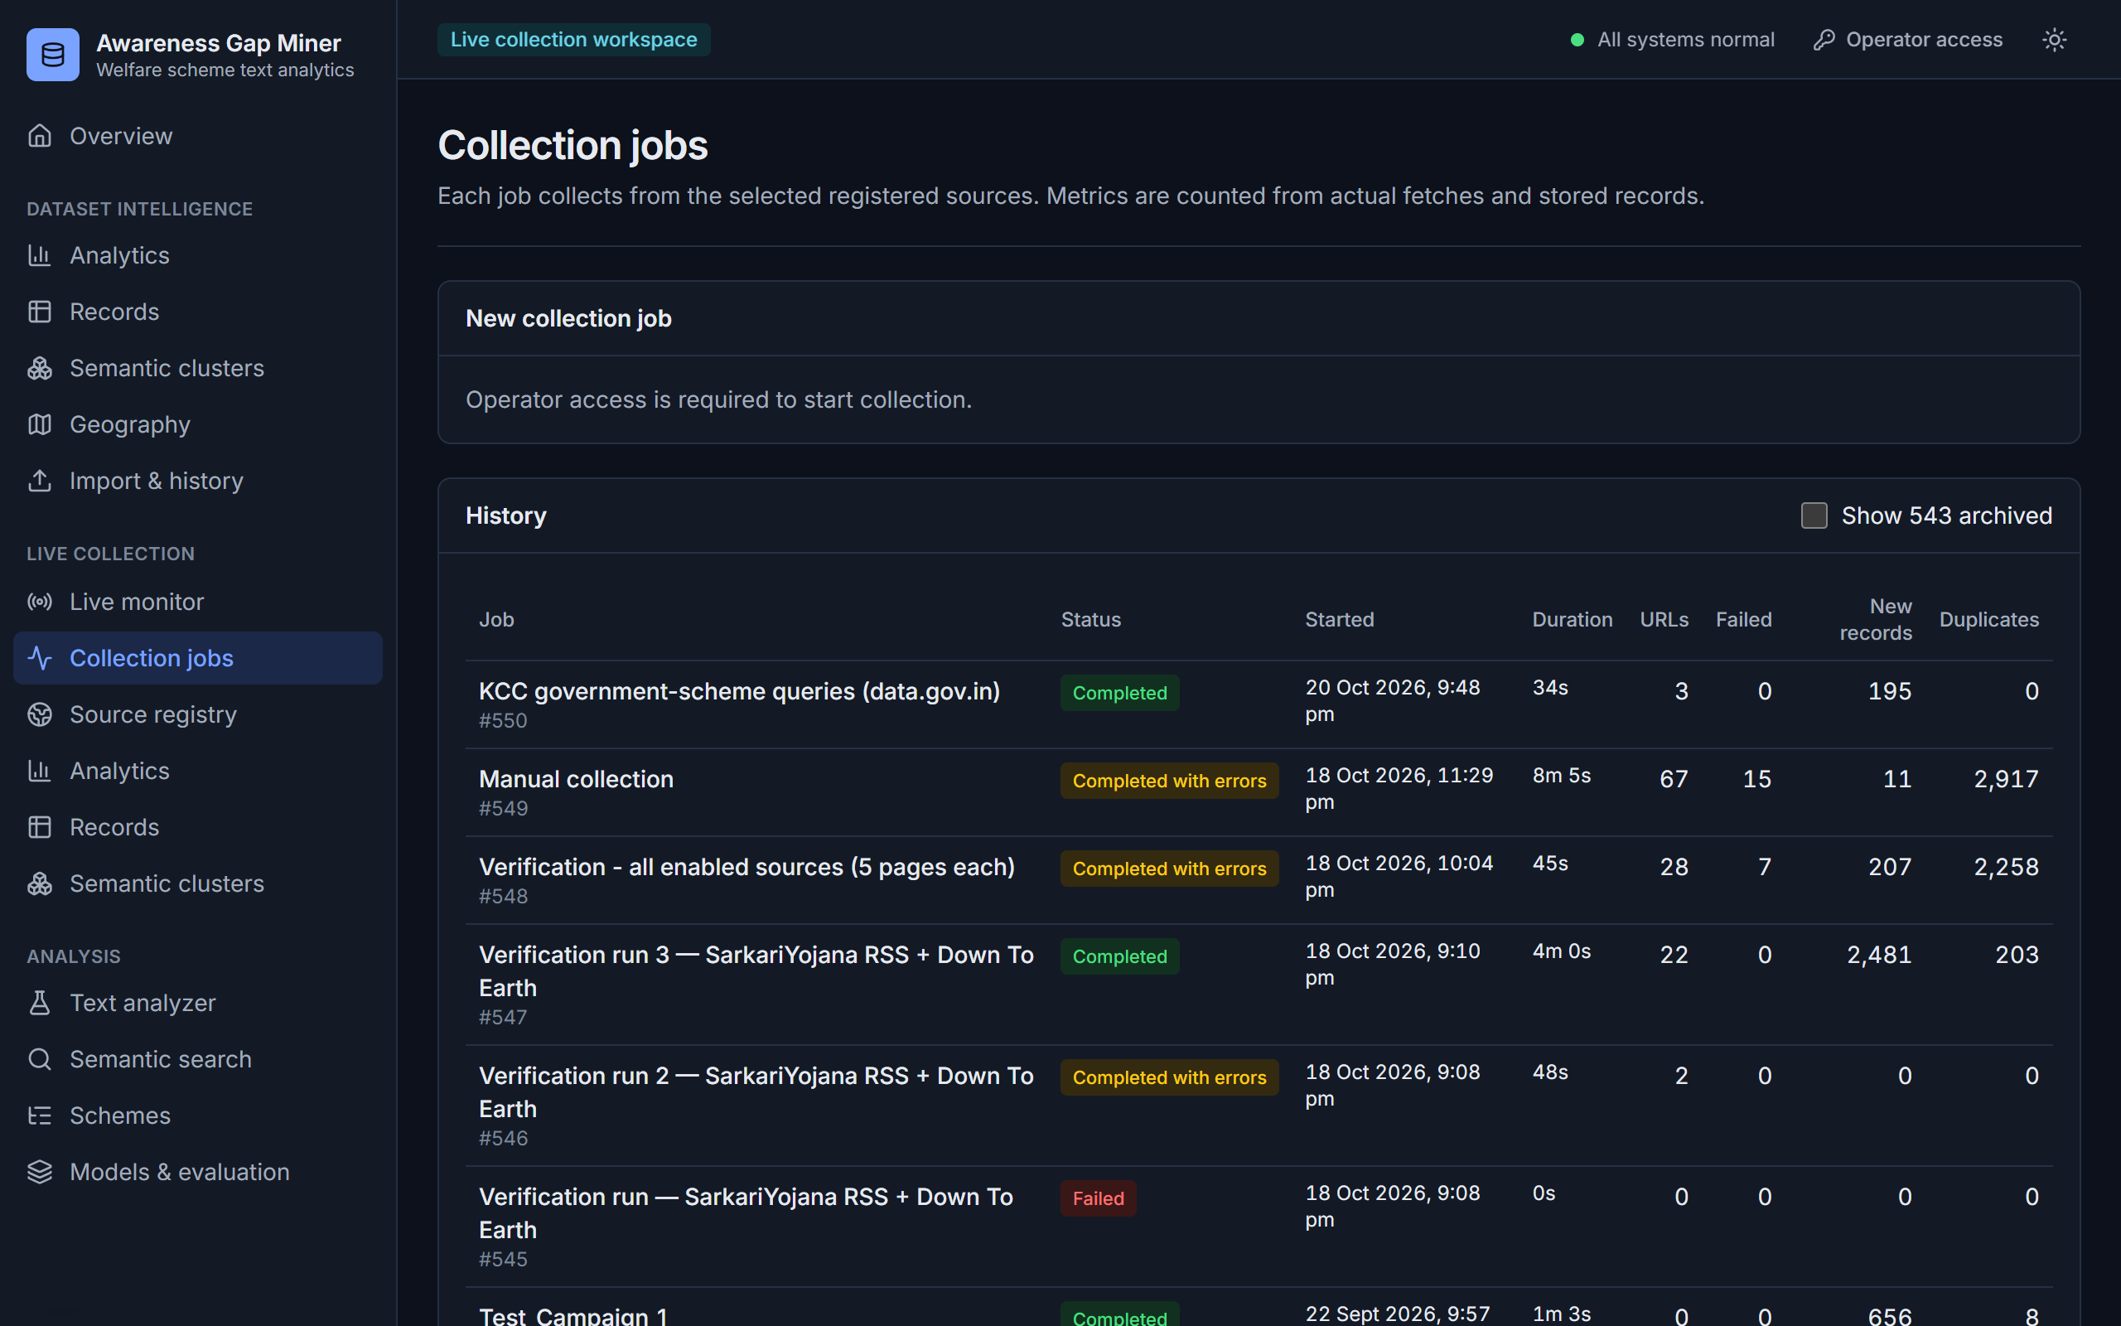
Figure 13: Collection jobs
History of collection jobs with status, duration and record counts.
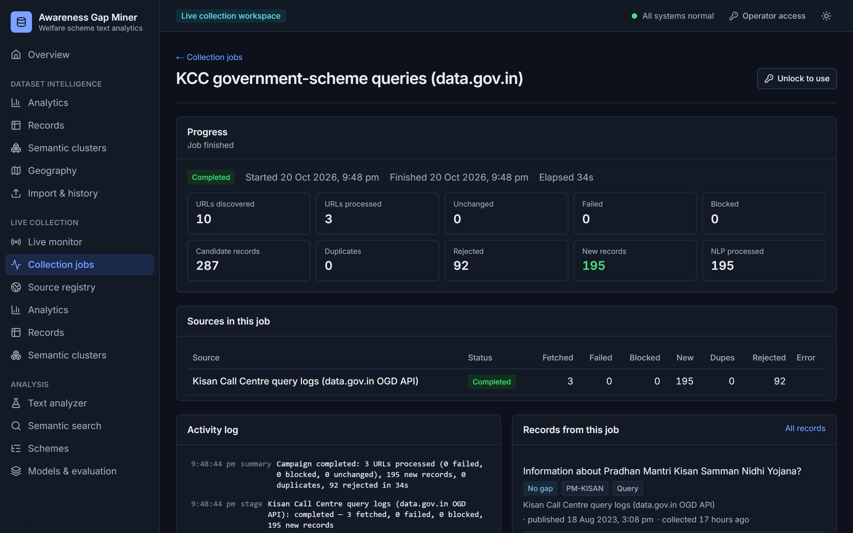
Figure 14: Collection job detail
Per-source results and the event log of one job.
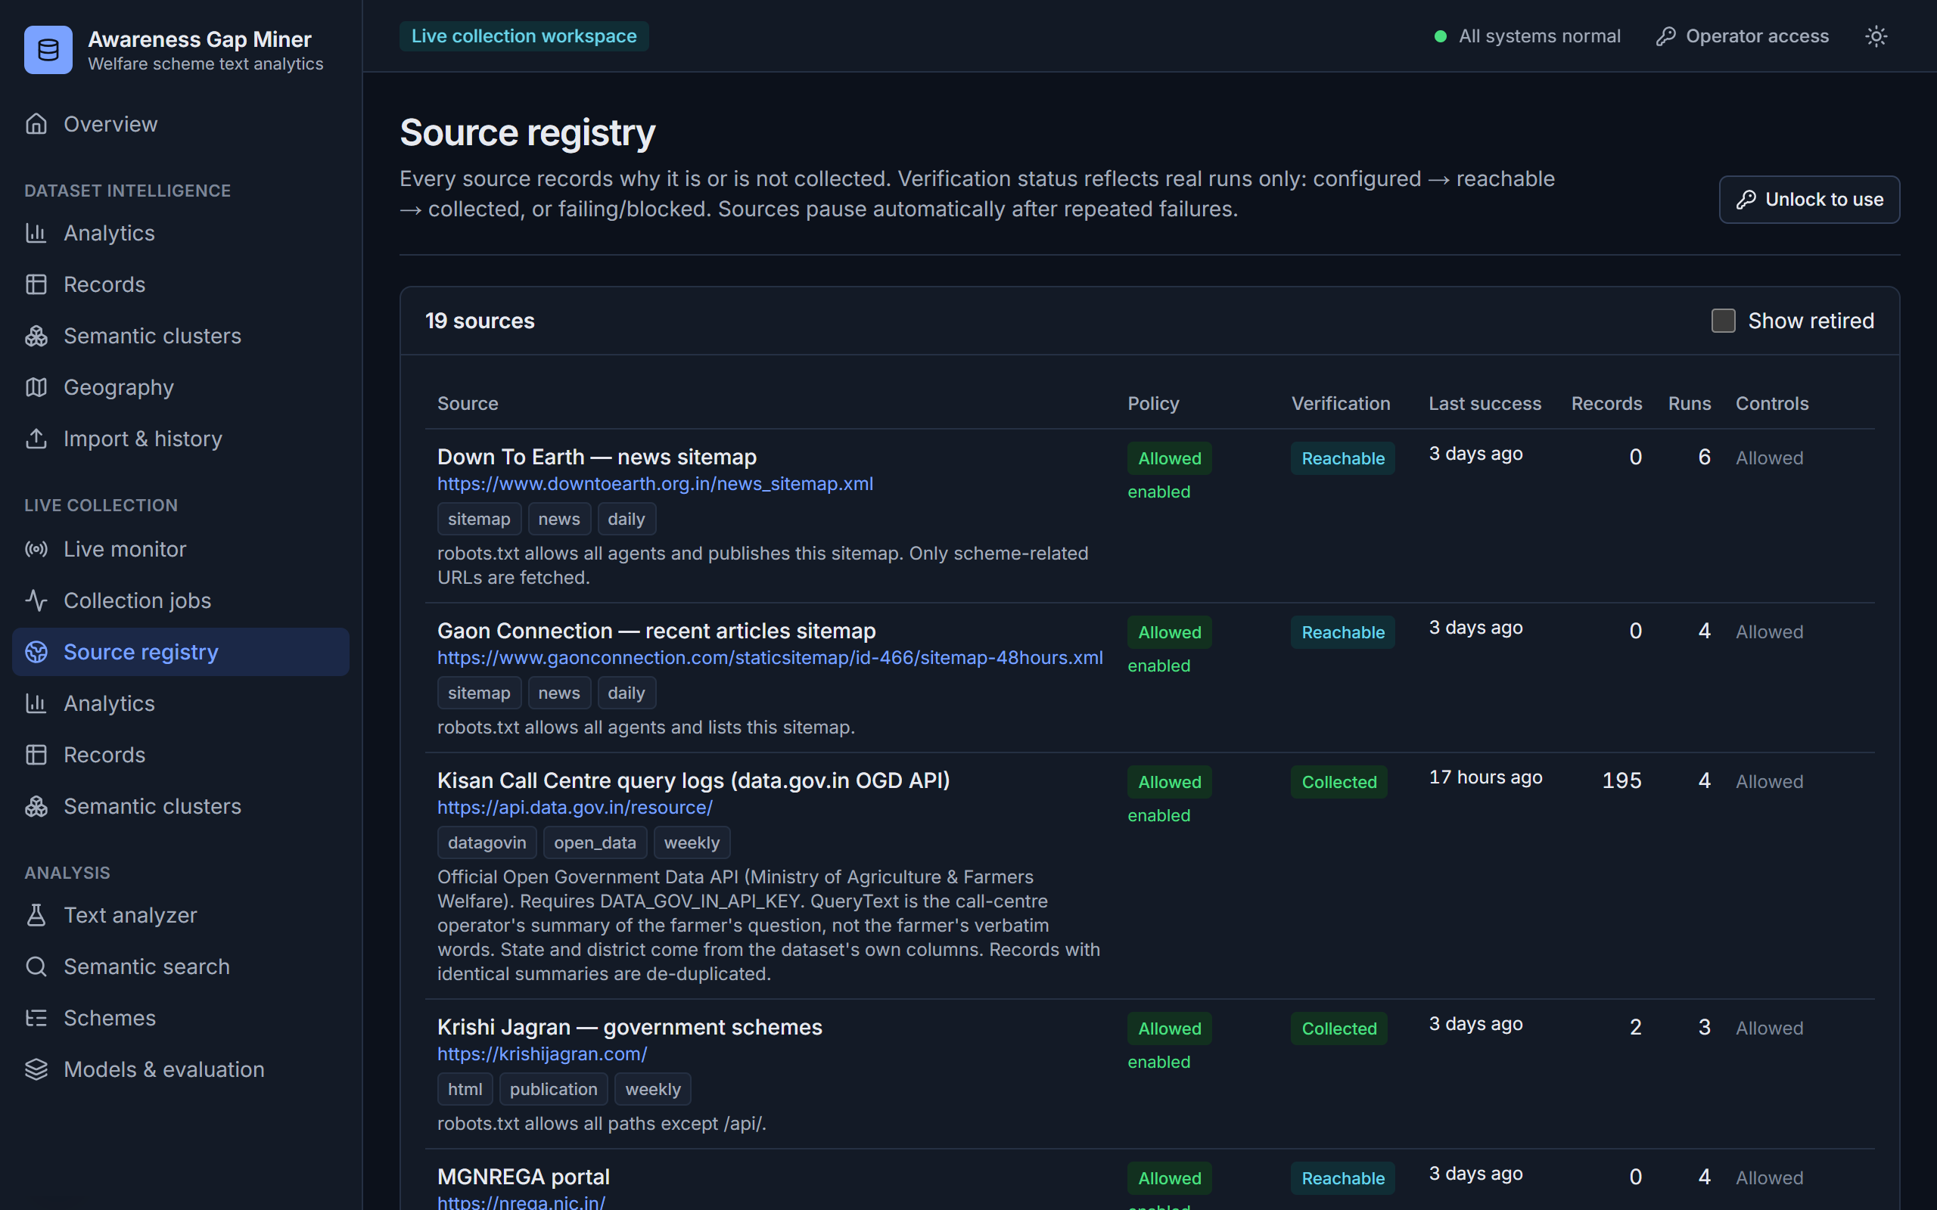
Figure 15: Source registry
Registered sources with their policy and verification status.
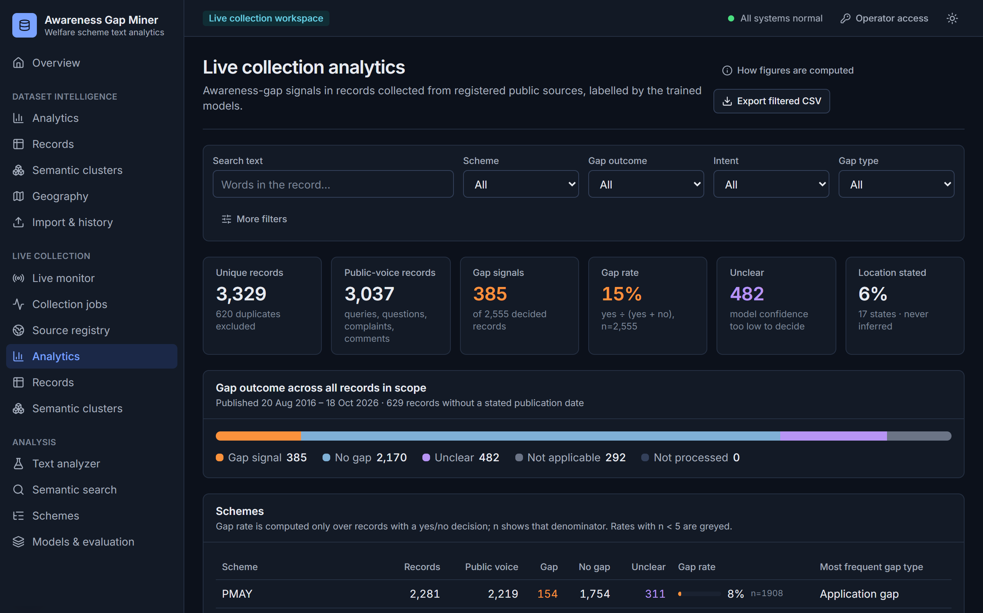
Figure 16: Live analytics
Outcomes, scheme table and timeline for collected records.
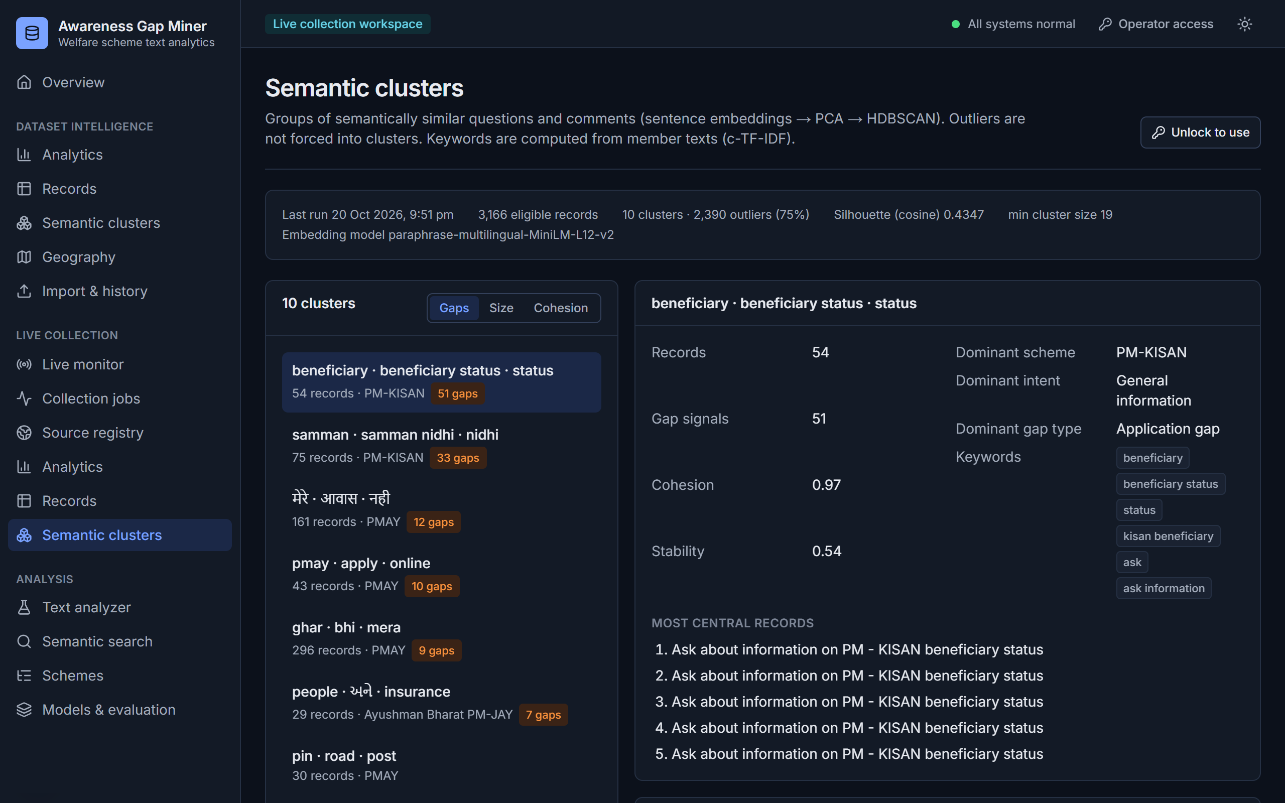
Figure 17: Live clusters
Recurring themes found in collected records.
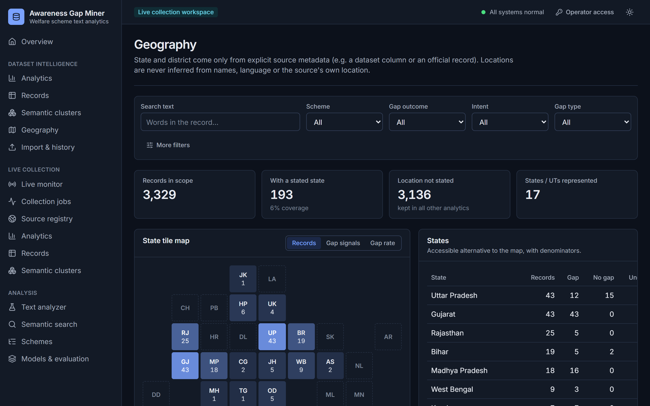
Figure 18: Geography
State-level view built only from records whose source states a location.
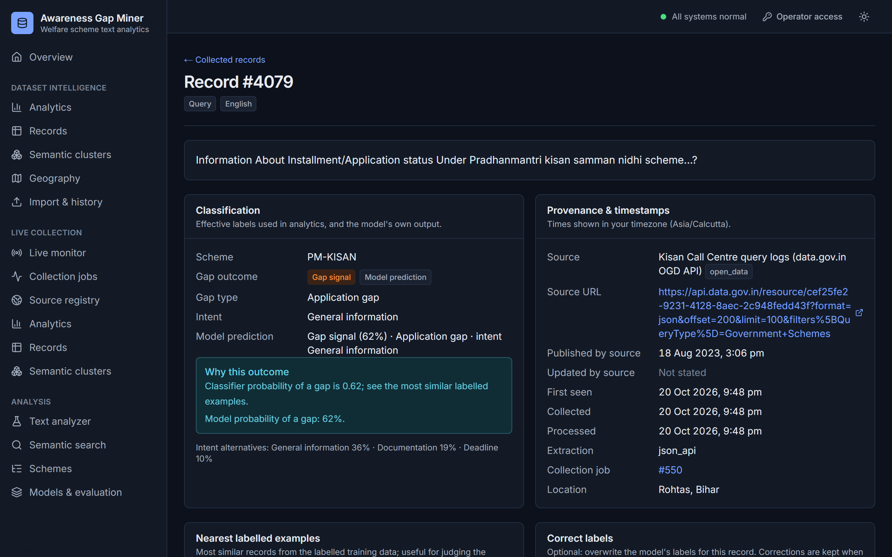
Figure 19: Record detail
One record with its labels, model probabilities, reason and nearest labelled examples.
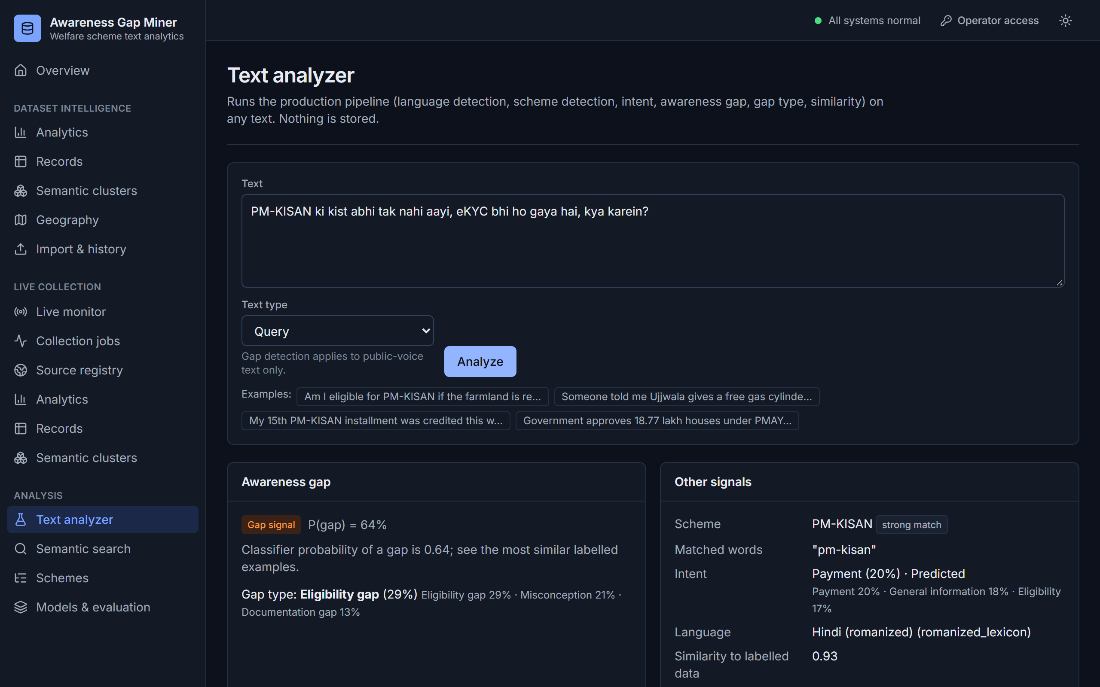
Figure 20: Text analyzer
Any text can be analysed on demand; this romanized-Hindi query is detected as a PM-KISAN gap signal.
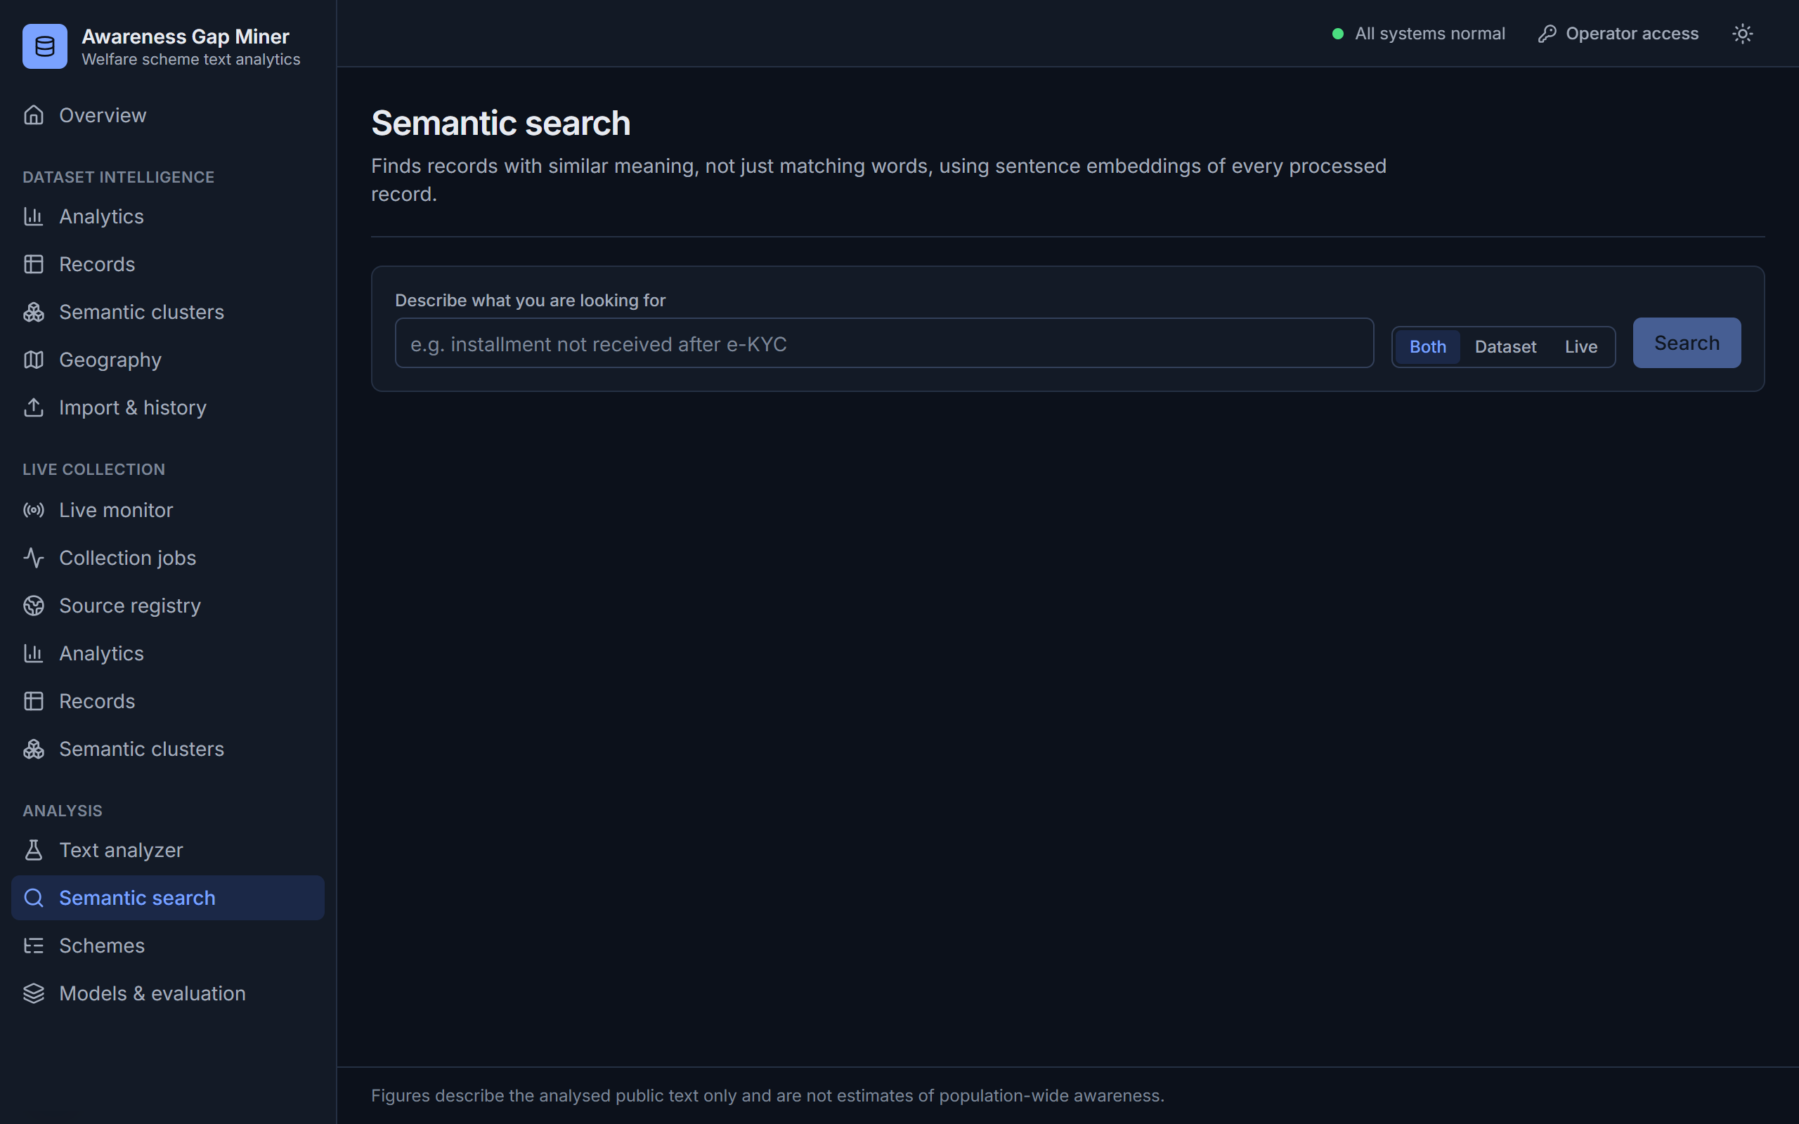
Figure 21: Semantic search
Records retrieved by meaning rather than exact words.
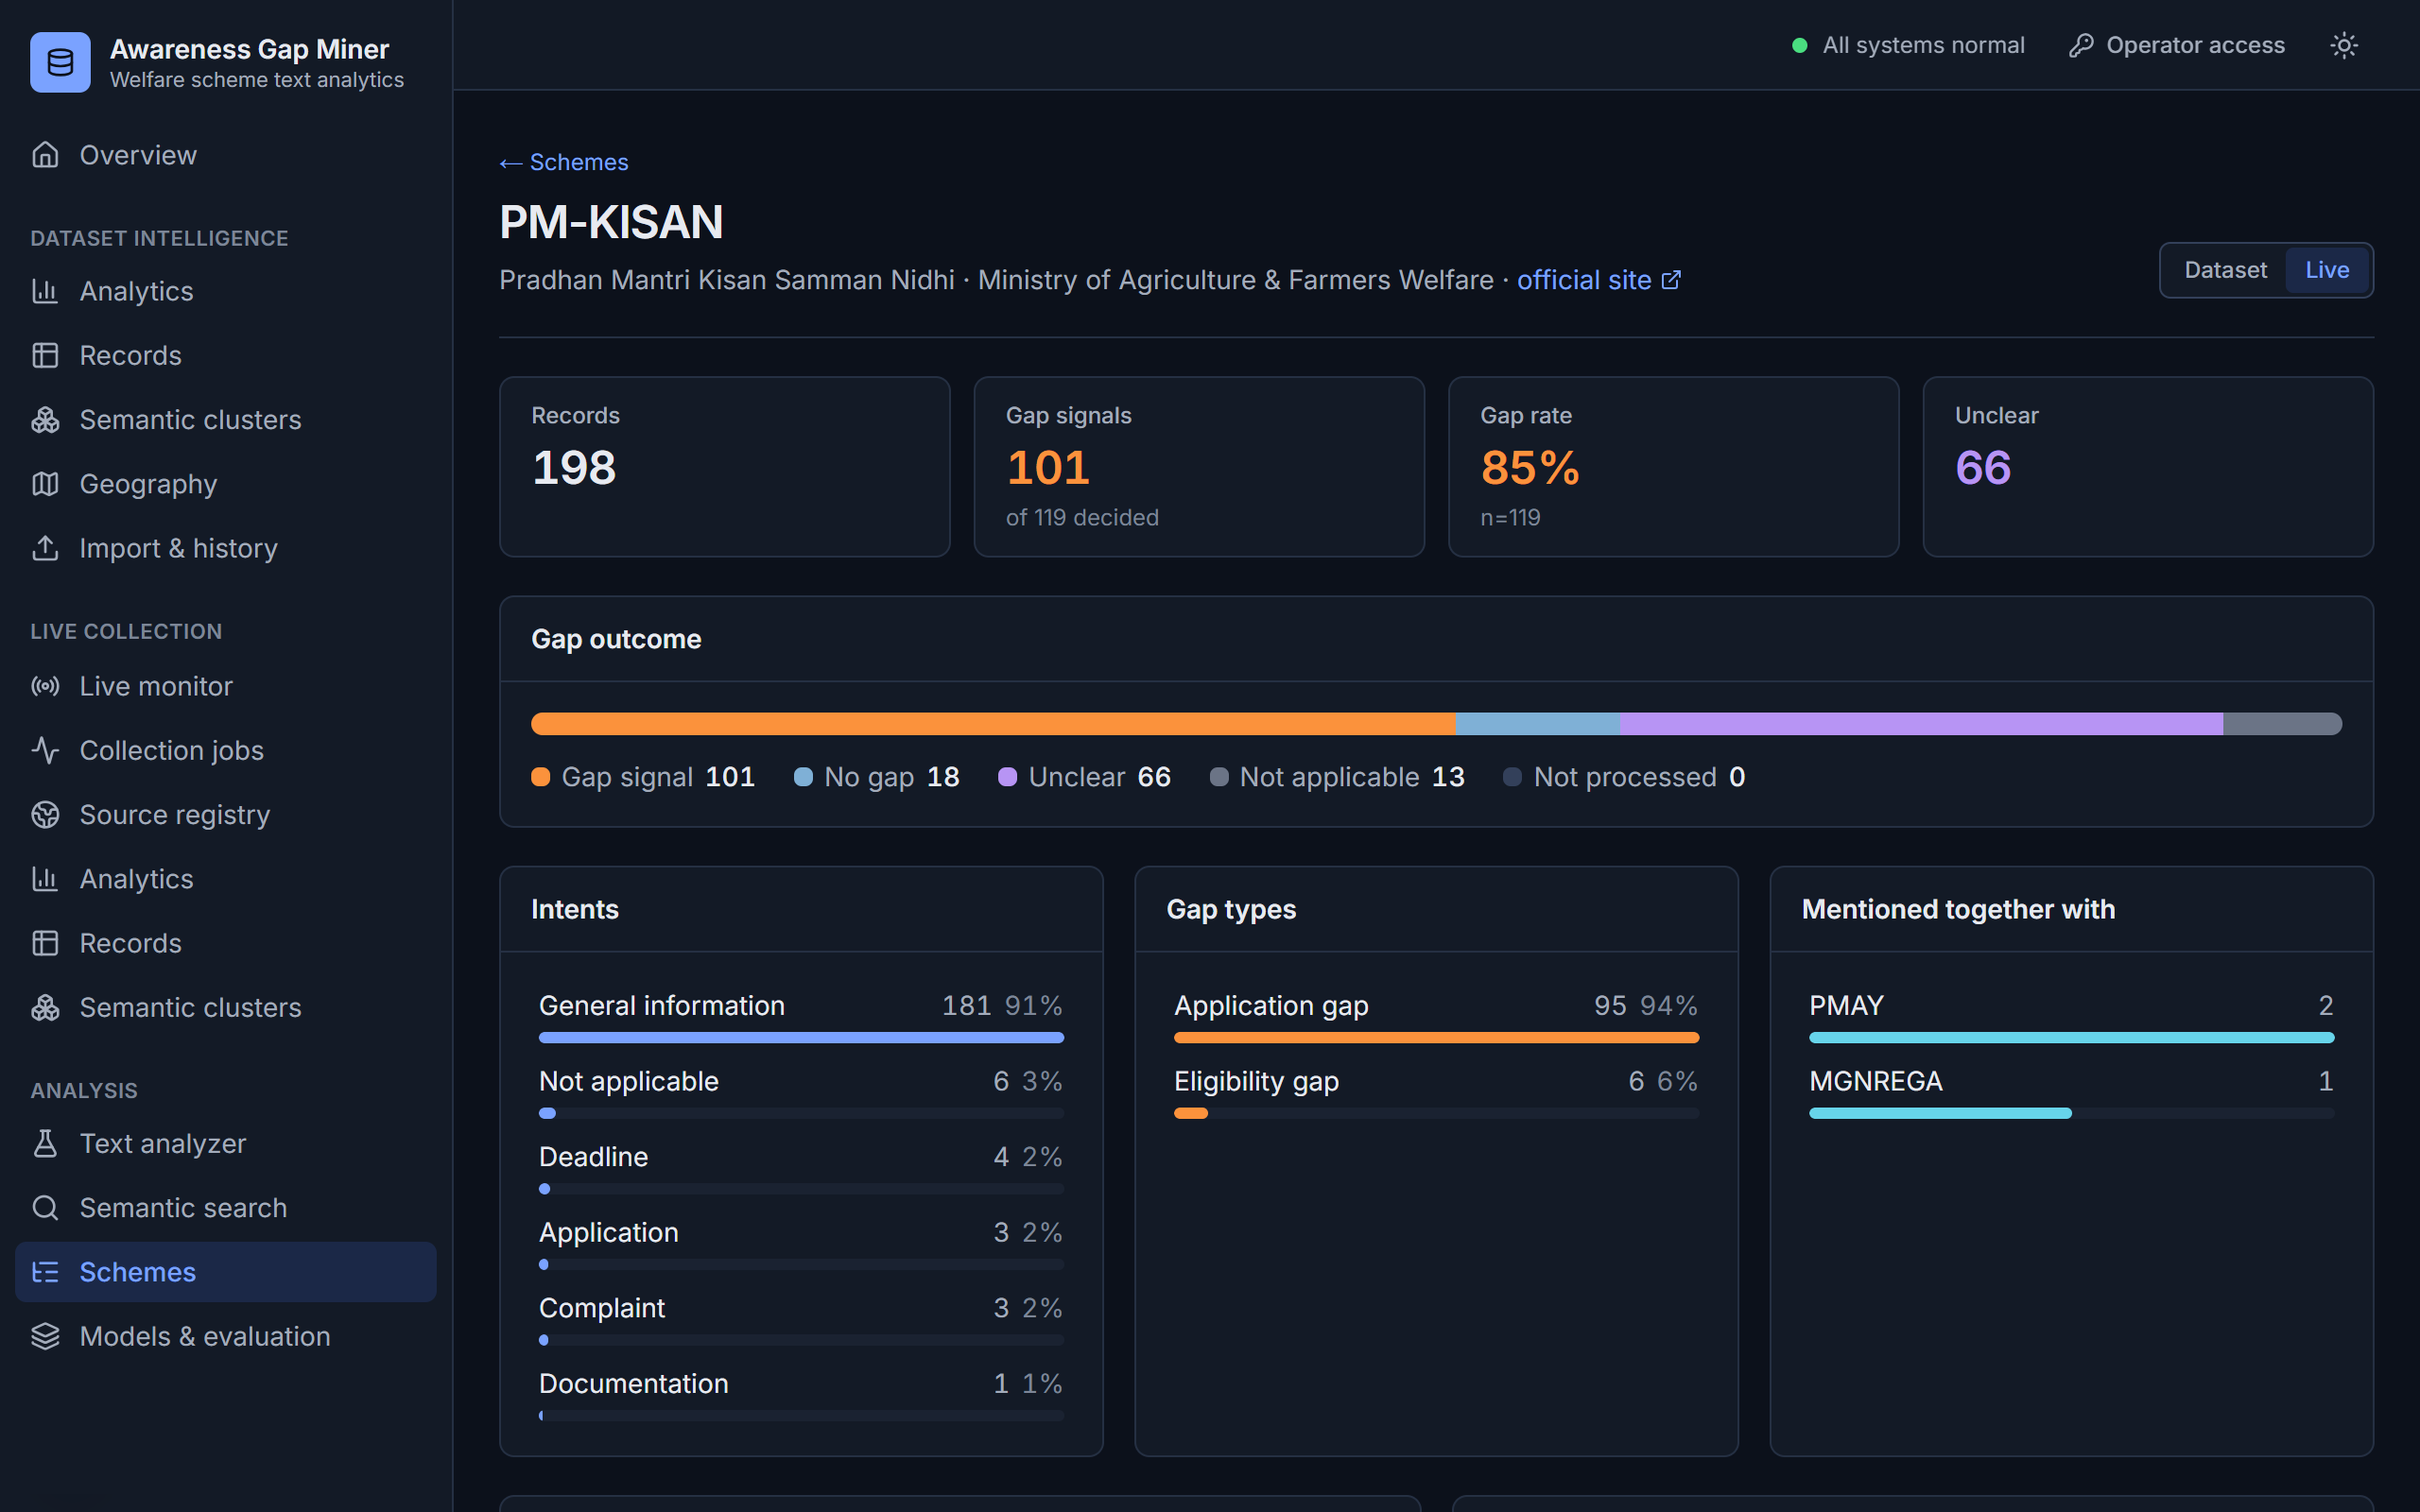
Figure 22: Scheme detail
Figures for a single scheme.
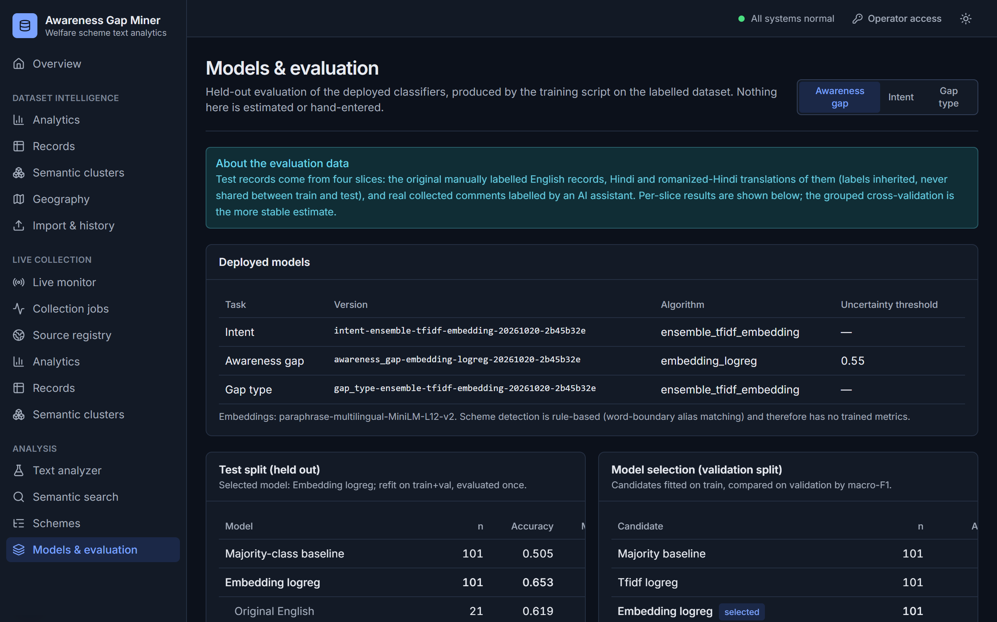
Figure 23: Models and evaluation
Selected models, test metrics and per-slice results as shown in the dashboard.

Conclusion
The project produced a working system that collects public text about Indian welfare schemes, processes it through one pipeline, and labels each record for scheme, language, intent, awareness gap and gap type, with evidence for every decision. It handles English, Hindi and romanized Hindi with one multilingual model. On held-out data the awareness-gap classifier reached a macro-F1 of 0.65 against a 0.34 baseline, and on 3,329 collected records it separated 385 gap signals from 2,170 ordinary records while marking 482 as unclear rather than guessing. The results are signals in the collected text, not population estimates.

Future work
Future work should add a larger, human-annotated training set, more official sources with location data, state-level schemes, and a tested PostgreSQL deployment.

References
Bogam, Chavan and Rani (2023) Awareness and utilisation of social welfare schemes among elderly villagers in rural Telangana. <<Verify journal, volume, pages>>
Campello, R.J.G.B., Moulavi, D. and Sander, J. (2013) 'Density-based clustering based on hierarchical density estimates', in Advances in Knowledge Discovery and Data Mining (PAKDD 2013). Berlin: Springer, pp. 160-172.
Jyrwa, Thabah, Khongtim and Kharbudon (2021) Awareness of Central Government schemes in Sohbar village, Meghalaya. <<Verify journal, volume, pages>>
Moorthy and Jeyadevi (2023) Awareness of Central Government schemes for sustainable development in rural India with reference to Coimbatore. <<Verify journal, volume, pages>>
Nikam, Ashok and Pal (2022) Farmers' information needs, access and impact across cotton-producing regions of Maharashtra. <<Verify journal, volume, pages>>
Reimers, N. and Gurevych, I. (2019) 'Sentence-BERT: sentence embeddings using Siamese BERT-networks', in Proceedings of EMNLP-IJCNLP 2019, pp. 3982-3992.
Reimers, N. and Gurevych, I. (2020) 'Making monolingual sentence embeddings multilingual using knowledge distillation', in Proceedings of EMNLP 2020, pp. 4512-4525.
Salton, G. and Buckley, C. (1988) 'Term-weighting approaches in automatic text retrieval', Information Processing & Management, 24(5), pp. 513-523.
Sethi and Biswal (2023) Awareness of farmers towards agricultural government schemes in Dhenkanal, Odisha. <<Verify journal, volume, pages>>
Shyam et al. (2013) Rural people's awareness and access to government schemes in six villages of Buxar, Bihar. <<Verify journal, volume, pages>>
Tripathi and Panwar (2024) Knowledge of rural women regarding selected government schemes. <<Verify journal, volume, pages>>
Vidhate and Kundap (2016) Awareness of newly launched social security schemes among rural population in India. <<Verify journal, volume, pages>>
Zhao, Z. and Mei, Q. (2013) 'Questions about questions: an empirical analysis of information needs on Twitter', in Proceedings of the 22nd International Conference on World Wide Web (WWW 2013), pp. 1545-1556.

