PROJECT REVIEW -1
ADVANCED PYTHON PROGRAMMING
Name: Hashwant Nagarajan Register No.: 23MID0221

1. Title
DepCheck: Dependency Audit for requirements.txt Files Using the PyPI Sentinel API

2. What does the website do?
DepCheck scans every package in a requirements.txt for malware and copycat names.
It shows which packages are safe, suspicious or high risk and exports a CSV report.

3. Frontend
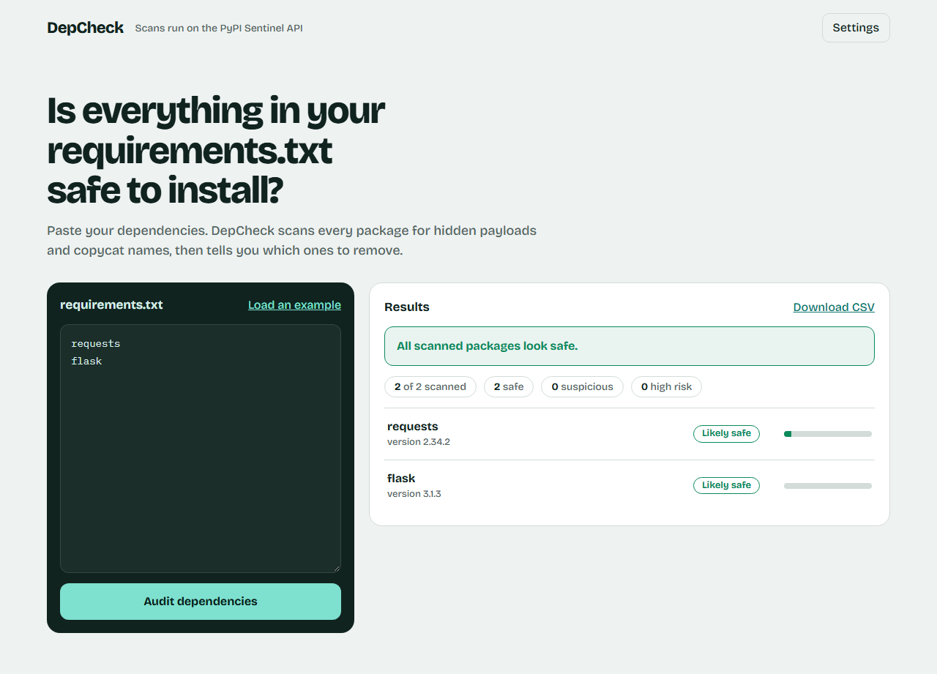
Figure 1: Audit results with the verdict banner and per-package findings

4. Backend architecture
DepCheck has no server of its own. It is a static website that sends package names to the Sentinel API and displays the results.
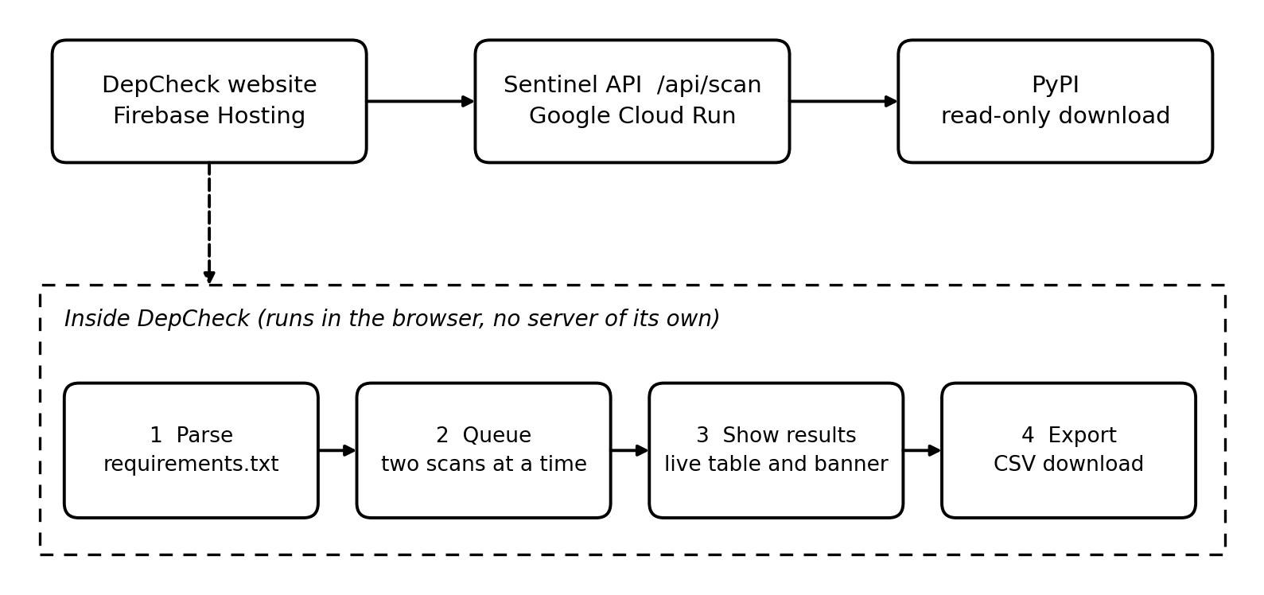
Figure 2: Backend architecture
- Parse: reads the pasted requirements.txt in the browser, ignoring comments, options and version pins, and removes duplicates.
- Queue: calls GET /api/scan for each package name, two at a time. Only package names are sent to the API, not the file.
- Results: each row updates live with a verdict (Likely safe, Suspicious or High risk), a risk bar and the top findings, and a banner says which packages to remove.
- Export: the CSV report is generated in the browser.
- Sentinel API: the service behind DepCheck fetches each package from PyPI without installing it, analyses its code, name and background, and returns a 0-100 risk score.

5. Are you hosting?
Yes. The website will be hosted on Firebase Hosting and uses the Sentinel API.
Website (frontend) | Firebase Hosting (separate site)
API used | Sentinel API on Google Cloud Run

