PROJECT REVIEW -1
ADVANCED PYTHON PROGRAMMING
Name: Rishi Kethan Reddy Register No.: 23MID0139

1. Title
PyPI Sentinel: Pre-Install Malware and Typosquat Detection for Python Packages

2. What does the website do?
Sentinel checks a Python package for malware and copycat names before you install it.
It shows a 0-100 risk score with the exact findings and file locations behind it.

3. Frontend
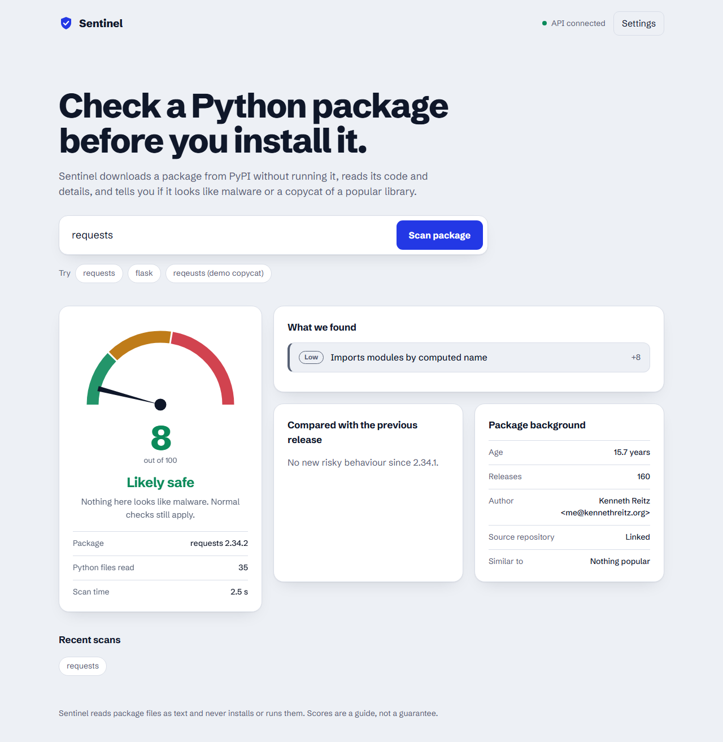
Figure 1: Home page with the package search box, scan results with the risk gauge and findings

4. Backend architecture
The backend is a Python FastAPI service. A scan never installs or runs the package.
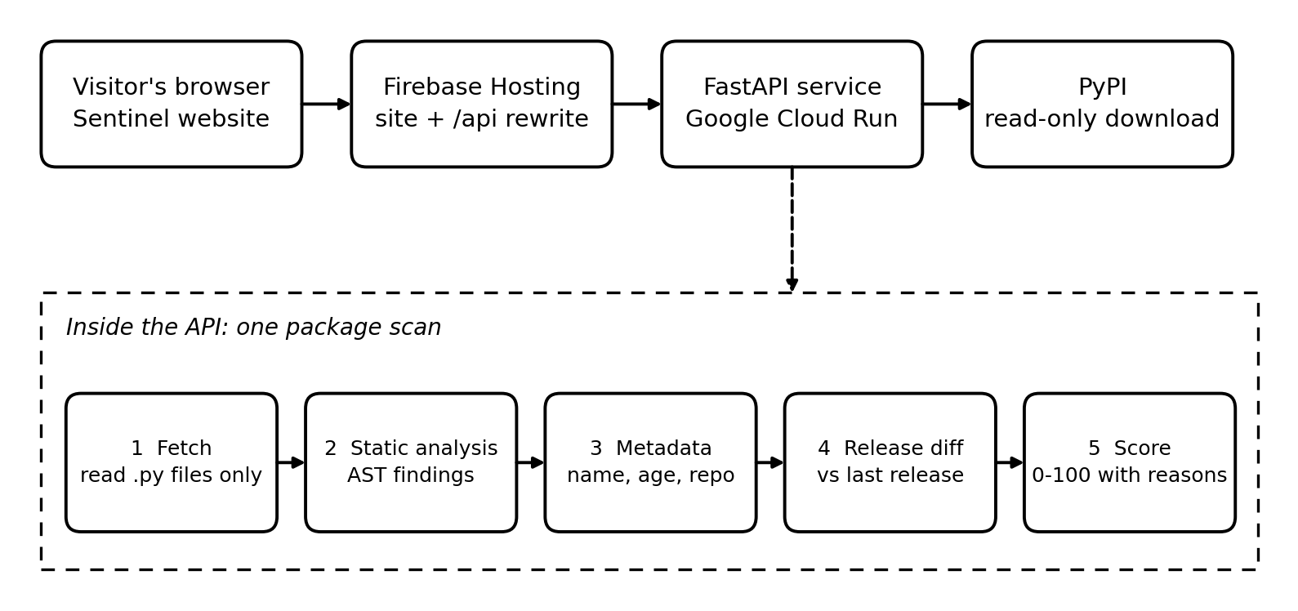
Figure 2: Backend architecture
- Fetcher: downloads the package archive from PyPI and reads only the .py files in memory.
- Static analysis: parses the code with Python's ast module and finds hidden payloads, dynamic exec or eval, network calls, system commands and credential-file paths, tagged by when the code runs (install, import or runtime).
- Metadata: measures how close the name is to popular packages (typosquatting), the package age and whether a source repository is linked.
- Release diff: compares the version with the previous release and reports newly added risky behaviour.
- Scoring: combines the findings with weighted rules into a 0-100 score and returns JSON with the reasons. A machine-learning classifier is planned as the next stage.
- Clients: the same engine powers a command-line tool, and the partner website DepCheck calls this API.

5. Are you hosting?
Yes. The website and its API will be hosted on Firebase and Google Cloud.
Website (frontend) | Firebase Hosting
API (backend) | Google Cloud Run (FastAPI in a container), reached through a Firebase Hosting rewrite from /api/**

