“Linux-Based Alarm Clock Using System Programming Concepts”
A Project Report Submitted in the partial fulfillment of the requirements for the award of the degree of

BACHELOR OF TECHNOLOGY
In

DEPARTMENT OF COMPUTER SCIENCE ENGINNERING

By

KARNATI LAXMI LAHARI 2520090206

SIVARAPU RISHIL 2520090174

SIDDOJU ANJANI SHREYAJ 2520090082

Under the Esteemed Guidance of

M. RAGUPATHI
Assistant Professor
Department of Computer Science and Engineering




K L (Deemed to be) University DEPARTMENT OF COMPUTER SCIENCE ENGINEERING
&

DEPARTMENT OF COMPUTER SCIENCE AND INFORMATION TECHNOL

Declaration

The Project Report entitled “Linux-Based Alarm Clock Using System Programming Concepts” is a record of Bonafide work of Karnati Laxmi Lahari–2520090206,SivarapuRishil-2520090174,SiddojuAnjaniShreyaj-252009082,submitted inpartial fulfillment for the award of B. Tech in Computer Science and Engineering (or) Computer Science and Information Technology to the K L University. The results embodied in this report have not been copied from any other departments/University/Institute.

KARNATI LAXMI LAHARI 2520090206

SIVARAPU RISHIL 2520090174

SIDDOJU ANJANI SHREYAJ 2520090082
K L (Deemed to be) University

DEPARTMENT OF COMPUTER SCIENCE ENGINEERING

CERTIFICATE

This is certify that the mini project based report entitled“Linux-Based Alarm Clock Using System Programming Concepts” is a bonafide work done and submitted by Karnati Laxmi Lahari – 2520090206 ,Sivarapu Rishil – 2520090174, Siddoju Anjani Shreyaj-252009082,in partial fulfillment of the requirements for the award of the degree of BACHELOR OF TECHNOLOGY in Department of Computer Science Engineering, K L (Deemed to be University), during the academic year 2024-2025.

Signature of the Guide

Signature of the Course Coordinator Signature of the HOD
ACKNOWLEDGEMENT
The success in this project would not have been possible but for the timely help and guidance rendered by many people. Our wish to express my sincere thanks to all those who has assisted us in one way or the other for the completion of my project.

Our greatest appreciation to my Course Coordinator Dr. K. Anusha, and my guide M.Ragupathi, Department of Computer Science which cannot be expressed in words for his/her tremendous support, encouragement and guidance for this project.

We express our gratitude to Dr. P Venkateshwara Roa (CSE), Head of the Department for Computer Science Engineering for providing us with adequate facilities, ways and means by which we are able to complete this project-based Lab.

We thank all the members of teaching and non-teaching staff members, and also who have assisted me directly or indirectly for successful completion of this project. Finally, I sincerely thank my parents, friends and classmates for their kind help and cooperation during my work.

KARNATI LAXMI LAHARI 2520090206

SIVARAPU RISHIL 2520090174

SIDDOJU ANJANI SHREYAJ 2520090082
Abstract

The Linux-Based Alarm Clock Using System Programming Concepts is a C-based application developed to demonstrate fundamental operating system concepts through a practical alarm management system. The project uses POSIX system programming interfaces to implement alarm creation, monitoring, cancellation, and notification. It demonstrates how operating systems provide services for process management, signal handling, timers, file operations, inter-process communication, memory management, and thread synchronization.
The main application uses the fork() system call to create a separate child process for each alarm. The alarm() function schedules a timer that generates the SIGALRM signal when the specified delay expires. The sigaction() function installs a signal handler, while pause() allows the child process to wait for the signal without continuously checking the timer. The parent process manages alarm information, supports cancellation using kill() and SIGTERM, monitors child-process completion using waitpid(), and maintains an event log using file operations.
In addition to the main alarm clock, the project includes separate demonstrations of inter-process communication using named pipes (FIFO), process memory isolation, low-level file input/output, and thread synchronization using POSIX threads and mutexes. A graphical user interface developed using Python Tkinter provides a convenient way to launch and demonstrate the different modules.
The project provides practical experience with C programming, POSIX APIs, process control, signal-driven events, and other essential operating system mechanisms. It also helps demonstrate how theoretical operating system concepts can be applied in a working software application.
Keywords: Operating System, System Programming, C Programming, POSIX, Process Management, Signals, Timers, Inter-Process Communication, Memory Management, File I/O, Threads, Synchronization.

Index

S. No. | Chapter | Topics / Subtopics | Page No.
 | Acknowledgement |  | i
 | Abstract |  | ii
1 | Introduction |  | 1–10
 |  | 1.1 Background of the Project
 |  | 1.2 Problem Statement
 |  | 1.3 Scope of the Project
 |  | 1.4 Objectives of the Project
 |  | 1.5 Importance of the Application
 |  | 1.6 Target Users / Audience
2 | OS Concepts and Background Study |  | 11-12
 |  | 2.1 Operating System Concepts Related to the Project
 |  | 2.2 Existing Methods / Algorithms
 |  | 2.3 Proposed Approach
 |  | 2.4 Advantages of the Proposed Approach
3 | System Requirements |  | 13–14
 |  | 3.1 Hardware Requirements
 |  | 3.2 Software Requirements
 |  | 3.3 Operating System Environment – Ubuntu / WSL
 |  | 3.4 Development Tools and Compilers
4 | Technology and Tools Used |  | 15–17
 |  | 4.1 C / C++ Programming
 |  | 4.2 GCC Compiler
 |  | 4.3 Linux System Calls
 |  | 4.4 POSIX Threads / Synchronization
 |  | 4.5 Linux Commands and Utilities
 |  | 4.6 Other Tools / Libraries Used
5 | System Architecture and Design |  | 18–21
 |  | 5.1 Overall System Architecture
 |  | 5.2System Workflow
 |  | 5.3 Flowchart / Data Flow
 |  | 5.4 Module Description
 |  | 5.5 Input and Output Design
6 | Implementation |  | 22–29
 |  | 6.1 Module-wise Implementation
 |  | 6.2 Algorithm / Pseudocode
 |  | 6.3 Core C / C++ Implementation
 |  | 6.4 Linux System Calls / APIs Used
 |  | 6.5 Process / Thread Implementation
 |  | 6.6 IPC / Synchronization Implementation
 |  | 6.7 Memory Management Implementation
 |  | 6.8 Optional User Interface Implementation
7 | Execution and Demonstration |  | 30-38
 |  | 7.1 Compilation in Ubuntu
 |  | 7.2 Execution Commands
 |  | 7.3 Sample Inputs and Outputs
 |  | 7.4 Screenshots of Execution
 |  | 7.5 Demonstration of OS Concepts
8 | Conclusion |  | 39-40
 |  | 8.1 Summary of the Project
 |  | 8.2 Objectives Achieved
 |  | 8.3 Results Achieved
 |  | 8.4 Skills and Learning Outcomes
9 | References |  | 41
 |  | 9.1 Books
 |  | 9.2 Research Papers
 |  | 9.3 Linux / GNU Documentation
 |  | 9.4 Online Resources

CHAPTER -1 INTRODUCTION

1.1 Background of the Project

Operating systems provide essential services that applications use for process creation, process management, memory management, file handling, inter-process communication, and signal handling. System programming allows programmers to directly use these operating-system services through system calls and POSIX APIs.
The Linux-Based Alarm Clock project is developed in C to demonstrate these operating-system concepts through a practical alarm application. Instead of implementing an alarm using only a simple timer, the project uses processes, signals, timers, and system calls to demonstrate how an operating system manages events and processes.
Each alarm is handled using a separate child process created using the fork() system call. The alarm() function schedules a SIGALRM signal, while pause() allows the child process to wait for the signal without continuously checking the time. When the alarm expires, a signal handler displays the alarm notification.
The project also demonstrates alarm cancellation, process monitoring, file logging, inter-process communication, memory management, file I/O, and thread synchronization.

1.2 Problem Statement

The objective of this project is to develop a terminal-based alarm clock using C and POSIX system-programming concepts.
The application should allow the user to:
- Set an alarm.
- View created alarms.
- Cancel an alarm.
- Receive a notification when an alarm expires.
- Maintain an alarm log.
The project should also demonstrate how operating-system concepts such as processes, signals, timers, system calls, IPC, memory management, file handling, and synchronization can be applied in a practical application.

1.3 Scope of the Project

The scope of the project includes:
- Creating alarms using a specified delay in seconds.
- Creating a child process for each alarm using fork().
- Scheduling alarms using alarm().
- Handling SIGALRM using sigaction().
- Waiting for signals using pause().
- Cancelling alarms using kill() and SIGTERM.
- Monitoring completed child processes using waitpid().
- Viewing active and completed/cancelled alarms.
- Maintaining an alarm log using file system calls.
- Demonstrating IPC using a named pipe/FIFO.
- Demonstrating memory isolation using fork().
- Demonstrating low-level file I/O.
- Demonstrating POSIX threads and mutex synchronization.
- Providing a Tkinter-based GUI for demonstrating CO-1 to CO-6.
1.4 Objectives of the Project
To understand the role of an operating system as a service provider.
- To implement process creation using fork().
- To understand parent and child processes.
- To implement timer-based events using alarm().
- To handle signals using sigaction().
- To demonstrate process cancellation using kill().
- To monitor child processes using waitpid().
- To demonstrate inter-process communication using FIFO.
- To demonstrate process memory isolation and Copy-on-Write.
- To demonstrate file descriptors and low-level file operations.
- To demonstrate threads and mutex-based synchronization.
- To integrate the demonstrations into a single GUI-based project presentation.

1.5 Importance of the Application
The project is important because it provides a practical way to understand operating-system concepts.
Instead of learning system calls and process management only theoretically, the project allows these concepts to be observed through actual program execution.
For example:
- fork() demonstrates process creation.
- alarm() demonstrates timer management.
- SIGALRM demonstrates signal delivery.
- kill() demonstrates process signalling.
- waitpid() demonstrates process monitoring.
- FIFO demonstrates inter-process communication.
- open(), read(), write(), and close() demonstrate file I/O.
- POSIX threads and mutex demonstrate concurrency and synchronizatio

1.6 Target Users / Audience
The project is mainly intended for:
- Students learning Operating Systems.
- Students learning System Programming.
- Students learning C and POSIX programming.
- Faculty evaluating practical OS concepts.
- Beginners studying processes, signals, IPC, memory, files, and threads.

CHAPTER -2 SYSTEM REQUIREMENTS

2.1 Operating System Concepts Related to the Project

OS Concept | Application in Project
Process Creation | fork() creates a child process for an alarm
Process ID | PID is used to identify each alarm process
Signals | SIGALRM triggers the alarm
Signal Handling | sigaction() installs the signal handler
Timers | alarm() schedules the alarm
Process Blocking | pause() waits for the signal
Process Termination | Child exits after alarm notification
Process Cancellation | kill() sends SIGTERM
Process Monitoring | waitpid() checks child completion
IPC | FIFO/named pipe transfers data between processes
File I/O | open(), read(), write(), close()
Memory Management | fork() demonstrates process memory isolation
Threads | POSIX threads demonstrate concurrency
Synchronization | Mutex protects shared data

2.2 Existing Methods / Algorithms

A basic alarm program can use a timer in a single process. However, such an approach provides limited demonstration of process management.
In this project, each alarm is associated with a separate child process. This allows multiple alarms to operate independently and demonstrates the relationship between parent and child processes.
The child process waits for its timer event instead of continuously checking the time. This avoids unnecessary busy waiting.

2.3 Proposed Approach

The proposed approach works as follows:
- The user selects Set Alarm.
- The user enters the alarm delay.
- The program validates the input.
- The parent process calls fork().
- A child process is created.
- The child installs a SIGALRM handler using sigaction().
- The child schedules the timer using alarm().
- The child waits using pause().
- When the timer expires, SIGALRM is delivered.
- The signal handler displays *** ALARM TRIGGERED ***.
- The child process exits.
- The parent detects the completed child using waitpid().
- The event is recorded in alarm_log.txt.

For cancellation:
- The user selects Cancel Alarm.
- The user enters the alarm ID.
- The parent finds the corresponding PID.
- kill() sends SIGTERM to the child.
- The parent waits for the child using waitpid().
- The alarm is marked as inactive.
- The cancellation event is recorded in the log.
2.4 Advantages of the Proposed Approach
Demonstrates real operating-system process management.
- Supports multiple alarms.
- Uses signal-driven notification.
- Avoids busy waiting.
- Allows alarm cancellation.
- Maintains alarm information using PIDs.
- Records alarm events.
- Demonstrates multiple OS concepts in one project.
- Provides separate demonstrations for all six course outcomes.

CHAPTER 3 – SYSTEM REQUIREMENTS

3.1 Hardware Requirements

The project requires a standard computer or laptop capable of running a C compiler and terminal-based applications.
Hardware requirements:
- Processor: Dual-core processor or above
- RAM: Minimum 4 GB
- Storage: Minimum 500 MB free space
- Keyboard and monitor/display
- Internet connection for Git/GitHub activities, if required
3.2 Software Requirements
Software / Tool | Purpose
C Programming Language | Development of the alarm clock and OS demonstrations
Clang / GCC | Compilation of C programs
Terminal / Shell | Compilation and execution
Python 3 | Running the GUI launcher
Tkinter | Graphical demonstration interface
Git | Version control
GitHub | Source-code repository and collaboration

3.3 Operating System Environment
The project is designed around Linux/POSIX system-programming concepts and is suitable for an Ubuntu/Linux environment.
During development and testing, the C programs were compiled and executed successfully on macOS using Clang and POSIX-compatible APIs.
The major APIs used in the project are POSIX-style interfaces such as:
- fork()
- alarm()
- sigaction()
- pause()
- kill()
- waitpid()
- open()
- read()
- write()
- close()
- mkfifo()

3.4 Development Tools and Compilers

Clang
Clang was used to compile the C programs during development on macOS.
Example:
clang alarm_clock.c -o alarm_clock

Terminal
The Terminal is used to compile and execute the C programs.

Python and Tkinter
Python with Tkinter is used to provide the graphical interface containing the CO-1 to CO-6 demonstration tabs.

Git and GitHub
Git and GitHub are used for maintaining and sharing the project source code.

CHAPTER 4 – TECHNOLOGY AND TOOLS USED
4.1 C Programming
The main alarm clock and supporting demonstrations are implemented using the C programming language.
C is suitable for system programming because it provides direct access to operating-system interfaces and POSIX APIs.
The main program is:
alarm_clock.c
Supporting programs include:
- memory_demo.c
- fifo_demo.c
- fifo_sender.c
- file_demo.c
- thread_demo.c
4.2 Compiler
The project was compiled using the Clang compiler during development.
Example:
clang alarm_clock.c -o alarm_clock
./alarm_clock
The same source code can be targeted toward Linux using GCC or Clang.

4.3 Linux / POSIX System Calls and APIs
The following APIs are used in the project:
API | Purpose
fork() | Creates a child process
alarm() | Schedules a SIGALRM signal
sigaction() | Installs a signal handler
pause() | Waits for a signal
kill() | Sends a signal to another process
waitpid() | Monitors or waits for child processes
open() | Opens or creates a file
read() | Reads data
write() | Writes data
close() | Closes a file descriptor
mkfifo() | Creates a named pipe

4.4 POSIX Threads and Synchronization
The project contains a separate thread demonstration using POSIX threads.
The demonstration shows:
- Thread creation
- Shared data
- Mutex
- Mutual exclusion
- Thread synchronization
A shared counter is accessed by multiple threads, while a mutex protects the shared data from simultaneous modification.
4.5 Linux Commands and Utilities
The following commands are used during development and execution:
cd ~/Desktop/Linux_Alarm_Clock_OS_Project
Compile:
clang alarm_clock.c -o alarm_clock
Run:
./alarm_clock
Run the GUI:
python3 gui.py
4.6 Other Tools and Libraries Used

Python Tkinter
Used to create the graphical interface for demonstrating the six course outcomes.

AppleScript / osascript
Used by the GUI on macOS to open the C demonstrations in Terminal windows.

Git / GitHub
Used for source-code management and project collaboration.

CHAPTER 5 – SYSTEM ARCHITECTURE AND DESIGN

5.1 Overall System Architecture
The system consists of a manager process and separate alarm child processes.
The manager process is responsible for:
- Displaying the menu
- Creating alarms
- Storing alarm information
- Viewing alarms
- Cancelling alarms
- Monitoring child processes
- Maintaining the alarm log
Each alarm is handled by a child process.

Architecture

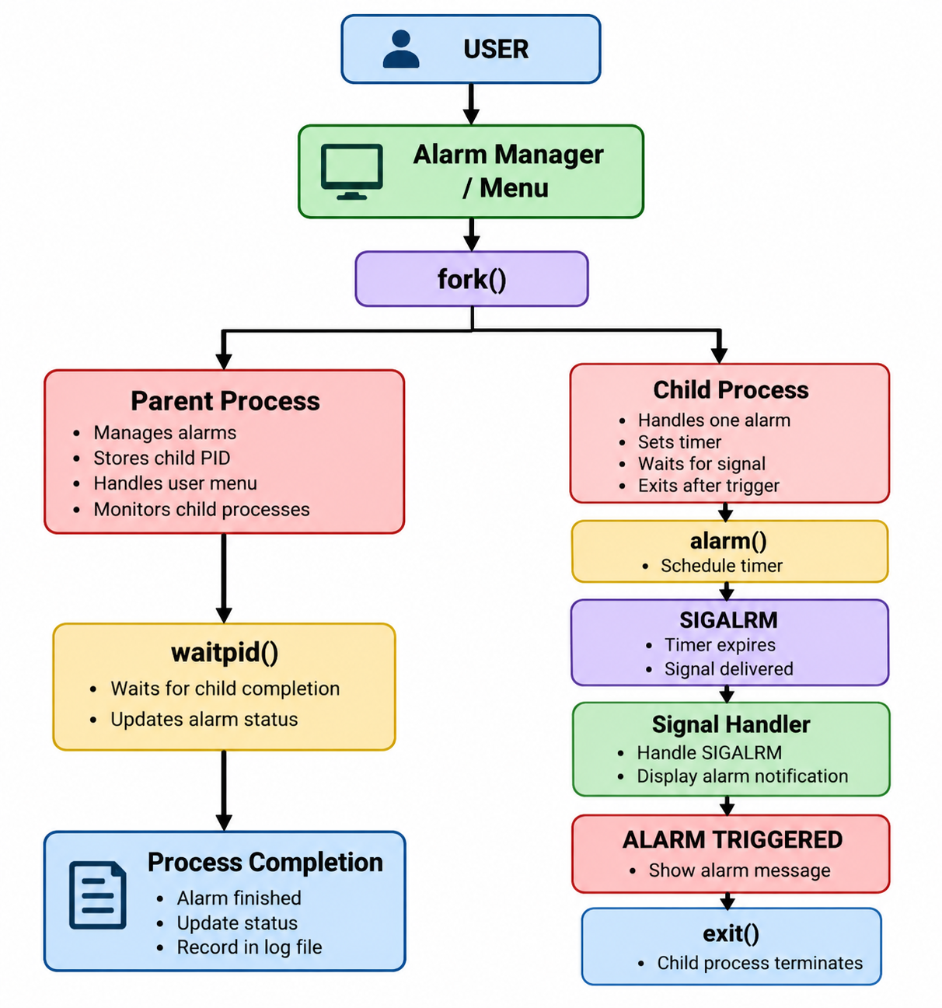

5.2 System Workflow
The working procedure of the alarm clock is:
- Start the alarm-clock program.
- Display the main menu.
- Select Set Alarm.
- Enter the alarm delay.
- Validate the input.
- Create a child process using fork().
- The child installs the SIGALRM handler.
- The child schedules the timer using alarm().
- The child waits using pause().
- The parent continues running the menu.
- When the timer expires, SIGALRM is delivered.
- The signal handler displays the alarm notification.
- The child process exits.
- The parent detects completion using waitpid().
- The event is recorded in the alarm log.
5.3 Flowchart / Data Flow

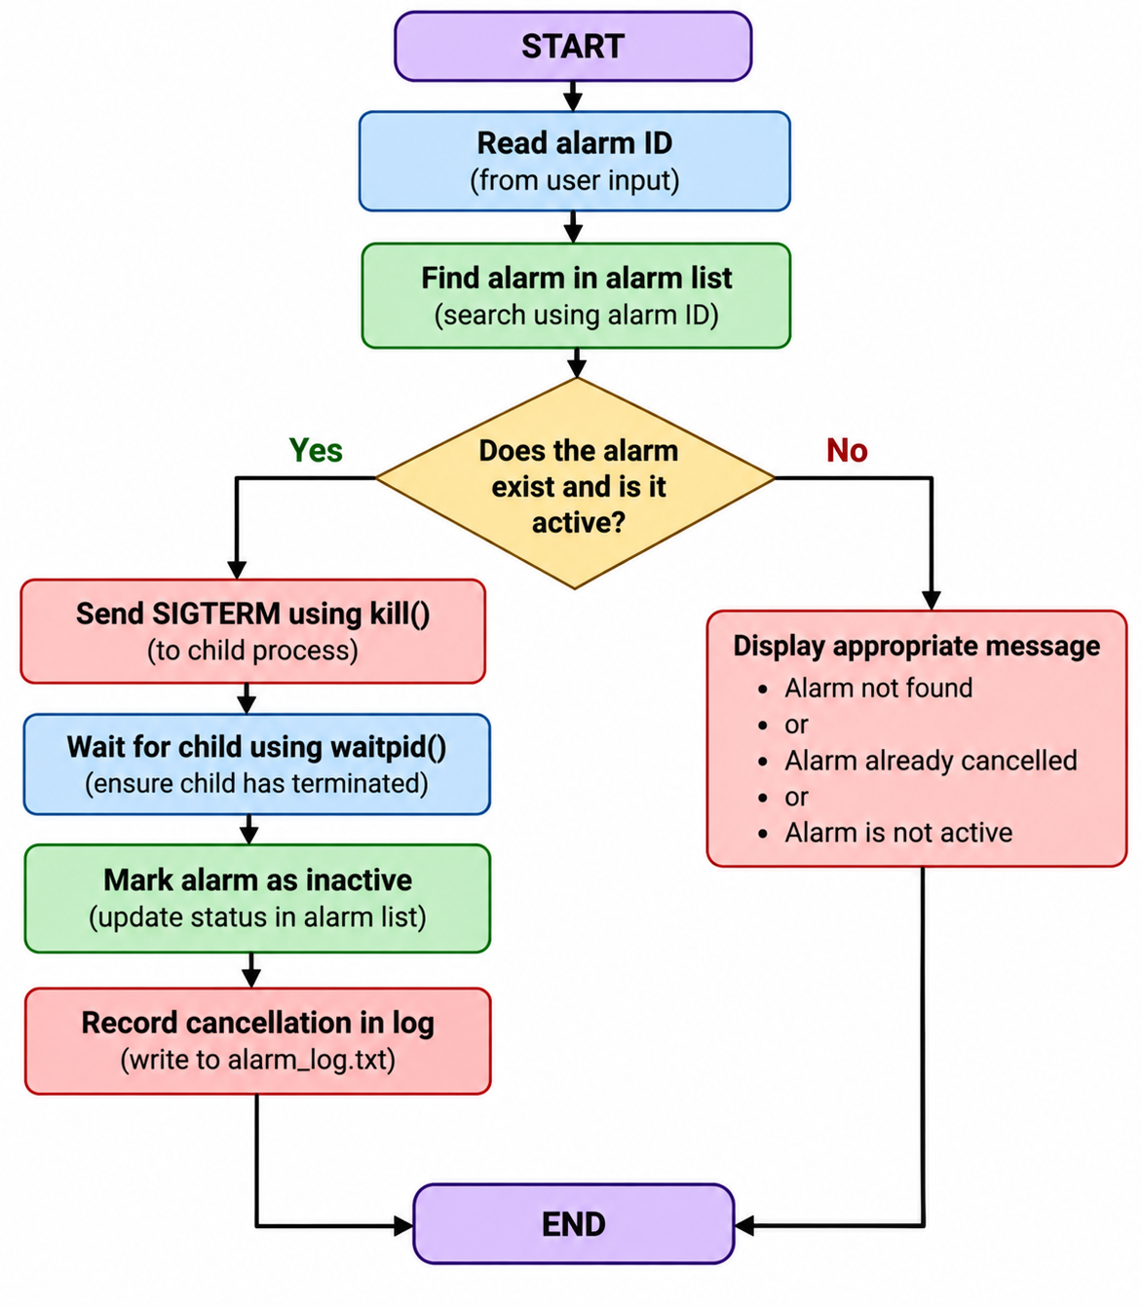

5.4 Module Description
Module | Description
Alarm Manager | Controls the main menu and alarm records
Alarm Child | Handles the timer and alarm notification
Signal Handler | Handles SIGALRM
Cancellation | Uses kill() and SIGTERM
Process Monitoring | Uses waitpid()
Logging | Stores alarm events in alarm_log.txt
FIFO Demo | Demonstrates named-pipe IPC
Memory Demo | Demonstrates process memory isolation
File Demo | Demonstrates low-level file I/O
Thread Demo | Demonstrates threads and mutex
GUI Launcher | Provides CO-1 to CO-6 demonstrations

5.5 Input and Output Design

Input
The main inputs to the application are:
- Menu choice
- Alarm delay in seconds
- Alarm ID for cancellation
Example:
1. Set alarm
2. View alarms
3. Cancel alarm
4. View alarm log
5. Exit
Enter choice:
For setting an alarm:
Enter delay in seconds: 5

Output
When an alarm is created:
Alarm 1 created. Child PID = 1234
When the timer expires:
*** ALARM TRIGGERED ***
The parent may then display:
[Manager] Alarm 1 has finished.
For cancellation:
Alarm 2 cancelled.

CHAPTER 6 – IMPLEMENTATION

6.1 Module-wise Implementation
The project is divided into multiple modules, with each module demonstrating a specific operating-system or system-programming concept.

Main Alarm Clock Module
The main program is implemented in:
alarm_clock.c
It provides the following options:
- Set alarm
- View alarms
- Cancel alarm
- View alarm log
- Exit
The main alarm clock uses processes, signals, timers, and system calls to manage alarms

Supporting Demonstration Modules
The project also contains:
File | Purpose
alarm_clock.c | Main alarm clock
fifo_demo.c | FIFO receiver
fifo_sender.c | FIFO sender
memory_demo.c | Memory management demonstration
file_demo.c | File I/O demonstration
thread_demo.c | Thread and mutex demonstration
gui.py | Graphical demonstration launcher

6.2 Algorithm / Pseudocode

Algorithm for Setting an Alarm
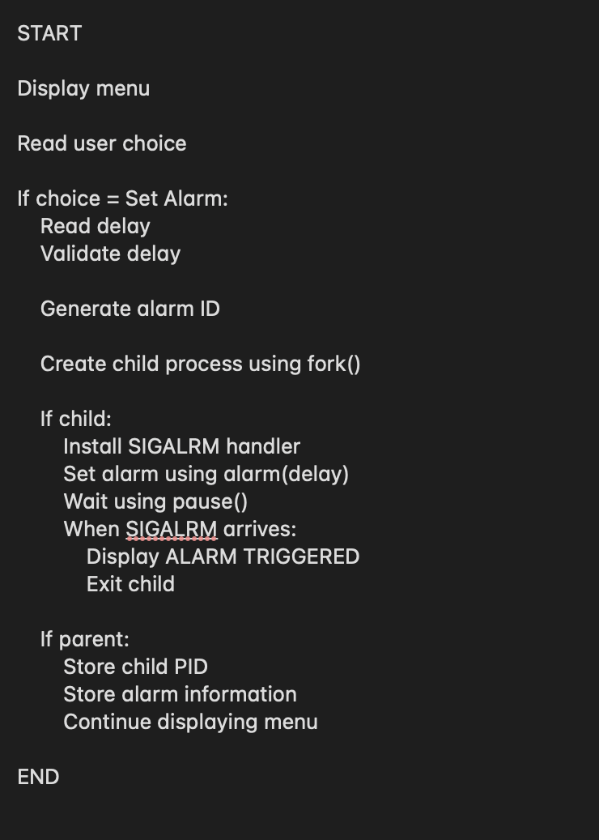

Algorithm for Cancelling an Alarm
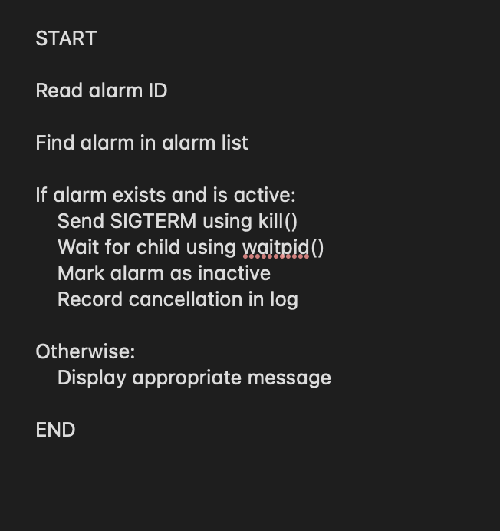

6.3 Core C Implementation
The alarm information is stored using a structure.
typedef struct {
int id;
pid_t pid;
unsigned int delay;
int active;
} Alarm;
The structure stores:
- Alarm ID
- Process ID
- Delay
- Active/inactive status
An array of these structures is maintained by the parent process.

Process Creation
The project uses:
pid_t pid = fork();
After fork():
- The parent process continues managing the alarms.
- The child process handles the timer for that alarm.

Timer Creation
The child process uses:
alarm(delay);
This schedules a SIGALRM signal after the specified number of seconds.

Signal Handling
The signal handler is installed using:
sigaction(SIGALRM, &sa, NULL);
When the timer expires, the handler displays:
*** ALARM TRIGGERED ***

Waiting for the Signal
The child uses:
pause();
This causes the child process to wait until a signal is delivered.
This avoids continuously checking the timer in a loop.
6.4 Linux System Calls / APIs Used
API | Function
fork() | Creates child process
alarm() | Creates timer
sigaction() | Installs signal handler
pause() | Waits for signal
kill() | Sends signal to process
waitpid() | Waits for/checks child process
open() | Opens or creates file
read() | Reads file data
write() | Writes file data
close() | Closes file descriptor
mkfifo() | Creates named pipe

6.5 Process / Thread Implementation

Process Implementation
Each alarm is associated with a child process.
For example:
Parent Process
|
+---- Child PID 1531 → Alarm 1
|
+---- Child PID 1532 → Alarm 2
|
+---- Child PID 1533 → Alarm 3
This allows multiple alarms to exist simultaneously.
The parent maintains the PIDs and can cancel a particular alarm using its ID.

Thread Implementation
The project also contains thread_demo.c.
The program demonstrates:
- POSIX thread creation
- Shared data
- Mutex
- Mutual exclusion
- Thread synchronization
Example output:
Thread + Mutex demonstration
Thread 1: alarm event handled. Shared count = 1
Thread 2: alarm event handled. Shared count = 2
Thread 3: alarm event handled. Shared count = 3
All alarm threads completed.
6.6 IPC / Synchronization Implementation
The project demonstrates IPC using a named pipe/FIFO.
The FIFO is named:
alarm_fifo
There are two programs:

Receiver
fifo_demo.c
It waits for a message through the FIFO.

Sender
fifo_sender.c
It sends a message through the FIFO.
The communication is:
fifo_sender.c
|
| write()
v
alarm_fifo
|
| read()
v
fifo_demo.c
The successful demonstration produced:
Received through FIFO:
Hello from FIFO sender - IPC message received!
This demonstrates communication between two separate processes.
6.7 Memory Management Implementation
The project contains memory_demo.c.
It demonstrates:
- Global memory
- Heap memory
- malloc()
- fork()
- Parent/child memory separation
- Copy-on-Write concept
Example:
Before fork: PID=1527, global=10, heap=20
Child: PID=1528, global=99, heap=88
Parent: PID=1527, global=10, heap=20
The child modifies its values, but the parent retains its original values.
This demonstrates that after fork(), parent and child have separate logical address spaces.
6.8 File I/O Implementation
The project contains:
file_demo.c
It demonstrates:
- open()
- write()
- read()
- close()
- File descriptors
The program first creates/opens a file and writes data to it.Then it closes the file, reopens it for reading, reads the contents, and displays them.The alarm clock itself also uses file operations to maintain:
alarm_log.txt
The log records events such as:
SET
TRIGGERED
CANCEL
6.9 Graphical User Interface Implementation
The project includes:
gui.py
The GUI is developed using Python Tkinter.
It contains six tabs:
CO-1
CO-2
CO-3
CO-4
CO-5
CO-6
Each tab contains a button for running or demonstrating the corresponding concept.
CO-1
Demonstrates the OS service layer and system calls.

CO-2
Launches the main alarm clock.

CO-3
Demonstrates signals and FIFO IPC.

CO-4
Launches the memory demonstration.

CO-5
Launches the file I/O demonstration.

CO-6
Launches the thread and mutex demonstration.
The GUI makes the project easier to demonstrate during evaluation.

CHAPTER 7 – EXECUTION AND DEMONSTRATION
7.1 Compilation
Navigate to the project directory:
cd ~/Desktop/Linux_Alarm_Clock_OS_Project
Compile the main program:
clang alarm_clock.c -o alarm_clock
Compile the supporting programs:
clang memory_demo.c -o memory_demo
clang fifo_demo.c -o fifo_demo
clang fifo_sender.c -o fifo_sender
clang file_demo.c -o file_demo
clang thread_demo.c -o thread_demo
7.2 Execution Commands

Main Alarm Clock
./alarm_clock

Memory Demo
./memory_demo

FIFO Demo
./fifo_demo

FIFO Sender
./fifo_sender

File I/O Demo
./file_demo

Thread Demo
./thread_demo

GUI
python3 gui.py
7.3 Sample Inputs and Outputs

Test Case 1 – Single Alarm

Input
1. Set alarm
Enter delay in seconds: 5

Output
Alarm 1 created. Child PID = 1531
*** ALARM TRIGGERED ***
The parent later detects that the child has finished:
[Manager] Alarm 1 has finished.

Test Case 2 – Alarm Cancellation

Input
1. Set alarm
Enter delay in seconds: 30
Then:
3. Cancel alarm
Enter alarm ID to cancel: 2

Output
Alarm 2 cancelled.
The alarm does not trigger after cancellation.

Test Case 3 – Multiple Alarms
Multiple alarms can be created with different delays.
Example:
Alarm 1 created. Child PID = 1531
Alarm 2 created. Child PID = 1532
Alarm 3 created. Child PID = 1533
Each alarm has its own child process and timer.

Test Case 4 – FIFO IPC
The FIFO demonstration successfully produced:
FIFO receiver waiting on alarm_fifo ...
Received through FIFO:
Hello from FIFO sender - IPC message received!
The sender and receiver communicate through the named pipe alarm_fifo.

Test Case 5 – Memory Demonstration
Before fork: PID=1527, global=10, heap=20
Child: PID=1528, global=99, heap=88
Parent: PID=1527, global=10, heap=20
This demonstrates process memory isolation.

Test Case 6 – File I/O
The file demonstration performs:
open()
write()
close()
open()
read()
close()
The program displays the contents read from the file.

Test Case 7 – Threads and Mutex
Example:
Thread + Mutex demonstration
Thread 1: alarm event handled. Shared count = 1
Thread 2: alarm event handled. Shared count = 2
Thread 3: alarm event handled. Shared count = 3
All alarm threads completed.
7.4 Screenshots of Execution

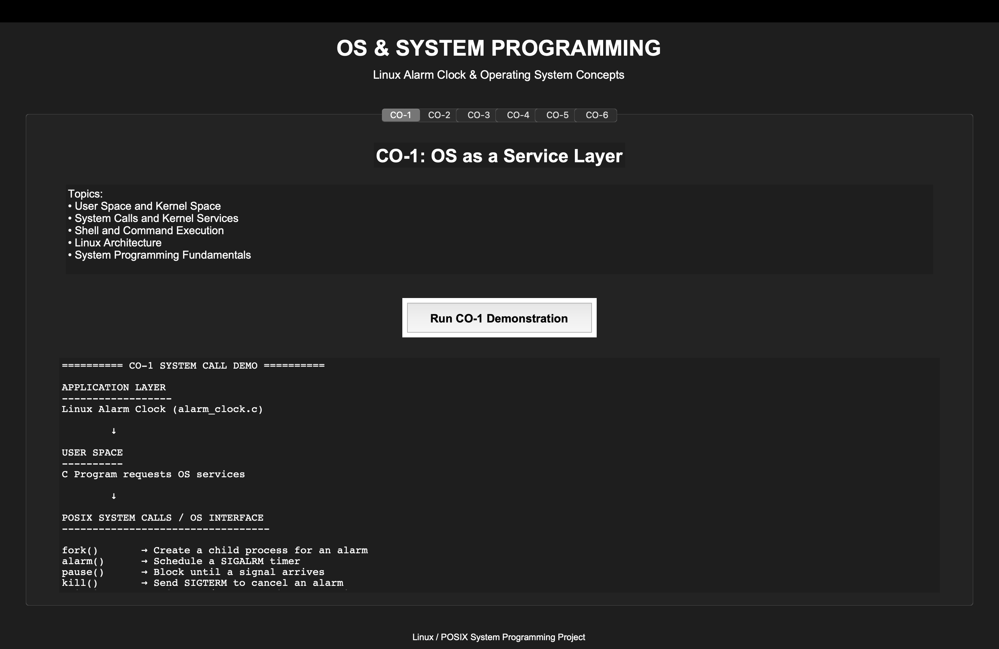

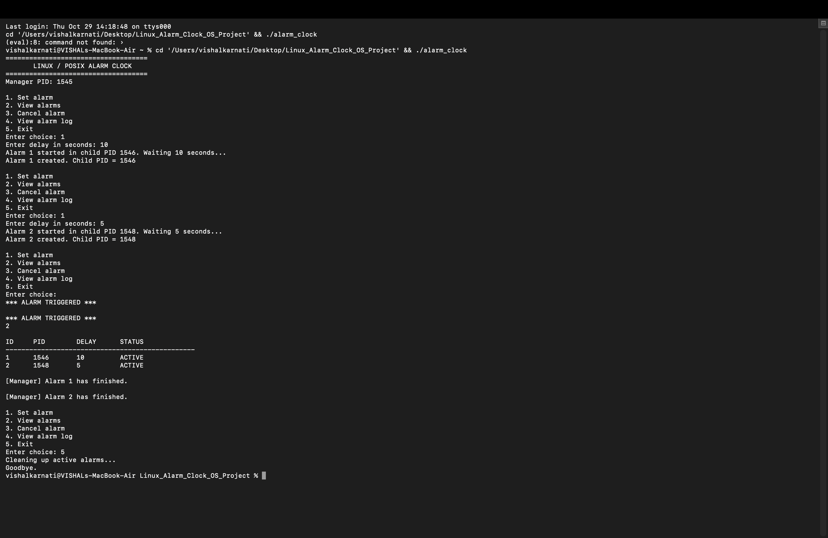
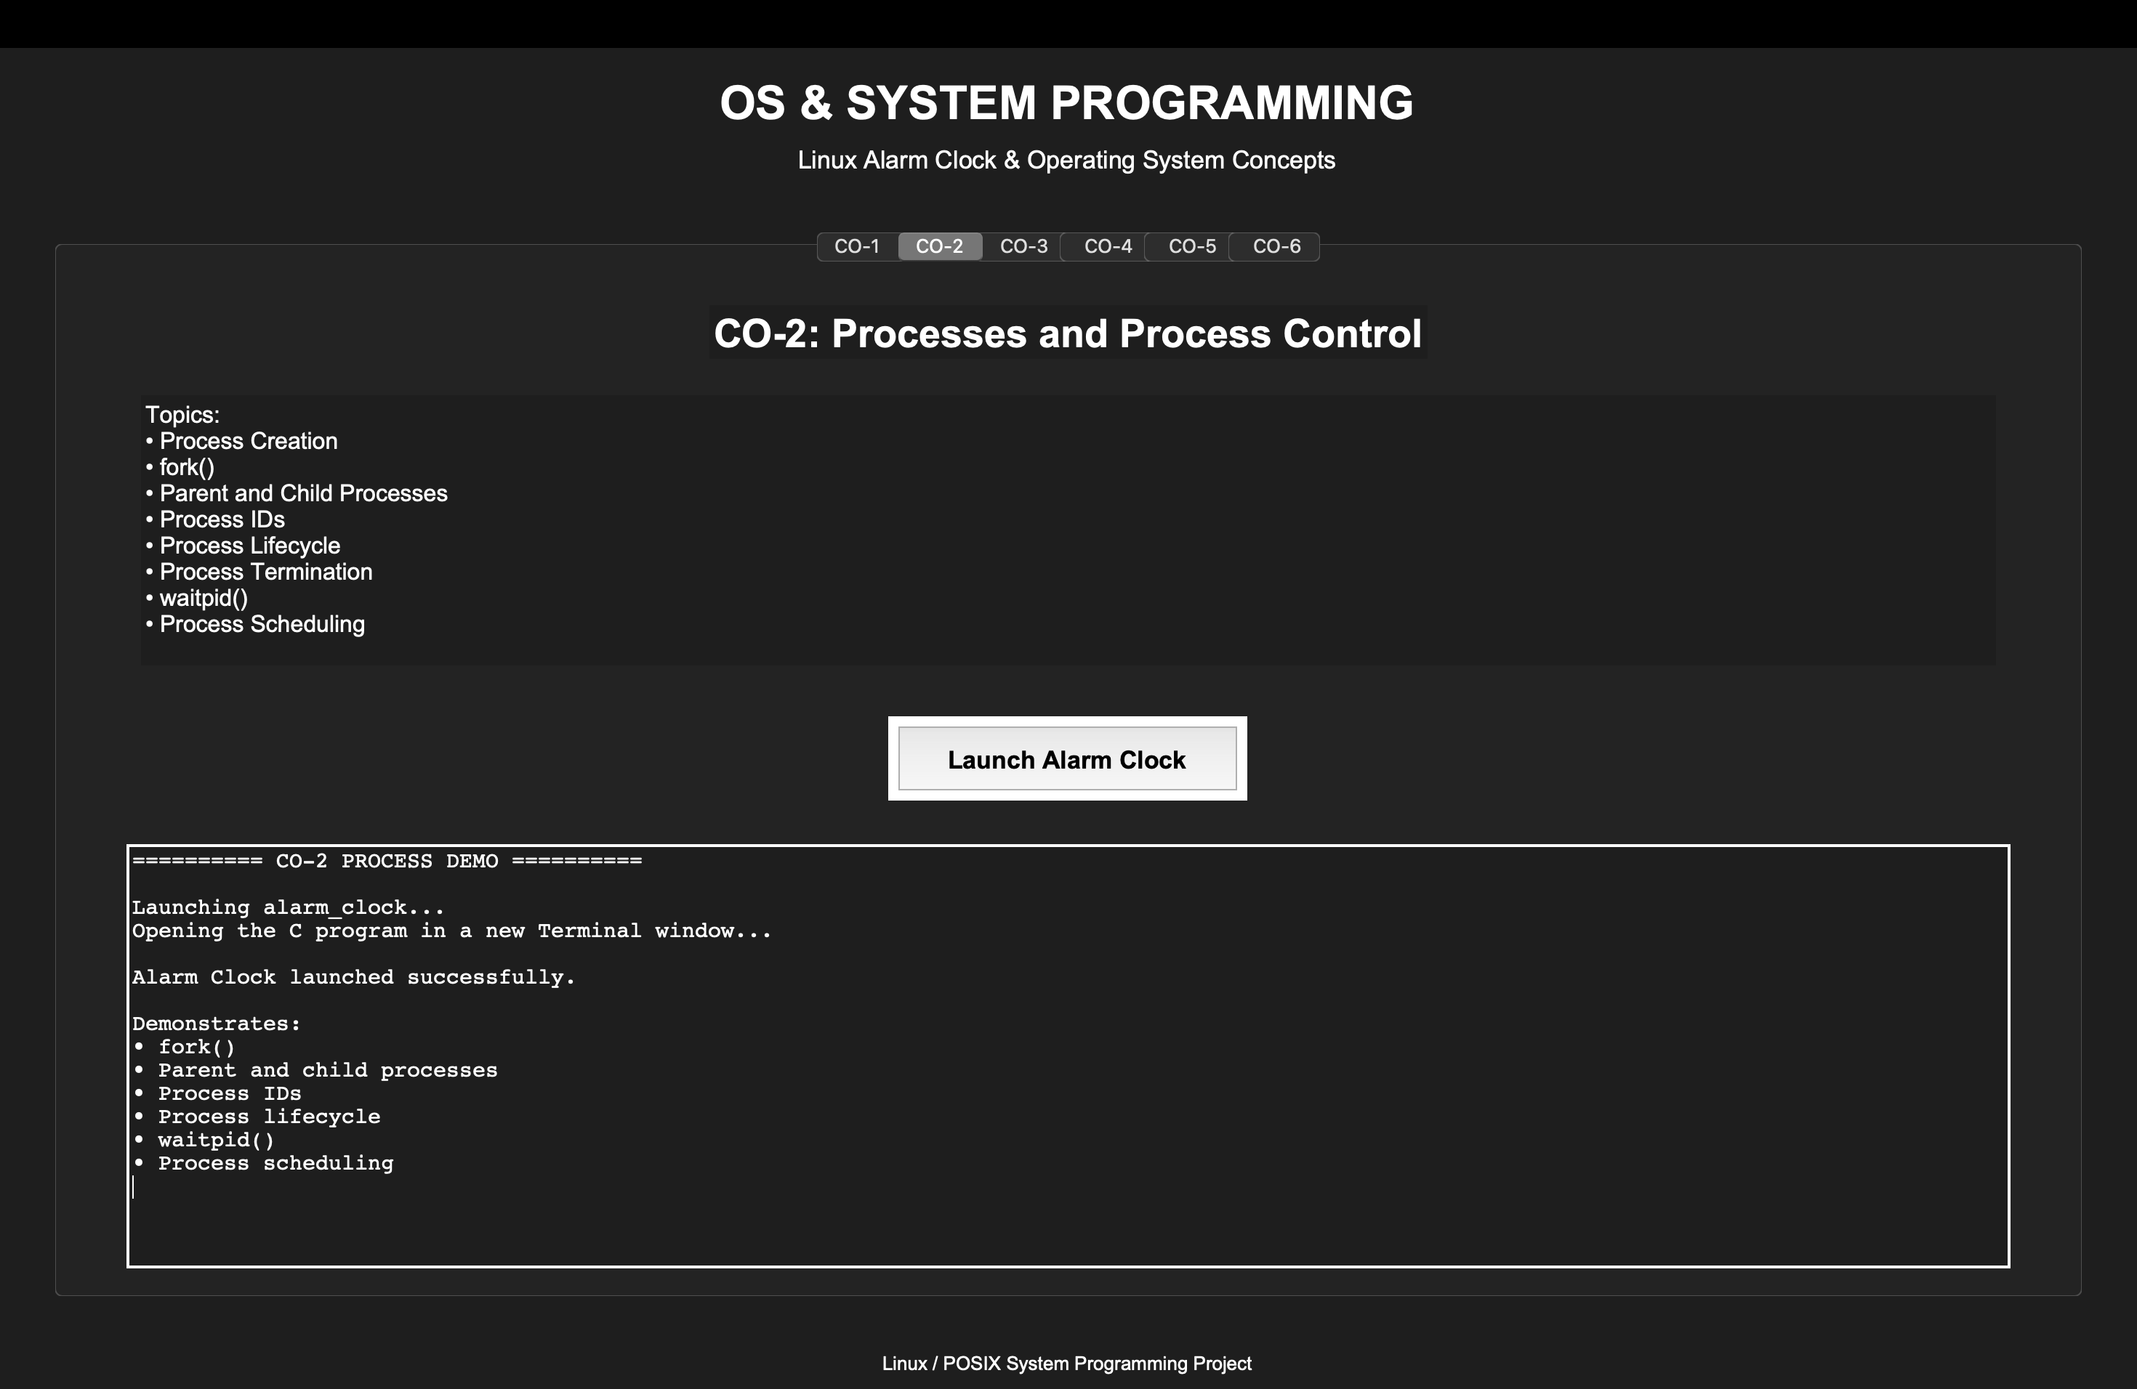

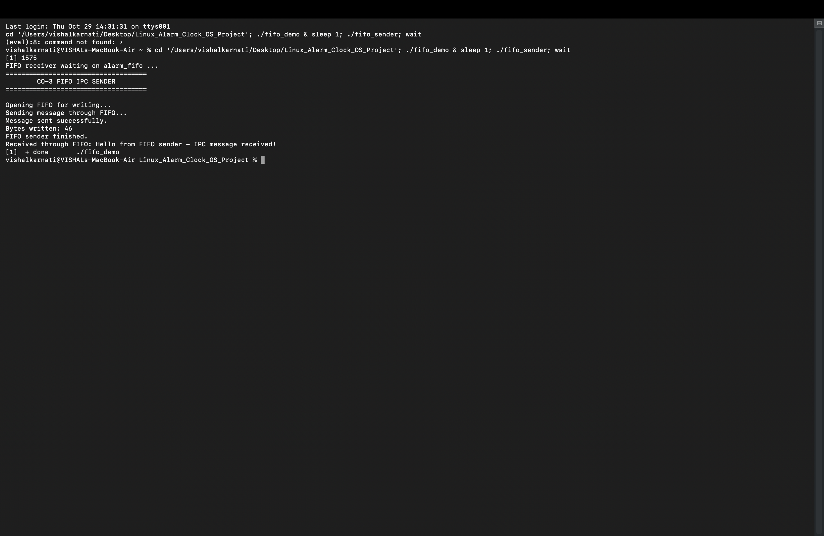
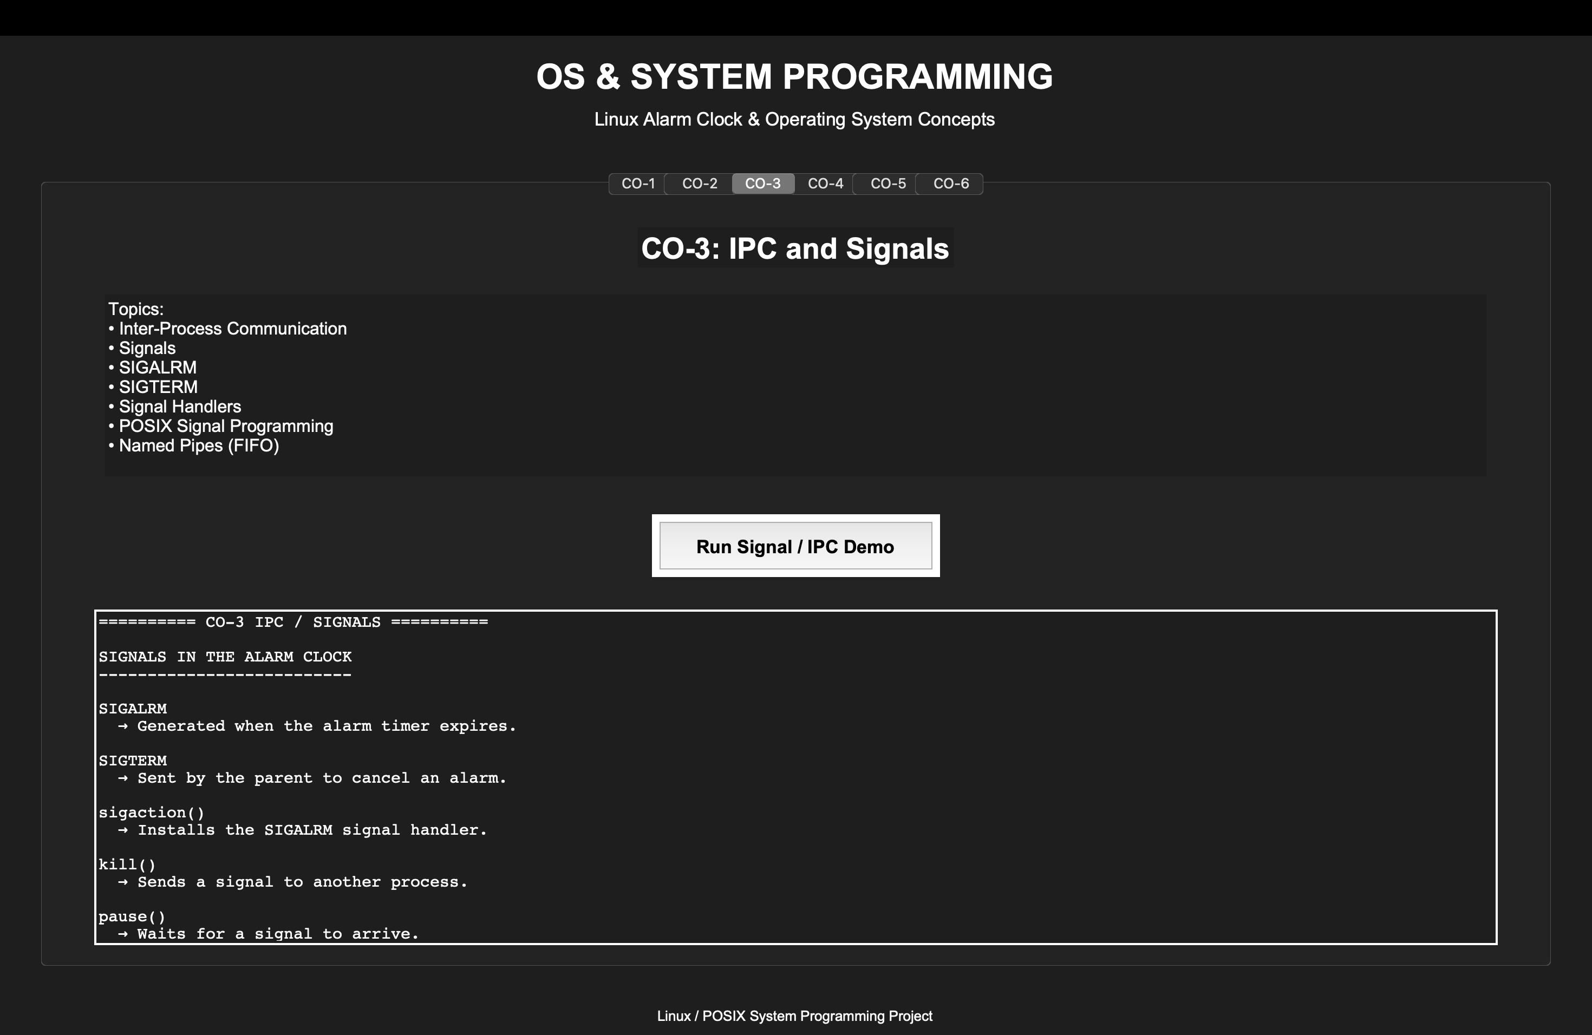

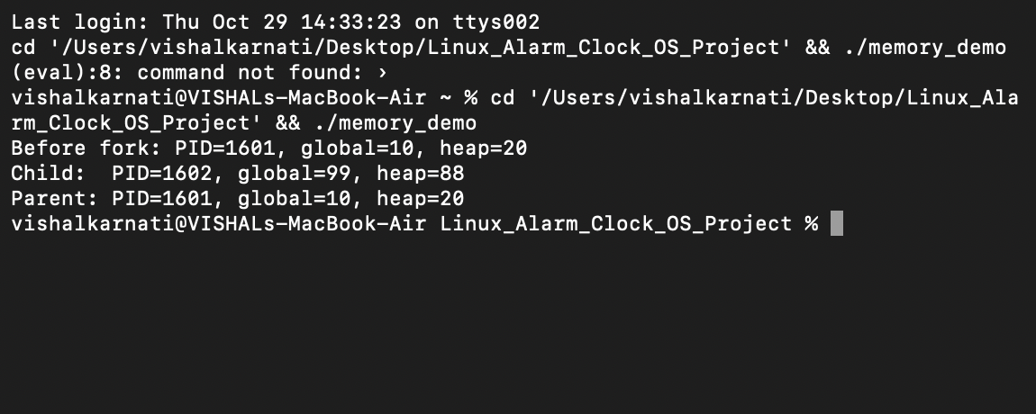
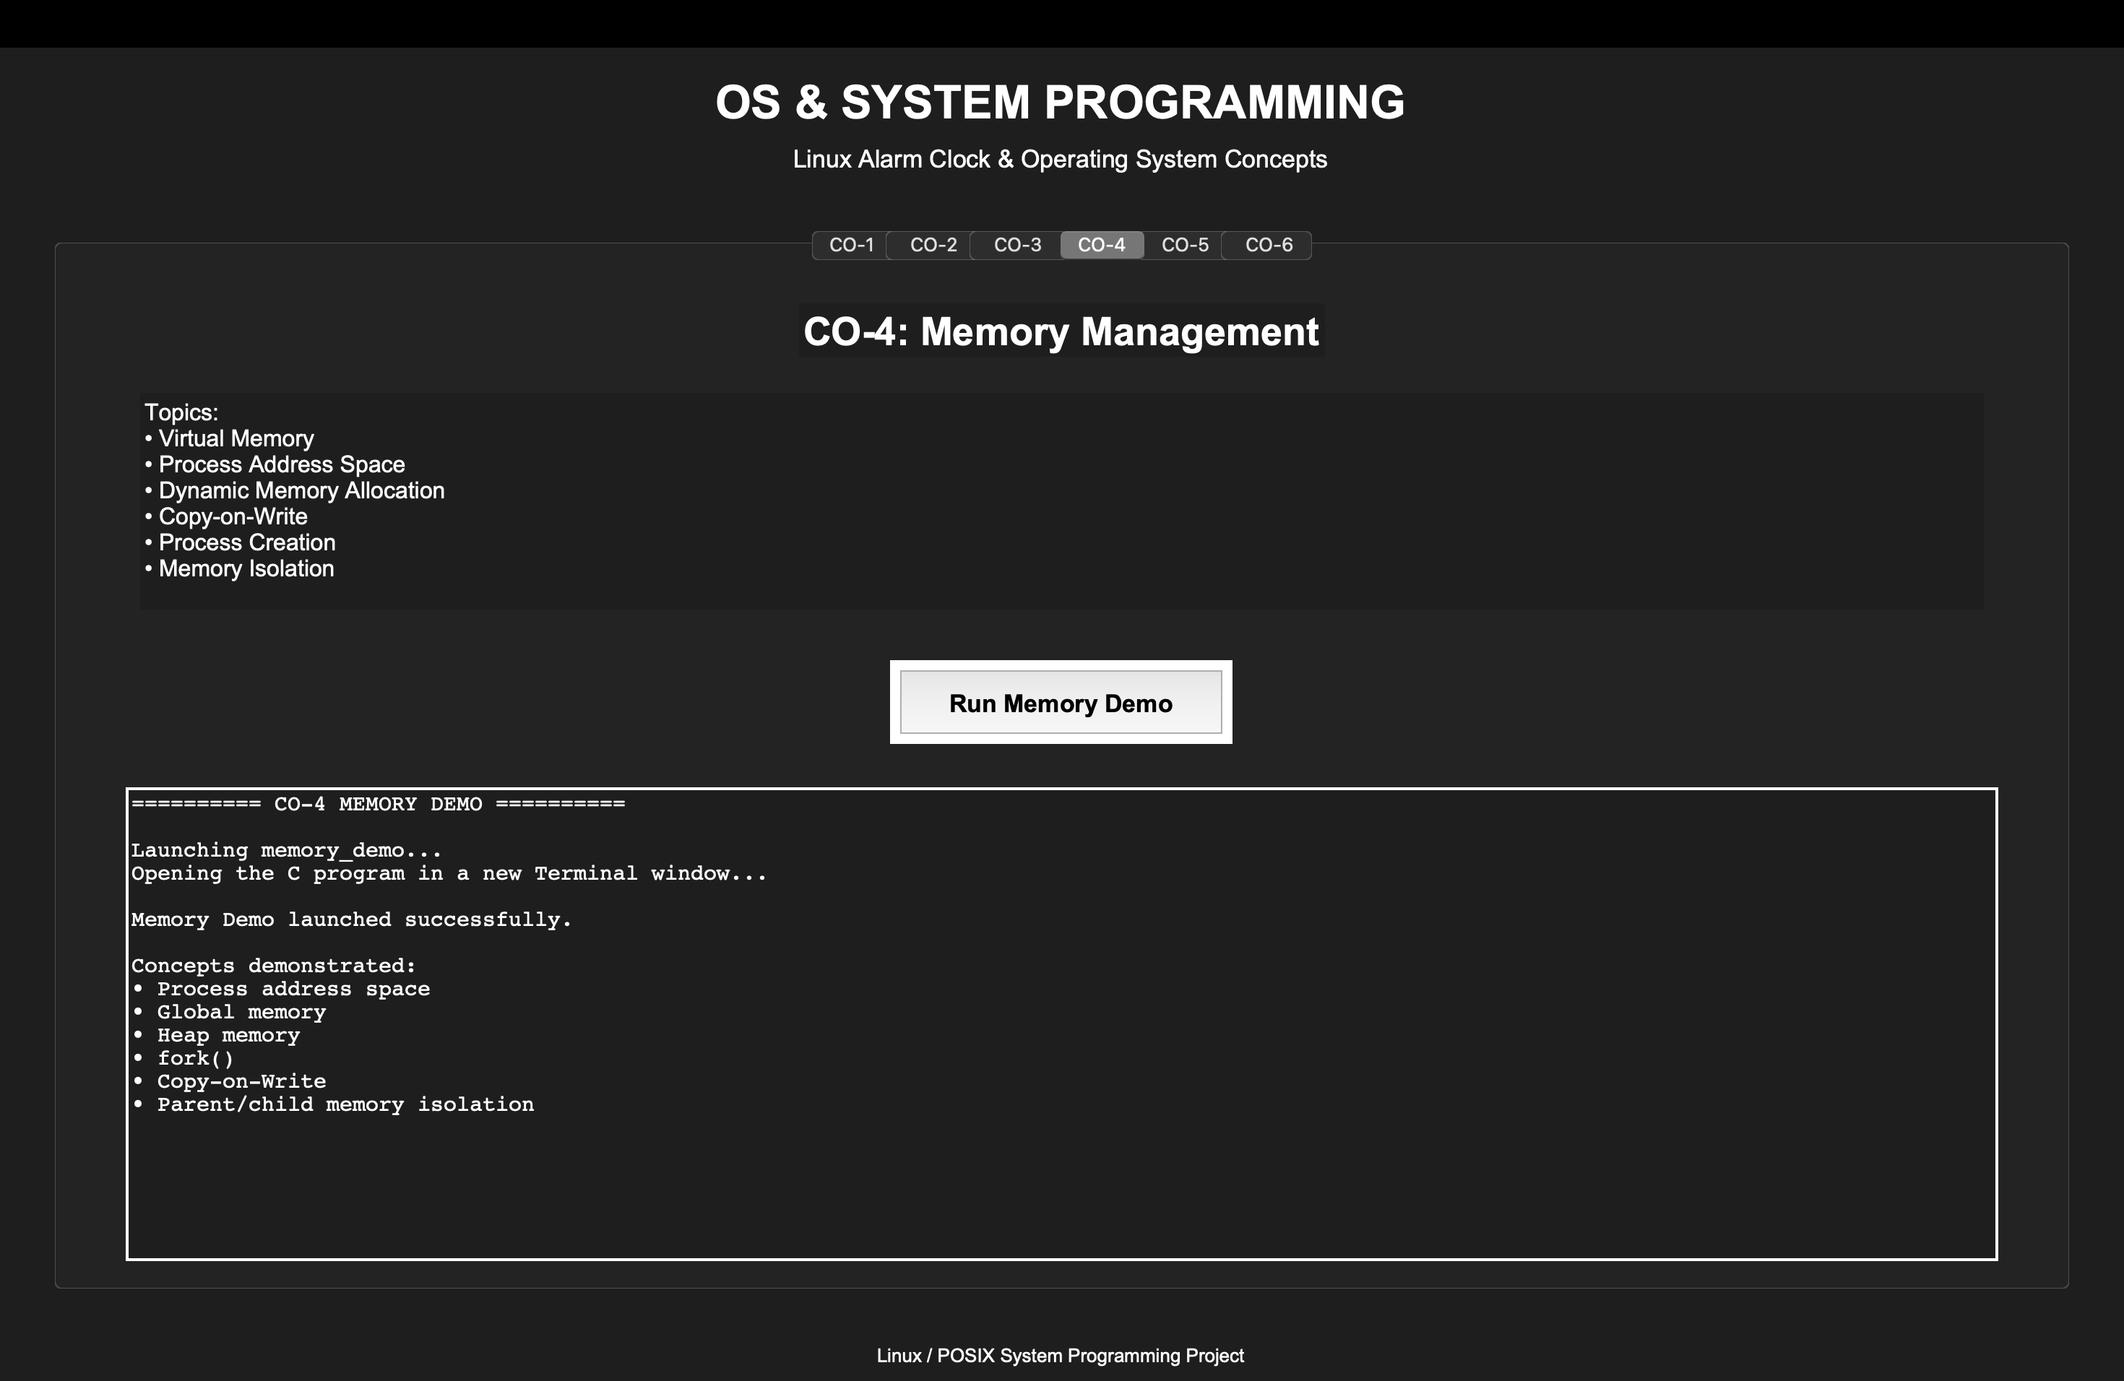
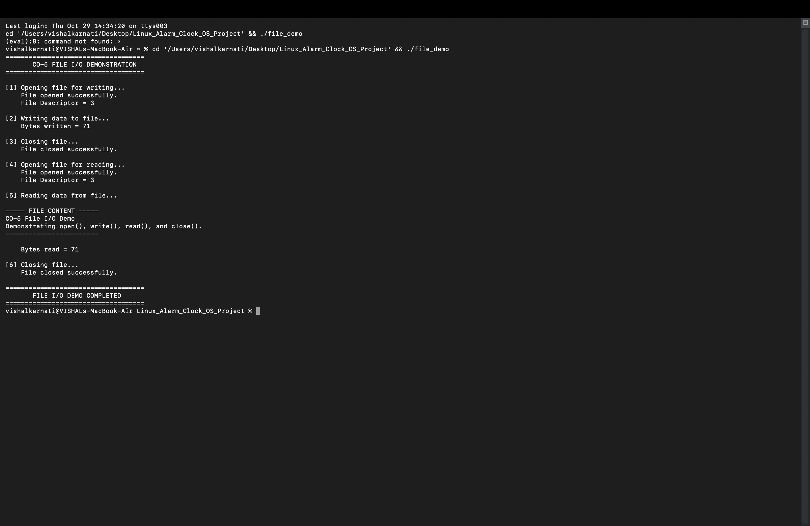
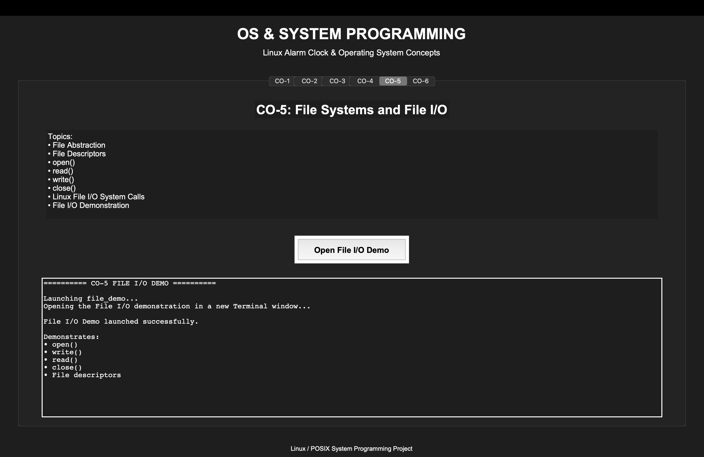

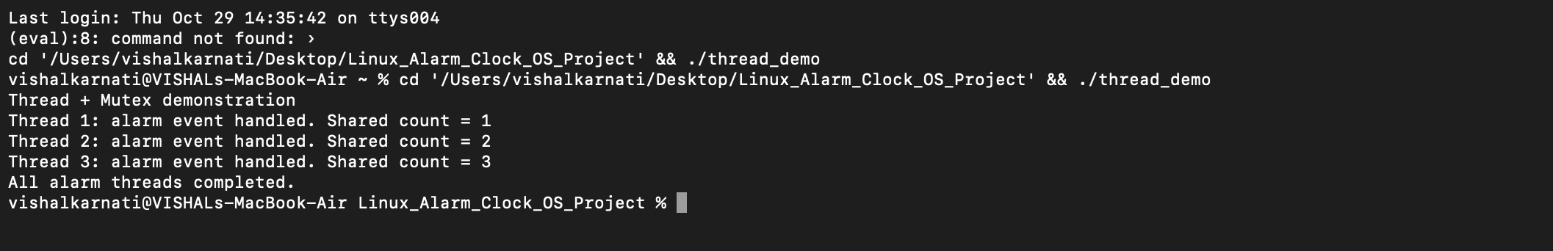
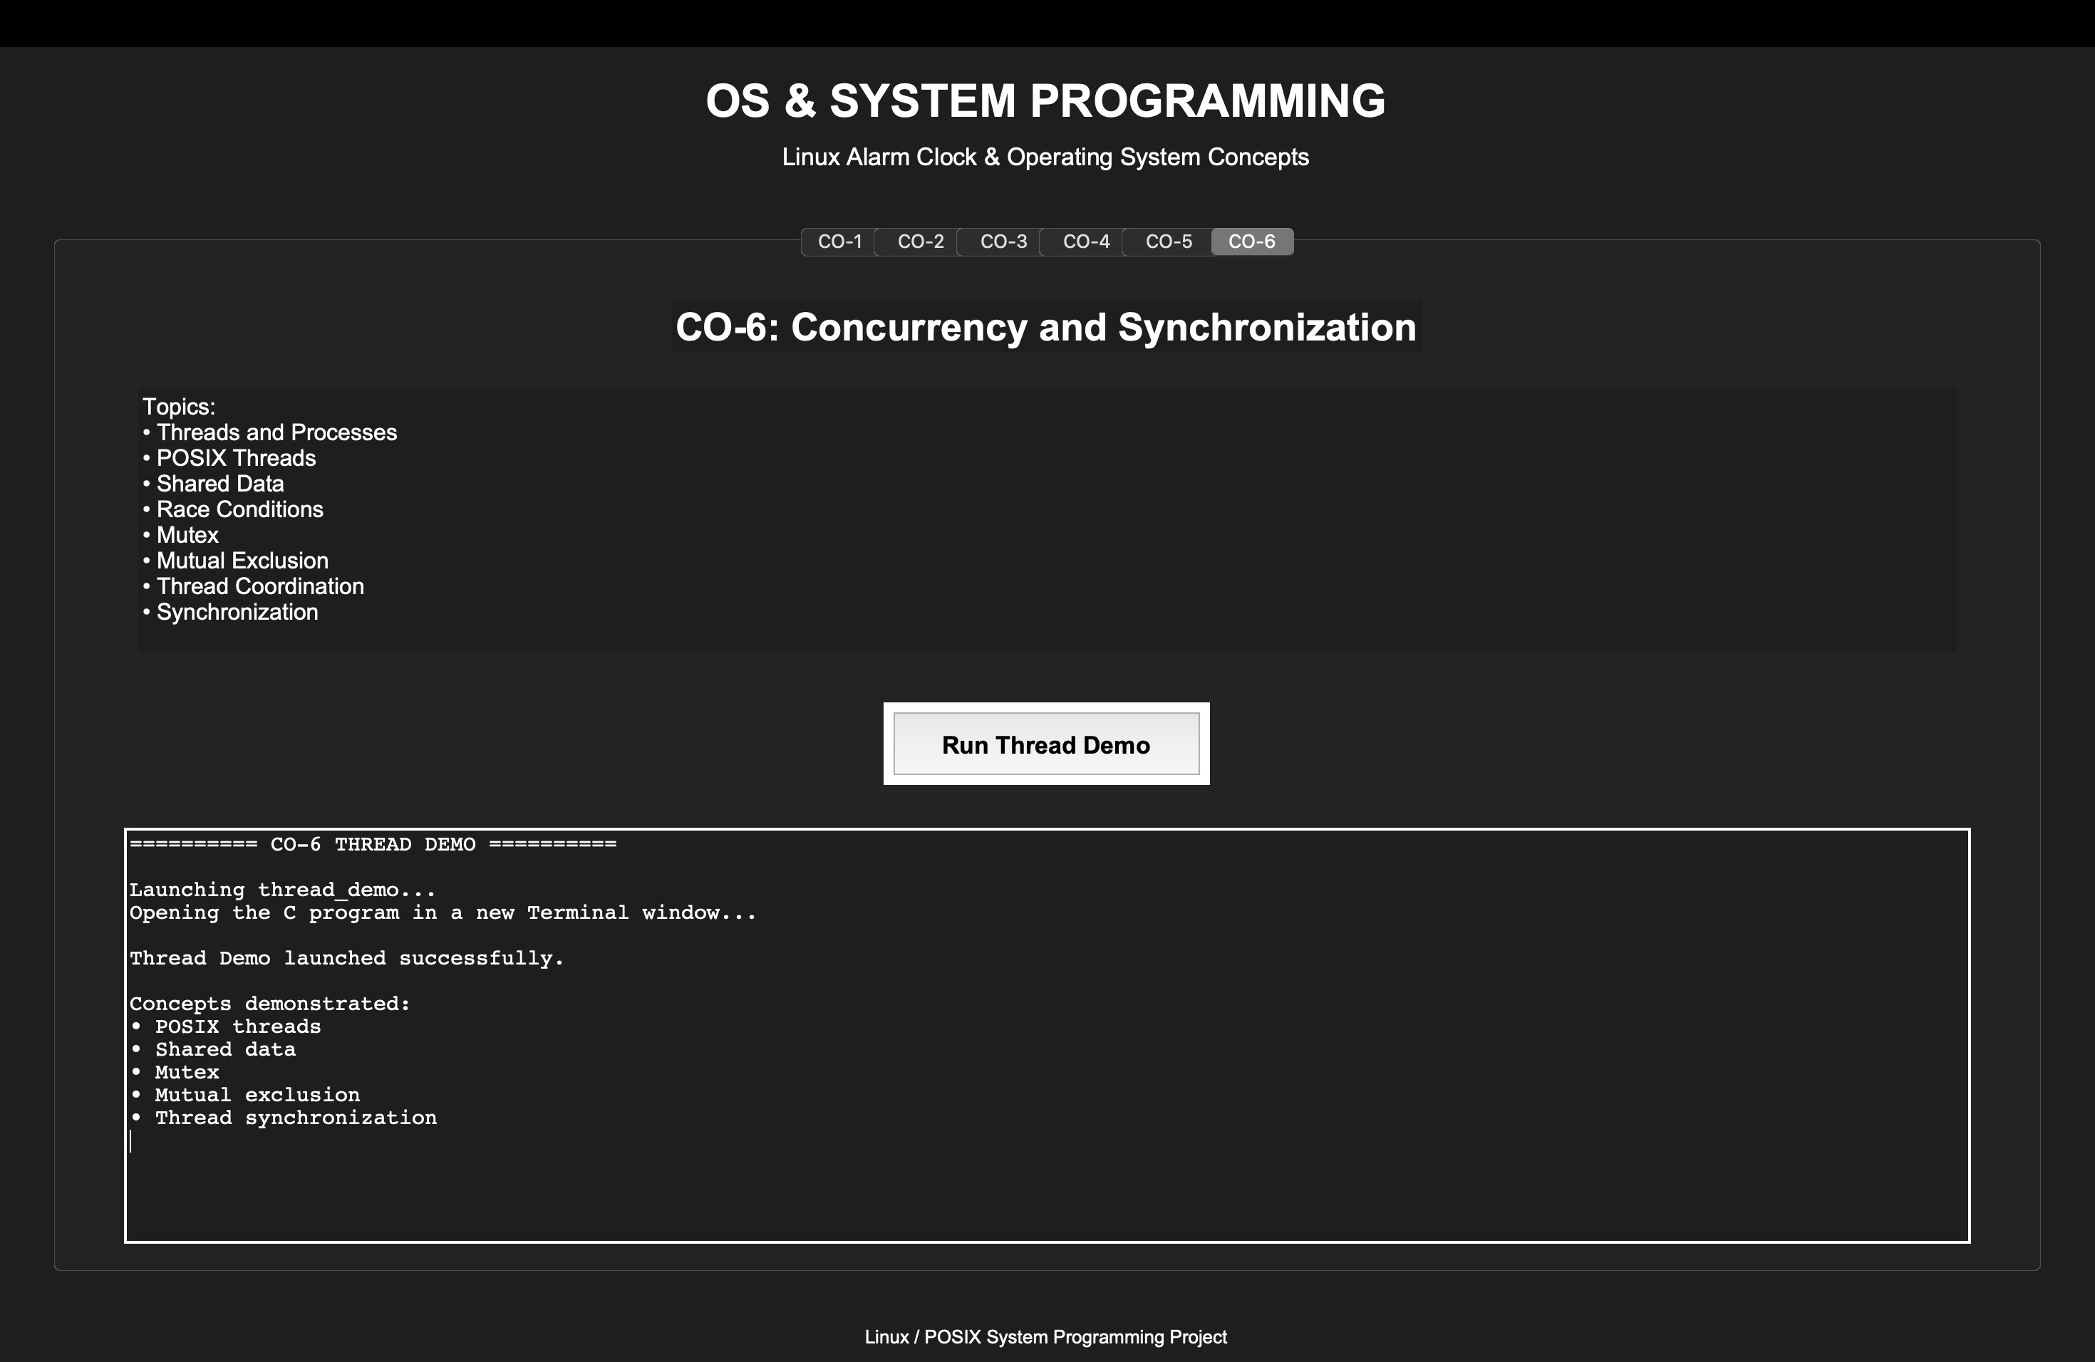
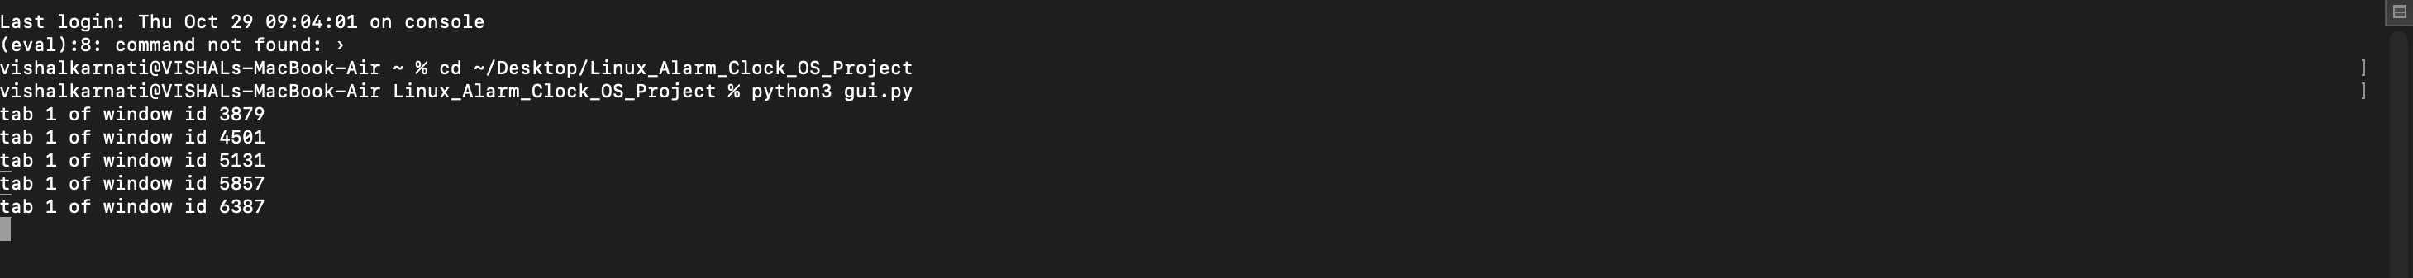
7.5 Demonstration of OS Concepts
CO | Demonstration | Concept Demonstrated
CO-1 | System Call Demo | OS as a service layer
CO-2 | Alarm Clock | Processes and process control
CO-3 | Signal + FIFO Demo | Signals and IPC
CO-4 | Memory Demo | Memory management
CO-5 | File Demo | File systems and file I/O
CO-6 | Thread Demo | Concurrency and synchronization

CHAPTER 8 – CONCLUSION
8.1 Summary of the Project
The Linux-Based Alarm Clock project successfully demonstrates important operating-system and system-programming concepts through a practical C application.
The main application provides functionality for setting, viewing, cancelling, and monitoring alarms.
The implementation uses:
- fork() for process creation
- alarm() for timer events
- SIGALRM for alarm notification
- sigaction() for signal handling
- pause() for waiting
- kill() for cancellation
- waitpid() for process monitoring
- File system calls for logging
In addition, separate demonstrations were developed for IPC, memory management, file I/O, and thread synchronization.

8.2 Objectives Achieved
The following objectives were successfully achieved:
- Implemented a functional alarm-clock application.
- Demonstrated process creation using fork().
- Demonstrated timer events using alarm().
- Implemented signal handling using sigaction().
- Implemented alarm cancellation using kill().
- Implemented process monitoring using waitpid().
- Demonstrated FIFO-based IPC.
- Demonstrated memory isolation after fork().
- Demonstrated low-level file I/O.
- Demonstrated POSIX threads and mutex synchronization.
- Developed a GUI for demonstrating CO-1 to CO-6.

8.3 Results Achieved
The project was successfully compiled and executed during testing.
The following functionalities were verified:
- Single alarm creation
- Multiple alarms
- Alarm triggering
- Alarm cancellation
- Process monitoring
- Alarm logging
- FIFO communication
- Memory demonstration
- File I/O demonstration
- Thread and mutex demonstration
- GUI-based demonstration
The successful FIFO test showed communication between the sender and receiver through alarm_fifo.

8.4 Skills and Learning Outcomes
Through this project, the following skills were developed:
- C programming
- POSIX system programming
- Process creation and management
- Signal handling
- Timer-based programming
- Inter-process communication
- File handling
- Memory management concepts
- Thread programming
- Synchronization using mutex
- Debugging and testing
- Linux/POSIX command-line usage
- Git/GitHub usage
- GUI development using Tkinter

8.5 Future Scope
The project can be extended in the future by adding:
- Real clock-time alarm scheduling instead of only delay-based alarms.
- Recurring alarms.
- Persistent storage of alarms.
- Sound-based alarm notifications.
- Desktop notifications.
- A more advanced Linux GUI.
- Better input validation.
- User-configurable alarm sounds.
- Formal deployment and testing on Ubuntu/Linux.
- More advanced process and IPC demonstrations.

CHAPTER 9 – REFERENCES

9.1 Books
- W. Richard Stevens and Stephen A. Rago, Advanced Programming in the UNIX Environment, 3rd Edition, Addison-Wesley Professional, 2013.
- Michael Kerrisk, The Linux Programming Interface: A Linux and UNIX System Programming Handbook, No Starch Press, 2010.
- Abraham Silberschatz, Peter B. Galvin, and Greg Gagne, Operating System Concepts, 10th Edition, Wiley, 2018.

9.2 Research Papers
- R. Pike, D. Presotto, K. Thompson, H. Trickey, and P. Winterbottom, “The Use of Name Spaces in Plan 9,” ACM SIGOPS Operating Systems Review, 1993.
- M. McKusick, K. Bostic, M. Karels, and J. Quarterman, The Design and Implementation of the 4.4BSD Operating System, Addison-Wesley, 1996.

9.3 Linux / GNU Documentation
- Linux man-pages project, fork(2) — Create a child process.
- Linux man-pages project, alarm(2) — Set an alarm clock for delivery of a signal.
- Linux man-pages project, sigaction(2) — Examine and change a signal action.
- Linux man-pages project, pause(2) — Wait for a signal.
- Linux man-pages project, kill(2) — Send a signal to a process.
- Linux man-pages project, waitpid(2) — Wait for process state changes.
- Linux man-pages project, open(2), read(2), write(2), and close(2) — File input/output operations.
- Linux man-pages project, mkfifo(3) — Create a named pipe.

9.4 Online Resources
- Linux man-pages — https://man7.org/linux/man-pages/
- GNU C Library Documentation — https://www.gnu.org/software/libc/manual/
- The Open Group Base Specifications (POSIX) — https://pubs.opengroup.org/onlinepubs/9799919799/
- Python Documentation — https://docs.python.org/3/
- Tkinter Documentation — https://docs.python.org/3/library/tkinter.html
- GitHub Documentation — https://docs.github.com/

