**Concat 🡪**

a= load '/user/test/acadgild/dataset_3.txt' using PigStorage(',') as (fi:chararray, f2:chararray, f3:chararray);

dump a;

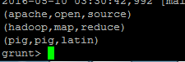

b = foreach a generate CONCAT(f2,f3);

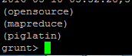

**Tokenize 🡪**

lines = load '/user/test/acadgild/dataset_1.txt' using PigStorage() as (line:chararray);

words = foreach lines generate TOKENIZE(line);

dump words;



**SUM 🡪**

a= load '/datagen_10.txt' using PigStorage(',') as (pid:int, pname:chararray, drug:chararray, gender:chararray, tot_amt:int);

b = group a by drug;

c = foreach b generate group,SUM(a.tot_amt);

dump c;



**Min 🡪**

a= load '/datagen_10.txt' using PigStorage(',') as (pid:int, pname:chararray, drug:chararray, gender:chararray, tot_amt:int);

b = group a by drug;

c = foreach b generate group,MIN(a.tot_amt);

dump c;



**Max🡪**

a= load '/datagen_10.txt' using PigStorage(',') as (pid:int, pname:chararray, drug:chararray, gender:chararray, tot_amt:int);

b = group a by drug;

c = foreach b generate group,MAX(a.tot_amt);

dump c;



**Limit 🡪**

a = load '/user/test/acadgild/dataset_2.txt' using PigStorage(',') as (f1:int, f2:int, f3:int);

dump a;

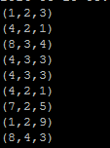

X= limit a 3;

dump X;



**Store 🡪**

a= load '/datagen_10.txt' using PigStorage(',') as (pid:int, pname:chararray, drug:chararray, gender:chararray, tot_amt:int);

b = group a by drug;

c = foreach b generate group,SUM(a.tot_amt);

store c into '/pigre_1' ;

**Distinct 🡪**

a = load '/user/test/acadgild/dataset_2.txt' using PigStorage(',') as (f1:int, f2:int, f3:int);

dump a;



b= distinct a;

dump b ;

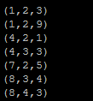

**Flatten 🡪**

lines = load '/user/test/acadgild/dataset_1.txt' using PigStorage() as (line:chararray);

words = foreach lines generate FLATTEN(TOKENIZE(line));

dump words;

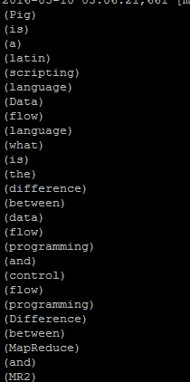

**IsEmpty 🡪**

a = load 'dataset.txt' using PigStorage() as (f1:long);

b = load 'students.txt' using PigStorage() as (f1:long, f2:chararray);

X = cogroup a by f1 inner, b by f1;

Y = filter X by IsEmpty(b);