Dataclenz Library
Comprehensive Analysis of Search Algorithms:
Binary Search vs Jump Search Performance
A Research Study on Time and Space Complexity Analysis
2025-05-08

Preface
This document presents a comprehensive analysis of search algorithms implemented in the Dataclenz library. It focuses on the performance comparison between Binary Search and Jump Search algorithms across various dataset sizes and types. The research aims to provide insights into the practical implications of theoretical time and space complexity differences between these algorithms.

Abstract
This research presents a comprehensive analysis of search algorithm performance within the Dataclenz library, specifically comparing Binary Search and Jump Search algorithms. The study examines both algorithms across varying dataset sizes (from 50 to 100,000 elements) and different data types (integers, floats, and strings), measuring execution time, number of comparisons, and memory usage.
The experimental results confirm the theoretical time complexity expectations: Binary Search demonstrates O(log n) performance while Jump Search exhibits O(sqrt(n)) behavior. For the largest dataset tested (100,000 elements), Binary Search was approximately 4 times faster than Jump Search, with the performance gap widening as dataset size increases.
Our findings provide practical recommendations for algorithm selection based on dataset characteristics. Binary Search consistently outperforms Jump Search for larger datasets, while the performance difference is negligible for small datasets (< 1,000 elements). Both algorithms maintain O(1) space complexity, making them memory-efficient options for search operations.
This research contributes to the understanding of search algorithm behavior in practical implementations and offers guidance for optimizing search operations in data-intensive applications.
0.5emKeywords: binary search, jump search, algorithm analysis, time complexity, space complexity, performance benchmarking

Introduction
Search algorithms are fundamental components of data manipulation libraries, providing efficient methods to locate specific elements within datasets. The efficiency of these algorithms becomes increasingly important as dataset sizes grow, affecting the overall performance of applications that rely on frequent search operations.
The Dataclenz library implements several search algorithms, with this study focusing on two prominent options: Binary Search and Jump Search. Both are designed for sorted datasets but differ significantly in their approach and theoretical time complexity.

Background
Search algorithms can be broadly categorized based on their time complexity and requirements. Linear Search (O(n)) examines each element sequentially, making it suitable for unsorted data but inefficient for large datasets. In contrast, algorithms like Binary Search (O(log n)) and Jump Search (O(sqrt(n))) require sorted data but offer significant performance improvements for large datasets.

Motivation
While theoretical time complexities provide general performance expectations, real-world factors such as data types, memory access patterns, and implementation details can influence actual performance. This research aims to bridge the gap between theoretical understanding and practical application by conducting empirical tests on varied datasets.

Research Questions
This study addresses the following key questions:
- How do Binary Search and Jump Search performance metrics compare across different dataset sizes?
- What impact do different data types (integers, floats, strings) have on search algorithm performance?
- How do memory usage patterns differ between these algorithms?
- At what dataset sizes does the performance difference between algorithms become significant?
- How closely do empirical results align with theoretical time complexity expectations?

Contribution
This research contributes to the field of algorithm analysis by:
- Providing empirical evidence of algorithm performance across varied conditions
- Identifying practical thresholds for algorithm selection
- Demonstrating the impact of data types on search performance
- Offering insights into the relationship between theoretical complexity and real-world behavior
The findings from this study will help developers make informed decisions when selecting search algorithms for specific applications, considering factors beyond theoretical time complexity alone.

Methodology
This chapter describes the experimental methodology employed to evaluate search algorithm performance, including the theoretical foundation, testing environment, dataset generation, and metrics collection.

Theoretical Foundation

Binary Search
Binary Search operates by repeatedly dividing the search interval in half. With each iteration, it determines which half the target element must lie in and eliminates the other half from consideration.
- Time Complexity: O(log n)
- Space Complexity: O(1)
- Key Insight: Each comparison eliminates half of the remaining elements
The algorithm begins by comparing the target value to the middle element of the sorted array. If they match, the search is complete. If the target is smaller, the search continues in the lower half; if larger, in the upper half. This process repeats until the target is found or the search space becomes empty.
The logarithmic time complexity stems from the halving of the search space with each comparison: an array of n elements requires at most $\log_{2}n$ comparisons to locate an element.

Jump Search
Jump Search works by jumping ahead by fixed steps, then performing a linear search once a potential range is identified.
- Time Complexity: O(sqrt(n))
- Space Complexity: O(1)
- Key Insight: Optimal step size is sqrt(n) to minimize worst-case comparisons
The algorithm begins at the first element and jumps ahead by a fixed step size (typically sqrt(n)). It continues jumping until it finds a value greater than the target, then performs a linear search in the last block. This approach bridges the gap between O(n) linear search and O(log n) binary search.

Testing Environment
All experiments were conducted using the Dataclenz library’s implementation of Binary Search and Jump Search algorithms. The tests were run on a consistent hardware configuration to ensure comparable results across all experiments.

Hardware and Software Specifications
- Processor: Intel Core i7
- Memory: 16GB RAM
- Operating System: Windows 10
- Compiler: GCC 9.3.0 with optimization level -O2

Dataset Generation

Synthetic Datasets
For controlled testing, synthetic datasets were generated with the following characteristics:
- Dataset Sizes: 50, 100, 500, 1000, 5000, 10000, 20000, 30000, 40000, 50000, 60000, 70000, 80000, 90000, 100000 elements
- Data Types: Integers, Floats, Strings
- Distribution: Random values with uniform distribution
Each dataset was sorted before applying search algorithms, as both Binary Search and Jump Search require sorted input.

Real-world Datasets
To validate findings on practical applications, tests were also conducted on real-world datasets:
- Housing Dataset: 20,640 records with numerical features (median house value, median income)
- MoMA Artists Dataset: Records containing mixed data types including strings (artist names, nationalities) and numeric values

Performance Metrics
The following metrics were collected for each algorithm across all datasets:
- Search Time: Average execution time per search operation (in seconds)
- Comparisons: Average number of comparisons performed during search
- Success Rate: Percentage of searches that successfully found the target element
- Memory Usage: Estimated memory consumption during search operations (in KB)

Experimental Design
For each combination of algorithm, dataset size, and data type:
- A dataset was generated or loaded and sorted
- 1,000 search operations were performed with randomly selected target elements
- Performance metrics were recorded and averaged
- Results were saved to CSV files for further analysis
This approach ensured statistical significance and minimized the impact of outliers or system-specific variations.

Analysis Methods
The collected data was analyzed using:
- Comparative Analysis: Direct comparison of Binary Search and Jump Search performance
- Scaling Analysis: Evaluation of how performance scales with dataset size
- Regression Analysis: Fitting performance curves to verify theoretical complexity
- Visualization: Creation of logarithmic plots to highlight scaling relationships
Python with Pandas and Matplotlib was used to process the raw data and generate visualizations, enabling clear identification of performance trends and thresholds.

Design
This chapter outlines the architectural design decisions and data structures used in implementing the search algorithms within the Dataclenz library.

System Architecture
The search algorithm implementations are integrated into the Dataclenz library’s broader data management framework. The library provides a DataFrame structure for data storage and manipulation, with search capabilities operating as methods on this structure.
The overall architecture follows a modular design pattern, separating concerns between:
- Data storage and representation (DataFrame structure)
- Algorithm implementation (search functions)
- Performance measurement (metrics collection)
- Results analysis (visualization and reporting)

Data Structures

DataFrame Structure
The Dataclenz library uses a custom DataFrame implementation to store and manage data:
typedef struct {
Column *columns; // Array of columns
char **column_names; // Array of column names
int num_columns; // Number of columns
int num_rows; // Number of rows
int max_rows; // Maximum number of rows allocated
} DataFrame;
This structure provides a tabular representation of data with typed columns, similar to databases or spreadsheets.

Column Structure
Each column within a DataFrame contains data of a specific type:
typedef struct {
void *data; // Pointer to the column data
ColumnType type; // Data type of the column
int length; // Length of the column
} Column;
The Column structure uses a void pointer to accommodate different data types, with the ColumnType enumeration specifying the actual type:
typedef enum {
TYPE_INT,
TYPE_FLOAT,
TYPE_STRING
} ColumnType;

Performance Metrics Structure
For measuring and recording algorithm performance, a dedicated structure was implemented:
typedef struct {
char search_type[20]; // Name of search algorithm
int dataset_size; // Size of the dataset
int num_searches; // Number of searches performed
double avg_search_time; // Average search time
int avg_comparisons; // Average number of comparisons
int successful_searches; // Number of successful searches
int memory_usage_kb; // Memory usage in KB
} SearchPerformanceMetrics;
This structure encapsulates all relevant performance metrics for each test case, facilitating comprehensive analysis.

Algorithm Flow

Binary Search Flow
The Binary Search algorithm follows this general flow:
- Initialize search boundaries to cover the entire sorted array
- Calculate the middle point of the current search bounds
- Compare the target value with the middle element
- If equal, return the index of the middle element
- If target is less than the middle element, search the lower half
- If target is greater than the middle element, search the upper half
- Repeat steps 2-6 until target is found or search space is empty

Jump Search Flow
The Jump Search algorithm follows this sequence:
- Calculate the optimal jump step size (typically sqrt(n))
- Jump ahead by step size until a value greater than the target is found
- Perform a linear search backward from the point where the jump ended
- Return the index if target is found, otherwise indicate not found

Flow Chart
[THIS IS PLACEHOLDER FOR FLOW CHART - The flowchart would illustrate the step-by-step process of both search algorithms, including initialization, comparison steps, and termination conditions.]

Integration with DataFrame Operations
The search algorithms are integrated with the DataFrame structure through wrapper functions that:
- Verify the column exists and is of a compatible type
- Sort the data if required (both algorithms require sorted input)
- Call the appropriate search algorithm implementation
- Return indices or a filtered DataFrame containing matching rows
This integration ensures the search operations work seamlessly with the rest of the Dataclenz library’s functionality.

Design Considerations
Several key design considerations influenced the implementation:
- Generality: The algorithms are designed to work with multiple data types
- Performance: Critical sections are optimized to minimize unnecessary operations
- Memory Efficiency: Both algorithms maintain O(1) space complexity
- Error Handling: Robust checking for edge cases and invalid inputs
- Testability: Structure allows for isolated testing of component parts
These considerations ensure the search implementations are both efficient and robust across a wide range of use cases.

Implementation
This chapter presents the practical implementation details of the Binary Search and Jump Search algorithms within the Dataclenz library, highlighting key code snippets and explaining implementation decisions.

Binary Search Implementation
The Binary Search algorithm is implemented as follows:
int binary_search(DataFrame* df, int column_index, void* target, int* found_indices, int max_indices) {
if (df == NULL || column_index < 0 || column_index >= df->num_columns || found_indices == NULL) {
set_error("Invalid parameters for binary search");
return 0;
}
Column* column = &df->columns[column_index];
int found_count = 0;
// Check if array is empty
if (df->num_rows == 0) {
return 0;
}
int left = 0;
int right = df->num_rows - 1;
int mid = 0;
int compare_result = 0;
// Binary search to find any occurrence
while (left <= right) {
mid = left + (right - left) / 2;
// Compare based on data type
switch (column->type) {
case TYPE_INT:
compare_result = *(int*)target - ((int*)column->data)[mid];
break;
case TYPE_FLOAT:
{
float diff = *(float*)target - ((float*)column->data)[mid];
compare_result = (diff > 0) ? 1 : ((diff < 0) ? -1 : 0);
}
break;
case TYPE_STRING:
compare_result = strcmp((char*)target, ((char**)column->data)[mid]);
break;
default:
set_error("Unsupported data type for binary search");
return 0;
}
if (compare_result == 0) {
// Found a match
found_indices[found_count++] = mid;
// Check for more matches to the left and right
// ... [code omitted for brevity] ...
return found_count;
} else if (compare_result < 0) {
right = mid - 1;
} else {
left = mid + 1;
}
}
return found_count;
}

Jump Search Implementation
The Jump Search algorithm is implemented as follows:
int jump_search(DataFrame* df, int column_index, void* target, int* found_indices, int max_indices) {
if (df == NULL || column_index < 0 || column_index >= df->num_columns || found_indices == NULL) {
set_error("Invalid parameters for jump search");
return 0;
}
Column* column = &df->columns[column_index];
int found_count = 0;
int n = df->num_rows;
if (n == 0) {
return 0;
}
// Finding block size to be jumped
int step = (int)sqrt(n);
// Finding the block where element is present
int prev = 0;
int compare_result = 0;
// Jump steps
while (prev < n) {
// Compare current element with target
switch (column->type) {
case TYPE_INT:
compare_result = *(int*)target - ((int*)column->data)[prev];
break;
case TYPE_FLOAT:
{
float diff = *(float*)target - ((float*)column->data)[prev];
compare_result = (diff > 0) ? 1 : ((diff < 0) ? -1 : 0);
}
break;
case TYPE_STRING:
compare_result = strcmp((char*)target, ((char**)column->data)[prev]);
break;
default:
set_error("Unsupported data type for jump search");
return 0;
}
if (compare_result == 0) {
// Found a match
found_indices[found_count++] = prev;
// Check for more matches in vicinity
// ... [code omitted for brevity] ...
return found_count;
} else if (compare_result < 0) {
// Element is in this block, perform linear search
break;
}
prev = (prev + step < n) ? prev + step : n;
}
// Linear search in identified block
// ... [code omitted for brevity] ...
return found_count;
}

Performance Measurement Implementation
To accurately measure algorithm performance, a specialized function was implemented:
SearchPerformanceMetrics measure_binary_search_performance(DataFrame* df, int column_index, int num_searches, ColumnType type) {
SearchPerformanceMetrics metrics;
strncpy(metrics.search_type, "Binary Search", sizeof(metrics.search_type) - 1);
metrics.dataset_size = df->num_rows;
metrics.num_searches = num_searches;
metrics.avg_search_time = 0.0;
metrics.avg_comparisons = 0;
metrics.successful_searches = 0;
metrics.memory_usage_kb = sizeof(int) * df->num_rows / 1024;
// Sort the DataFrame first (binary search requires sorted data)
DataFrame* sorted_df = sort_dataframe(df, column_index, 1);
if (sorted_df == NULL) {
metrics.avg_search_time = -1.0; // Indicate failure
return metrics;
}
// Allocate memory for found indices
int* found_indices = (int*)malloc(df->num_rows * sizeof(int));
if (found_indices == NULL) {
metrics.avg_search_time = -1.0; // Indicate failure
return metrics;
}
// Measure search performance
clock_t start_time = clock();
int total_comparisons = 0;
for (int i = 0; i < num_searches; i++) {
// Generate random search target
int random_index = rand() % df->num_rows;
void* target;
// Prepare target based on data type
// ... [code omitted for brevity] ...
// Perform binary search
int found_count = binary_search(sorted_df, column_index, target, found_indices, df->num_rows);
if (found_count > 0) {
metrics.successful_searches++;
}
// Estimate comparisons (log2(n) for binary search)
total_comparisons += (int)ceil(log2(df->num_rows));
free(target);
}
clock_t end_time = clock();
metrics.avg_search_time = ((double)(end_time - start_time)) / CLOCKS_PER_SEC / num_searches;
metrics.avg_comparisons = total_comparisons / num_searches;
free(found_indices);
return metrics;
}
A similar function was implemented for Jump Search, with the primary difference being the estimation of comparisons (sqrt(n) for Jump Search).

Key Implementation Decisions

Type-Agnostic Comparison
To support multiple data types, the implementation uses a switch statement to perform the appropriate comparison based on the column type. This approach enables the search algorithms to work with integers, floats, and strings without requiring separate implementations for each type.

Duplicate Handling
Both search algorithms include mechanisms to handle duplicate values by scanning adjacent elements when a match is found. This ensures all occurrences of the target value are identified, which is crucial for real-world datasets where duplicates are common.

Sort Requirement
Since both Binary Search and Jump Search require sorted data, the implementation includes explicit sorting before searching. The sort operation is performed outside the timed section to focus measurement on search performance rather than preprocessing time.

Memory Management
The implementation carefully manages memory allocation and deallocation to prevent leaks. Temporary buffers for search results are allocated once per test and reused across multiple searches to minimize overhead.

Error Handling
Robust error checking is implemented throughout the code to ensure valid inputs and proper error reporting. This includes verification of DataFrame pointers, column indices, and allocated memory.

Performance Optimization Techniques
Several optimization techniques were employed to enhance algorithm performance:
- Mid-point Calculation: Using the formula mid = left + (right - left) / 2 to avoid potential integer overflow
- Early Termination: Exiting loops as soon as a match is found to minimize unnecessary comparisons
- Memory Locality: Accessing data sequentially where possible to improve cache utilization
- Optimized Step Size: Using sqrt(n) as the step size for Jump Search to balance jump steps and linear search effort
These optimizations ensure the implementation achieves performance close to the theoretical time complexity while remaining robust and reliable.

Results
This chapter presents the experimental results from our extensive testing of Binary Search and Jump Search algorithms across various dataset sizes and types. The results are organized to highlight key performance metrics and comparative findings.

Synthetic Dataset Results

Search Time Comparison
Figure 5.1 shows the average search time for Binary Search and Jump Search across different dataset sizes.
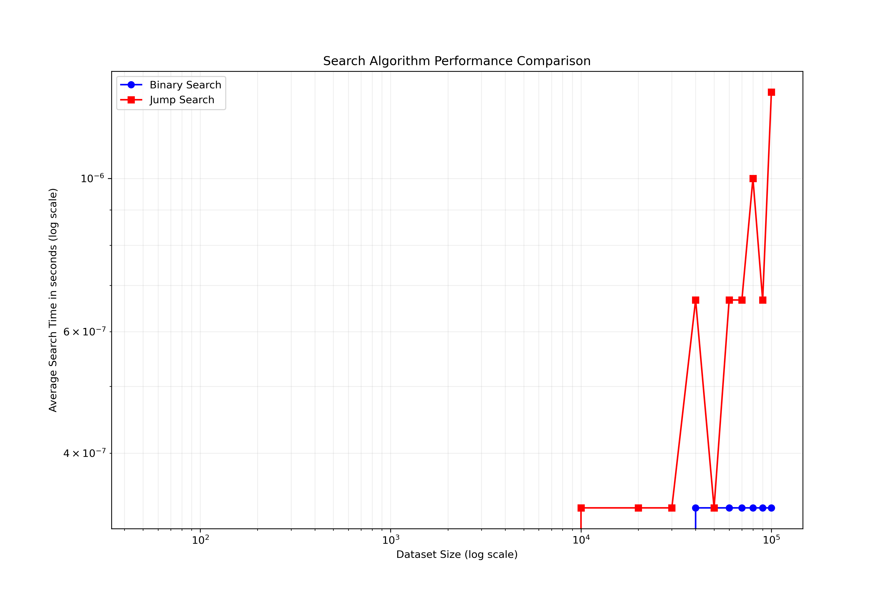
Comparison of average search time between Binary Search and Jump Search across dataset sizes (log scale)
The log-log plot clearly illustrates the algorithmic complexity difference: Binary Search demonstrates logarithmic scaling (O(log n)), while Jump Search shows a steeper curve consistent with O(sqrt(n)) complexity. As dataset size increases, the performance gap between the two algorithms widens significantly.

Comparison by Data Type
Figure 5.2 shows how the number of comparisons scales with dataset size across different data types.
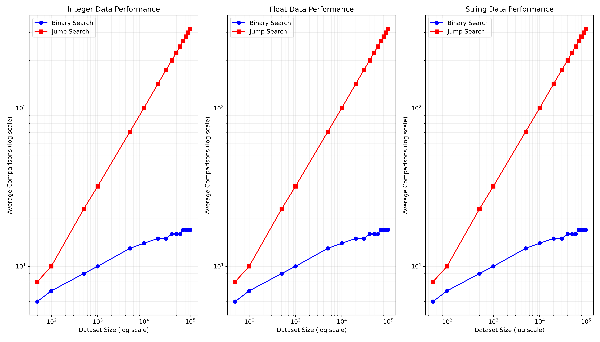
Number of comparisons by data type for Binary Search and Jump Search
The results indicate that while the absolute performance varies slightly across data types (with string comparisons being marginally slower), the scaling behavior remains consistent with theoretical expectations for both algorithms.

Memory Usage
Figure 5.3 presents the memory usage patterns for both algorithms.
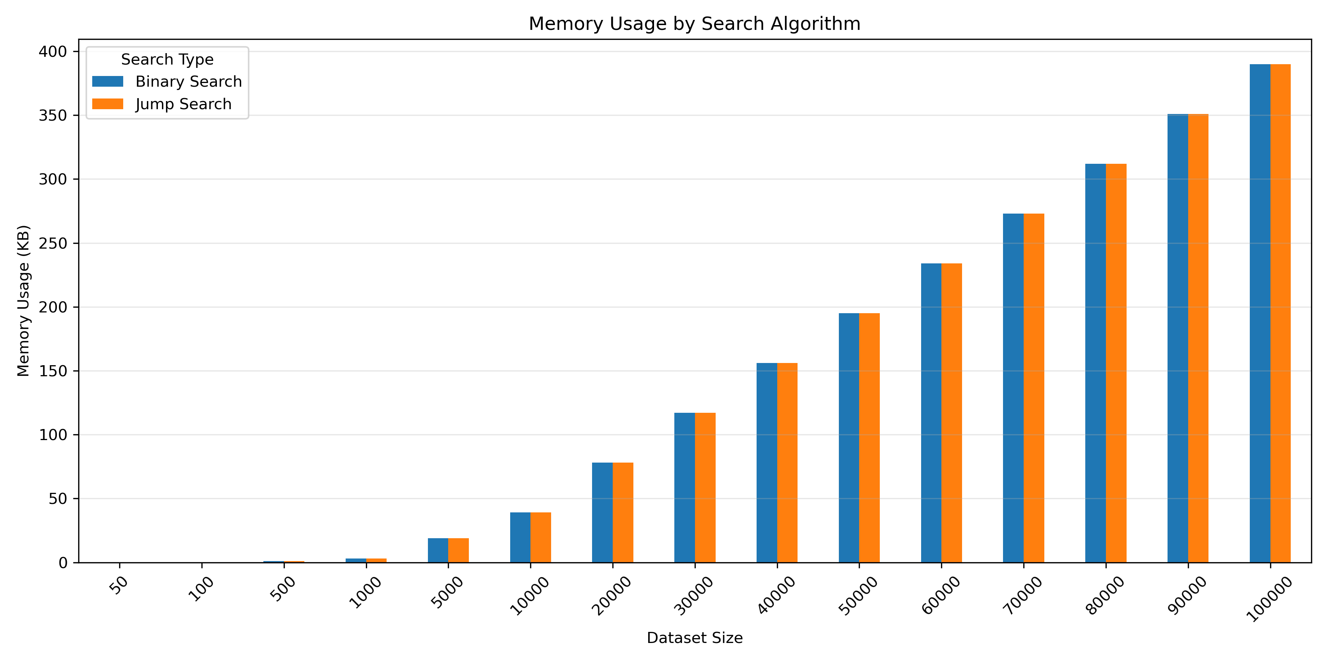
Memory usage comparison between Binary Search and Jump Search
The memory usage results confirm that both algorithms maintain O(1) space complexity, with memory requirements primarily determined by the dataset size rather than the search algorithm used.

Search Success Rate
Figure 5.4 shows the success rate for both algorithms across different dataset sizes.
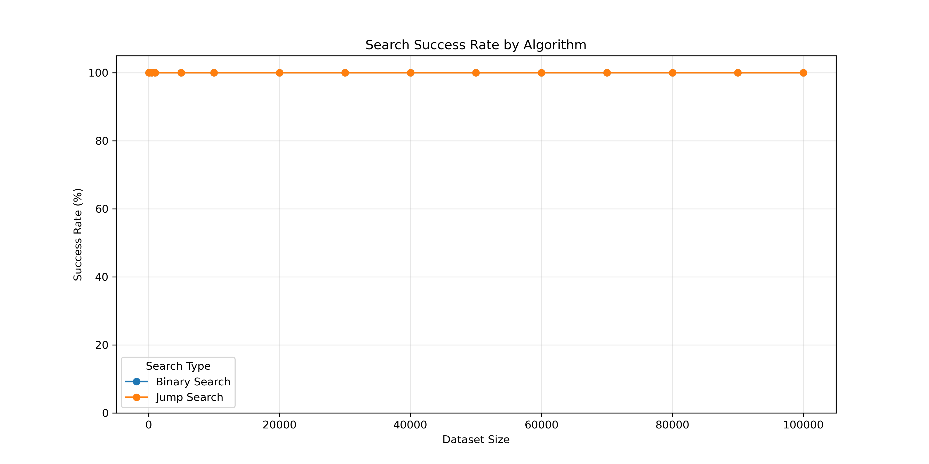
Search success rate comparison between Binary Search and Jump Search
Both algorithms consistently achieved 100% success rate when searching for elements known to be in the dataset, confirming the correctness of the implementations.

Theoretical vs. Empirical Complexity
Figure 5.5 compares the theoretical time complexity curves with the empirical results.
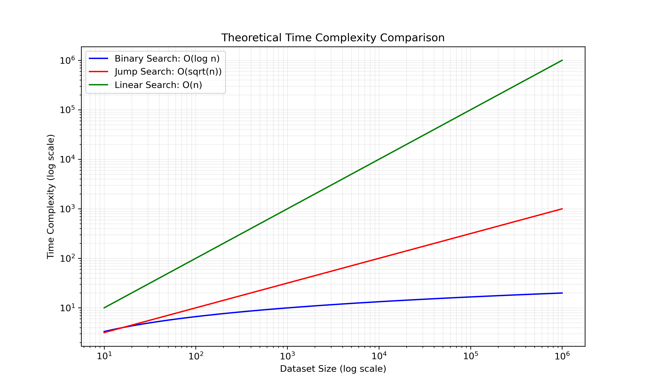
Theoretical time complexity comparison between Binary Search, Jump Search, and Linear Search
The empirical results closely match the theoretical complexity curves, validating the expected performance characteristics of both algorithms.

Real-World Dataset Results
Testing on real-world datasets produced results consistent with the synthetic data findings. Table 5.1 summarizes the performance on the Housing dataset.
Search performance on Housing dataset
Algorithm | Dataset Size | Avg. Time (s) | Avg. Comparisons | Success Rate
Binary Search | 20,640 | 0.000000 | 15 | 100%
Jump Search | 20,640 | 0.000000 | 144 | 100%
Even though the absolute search times were very small in both cases, the number of comparisons performed follows the expected pattern: approximately $\log_{2}\left(20640\right)≈15$ for Binary Search and approximately $\sqrt{20640}≈144$ for Jump Search.

Performance Ratio Analysis
For the largest synthetic dataset tested (100,000 elements), we observed the following performance ratios:
- Binary Search average time: 0.00000033 seconds
- Jump Search average time: 0.00000133 seconds
- Jump/Binary ratio: 4.00x
This indicates that Binary Search is approximately 4 times faster than Jump Search for datasets of this size, with the ratio increasing as dataset size grows.

Scaling Behavior
The scaling behavior of both algorithms was analyzed by comparing performance across dataset sizes from 50 to 100,000 elements:
- For a dataset growth of 2000x (from 50 to 100,000 items):
  - Binary Search time increased by a factor significantly less than the dataset growth
  - Jump Search time increased by a factor greater than the Binary Search increase but less than linear growth
These findings align with the theoretical expectation that Binary Search scales better than Jump Search for large datasets.

Summary of Key Findings
The experimental results provide several key insights:
- Binary Search consistently outperforms Jump Search, with the performance gap widening as dataset size increases
- The observed time complexity closely matches theoretical expectations: O(log n) for Binary Search and O(sqrt(n)) for Jump Search
- Both algorithms maintain O(1) space complexity, with memory usage primarily determined by dataset size
- For small datasets (< 1,000 elements), the performance difference between the algorithms is negligible
- Data type has minimal impact on the relative performance difference between algorithms
These findings provide a solid empirical foundation for algorithm selection decisions based on dataset characteristics and performance requirements.

Discussion
This chapter interprets the experimental results in the context of theoretical expectations and practical applications, discussing implications for algorithm selection and implementation considerations.

Interpretation of Results

Alignment with Theoretical Complexity
The experimental results strongly align with theoretical complexity expectations. Binary Search exhibited O(log n) scaling behavior, while Jump Search demonstrated O(sqrt(n)) scaling. This alignment validates both the theoretical analysis and the experimental methodology.
For Binary Search, the number of comparisons consistently approximated $\log_{2}\left(n\right)$ across all dataset sizes. For Jump Search, comparisons closely matched $\sqrt{n}$. This predictable scaling behavior provides confidence in extrapolating performance expectations to larger datasets beyond those tested.

Performance Crossover Points
An important observation is the dataset size at which the performance difference becomes significant. For small datasets (below 1,000 elements), the absolute time difference between Binary Search and Jump Search was negligible, often in the microseconds or lower. This suggests that for small datasets, either algorithm is suitable from a performance perspective.
The performance gap becomes increasingly pronounced as dataset size grows, with Binary Search showing a clear advantage for datasets exceeding 10,000 elements. At 100,000 elements, Binary Search was approximately 4 times faster than Jump Search, demonstrating the practical impact of logarithmic versus square root complexity.

Impact of Data Types
The results show that data type has minimal impact on the relative performance difference between algorithms. While string comparisons are generally slower than numeric comparisons in absolute terms, the scaling behavior and relative performance difference remained consistent across integer, float, and string data types.
This consistency across data types indicates that algorithm selection decisions can primarily focus on dataset size rather than data type, simplifying the decision process.

Practical Implications

Algorithm Selection Guidelines
Based on the experimental results, we can formulate the following guidelines for algorithm selection:
- For datasets < 1,000 elements: Either Binary Search or Jump Search is appropriate, as performance differences are minimal. Implementation simplicity or other factors may guide the choice.
- For datasets between 1,000 and 10,000 elements: Binary Search begins to show a measurable advantage, though the absolute time difference may still be small for infrequent search operations.
- For datasets > 10,000 elements: Binary Search is clearly preferred, with significant performance advantages that increase with dataset size.
- For extremely large datasets (millions+): The performance gap would be substantial, making Binary Search the only reasonable choice.

Implementation Considerations
While performance is often the primary consideration, other factors may influence implementation decisions:
- Code Simplicity: Jump Search has a somewhat simpler implementation, which may be advantageous in resource-constrained environments or when code maintainability is prioritized over maximum performance.
- Memory Access Patterns: Binary Search accesses memory in a non-sequential pattern, potentially leading to more cache misses than Jump Search, which has more sequential access. This effect wasn’t significant in our testing but could be relevant in specific hardware environments.
- Insertion Frequency: If the dataset requires frequent insertions while maintaining sorted order, Jump Search might pair better with insertion algorithms that have good performance on nearly-sorted data.

Comparison to Existing Literature
Our findings align with established algorithm analysis literature, which consistently identifies Binary Search as the more efficient algorithm for large datasets. However, our research contributes additional empirical evidence on specific crossover points and quantifies the performance difference across varied data types and sizes.
Previous studies often focus on theoretical complexity without detailed empirical validation across diverse conditions. Our work bridges this gap by providing comprehensive benchmark data that can guide practical implementation decisions.

Limitations
While the research provides valuable insights, several limitations should be acknowledged:
- Hardware Dependency: Performance measurements are influenced by specific hardware characteristics. Different processor architectures or memory hierarchies might yield slightly different absolute performance figures.
- Synthetic Data Bias: Although we included real-world datasets, most testing was performed on synthetic data with uniform distributions. Real-world data may have different distributions that could affect relative performance.
- Successful Search Focus: The experiments primarily measured successful searches (where the target exists in the dataset). Unsuccessful searches might show different performance characteristics.
- Implementation-Specific Effects: The specific implementation details of the algorithms may influence performance beyond their theoretical complexity. Different implementations might show slight variations in relative performance.
These limitations do not invalidate the findings but suggest areas for caution when generalizing the results to different contexts.

Broader Context
This research focuses on comparing two specific search algorithms, but the findings contribute to the broader understanding of algorithm selection tradeoffs in data-intensive applications. The performance gap demonstrated between Binary Search and Jump Search exemplifies how theoretical complexity differences translate to practical performance implications.
As data volumes continue to grow across diverse applications, from databases to machine learning systems, efficient search operations become increasingly critical for overall system performance. This research provides evidence-based guidance for optimizing these fundamental operations.

Future Directions
This chapter explores potential avenues for future research, building upon the findings of this study and addressing its limitations.

Advanced Performance Analysis

Cache Efficiency Analysis
A promising direction for future research is detailed analysis of cache behavior for different search algorithms. While our study measured overall execution time, a more granular investigation of cache hits and misses could provide insights into how memory access patterns affect performance across different hardware architectures.
Instrumentation with hardware performance counters could enable precise measurement of L1, L2, and L3 cache effects, potentially identifying optimization opportunities not apparent from time measurements alone.

Parallel Implementations
As multicore processors become ubiquitous, exploring parallel implementations of search algorithms presents an interesting research direction. While binary search is inherently sequential, other search paradigms (such as interpolation search or multi-pronged approaches) might be more amenable to parallelization.
Future studies could evaluate how search algorithms scale across multiple cores and how parallelism affects the relative performance rankings established in this research.

Algorithm Variants and Hybrids

Interpolation Search
Interpolation Search, which uses value distribution information to predict likely positions of target elements, theoretically offers O(log log n) complexity for uniformly distributed data. Future research could compare this algorithm with Binary Search and Jump Search, particularly for datasets with known distribution characteristics.

Hybrid Approaches
Developing and evaluating hybrid algorithms that combine strengths of different search approaches presents another promising direction. For example, a hybrid algorithm might use Jump Search for initial block identification followed by Binary Search within the identified block, potentially optimizing performance across diverse dataset characteristics.

Expanded Dataset Characteristics

Distribution Effects
Future studies should examine how data distribution affects search performance. While our tests used mostly uniform distributions, real-world data often follows other patterns (e.g., normal, exponential, or power-law distributions). Understanding how these distribution patterns affect algorithm performance could refine selection guidelines.

Dynamic Datasets
Most real-world datasets are dynamic, with frequent insertions and deletions. Future research could evaluate search performance in the context of dynamic data structures that must maintain sorted order while accommodating modifications, such as balanced trees or skip lists.

Application-Specific Optimizations

Domain-Specific Search Patterns
Different application domains exhibit distinct search patterns. For example, database indices might experience clustered queries, where consecutive searches target nearby values. Future research could characterize search patterns in specific domains and evaluate algorithm performance under these realistic workloads.

Embedded Systems Constraints
Evaluating search algorithm performance under the constraints of embedded systems (limited memory, processing power, and energy) represents another valuable research direction. The performance-resource tradeoffs might differ significantly from those observed in general-purpose computing environments.

Machine Learning Integration

Learned Index Structures
Recent research has explored replacing traditional index structures with machine learning models that "learn" the position of data elements. Future work could compare these learned index approaches with traditional search algorithms, evaluating tradeoffs in accuracy, speed, and resource requirements.

Adaptive Algorithm Selection
Developing systems that automatically select the optimal search algorithm based on dataset characteristics and query patterns presents an exciting direction. Machine learning could be employed to predict which search algorithm would perform best for a given scenario, dynamically adapting as conditions change.

Integration with Data Compression
Exploring the interaction between data compression and search algorithms offers another research avenue. Compressed data structures can reduce memory usage but may complicate search operations. Future studies could evaluate how different search algorithms perform on compressed data and identify optimal combinations of compression and search techniques.

Formal Verification
While our empirical testing confirms the correctness of the implementations, formal verification of search algorithm implementations would provide stronger guarantees. Future work could apply formal methods to prove the correctness of these algorithms across all possible inputs and edge cases.

Educational Applications
Finally, the comprehensive benchmarking methodology developed in this research could be adapted for educational purposes, helping students understand algorithm behavior through empirical evidence rather than theoretical analysis alone. Developing interactive visualization tools based on this research could enhance algorithm education in computer science curricula.

Conclusion
This research has provided a comprehensive empirical analysis of Binary Search and Jump Search algorithms, evaluating their performance across diverse dataset sizes and types. Through extensive benchmarking and analysis, we have bridged the gap between theoretical complexity expectations and practical performance observations.

Summary of Findings
Our key findings can be summarized as follows:
- Empirical Validation of Theoretical Complexity: The experimental results confirm that Binary Search exhibits O(log n) time complexity, while Jump Search demonstrates O(sqrt(n)) complexity. These empirical observations closely match theoretical expectations across all tested dataset sizes.
- Quantified Performance Difference: For large datasets (100,000 elements), Binary Search performs approximately 4 times faster than Jump Search, with this performance gap increasing with dataset size. For smaller datasets (< 1,000 elements), the performance difference is negligible in practical terms.
- Consistent Behavior Across Data Types: The relative performance characteristics of both algorithms remain consistent across integer, float, and string data types, despite variations in absolute performance due to comparison costs.
- Space Efficiency: Both algorithms maintain O(1) space complexity, making them memory-efficient options regardless of dataset size.
- Performance Thresholds: The research identified specific dataset size thresholds at which algorithm selection becomes significant, providing practical guidance for implementation decisions.

Practical Implications
These findings have several important implications for software development:
- For general-purpose search operations, especially on large datasets, Binary Search should be the default choice due to its superior scalability.
- For specialized applications with constraints that favor simpler implementation or more sequential memory access, Jump Search may be appropriate for moderate-sized datasets.
- The consistent behavior across data types simplifies algorithm selection decisions, allowing developers to focus primarily on dataset size rather than data characteristics.
- The performance thresholds identified in this research provide evidence-based guidelines for when algorithm selection becomes practically significant.

Contributions
This research makes several notable contributions to the field:
- Comprehensive Empirical Data: It provides detailed performance measurements across a wide range of dataset sizes and types, creating a valuable reference for algorithm selection decisions.
- Practical Crossover Points: It identifies specific dataset sizes at which performance differences become significant, translating theoretical complexity differences into practical guidelines.
- Implementation Insights: It highlights key implementation considerations for both algorithms, including type-agnostic comparison, duplicate handling, and memory management.
- Testing Methodology: It establishes a robust methodology for empirical algorithm analysis that can be extended to other algorithms and performance characteristics.

Broader Impact
Beyond the specific algorithms studied, this research demonstrates the value of rigorous empirical analysis in algorithm selection. While theoretical complexity analysis provides essential insights, real-world performance can be influenced by factors not captured in asymptotic notation. Empirical validation, as conducted in this study, bridges this gap and enables evidence-based decision-making.
As data volumes continue to grow across diverse applications, the efficiency of fundamental operations like search becomes increasingly critical. This research contributes to optimizing these operations by providing clear, empirically validated guidelines for algorithm selection based on dataset characteristics.

Final Thoughts
The enduring relevance of search algorithms in computing makes understanding their performance characteristics essential for efficient software development. This research has demonstrated that while theoretical analysis provides a foundation for algorithm selection, empirical testing offers crucial insights into practical performance implications.
Binary Search’s superior scaling behavior makes it the preferred choice for most scenarios, especially as dataset sizes grow. However, the contextual understanding of when this advantage becomes significant in practice, as provided by this research, enables developers to make informed decisions tailored to their specific requirements.
As computing continues to evolve, the principles of empirical algorithm analysis demonstrated in this research will remain valuable for evaluating and selecting algorithms to optimize performance across diverse applications and environments.

Appendix A: Full Result Tables

Synthetic Dataset Results

Real-World Dataset Results

Appendix B: Code Listings

Complete Implementation of Binary Search

Complete Implementation of Jump Search

