

**DATA VISUALIZATION**

***FIFA 19: Data Analysis and Visualization***

Submitted by

**Rishindra Mani Katiyar**

**11715013**

**RKM050B44**

**B Tech. (Computer Science and Engineering)**

Course Code: **INT233**

Under the Guidance of

**Miss Shaina Gupta**

Discipline of CSE/IT

**School of Computer Science & Engineering**

**Lovely Professional University, Phagwara**



**DECLARATION**

I, **Rishindra Mani Katiyar** student of **BTech CSE**, under CSE/IT Discipline at, Lovely Professional University, Punjab, hereby declare that all the information furnished in this project report is based on my own intensive work and is genuine.

Date: 17th April 2020

Registration No. 11715013 Rishindra Mani Katiyar



**INTRODUCTION**

FIFA 19 is a football simulation video game developed by EA Vancouver as part of Electronic Arts' FIFA series. It is the 26th installment in the FIFA series. FIFA is not only a game or tournament for football fans, but it is emotion that drives them through the game. FIFA lovers are found around the globe. FIFA is a tournament in which many clubs compete to win a trophy. Some of the popular teams that participate in FIFA are Real Madrid, FC Barcelona, PGS, Juventus etc. Different players from different countries come together in a club and plays together. They compete with the other club. Some of the most popular players are Cristiano Ronaldo, Lionel Messi, Neymar Jr, Luka Modric etc.

FIFA 19’s dataset gives detailed description of all the players that are participating in FIFA 19 tournament. FIFA 19 dataset allows one to know the player and their statistics. The dataset contains information of all 18207 players from the latest edition FIFA 19. There are 89 attributes including personal information like age, name, nationality, photo, club, wage, etc., and player skill information like ball control, dribbling, crossing, finishing, GK skills, etc. As a football fan, and as a video game lover, I have played and watched a lot of football. From my experience of the game I have come up with following objectives as exploration on the provided FIFA 19 complete player dataset

**Source of Dataset:**

**FIFA 19 Complete Player Dataset:**

I got FIFA 19 football dataset from Kaggle.com. Special thanks to Mr. Karan Gadhiya who provided this dataset on Kaggle. The link to the dataset is given below:

<https://www.kaggle.com/karangadiya/fifa19>



**Overview of dataset columns**

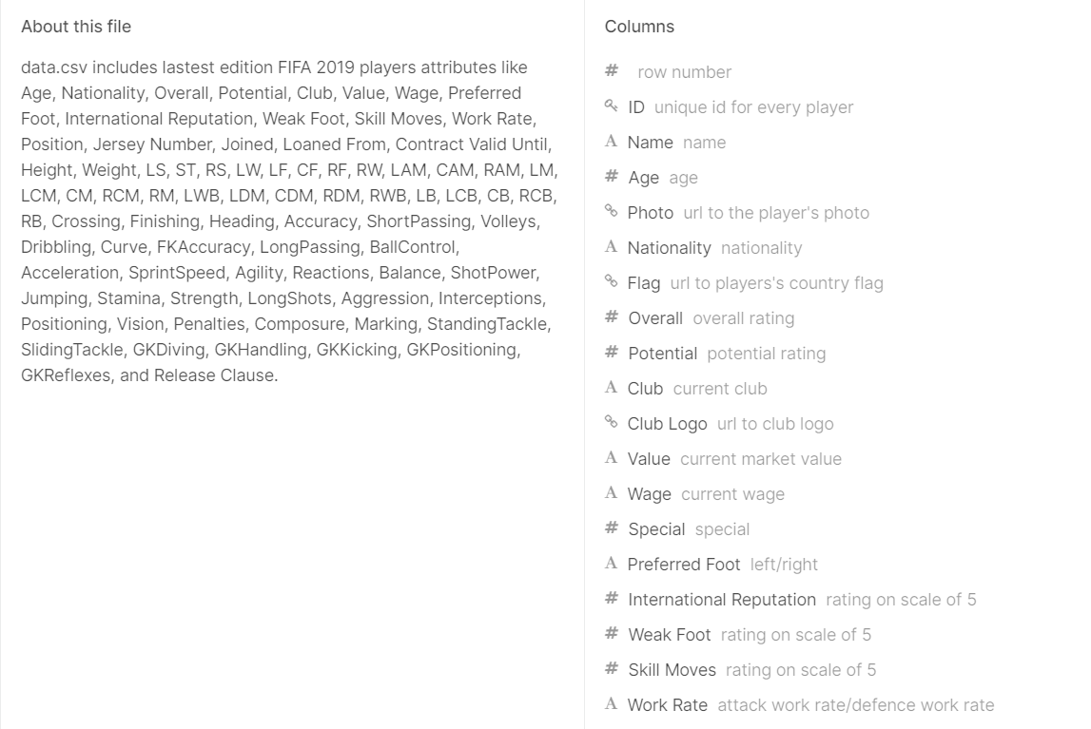



**Tableau Public Link:**

<https://public.tableau.com/profile/rishindramani#!/vizhome/fifa19_15871740855920/FIFA19>

**OBJECTIVES**

**Objective 1:**

Report card of top N players.

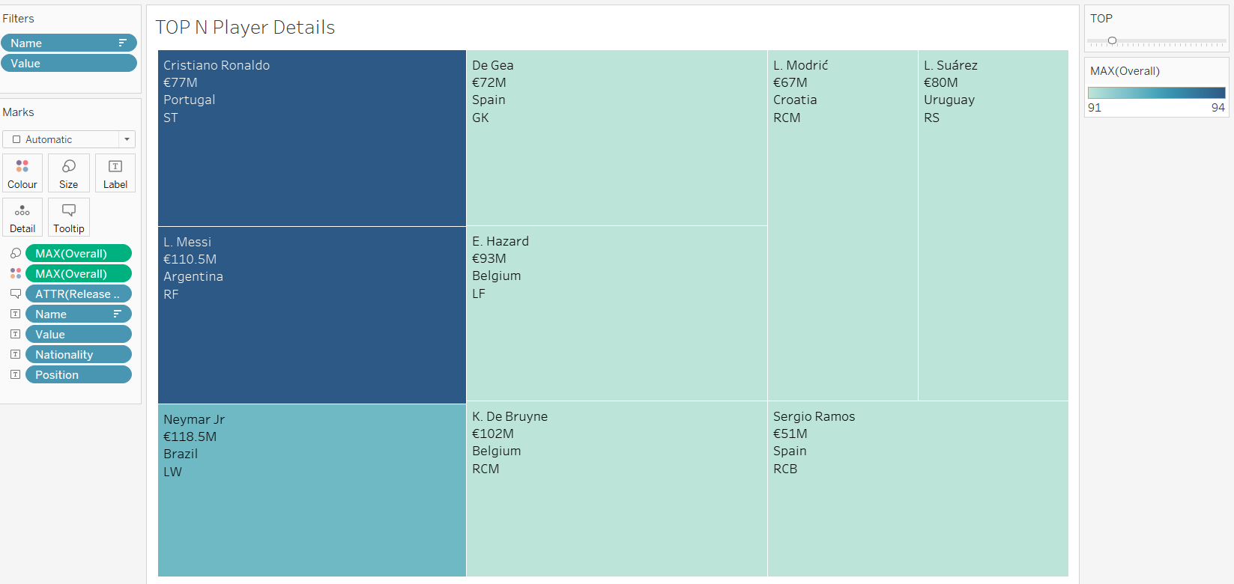

**Objective 2:**

Comparison of overall scores with respect to preferred foot:

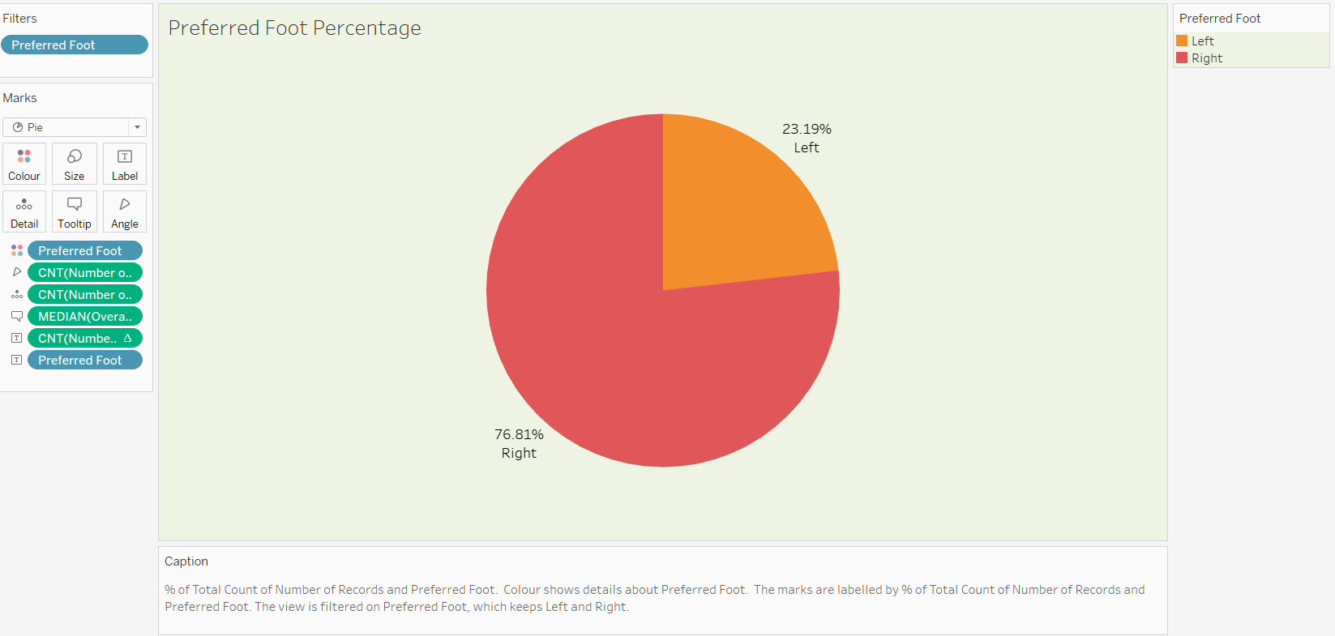



**Objective 3:**

Statistics of different nations participating in FIFA

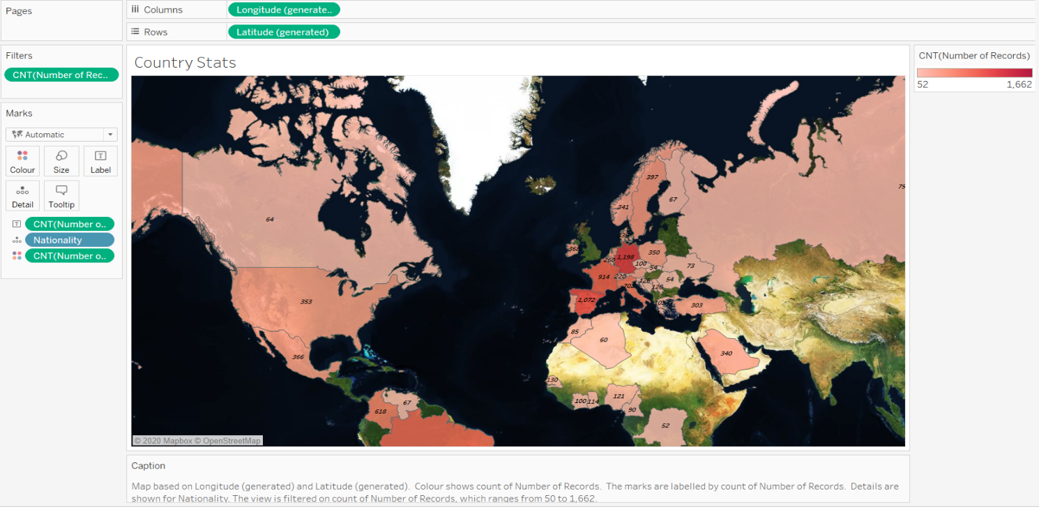

**Objective 4:**

Players with highest potential to grow.

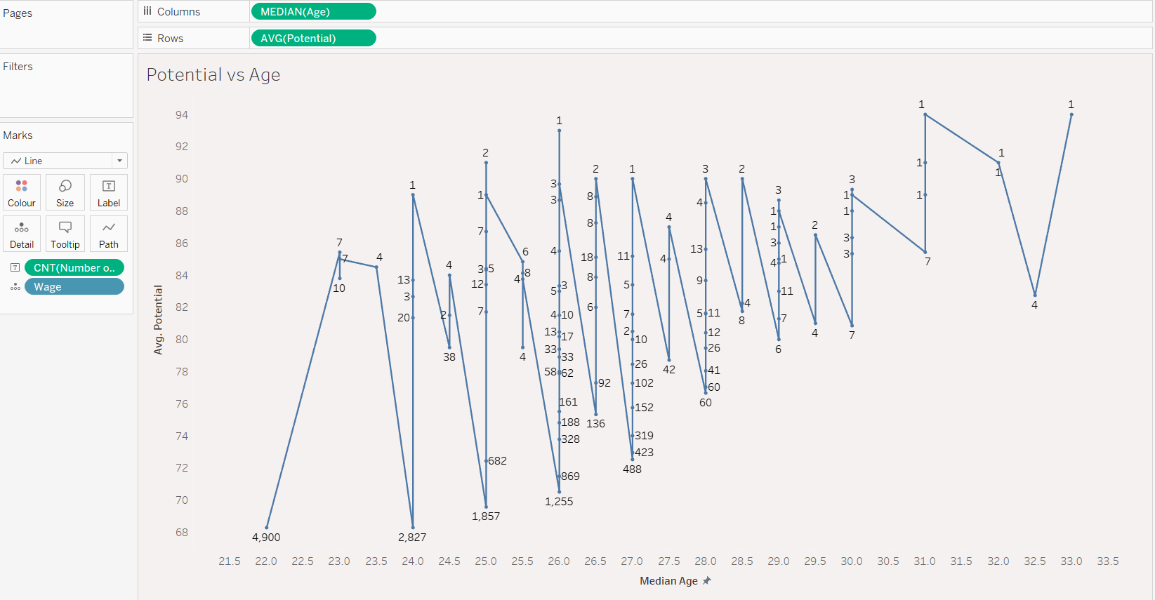

**Objective 5**

Interactive Dashboard

