COMPUTER INVESTIGATORY PROJECT

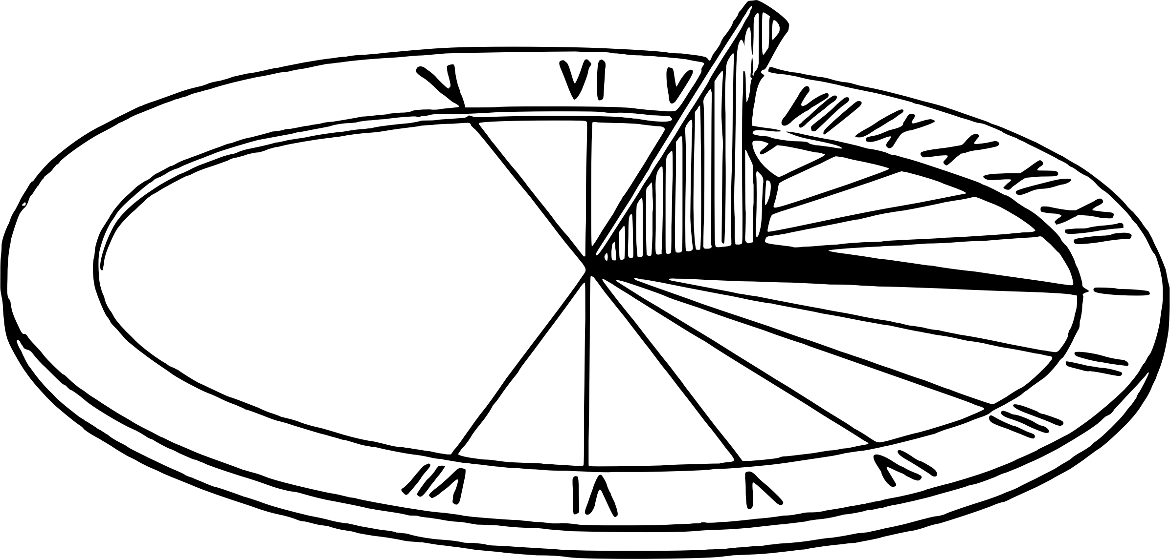

SOLARIZED
A monitoring tool for solar power production & consumption

IDENTTITY

Name | Saptarshi Mandal
Class | XII - Science
Roll No | 12676157
Subject | Computer Science (083)
Session | 2022 - 2023

INDEX

Sl No. | Topic | Page No.
1 | Acknowledgement | 4
2 | Introduction | 5
3 | Modules used in the project | 6
4 | Obejctives of the Project | 7
5 | Advantages | 8
6 | Flow Diagram | 9
7 | Source Code | 10
8 | Output | 22
9 | Bibliography | 25
10 | Certificate | 26

ACKNOWLEDGEMENT

I would like to express my deep gratitude towards our Principal Ma’am for her encouragement and all the facilites she has provided to us for this project.

I would also like to extend my thanks to our Computer Teacher – Mrs. Tinny Bhattacharjee who provided us with her guidance.

I also would like to thank my teammates who made the course of this project a smooth and swift one.

Thanking You,

Saptarshi Mandal
XII - Science
INTRODUCTION

About Python

Python is an interpreted, object-oriented, high-level programming language with dynamic semantics. Its high-level built in data structures, combined with dynamic typing and dynamic binding, make it very attractive for Rapid Application Development, as well as for use as a scripting or glue language to connect existing components together. Python's simple, easy to learn syntax emphasizes readability and therefore reduces the cost of program maintenance. Python supports modules and packages, which encourages program modularity and code reuse. The Python interpreter and the extensive standard library are available in source or binary form without charge for all major platforms, and can be freely distributed.

About SQL

SQL stands for Structured Query Language. SQL is used to communicate with a database. According to ANSI (American National Standards Institute), it is the standard language for relational database management systems. SQL statements are used to perform tasks such as update data on a database, or retrieve data from a database. Some common relational database management systems that use SQL are: Oracle, Sybase, Microsoft SQL Server, Access, Ingres, etc.

Modules used in the project:
- PyQt5
- matplotlib
- random
- mysql.connector
- sys
- csv
- pickle

MODULE | DESCRIPTION
PyQt5 | PyQt5 is a comprehensive set of Python bindings for Qt v5. It is implemented as more than 35 extension modules and enables Python to be used as an alternative application development language to C++ on all supported platforms including iOS and Android.  Qt is set of cross-platform C++ libraries that implement high-level APIs for accessing many aspects of modern desktop and mobile systems.
matplotlib | Matplotlib is a comprehensive library for creating static, animated, and interactive visualizations in Python.  Matplotlib produces publication-quality figures in a variety of hardcopy formats and interactive environments across platforms. Matplotlib can be used in Python scripts, Python/IPython shells, web application servers, and various graphical user interface toolkits.
mysql.connector | MySQL driver written in Python
random | This module implements pseudo-random number generators for various distributions.
sys | This module provides access to some variables used or maintained by the interpreter.
csv | The csv module implements classes to read and write tabular data in CSV format.
pickle | The pickle module implements binary protocols for serializing and de-serializing a Python object structure.
OBJECTIVES OF THE PROJECT

Solar power is an incredible venture that aims to provide a sustainable and self-sufficient source of power to the rural parts of the country. It is playing an important role in the development of Indian villages.

With the installation of solar panels each house is capable of producing power for itself and sometimes for their neighbours too. Since, the production of solar power is not consistent, and is subject to factors like day-to-day weather, seasonal changes and cloud cover, it is important to monitor the production regularly.

Sometimes, when a house overproduces, it can supply the excess power to the grid and when a house underproduces, it can the deficient power from the grid and hence, each house needs to be billed at seperate rates.

These trends also need to be monitored over time, to develop a proper revenue model that is both sustainable for the government or private supplier and affordable for the rural people.

This tool helps in solving this problem, my providing a simulation environment where trends can be monitored for different values of fluctuation, power cost and payouts.

It utilizes an SQL database, to store the average power production, and varies that over time according to the parameters entered by the user in order to demonstrate how they affect the overall revenue generated.

The program is made extensible by the utilization of SQL and it is also capable of importing and exporting data from and to csv files for further extensibility.

ADVANTAGES

There are multiple advantages to using this tool. They include:

- No actual field-work has to be performed.
- The user just needs to know the comparative performance of different solar power generation devices and not the actual performances.
- The revenue model can be varied easily.
- Data can be imported from Excel sheets which are in common use.
- Consumption graphs are automatically generated and can easily be saved for future reference.

The file structure of the program itself also provides certain advantages. These are:

- Each unit of the program is completely independent and can easily be used as part of any other program.
- The default data file is openly editable.
- Settings are saved in a transparent manner.

This sort of a simulation environment has many more applications which can easily be implement through some surface level modifications. It can be utilized in any situation where production or consumption is very inconsistent. Some of such applications include:

- Monitoring sports players and deciding salary bonuses over a season based on their performance.
- Monitoring content creaters on various online platorms and assigning cuts from the ad revenue generated based on their production.
- Monitoring profits and losses in gambling houses.
FLOW DIAGRAM

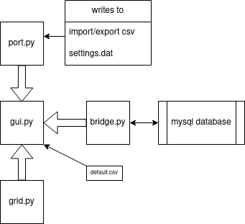
FILE | ROLE
Bridge.py | To provide for easy connection to the mysql database, add/remove records, search for specific records, etc.
Grid.py | To generate the random production and consumption over each cycle and also calculate the revenue generated.
Gui.py | To display everything in presentable gui, graph the consumption history, and make it easy for the user to edit the database, look for a record, or change the parameters.
Port.py | To easily import/export csv files and save settings.
Default.csv | To store the default data for demonstration purposes.
Settings.dat | To store the saved settings.
SOURCE CODE

The source code consists of following files:
- Python files:
  - bridge.py
  - grid.py
  - gui.py
  - port.py
- Other files:
  - default.csv
  - settings.dat

bridge.py
#========== IMPORT ==========#

import mysql.connector as mc

#========== GLOBALS ==========#

host = "localhost"
user = "rishi"
passwd = "rishi123"
database = "grid"

#========== CONNECTION FUNCTIONS ==========#

def connect():
global mycon, cur
mycon = mc.connect(host=host, user=user, passwd=passwd, database=database)
if mycon.is_connected():
cur = mycon.cursor()
else:
print("Error connecting...")

def disconnect():
mycon.close()

#========== TABLE FUNCTIONS ==========#

def create_tables():
cur.execute("create table if not exists houses (acc integer primary key, name char(20) not null, ph bigint not null, rate integer not null);")
mycon.commit()

#========== DATA HANDLING ==========#

def add_house(acc, name, ph, rate):
cur.execute("insert into houses values({}, '{}', {}, {})".format(acc, name, ph, rate))
mycon.commit()

def get_houses(col="*"):
cur.execute("select %s from houses" % col)
return cur.fetchall()

def remove_house(acc):
cur.execute("delete from houses where acc = %s" % acc)
mycon.commit()

def remove_all():
cur.execute("delete from houses;")
mycon.commit()

#========== OTHER FUNCTIONS ==========#

def search_house(col, query):
cur.execute("select * from houses where {} like \"%{}%\"".format(col, query))
grid.py
#========== IMPORT ==========#

import random

#========== GRID CLASS ==========#

class Grid:
def __init__(self, houses, fluc, chg, pay):
self.houses = houses
self.fluc = fluc
self.chg = chg
self.pay = pay
self.cur_sheet = []
self.revenue = 0

def cycle(self):
self.cur_sheet = []
self.revenue = 0
for i in range(self.houses):
prod = round((random.random()-0.5)*self.fluc, 4)
cons = round((random.random()-0.5)*self.fluc, 4)
diff = round((prod - cons), 4)
self.revenue -= diff
self.cur_sheet.append((prod, cons, diff))

def get_amount(self):
if self.revenue >= 0:
return self.revenue * self.chg
else:
return self.revenue * self.pay
gui.py
#========== IMPORT ==========#

import sys
import bridge
import grid
import port

import matplotlib
matplotlib.use('Qt5Agg')
from matplotlib.backends.backend_qt5agg import FigureCanvasQTAgg as FigureCanvas
from matplotlib.backends.backend_qt5agg import NavigationToolbar2QT as NavigationToolbar
from matplotlib.figure import Figure

from PyQt5.QtCore import Qt
from PyQt5.QtWidgets import QApplication, QMainWindow, QAction, QDialog, QInputDialog, QPushButton, QLabel, QDialogButtonBox, QVBoxLayout, QMessageBox, QWidget, QTableWidget, QTableWidgetItem, QFileDialog

#========== GLOBALS ==========#

cols = {'Account Number' : 'acc', 'Name of Owner': 'name', 'Phone Number': 'ph'}
default = "./default.csv"

#========== GRAPH CLASS ==========#

class Graph(FigureCanvas):
def __init__(self, parent=None, width=5, height=4, dpi=100):
fig = Figure(figsize=(width, height), dpi=dpi)
self.axes = fig.add_subplot(111)
super(Graph, self).__init__(fig)

#========== PANEL CLASS ==========#

class Panel(QMainWindow):
def __init__(self):
super(Panel, self).__init__()
self.settings = port.load_settings()
self.gd = grid.Grid(len(bridge.get_houses()), self.settings[0], self.settings[1], self.settings[2])
self.revenue_hist = []

self.setWindowTitle('Grid')
self.layout = QVBoxLayout()

self.setup_menus()
self.setup_table()
self.setup_graph()

widget = QWidget()
widget.setLayout(self.layout)
self.setCentralWidget(widget)

#========== SETUP FUNCTIONS ==========#

def setup_menus(self):
self.menuBar = self.menuBar()

#== filemenu ==#
fileMenu = self.menuBar.addMenu('File')

import_action = QAction('Import CSV', self)
import_action.setShortcut('o')
import_action.triggered.connect(lambda :self.import_csv())

export_action = QAction('Export to CSV', self)
export_action.setShortcut('s')
export_action.triggered.connect(lambda :self.export_csv())

exit_action = QAction('Exit', self)
exit_action.setShortcut('q')
exit_action.triggered.connect(lambda :QApplication.quit())

fileMenu.addAction(import_action)
fileMenu.addAction(export_action)
fileMenu.addAction(exit_action)

#== editmenu ==#
editMenu = self.menuBar.addMenu('Edit')

add_action = QAction('Add House', self)
add_action.setShortcut('a')
add_action.triggered.connect(lambda :self.add_house())

rem_action = QAction('Remove House', self)
rem_action.setShortcut('v')
rem_action.triggered.connect(lambda :self.remove_house())

search_action = QAction('Search House', self)
search_action.setShortcut('/')
search_action.triggered.connect(lambda :self.search_house())

editMenu.addAction(add_action)
editMenu.addAction(rem_action)
editMenu.addAction(search_action)

#== gridmenu ==#
gridMenu = self.menuBar.addMenu('Grid')

cycle_action = QAction('Cycle', self)
cycle_action.setShortcut('space')
cycle_action.triggered.connect(lambda :self.cycle())

ff_action = QAction('Fast Forward', self)
ff_action.setShortcut('f')
ff_action.triggered.connect(lambda :self.ff())

fluc_action = QAction('Fluctuation', self)
fluc_action.triggered.connect(lambda :self.change_fluc())

chg_action = QAction('Power Charge', self)
chg_action.triggered.connect(lambda :self.change_chg())

pay_action = QAction('Power Payout', self)
pay_action.triggered.connect(lambda :self.change_pay())

amt_action = QAction('Get Amount', self)
amt_action.setShortcut('g')
amt_action.triggered.connect(lambda :self.get_amount())

gridMenu.addAction(cycle_action)
gridMenu.addAction(ff_action)
gridMenu.addAction(fluc_action)
gridMenu.addAction(chg_action)
gridMenu.addAction(pay_action)
gridMenu.addAction(amt_action)

#== tablemenu ==#
tableMenu = self.menuBar.addMenu('Table')

update_action = QAction('Update', self)
update_action.setShortcut('r')
update_action.triggered.connect(lambda :self.update_table())

default_action = QAction('Default Houses', self)
default_action.setShortcut('n')
default_action.triggered.connect(lambda :self.default_house())

clear_action = QAction('Clear Table', self)
clear_action.setShortcut('c')
clear_action.triggered.connect(lambda :self.clear_house())

tableMenu.addAction(update_action)
tableMenu.addAction(default_action)
tableMenu.addAction(clear_action)

#== graphmenu ==#
graphMenu = self.menuBar.addMenu('Graph')

graphclr_action = QAction('Clear Graph', self)
graphclr_action.setShortcut('x')
graphclr_action.triggered.connect(lambda :self.clear_graph())

graphMenu.addAction(graphclr_action)

def setup_table(self):
self.table = QTableWidget()
self.table.setColumnCount(7)
self.table.setHorizontalHeaderLabels(['Account', 'Name', 'Phone', 'Avg Prod Rate', 'Cur Prod Rate', 'Cur Cons Rate', 'Cur Diff'])
self.table.setSortingEnabled(True)
self.update_table()
self.layout.addWidget(self.table)

def setup_graph(self):
self.sc = Graph(self, width=5, height=4, dpi=100)
self.layout.addWidget(self.sc)

self.graphbar = NavigationToolbar(self.sc)
self.layout.addWidget(self.graphbar)
self.draw_graph()

def draw_graph(self):
self.sc.axes.set_title("CONSUMPTION GRAPH")
self.sc.axes.set_xlabel("cycles")
self.sc.axes.set_ylabel("consumption")
leg = self.sc.axes.legend(loc='upper right', frameon=True)
self.sc.draw()

#========== UPDATE FUNCTIONS ==========#

def update_table(self):
data = bridge.get_houses()
self.gd.houses = len(data)
self.table.setRowCount(len(data))

for row in range(len(data)):
for col in range(len(data[0])):
if type(data[row][col]) is int:
cell = QTableWidgetItem()
cell.setData(Qt.EditRole, data[row][col])
else:
cell = QTableWidgetItem((data[row][col]))
cell.setFlags(cell.flags() ^ Qt.ItemIsEditable)
self.table.setItem(row, col, cell)

def update_graph(self):
self.sc.axes.cla()
self.sc.axes.plot(range(len(self.revenue_hist)), self.revenue_hist, color='blue', label="Consumption")
if len(self.revenue_hist) >= 2:
avgline = self.revenue_hist[0:1] + self.revenue_hist[-1::]
self.sc.axes.plot([0, len(self.revenue_hist)-1], avgline, color='green', label="Average")

zeroline = [0]*(len(self.revenue_hist))
self.sc.axes.plot(range(len(self.revenue_hist)), zeroline, color='black', label="Zero")
self.draw_graph()

#========== CYCLE FUNCTIONS ==========#

def cycle(self):
revenue = 0
self.gd.cycle()
self.update_table()
data = bridge.get_houses("rate")

for row in range(len(self.gd.cur_sheet)):
for col in range(4,6):
cell = QTableWidgetItem(str(data[row][0] + self.gd.cur_sheet[row][col-4]))
self.table.setItem(row, col, cell)
self.table.setItem(row, 6, QTableWidgetItem(str(self.gd.cur_sheet[row][2])))

self.revenue_hist.append(round(self.gd.revenue, 4))
self.update_graph()

def ff(self):
n, done1 = QInputDialog.getInt(self, 'Input Dialog', 'Enter number of cycles:', value=2, min=0)
if done1 and self.confirm("Fast Forward", "Are you sure you want to fast forward "+str(n)+" cycles?"):
for i in range(n):
self.cycle()

#========== REVENUE FUNCTIONS ==========#

def get_amount( >>> int('0b100', base=0)
amt = round 4
if amt >= 0:
self.dialog("Revenue Generated", "A profit of "+str(amt)+" has been made.")
else:
self.dialog("Revenue Generated", "A loss of "+str(-amt)+" has been made.")

#========== EDIT FUNCTIONS ==========#

def add_house(self):
message = ""
acc, done1 = QInputDialog.getInt(self, 'Input Dialog', 'Enter Account Number:', min=1, value=len(bridge.get_houses("acc"))+1)
if done1:
if (acc,) in bridge.get_houses("acc"):
message = "Duplicate Account Number"
else:
name, done2 = QInputDialog.getText(self, 'Input Dialog', 'Enter Owner Name:')
if done2 and isinstance(name, str):
ph, done3 = QInputDialog.getInt(self, 'Input Dialog', 'Enter Phone:', min=0)
if done3:
rate, done4 = QInputDialog.getInt(self, 'Input Dialog', 'Enter Avg Prod Rate:', min=0)17
if done4:
bridge.add_house(acc, name, ph, rate)
message = "House Successfully Added!"
self.update_table()
if message != "":
self.dialog("Adding...", message)

def remove_house(self):
message = ""
acc, done1 = QInputDialog.getInt(self, 'Input Dialog', 'Enter Account Number', min=1)
if done1:
if (acc,) not in bridge.get_houses("acc"):
message = "No Such Account"
else:
bridge.remove_house(acc)
message = "House Successfully Removed!"
self.update_table()
if message != "":
self.dialog("Removing...", message)

def clear_house(self):
if self.confirm("Clear House", "Are you sure you want to clear all the houses?"):
bridge.remove_all()
self.update_table()

def clear_graph(self):
self.revenue_hist = self.revenue_hist[-1::]
self.sc.axes.cla()
self.draw_graph()

#========== OTHER FUNCTIONS =========#

def search_house(self):
global cols
col, done1 = QInputDialog.getItem(self, 'Input Dialog', 'Choose the search category:', cols.keys())
if done1 and col in cols.keys():
query, done2 = QInputDialog.getText(self, 'Input Dialog', ('Enter '+col))
if done2:
results = bridge.search_house(cols[col], query)
if results == []:
self.dialog("Search Results", "No Reuslts!")
else:
dlg = QDialog()
dlg.setWindowTitle("Search Results")
buttons = QDialogButtonBox.Ok
dlg.buttonBox = QDialogButtonBox(buttons)
dlg.buttonBox.accepted.connect(dlg.accept)

result_table = QTableWidget()
result_table.setColumnCount(4)
result_table.setRowCount(len(results))
result_table.setHorizontalHeaderLabels(['Account', 'Name', 'Phone', 'Avg Prod Rate'])
result_table.setSortingEnabled(True)

for row in range(len(results)):
for col in range(len(results[0])):
cell = QTableWidgetItem(str(results[row][col]))
result_table.setItem(row, col, cell)

dlg.layout = QVBoxLayout()
dlg.layout.addWidget(result_table)
dlg.layout.addWidget(dlg.buttonBox)
dlg.setLayout(dlg.layout)
dlg.exec()

def default_house(self):
if self.confirm("Default House", "Do you really want to restore default houses? This will delete current data!"):
global default
bridge.remove_all()
port.import_csv(default, bridge)
self.update_table()

#========== TUNING FUNCTIONS ==========#

def change_fluc(self):
fluc, done = QInputDialog.getDouble(self, 'Input Dialog', 'Enter Fluctuation Level:', min=0.0, max=10.0, value=self.settings[0])
if done:
self.gd.fluc = fluc
port.save_settings(fluc, self.settings[1], self.settings[2])
self.settings = port.load_settings()
self.dialog("Changing Fluctuation...", "Fluctuation Level Changed!")

def change_chg(self):
chg, done = QInputDialog.getDouble(self, 'Input Dialog', 'Enter Power Charge:', min=0.0, value=self.settings[1])
if done:
self.gd.chg = chg
port.save_settings(self.settings[0], chg, self.settings[2])
self.settings = port.load_settings()
self.dialog("Changing Power Charge...", "Power Charge Changed!")

def change_pay(self):
pay, done = QInputDialog.getDouble(self, 'Input Dialog', 'Enter Power Payout:', min=0.0, value=self.settings[2])
if done:
self.gd.pay = pay
port.save_settings(self.settings[0], self.settings[1], pay)
self.settings = port.load_settings()
self.dialog("Changing Power Payout...", "Power Payout Changed!")

#========== IMPORT-EXPORT WRAPPERS ==========#

def import_csv(self):
dlg, done = QFileDialog.getOpenFileUrl(self)
if done and self.confirm("Importing...", "Are you sure you want to import from csv? Current data will be deleted!"):
bridge.remove_all()
port.import_csv(dlg.path(), bridge)
self.update_table()

def export_csv(self):
dlg, done = QFileDialog.getSaveFileUrl(self)
if done:
port.export_csv(dlg.path(), bridge)

#========== UTILITY FUNCTIONS ==========#

def dialog(self, title, message):
dlg = QMessageBox(self)
dlg.setWindowTitle(title)
dlg.setText(message)
dlg.exec()
del dlg

def confirm(self, title, message):
dlg = QDialog()
dlg.setWindowTitle(title)
buttons = QDialogButtonBox.Yes | QDialogButtonBox.No
dlg.buttonBox = QDialogButtonBox(buttons)
dlg.buttonBox.accepted.connect(dlg.accept)
dlg.buttonBox.rejected.connect(dlg.reject)

dlg.layout = QVBoxLayout()
dlg.layout.addWidget(QLabel(message))
dlg.layout.addWidget(dlg.buttonBox)
dlg.setLayout(dlg.layout)

if dlg.exec():
return True
else:
return False
del dlg

#========== MAIN LOOP ==========#

if __name__ == '__main__':
bridge.connect()
bridge.create_tables()
app = QApplication(sys.argv)
panel = Panel()
panel.show()
try:
sys.exit(app.exec_())
except SystemExit:
bridge.disconnect()
print("Closing Window")
port.py
#========== IMPORT ==========#

import csv
import pickle

#========== DATA FUNCTIONS ==========#

def import_csv(url, bridge):
file = open(url, "r")
csvreader = csv.reader(file)
for rec in csvreader:
bridge.add_house(rec[0], rec[1], rec[2], rec[3])
file.close()

def export_csv(url, bridge):
file = open(url, "w")
csvwriter = csv.writer(file)
csvwriter.writerows(bridge.get_houses())
file.close()

#========== SETTINGS FUNCTIONS ==========#

def save_settings(fluc, chg, pay):
file = open("./settings.dat", "wb")
pickle.dump([fluc, chg, pay], file)
file.close()

def load_settings():
file = open("./settings.dat", "rb")
settings = pickle.load(file)
file.close()
return settings
default.csv
1,Ashish Agarwal,101,7
2,Brijesh Biswas,202,5
3,Chirayu Chandra,303,2
4,Diya Deshmukh,404,3
5,Eshanika Emami,505,6
6,Farukkh Fawaz,606,4
7,Ganesh Ganguly,707,5
8,Hrithik Haider,808,3
OUTPUT
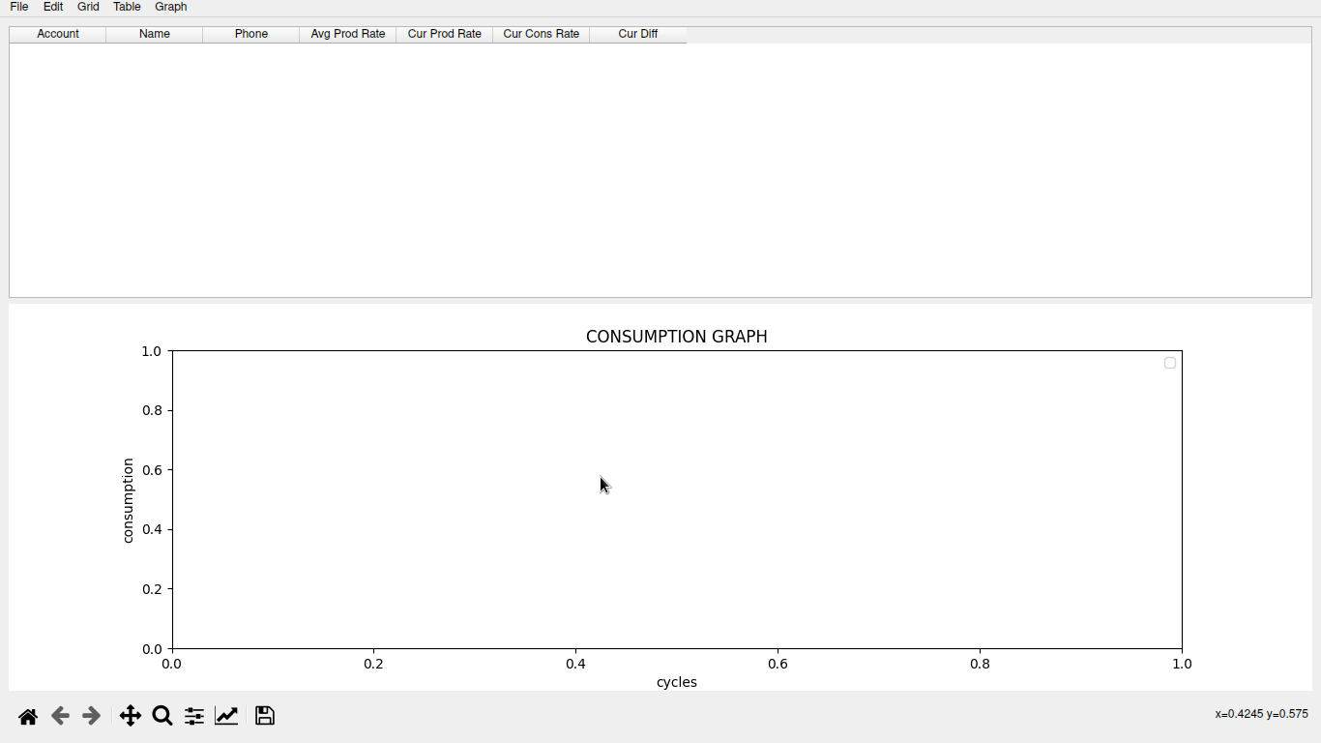
First time starting the program
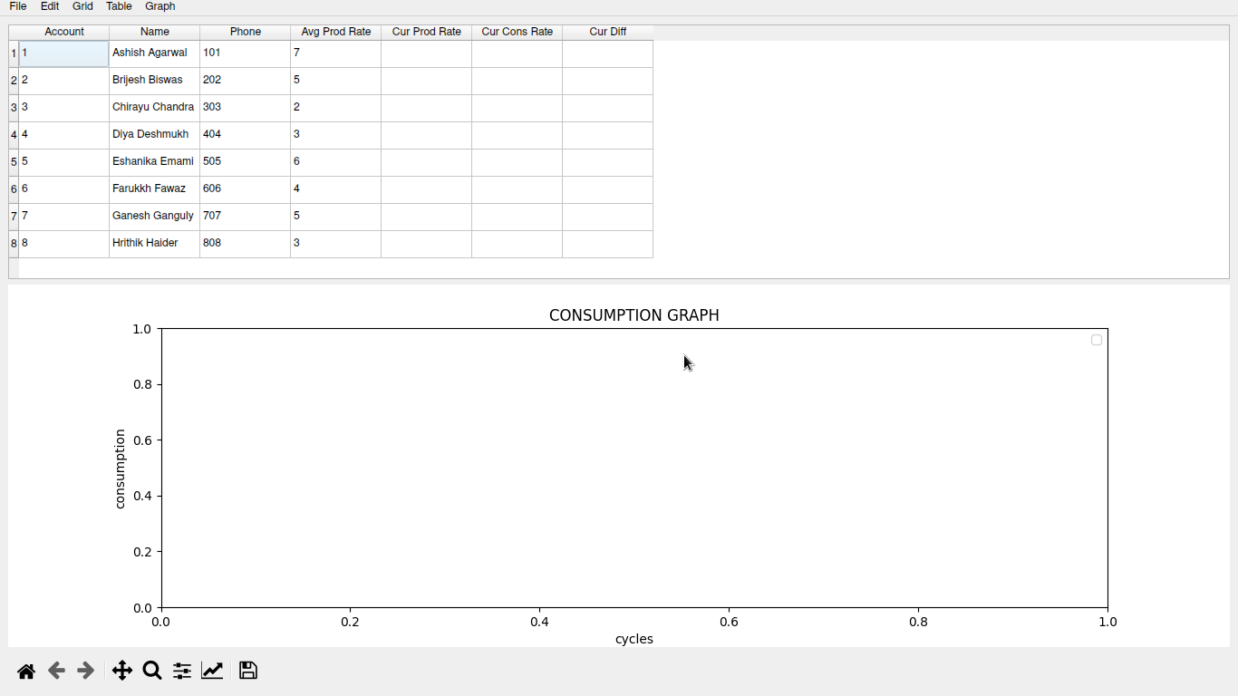Default data loaded into program (Table > Default Houses)
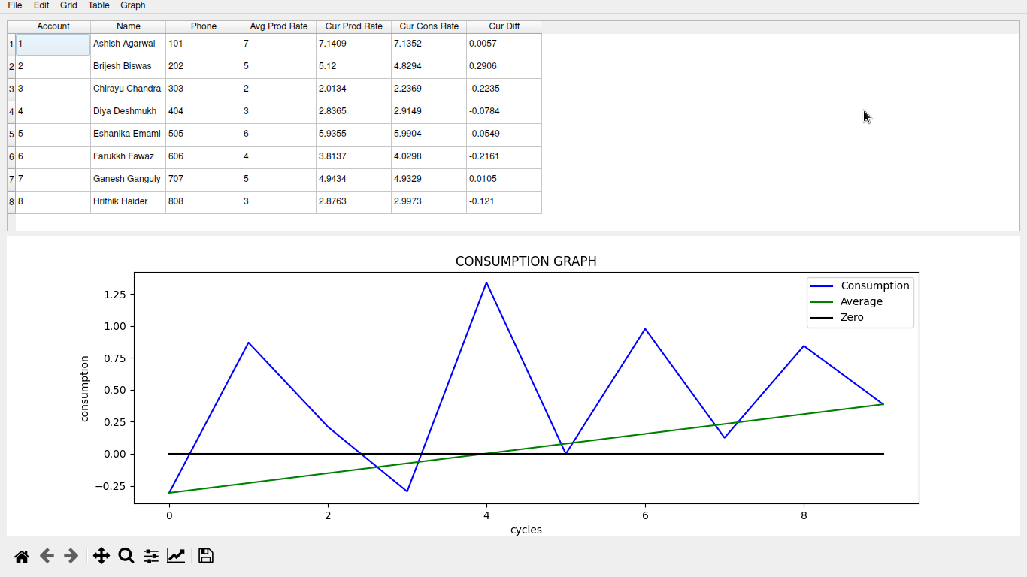After running 10 cycles (Grid > Cycle)
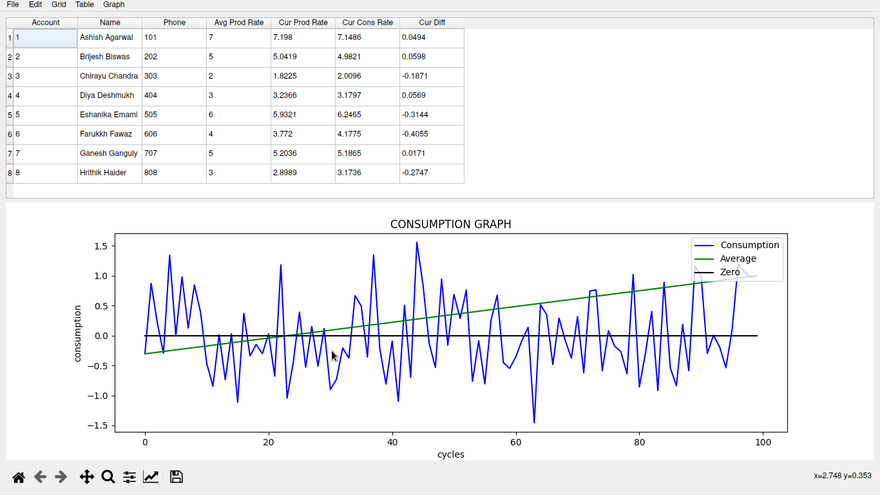After fast forwarding to the 100th cycle (Grid > Fast Forward)
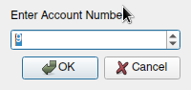 | 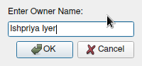 |  | 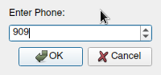 |  | 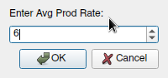
Adding a house (Edit > Add House)
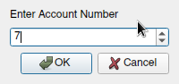 |  |  | 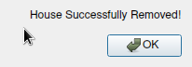
Removing a house (Edit > Remove House)
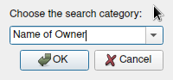 |  |  | 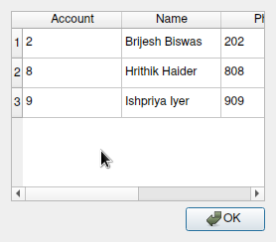
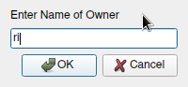
Searching for a house (Edit > Search House)
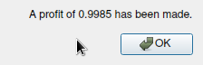 |  |  | 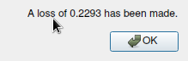
Getting the amount (Grid > Get Amount)
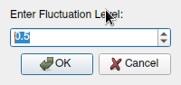 |  | 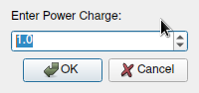 |  | 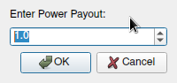
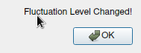 |  | 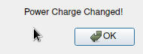 |  | 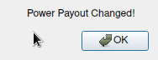
Tuning the program (Grid > Fluctuation / Power Charge / Power Payout)
BIBLIOGRAPHY

The following resources were utilized in the completion of this project.

Books:
- Computer Science with Python – Textbook for class XII by Sumita Arora

Websites:
- https://www.riverbankcomputing.com/static/Docs/PyQt5
- https://pypi.org/project/pip/
- https://matplotlib.org/stable/users/index.html

CERTIFICATE

This is to certify that Saptarshi Mandal of Class XII-Science of Hariyana Vidya Mandir has completed a project work entitled - “Solarized – a monitoring tool for solar power production & consumption” in Computer Science (083) successfully as a part of AISSCE 2023.

Tinny Bhattacharjee
External Examiner

