224. Introduction to APIs
- API: Application Programming Interface.
- A set of rules or protocols that tells applications how to interact with each other.
- Type of APIs by architectural structure:
  - GraphQL
  - REST:API
  - SOAP
  - gRPC
- REST:API uses HTTP protocols (GET, POST etc.).
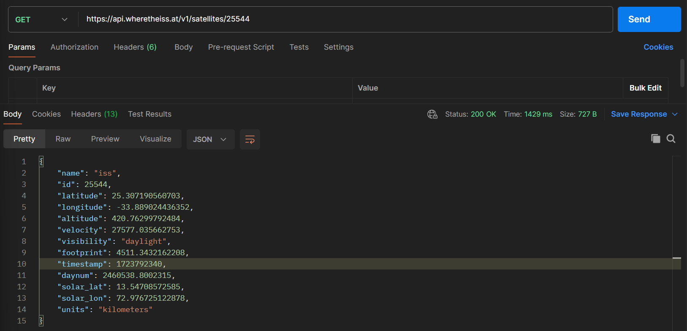
225. Structuring API Requests
- API Endpoint:
  - BaseURL/Endpoint
  - E.g. https://bored-api-appbrewery.com/random; where random is and endpoint.
- Query Parameters:
  - BaseURL/Endpoint?query1=value1&query2=value2
  - E.g. https://bored-api-appbrewery.com/filter?type=education; where filter?type=education is a query parameter.
- Path parameters:
  - BaseURL/Endpoint/{path-parameter}
  - E.g. https://bored-api-appbrewery.com/activity/3943506; where 394350 is path parameter.
226. What is JSON?
- JSON: JavaScript object notation.
- It’s a way to format data that can be sent over the internet in a readable format.
- Unlike JS object, the keys are strings.
- JS Object -> JSON
  - const jsonData = JSON.stringify(data);
- JSON -> JS Object
  - const data = JSON.parse(jsonDATA);
227. Making Server-Side API Requests with Axios
- Axios is a popular JavaScript library used for making HTTP requests from the browser or Node.js. It is a promise-based HTTP client that works on both client and server-side, allowing developers to perform various network requests, such as GET, POST, PUT, DELETE, etc.
- Example usage:
import express from "express";
import bodyParser from "body-parser";
import axios from "axios";
const APP = express();
const PORT = 3000;
APP.use(express.static("public"));
APP.use(bodyParser.urlencoded({ extended: true }));

APP.get("/", async (req, res) => {
try {
const response = await axios.get("https://bored-api.appbrewery.com/random");
const result = response.data;
console.log(result);
res.render("index.ejs", { data: result });
} catch (error) {
console.error("Failed to make request:", error.message);
res.render("index.ejs", { error: error.message });
}
});

APP.post("/", async (req, res) => {
try {
console.log(req.body);
const type = req.body.type;
const participants = req.body.participants;
const response = await axios.get (
`https://bored-api.appbrewery.com/filter?type=${type}&participants=${participants}`
);
const result = response.data;
console.log(result);
res.render("index.ejs", {
data: result[Math.floor(Math.random() * result.length)]
});
} catch (error) {
console.error("Failed to make request:", error.message);
res.render("index.ejs", {
error: "No activities that match your criteria.",
});
}
});

APP.listen(PORT, () => {
console.log(`Server running on PORT: ${PORT}`);
});

