Section 33: PostgreSQL
247. Introduction to Postgres
- PostgreSQL is an open-source, object-relational database management system (ORDBMS) known for its robustness, extensibility, and standards compliance. It supports SQL for querying and managing data and provides powerful features such as:
  - ACID Compliance: Ensures reliable transactions with strong data integrity and consistency.
  - Extensibility: Allows users to define custom data types, operators, and functions, making it highly customizable.
  - Advanced Features: Supports advanced data types (JSON, XML, arrays), full-text search, and geospatial data with PostGIS.
  - Concurrency Control: Utilizes Multi-Version Concurrency Control (MVCC) to handle high levels of concurrent transactions without locking.
  - Cross-Platform: Available on various operating systems, including Windows, macOS, and Linux.
  - Community and Support: Backed by a strong community and numerous extensions, it offers extensive support and documentation.
- PostgreSQL is commonly used for web applications, data warehousing, and complex applications that require advanced data handling capabilities.
- Why PostgreSQL?
  - Free and open source
  - Widely used in industry
  - Community support
  - Career opportunities
- How to use PostgreSQL?
import Client from "pg";
const DB = new Client({
user: "username",
host: "localhost",
database: "myDatabase",
password: "password",
port: 5432
});
DB.connect();

DB.query("SELECT * FROM users", (err, res) => {
if (err) console.error("Error executing query", err.stack);
else console.log("User data: ", res.rows);
DB.end();
});
- Package name: `pg` (node-postgres).
- Pre-requisites:
  - Postgres Server: Stands up a Postgres server on our local computer.
  - pgAdmin: UI to tap into our Postgres server.
249. Understand how to use keys, Postgres types and keywords
- Postgres Data Types: https://www.postgresql.org/docs/current/datatype.html
- CSV – Comma Separated Values.
253. Query data using SELECT, WHERE and LIKE
- Various select methods:
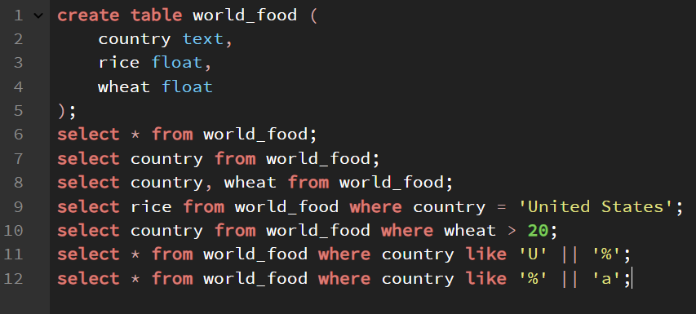
254. UNIQUE and NOT NULL | Travel Tracker Part 1
- NOT NULL – Missing or empty values are not allowed. Attempts to ass NULL will result in an error.
- UNIQUE – Value cannot be repeated in the table. No other value stored can be the same (avoids duplicates).
255. INSERT and add Data | Travel Tracker Part 2
await DB.query(
"INSERT INTO visited_countries (country_code) VALUES ($1)",
[countryCode]
);

257. One to One Relationships and Inner Joins
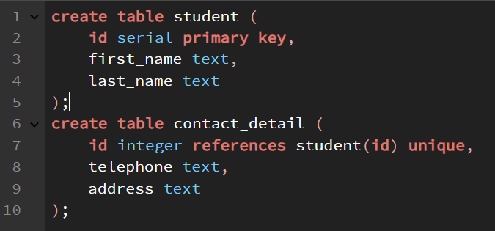
- Example of one-to-one relationship.
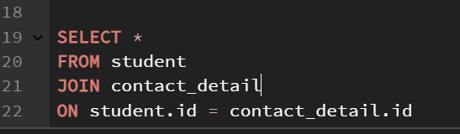
- Inner join

