DEPARTMENT OF COMPUTER APPLICATIONS
UNIVERSITY / COLLEGE NAME
MEDIFIND: HYPERLOCAL MEDICINE AVAILABILITY DISCOVERY & AI CLINICAL TRIAGE SYSTEM
A PROJECT SYNOPSIS
Submitted in partial fulfillment of the requirements for the award of the degree of
MASTER OF COMPUTER APPLICATIONS (MCA)

SUBMITTED BY:  Student Name: Rishi Pal  Roll No.: MCA-2026-089  Enrollment No.: EN-2024-99812  Semester: MCA IV Semester | UNDER THE GUIDANCE OF:  Guide Name: Dr. Project Guide  Designation: Associate Professor  Department of Computer Applications
ACADEMIC SESSION: 2026–2027

CERTIFICATE
This is to certify that the project synopsis entitled "MEDIFIND: HYPERLOCAL MEDICINE AVAILABILITY DISCOVERY & AI CLINICAL TRIAGE SYSTEM" submitted by Rishi Pal (Roll No.: MCA-2026-089, Enrollment No.: EN-2024-99812) in partial fulfillment of the requirements for the award of the degree of Master of Computer Applications (MCA) to the Department of Computer Applications, is an authentic record of work carried out by him under my supervision and guidance.
To the best of my knowledge, the matter embodied in this synopsis has not been submitted to any other University or Institution for the award of any degree or diploma.
_________________________ _________________________
(Dr. Project Guide) (Head of Department)
Project Guide Department of Computer Applications
Date: _______________ Date: _______________

DECLARATION
I hereby declare that the project synopsis entitled "MEDIFIND: HYPERLOCAL MEDICINE AVAILABILITY DISCOVERY & AI CLINICAL TRIAGE SYSTEM" submitted to the Department of Computer Applications, is an original work done by me under the guidance of Dr. Project Guide, Associate Professor, Department of Computer Applications.
I further declare that this synopsis work has not been submitted previously, either in part or in full, to this or any other University or Institution for the award of any degree, diploma, or title.
Rishi Pal
Roll No.: MCA-2026-089
Enrollment No.: EN-2024-99812
Department of Computer Applications
Date: _______________

ACKNOWLEDGEMENT
I express my deep sense of gratitude and sincere thanks to my esteemed project guide, Dr. Project Guide, Associate Professor, Department of Computer Applications, for invaluable guidance, constructive suggestions, constant encouragement, and continuous monitoring throughout the preparation of this project synopsis.
I extend my heartfelt gratitude to the Head of Department, Department of Computer Applications, for providing the necessary infrastructural facilities, academic support, and an inspiring environment to work on this project.
I am also thankful to all faculty members and technical staff of the department for their indirect assistance and valuable advice. Lastly, I express my sincere gratitude to my parents and friends for their continuous encouragement and moral support during the completion of this synopsis work.
Rishi Pal
Roll No.: MCA-2026-089

TABLE OF CONTENTS
S. No. | Section / Page Title | Page No.
 | Certificate | i
 | Declaration | ii
 | Acknowledgement | iii
 | Table of Contents | iv
 | List of Figures | v
 | List of Tables | vi
 | Abstract / Project Summary | vii
1 | Introduction | 1
2 | Problem Statement | 2
3 | Existing System | 3
4 | Limitations of Existing System | 4
5 | Proposed System | 5
6 | Objectives of the Project | 6
7 | Scope of the Project | 7
8 | Users and Roles | 8
9 | Modules of the System | 9
10 | Functional Requirements | 11
11 | Non-Functional Requirements | 13
12 | Technology Stack | 14
13 | Development Methodology | 15
14 | System Architecture | 16
15 | Use Case Diagram | 18
16 | DFD Level 0 (Context Diagram) | 20
17 | DFD Level 1 | 21
18 | ER Diagram | 23
19 | Database Design | 25
20 | Hardware and Software Requirements | 28
21 | Project Development Timeline | 29
22 | Expected Outcome | 30
23 | Limitations | 31
24 | Future Scope | 32
25 | Conclusion | 33
26 | References / Bibliography | 34

LIST OF FIGURES
Figure No. | Figure Title | Page No.
Figure 1 | System Architecture Diagram of MediFind | 17
Figure 2 | Use Case Diagram of MediFind System | 19
Figure 3 | DFD Level 0 Context Diagram | 20
Figure 4 | DFD Level 1 Process Breakdown Diagram | 22
Figure 5 | Entity-Relationship (ER) Diagram | 24

LIST OF TABLES
Table No. | Table Title | Page No.
Table 1 | Technology Stack Layer Breakdown | 14
Table 2 | Hardware and Software Specifications | 28
Table 3 | Project Development Schedule (Gantt Timeline) | 29

ABSTRACT / PROJECT SUMMARY
In modern healthcare distribution, patients experiencing urgent medical needs frequently face severe difficulties in locating essential pharmaceutical drugs across local retail medical stores. Traditional medicine procurement relies on physical store visits or manual phone calls, causing emergency delays, high travel costs, and distress during critical medical situations. Furthermore, unreadable handwritten prescriptions and complex multi-medicine doctor orders force patients to visit multiple pharmacies to fulfill a single prescription package.
To resolve these challenges, this project introduces MediFind—a full-stack hyperlocal medicine availability discovery platform and AI clinical triage assistant. MediFind is engineered using the MERN stack (MongoDB Atlas, Express.js, React.js, and Node.js). The system features a real-time stock lookup engine integrated with the Haversine geospatial proximity algorithm, enabling instant location-based sorting of stocked retail pharmacies. To eliminate prescription misinterpretation, MediFind incorporates Multimodal Vision AI OCR (powered by Google Gemini Vision), capable of digitizing handwritten doctor notes and translating Devanagari Hindi medicine terms into standard English catalog items. Additionally, an AI Clinical Symptom Triage engine evaluates patient symptoms and cross-references suggested remedies directly with live database stock.
To ensure public safety and vendor authenticity, MediFind enforces a mandatory Super Admin approval workflow requiring valid 15-digit GSTIN verification before any retail store can list inventory. The expected outcome of MediFind is a scalable, secure, and user-friendly digital healthcare ecosystem that eliminates emergency medicine search delays and optimizes local pharmacy distribution.

1. INTRODUCTION
Access to essential pharmaceutical medicines is one of the most vital components of public healthcare. In emergency medical situations or acute health conditions, obtaining prescribed drugs promptly can significantly influence patient recovery and outcomes. However, the current retail pharmacy ecosystem in urban and semi-urban regions remains highly fragmented. Patients searching for specific brand-name medicines, rare formulations, or complete multi-drug prescriptions must physically travel from store to store or rely on informal telephone inquiries.
MediFind is designed as a web-based, full-stack hyperlocal medicine availability discovery platform and AI clinical triage assistant. The primary goal of MediFind is to connect healthcare seekers directly with verified neighborhood retail pharmacies in real time. By digitizing local pharmacy inventory management and providing location-aware search capabilities, MediFind transforms how patients discover and procure medicines.
1.1 Project Domain & Context
MediFind operates at the intersection of HealthTech (Healthcare Technology), Hyperlocal E-Commerce, and Artificial Intelligence (AI). The platform leverages modern web standards, cloud database management, geospatial mathematics, and multimodal generative AI model APIs to address pharmaceutical supply visibility.
1.2 Need of the Proposed System
The proposed system is required to bridge the communication gap between retail pharmacists and local patients. During health crises, time lost in physical store hunting can lead to medical complications. MediFind reduces emergency search delays to sub-seconds, enabling patients to identify the nearest stocking pharmacy before stepping out of their homes.
2. PROBLEM STATEMENT
In the current healthcare environment, patients face severe operational inefficiencies when purchasing prescribed medicines. The specific core problems addressed by MediFind include:
• 1. Information Asymmetry: Lack of centralized digital inventory visibility across independent retail medical stores forces patients into blind physical searches.
• 2. Emergency Supply Delays: Time lost searching for critical drugs in emergency scenarios leads to patient anxiety and medical risks.
• 3. Multi-Medicine Prescription Fragmentation: Prescriptions containing 3 to 5 distinct medicines often require visiting multiple different pharmacies due to partial stock availability.
• 4. Unreadable Doctor Handwriting: Patients struggle to decipher handwritten prescriptions, resulting in incorrect manual search terms or ordering errors.
• 5. Unregulated Pharmacy Listings: Unverified online listings risk exposing patients to fake vendors or non-compliant suppliers.
3. EXISTING SYSTEM
The existing pharmaceutical procurement process relies primarily on two traditional approaches: physical retail store visits and centralized e-pharmacy delivery applications.
3.1 Current Workflow
Under the current offline workflow, a patient receives a paper prescription from a physician and physically visits the nearest medical store. If the item is out of stock, the pharmacist verbally directs the patient to another distant market, repeating the manual search cycle.
3.2 Existing Online Platforms
Centralized e-pharmacy platforms (e.g., Tata 1mg, PharmEasy) focus on warehouse-based courier dispatch. While effective for planned monthly refills, they require 24 to 48 hours for home delivery and fail to meet immediate emergency medical needs.
4. LIMITATIONS OF EXISTING SYSTEM
The existing approaches suffer from the following major limitations:
• High Manual Effort & Physical Fatigue: Patients spend hours traveling between pharmacies.
• Delivery Delays: Centralized e-commerce apps cannot serve immediate 30-minute emergency requirements.
• Lack of Real-Time Local Visibility: Neighborhood stores do not broadcast live stock levels to nearby residents.
• Absence of Prescription OCR: Existing tools require manual typing of complex drug names.
• Lack of Integrated AI Triage: Patients have no built-in tool to understand symptom urgency before visiting a doctor.
5. PROPOSED SYSTEM
The proposed system, MediFind, is an interactive web platform that digitizes neighborhood pharmacy inventories and connects them with local users in real time.
5.1 How the Proposed System Works
Retail pharmacists register their stores, undergo GSTIN verification by Super Admin, and manage their stock inventory online. Patients search for single or multiple medicines via text input or prescription photo upload. MediFind executes regex matching against a unified master catalog, calculates store proximity using the Haversine algorithm, and displays matching stores on an interactive Leaflet map sorted by distance.
6. OBJECTIVES OF THE PROJECT
The primary objectives of the MediFind project are:
• 1. Hyperlocal Availability Lookup: Provide sub-second search results for medicine queries across local pharmacy inventories.
• 2. Geospatial Proximity Sorting: Calculate real-time physical distance between patient location and pharmacies using the Haversine algorithm.
• 3. Multimodal Prescription Vision OCR: Extract drug names automatically from prescription photo uploads using Google Gemini Vision AI.
• 4. Multi-Item Package Optimization: Filter pharmacies by their ability to fulfill complete multi-drug prescription packages.
• 5. AI Health Triage Consult: Provide safe, educational symptom assessment with risk triage and home-care guidance.
• 6. Secure Vendor Portal: Equip retail store owners with an intuitive dashboard for live stock CRUD management.
• 7. Centralized Super Admin Governance: Enforce mandatory GSTIN verification before approving store listings.
• 8. Multilingual Devanagari Translation: Convert Hindi script medicine terms into standard English catalog items.
7. SCOPE OF THE PROJECT
7.1 Current Scope (Implemented Features)
• Full-stack web application with responsive React UI and Node.js REST API.
• Real-time single and multi-medicine availability search engine.
• Gemini Vision AI OCR prescription image processing.
• Gemini 2.5 Flash clinical symptom triage engine.
• Vendor OTP authentication & inventory management dashboard.
• Super Admin dashboard for store approvals and global theme controls.
7.2 Future Scope (Post-Release Enhancements)
• Native mobile applications for Android and iOS using React Native.
• Integration with third-party hyperlocal delivery couriers (Swiggy Genie, Dunzo).
• Automated desktop POS billing software sync for automated stock updates.
8. USERS AND ROLES
MediFind defines three distinct user roles:
• 1. Customer / Patient: Searches medicine stock, uploads prescriptions for OCR extraction, accesses AI symptom triage, and views store directions on Leaflet maps.
• 2. Vendor / Pharmacist: Registers store details with GSTIN, verifies email via 6-digit OTP, adds/edits medicine stock, updates prices, and toggles availability flags.
• 3. Super Admin: Evaluates pending vendor registrations, verifies GSTIN records, toggles store approval status, and configures global application themes.
9. MODULES OF THE SYSTEM
MediFind is partitioned into 6 logical system modules:
9.1 Authentication & Security Module
Handles vendor registration, email OTP generation via Nodemailer/Resend, bcrypt password hashing, stateless JWT session token generation, and Super Admin login authentication.
9.2 Search & Discovery Module
Executes regex queries against MasterMedicine catalog, computes multi-medicine store match percentages, calculates Haversine geospatial distances, and renders interactive Leaflet map markers.
9.3 Vision AI Prescription OCR Module
Processes Base64 prescription image uploads, invokes Gemini Vision API with custom pharmaceutical prompts, translates Hindi script terms, and extracts clean medicine names.
9.4 AI Clinical Symptom Triage Module
Analyzes patient symptoms, duration, and severity using Gemini 2.5 Flash, generates risk tier ratings (Low, Moderate, High), and cross-references suggested remedies directly with live database stock.
9.5 Vendor Inventory Management Module
Provides pharmacists with CRUD controls over store stock, real-time InStock toggles, price updates, MRP tracking, and expiry date monitoring.
9.6 Super Admin Governance Module
Provides centralized administrative control for reviewing store GSTIN credentials, approving vendor registrations, and managing global UI themes.
10. FUNCTIONAL REQUIREMENTS
Functional requirements specify the exact operations that the MediFind system must perform:
Req ID | Functional Requirement Title | Detailed Functional Description
FR-01 | Vendor Email OTP Verification | The system shall generate a 6-digit OTP code and send it via email to verify vendor email addresses during registration.
FR-02 | GSTIN Format Validation | The system shall validate that vendor GSTIN inputs match the standard 15-character statutory format regex.
FR-03 | Pending Admin Approval Gate | The system shall block vendor store login until Super Admin manually approves the registration.
FR-04 | Single Medicine Search | The system shall allow users to search for medicines by generic name, brand name, or active composition.
FR-05 | Multi-Medicine Optimization | The system shall accept multiple medicine names and prioritize pharmacies stocking the highest match percentage.
FR-06 | Vision AI Prescription OCR | The system shall accept prescription photo uploads and extract standard drug names using Gemini Vision AI.
FR-07 | Hindi Script Translation | The system shall translate Devanagari Hindi drug terms into standard English pharmaceutical names.
FR-08 | Haversine Distance Calculation | The system shall calculate distance in kilometers between patient location and pharmacies.
FR-09 | AI Symptom Triage | The system shall evaluate symptom inputs and assign risk levels (Low, Moderate, High) with care advice.
FR-10 | Remedy DB Cross-Referencing | The system shall verify whether remedies suggested by AI triage exist in the live database.
FR-11 | Inventory Stock CRUD | The system shall allow authenticated vendors to add, update, and delete inventory items in their store.
FR-12 | Real-Time InStock Toggle | The system shall allow vendors to instantly toggle medicine stock availability status on/off.
FR-13 | Super Admin Store Management | The system shall allow Super Admin to view, approve, edit, or delete retail medical store accounts.
FR-14 | Global Theme Control | The system shall persist dark/light theme choices across user browser sessions.
FR-15 | Interactive Map Rendering | The system shall display pharmacy locations on an interactive Leaflet cartographic map.

11. NON-FUNCTIONAL REQUIREMENTS
Non-functional requirements define system quality attributes, performance benchmarks, and security constraints:
• 1. Security: Password encryption via bcrypt (10 salt rounds), stateless JWT bearer token authentication, GSTIN statutory validation, and ReDoS input sanitization.
• 2. Performance: Sub-200ms database query response time for search operations using compound MongoDB indexes.
• 3. Reliability: High availability with automated fallback mechanisms for Gemini AI APIs and Nodemailer/Resend SMTP services.
• 4. Usability: Intuitive, responsive web design supporting mobile devices, desktop screens, and dark/light themes.
• 5. Scalability: Decoupled client-server architecture capable of serving concurrent patient requests across multiple cloud container nodes.
• 6. Maintainability: Modular MVC backend folder structure and component-driven React frontend architecture.
• 7. Availability: 99.9% uptime target backed by MongoDB Atlas cloud cluster replication.
12. TECHNOLOGY STACK
The technologies selected for building MediFind are listed in Table 1:
Table 1: Technology Stack Layer Breakdown
Layer | Technology / Library | Version | Technical Purpose & Rationale
Frontend UI | React.js | ^18.2.0 | Declarative component-driven user interface framework
Build Tool | Vite | ^4.4.4 | Ultra-fast development HMR server and production bundler
Client Routing | React Router DOM | ^6.14.1 | Single Page Application client-side routing
HTTP Client | Axios | ^1.4.0 | Promise-based HTTP client for REST API communication
Geospatial Map | Leaflet.js & React-Leaflet | ^1.9.4 / ^4.2.1 | Interactive map rendering using OpenStreetMap tiles
Styling Engine | Tailwind CSS | ^3.3.3 | Utility-first responsive styling framework
Backend Runtime | Node.js | v18+ | Asynchronous event-driven JavaScript server runtime
Web Framework | Express.js | ^4.18.2 | Lightweight REST API web server framework
Database | MongoDB Atlas | v7.0+ | Cloud Document Database for flexible JSON schema storage
ODM Framework | Mongoose | ^7.3.1 | Object Data Modeling with validation and indexing support
Authentication | JSON Web Token (JWT) | ^9.0.0 | Stateless bearer token authentication
Password Security | Bcrypt.js | ^2.4.3 | Salt-hashed password encryption
Email Service | Nodemailer / Resend | ^9.0.5 / ^6.24.0 | Transactional SMTP delivery for verification OTP codes
AI Vision / Triage | Google Gemini AI API | 2.5-flash / 3.6-flash | Multimodal prescription OCR and clinical symptom triage

13. DEVELOPMENT METHODOLOGY
MediFind is developed following the Agile Software Development Methodology. Agile allows iterative development, continuous integration, and rapid refinement based on testing feedback.
13.1 Agile Development Phases
• 1. Requirement Analysis: Defining user roles, functional requirements, and database schema fields.
• 2. System Planning: Architecture design, API endpoint mapping, and technical feasibility checks.
• 3. Design & Prototyping: Creating wireframes, Leaflet map component layouts, and database indexes.
• 4. Iterative Sprint Development: Building backend REST APIs first, followed by React frontend integration and Gemini AI API binding.
• 5. System Integration & Testing: End-to-end testing of OCR image parsing, OTP email delivery, and multi-medicine search queries.
• 6. Deployment: Cloud hosting deployment on Render and MongoDB Atlas.
14. SYSTEM ARCHITECTURE
MediFind follows a multi-tier Layered Model-View-Controller (MVC) architecture. The system separates client presentation, business logic processing, and data persistence layers.

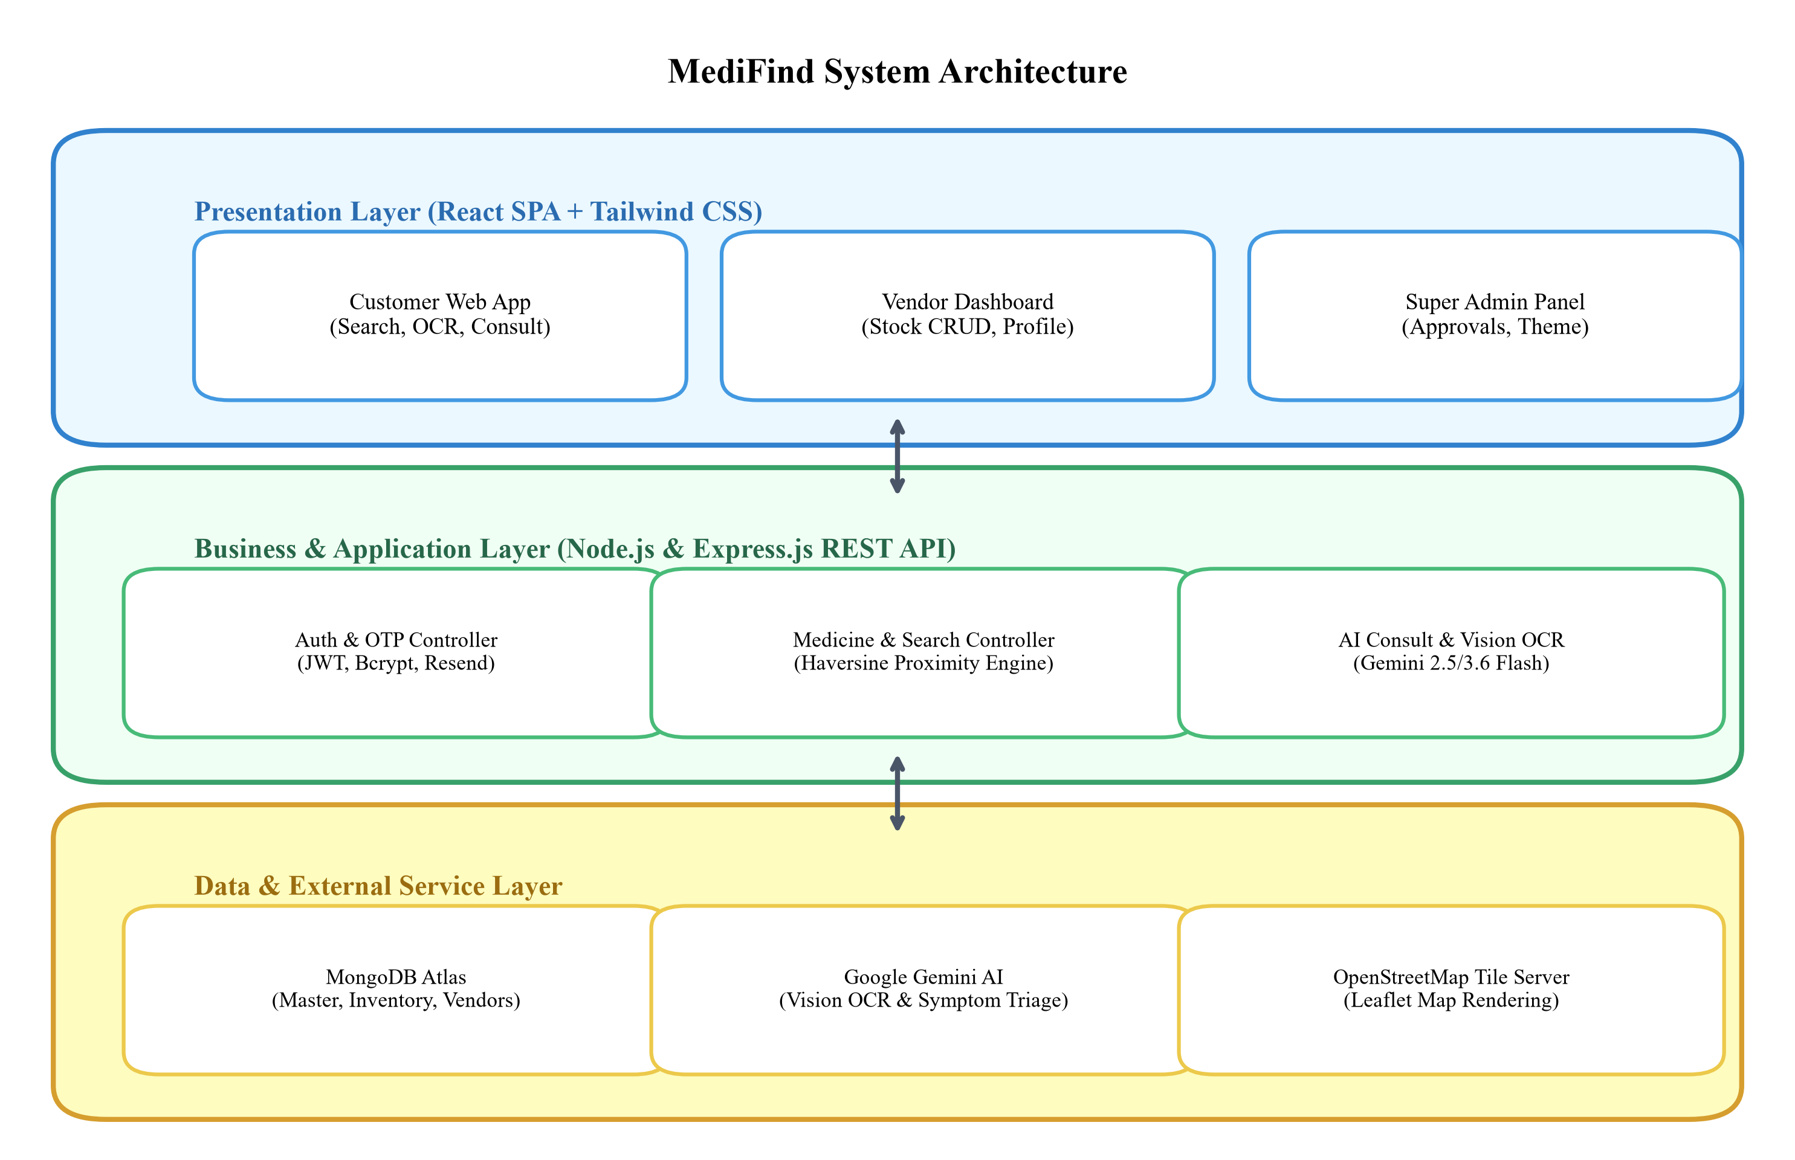
Figure 1: System Architecture Diagram of MediFind
As illustrated in Figure 1, the client tier consists of a React Single Page Application communicating over HTTPS REST APIs. The Node.js Express server routes incoming requests through authentication middleware to controller modules. The backend queries MongoDB Atlas for stock matching and integrates with Google Gemini API services for vision OCR and symptom triage.
15. USE CASE DIAGRAM
The Use Case Diagram depicts interactions between external actors (Customer, Vendor, Super Admin) and primary system functionalities.

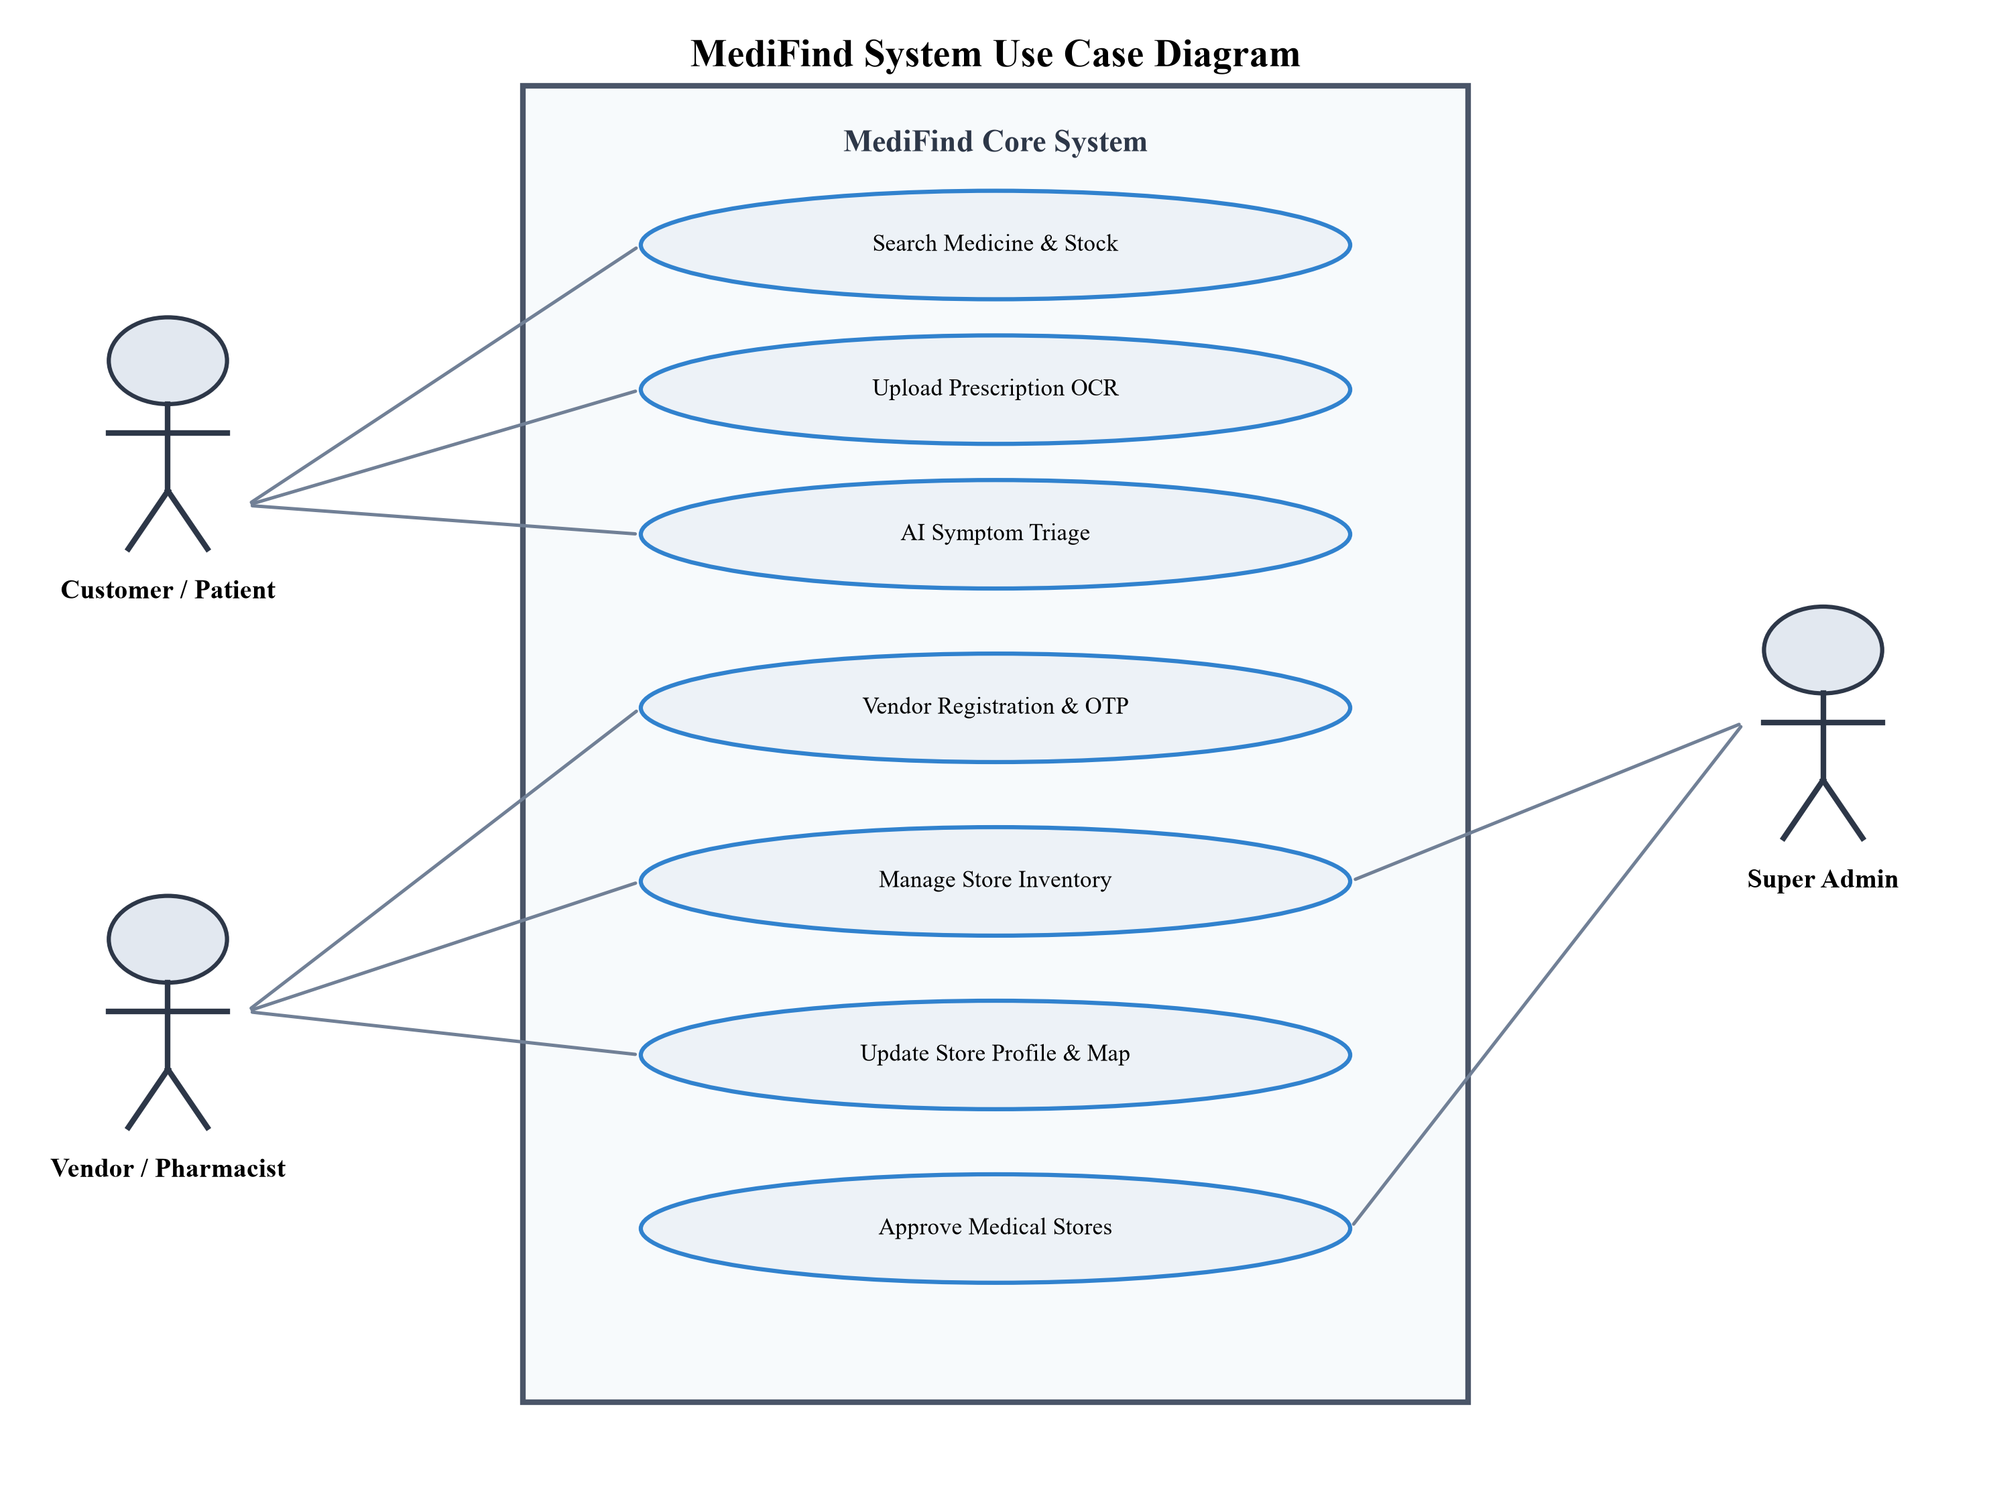
Figure 2: Use Case Diagram of MediFind System
Figure 2 illustrates the primary actors and their interactions: Customers execute searches, upload prescriptions, and request symptom consults; Vendors register via OTP, manage store inventory, and update profile maps; Super Admins review GSTIN records and approve store listings.
16. DFD LEVEL 0 (CONTEXT DIAGRAM)
Data Flow Diagram (DFD) Level 0 represents MediFind as a central single-process system interacting with external entities.

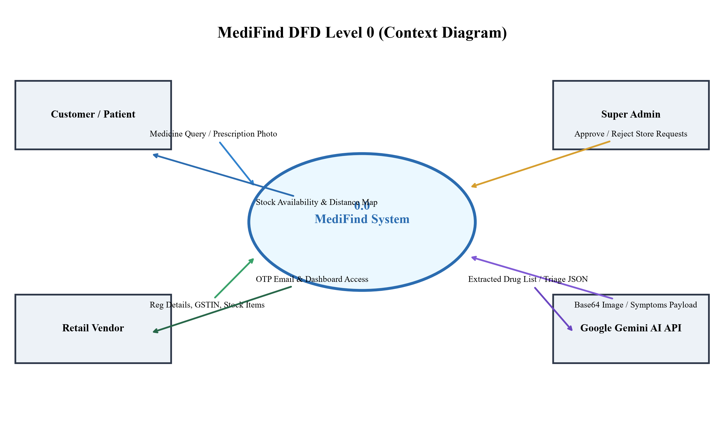
Figure 3: DFD Level 0 Context Diagram
In Figure 3, the central MediFind process receives queries and prescription images from Customers, store details from Vendors, and approval decisions from Super Admin. It interfaces with Google Gemini AI for OCR parsing and outputs stock availability maps and triage reports.
17. DFD LEVEL 1
DFD Level 1 decomposes the central system into 5 major internal processes and data stores.

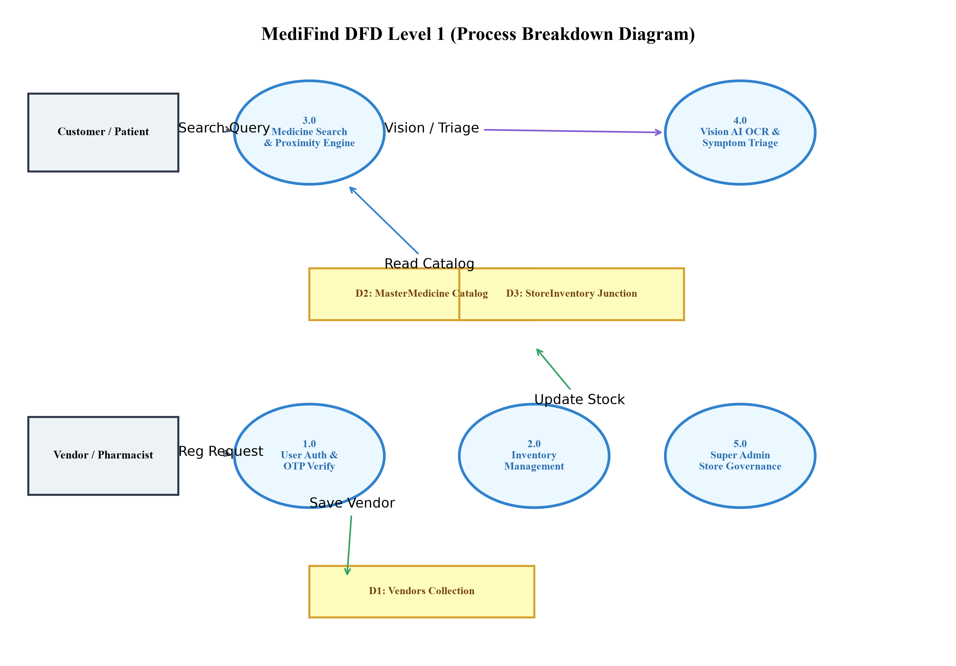
Figure 4: DFD Level 1 Process Breakdown Diagram
Figure 4 details internal processes: 1.0 Auth & OTP Verification, 2.0 Inventory Management, 3.0 Medicine Search & Proximity Engine, 4.0 Vision AI OCR & Symptom Triage, and 5.0 Super Admin Store Governance, showing data flows between processes and datastores (Vendors, MasterMedicine, StoreInventory).
18. ER DIAGRAM
The Entity-Relationship (ER) Diagram models logical database entities, attributes, primary keys, foreign keys, and cardinalities.

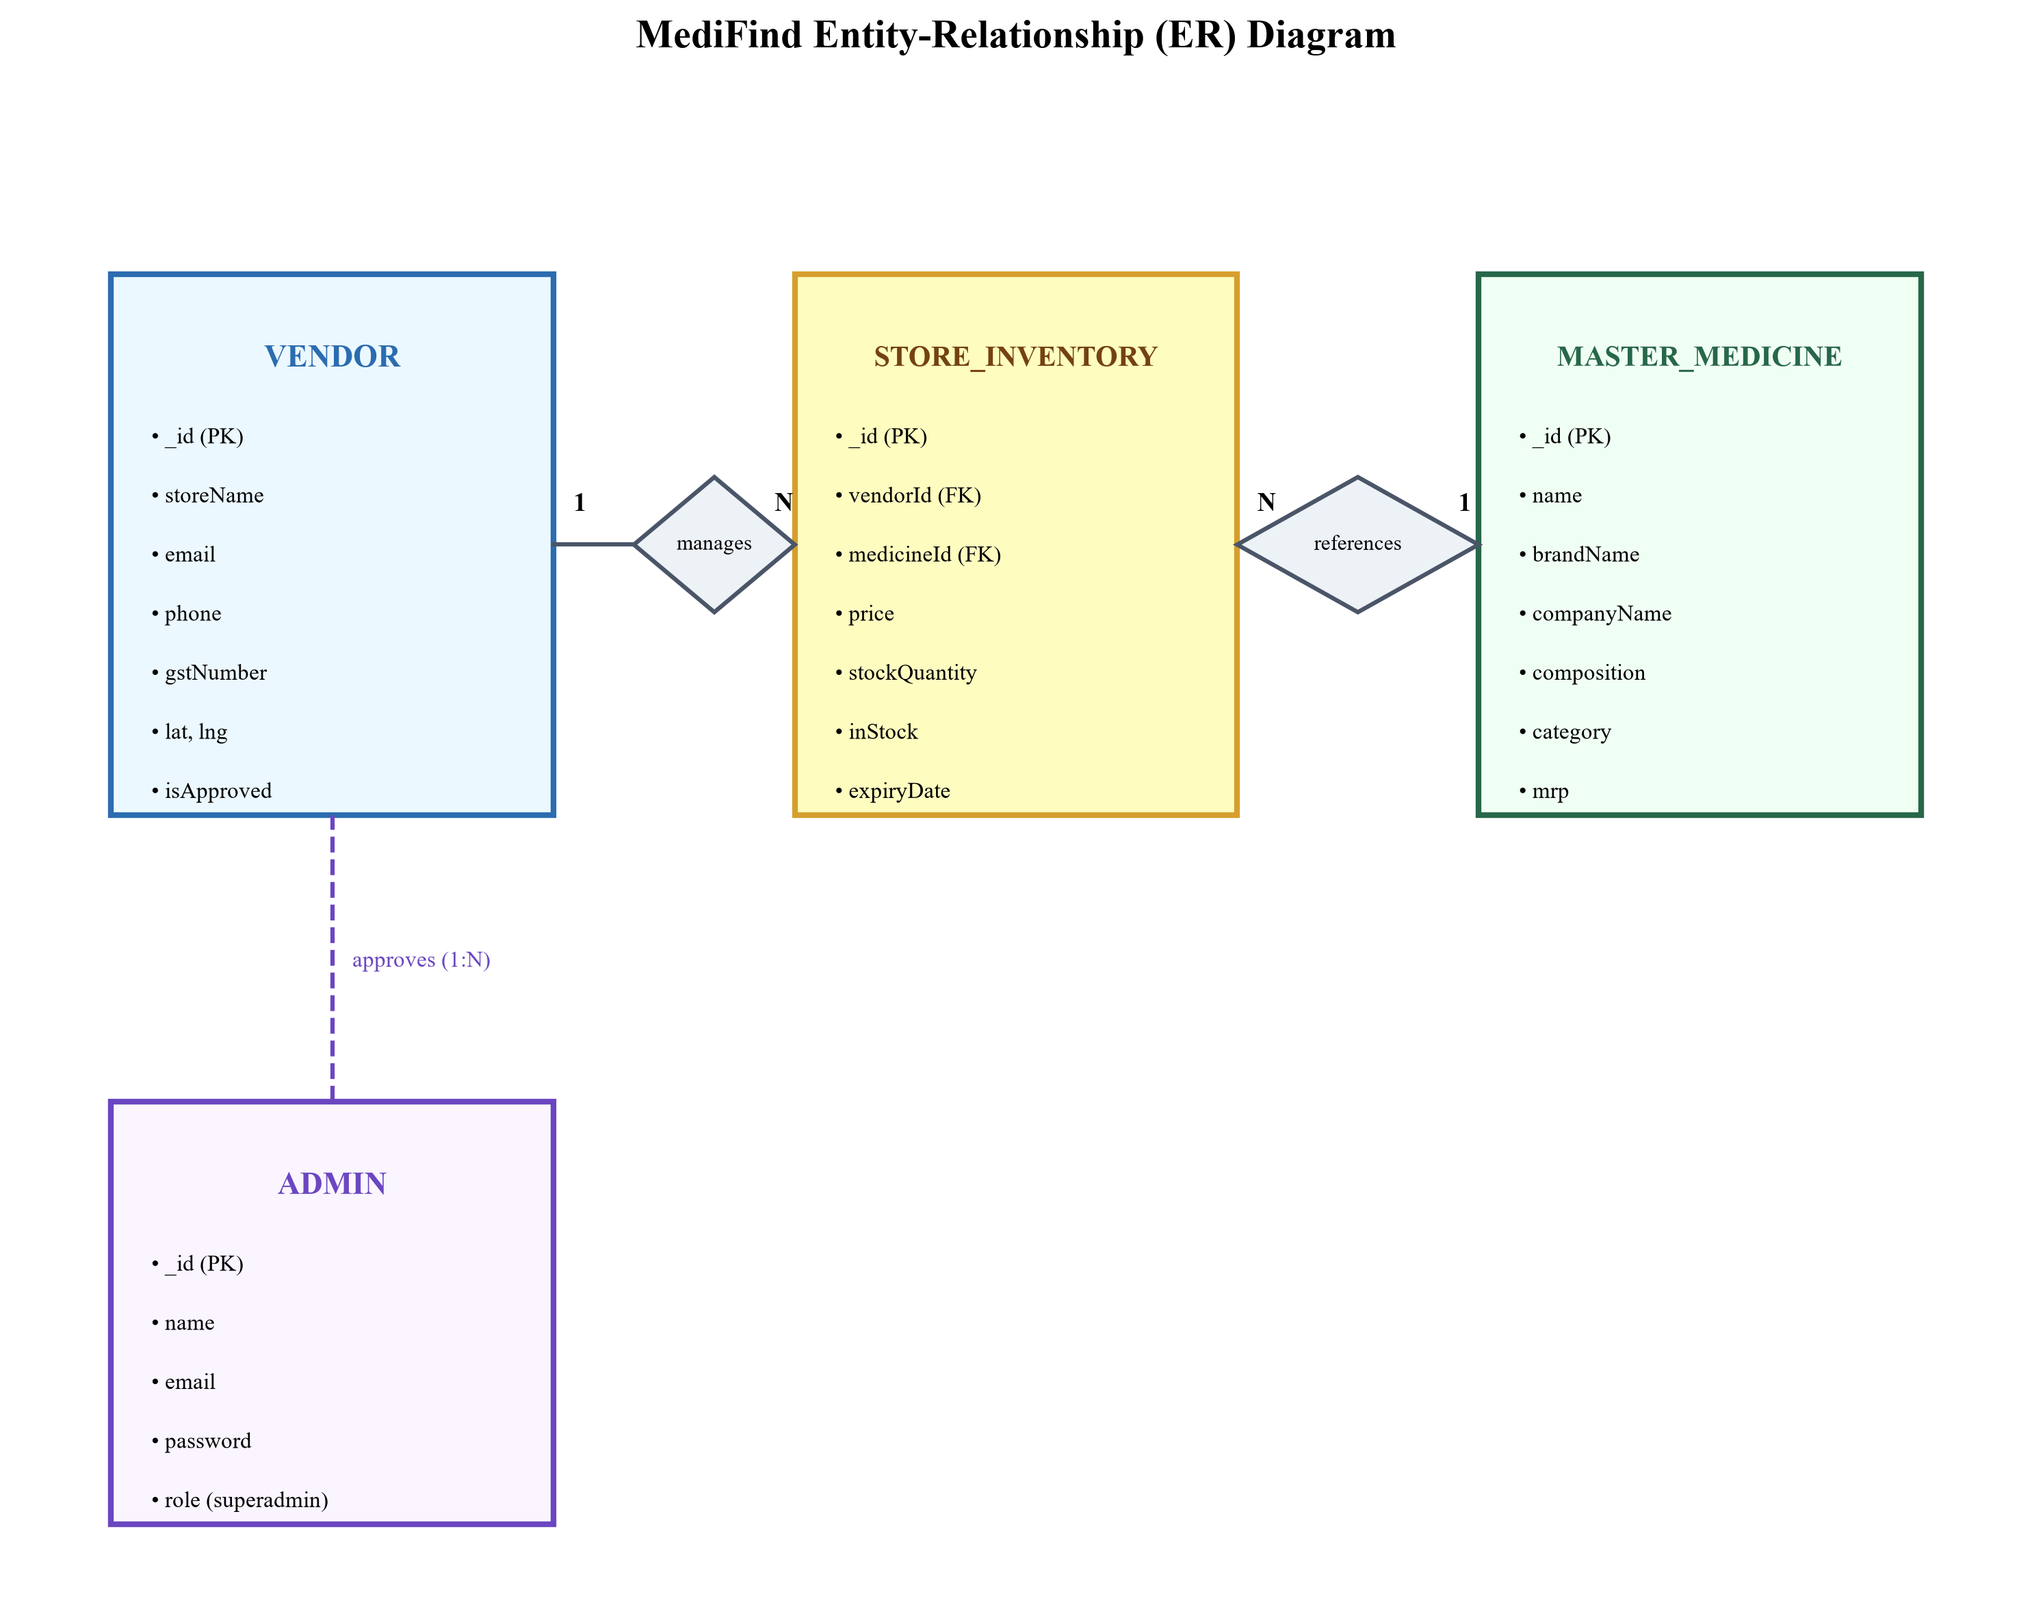
Figure 5: Entity-Relationship (ER) Diagram
Figure 5 shows key entities: Vendor (1) manages (N) StoreInventory items. StoreInventory (N) references (1) MasterMedicine catalog items. Super Admin (1) approves (N) Vendor store accounts.
19. DATABASE DESIGN
MediFind database design comprises 4 primary MongoDB collections. Mongoose schema definitions and constraints are detailed below:
19.1 Vendor Collection Schema
Field Name | Data Type | Constraints / Validation | Description
_id | ObjectId | Primary Key, Auto | Unique vendor store identifier
name | String | Required, trim | Pharmacist / owner name
email | String | Required, Unique, Lowercase | Login email & OTP target
password | String | Required, Bcrypt Hash | Encrypted password hash
storeName | String | Required, trim | Public pharmacy name
phone | String | Required, 10+ digits | Contact phone number
address | String | Required, trim | Physical street address
city | String | Required, trim | City for search filtering
gstNumber | String | 15-char GSTIN Regex | Statutory tax identification
lat | Number | Float | Latitude map coordinate
lng | Number | Float | Longitude map coordinate
isApproved | Boolean | Default: false | Super Admin approval gate
isVerified | Boolean | Default: false | Email OTP verification status

19.2 MasterMedicine Collection Schema
Field Name | Data Type | Constraints / Validation | Description
_id | ObjectId | Primary Key, Auto | Global catalog item ID
name | String | Required, Lowercase, Text Index | Generic chemical / primary name
brandName | String | Text Index, Trim | Commercial brand name (e.g. Dolo)
companyName | String | Trim | Manufacturer name
composition | String | Text Index, Trim | Active chemical ingredients
category | String | Enum (tablet, syrup, etc.) | Formulation category
mrp | Number | Float | Maximum Retail Price (₹)

19.3 StoreInventory Collection Schema
Field Name | Data Type | Constraints / Validation | Description
_id | ObjectId | Primary Key, Auto | Inventory record ID
vendorId | ObjectId | Foreign Key -> Vendor | Store offering this stock
medicineId | ObjectId | Foreign Key -> MasterMedicine | Catalog medicine reference
price | Number | Required, Float | Store selling price (₹)
stockQuantity | Number | Integer count | Physical stock units available
inStock | Boolean | Index, Default: true | Availability flag
expiryDate | String | Trim | Stock expiration date

20. HARDWARE AND SOFTWARE REQUIREMENTS
The minimum hardware and software environments required for developing and running MediFind are listed in Table 2:
Table 2: Hardware and Software Specifications
Category | Component / Tool | Minimum Requirement | Recommended Specification
Hardware | Processor (CPU) | Dual-Core 2.0 GHz | Intel Core i5 / AMD Ryzen 5 or higher
Hardware | RAM (Memory) | 4 GB RAM | 8 GB RAM or higher
Hardware | Storage (Disk) | 10 GB free disk space | 256 GB SSD storage
Hardware | Internet | 1 Mbps broadband connection | 10+ Mbps high-speed internet
Software | Operating System | Windows 10 / Linux / macOS | Windows 11 / Ubuntu 22.04 LTS
Software | Development IDE | VS Code v1.80+ | VS Code with ES7 & React extensions
Software | Runtime Environment | Node.js v18.0+ | Node.js v20.x LTS
Software | Database System | MongoDB v6.0+ | MongoDB Atlas Cloud Cluster v7.0
Software | Web Browser | Google Chrome / Firefox | Chrome v115+ / Edge v115+
Software | Version Control | Git v2.35+ | Git & GitHub Cloud Repository

21. PROJECT DEVELOPMENT TIMELINE
The 12-week development schedule for MediFind is outlined in Table 3:
Table 3: Project Development Schedule (Gantt Timeline)
Week # | Phase / Activity Name | Detailed Tasks & Deliverables Completed
Week 1 | Requirement Analysis | Problem identification, scope definition, stakeholder requirement gathering.
Week 2 | SRS & Feasibility Study | Preparing Software Requirement Specification and tech stack feasibility analysis.
Week 3 | System Design & Modeling | Designing System Architecture, Use Case Diagrams, DFDs, and ER Diagrams.
Week 4 | Database Schema Design | Creating MongoDB Mongoose schemas, defining compound indexes, and seeding catalog.
Week 5 | Backend Auth & OTP Module | Building Express server, auth controllers, bcrypt password hashing, Nodemailer OTP.
Week 6 | Backend Stock & Search API | Developing medicine search APIs, multi-item optimizer, and Haversine distance engine.
Week 7 | Gemini Vision & Triage API | Integrating Google Gemini Vision OCR endpoint and clinical symptom triage controller.
Week 8 | Frontend React Setup & UI | Initializing Vite React SPA, Tailwind CSS design system, ThemeContext, and Navbar.
Week 9 | Frontend Page Integration | Building Home, SearchResults, StoreDetail, and Consult UI pages with Leaflet maps.
Week 10 | Vendor & Admin Dashboards | Developing Vendor stock CRUD panel and Super Admin store approval dashboard.
Week 11 | System Testing & Bug Fixing | Executing end-to-end integration tests, ReDoS input sanitization, IPv4 DNS fixes.
Week 12 | Documentation & Deployment | Deploying to Render & MongoDB Atlas; finalizing project synopsis and report.

22. EXPECTED OUTCOME
The completion of the MediFind project delivers the following concrete outcomes:
• 1. Sub-Second Medicine Discovery: Patients can instantly verify medicine stock availability at nearby pharmacies.
• 2. Distance-Aware Store Guidance: Proximity sorting guides patients directly to the closest stocking store.
• 3. Automated Prescription Digitization: Vision AI OCR eliminates errors in reading handwritten prescriptions.
• 4. Efficient Multi-Drug Procurement: Multi-medicine matching minimizes the number of store visits required.
• 5. Digitized Retail Inventory: Local pharmacies gain an easy digital dashboard to broadcast inventory online.
• 6. Regulated Pharmacy Safety: Super Admin verification ensures only authenticated GSTIN-registered stores operate on the platform.
23. LIMITATIONS
The current implementation of MediFind has the following genuine limitations:
• Internet Dependency: The system requires an active internet connection for real-time database queries and Gemini AI API calls.
• Vendor Stock Update Reliance: Stock accuracy depends on retail pharmacists regularly updating their digital inventory counts.
• Optical Quality Constraints: Extremely damaged or illegible handwritten prescriptions may require manual user verification.
• Absence of In-App Payments: The current prototype does not process online payments or direct delivery dispatch.
24. FUTURE SCOPE
Planned future enhancements for MediFind post-release include:
• 1. Native Mobile Apps: Developing iOS and Android native mobile applications using React Native.
• 2. Hyperlocal Delivery Integration: Partnering with third-party courier services (Dunzo, Swiggy Genie) for 30-minute delivery.
• 3. POS Software Integration: Building desktop plugins to auto-sync inventory from retail pharmacy billing software.
• 4. Generic Substitute Recommendation Engine: Automatically suggesting generic alternatives when a branded medicine is out of stock.
• 5. Chronic Refill Reminders: Sending automated SMS alerts to chronic care patients when stock runs low.
25. CONCLUSION
MediFind addresses a critical real-world problem in healthcare distribution by bridging the gap between healthcare seekers and neighborhood retail pharmacies. By combining real-time inventory queries, Haversine geospatial proximity sorting, Multimodal Vision AI OCR prescription parsing, and AI clinical symptom triage, MediFind modernizes how patients locate urgently needed medicines.
The project achieves its technical and operational objectives by providing sub-second search speeds, an intuitive React user interface, a secure Node.js REST API, and strict Super Admin GSTIN verification governance. MediFind is an achievable, industry-relevant, and scalable project that establishes a strong foundation for future e-health digital innovations.
26. REFERENCES / BIBLIOGRAPHY
[1] React Documentation, "React – A JavaScript library for building user interfaces," Facebook Open Source, 2024. [Online]. Available: https://react.dev
[2] Node.js Documentation, "Node.js v18.x Long Term Support API Reference," OpenJS Foundation, 2024. [Online]. Available: https://nodejs.org/docs
[3] Express.js Guide, "Fast, unopinionated, minimalist web framework for Node.js," OpenJS Foundation, 2024. [Online]. Available: https://expressjs.com
[4] MongoDB Atlas Documentation, "MongoDB Manual & Data Modeling Guides," MongoDB Inc., 2024. [Online]. Available: https://www.mongodb.com/docs
[5] Google Cloud AI, "Gemini API REST reference & Multimodal Vision models," Google Developers, 2024. [Online]. Available: https://ai.google.dev/docs
[6] Leaflet Documentation, "An open-source JavaScript library for mobile-friendly interactive maps," 2024. [Online]. Available: https://leafletjs.com
[7] R. Pressman and B. Maxim, Software Engineering: A Practitioner's Approach, 9th ed. New York: McGraw-Hill Education, 2020.

