Q1) **Query to find the top 5 most ordered dishes by “Arjun Mehta”**

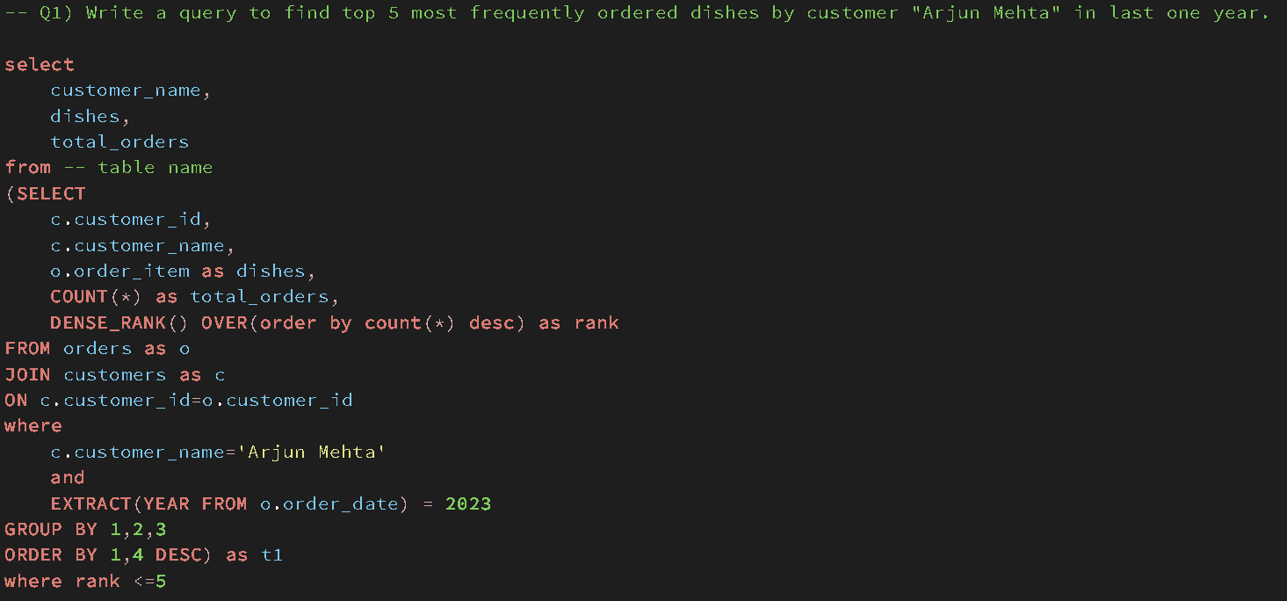

**Answer**

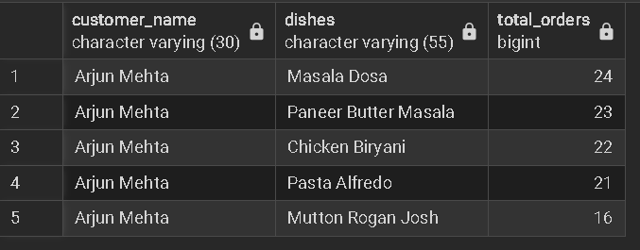

Q2) **Popular Time Slots - Identify the time slots in which most orders are placed. Based on 2 hour intervals**

**Approach 1**

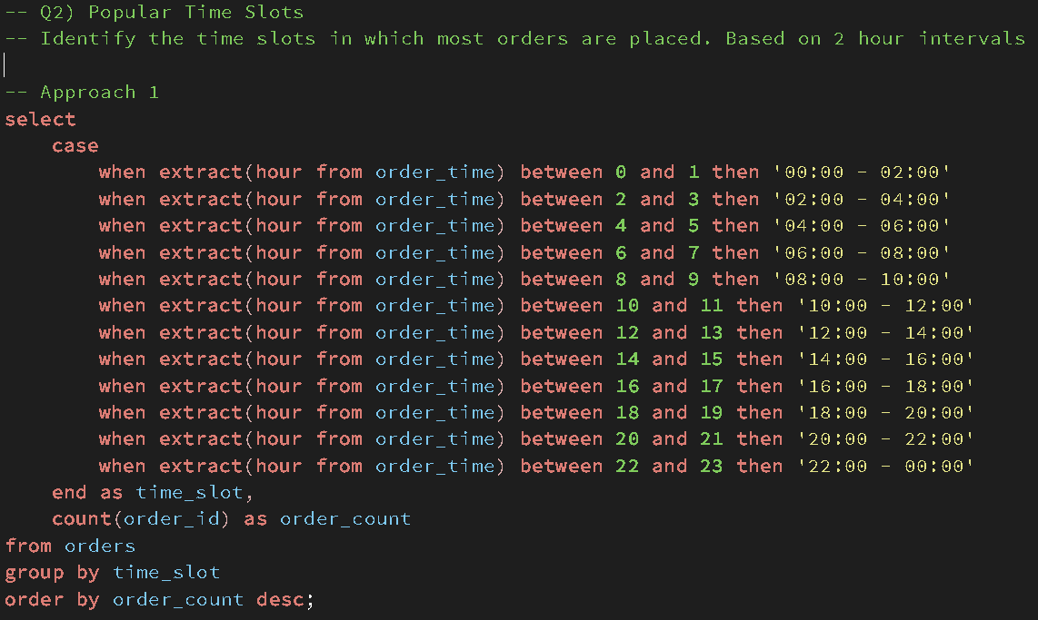

**Output**

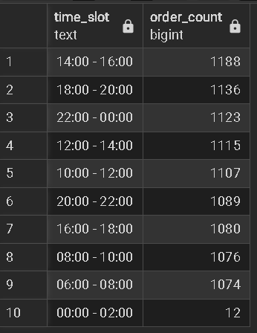

**Approach 2**

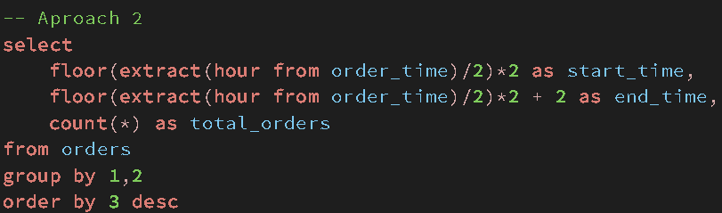

**Output**

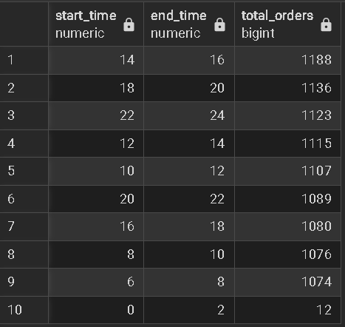

**Q3) Order Value Analysis - Find the average order value per customer who has placed more than 750 orders**

**Return customer name, and aov(average order value)**

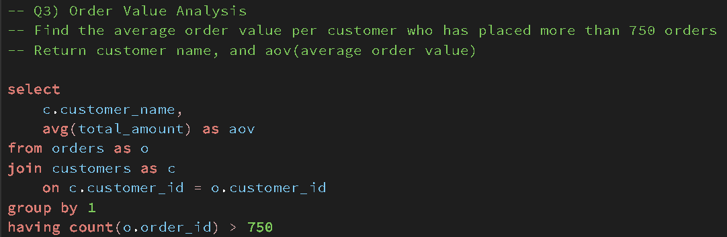

**Output**

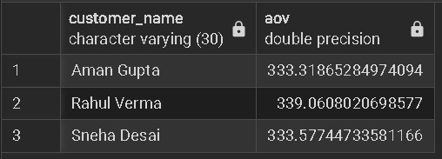

**Q4) Q4) High Value Customers - List the customers who have spent more than 100K in total on food orders**

**Return customer name and customer id**

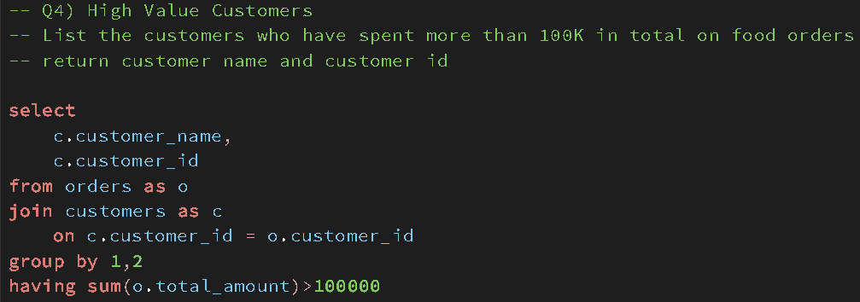

**Output**

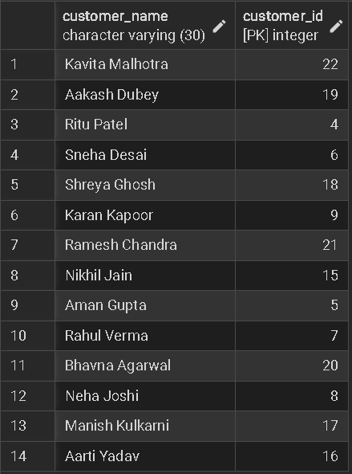

**Q5) Orders without Delivery - Write a query to find orders that were placed but not delivered**

**return restaurant name, city and number of orders not delivered**

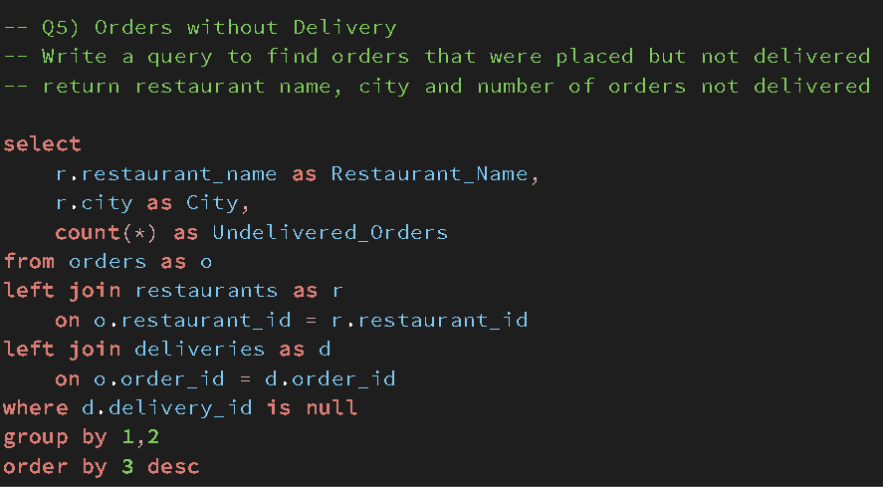

**Output**

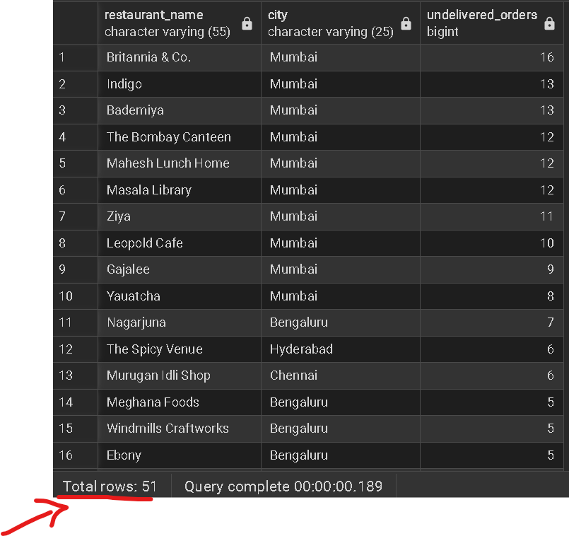

**Q6) Restaurant Revenue Ranking - Rank the restaurants by their total revenue last year, including their name, total revenue and rank within their city**

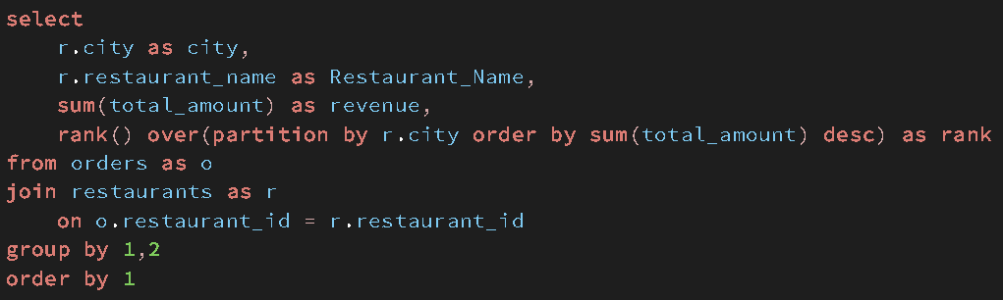

**Output**

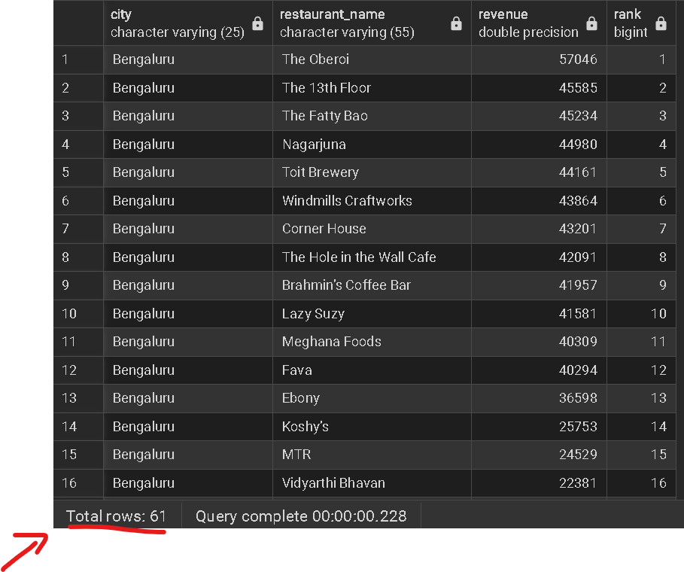

**Another modification to the question.**

**Further if let's assume you want to filter restaurants in all cities via a particular rank you need subqueries**

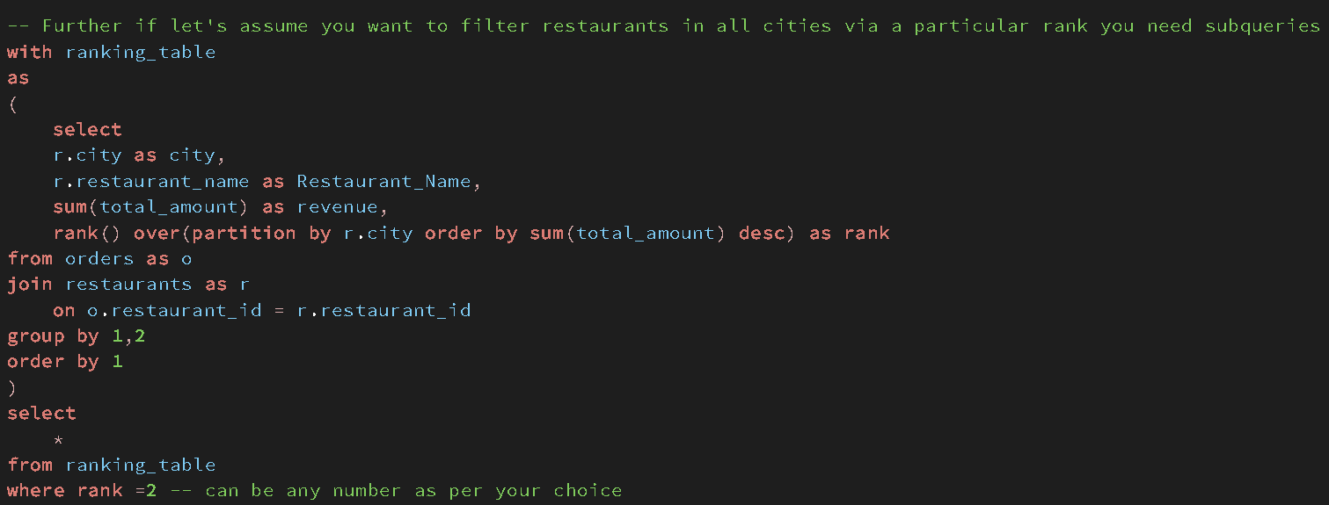

**Output  
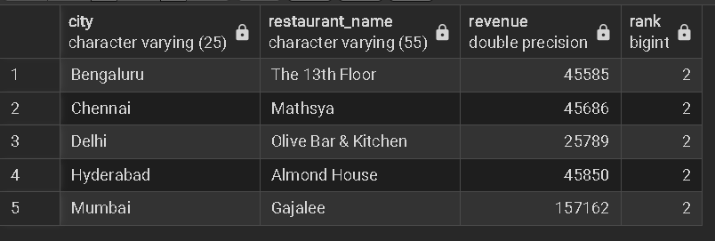**

**Q7) Most Popular Dish by City - Identify most Popular dish in each city by number of orders**

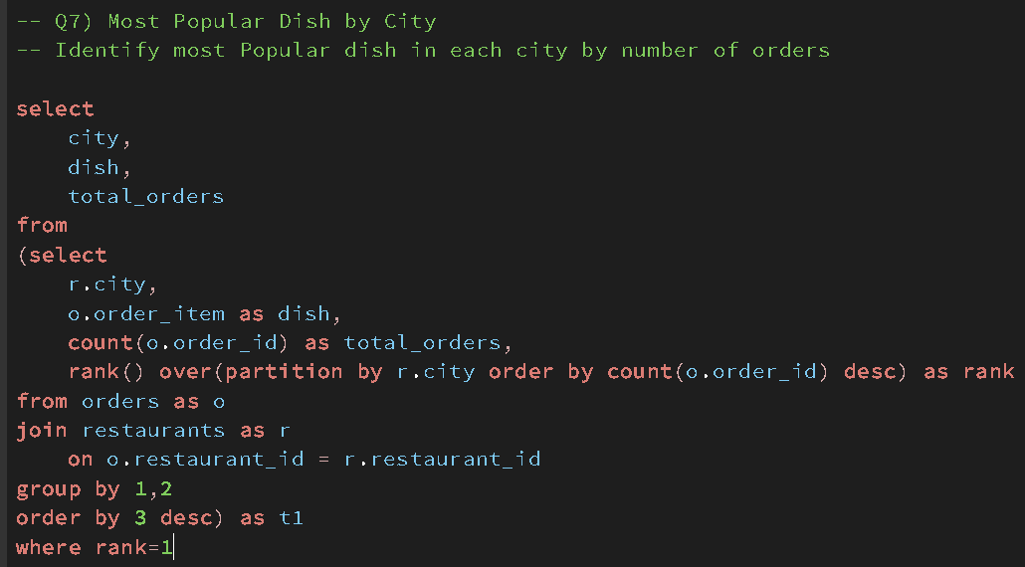

**Output**

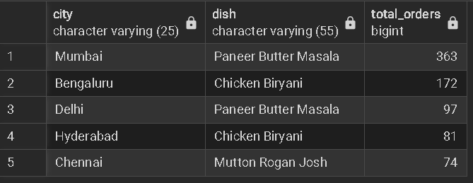

**Q8)** 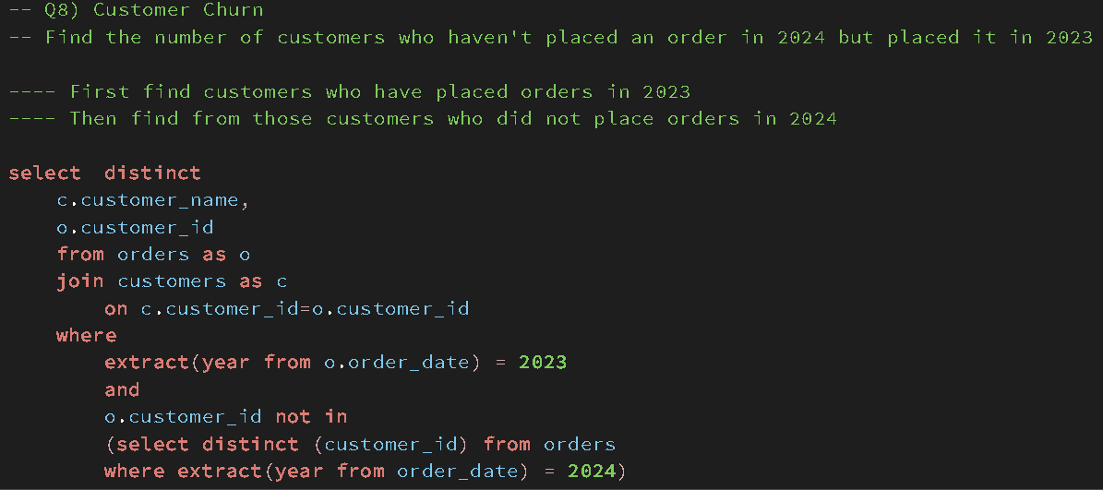

**Output**

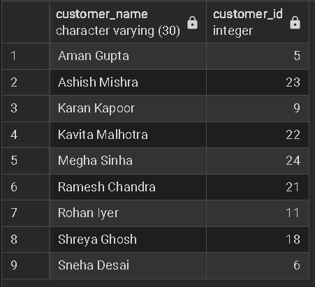

**Q9) Cancellation Rate Comparison**

**-- Calculate and Compare order cancellation rate for each restaurant**

**-- in the current year(2024) and previous year(2023)**

**--- A cancelled order will have delivery id as "NUll" in the delivery column**

**-- CTE 1**

**with cancellation_ratio_23**

**as**

**(select**

**o.restaurant_id,**

**count(o.order_id) as total_orders,**

**count(case when d.delivery_id is null then 1 end) as not_delivered**

**from orders as o**

**left join deliveries as d**

**on o.order_id = d.order_id**

**where extract (year from order_date) = 2023**

**group by 1),**

**-- CTE 2**

**cancellation_ratio_24**

**as**

**(select**

**o.restaurant_id,**

**count(o.order_id) as total_orders,**

**count(case when d.delivery_id is null then 1 end) as not_delivered**

**from orders as o**

**left join deliveries as d**

**on o.order_id = d.order_id**

**where extract (year from order_date) = 2024**

**group by 1),**

**-- CTE 3**

**last_year_data**

**as**

**(select**

**restaurant_id,**

**total_orders,**

**not_delivered,**

**round((not_delivered::numeric/total_orders::numeric)*100,2) as ratio**

**from cancellation_ratio_23),**

**-- CTE 4**

**current_year_data**

**as**

**(select**

**restaurant_id,**

**total_orders,**

**not_delivered,**

**round((not_delivered::numeric/total_orders::numeric)*100,2) as ratio**

**from cancellation_ratio_24)**

**select**

**cyd.restaurant_id,**

**cyd.ratio as current_year,**

**lyd.ratio as last_year**

**from current_year_data as cyd**

**join last_year_data as lyd**

**on cyd.restaurant_id=lyd.restaurant_id**

**Output**

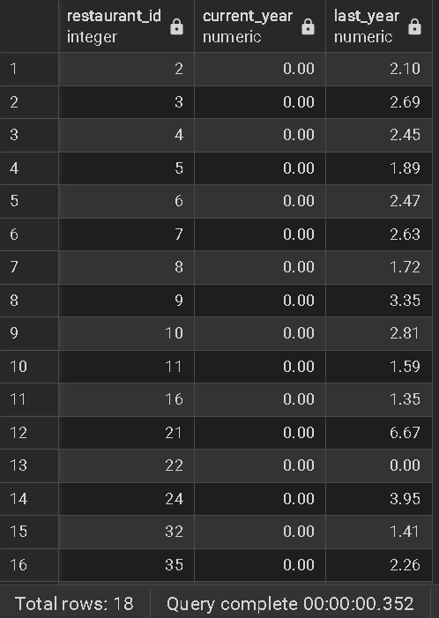

**Q10) Average Delivery time – Determine each rider’s delivery time**

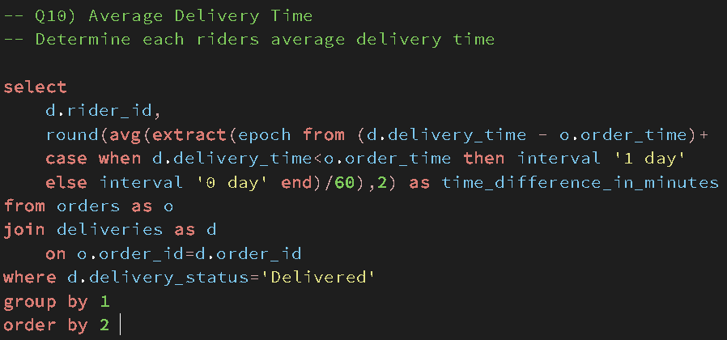

**Output**

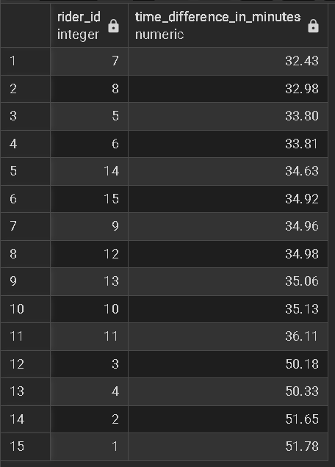

**Q11) Monthly Restaurant Growth Rate -**Calculate each restaurant's growth rate since based on total number of orders deilvered since its joining.

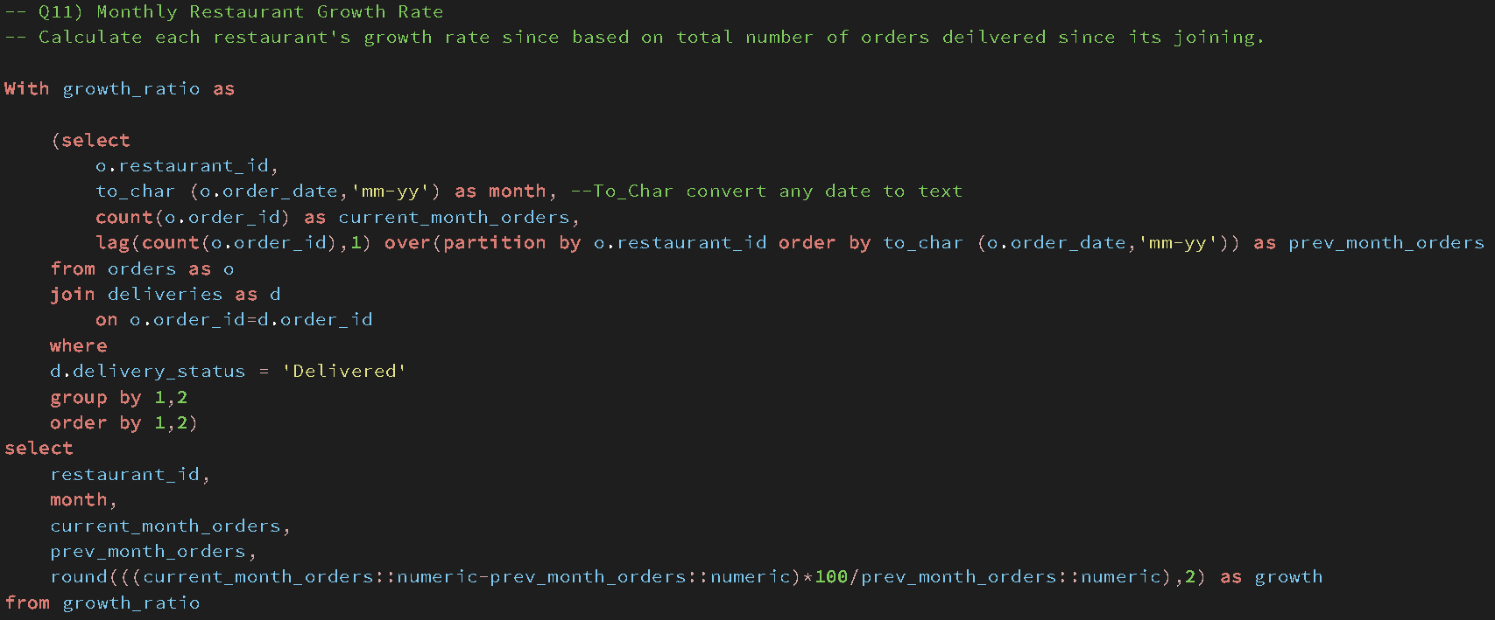

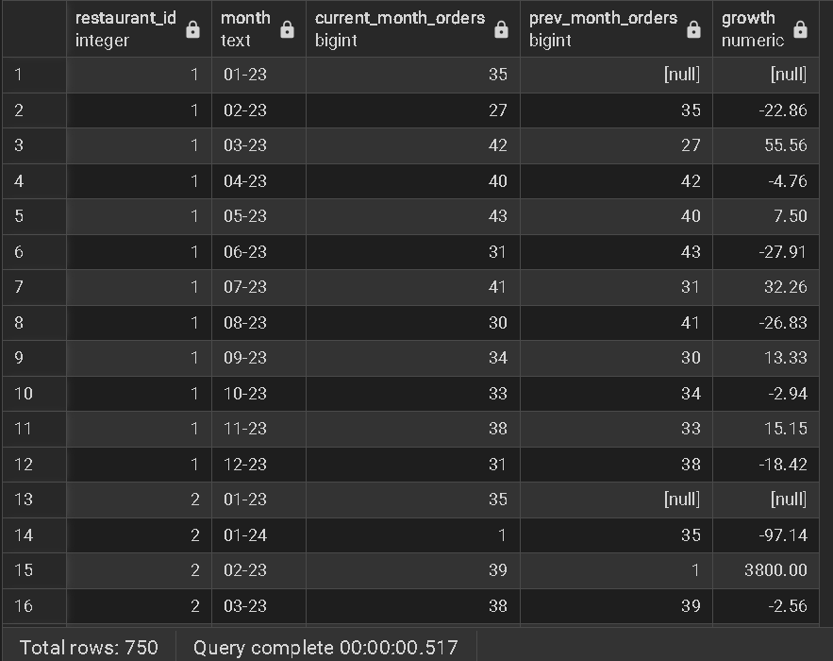

**Q12) Customer Segmentation**

**-- Customer Segmentation - Segment customers into gold or silver groups based on their total spending**

**-- compared to Average order Value(AOV), If customers spending exceeds AOV**

**-- label them as 'Gold'; otherwise 'Silver'. Write SQL query to determine each segment's**

**-- total number of orders and total revenue**

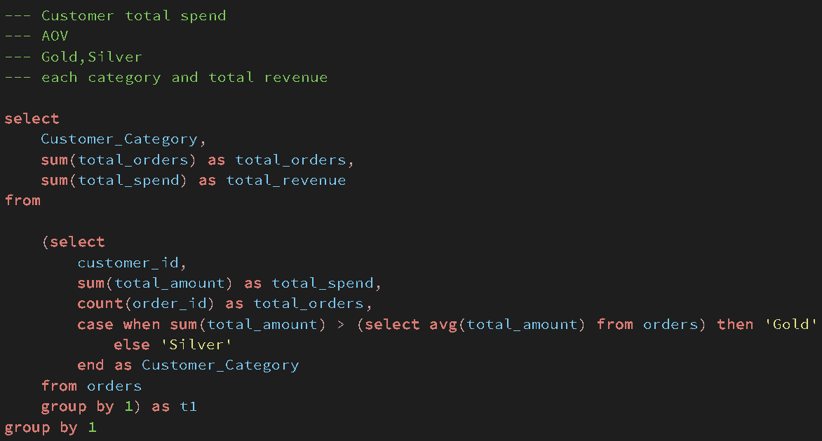

**Output**

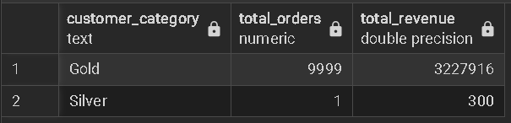

**Q13) Rider Monthly Earning - Calculate each riders' monthly earning assuming they earn 8% of the order amount**

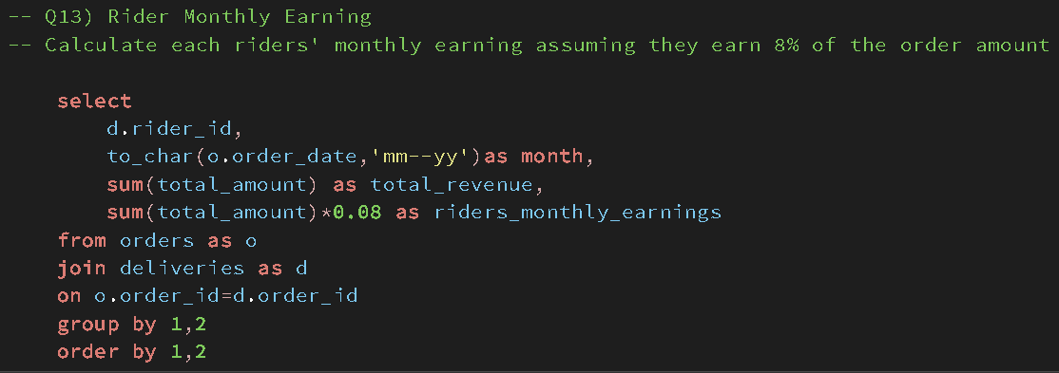

**Output**

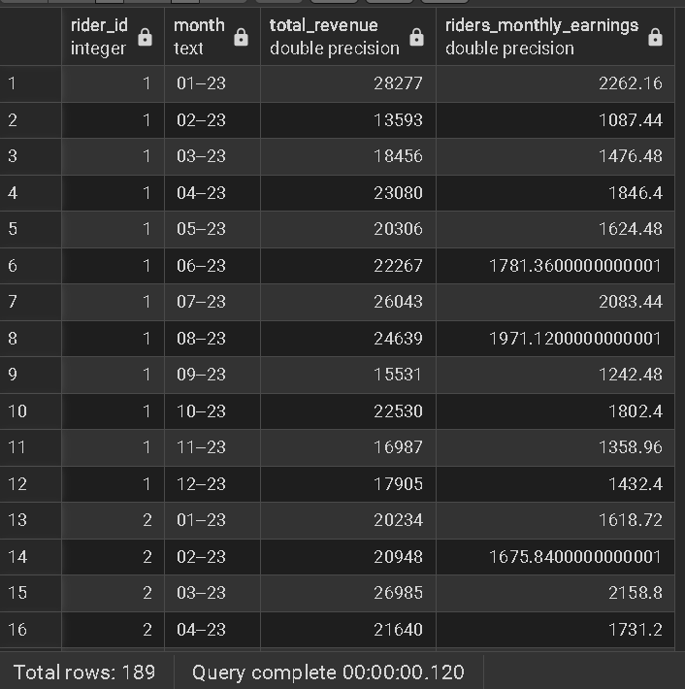

**Q14) Rider Rating Analysis**

**-- Find the numbers of 5,4 and 3 star rating each rider has**

**-- riders receive this rating based on delivery times**

**-- if order delivered in less than 15 minutes - 5 star**

**-- if order delivered between 15 and 20 minutes - 4 star**

**-- if order delivered after 20 minutes - 3 star**

**select**

**rider_id,**

**ratings,**

**count(*) as total_ratings**

**from**

**(**

**select**

**rider_id,**

**delivery_process_time,**

**case when delivery_process_time < 15 then '5 star'**

**when delivery_process_time between 15 and 20 then '4 star'**

**else '3 star'**

**end as ratings**

**from**

**(select**

**o.order_id,**

**o.order_date,**

**o.order_time,**

**d.delivery_time,**

**extract (epoch from (d.delivery_time-o.order_time +**

**case when d.delivery_time<o.order_time then interval'1 day'**

**else interval '0 day' end**

**))/60 as delivery_process_time,**

**d.rider_id**

**from orders as o**

**join deliveries as d**

**on o.order_id = d.order_id**

**where d.delivery_status = 'Delivered') as t1**

**) as t2**

**group by 1,2**

**order by 1,3 desc**

**Output**

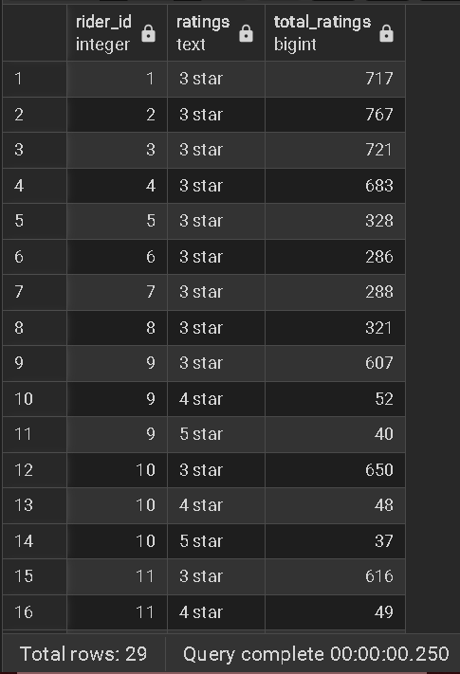

**Q15) Order Frequency by Day - Analyze order frequency per day of the week and identify peak day for each restaurant.**

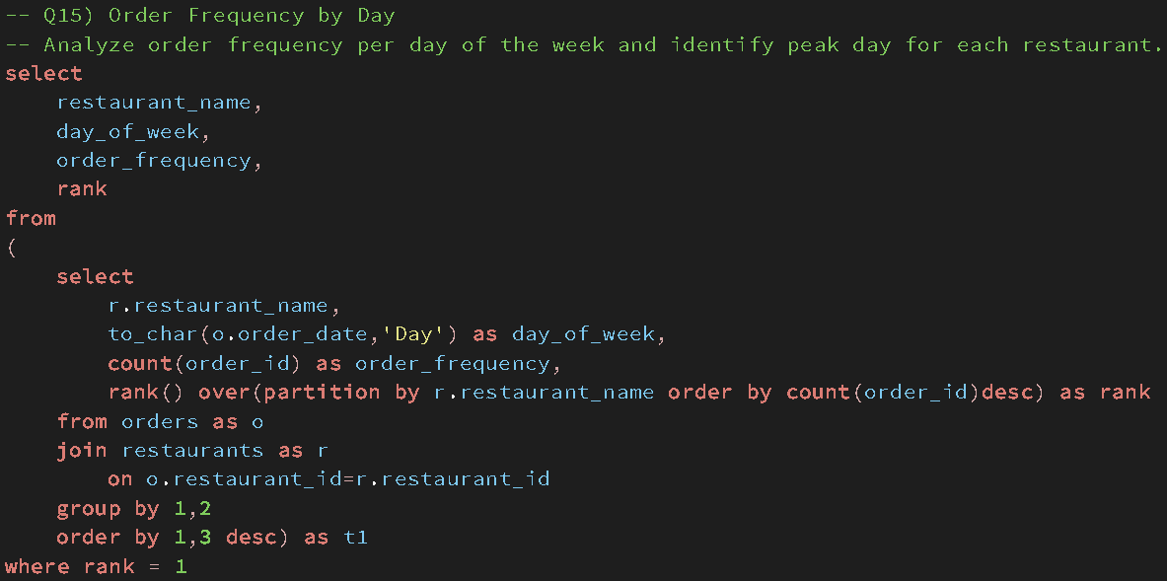

**Output**

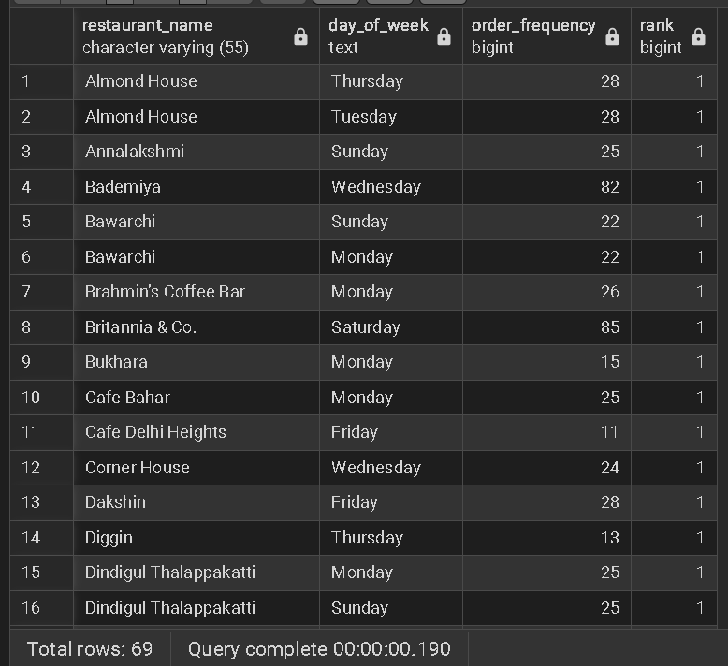

**Q16) Customer Lifetime Value - Calculate total revenue generated by reach customer over all their orders**

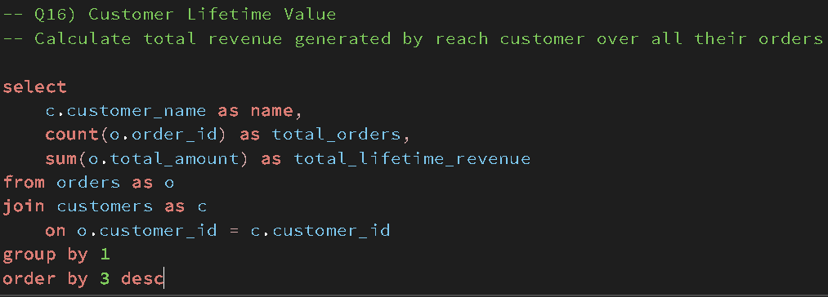

**Output**

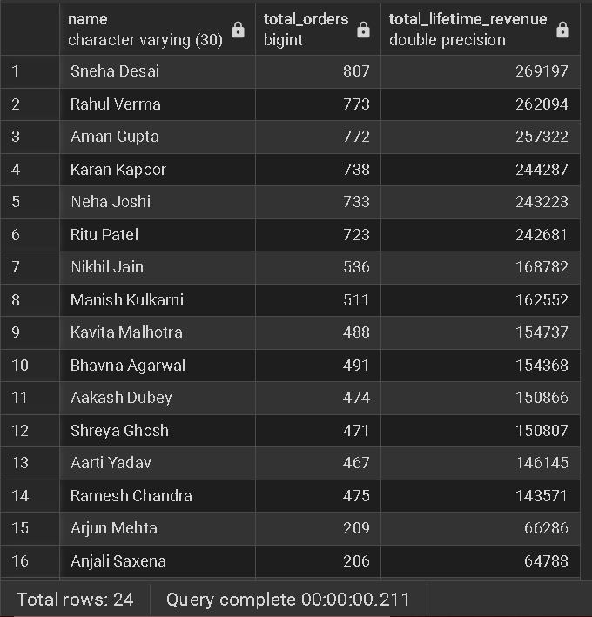

**Q17) Monthly Sales Trend - Identify sales trend by comparing each months sales by previous month**

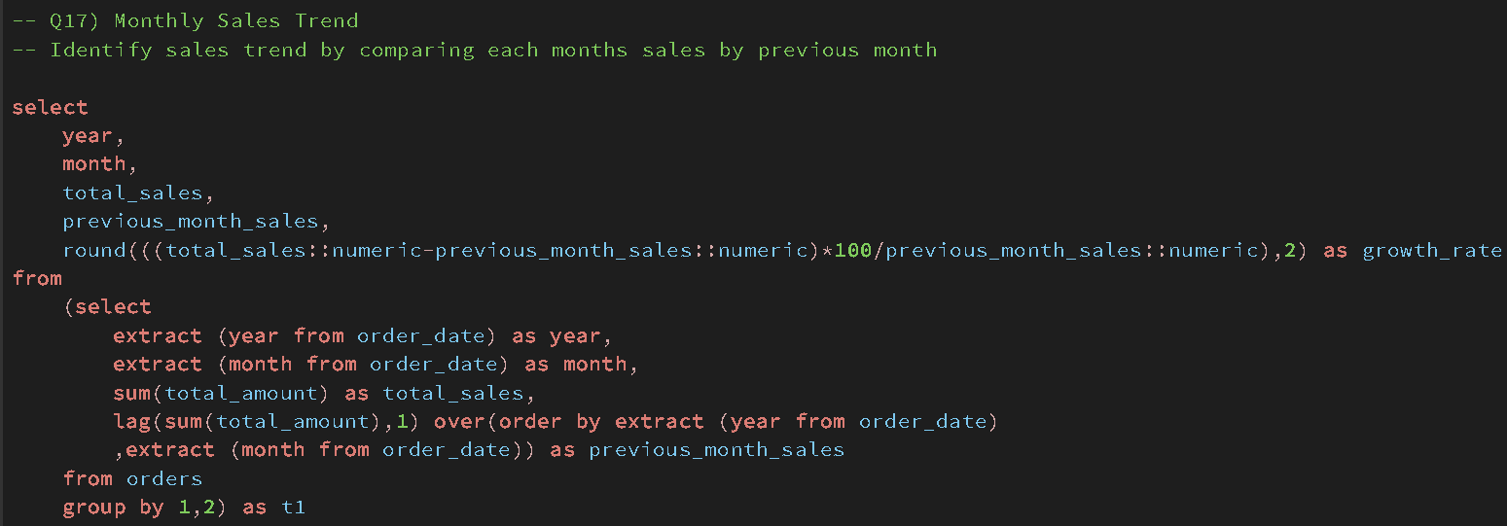

**Output**

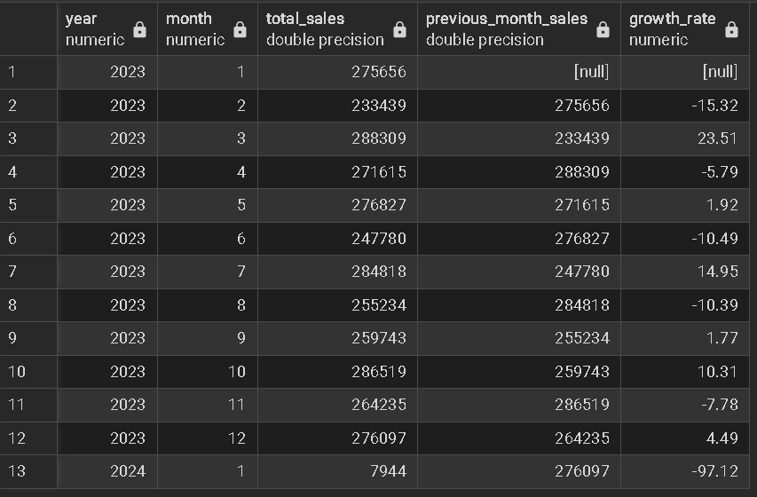

**Q18) Rider Efficiency - Evaluate Rider efficiency by determining average delivery times and identifying the lowest and highest averages**

**with delivery_table as**

**(**

**select**

**d.rider_id as rider_id,**

**round(avg(extract(epoch from (d.delivery_time - o.order_time)+**

**case when d.delivery_time<o.order_time then interval '1 day'**

**else interval '0 day' end)/60),2) as time_to_deliver**

**from orders as o**

**join deliveries as d**

**on o.order_id = d.order_id**

**where d.delivery_status = 'Delivered'**

**group by 1),**

**riders_time as(**

**select**

**rider_id,**

**round(avg(time_to_deliver::numeric),2) as avg_time**

**from delivery_table**

**group by 1)**

**select**

**min(avg_time),**

**max(avg_time)**

**from riders_time**

**Output**

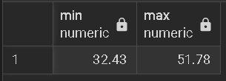

**Q19)**