A. D. PATEL INSTITUTE OF TECHNOLOGY
NEW VALLABH VIDYANAGAR
THE CHARUTAR VIDYA MANDAL(CVM) UNIVERSITY

Level : second

division : it-a

Course No : 202040402

Course title : Operating system

nAME OF THE STUDENT : Patel Rishi nirajkumar

Enrolment number :12402080603014

Batch : d8a

Submission date :

Submission STATUS :

----------------------------------------------------------
Name and sign of the laboratory teacher

Aim: Design and implement a web-based simulator for various CPU process scheduling algorithms including First Come First Serve (FCFS), Shortest Job First (SJF), Shortest Remaining Time First (SRTF), and Round Robin (RR), along with dynamic process input, Gantt chart visualization, and average time calculations.

- Introduction
In operating systems, CPU scheduling is fundamental for process management. Efficient scheduling ensures maximum CPU utilization and process throughput, while minimizing waiting and turnaround time. This simulator provides a visual and interactive method to understand how different scheduling algorithms behave with various process inputs.

- Objectives:
- To simulate different process scheduling algorithms.

- To visualize the execution using Gantt charts.

- To calculate average waiting and turnaround times.

- To dynamically input and remove process data.

- To analyze and compare different scheduling strategies.

- Methodology :

The process scheduling simulator follows a systematic approach to simulate and analyze the behavior of four commonly used scheduling algorithms. The methodology consists of several key phases:

- Input Phase
- Process Initialization: The user can input a set of processes, where each process has the following attributes:
- Process ID (PID)
- Arrival Time
- Burst Time (CPU time required by the process)
- The user selects the algorithm they wish to use from a dropdown menu.
- For Round Robin (RR), the user also inputs a time quantum, which is the maximum time a process can run before being preempted.

- Simulation Phase
- Based on the chosen algorithm, the simulator executes the process scheduling logic.
- The process scheduling algorithms are implemented using their specific strategies:
- FCFS schedules processes in the order of their arrival.
- SJF schedules the shortest burst time first.
- SRTF preempts processes based on the remaining burst time.
- RR cycles through processes in a round-robin fashion.
- Metrics such as waiting time, turnaround time, and completion time are calculated during this phase.

c. Output Phase
- The simulator outputs a Gantt Chart for visualizing the order of execution.
- A table is displayed showing the completion time, waiting time, turnaround time, and average waiting time and turnaround time for all processes.

d. Edge Case Handling
- The simulator handles invalid inputs (e.g., missing process attributes).
- It ensures processes are executed correctly, even when there are edge cases like identical arrival times or burst times.

- Algorithm used:

Algorithm 1: FCFS(First Come First Serve)
- FCFS is the simplest scheduling algorithm that schedules processes in the order of their arrival times. If two processes have the same arrival time, they are executed in the order they are entered.
Steps:
- Input: Process list with arrival times and burst times.
- Sort the processes based on arrival times (if they are not already sorted).
- Execute the first process, calculate its completion time, waiting time (completion time - arrival time - burst time), and turnaround time (completion time - arrival time).
- Repeat the process for all other processes:
- For each process, calculate its completion time, waiting time, and turnaround time.
- Add the burst time of the current process to the previous process's completion time to determine the next process’s start time.
- Output: Display the Gantt chart and metrics (waiting time, turnaround time).

Algorithm 2: SJF (Shortest job first)
SJF schedules processes based on the shortest burst time. Among the processes that have arrived, it picks the one with the shortest burst time for execution. This is a non-preemptive algorithm.
Steps:
- Input: Process list with arrival times and burst times.
- Sort the processes based on arrival times.
- Select the process with the shortest burst time from the ready queue.
- Execute the selected process, and then calculate its completion time, waiting time, and turnaround time.
- Repeat the process for the remaining processes:
After completing one process, pick the next process with the shortest burst time among the remaining processes that have arrived.
- Output: Display the Gantt chart and metrics.

Algorithm 3: SRTF (Shortest Remaining Time First)
SRTF is a preemptive version of SJF. The key difference is that a running process can be preempted if a new process with a shorter burst time arrives.
Steps:
- Input: Process list with arrival times and burst times.
- Sort the processes based on arrival times.
- Track the remaining burst time for each process.
- Execute the process with the shortest remaining burst time.
- Preempt the process if a new process with a shorter remaining burst time arrives.
- Repeat the process until all processes are completed.
Update the remaining burst times.
Recalculate the completion time, waiting time, and turnaround time for each process after completion.
- Output: Display the Gantt chart and metrics

Algorithm 4:RR (Round Robin)
Round Robin (RR) is a preemptive algorithm that assigns each process a fixed time quantum. When a process’s quantum expires, it is preempted and the next process is given the CPU.
Steps:
- Input: Process list with arrival times, burst times, and a time quantum value.
- Sort the processes based on arrival times.
- Initialize a ready queue and enqueue all processes that have arrived.
- Allocate CPU time to each process for a fixed time quantum.
- If a process's remaining burst time is greater than the time quantum, it is preempted and moved back to the queue with the remaining burst time.
- If a process finishes its burst time during its allocated quantum, remove it from the queue.
- Repeat the process until all processes are completed.
- Calculate the metrics such as waiting time, turnaround time, and completion time for each process.
- Output: Display the Gantt chart and metrics.

Time Complexity of Each Algorithm
- FCFS: O(n log n) due to sorting by arrival time, where n is the number of processes.
- SJF: O(n log n) for sorting the processes by burst time.
- SRTF: O(n log n) for maintaining a sorted list of processes based on burst time (using priority queues).
- RR: O(n) as each process is visited in a round-robin fashion with a fixed time quantum.

- Simulation results / Code:

- Index.html
<!DOCTYPE html>
<html lang="en">
<head>
<meta charset="UTF-8" />
<meta name="viewport" content="width=device-width, initial-scale=1.0" />
<title>Process Scheduling Algorithms</title>

<link href="./index.css" rel="stylesheet" />
</head>
<body onload="displaytq()">
<section id="head">
<h1 id="title">Process Scheduling Algorithm Simulator</h1>
<!-- <p id="subtitle">Process Scheduling Algorithm Simulator</p> -->
</section>

<section id="algorithm">
<div id="data">
Select a algorithm:
<select name="algorithm" id="algo" onchange="displaytq()">
<option value="FCFS" selected>First Come First Serve</option>
<option value="SJF">Shortest Job First</option>
<option value="SRTF">Shortest Remaining Time First</option>
<option value="RR">Round Robin</option>
</select>
<br />
<div id="timeQuantumBlock">
<span id="tq"
>Time Quantum: <input type="text" id="timequantum" onkeydown="return alphaInput()"
/></span>
</div>
<br />
<!-- Seleted element is: <span id="out">FCFS</span><br> -->

<div id="content">
<table id="processTable">
<tr id="processTableHead">
<th>Process ID</th>
<th>Arrival Time</th>
<th>Burst Time</th>
<th></th>
</tr>
</table>
</div>
<br />

<button id="addProcess" onclick="addProc()">Add Process</button><br />
<button id="runProcess" onclick="getValues()">Run Process</button>
</div>
<br />
<!-- <br> -->
<div id="ganttchart"></div>

<br />
<br />
<div id="display"></div>
</section>

<!-- <button onclick="display()">Check </button> -->
<script src="./index.js"></script>
</body>
</html>

- index.css

/* General Layout */
body {
font-size: 25px;
background-color: #f9f9f9;
color: #1a1a1a;
font-family: 'Trebuchet MS', sans-serif;
margin: 0;
padding: 0;
}

/* Header Section */
#head {
text-align: center;
padding-top: 20px;
}

#title {
font-size: 45px;
margin-bottom: 60px;
color: #2c3e50;
}

/* Buttons */
button {
height: 50px;
width: 220px;
font-size: 20px;
font-family: 'Courier New', Courier, monospace;
font-weight: 600;
border: none;
border-radius: 10px;
color: #fff;
background-color: #3498db;
cursor: pointer;
transition: background 0.3s ease;
margin: 10px;
}

button:hover {
background-color: #2980b9;
}

/* Dropdown and Inputs */
#algo {
height: 40px;
width: 220px;
border-radius: 7px;
text-align: center;
font-size: 18px;
background-color: #ffffff;
color: #2c3e50;
border: 1px solid #ccc;
}

#timeQuantumBlock {
margin-top: 10px;
}

#timeQuantumBlock input {
width: 60px;
height: 35px;
border: 1px solid #ccc;
border-radius: 10px;
background-color: #ffffff;
color: #2c3e50;
text-align: center;
}

/* Table Styling */
#processTable {
margin: 0 auto;
border-collapse: separate;
border-spacing: 10px;
}

th {
background-color: transparent;
font-weight: bold;
color: #34495e;
}

td,
input {
text-align: center;
font-size: 20px;
border: none;
outline: none;
color: #2c3e50;
background-color: #ecf0f1;
padding: 8px;
border-radius: 5px;
}

/* Gantt Chart Table */
#ganttTable {
border-collapse: collapse;
border-spacing: 0;
margin: 20px auto;
}

#ganttTable td {
border: 2px solid #2c3e50;
height: 30px;
width: 50px;
text-align: center;
background-color: #dff0d8;
color: #2c3e50;
}

#timeline td {
font-size: 12px;
background: transparent;
text-align: center;
color: #7f8c8d;
}

/* Section Content */
#algorithm {
text-align: center;
font-size: 22px;
padding: 20px;
}

#content {
margin: 0 auto;
text-align: center;
padding: 20px;
}
#ganttchart h1 {
text-align: center;
font-size: 30px;
color: #2c3e50;
}

#ganttchart div {
font-family: 'Courier New', Courier, monospace;
}
#display {
margin-top: 30px;
text-align: center;
}

#display table {
margin: 0 auto;
border-collapse: collapse;
width: 90%;
max-width: 900px;
box-shadow: 0 0 10px rgba(0, 0, 0, 0.1);
background-color: #ffffff;
color: #2c3e50;
font-family: 'Segoe UI', sans-serif;
font-size: 18px;
}

#display th {
background-color: #0984e3;
color: white;
padding: 12px;
font-weight: bold;
border: 1px solid #dfe6e9;
}

#display td {
padding: 10px;
border: 1px solid #dfe6e9;
}

#display tr:nth-child(even) {
background-color: #f1f2f6;
}

#display h5 {
font-size: 20px;
margin-top: 25px;
color: #2d3436;
font-weight: 500;
}

- Index.js
var tableCol = 4;
var resultHead = new Array();
resultHead = [
'Process ID',
'Arrival Time',
'Burst Time',
'Completion Time',
'Turn Around Time',
'Waiting Time',
];
var n = 0,
processID,
arrivalTime,
burstTime,
completionTime,
turnAroundTime,
waitingTime,
ganttChart,
timeline,
index,
ready,
dupBurstTIme;
function displaytq() {
var sel = document.querySelector('#algo').value;
var tq = document.querySelector('#tq');

if (sel === 'RR') {
tq.style.display = 'block';
} else {
tq.style.display = 'none';
}
}

function getValues() {
var inputs = document.querySelectorAll('input');
if (
document.getElementById('timequantum').value == '' &&
document.querySelector('#algo').value == 'RR'
) {
alert('Please enter all the details');
return;
}
for (var i = 0; i < inputs.length; i++) {
if (inputs[i].value === '' && inputs[i].getAttribute('id') != 'timequantum') {
alert('Please enter all the details');
return;
}
}
var procTable = document.querySelector('#processTable');

n = procTable.rows.length - 1;

processID = new Array(n);
arrivalTime = new Array(n);
burstTime = new Array(n);
dupBurstTIme = new Array(n);
turnAroundTime = new Array(n);
waitingTime = new Array(n);
completionTime = new Array(n);
index = new Array(n);
for (var i = 1; i < procTable.rows.length; i++) {
index[i - 1] = i - 1;
for (var j = 0; j < procTable.rows[i].cells.length - 1; j++) {
var element = Number(procTable.rows[i].cells[j].childNodes[0].value);
if (j == 0) {
processID[i - 1] = element;
} else if (j == 1) {
arrivalTime[i - 1] = element;
} else if (j == 2) {
burstTime[i - 1] = element;
dupBurstTIme[i - 1] = element;
}
}
}

var algorithm = document.querySelector('#algo').value;
console.log(typeof algorithm + ' ' + n);

if (algorithm === 'FCFS') {
FCFS();
} else if (algorithm === 'SJF') {
SJF();
} else if (algorithm === 'SRTF') {
SRTF();
} else if (algorithm === 'RR') {
RR();
}
}

function FCFS() {
sortAt();

ready = new Array();
var ind = 0,
t = 0;

ganttChart = new Array();
timeline = new Array();
timeline.push(0);

while (ready.length > 0 || ind < n) {
if (ready.length == 0 && ind < n && arrivalTime[ind] > t) {
timeline.push(arrivalTime[ind]);
ganttChart.push(-1);

t = arrivalTime[ind];
}

while (ind < n && arrivalTime[ind] <= t) {
ready.push(ind);
ind++;
}

var idx = ready.shift();

for (var i = 0; i < burstTime[idx]; i++) {
while (ind < n && arrivalTime[ind] <= t) {
ready.push(ind);
ind++;
}
t++;
}

timeline.push(t);
completionTime[idx] = t;
ganttChart.push(processID[idx]);
}

test();

displayResult();
}

function test() {
var s = ' ';

for (var i = 0; i < ganttChart.length; i++) {
s = s + ganttChart[i] + ' ';
}
console.log('Gantt ' + s);
s = ' ';

for (var i = 0; i < timeline.length; i++) {
s = s + timeline[i] + ' ';
}
console.log('timeline ' + s);
}

function SJF() {
sortAt();

ready = new Array();
var ind = 0,
t = 0;

ganttChart = new Array();
timeline = new Array();
timeline.push(0);

while (ready.length > 0 || ind < n) {
if (ready.length == 0 && ind < n && arrivalTime[ind] > t) {
timeline.push(arrivalTime[ind]);
ganttChart.push(-1);
t = arrivalTime[ind];
}

while (ind < n && arrivalTime[ind] <= t) {
ready.push(ind);
ind++;
}

testReady();
sortReadyBt();
testReady();
var idx = ready.shift();

for (var i = 0; i < burstTime[idx]; i++) {
while (ind < n && arrivalTime[ind] <= t) {
ready.push(ind);
ind++;
}
t++;
}

timeline.push(t);
completionTime[idx] = t;
ganttChart.push(processID[idx]);
}

test();

displayResult();
}

function SRTF() {
sortAt();

ready = new Array();
var ind = 0,
t = 0;

ganttChart = new Array();
timeline = new Array();
timeline.push(0);

while (ready.length > 0 || ind < n) {
if (ready.length == 0 && ind < n && arrivalTime[ind] > t) {
timeline.push(arrivalTime[ind]);
ganttChart.push(-1);
t = arrivalTime[ind];
}

while (ind < n && arrivalTime[ind] <= t) {
ready.push(ind);
ind++;
}

testReady();
sortReadyBt();
testReady();
var idx = ready.shift(),
bt = burstTime[idx];
var flag = false;

for (var i = 0; i < bt; i++) {
while (ind < n && arrivalTime[ind] <= t) {
ready.push(ind);
ind++;
flag = true;
}

if (flag) {
sortReadyBt();
if (burstTime[ready[0]] < burstTime[idx]) {
timeline.push(t);
ganttChart.push(processID[idx]);
ready.push(idx);
break;
}
flag = false;
}
t++;
burstTime[idx]--;
}

if (burstTime[idx] == 0) {
timeline.push(t);
completionTime[idx] = t;
ganttChart.push(processID[idx]);
}
}

displayResult();
}

function RR() {
var tq = Number(document.querySelector('#timequantum').value);

sortAt();

ready = new Array();
var ind = 0,
t = 0;

ganttChart = new Array();
timeline = new Array();
timeline.push(0);

while (ready.length > 0 || ind < n) {
if (ready.length == 0 && ind < n && arrivalTime[ind] > t) {
timeline.push(arrivalTime[ind]);
ganttChart.push(-1);
t = arrivalTime[ind];
}

while (ind < n && arrivalTime[ind] <= t) {
ready.push(ind);
ind++;
}

var idx = ready.shift(),
bt = burstTime[idx];

for (var i = 0; i < Math.min(bt, tq); i++) {
while (ind < n && arrivalTime[ind] <= t) {
ready.push(ind);
ind++;
}
t++;
burstTime[idx]--;
}

if (burstTime[idx] <= 0) {
timeline.push(t);
completionTime[idx] = t;
ganttChart.push(processID[idx]);
} else {
timeline.push(t);
ready.push(idx);
ganttChart.push(processID[idx]);
}
}

displayResult();
}

function testReady() {
var s = ' ';
for (var i = 0; i < ready.length; i++) {
s = s + ready[i] + ' ';
}

console.log('Ready ' + s);
}

function sortAt() {
for (var i = 0; i < n; i++) {
for (var j = 0; j < n - i - 1; j++) {
if (arrivalTime[j] > arrivalTime[j + 1]) {
var temp = arrivalTime[j];
arrivalTime[j] = arrivalTime[j + 1];
arrivalTime[j + 1] = temp;

temp = burstTime[j];
burstTime[j] = burstTime[j + 1];
burstTime[j + 1] = temp;

temp = processID[j];
processID[j] = processID[j + 1];
processID[j + 1] = temp;

temp = index[j];
index[j] = index[j + 1];
index[j + 1] = temp;

temp = dupBurstTIme[j];
dupBurstTIme[j] = dupBurstTIme[j + 1];
dupBurstTIme[j + 1] = temp;
}
}
}
}

function sortReadyBt() {
for (var i = 0; i < ready.length; i++) {
for (var j = 0; j < ready.length - i - 1; j++) {
if (burstTime[ready[j]] > burstTime[ready[j + 1]]) {
var temp = ready[j];
ready[j] = ready[j + 1];
ready[j + 1] = temp;
}
}
}
}

function sortInd() {
for (var i = 0; i < n; i++) {
for (var j = 0; j < n - i - 1; j++) {
if (index[j] > index[j + 1]) {
var temp = arrivalTime[j];
arrivalTime[j] = arrivalTime[j + 1];
arrivalTime[j + 1] = temp;

temp = burstTime[j];
burstTime[j] = burstTime[j + 1];
burstTime[j + 1] = temp;

temp = processID[j];
processID[j] = processID[j + 1];
processID[j + 1] = temp;

temp = index[j];
index[j] = index[j + 1];
index[j + 1] = temp;

temp = completionTime[j];
completionTime[j] = completionTime[j + 1];
completionTime[j + 1] = temp;

temp = dupBurstTIme[j];
dupBurstTIme[j] = dupBurstTIme[j + 1];
dupBurstTIme[j + 1] = temp;
}
}
}
}

function addProc() {
var procTable = document.querySelector('#processTable');
var tr = document.createElement('tr');

for (var i = 0; i < tableCol; i++) {
var td = document.createElement('td');

if (i < tableCol - 1) {
var inp = document.createElement('input');
inp.addEventListener('keydown', alphaInput);
inp.setAttribute('type', 'text');
inp.setAttribute('value', '');
td.appendChild(inp);
} else {
var btn = document.createElement('input');
btn.setAttribute('value', 'X');
btn.setAttribute('type', 'button');
btn.setAttribute('class', 'rembtn');
btn.setAttribute('onclick', 'removeRow(this)');
td.appendChild(btn);
}
tr.appendChild(td);
}

procTable.appendChild(tr);
}

function alphaInput() {
if ((event.keyCode >= 48 && event.keyCode <= 57) || event.keyCode == 8) {
return true;
} else {
event.preventDefault();
return false;
}
}

function removeRow(event) {
var procTable = document.querySelector('#processTable');
procTable.deleteRow(event.parentNode.parentNode.rowIndex);
}

function displayResult() {
sortInd();
var output = document.querySelector('#display');
output.innerHTML = '';

var ganttHead = document.createElement('h1');

const colorMap = {
'-1': '#b2bec3', // Idle
'P1': '#74b9ff',
'P2': '#55efc4',
'P3': '#fd79a8',
'P4': '#ffeaa7',
'P5': '#a29bfe',
'P6': '#fab1a0',
'P7': '#e17055',
'P8': '#00cec9',
'P9': '#e84393',
'P10': '#81ecec'
};

const gantt = document.querySelector('#ganttchart');
gantt.innerHTML = '';
ganttHead.innerText = 'Gantt Chart';
gantt.appendChild(ganttHead);

const ganttWrapper = document.createElement('div');
ganttWrapper.style.display = 'inline-block';
ganttWrapper.style.margin = '20px auto';
ganttWrapper.style.textAlign = 'center';

const processRow = document.createElement('div');
processRow.style.display = 'flex';
processRow.style.borderTop = '2px solid #2c3e50';
processRow.style.borderBottom = '2px solid #2c3e50';

for (let i = 0; i < ganttChart.length; i++) {
const cell = document.createElement('div');
const label = ganttChart[i] === -1 ? 'Idle' : 'P' + ganttChart[i];
cell.innerText = label;
cell.style.minWidth = '60px';
cell.style.padding = '10px 0';
cell.style.borderRight = '2px solid #2c3e50';
cell.style.backgroundColor = colorMap[label] || '#dfe6e9';
cell.style.color = '#2c3e50';
cell.style.fontWeight = 'bold';
cell.style.boxSizing = 'border-box';
processRow.appendChild(cell);
}

const timelineRow = document.createElement('div');
timelineRow.style.display = 'flex';
timelineRow.style.justifyContent = 'space-between';
timelineRow.style.marginTop = '5px';

for (let i = 0; i < timeline.length; i++) {
const timeMark = document.createElement('div');
timeMark.innerText = timeline[i];
timeMark.style.minWidth = '60px';
timeMark.style.fontSize = '14px';
timeMark.style.textAlign = 'left';
timeMark.style.boxSizing = 'border-box';
timelineRow.appendChild(timeMark);
}

ganttWrapper.appendChild(processRow);
ganttWrapper.appendChild(timelineRow);
gantt.appendChild(ganttWrapper);
const legend = document.createElement('div');
legend.style.display = 'flex';
legend.style.justifyContent = 'center';
legend.style.flexWrap = 'wrap';
legend.style.marginTop = '15px';

const usedProcesses = [...new Set(ganttChart)].filter(p => p !== -1);

usedProcesses.forEach(pid => {
const box = document.createElement('div');
box.style.display = 'flex';
box.style.alignItems = 'center';
box.style.margin = '5px 10px';

const colorBox = document.createElement('div');
colorBox.style.width = '20px';
colorBox.style.height = '20px';
colorBox.style.backgroundColor = colorMap['P' + pid];
colorBox.style.marginRight = '8px';
colorBox.style.border = '1px solid #2d3436';

const label = document.createElement('span');
label.innerText = 'P' + pid;

box.appendChild(colorBox);
box.appendChild(label);
legend.appendChild(box);
});

gantt.appendChild(legend);

var result = document.createElement('table');
result.setAttribute('border', '1');

var tr = document.createElement('tr');

for (var i = 0; i < resultHead.length; i++) {
var th = document.createElement('th');
th.innerHTML = resultHead[i];
tr.appendChild(th);
}

result.appendChild(tr);

for (var i = 0; i < n; i++) {
burstTime[i] = dupBurstTIme[i];
}

var avgTAT = 0,
avgWT = 0;

for (var i = 0; i < n; i++) {
var tr = document.createElement('tr');
for (var j = 0; j < resultHead.length; j++) {
var td = document.createElement('td');
var text;
if (j == 0) {
text = document.createTextNode(processID[i]);
} else if (j == 1) {
text = document.createTextNode(arrivalTime[i]);
} else if (j == 2) {
text = document.createTextNode(burstTime[i]);
} else if (j == 3) {
text = document.createTextNode(completionTime[i]);
} else if (j == 4) {
turnAroundTime[i] = completionTime[i] - arrivalTime[i];
avgTAT += turnAroundTime[i];
text = document.createTextNode(turnAroundTime[i]);
} else if (j == 5) {
waitingTime[i] = turnAroundTime[i] - burstTime[i];
avgWT += waitingTime[i];
text = document.createTextNode(waitingTime[i]);
}
td.appendChild(text);
tr.appendChild(td);
}
result.appendChild(tr);
}
output.appendChild(result);

if (turnAroundTime.length > 0) avgTAT = avgTAT / turnAroundTime.length;

if (waitingTime.length) avgWT = avgWT / waitingTime.length;

var tat = document.createElement('h5');
tat.innerText = 'Average Turn Around Time is ' + avgTAT.toFixed(2) + ' unit time';
output.append(tat);

var wt = document.createElement('h5');
wt.innerText = 'Average Waiting Time is ' + avgWT.toFixed(2) + ' unit time';
output.append(wt);
}

- Analysis of the Design/ Result of the Program:

- Dynamic Input: Processes can be added or removed at runtime.
- Versatility: Supports both preemptive and non-preemptive scheduling.
- Scalability: Handles any number of processes.
- Interactive Gantt Chart: Offers visual clarity of execution order and timeline.
- Validation: Ensures user inputs are non-empty and numeric.

- Output of the code
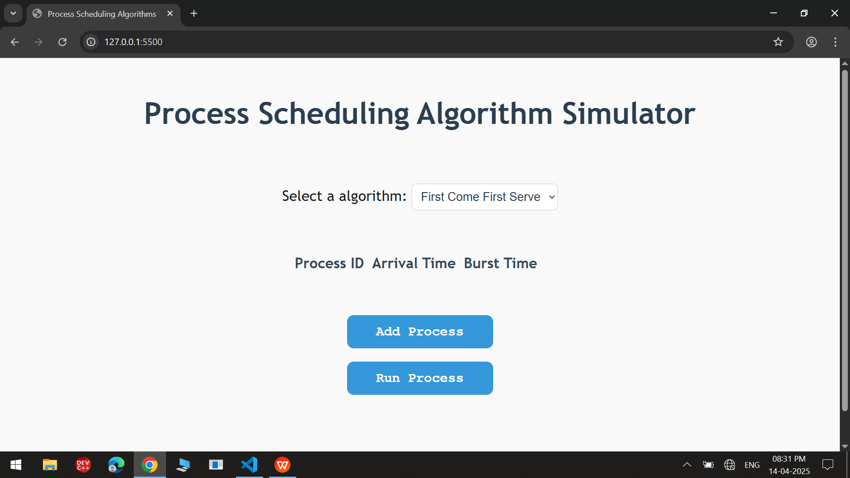

Process added
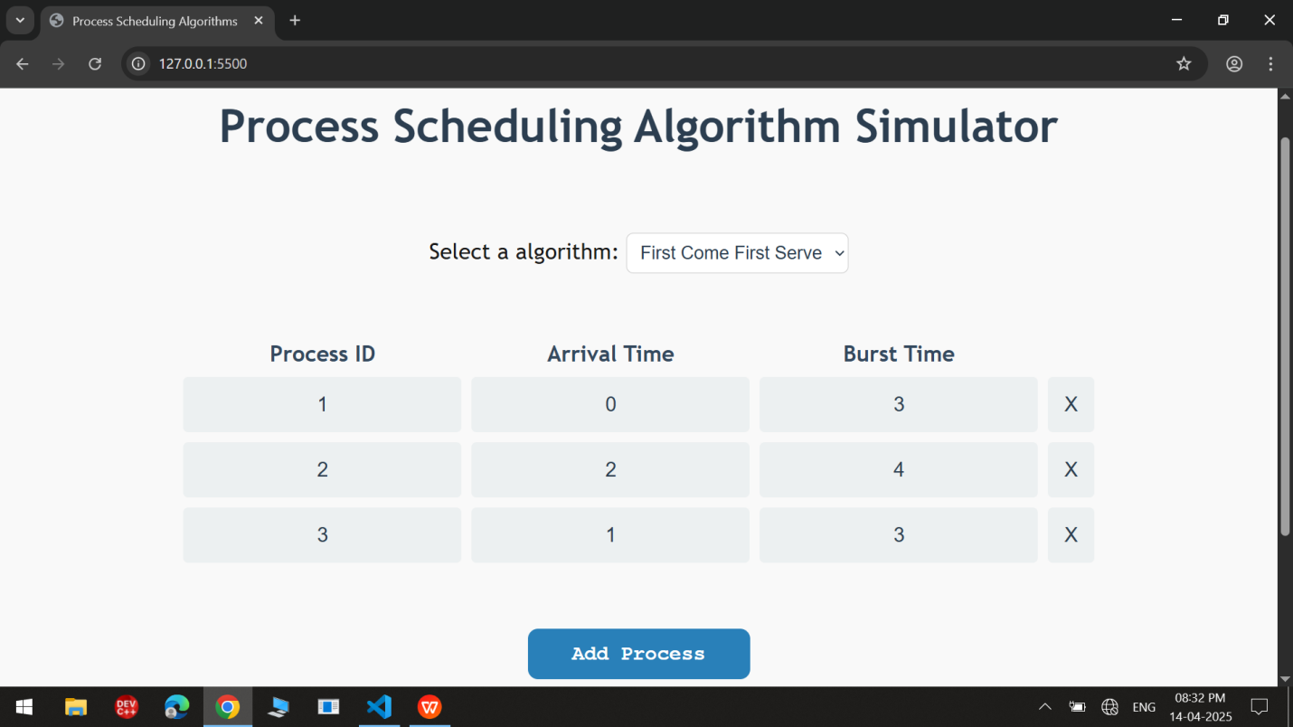
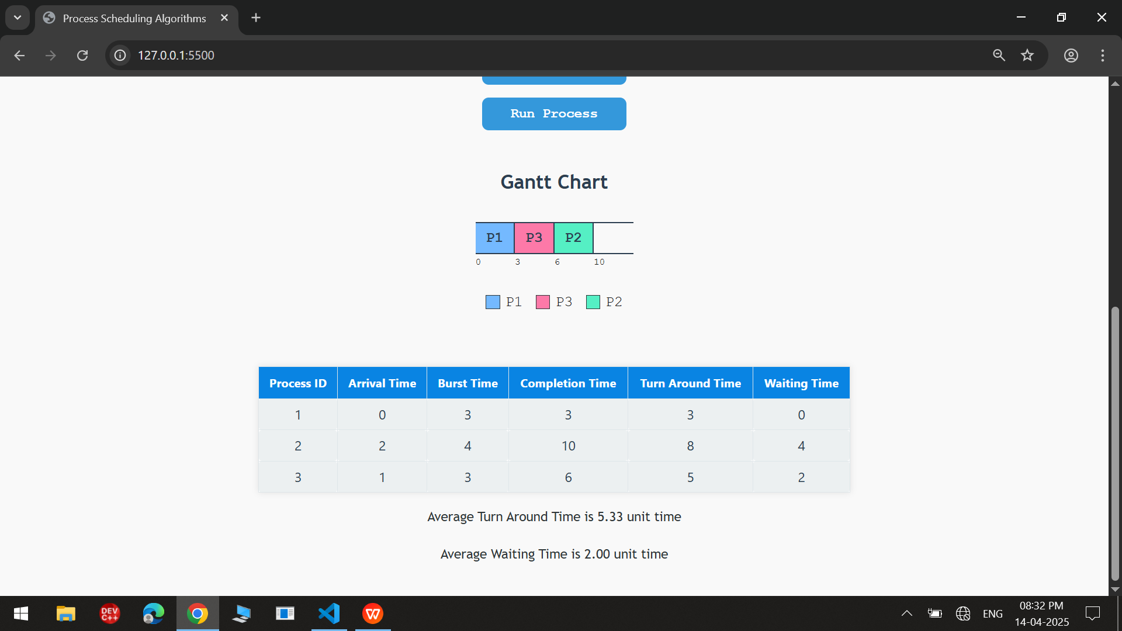
FCFS(First Come First Serve) RESULT
SJF (Shortest Job first) RESULT
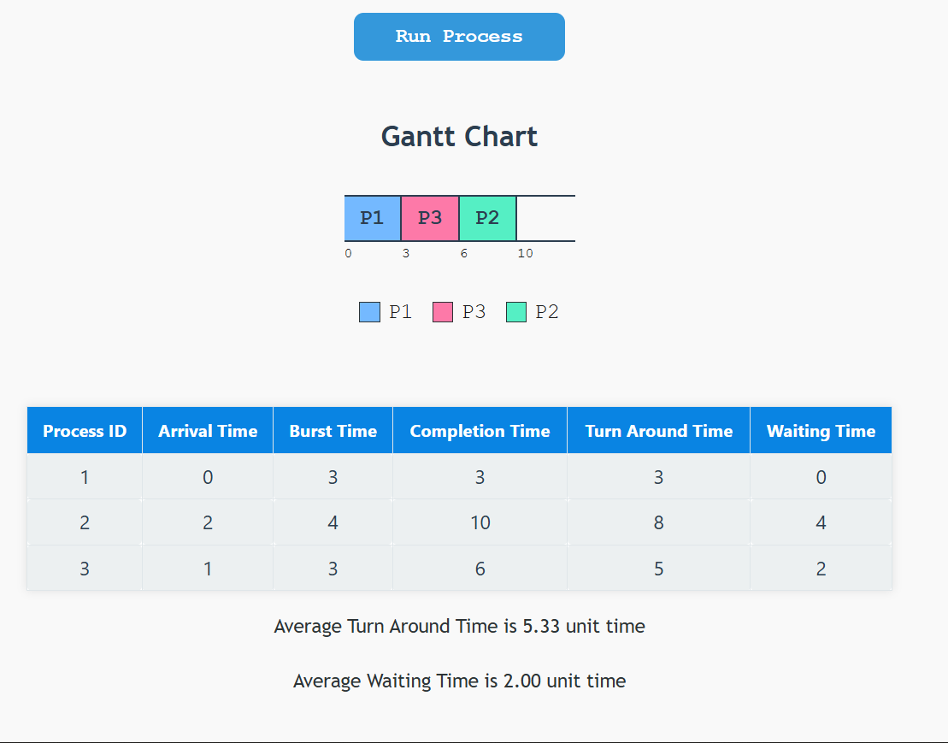
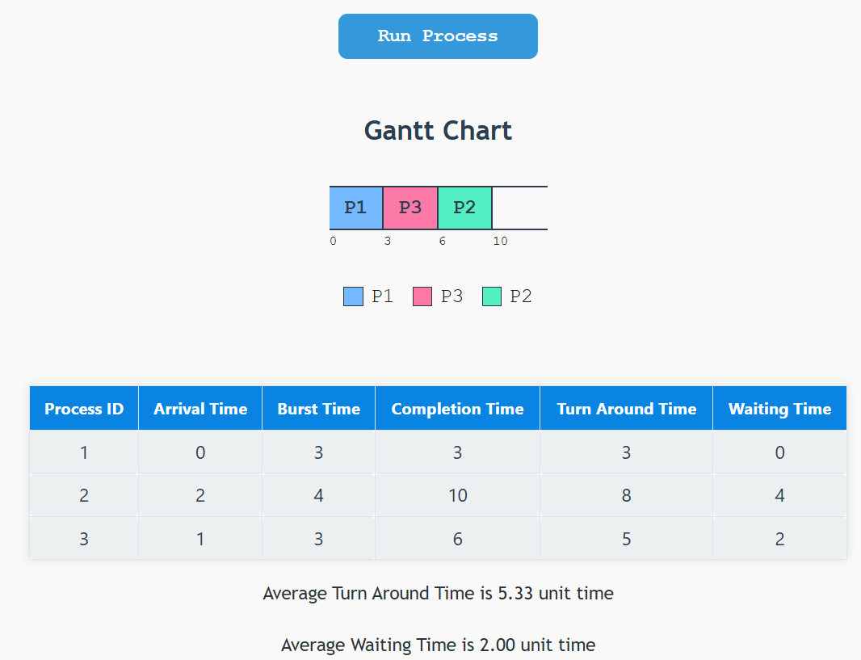
SRTF(Shortest Remaining Time First) RESULT
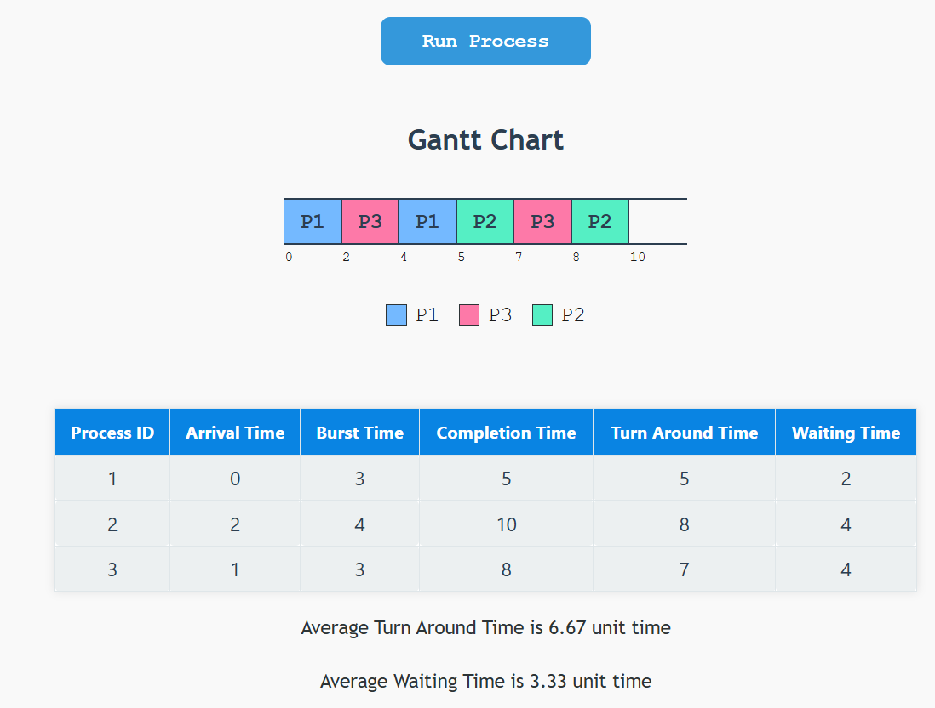
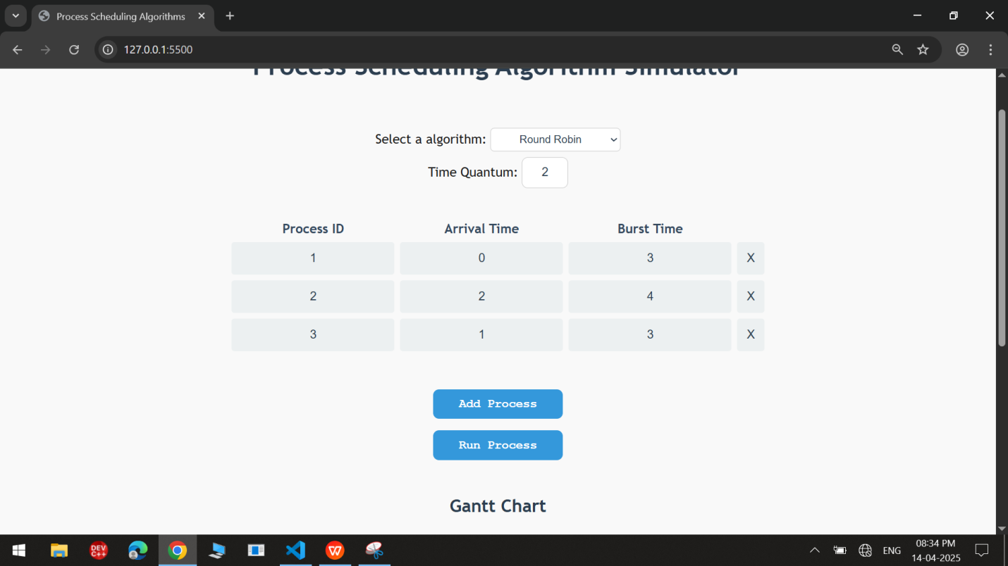
RR(Round Robin) RESULT

- Conclusion and Future Scope:
Conclusion:
This simulator effectively demonstrates the implementation of four fundamental CPU scheduling algorithms. By providing an interactive and visual experience, it serves as a valuable educational tool for understanding process management in operating systems.

- Future Scope:
- Addition of Priority Scheduling (Preemptive/Non-preemptive).
- Color-coded Gantt chart for better process distinction.
- Export results as PDF or image.
- Save/load session via localStorage or database.
- Mobile responsive design for accessibility on small screens.

References:
https://www.geeksforgeeks.org/cpu-scheduling-in-operating-systems/
https://developer.mozilla.org/en-US/docs/Web/JavaScript

