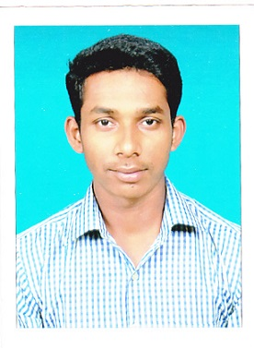
NILESH NAMDEV JADHAV
At-Doulatwadi, Tal-Kagal, Dist-Kolhapur, 416219
Mob: +919552714978/+918830312510
Email: nilesh7346@gmail.com
Computer Science and Engineering
Date of Birth: 26 June 1993
Gender: Male

career OBJECTIVE:

Seeking a position to utilize my skills and abilities in the engineering and also increase my knowledge, learning new technologies & softwares.

education / qualification:

Exam | University/Board | Institution | Year of Passing | Aggregate %Marks
B.E(CSE) | Shivaji University  (Kolhapur)  MSBTE(MUMBAI) | Dhananjay Mahadik Group of Institutions.  Vikaswadi,Kagal.  ICRE, Gargoti | 2018 | Pursuing
T.E | Shivaji University  (Kolhapur)  MSBTE(MUMBAI) |  | 2017 | 64.19
S.E | Shivaji University  (Kolhapur)  MSBTE(MUMBAI) |  | 2016 | 62.19
Diploma  (Computer Engineering) | Shivaji University  (Kolhapur)  MSBTE(MUMBAI) |  | 2015 | 80.77
12th(Science) | HSC | M.V.M Jr. College, Murgud | 2011 | 42.50
10th | SSC | M.V.M High school,  Murgud | 2009 | 53.07

computer SKILLS:
- C
- C++
- Java
- C#
- HTML
- Android

ACADEMIC PROJECTS:
- Currently working on project named Home Automation Using IOT. The aim of the project is to create an android application which is helpful for Human being. By using these app user can use various services e.g. ON/OFF TV, FANS, LEDS and Other Electrical Equipments in House.
- Successfully completed the project on E Locker System. The aim of the project is to create a DATABASE system application by using C# to provide application for storing and retrieving documents of various users.
- Successfully completed the project named Interview Scheduling.The aim of the project is to create an application in c language for a company which basically want to conduct interview to recruit candidates, we have to create a logic for allot that candidates in a particular time and date manner so as to its become easy to handle huge no of candidate in efficient way without collision.

Seminars and workshops :

- Seminar :
- Delivered a seminar on Distributed File System at BIMAT in October - 2017.
- Delivered a seminar on C language at ICRE0 Gargoti in January - 2013.
- Workshops :
- Successfully completed 2 days workshop on PHP at BIMAT in October -2016.
- Successfully completed 2 days workshop on Ethical Hacking at BIMAT in February -2017.

Co-curricular Activities:

- Participated in Mind Spark 2013 organized by COEP Pune.
- Participated in TechnoZeal 2013 organized by KIT Kolhapur.
- Secured 3nd rank in TE in computer science department based on university results 2017.
- Secured 3nd rank in Diploma Computer Engineering department based on board results 2014.
- Participated in Softronics 2k13 organized by ICRE Gargoti.
- Participated in VidyaVision 2k14 organized by VIT,Pal.

EXTRA-curricular activities:
- Got A Certificate in National Cadet Corps Programme.
- Participated in Annual Training Camp( ATC ) -2007 of NCC.
- Successfully completed 3 days training programme entrepreneurship development programme
- MSCIT

hobbies & interests:

- Reading Books
- Surfing Internet
- Swimming
- Playing cricket
- Travelling and exploring.

I declare that the information furnished above is correct to the best of
My knowledge and belief.

Date: 21 / 01 / 2018

Place : Kolhapur
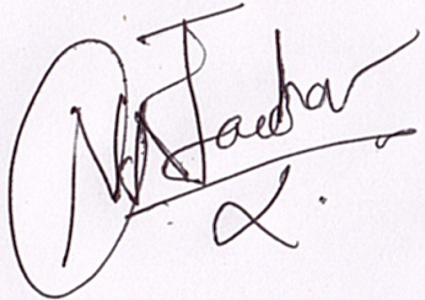
Jadhav Nilesh Namdev

