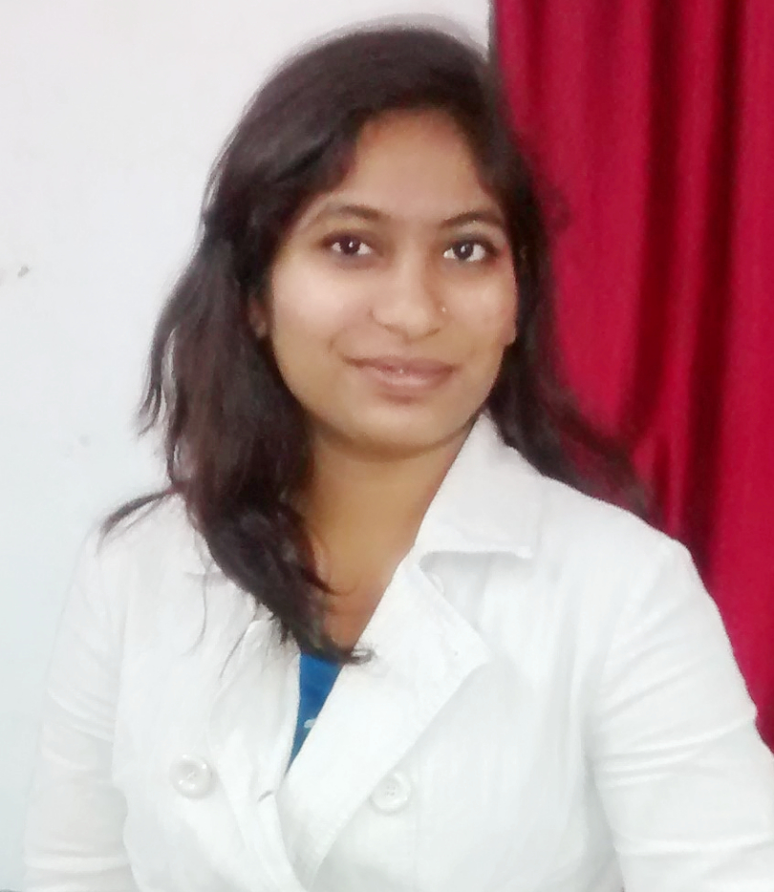 **RESUME**

**AISHWARYA R.GHOSHEWAR**

**BE- ENTC**

[ghoshewaraish@gmail.com](mailto:ghoshewaraish@gmail.com)

9637771530

Mukhed Road, Shirur Tajband,Dist-Latur

Career objective:-

To look for the appropriate position in the company whereby I will get opportunity to extensively interact with people and deriving satisfaction by enriching their performance standards which ultimately lead to growth of the company.

Education Details:-

|  |  |  |  |  |
| --- | --- | --- | --- | --- |
| **Qualification** | **Institute** | **University/Board** | **Year of passing** | **Percentage (%)** |
| **Electronics and** | SINHGAD INSTITUTE OF TECHNOLOGY, LONAVALA | University of | 2013-2017 | 61.69% |
| **Telecommunication** |  | Pune |  |  |
| **(BE)** |  |  |  |  |
| **H.S.C (Science)** | MAHATMA GANDHI MAHAVIDYALAYA,AHMEDPUR | Maharashtra | 2013 | 66.5% |
|  |  | State Board |  |  |
| **S.S.C (10th)** | SHREE MAHESH VIDYALAYA,SHIRUR TAJBAND | Maharashtra State Board | 2011 | 84.60% |
|  |  |  |  |  |
|  |  |  |  |  |

Personal Details:-

Fathers name – Rajaram Sambhaji Ghoshewar

Date of birth – 25/08/1995

Languages: - English, Hindi, Marathi .

Marital Status - single

Hobbies

* + - Painting and Drawing
    - Listening Music
    - Cooking
    - Making creative things

Skills:

C, C++ , HTML ,CSS, JAVASCRIPT , CORE JAVA , ADVANCE JAVA , SQL-PLSQL.

Hardworking , Eager to learn new technologies.

Extra curricular activities and Certifications:

1.Participated in TECHTONIC **PCB DESIGN**

2. Completed course in **C++ PROGRAMMING WITH GRADE B**.

3. Participated in **LATEX WORKSHOP.**

4.Co-ordinator in SPOKEN TUTORIAL test organized by **IIT BOMBAY**

Academic Projects:

1. **RFID BASED ATTENDENCE SYSTEM.**
2. **FPGA BASED DSP PROCESSOR.**

Declaration: I here by declare that all the above information furnished by me are true to the best of my knowledge.

Date : Aishwarya Ghoshewar