RESUME

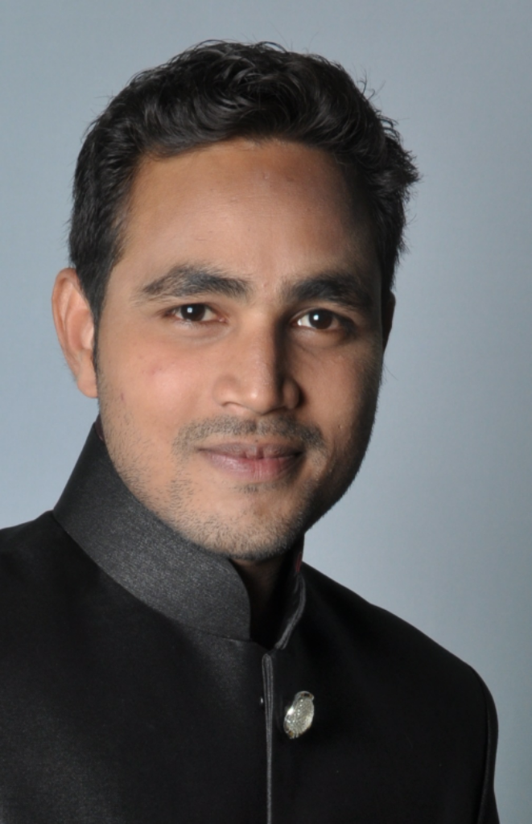

NAME: SHOAIB ALTAF MULLA

ADDRESS: 2284, 'A' ward, Babujamal, Kolhapur.

D.O.B: 26/07/1991

MARITAL STATUS: unmarried

LANGUAGE KNOWN: English, Hindi, Marathi

EMAIL: shoaibmulla26@gmail.com

MOBILE NO.: 9552143399/ 8485844010

* EDUCATIONAL QUALIFICATIONS:

|  |  |  |
| --- | --- | --- |
| Exam | Board | Percentage |
| SSC | Kolhapur | 60.15 % |
| HSC | Kolhapur | 50.00 % |
| BCA | Dr. C V Raman Open University , Bislapur, Kota, (C.G) | 72.00 % |

* **Computer Language Known:** C Programming, C++, HTML (CSS, JavaScript)
* OTHER QUALIFICATIONS:

1) Chiplevel Training in Laptop/ Desktop: Dr. Lab Care Training Institute, Pune

2) Basic Electronic: Gadkari Advance Training Institute, Shahupuri, Kolhapur.

3) Computer Hardware: Pradhan Mantri Kaushal Vikas Yojna,

Pramod Mahajan Kaushal Yojna,

MKCL, IG Computers, Kolhapur

4) MS - CIT: MKCL

5)) C- Programming: MKCL

* EXPERIENCE: Work as Computer Hardware Eng. In ACCESS TECHNOLOGY in Shahupuri, Kolhapur. (1 Year), Work as Laptop Chip Level Eng. In ASIA LINKS