**Jayshri More**

**RESUME**

B1-24,M R Pride ,Dighi, Pune

**EDUCATION**

+91-8698605657

**Bachelor of Engineering – Computer Science**

**Marathwada University Aurangabad, Maharashtra**

Computer Science With 71.74% (Distinction)

**HSC Science 12th**

**Maharashtra State Board**

HSC Science with 59.00% (First Class)

**SSC 10th**

**Maharashtra State Board**

SSC with 86% (Distinction)

Jayshri729@gmail.com

https://in.linkedin.com/in/jayshri-m-a16a07124



**OBJECTIVE**



To pursue a career in software development and contribute to any Implementation department in the organisation and enhance my skills



**2017**

**2013**

**2011**

**Employability Exam Results**



● **AMCAT Exam - ID - 30000463728237**

● **Cocubes Pre-Assess**

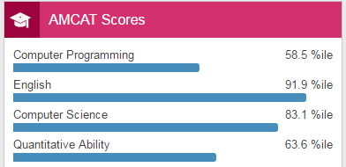 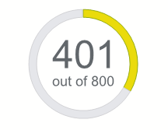

**RESUME**

**Jayshri More**



**SKILLS & STRENGTHS**

**PERSONAL DETAILS**

**Language used** – C#

**Database** - Microsoft Access

The main objective of the Library Management system project is discipline of the planning, organizing and managing the library tasks. Our project aims at making the task of library easy.

Permanent Address : Chandhai Ekko, Taluka Bhokardan Dist Jalna – 431213

Date of Birth : 07th Oct 1995

Marital Status : Single

Language Proficiency : Marathi, Hindi, English.

**LBS- Library Management System**

**May 2016**

**Language used** - Java

**Database** - Microsoft Access

The main objective of this project is to analyse the historical data available on stocks using decision tree technique as one of the classification methods of data mining in order to help investors to know when to buy new stocks or to sell their stocks.

**January 2017 - Current**

**Stock Market Analysis Using Data Mining**

**PROJECTS**



● **Languages: Core Java, OOPS Concepts, SQL, C++**

● **OS – Basic knowledge of UNIX Commands, Windows OS**



**TECHNICAL EXPERTISE**

● **Attention to Detail**

● **Ability to Prioritize**

● **Strong communication skills**

● **Capable problem solver**

**RESUME**