HomeWork 5

Rishi – rr3261

Anoop- adn322

**REPORT**

**Data Cleaning and Preprocessing:**

The clearest way to see if there is any relationship amongst the numerical features, categorical features and the wages, is to create a correlation plot. However, due to various categorical features (workerclass, marital, vechicleoccupancy, etc.) it isn’t possible to add features not having numerical values directly to the correlation plot. Therefore, I made changes to the categorical features by replacing the ‘?’ with 0 as another category and changing the datatype to numeric.

trainfile = trainfile.replace("?",0)  
for i in trainfile.columns:  
 trainfile[i] = pd.to_numeric(trainfile[i])

Once this was fixed a correlation matrix could be easily plotted.

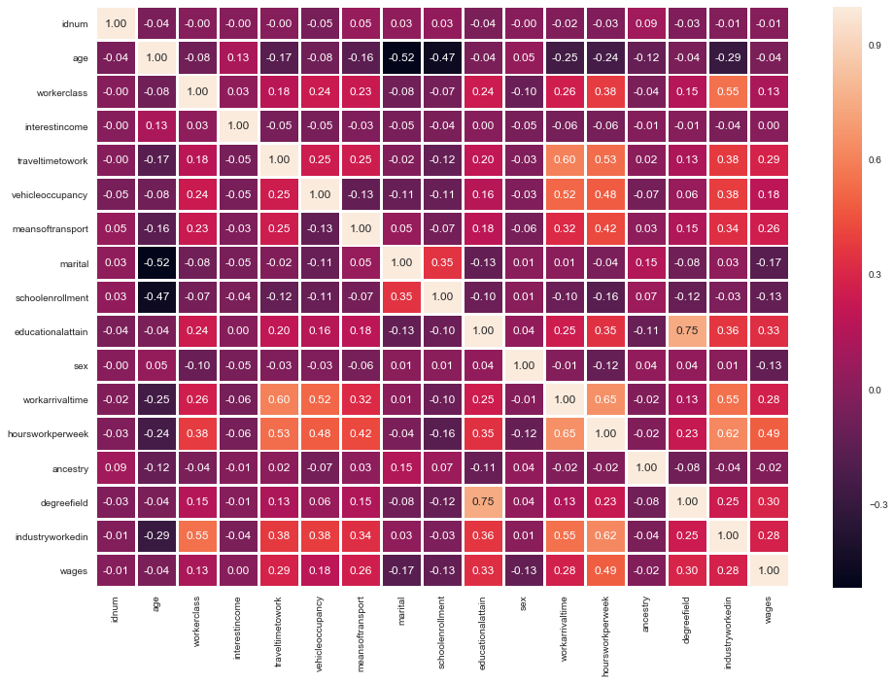

From this Matrix it could easily be seen that hoursperweek, degreefield, educationobtain are some of the most important features and features such as sex, ancestry, age, interestincome doesn’t really offer anything.

Hence, we remove the following features:

'age','interestincome','marital','schoolenrollment','sex','ancestry','wages'

One of the most important feature Education attained plot shows how the wages differ by different level of education.

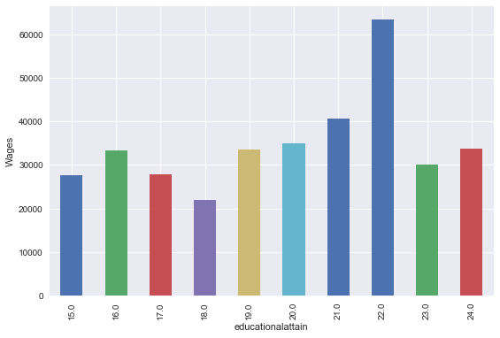

Once the Extraneous features has been removed, we try to simplify the categorical attributes having many features (workarrivaltime, degreefield, industryworkedin) by binning them into similar slots.

Workarrival time bins: Based on shifts we have divided the bin

So 12am-7am : BIN 1  
7am-9:30am : BIN 2 and so on……….

For Degreefield and industryworked in we noticed that the similar fields are in the same hundred values i.e. values b/w 2200 and 2299 belong to same field. So we divided this feature into bins of 100.

**Scaling Data**

Since the value of the category in some sense, **establish a priori assumption** between the features (not really reflection of data itself). And also, the nature of most algorithms is to find the most appropriate weight percentage between the features to fittest the data. So, when these algorithms' input is unscaled features, large scale data has more influence on the weight. It’s not the reflection of data itself. The main advantage of scaling is to avoid attributes in greater numeric ranges dominating those in smaller numeric ranges

We have used MinMax Scaler to scale all the values between 0 and 1.

**Modelling:**

PREDICTIVE MODELLING:

1. (a) TRAIN-TEST SPLIT – We split the training and testing datasets, on a 75/25 ratio of training to testing datasets. After the final model has been selected the cross validation has been performed in order to get a more accurate value of the error function.
2. (b) ERROR FUNCTION – Sci-kitlearn’s mean_squared_error() function was used and then the square root of mean squared error was taken, as per the instructions described in the PDF.

$$\sum_{t=1}^{N}{{(rt-yt)}^{2}}$$

**Regression Models**

As the problem involves predicting the wages, we are using regression models and not the classification models.

Models Used:

1. Linear Regression and Polynomial Regression

The basic linear regression and polynomial regression were our first choice, going by the traditional approaches.

Rmse Score varied from 37000 to 45000.

1. Lasso Regression

Lasso Regression from the scikit learn model was used as the 2nd Model.

Rmse score ranged from 35000 to 43000

1. Decision Tree Regressor

Next, we decided to try the decision tree regressor as we can tune no of splits in order to get lesser rmse. The following image describes the rmse for different leaf nodes (splitting value)

Error in Decision Tree Regressor:

Min sample leaves: 10

rmse: 42323.176654867304

Min sample leaves: 20

rmse: 37027.77805019394

Min sample leaves: 30

rmse: 35776.21661475761

Min sample leaves: 50

rmse: 34722.34808316169

Min sample leaves: 70

rmse: 39229.402442094644

Min sample leaves: 100

rmse: 37667.85308780998

1. Random Forest Regressor

Since decision tree gave a better result, we though why not tune the no of trees as well. So, the obvious choice after Decision Tree was Random Forest Regressor and unsurprisingly, the rmse value where between 33000 to 43000.

We experimented with different no. of splitting leaf values and also with minimum number of trees.

1. Elastic Net Regressor

Elastic Net Regressor Model from sklearn is a great combination of Ridge and Lasso models, so we decided why not give it a try. Alas, the results weren’t better than the Random Forest Regressor

The rmse values ranged from 36000 to 44000

1. Ridge Regressor

The Ridgre Regressor is similar to the Lasso Regressor and comes along with sklearn models.

The rmse values ranged from 36000 to 44000

**Final Model:**

The final model selected is Random Forest Regressor after comparing all the rmse values of different models.

Once the model was finalized cross validation was performed to get the final root mean square error value.

10-Fold validation was performed on the dataset and the   
resulting root mean square error was: 40387.39446

References

1. <https://scikit-learn.org/stable/modules/generated/sklearn.preprocessing.MinMaxScaler.html>
2. <https://scikit-learn.org/stable/modules/preprocessing.html>
3. <https://pythonprogramming.net/pandas-statistics-correlation-tables-how-to/>
4. <https://seaborn.pydata.org/examples/many_pairwise_correlations.html>
5. <https://scikit-learn.org/stable/modules/generated/sklearn.linear_model.LinearRegression.html>
6. <https://scikit-learn.org/stable/modules/generated/sklearn.linear_model.Lasso.html>
7. <https://scikit-learn.org/stable/modules/generated/sklearn.linear_model.ElasticNet.html>
8. <https://scikit-learn.org/stable/modules/generated/sklearn.linear_model.Ridge.html>
9. <https://scikit-learn.org/stable/modules/generated/sklearn.tree.DecisionTreeRegressor.html>
10. <https://scikit-learn.org/stable/modules/generated/sklearn.ensemble.RandomForestRegressor.html>
11. <https://scikit-learn.org/stable/modules/generated/sklearn.metrics.mean_squared_error.html>
12. <https://www.analyticsvidhya.com/blog/2015/08/comprehensive-guide-regression/>