PROGRAMMING FOR DATA SCIENCE
Telco Customer Churn Analysis
Data Analysis using Pandas, NumPy and Matplotlib
Data heading | IBM Telco Customer Churn Dataset (7,043 customers)
Subject | Programming for Data Science
Student 1 | Rishiraj Saha PRN: 26020845025
Student 2 | Ritika Mandol PRN: 26020845026
Institute | Symbiosis Institute of Business Management
Date of submission | 24 September 2026

Chapter 1: Introduction and Data Description

1.1 Introduction
Churn is when a customer stops using a company's service and moves away. For a telecom company this hurts a lot. Getting a new customer costs much more than keeping an old one, and every customer who leaves takes their future monthly bills with them.
For this project we picked a telecom dataset and tried to answer three simple questions: who is leaving, when do they leave, and why. Everything was done in Python. We used Pandas to load and clean the data and to make summary tables, NumPy for things like averages, percentiles and correlation, and Matplotlib for the charts. For every part we have put the code, the output we got and what we think it means.

1.2 Objectives
- Find out how many customers left and how much money the company lost because of it.
- See which groups of customers leave the most, based on contract, internet service and payment method.
- Check if customers who have been with the company longer are less likely to leave.
- Look at the reasons customers gave for leaving and come up with a few ideas to reduce churn.

1.3 About the Dataset
We took the Telco Customer Churn dataset, which was made by IBM and is available on Kaggle (kaggle.com/datasets/ylchang/telco-customer-churn-1113). The company in it is not real. It is a sample telecom company based in California, and each row in the file is one customer. We worked with the file Telco_customer_churn.xlsx.
Detail | Value
Number of rows | 7,043 customers
Number of columns | 33
Categorical columns | Gender, Partner, Contract, Internet Service, Payment Method, Churn Label, etc.
Numerical columns | Tenure Months, Monthly Charges, Total Charges, CLTV, Churn Score
Target column | Churn Value (1 = customer left, 0 = customer stayed)
Source | IBM sample data, available on Kaggle

1.4 Important Columns
Column | Type | What it means
CustomerID | Text | Unique ID of each customer
City, Zip Code | Categorical | Where the customer lives
Gender, Senior Citizen, Partner, Dependents | Categorical | Basic details about the customer
Tenure Months | Numerical | How many months the customer has been with the company
Phone Service, Multiple Lines | Categorical | Phone plan details
Internet Service | Categorical | DSL, Fiber optic or no internet
Online Security, Tech Support, etc. | Categorical | Extra services taken by the customer
Contract | Categorical | Month-to-month, One year or Two year
Payment Method | Categorical | How the customer pays the bill
Monthly Charges | Numerical | Current monthly bill in dollars
Total Charges | Numerical | Total amount paid till now
Churn Value / Churn Label | Numerical / Categorical | Whether the customer left (1 / Yes) or not (0 / No)
Churn Score | Numerical | A score from 0 to 100 given by IBM showing chance of leaving
CLTV | Numerical | Customer Lifetime Value, i.e. expected value of the customer
Churn Reason | Categorical | The reason given by the customer for leaving

1.5 Tools Used
We wrote all the code in Python 3 using just three libraries, Pandas, NumPy and Matplotlib. Everything is in one file, telco_churn_analysis.py, and we split it into small parts so each application can be run and explained on its own.

Chapter 2: Data Analysis using Python

Getting Started: Importing Libraries and Loading the Data
Code
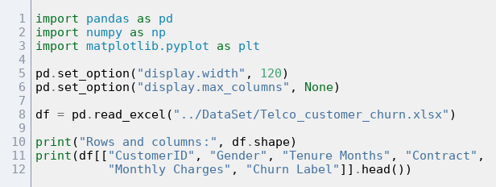
Output
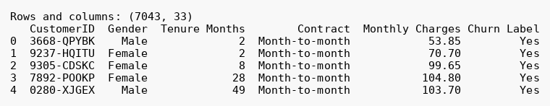
Inference: The file opened fine. There are 7,043 rows and 33 columns, which is way more than the 510 rows we needed. Every row is a customer. Some columns are categories like gender, contract and payment method, and some are numbers like tenure, monthly charges and CLTV, so we have both kinds of data to work with.

2.1 Pandas: Three Applications

Pandas 1 - Cleaning the data and basic statistics
Code
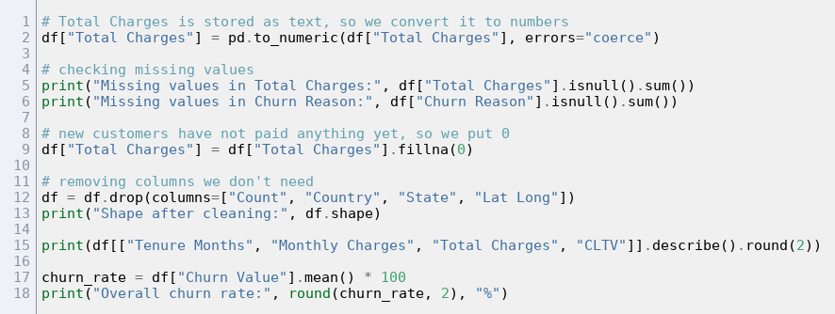

Output
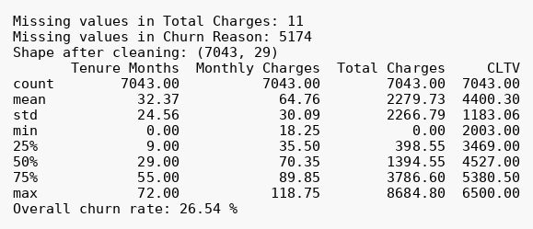
Inference: Only two columns had missing values. Total Charges had 11 empty cells. When we looked at those rows, all of them were customers with 0 months tenure, meaning they had just joined and had not got a bill yet, so we filled them with 0. Churn Reason had 5,174 empty cells. That is exactly the number of customers who did not leave, which makes sense because they have no reason to give, so we left those as they were. The average customer has stayed around 32 months and pays about $65 a month. Overall churn came out to 26.54%, so about 1 in 4 customers left.

Pandas 2 - Churn rate by contract, internet service and payment method
Code
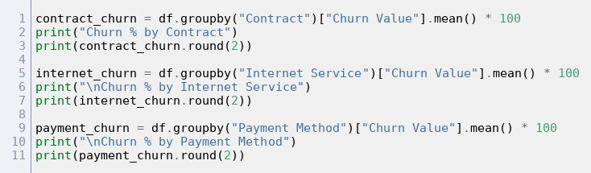
Output
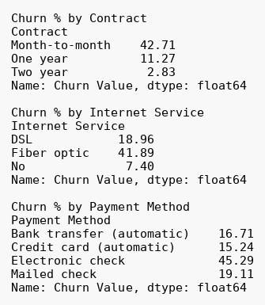
Inference: Contract type shows the biggest gap. 42.7% of month-to-month customers left, but only 2.8% of the ones on a two-year contract did. Fiber optic users left at almost 42%, which is more than twice the DSL figure. We didn't expect this since fiber is the more expensive, better service. Payment method also matters. Electronic check users churned at 45.3%, while people paying automatically by bank transfer or credit card were only around 15 to 17%.

Pandas 3 - Tenure groups, pivot table and churn reasons
Code
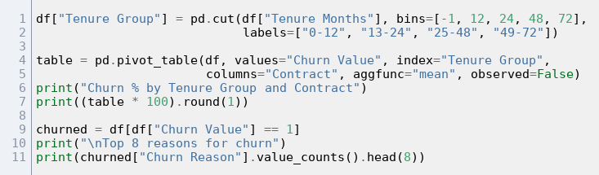
Output
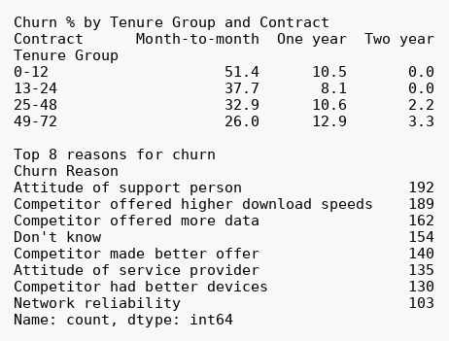

Inference: From the pivot table we can see that new month-to-month customers are the ones leaving the most. In their first year, 51.4% of them churned. On the other hand, not a single two-year contract customer left in the first 24 months. Looking at the reasons, the top one on its own was the attitude of the support person (192 customers). But when we added up all the reasons that mention a competitor (faster speed, more data, a better offer, better devices), the total was over 600. So overall, losing customers to competitors is the bigger problem.

2.2 NumPy: Three Applications

NumPy 1 - Comparing monthly charges of churned and retained customers
Code
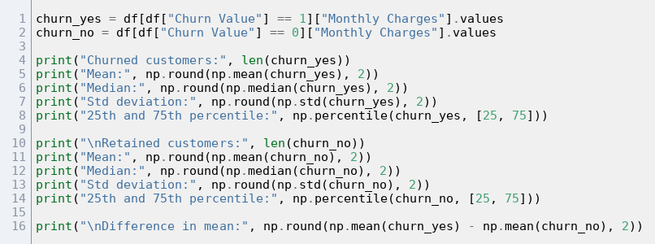
Output
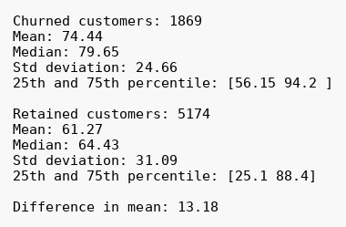
Inference: Customers who left were paying more every month. Their average bill was $74.44 while customers who stayed paid $61.27, about $13 less. The medians say the same thing ($79.65 and $64.43). For the customers who stayed, the 25th percentile is only $25.10. A lot of them are on cheap phone-only plans, which pulls their numbers down. It looks like the higher the bill, the more likely a customer is to leave.

NumPy 2 - Correlation between numeric columns
Code
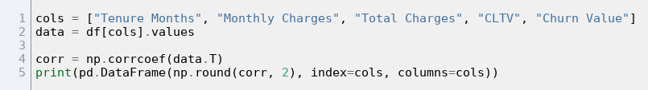
Output
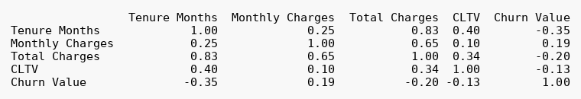
Inference: Out of these columns, tenure has the strongest connection with churn, with a value of -0.35. Since it is negative, it means customers who have been around longer are less likely to leave. Monthly charges have a weak positive value (0.19), and this fits with what we saw in NumPy 1. Tenure and Total Charges have a high value of 0.83, but that is obvious because the longer you stay, the more you have paid in total.

NumPy 3 - Risk groups and revenue lost
Code
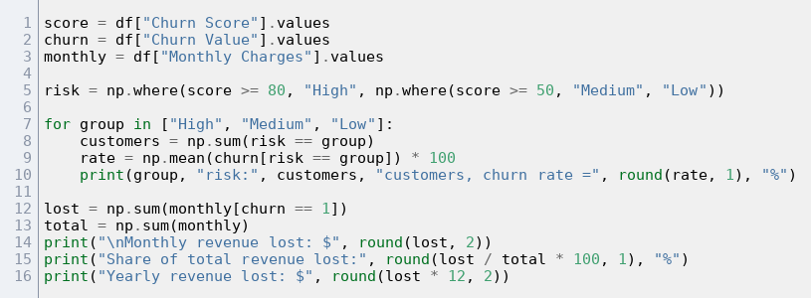
Output
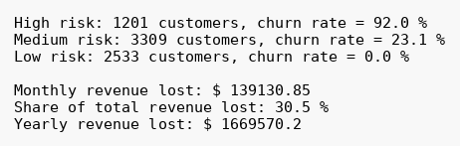
Inference: Using np.where, we split customers into High, Medium and Low risk groups based on their churn score. The score worked well. 92% of the High risk customers actually left, and none of the Low risk ones did, which means the company can use the score to decide who to call first. In terms of money, churned customers were paying $139,131 a month in total. That is 30.5% of the company's monthly revenue, and if you multiply by 12 it is about $1.67 million a year. The share of revenue lost (30.5%) is more than the share of customers lost (26.5%) because the ones who left were paying more.

2.3 Matplotlib: Three Applications

Matplotlib 1 - Overall churn and churn by contract
Code
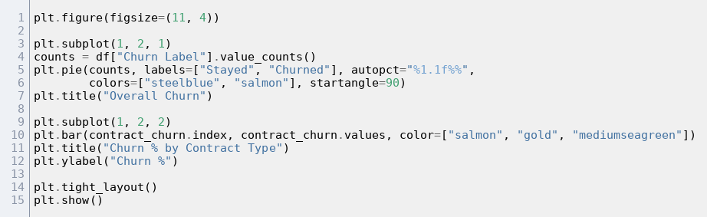
Chart
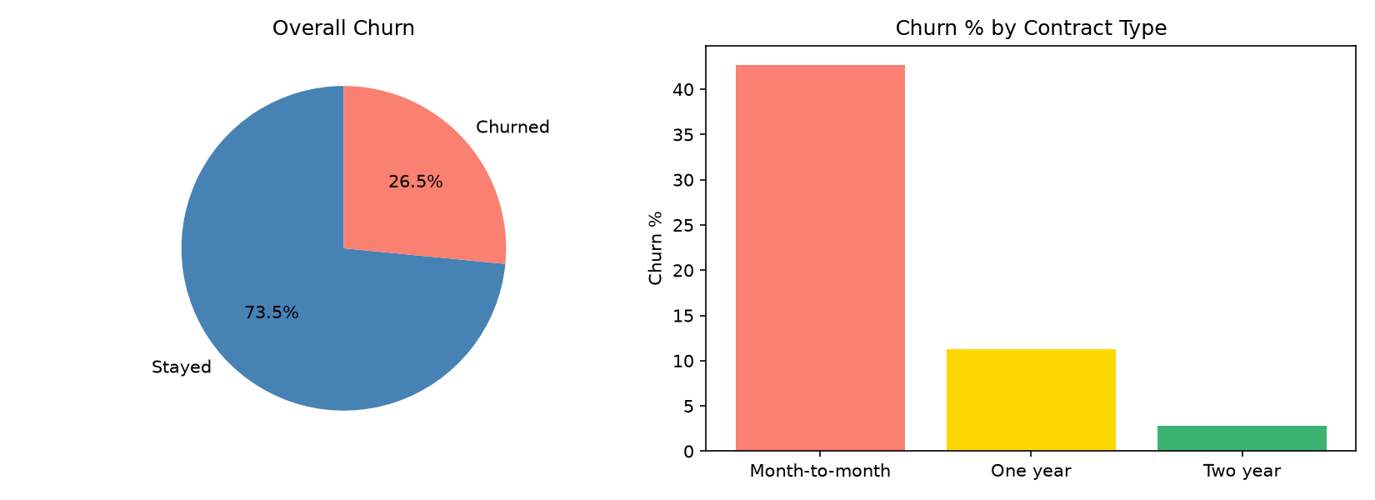
Figure 1: Overall churn and churn by contract
Inference: The pie chart shows 73.5% of customers stayed and 26.5% left. The bar chart shows the contract effect really clearly, with the month-to-month bar way above the other two. Getting more people onto one or two year contracts seems like the simplest way to bring churn down.

Matplotlib 2 - Monthly charges and tenure of churned vs retained customers
Code
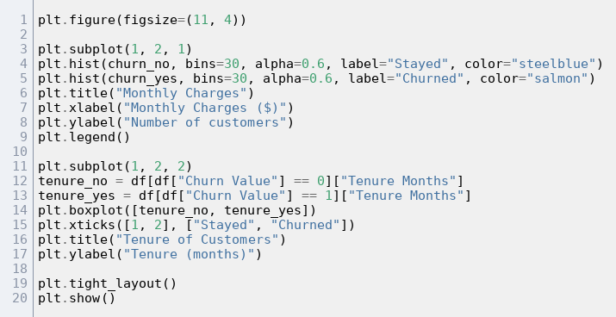
Chart
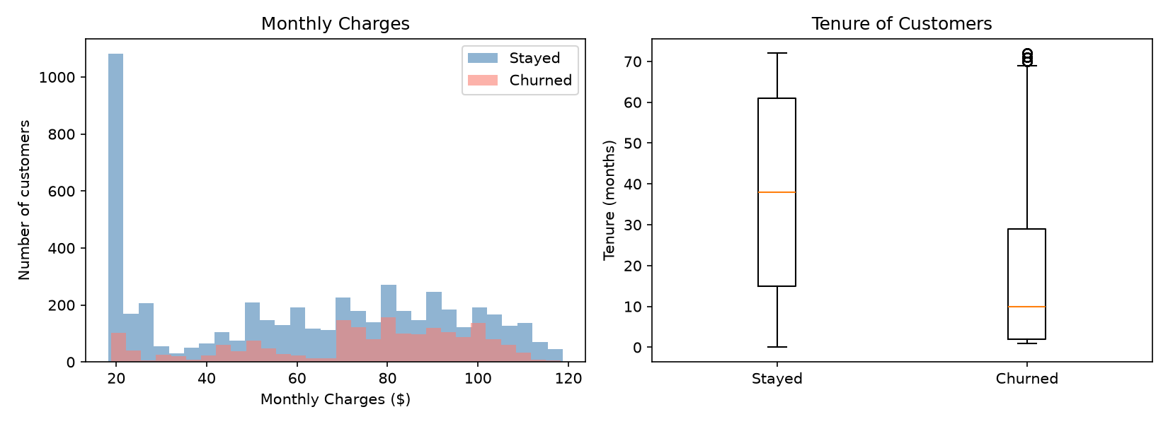
Figure 2: Monthly charges and tenure of churned vs retained customers
Inference: In the histogram, many of the customers who stayed pay around $20 a month. The churned customers are mostly in the $70 to $105 range, which is roughly what fiber and streaming plans cost. The box plot tells us that customers who leave usually do it early on. Their median tenure is just about 10 months, and for customers who stayed it is around 38 months.

Matplotlib 3 - Churn over tenure and top churn reasons
Code
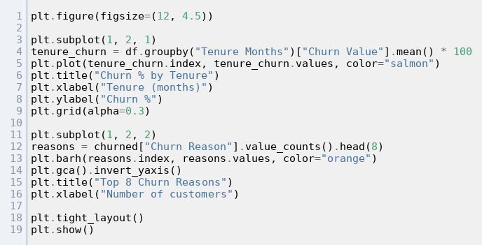
Chart
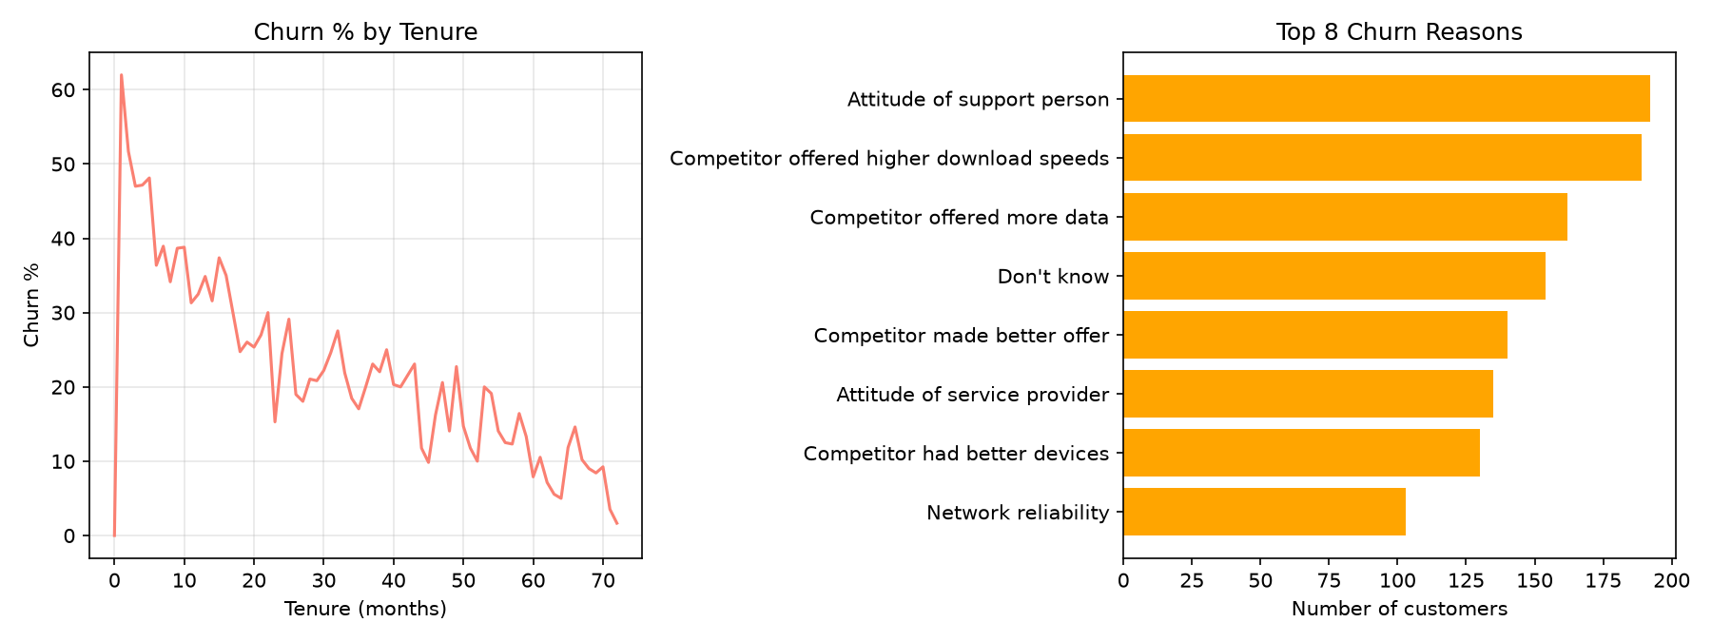
Figure 3: Churn over tenure and top churn reasons
Inference: Churn is really high in the first few months, somewhere around 50 to 60%, and after that the line keeps dropping. By 5 to 6 years it is under 10%. The 0% at month 0 is only because those customers had just joined and had not had time to leave. In the reasons chart, most of the bars fall into two groups. Either customers were unhappy with the service or the staff, or a competitor gave them a better deal.

Chapter 3: Conclusion

3.1 What the Data Tells Us
Around one in four customers (26.5%) left the company. Because these customers were paying more than average, the company actually lost 30.5% of its monthly revenue, about $1.67 million a year. Churn is not the same across all customers. Most of it comes from a few groups, which we have put together in the table below.
Factor | Churns the most | Churns the least
Contract | Month-to-month (42.7%) | Two year (2.8%)
Tenure | First 12 months (47.4%) | 49 to 72 months (9.5%)
Internet service | Fiber optic (41.9%) | No internet (7.4%)
Payment method | Electronic check (45.3%) | Credit card, automatic (15.2%)
Monthly charges | Churned: $74.44 on average | Stayed: $61.27 on average

3.2 Key Findings
- Contract type matters the most. People on one or two year contracts almost never leave, even in their first year.
- The first year is when most customers leave. Churn is highest in the first few months and goes down the longer a customer stays. Most of the customers who left did so within about 10 months.
- Fiber optic customers seem unhappy. They pay the most but leave about twice as often as DSL users. A lot of the reasons given also mention competitors having better speed or more data.
- Payment method is linked to churn. Customers who pay by electronic check leave about three times as often as those on automatic payment.
- Customer service needs work. The most common single reason for leaving was the attitude of the support person.
- The churn score is useful. It picked out a high risk group where 92% of customers actually left.

3.3 Suggestions
- Offer discounts or small rewards to month-to-month customers who agree to move to a one or two year contract.
- Look after new customers more closely in their first 3 to 6 months, for example through welcome calls and help with setting things up.
- Check fiber prices and speeds against competitors, and maybe add free extras like online security or tech support.
- Give a small discount on the bill to customers who switch to automatic payment.
- Train the support team better and keep track of customer satisfaction.
- Use the churn score to reach out to high risk customers before they leave.

3.4 Limitations
There are a few limitations. The company in this dataset is not real, and the data only covers one quarter in one US state, so a real company might show different results. Our analysis also only shows what is linked to churn. It does not prove what causes it. Later on, a machine learning model could be trained on this data to predict churn better.

