

ANALYTICS ARENA 2026


ACADEMIC PROGRAM COMMITTEE REPORT
2026-27


About the committee

The Academic Program Committee aims to create high standards of academic rigor by creating an ecosystem that facilitates learning and by formulating an academic curriculum that matches industrial expectations. As a part of the student council at SIBM Bengaluru, this team supports various academic tasks and processes that are vital to the institute’s reputation. The APC functions as an autonomous student body, along with the support of the Director and faculty. This collaboration of efforts and ideas gives this team a holistic understanding of the academic needs of the institution. The committee strives to create synergy between the academic experience at SIBM-B and the multifaceted industry.

Committee Member Details

Name of the Committee: Academic Program Committee
Faculty In-Charge/s: Dr. Arunkumar ON and Dr. Swarnalakshmi Umamaheswaran
Student Coordinator: Tina Kadian
Sr. No. | Name of the Student Member | Contact Number | Email ID
1. | Tina Kadian | 7015613014 | tina.kadian26@sibm.edu.in
2. | Ashu Kittur | 6362502407 | ashu.kittur26ba@sibm.edu.in
3. | Gauri Nagre | 9769488981 | gauri.nagre26ba@sibm.edu.in
4. | Harnoor Arora | 9326466617 | harnoor.arora26@sibm.edu.in
5. | Jatin Gupta | 8285500829 | jatin.gupta26@sibm.edu.in
6. | Prutha Benara | 9625565993 | prutha.benara26@sibm.edu.in
7. | Rishabh Gaba | 8847095448 | rishabh.gaba26@sibm.edu.in
8. | Snigddha Varahagiri | 7674826190 | snigddha.varahagiri26@sibm.edu.in
9. | Subithra S | 9150248108 | subithra.sri26@sibm.edu.in
10. | Aaradhya Katija | 9691938804 | aaradhya.katija27@sibm.edu.in
11. | Anushikha Saxena | 9548263820 | anushikha.saxena27@sibm.edu.in
12. | Atharva Sawant | 9920981481 | atharva.sawant27ba@sibm.edu.in
13. | Dia Dewan | 7044811095 | dia.dewan27@sibm.edu.in
14. | Kaustubh Hari Namjoshi | 8010220232 | kaustubh.namjoshi27@sibm.edu.in
15. | Manan Danodia | 9571708375 | manan.danodia27@sibm.edu.in
16. | Pratik Randive | 8432128056 | pratik.randive27@sibm.edu.in
17. | Raunak Khemka | 8820921158 | raunak.khemka27@sibm.edu.in
18. | Yashsvi Ambere | 6263318189 | yashsvi.ambere27ba@sibm.edu.in

Calendar of events/activities

Date | Particulars
3rd October 2026 | Round 0 – Online Quiz
4th October 2026 | Round 1 – KPI Hunt & Excel Treasure Hunt
4th October 2026 | Round 2 – Doomsday (Rapid Fire)
4th October 2026 | Round 3 – Power BI Dashboard (Final)

Event Report (Detailed) for each event/activity mentioned in the Calendar of Events
- Name of the Event/ Panel: Analytics Arena 2026
- Event Theme and description: Analytics Arena 2026 – “Think • Analyse • Outperform” – is an analytics competition for the first-year MBA batch at SIBM Bengaluru, organised by the Academic Program Committee (APC) in collaboration with the Datalytics Club. The event assessed students’ proficiency in Microsoft Excel and Power BI through an online quiz followed by three offline rounds that tested their technical proficiency, problem-solving abilities, and teamwork.
Date of the Event: 3rd October 2026 (Round 0 – Online Quiz) and 4th October 2026 (Offline Rounds 1–3)

- Event Schedule and Participation
MBA-Core and MBA-BA (First Year)

ROUND-WISE PARTICIPATION
Round | Participation
Round 0 – Online Quiz (3rd Oct) | Approx. 173 students
Round 1 – KPI Hunt & Excel Treasure Hunt (4th Oct) | 25 teams (2 members each)
Round 2 – Doomsday (Rapid Fire) (4th Oct) | 15 teams
Round 3 – Power BI Dashboard (4th Oct) | 6 teams
Winner | Data Warriors – Sofia Afsar & Archana G (MBA-BA, First Year)
Runner-up | NextGen Frontiers – Ayush Dwivedi & Ishan Bhatnagar (MBA-Core, First Year)

- Event Invitation/Brochure and Poster:

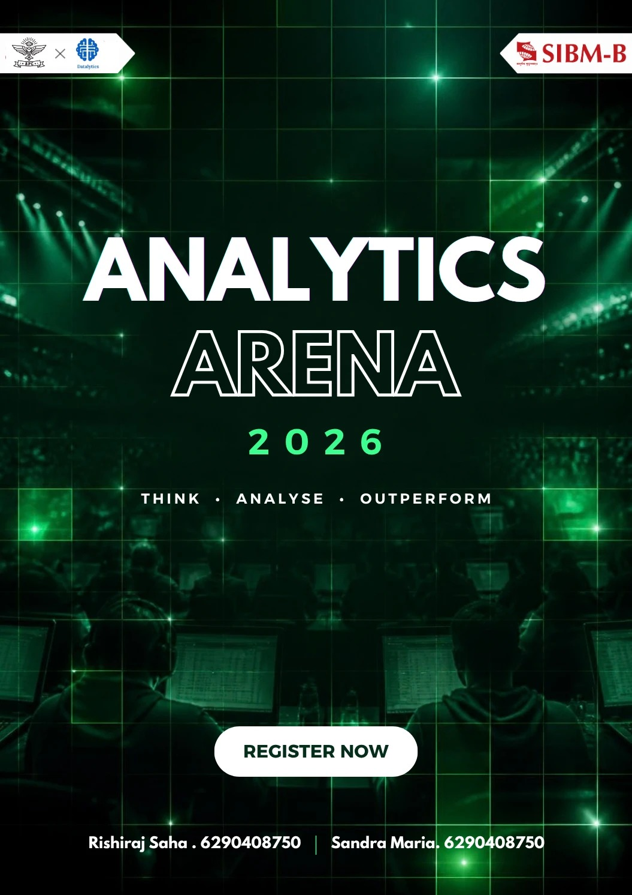

- Event photographs:

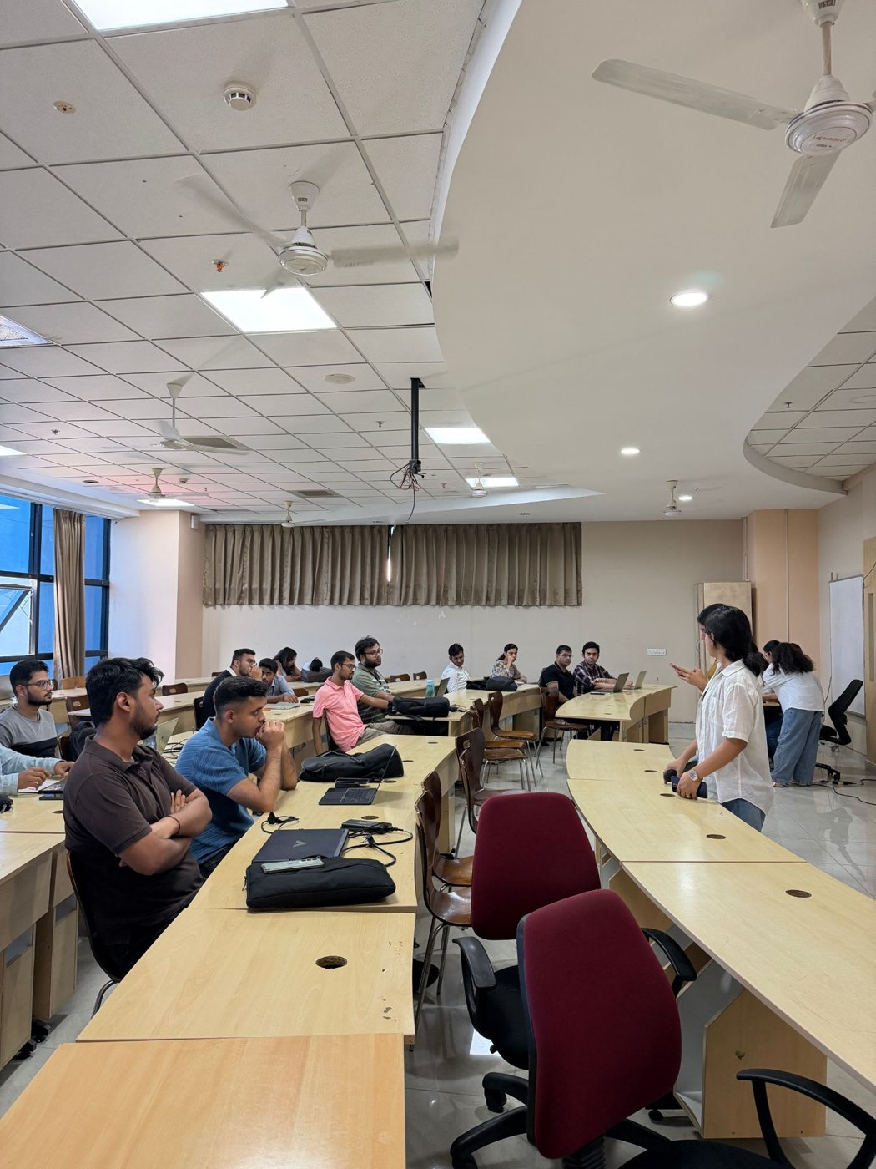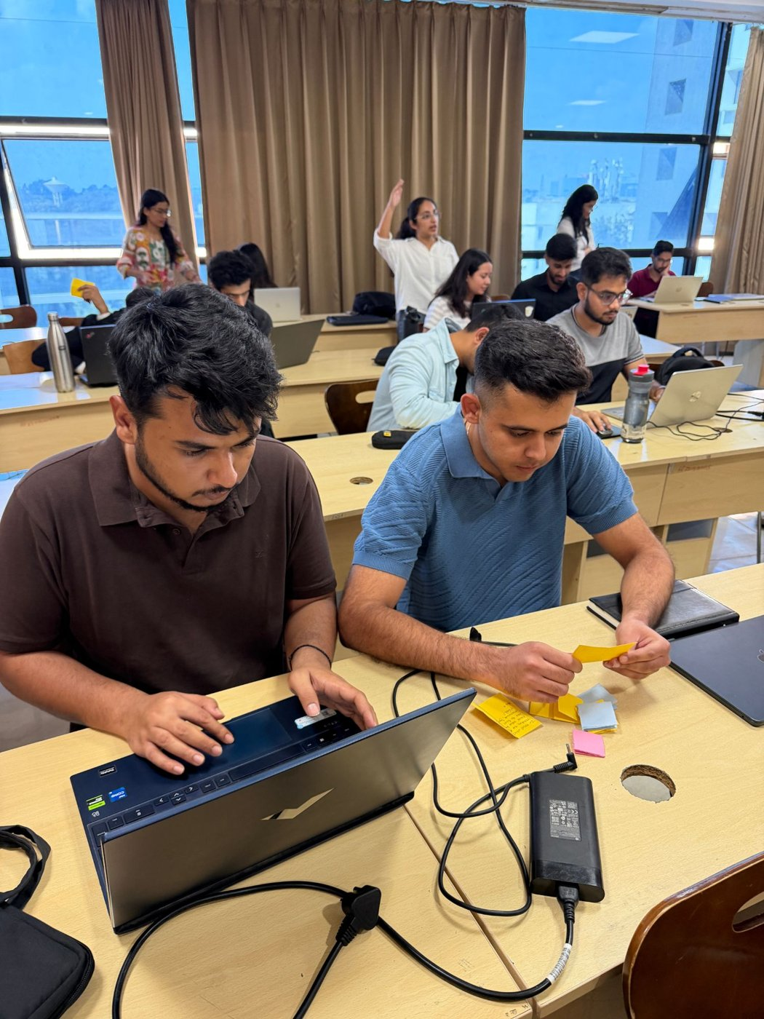

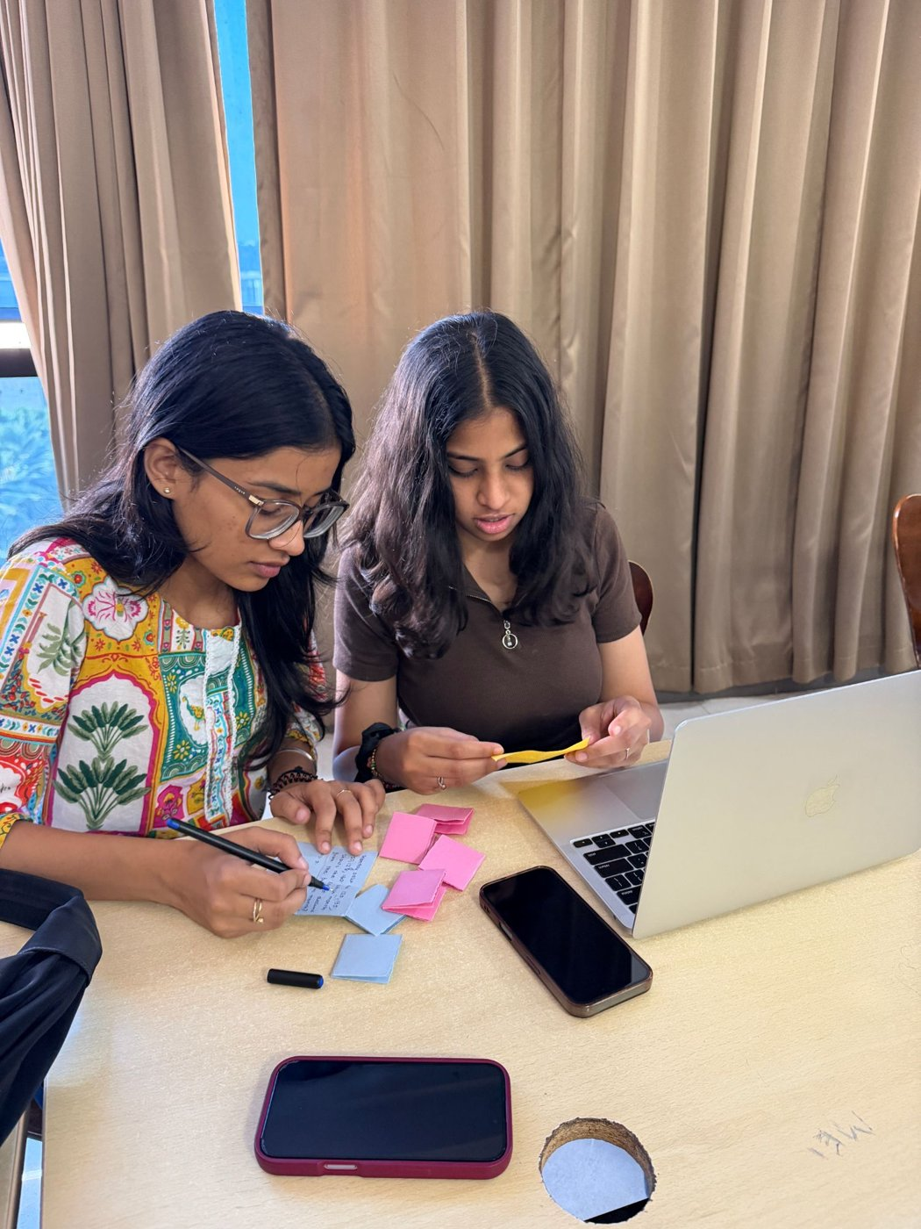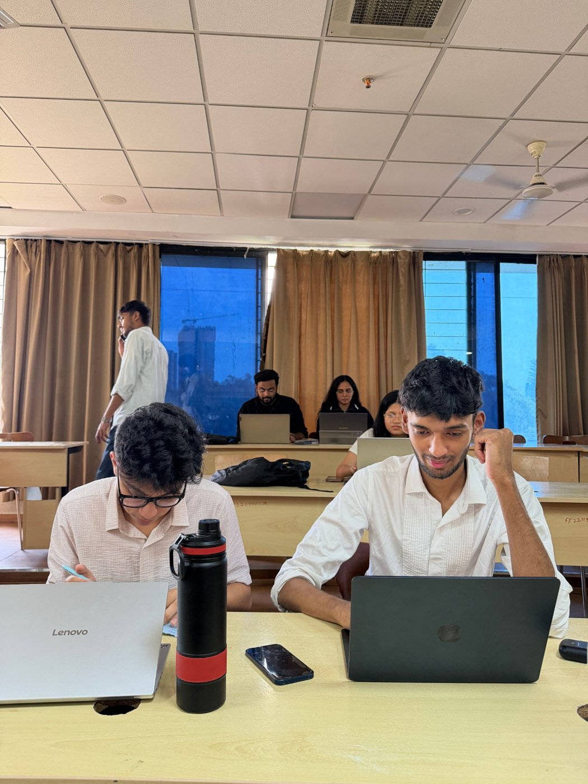

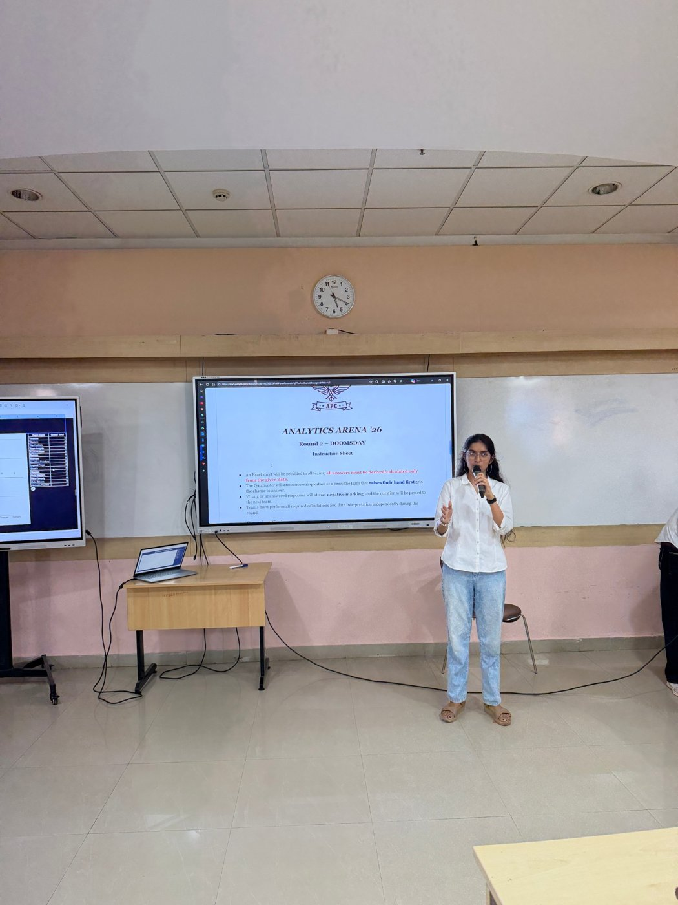

Emails exchanged within the Institute (Invitation email and Vote of thanks):
- Registration form for Round 0 – Online Quiz
- Quiz instructions and link shared with participants
- Announcement of teams shortlisted for the offline rounds
- Schedule and rules for the offline rounds
- Announcement of results and Vote of Thanks
- Certificates to winners and participants

Comprehensive Summary:

Analytics Arena 2026, organised by the Academic Program Committee (APC) in collaboration with the Datalytics Club at SIBM Bengaluru, brought together the first-year MBA batch to test and develop their analytical skills. The event focused on assessing students’ proficiency in Microsoft Excel and Power BI through a series of engaging challenges, beginning with an online quiz (Round 0) on 3rd October 2026 that saw participation from approximately 173 students.
The offline rounds were held on 4th October 2026. In Round 1, 25 teams of two took part in a KPI hunt, working with data to identify key performance indicators, and an Excel treasure hunt in which team members alternated between solving Excel problems and hunting for chits carrying problems of easy, medium, and hard difficulty. Fifteen teams advanced to Round 2, a rapid-fire round in which teams found answers from a dataset using Excel against the clock. The top six teams reached Round 3, where they were given a problem statement and dataset and built Power BI dashboards to answer strategic business questions. Data Warriors (Sofia Afsar and Archana G, MBA-BA, First Year) emerged as the winners, with NextGen Frontiers (Ayush Dwivedi and Ishan Bhatnagar, MBA-Core, First Year) as the runners-up.
Beyond the competition, Analytics Arena 2026 gave students an opportunity to apply their classroom knowledge to practical tasks and understand how analytics can support business decisions. It also helped participants recognise their strengths and identify areas for improvement in their analytical and technical skills, while encouraging teamwork, building confidence, and highlighting the importance of data-driven decision-making in the journey towards becoming future managers.

Accurate Activity Report:
- Planning and Collaboration:
○ The APC partnered with the Datalytics Club to design an event assessing first-year students’ proficiency in Microsoft Excel and Power BI.
○ The event was structured as an online preliminary quiz followed by three offline rounds held on campus.
- Round 0 – Online Quiz (3rd October 2026):
○ Registrations were opened for the first-year MBA batch.
○ The online quiz saw participation from approximately 173 students and was used to shortlist 25 teams of two for the offline rounds.
- Round 1 – KPI Hunt & Excel Treasure Hunt (4th October 2026):
○ In the KPI hunt, the 25 teams worked with data to identify key performance indicators.
○ In the treasure hunt, teams collected chits carrying Excel problems of three difficulty levels – easy, medium, and hard – each carrying a different score.
○ The round ran in two 15-minute shifts: in the first, one member solved the Excel problem while the other searched for chits; in the second, they swapped roles.
○ Once all problems were solved, teams submitted their work and scores were calculated.
- Round 2 – Doomsday (Rapid Fire):
○ 15 teams advanced to the rapid-fire round, where they were given a dataset and had to find answers to the questions displayed using Excel.
○ The team that raised their hand first got the chance to answer; wrong or unanswered responses attracted negative marking and the question passed to the next team, with up to three teams getting a chance per question.
- Round 3 – Power BI Dashboard (Final):
○ The top 6 teams were given a problem statement and dataset and built Power BI dashboards to answer strategic business questions.
○ Teams presented their dashboards along with the insights they had derived from the data.
- Results and Vote of Thanks:
○ Data Warriors (Sofia Afsar and Archana G, MBA-BA, First Year) were declared the winners, and NextGen Frontiers (Ayush Dwivedi and Ishan Bhatnagar, MBA-Core, First Year) the runners-up.
○ A vote of thanks was extended to the Datalytics Club, the faculty, and all participants for their contribution to the event.
- Learning Outcomes:
○ Participants applied classroom knowledge to practical, data-driven tasks and understood how analytics can support business decisions.
○ The event helped students recognise their strengths and identify areas for improvement in their analytical and technical skills.

Closing Remarks:
Analytics Arena 2026 concluded on a high note, combining practical application with healthy competition. From the online quiz to the final Power BI dashboard presentations, each round challenged participants to think analytically, work under time pressure, and collaborate effectively as a team.
We extend our sincere gratitude to the Datalytics Club for their collaboration, to the faculty for their guidance and support, and to all the participants for their enthusiasm. We congratulate Data Warriors (Sofia Afsar and Archana G) on their win and NextGen Frontiers (Ayush Dwivedi and Ishan Bhatnagar) on finishing as runners-up, along with every team that competed across the rounds.
The success of Analytics Arena 2026 highlights the importance of data-driven decision-making in the journey towards becoming future managers. We look forward to building on this foundation in future editions and continuing to strengthen the analytical culture at SIBM Bengaluru.

