Event Outcome Report

- Topic/ Title of Event: Analytics Arena 2026
(Refer to the Indicative List of Events)

- Type of Event: (Annex the brochure/ information manual) (tick √ the appropriate box)

Conference |  | Seminar |  | FDP |  | SDP |  | Others, Specify | √
Guest Lecture |  | Webinar |  | MDP |  | Industrial Visit

Others, Specify : Analytics Competition (Microsoft Excel & Power BI)

- Date/ Duration of Event Date: 3rd October, 2026 (Round 0 – Online Quiz) and 4th October, 2026 (Offline Rounds 1–3)

Online |  | Offline |  | Blended | √
- Mode (tick √):

- Collaboration, if any:

Name of Organisation | Datalytics Club, SIBM Bengaluru
Sponsorship, if any | None

- Objective of Event:

- To assess and develop first-year MBA students’ proficiency in Microsoft Excel and Power BI.
- To enable students to apply classroom knowledge to practical, data-driven business problems.
- To build problem-solving ability, teamwork, and confidence through healthy competition.

- Event contributing to SDGs (Global/ National/ Regional/ Local requirement). (Yes/ No)
NO

- Event usefulness leading to - Employability/ Entrepreneurship/ Skill Development/ IPR/ Innovation/ Professional Ethics/ Gender/ Environment etc. (Yes/ No)
Yes – Skill Development and Employability

- Name of Faculty Coordinators:
Dr. Arun Kumar, Dr. Swarnalaxmi Umamaheswaram

- Resource Persons: Provide brief profile of resource person(s) in Brochure/ Information Manual

S.No. | Name and Designation | Organization | Contact (Email & Ph. No.)

- Total Number of Participants:

Students |  | Faculty |  | Staff |  | Total Participants
173 |  | – |  | – |  | 173

- Student Attendance (Annex attendance details in the below-given format)
S.No. | Name of Student | PRN | Program & Sem | Signature (Yes/No) in case of online)
- | - | - | - | --

- Faculty/ Staff Attendance (Annex attendance details in the below-given format)
S.No. | Name Faculty/ Staff | Department | Signature (Yes/No) in case of online)
- | - | - | -

- Programme Schedule (Minute to Minute)

3rd October 2026 – Round 0: Online Quiz
- Preliminary online quiz conducted for the first-year MBA batch.
- Participation: approximately 173 students; teams were shortlisted for the offline rounds.
4th October 2026 – Offline Rounds
- Round 1 – KPI Hunt & Excel Treasure Hunt: 25 teams of two identified KPIs from data, then solved Excel problems from chits of easy, medium, and hard difficulty (each scored differently), swapping solver and hunter roles across two 15-minute shifts.
- Round 2 – Doomsday (Rapid Fire): 15 teams answered questions from a dataset using Excel; the first team to raise their hand answered, and wrong or unanswered responses drew negative marking and passed the question on (up to three teams per question).
- Round 3 – Power BI Dashboard (Final): 6 teams were given a problem statement and dataset and built Power BI dashboards to answer strategic business questions.
- Winner: Data Warriors – Sofia Afsar and Archana G (MBA-BA, First Year).
- Runner-up: NextGen Frontiers – Ayush Dwivedi and Ishan Bhatnagar (MBA-Core, First Year).

- Description of Event (max. 250 words)

Analytics Arena 2026, organised by the Academic Program Committee (APC) in collaboration with the Datalytics Club, brought together the first-year MBA batch at SIBM Bengaluru to test and develop their skills in Microsoft Excel and Power BI.

The event began with an online quiz (Round 0) on 3rd October 2026, which saw participation from approximately 173 students. The offline rounds were held on 4th October 2026. In Round 1, 25 teams of two took part in a KPI hunt and an Excel treasure hunt, alternating every 15 minutes between solving Excel problems and hunting for chits of easy, medium, and hard difficulty. Fifteen teams advanced to the rapid-fire Round 2, answering dataset-based questions in Excel. In the final Round 3, six teams built Power BI dashboards to answer strategic questions from a given problem statement and dataset.

Data Warriors (Sofia Afsar and Archana G, MBA-BA, First Year) emerged as the winners, with NextGen Frontiers (Ayush Dwivedi and Ishan Bhatnagar, MBA-Core, First Year) as the runners-up. Beyond the competition, the event allowed students to apply classroom knowledge to practical tasks and understand how analytics supports business decisions.

Overall, Analytics Arena 2026 combined practical application with healthy competition, encouraging teamwork, building confidence, and highlighting the importance of data-driven decision-making for future managers.

Tick (√) to Scale on 1-10 (1 – unsatisfactory and 10 – exceptional)
 | 1 | 2 | 3 | 4 | 5 | 6 | 7 | 8 | 9 | 10
Overall Satisfaction
Usefulness of Event
Resource Persons
Quality of Content
Ease in attending (Offline/ Online/ Blended)
Support at Event (Organizing team feedback)
Accommodation (if availed)
Handouts/ Study Material (if provided)

Suggestions, if any____________________________________________________________
____________________________________________________________________________

- Details of Achieved Outcomes (Whether the objectives were achieved and an inclusive environment was created?)
The objectives were achieved: students applied their knowledge of Microsoft Excel and Power BI to practical, data-driven tasks.
Participants strengthened their problem-solving, speed, and accuracy, and learned to communicate insights through dashboards.
The team-based rounds encouraged coordination and collaboration, and helped students identify their strengths and areas for improvement.
The online quiz was open to the entire first-year batch, creating an inclusive and competitive learning environment.
- Photographs/ Press Note/ Media Coverage:

Note: Max 2-4 geotagged pics (please follow geo tagging guidelines issued by SIU)
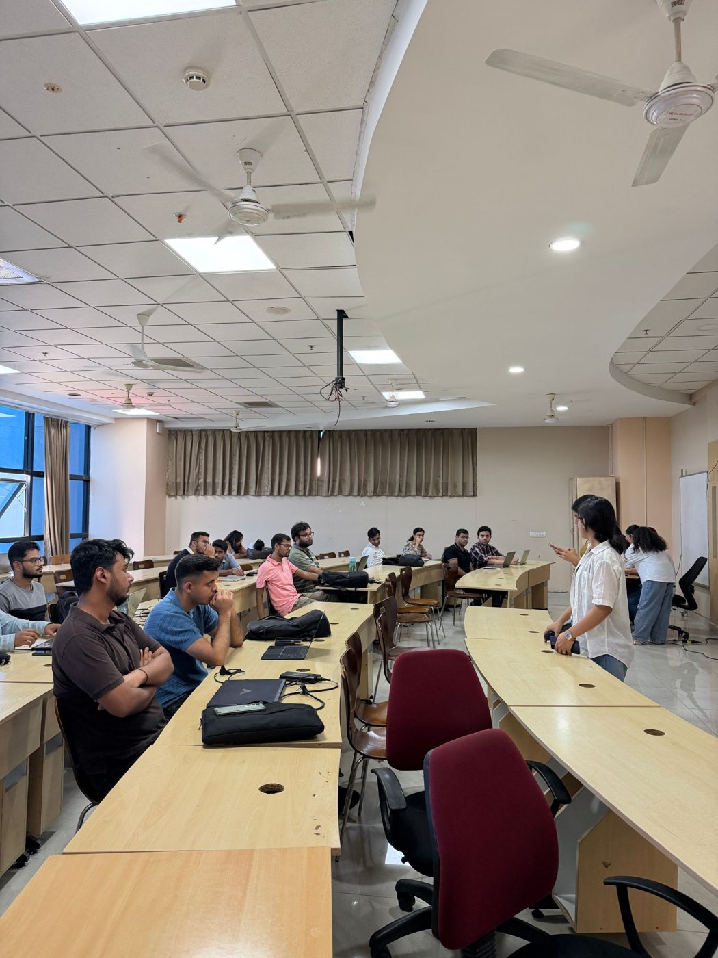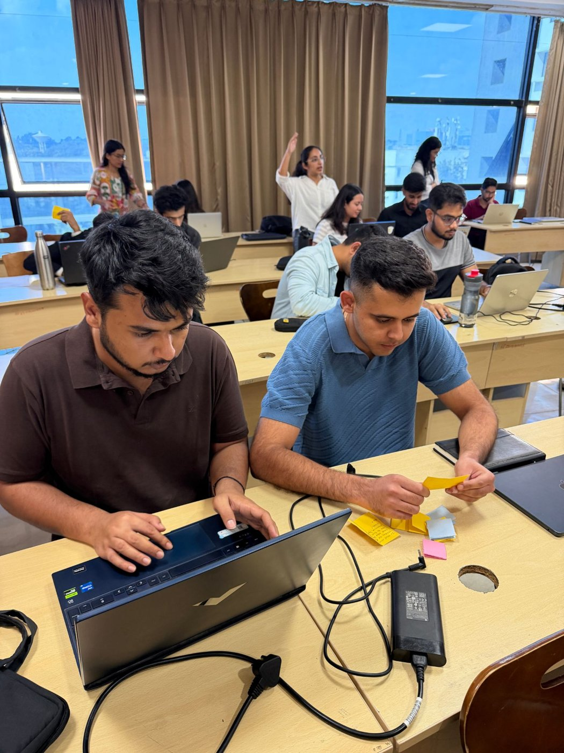

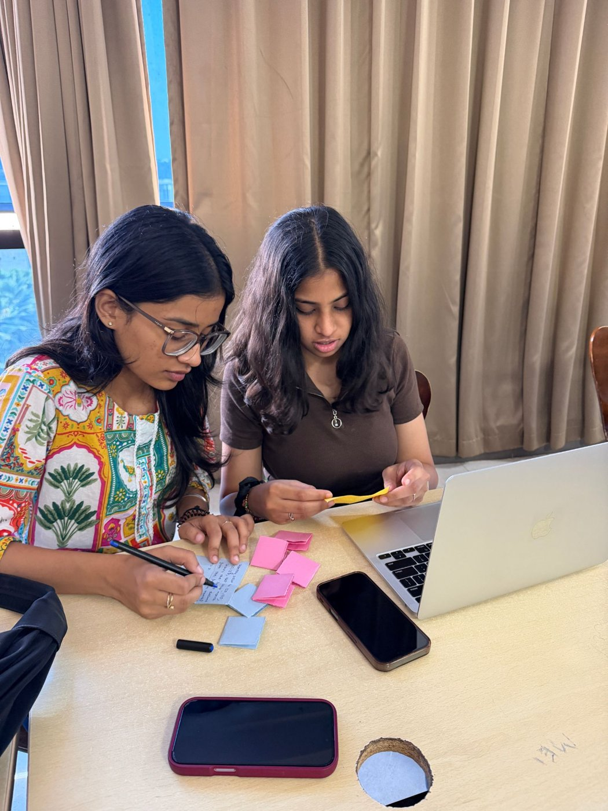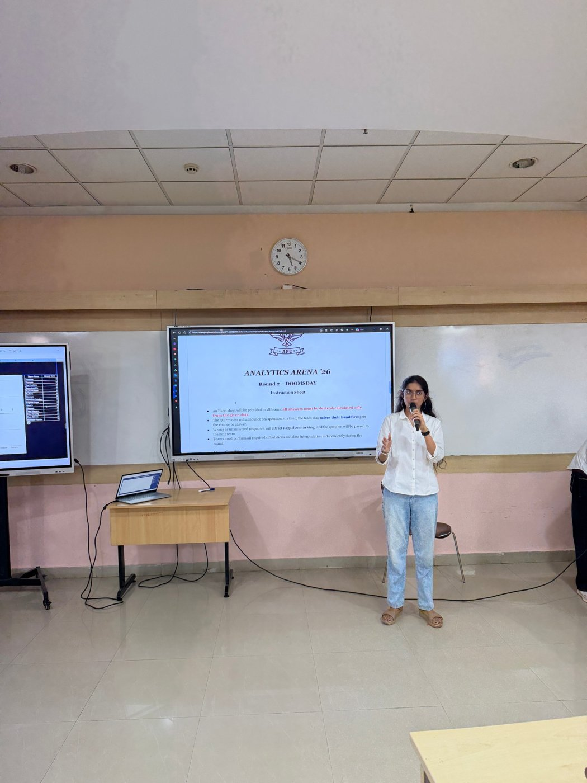

Signature & Name  (QIC Coordinator) | Signature, Name & Seal  (Director of Institute)

