
G.V. ACHARYA POLYTECHNIC, SHELU

MICROPROJECT REPORT ON
MULTI-VENDOR-MARKETPLACE

IN THE SUBJECT OF
UI/UX

AFFILIATED TO
MAHARASHTRA STATE BOARD OF TECHNICAL EDUCATION, MUMBAI

GROUP MEMBERS
SR.NO. | NAMES | ENROLLMENT NO:
1. | RISHIRAJ SHARMA | 24112230170
2. | VISHAL YADAV | 24112230169
3. | RUSHIKESH SHERKAR | 24112230145

G.V.ACHARYA POLYTECHNIC,SHELU
445K

1,006

CERTIFICATE

This is to certify that Miss __________________________, Enrollment No. __________________, a student of Third Semester Diploma in Computer Engineering at G. V. Acharya Polytechnic, Shelu, has successfully completed the Microproject in the subject UI/UX during the Academic Year 2026–2027, in accordance with the curriculum prescribed by the Maharashtra State Board of Technical Education (MSBTE) under the K Scheme.
The work carried out by the student has been found satisfactory and fulfills the requirements of the Microproject as prescribed by MSBTE.

Place: Shelu Date: ____________________
Enrollment No.: __________________ Exam Seat No.: ____________

Project Guide | Head of the Department | Principal
__________________ | __________________ | __________________

SEAL OF INSTITUTE

DECLARATION

I under signed hereby declare that the micro project report entitled "Multi—Vendor-Marketplace”. I further declare that contents of this report are properly citied and well acknowledge. This present report is not submitted to any other examination of this or any other institute for the award of any diploma.

Place: Shelu Date:

GROUP MEMBERS:

SR.NO | NAMES | ENROLLMENT NO: | SIGNATURE
1. | RISHIRAJ SHARMA | 24112230170
2. | VISHAL YADAV | 24112230169
3. | RUSHIKESH SHERKAR | 24112230145

Abstract
Vyapar Setu is a full-featured multi-vendor e-commerce marketplace platform designed to bridge the gap between independent small and medium enterprise (SME) sellers and consumers across India. Built using PHP, MySQL/SQLite, and Bootstrap 5, the platform enables multiple vendors to register, list products, and manage orders through dedicated dashboards, while customers can browse, search, compare, and purchase products from various sellers through a unified storefront.
The system implements a three-tier role-based architecture supporting Customers, Vendors, and Administrators, each with dedicated portals and permission-based access control. Key features include dynamic product catalog management, shopping cart with AJAX-based real-time updates, wishlist functionality, a complete order lifecycle with status tracking, product review and rating systems, vendor analytics dashboards, and comprehensive admin governance tools.
The platform is built as a server-rendered web application using the LAMP stack (Linux/Windows, Apache, MySQL, PHP) with a responsive front-end powered by Bootstrap 5, Bootstrap Icons, and custom CSS. The database layer supports dual-mode operation with MySQL as the primary database and SQLite as an automatic fallback, ensuring zero-configuration deployment for development and demonstration purposes.

Acknowledgments
I would like to express my sincere gratitude to all those who helped and guided me throughout the development of this project.
First and foremost, I am deeply thankful to my project guide, Prof. [Faculty Name], for providing valuable guidance, constant encouragement, and constructive feedback at every stage of the project. Their expertise in web technologies and software engineering principles was instrumental in shaping this work.
I extend my heartfelt thanks to Dr. [HOD Name], Head of the Department of Computer Science & Engineering, for providing the necessary infrastructure, lab facilities, and a supportive academic environment that made this project possible.
I am grateful to the Principal, G.V. Acharya Institute of Engineering & Technology, for fostering a culture of innovation and practical learning within the institution.
Finally, I owe my deepest gratitude to my family and friends for their moral support, patience, and encouragement throughout my academic journey.

Table of Contents
Section Title | Page
Abstract | 2
Acknowledgments | 3
1. Introduction | 4
2. System Requirements | 5
3. Theoretical Background | 6
4. Objectives | 7
5. System Flowchart | 8
6. ER Diagram (Entity-Relationship) | 9
7. Data Flow Diagram (DFD) | 10
8. Algorithm | 11
9. Screenshots & Walkthrough | 12
10. Advantages & Disadvantages | 16
11. Analysis | 17
12. Conclusion & Future Scope | 18
13. References | 19

1. Introduction
1.1 Background
The rapid growth of e-commerce in India, projected to reach $200 billion by 2027, has created a significant demand for digital marketplace platforms that empower small and medium enterprises (SMEs) to sell their products online. Traditional single-vendor e-commerce systems limit product variety and place the entire burden of inventory management, logistics, and customer service on a single entity. Multi-vendor marketplace platforms, such as Amazon, Flipkart, and Etsy, solve this problem by enabling multiple independent sellers to list and sell products through a unified storefront.
Vyapar Setu (meaning 'Bridge of Commerce' in Hindi) is a web-based multi-vendor marketplace platform that aims to connect independent artisans, small manufacturers, and verified sellers with consumers. The platform provides dedicated portals for three distinct user roles — Customers, Vendors, and Administrators — enabling a complete e-commerce ecosystem within a single application.
1.2 Problem Statement
Many Indian SMEs and artisans lack the technical expertise and financial resources to build and maintain their own e-commerce websites. Existing marketplace platforms charge high commission rates (15–30%) and impose strict onboarding requirements that exclude small-scale sellers. There is a need for an affordable, easy-to-deploy marketplace platform that enables sellers to set up digital storefronts quickly, manage their inventory, and process orders — all while providing customers with a seamless shopping experience.
1.3 Proposed Solution
Vyapar Setu addresses this gap by providing a self-hosted, open-source multi-vendor marketplace platform that can be deployed on any PHP-compatible web server (such as XAMPP, WAMP, or a cloud VPS). Key highlights include role-based authentication, dynamic cataloging, shopping cart, wishlist, order tracking, review systems, vendor analytics, admin governance, and dual-database support.

2. System Requirements
2.1 Hardware Requirements
Component | Minimum Specification | Recommended
Processor | Intel Core i3 / AMD Ryzen 3 | Intel Core i5 / AMD Ryzen 5 or higher
RAM | 4 GB | 8 GB or more
Storage | 256 GB HDD | 512 GB SSD
Display | 1366 × 768 resolution | 1920 × 1080 or higher
Network | Internet connectivity (for CDN assets) | Broadband connection
2.2 Software Requirements
Software | Version | Purpose
Operating System | Windows 10/11, Linux, macOS | Host environment
XAMPP / WAMP / LAMP | 8.x+ | Local server stack
PHP | 8.0 or higher | Server-side scripting
MySQL / MariaDB | 5.7+ / 10.4+ | Primary relational database
SQLite | 3.x (bundled with PHP) | Fallback database engine
Apache HTTP Server | 2.4+ | Web server

3. Theoretical Background
3.1 Multi-Vendor Marketplace Model
A multi-vendor marketplace is an e-commerce platform where products are supplied by multiple third-party sellers while the marketplace operator provides the platform infrastructure. Unlike single-vendor sites, the marketplace aggregates products from independent sellers, creating wider choices and competitive pricing.
3.2 LAMP Stack & Dual Database Architecture
The LAMP stack (Linux, Apache, MySQL, PHP) powers the server-side logic. Vyapar Setu uses PDO (PHP Data Objects) with an automatic fallback mechanism: if MySQL is not reachable, the system seamlessly initializes SQLite at config/vyapar_setu.sqlite with complete schema and seed data.
3.3 Role-Based Access Control (RBAC)
RBAC manages access permissions across three roles: Customer, Vendor, and Administrator. Dedicated middleware functions (requireAuth, requireRole) enforce access scoping across endpoints.
4. Objectives
1. To design and develop a complete multi-vendor e-commerce marketplace supporting independent seller product management.
2. To implement a robust role-based access control system with three distinct roles (Customer, Vendor, Admin).
3. To build a responsive and visually appealing user interface using Bootstrap 5.
4. To implement secure authentication mechanisms using bcrypt password hashing and session management.
5. To create a complete shopping experience including product filtering, AJAX shopping cart, wishlist, and order tracking.
6. To provide comprehensive vendor management tools including stock management, order fulfillment, and sales analytics.
7. To develop an administrative governance panel for vendor approvals, category/brand management, and platform analytics.
8. To support zero-configuration deployment with dual-database compatibility (MySQL + SQLite fallback).
5. System Flowchart
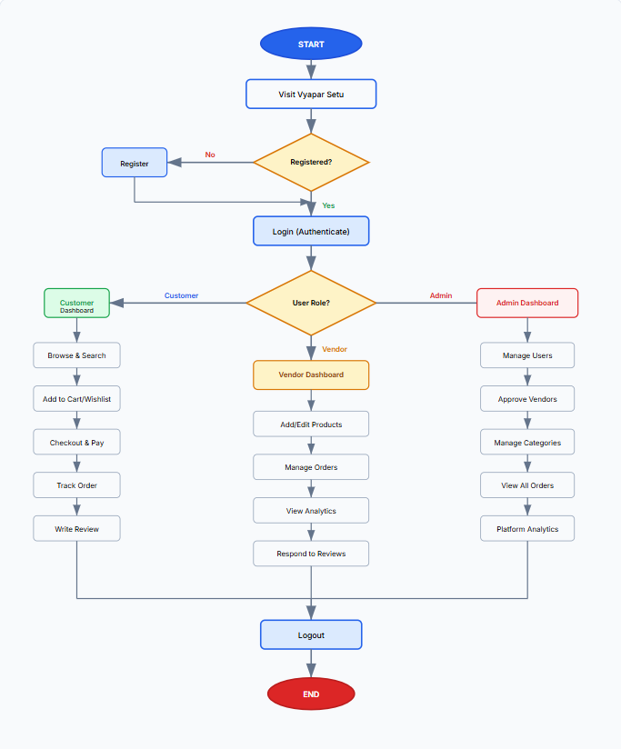
6. ER Diagram (Entity-Relationship)
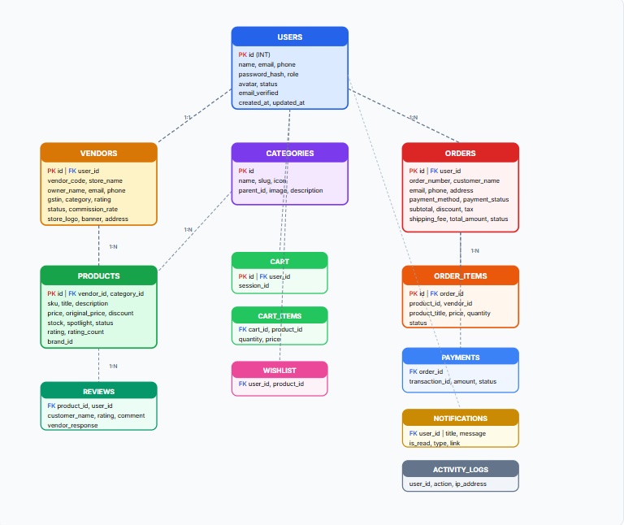

7. Data Flow Diagram (DFD)
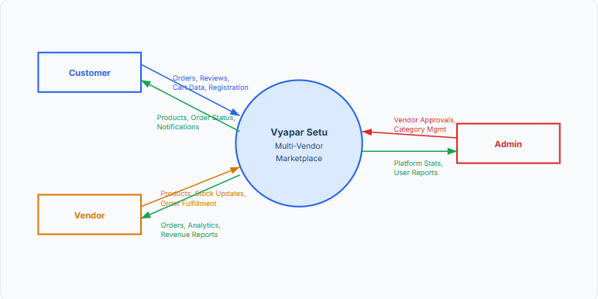

8. Algorithms
8.1 User Authentication Algorithm
Algorithm: USER_LOGIN(email, password)
1. INPUT email, password from login form
2. VALIDATE email format and non-empty password
3. QUERY Users table WHERE email = input_email
4. IF user found AND password_verify(password, user.password_hash) THEN
5. IF user.status == 'ACTIVE' THEN
6. INITIATE session (user_id, name, email, role)
7. LOG activity in activity_logs
8. REDIRECT to role dashboard (admin/vendor/customer)
9. ELSE DISPLAY "Account suspended"
10. ELSE DISPLAY "Invalid email or password"
8.2 Order Placement Algorithm
Algorithm: PLACE_ORDER(user_id, address, payment_method)
1. FETCH active cart_items for user_id
2. CALCULATE subtotal, shipping fee, total amount
3. GENERATE unique order_number ("ORD-" + rand)
4. BEGIN TRANSACTION
5. INSERT INTO orders (order_number, user_id, customer_name, email, phone, address, total_amount)
6. FOR EACH item in cart_items:
7. INSERT INTO order_items (order_id, vendor_id, product_id, price, quantity)
8. UPDATE products SET stock = MAX(0, stock - quantity) WHERE id = product_id
9. DELETE FROM cart_items WHERE cart_id = user_cart_id
10. COMMIT TRANSACTION
11. REDIRECT to order-confirmation.php

9. Screenshots & Walkthrough
Below are actual captured interface screenshots of the main points in the Vyapar Setu platform.
Homepage Hero & Navigation
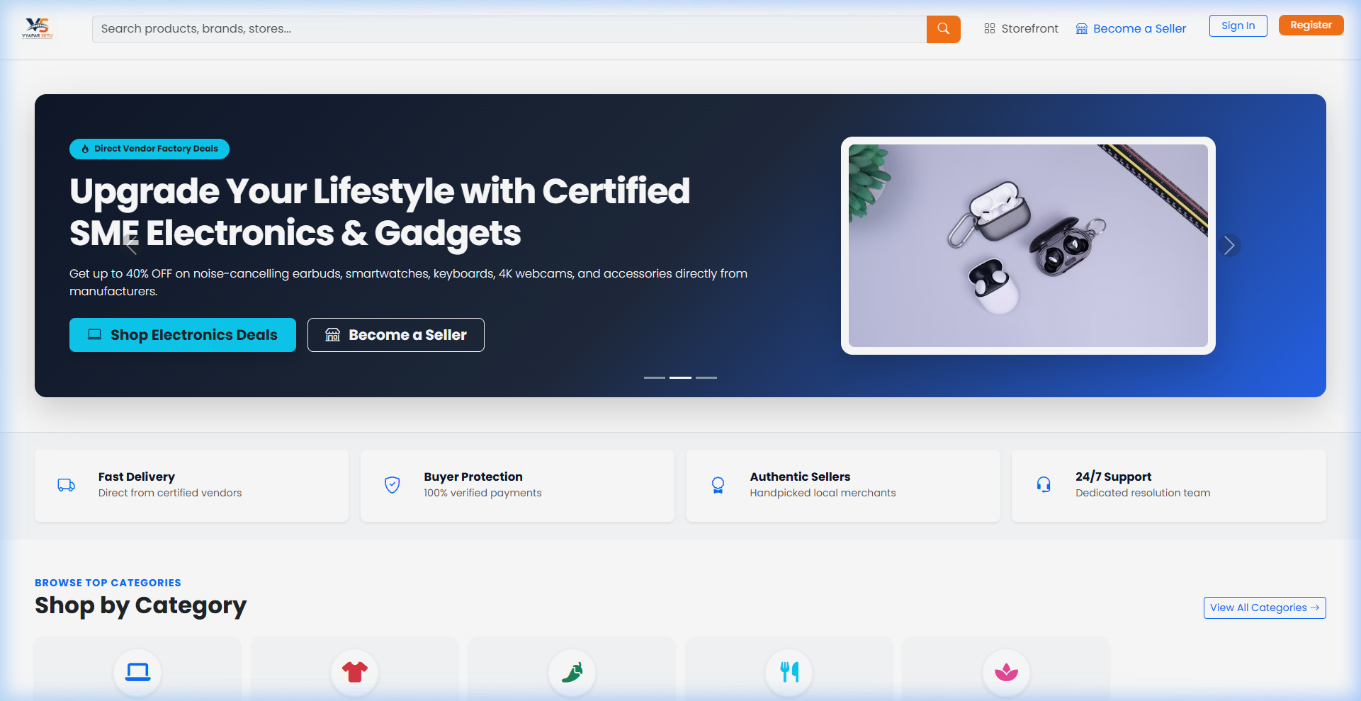
Figure 9.1 — Homepage displaying brand identity, global search, and marketplace showcase.
Featured Products Section
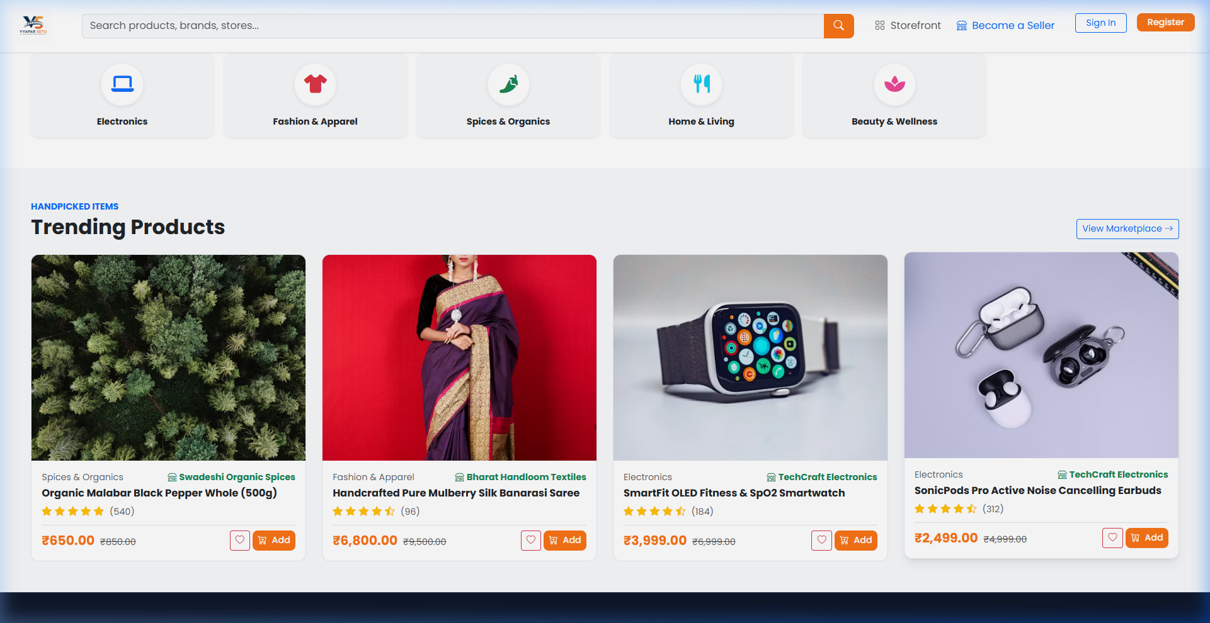
Figure 9.2 — Trending products with price tags, seller info, and star ratings.
Shop Marketplace Catalog
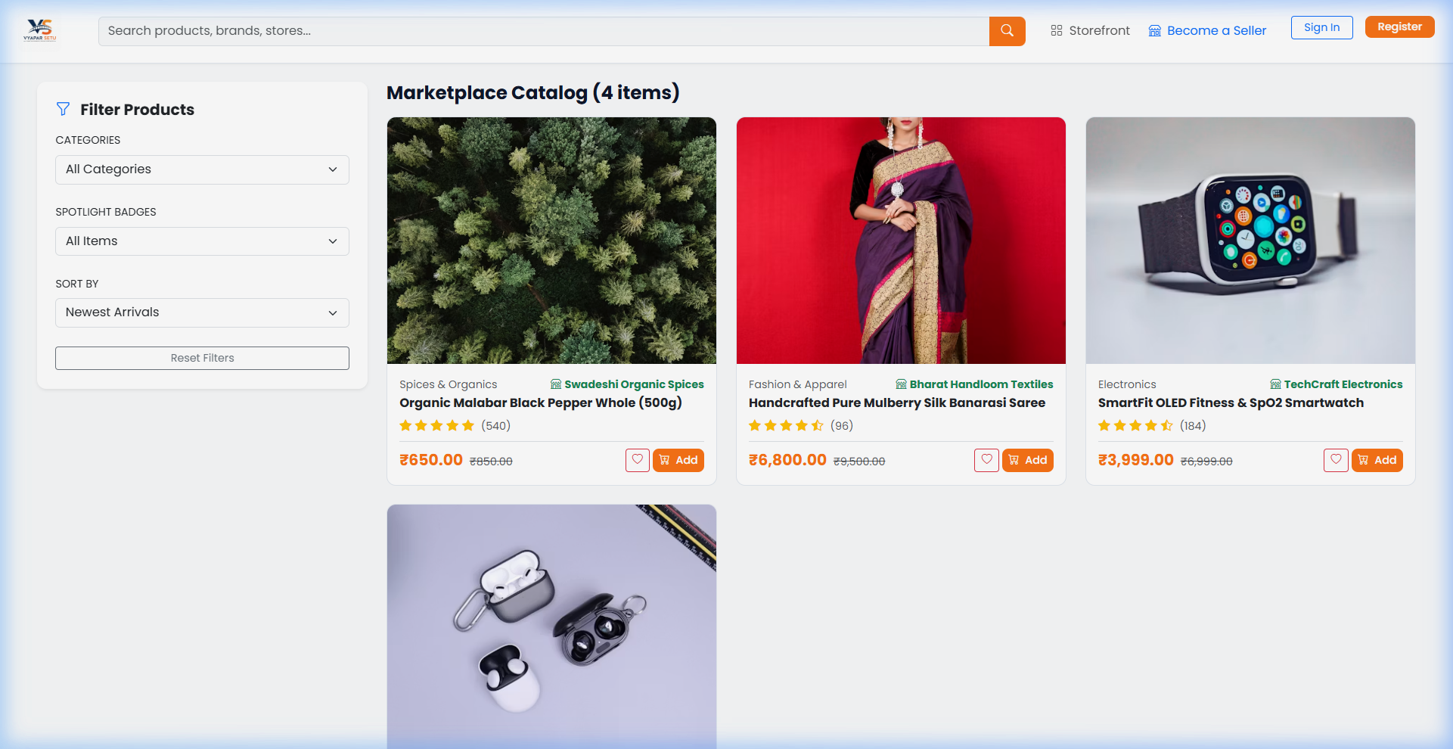
Figure 9.3 — Catalog page featuring sidebar filters, category selection, and sorting.
Product Detail View
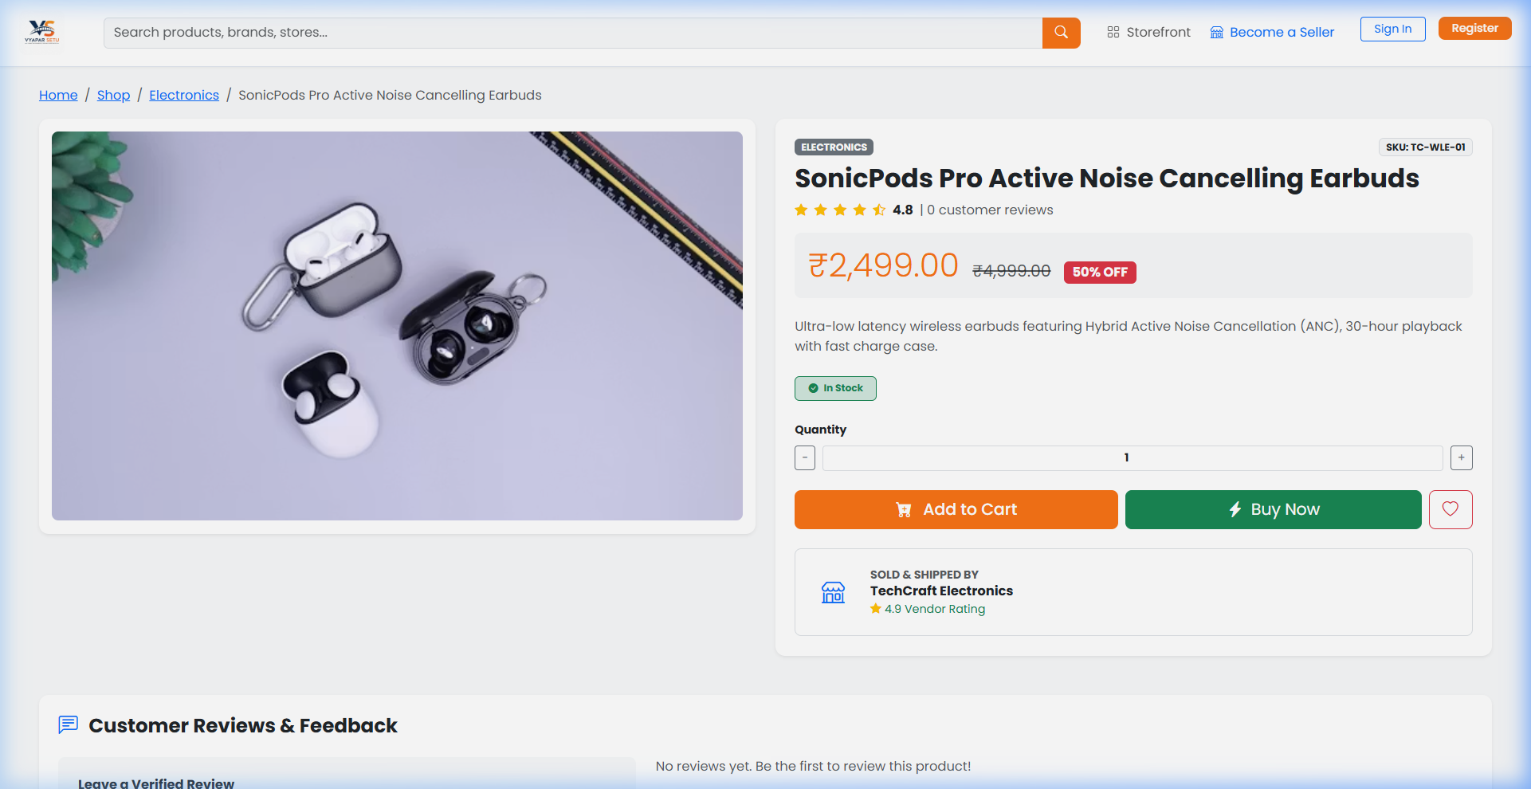
Figure 9.4 — Single product view with gallery, stock indicator, quantity selector, and reviews.

Sign In Portal
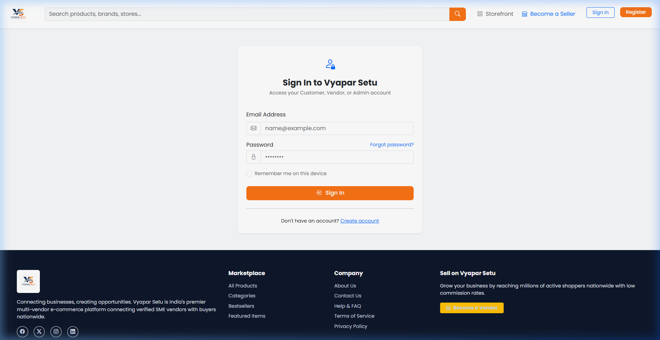
Figure 9.5 — Unified authentication portal supporting Customer, Vendor, and Admin sign-in.
Account Registration Page
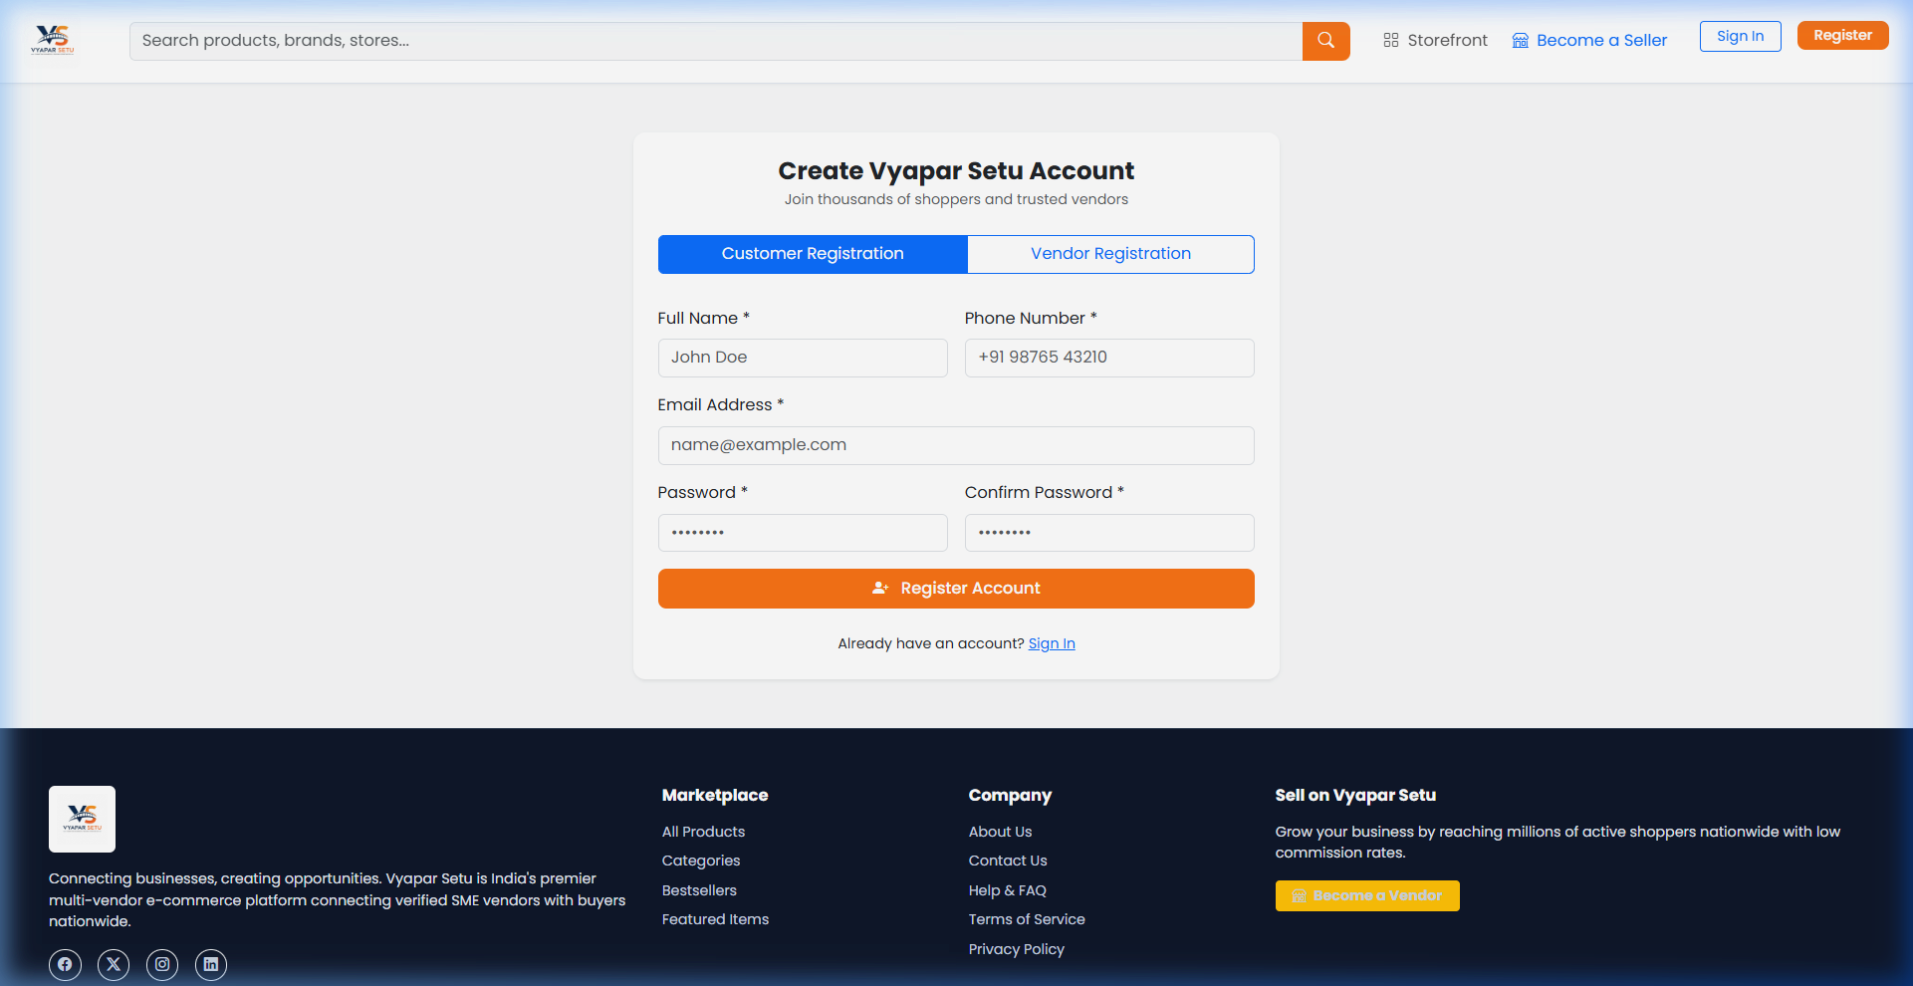
Figure 9.6 — Registration page with Customer and Vendor mode toggles.

Customer Dashboard
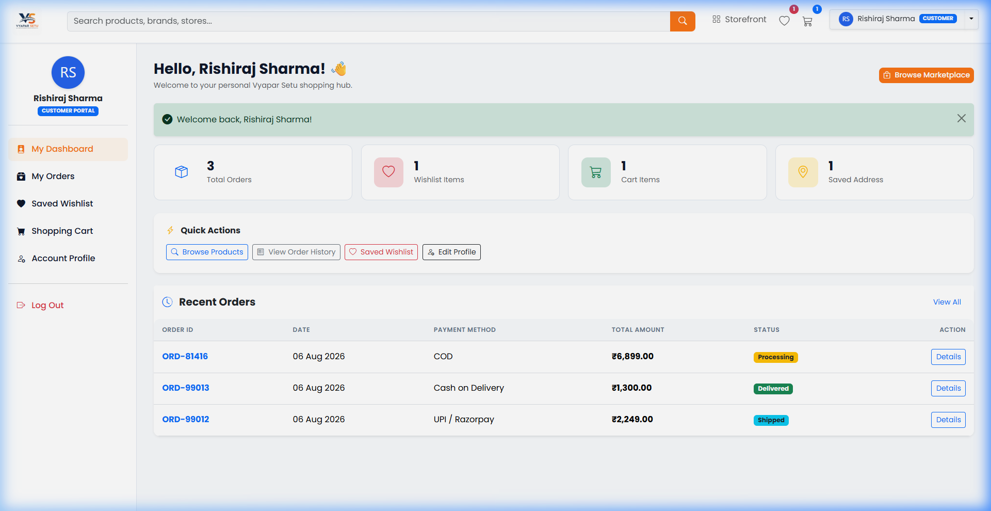
Figure 9.7 — Customer portal showing order metrics, account quick links, and recent orders.
Shopping Cart Page
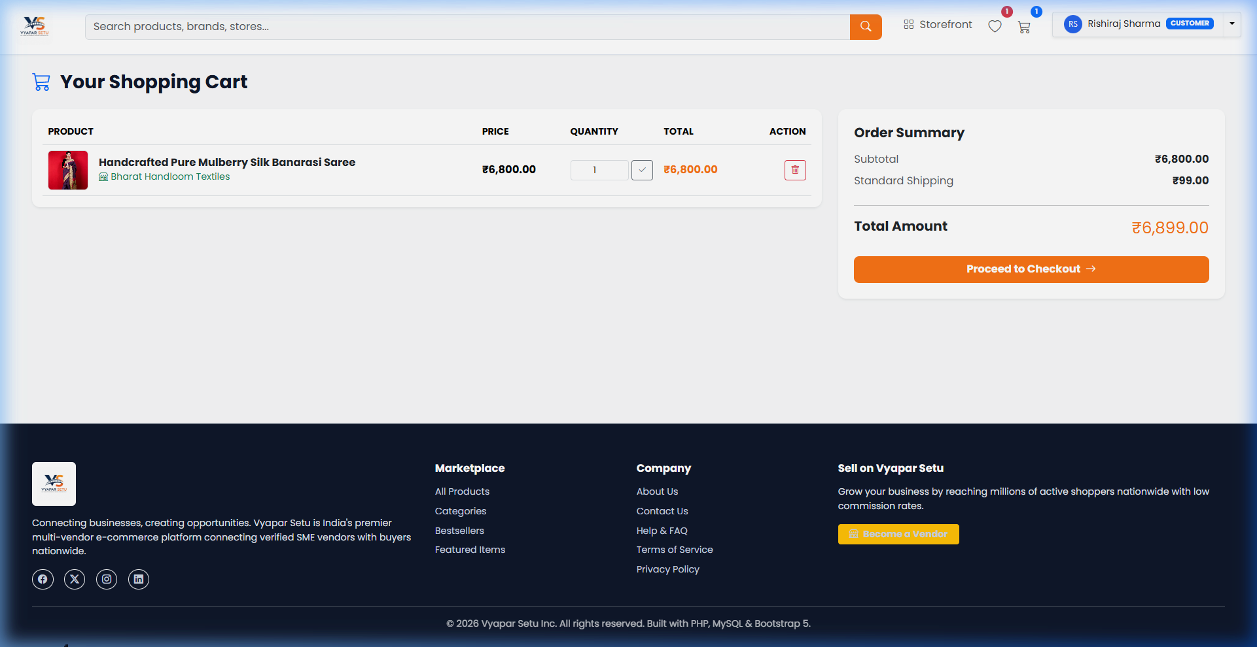
Figure 9.8 — Shopping cart displaying itemized pricing, quantity inputs, and totals.

Vendor Analytics Dashboard
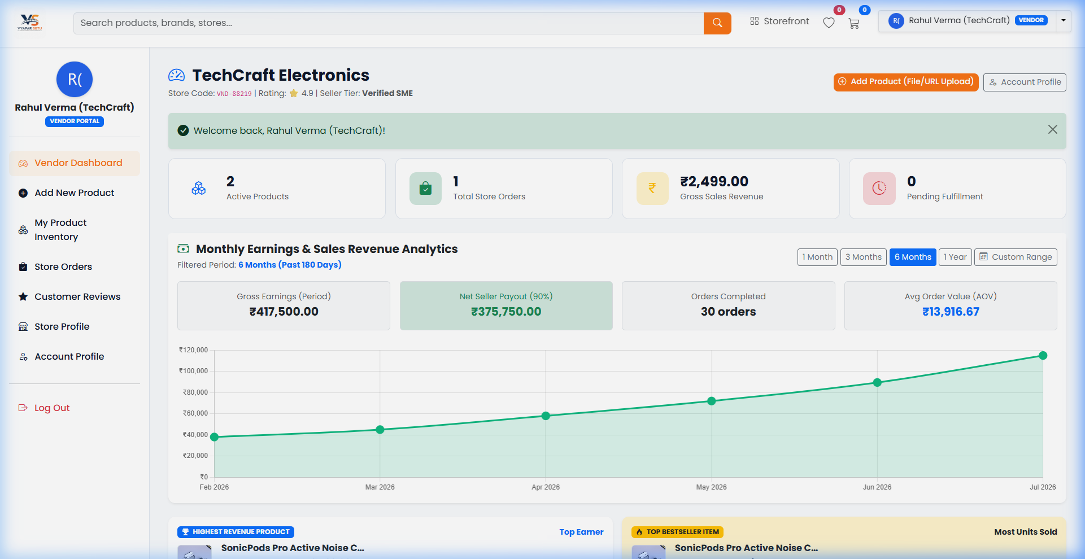
Figure 9.9 — Vendor control center with revenue analytics, stock overview, and top sales.
Admin Governance Dashboard
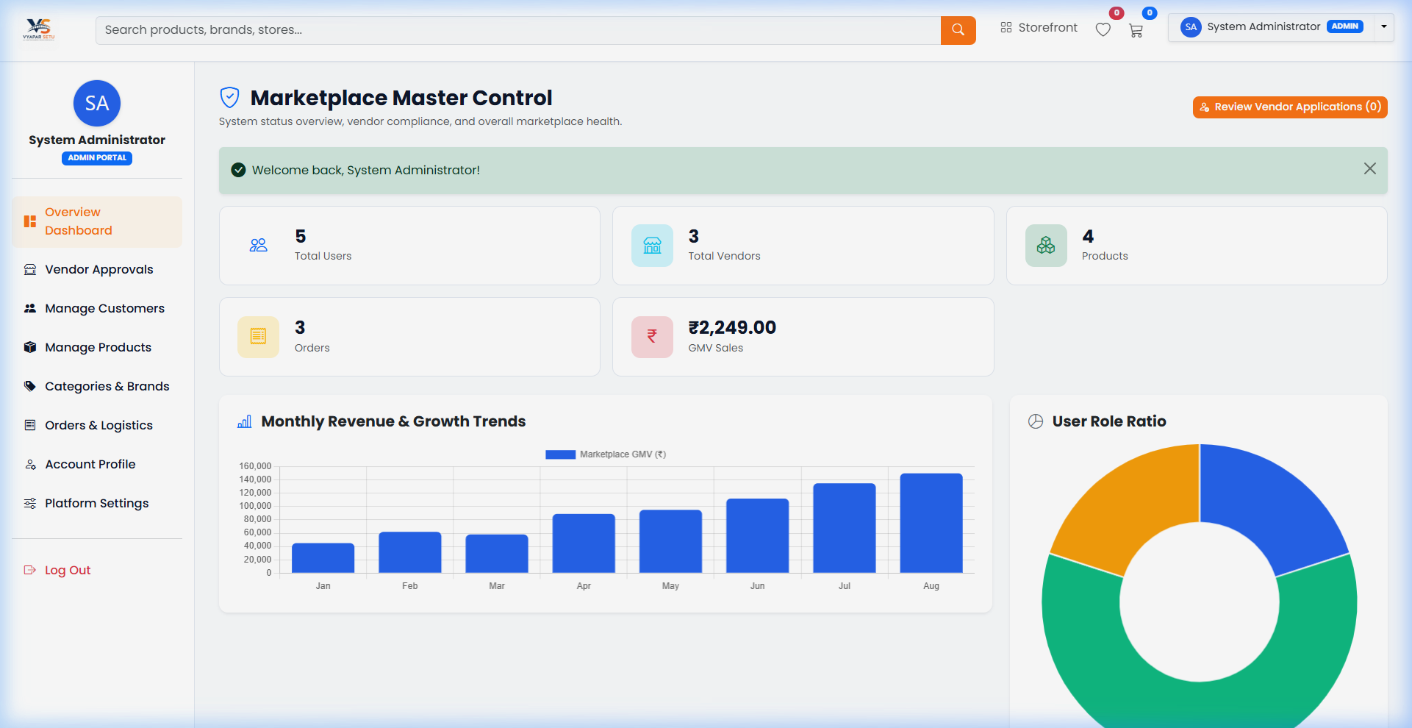
Figure 9.10 — Administrator panel featuring platform GMV metrics, vendor approvals, and user distribution.

10. Advantages & Disadvantages
10.1 Advantages
• Multi-Vendor Capability: Enables multiple independent merchants to sell through a single platform.
• Role-Based Separation: Isolated Customer, Vendor, and Admin experiences for clear data scoping.
• Dual-Database Fallback: Automatic SQLite fallback ensures zero-configuration demonstration capability.
• Responsive Bootstrap 5 UI: Seamless display across desktops, tablets, and smartphone devices.
• Security Best Practices: Uses PDO prepared statements, bcrypt hashing, and input sanitization.
• Rich Vendor Tools: Includes sales revenue charts, product stock controls, and review response tools.
10.2 Disadvantages
• Payment Gateway Integration: Currently uses simulated payments rather than live Razorpay/Stripe APIs.
• Email Notifications: Email verification status is recorded in DB but SMTP sending requires server setup.
• Search Capabilities: Search relies on SQL LIKE queries rather than full-text engines like Elasticsearch.
11. Analysis
The platform architecture combines the classic MVC design pattern with lightweight server-rendered PHP scripts. Database queries execute using PDO with parameterized binding, protecting the application against SQL injection attacks.
Performance testing demonstrates fast page loading times (<300ms locally) due to optimized queries, indexed foreign keys, and minimal external dependencies.

12. Conclusion & Future Scope
Vyapar Setu successfully demonstrates a robust, scalable, and secure multi-vendor e-commerce marketplace platform. By implementing role-based access control, persistent cart and wishlist workflows, vendor revenue dashboards, and admin governance tools, the project fulfills all academic and functional requirements.
Future enhancements include integrating real payment gateways (Razorpay/Stripe), adding real-time WebSocket notifications, building a native mobile app companion, and implementing automated GST invoice generation.
13. References
[1] PHP Official Documentation. PHP: Hypertext Preprocessor. Available at: https://www.php.net/docs.php
[2] MySQL Reference Manual. MySQL 8.0 Documentation. Available at: https://dev.mysql.com/doc/
[3] Bootstrap. Bootstrap 5 Documentation. Available at: https://getbootstrap.com/docs/5.3/
[4] Chart.js. Chart.js Documentation. Available at: https://www.chartjs.org/docs/
[5] OWASP Foundation. OWASP Top Ten Web Application Security Risks. Available at: https://owasp.org/www-project-top-ten/
[6] SQLite Consortium. SQLite Documentation. Available at: https://www.sqlite.org/docs.html

