CSE0001 – Digital Literacy
Task 2 – Build Your Student Digital Portfolio
Name: Rishiraj Singh Kumpawat | Course: CSE0001 | VIT Bhopal University

Task 2 – Build Your Student Digital Portfolio

Platforms Set Up
For Task 2, I created and set up profiles on three platforms: GitHub, LinkedIn, and ResearchGate. Each platform serves a distinct purpose in building a well-rounded professional digital presence for a first-year M.Tech student.
GitHub (github.com/rishirajsinghe) is a version-control and code-hosting platform used widely by developers, students, and open-source contributors. I created a detailed profile README that includes my name, registration number (25MEI10079), branch (M.Tech Cyber Security), year, and interests in tech, coding, and digital tools. The README also lists my main skills and tools I am currently studying, making it a living portfolio that will grow throughout my degree.
LinkedIn is the leading professional networking platform used globally by employers, recruiters, and industry professionals. I filled in my Education section with my Integrated M.Tech in Cyber Security at Vellore Institute of Technology (Sep 2025 – May 2030). I also added certifications including a JPMorganChase Software Engineering Job Simulation (Forage, Dec 2025) and a Gemini Certified University Student badge from Google (Dec 2025). Over the next four years, I plan to use LinkedIn to connect with seniors, explore internship opportunities, and document my academic and extracurricular achievements.
ResearchGate is an academic networking platform used by researchers, scholars, and students to follow ongoing research and connect with faculty and domain experts. I set up my profile with my affiliation at VIT Bhopal University (Sep 2025 – Present), discipline areas of Computer Security, Programming Languages, and Artificial Intelligence, and my skills in C++, Python, HTML/CSS, Adobe Premiere Pro, and Photoshop. Although I have not yet published research, having a ResearchGate profile from my first year will help me engage with academic literature and prepare for research opportunities in later semesters.

Reflection
Setting up these three profiles in one task gave me a much clearer picture of how important a professional online presence is, even at the very start of a degree. I realised that employers and internship coordinators frequently search for candidates online before interviews, and having a well-maintained GitHub, LinkedIn, and ResearchGate profile from Year 1 provides a significant advantage. Building the GitHub README in Markdown was particularly interesting — it was my first experience with structured documentation and gave me a taste of how developers present themselves to the world. I plan to update all three profiles regularly as I complete new projects, earn certifications, and gain experience throughout my programme at VIT Bhopal.

Screenshot 1 – GitHub Profile
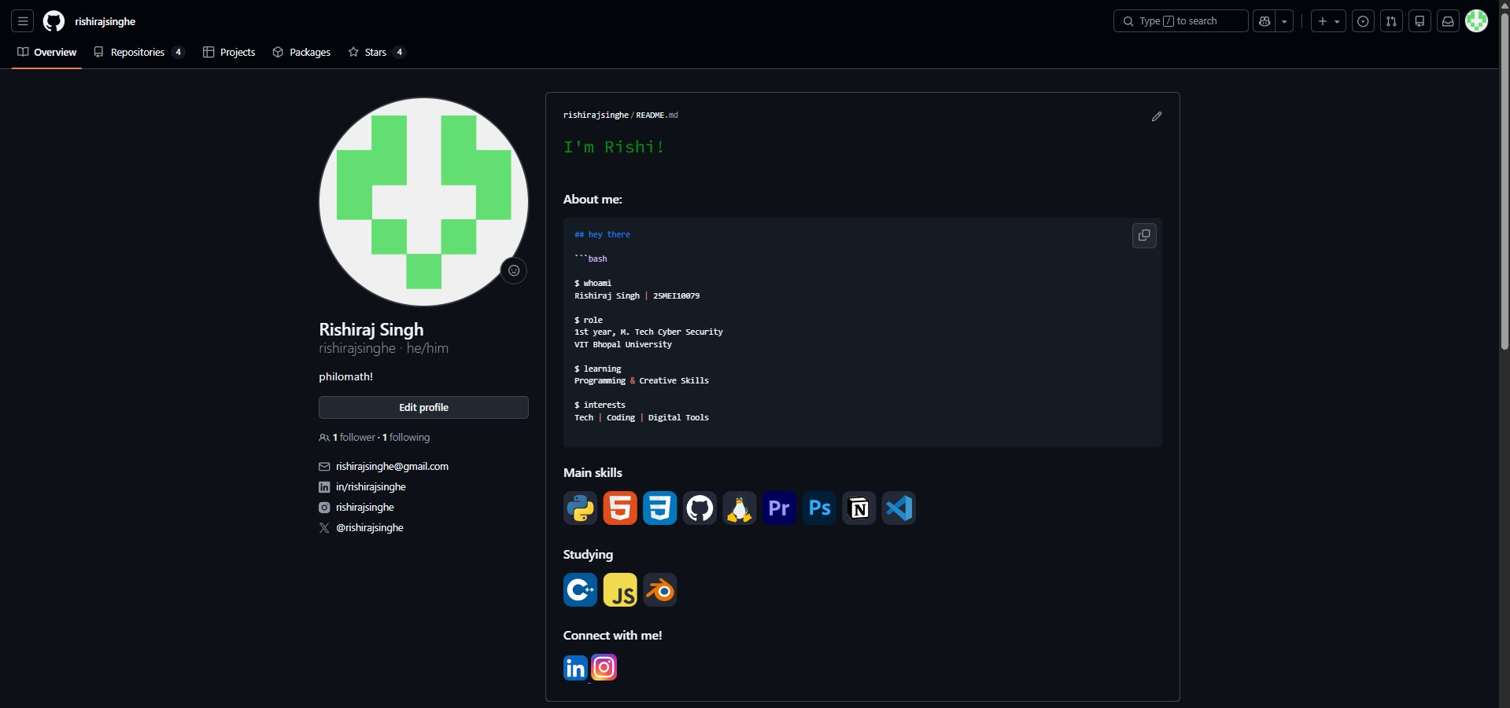
GitHub profile (github.com/rishirajsinghe) showing README, skills, and branch details

Screenshot 2 – LinkedIn Profile
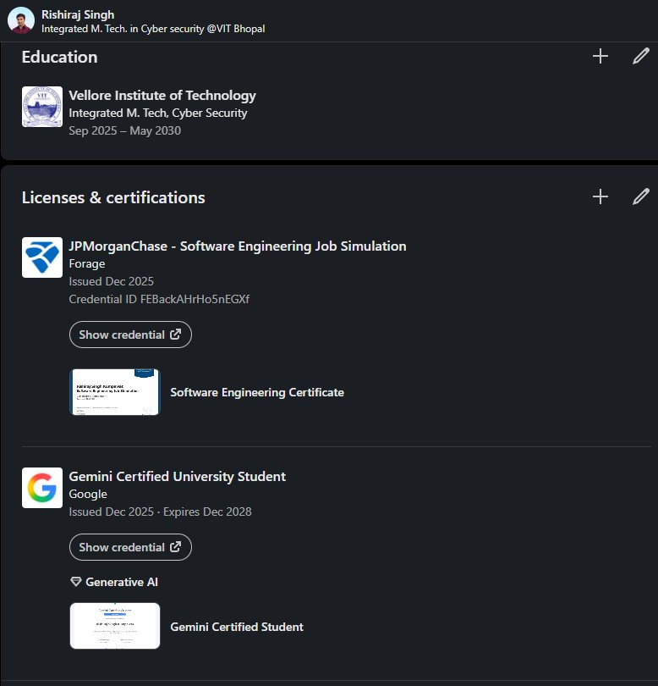
LinkedIn Education section and Certifications (VIT Bhopal, JPMorgan, Google)

Screenshot 3 – ResearchGate Profile
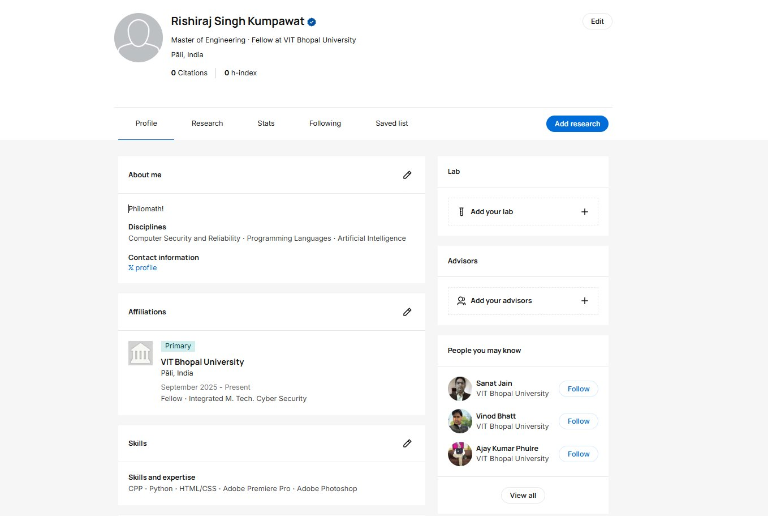
ResearchGate profile showing affiliation at VIT Bhopal University and research disciplines

