CSE0001 – Digital Literacy
Task 3 – Explore Coding & Collaboration Platforms
Name: Rishiraj Singh Kumpawat | Course: CSE0001 | VIT Bhopal University

Task 3 – Explore Coding & Collaboration Platforms

Part A – Coding Practice (HackerRank)
For the coding practice component of Task 3, I created an account on HackerRank (username: rishirajsinghe) and completed challenges under the C++ Introduction track. HackerRank is a competitive programming platform used by students and professionals worldwide to practise problem-solving, prepare for technical interviews, and earn skill-based certifications and badges.
I completed two beginner-level challenges in the C++ track. The first was the 'Input and Output' challenge, where I wrote a C++ program to read three integers from standard input and print their sum to standard output. All six test cases passed successfully with a 'Congratulations' confirmation on submission. The second was the 'Print all Arithmetic Operations' challenge on CodeChef, where I wrote a C++ program that calculates and prints the results of addition, subtraction, division, and multiplication between two numbers, producing the correct output (12, 4, 2, 32 for inputs 8 and 4). I also earned a C++ (CPP) badge on my HackerRank profile as a result of completing these exercises.

Part B – Google Workspace Collaboration (Google Forms)
For the mandatory collaboration component, I created a Google Form titled 'Digital Literacy Awareness Quiz' with five questions designed for first-year students at VIT Bhopal. The form includes a mix of question types as required: multiple choice questions (Q1: What does Digital Literacy mean?, Q3: Which practices improve online security?, Q4: Which is the safest way to store passwords?, Q5: Which action is unsafe on public Wi-Fi?) and a short-answer question (Q2: What is the term for deceptive attempts to steal sensitive information online?). The form is linked to a Google Sheet that automatically collects and organises all responses with timestamps and scores, making analysis straightforward.

Reflection
Completing both parts of Task 3 helped me understand how different categories of digital tools serve distinct academic purposes. HackerRank provided a structured environment for individual skill development through hands-on coding practice, and the immediate feedback from automated test cases helped me understand my mistakes and correct them quickly. Google Forms and Sheets, on the other hand, demonstrated the power of cloud-based collaboration — the form I built could genuinely be distributed to batchmates to test their digital literacy awareness. Both types of tools will be directly useful to me throughout my programme: HackerRank for preparing for placement tests and coding competitions, and Google Workspace for group assignments, surveys, and data collection in research projects at VIT Bhopal.

Screenshot 1 – HackerRank: Input & Output Challenge (Code)
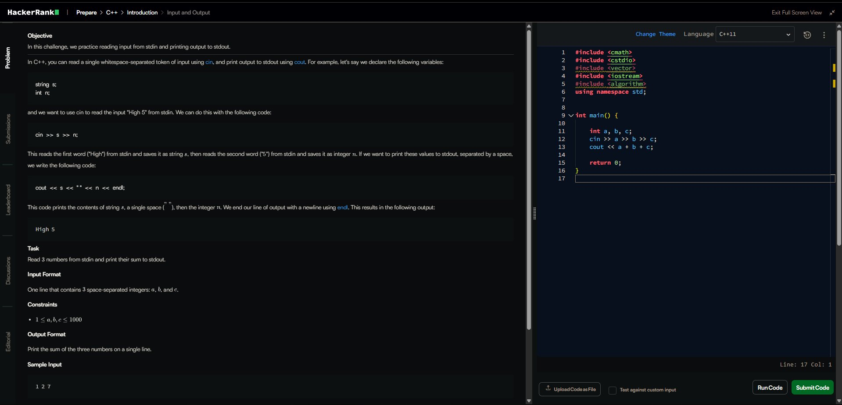
HackerRank C++ Input and Output challenge – code written and test cases running

Screenshot 2 – HackerRank: Input & Output Challenge (Success)
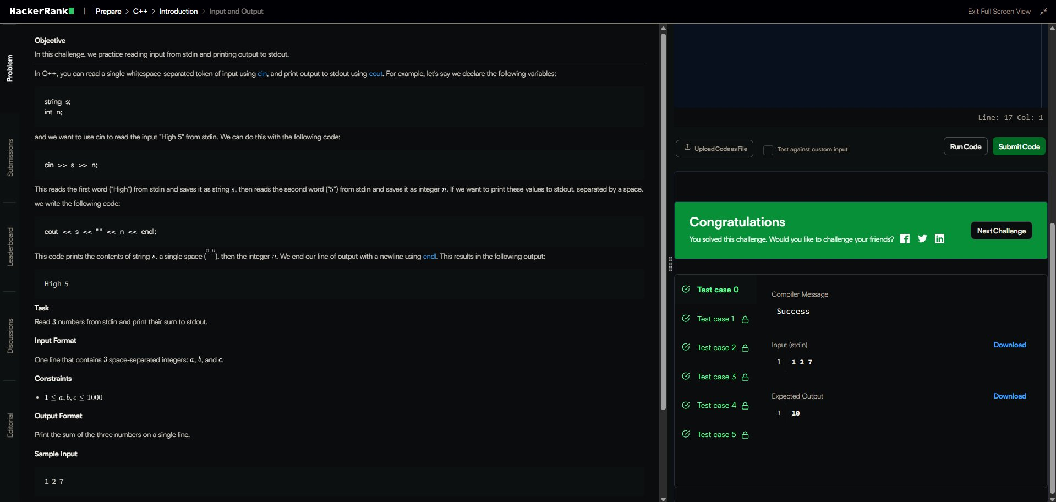
HackerRank C++ Input and Output – all test cases passed, Congratulations screen

Screenshot 3 – HackerRank Profile & C++ Badge
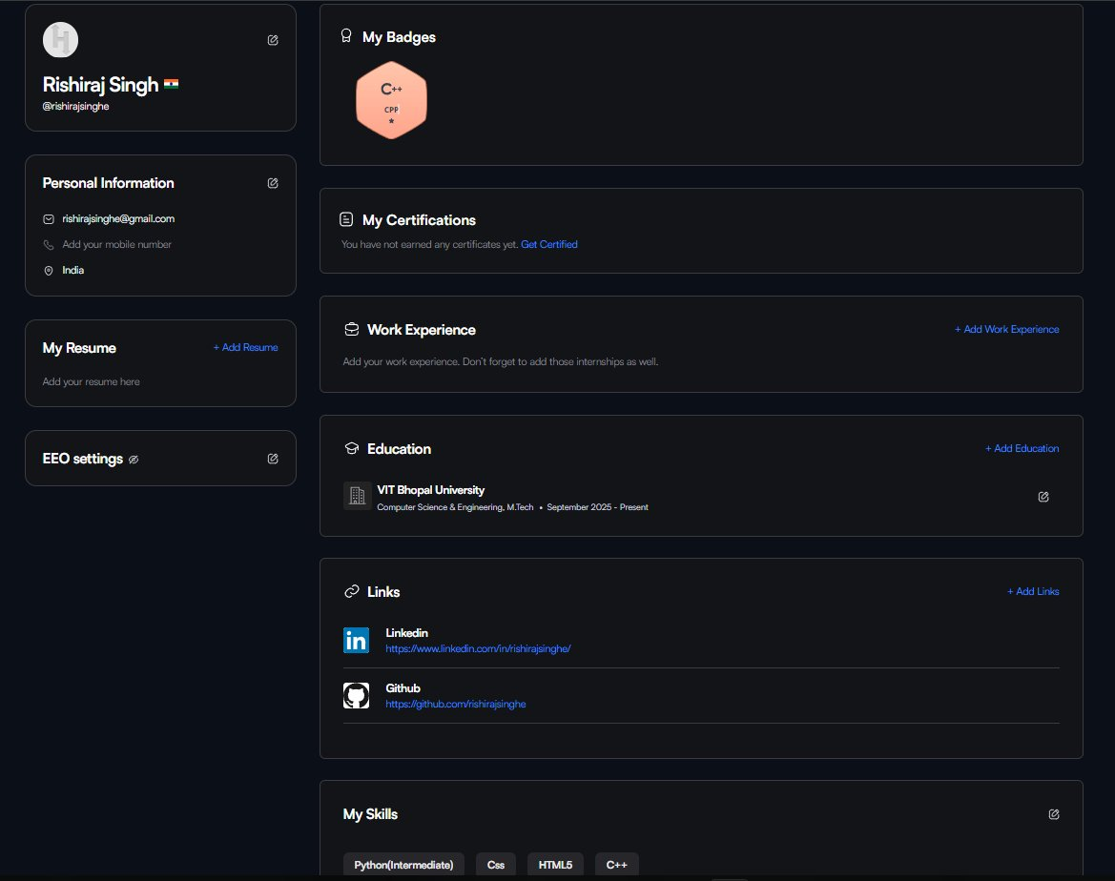
HackerRank profile (Rishiraj Singh) showing C++ (CPP) badge earned

Screenshot 4 – Google Form: Digital Literacy Quiz (Part 1)
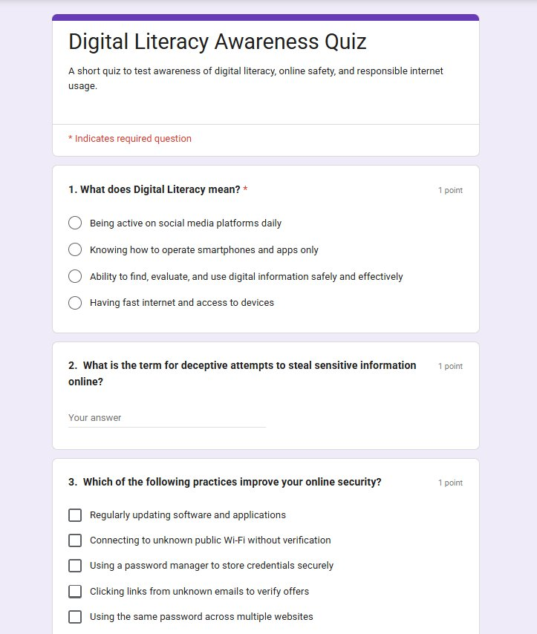
Google Form – Digital Literacy Awareness Quiz showing Questions 1 and 2

Screenshot 5 – Google Form: Digital Literacy Quiz (Part 2)
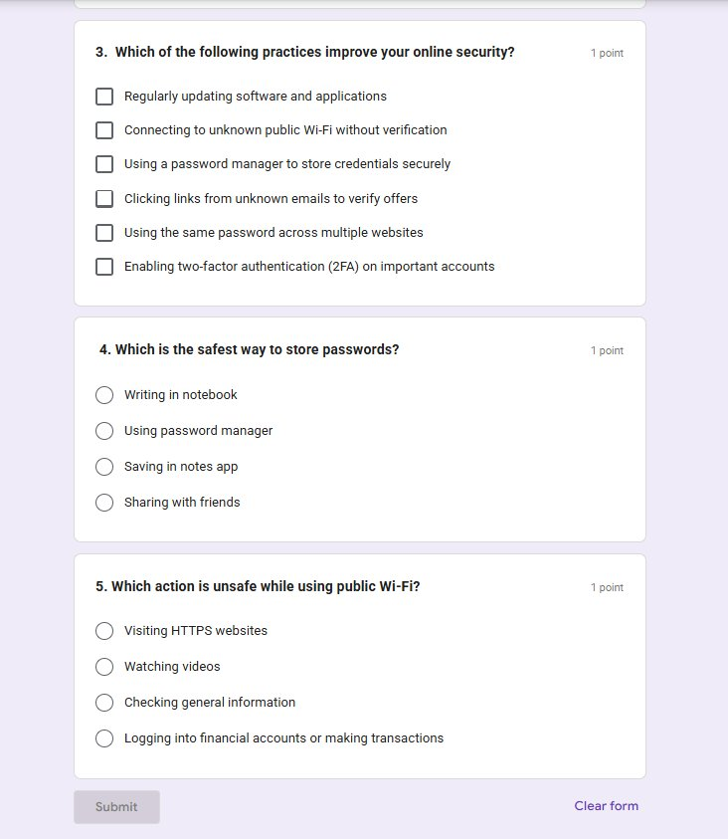
Google Form – Questions 3, 4, and 5 with Submit button

Screenshot 6 – Google Sheet Response View
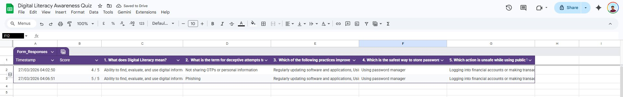
Google Sheet linked to the form showing 2 responses collected with timestamps and scores

