Product Design
Team | 13  Anhad Jai Singh (201101072)  Rishi Raj Singh Jhelumi (201101046)  Vinil Narang (201101029)

Architectural Model

User Interface | Component state  - The current state is the main page of project that takes the user to next state which fulfills the requirements for startup of application.  Component behavior  - The current component takes the user to the next activity.
Requirements | Component state  - This component stores the status of the GPS and Network whether they are on/off and also prompts user to calibrate the sensors.  Component behavior  - This component is responsible for ensuring that all the other components which require GPS and Network are not affected if any of them is not on.
Main Functionality | Component state  - This provides the facility to the user that if he violates the speed (over speeding) or he accelerates of decelerates too fast he is alerted via a sound notification .  Component behavior  - This component gives all the information about the violation (date , time , violation type) to the logging component
Logging | Component state  - This component stores the violations made by the user while driving their time , date and type.  Component behavior  - This component enables the user to see his violations .

Class Diagram(s)
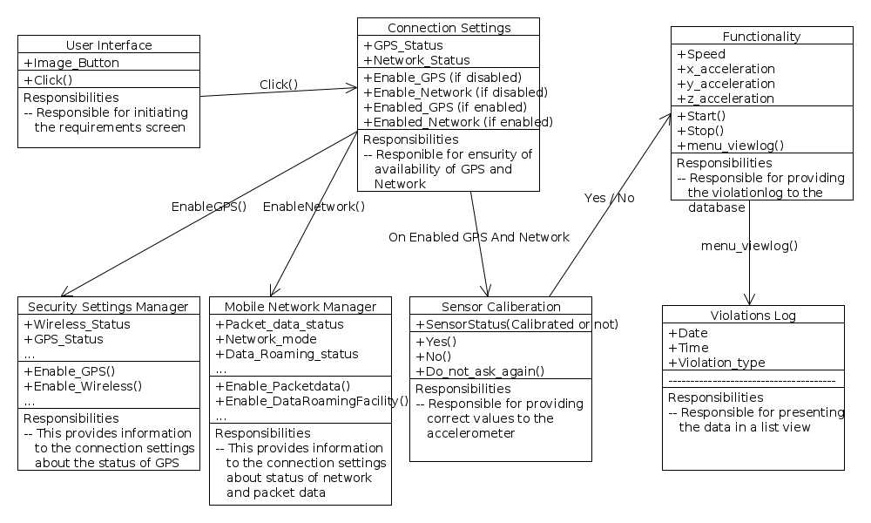

Sequence Diagram(s)
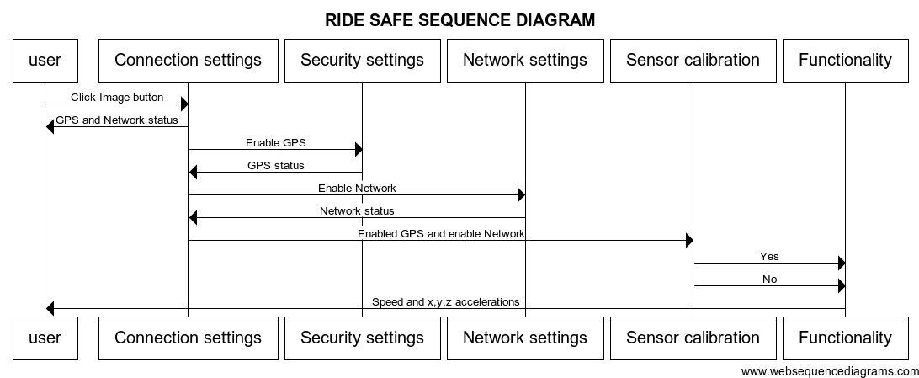

Design Rationale
- One issue we were having was that whether to show the enabled status of the services like GPS , Network or not. For the user who might want to know which services are being user by the application we went on with the first option.
- Another issue was that whether to take the input maximum speed from the user or to use the default prescribed speed . As the user can possibly set the maximum speed to a high value which thus will not give a violation thus not performing its function. So we decided to go with predefined value of default speed.
- Also the issue was that if the log file is to be accessed by the user or not . As the user can modify the violations log file if given access we stored the violation in the already built android database so that user can only read the violations not edit them.

