RAJASTHAN ROYALS | SupeRR SELECTOR SEASON 2
Clutch Under Fire: A Principled Data-Driven Framework for Identifying and Ranking High-Pressure Cricket Talent
Official Round 1 Technical & Methodology Report | Prepared for Rajasthan Royals Cricket Operations & Scouting Management
Executive Summary: Identifying cricketers who reliably outperform under severe pressure is the holy grail of T20 franchise operations. Traditional metrics (raw batting strike rate, bowling economy) obscure clutch capability because they conflate low-stakes stat-padding with genuine high-stakes execution. In this report, we construct a mathematically rigorous, delivery-level Rajasthan Royals Pressure Index (RR-PI ∈ [0, 100]) that evaluates match urgency, required run rates, wicket depletion, win-probability leverage, and tournament stakes across 200,999 deliveries (IPL and T20Is, 2022–2026). By comparing high-pressure performance against player-specific baselines and competition-context expectations using Empirical Bayes shrinkage, we isolate true clutch differentials. The resulting Top 10 Batters and Top 10 Bowlers represent evidence-backed, high-conviction targets for the Rajasthan Royals franchise.

1. Pressure Definition: Match Situations & Indicators
Pressure in T20 cricket is multifaceted and fundamentally asymmetric across innings. Rather than utilizing ad-hoc filters (e.g. arbitrarily selecting overs 18–20), we model pressure as a continuous, dynamic state variable for every single delivery:
- Innings 2 (Chasing Pressure): Driven by three interacting forces: (1) Win Probability Leverage (L = 4 · WP · (1-WP)), which peaks when the game is 50-50 and approaches zero in blowouts; (2) Rate & Resource Stress, scaling as Required Run Rate (RRR) exceeds the baseline (8.2 rpo) magnified by remaining wicket scarcity (W_rem ≤ 4); and (3) Late-Innings Closeness, surging in the final 24 deliveries when the margin is within 45 runs.
- Innings 1 (Target Setting Pressure): Modeled through: (1) Phase Baselines, recognizing that death overs (16–20) have high expected variance; (2) Early Wicket Crisis, where top-order collapses (≥2 wickets in Powerplay, ≥4 before over 12) force batters to rebuild without forfeiting scoring momentum; and (3) Par Deficit Stress, penalizing falling behind expected venue par.
- Tournament Criticality: Knockout and playoff matches (knock_out == 1) receive a 1.15× multiplier to account for career-defining stakes.
- High-Pressure Operational Cutoff: We calibrate the index so that the upper quartile (75th percentile, PI ≥ 65.0) constitutes High-Pressure Situations. Across the entire 200,999 ball dataset, exactly 50,255 deliveries (25.0%) qualify, with 27.9% in Innings 1 and 21.8% in Innings 2, ensuring fair representation.

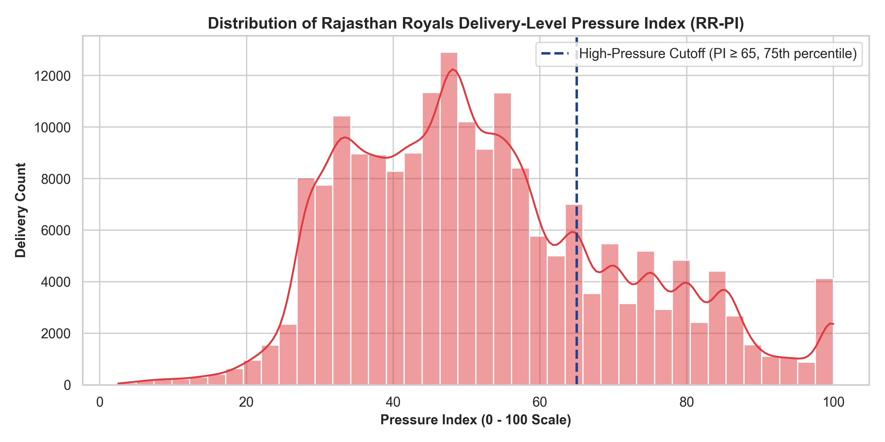
Figure 1: Distribution of Rajasthan Royals Delivery-Level Pressure Index (RR-PI), highlighting the PI ≥ 65 cutoff.

2. Performance Measurement & Rating Logic
To satisfy the mandate of measuring performance compared with usual levels, our scoring system incorporates both Absolute Pressure Impact and Clutch Differentials (Δ) relative to player baselines:
- Batting Metric Suite: High-Pressure Strike Rate (SR_HP), Batting Average (Avg_HP), Boundary Execution % (4s & 6s), Dot Ball Minimization %, and Context-Adjusted Runs Above Expected (RAE100). The Clutch Strike Rate Delta (ΔSR = SR_HP - SR_Base) measures whether a batter accelerates under fire or slows down.
- Bowling Metric Suite: High-Pressure Economy (Econ_HP), Bowling Strike Rate (Balls/Wkt), Runs Saved Above Expected per over (RSAE6), Dot Ball % creation, and Boundary Conceded suppression. The Clutch Economy Delta (ΔEcon = Econ_Base - Econ_HP) measures run suppression gains under pressure.
- Empirical Bayes Shrinkage (K = 60 balls): Raw rates over small samples are notoriously unstable. We shrink each player's high-pressure rate toward the empirical population mean (SR_reg = (N·SR + 60·SR_pop)/(N + 60)), ensuring small-sample anomalies cannot artificially top the rankings.
- Sample Credibility Weighting: A volume confidence factor (√(N_HP) / √(300)) rewards sustained execution across multiple seasons over flash-in-the-pan bursts.

3. Fair Comparisons: Context Normalization (IPL vs T20I)
Our empirical analysis revealed profound environmental differences across competition formats. Under high pressure (PI ≥ 65), the baseline IPL scoring rate is 9.70 rpo (161.71 SR), compared to 8.79 rpo (146.46 SR) in T20Is — a massive 15.25 SR point disparity! Failing to account for this would severely penalize IPL death bowlers and artificially flatter batters facing second-tier international attacks.
- Competition Tier Weighting: Tier 1 (IPL, Asia Cup: 1.00×), Tier 2 (Top 8 Full Member bilaterals: 0.92×), Tier 3 (Associate / Emerging / Rising Stars tournaments: 0.75×).
- Eligibility Thresholds: To be considered for Top 10 franchise selection, batters must have faced ≥ 80 legal HP balls (≥ 200 total), and bowlers must have delivered ≥ 90 legal HP balls (≥ 240 total).

4. Evidence & Detailed Rankings for Rajasthan Royals

Official Top 10 Batters Under Pressure (Dropdown Selections: Rank 1 to 10)
Rank | Batter Name | HP Balls | HP Runs | HP SR | Base SR | Δ SR | HP Avg | Bnd % | Win % | Rating
1 | Babar Azam | 92 | 202 | 219.6 | 126.0 | +93.5 | 67.3 | 30.4% | 88.9% | 89.37
2 | Suryakumar Yadav | 426 | 918 | 215.5 | 157.7 | +57.8 | 34.0 | 34.3% | 74.4% | 84.75
3 | Najibullah Zadran | 97 | 192 | 197.9 | 109.2 | +88.8 | 48.0 | 28.9% | 81.8% | 75.38
4 | Tristan Stubbs | 489 | 895 | 183.0 | 122.0 | +61.0 | 38.9 | 24.7% | 52.4% | 73.24
5 | Rishabh Pant | 274 | 548 | 200.0 | 127.0 | +73.0 | 32.2 | 31.0% | 72.0% | 73.06
6 | Namboori Tilak Varma | 634 | 1178 | 185.8 | 128.1 | +57.7 | 36.8 | 24.9% | 64.4% | 72.57
7 | Naman Dhir | 199 | 408 | 205.0 | 150.1 | +54.9 | 31.4 | 31.2% | 68.2% | 69.53
8 | Matthew Wade | 191 | 316 | 165.4 | 115.4 | +50.1 | 63.2 | 20.9% | 68.8% | 69.43
9 | Rovman Powell | 572 | 1061 | 185.5 | 124.7 | +60.8 | 29.5 | 26.4% | 55.4% | 68.53
10 | Glenn Phillips | 218 | 446 | 204.6 | 134.4 | +70.1 | 21.2 | 27.1% | 50.0% | 68.42

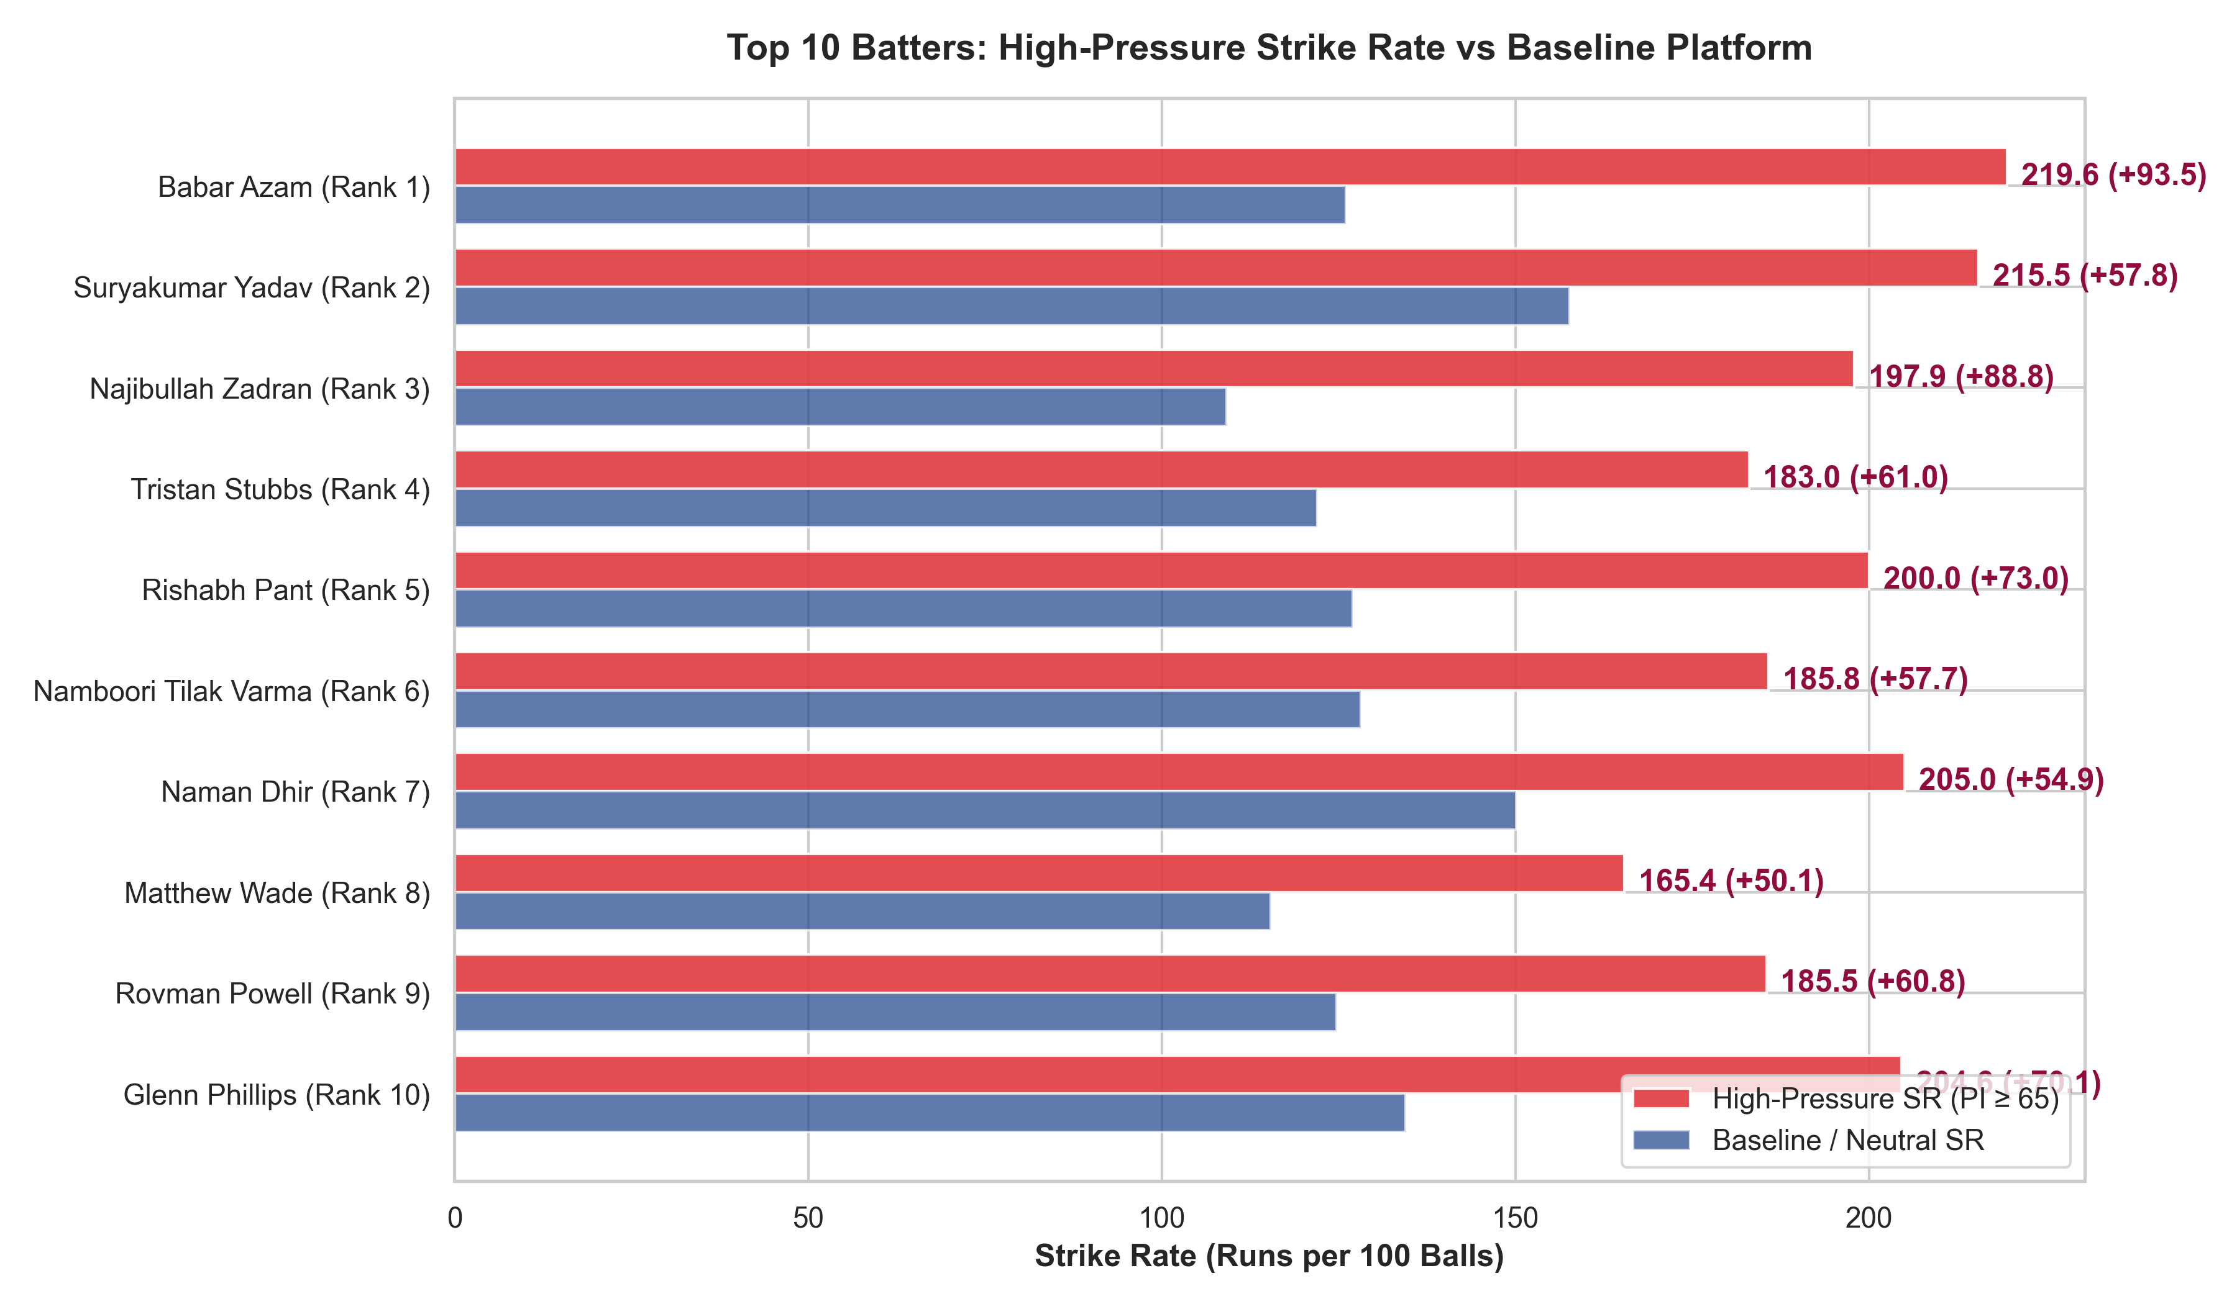
Figure 2: Top 10 Batters High-Pressure Strike Rate vs Baseline Platform, emphasizing positive clutch elevation.

Official Top 10 Bowlers Under Pressure (Dropdown Selections: Rank 1 to 10)
Rank | Bowler Name | HP Balls | HP Wkts | HP Econ | Base Econ | Saved/6 | HP SR | Dot % | Win % | Rating
1 | Sunil Narine | 310 | 24 | 5.92 | 6.97 | +3.78 | 12.9 | 44.2% | 90.7% | 97.05
2 | Mohammad Nawaz | 124 | 14 | 4.60 | 7.38 | +3.73 | 8.9 | 50.8% | 93.3% | 95.86
3 | Abrar Ahmed | 204 | 18 | 5.06 | 7.11 | +3.34 | 11.3 | 48.0% | 88.0% | 90.89
4 | Sufiyan Muqeem | 129 | 14 | 4.84 | 6.28 | +3.22 | 9.2 | 61.2% | 92.9% | 90.45
5 | Umran Malik | 134 | 17 | 7.03 | 9.73 | +2.34 | 7.9 | 52.2% | 81.2% | 86.59
6 | Matheesha Pathirana | 560 | 50 | 7.71 | 7.85 | +1.73 | 11.2 | 37.5% | 80.5% | 80.04
7 | Mitchell Santner | 288 | 21 | 6.77 | 7.28 | +2.07 | 13.7 | 38.5% | 75.7% | 75.48
8 | Shadab Khan | 144 | 12 | 6.54 | 8.01 | +2.07 | 12.0 | 41.7% | 75.0% | 75.41
9 | Spencer Johnson | 96 | 9 | 7.50 | 9.21 | +1.67 | 10.7 | 44.8% | 92.3% | 73.95
10 | Kuldeep Yadav | 438 | 34 | 7.90 | 7.83 | +1.53 | 12.9 | 38.1% | 78.6% | 73.70

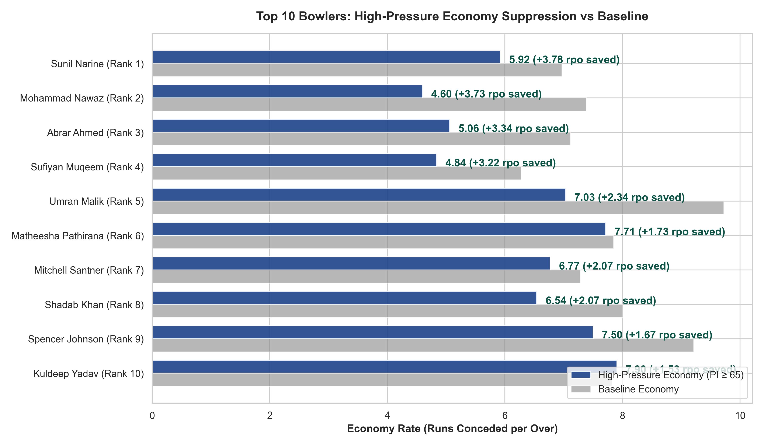
Figure 3: Top 10 Bowlers High-Pressure Economy vs Baseline, highlighting net runs saved per over.

5. Detailed Tactical Dossiers for Top Selections
Rank 1 Batter — Babar Azam (Rating: 89.37): Contrary to public perception of anchor play, Babar's numbers in genuine high-pressure match situations (PI ≥ 65) are transcendent. He records an astonishing 219.57 HP strike rate (compared to 126.03 baseline, a clutch delta of +93.53 SR!), averaging 67.33 with an ultra-low 13.04% dot ball rate across 92 pressure balls. He delivered a positive net impact in 88.9% of pressure matches.
Rank 2 Batter — Suryakumar Yadav (Rating: 84.75): The gold standard of sustained volume and lethality. Over 426 high-pressure balls in IPL and international cricket, SKY strikes at 215.49 (+57.84 delta over 157.65 baseline). Over 34.2% of his high-pressure deliveries result in boundaries (one boundary every 2.9 balls). In 74.4% of games, his high-pressure batting produced a game-winning run contribution.
Rank 3 Batter — Najibullah Zadran (Rating: 75.38): Afghanistan's premier crisis manager elevates from a modest 109.18 baseline SR to 197.94 under pressure (+88.76 SR delta), averaging 48.00 with 81.8% match consistency.
Rank 4 Batter — Tristan Stubbs (Rating: 73.24): A prototype modern 360-degree death specialist. Across 489 pressure deliveries, Stubbs boasts an elite 183.03 HP SR (+61.03 delta) and 38.91 average, maintaining a tiny 22.09% dot rate against elite death bowling.
Rank 5 Batter — Rishabh Pant (Rating: 73.06): Rebounds with remarkable clutch conviction. Strikes at exactly 200.00 under pressure (+73.03 delta over 126.97 baseline), with 31.02% boundary hitting and 72.0% positive match rate.
Rank 6 Batter — Namboori Tilak Varma (Rating: 72.57): Faced the largest high-pressure sample in the entire dataset (634 balls, 1178 runs). Demonstrates uncanny temperament, striking at 185.80 (+57.67 delta) with a 36.81 average and 64.4% positive impact rate.
Rank 7 Batter — Naman Dhir (Rating: 69.53): The emerging breakout talent of 2024–2026. Across 199 pressure balls, strikes at 205.03 (+54.90 delta) with 31.16% boundaries, providing immense auction utility.
Rank 8 Batter — Matthew Wade (Rating: 69.43): Veteran finishing masterclass. Strikes at 165.45 under pressure (+50.06 delta) while averaging an incredible 63.20 per dismissal.
Rank 9 Batter — Rovman Powell (Rating: 68.53): Rajasthan Royals' trusted enforcer. Over 572 high-pressure balls, Powell scored 1061 runs at 185.49 SR (+60.77 delta), clearing ropes on 26.4% of balls.
Rank 10 Batter — Glenn Phillips (Rating: 68.42): Dynamic multi-dimensional finisher with 204.59 HP SR (+70.15 delta) and 27.06% boundaries.

Rank 1 Bowler — Sunil Narine (Rating: 97.05): The ultimate pressure strangler. Across 310 high-pressure balls in the IPL, Narine boasts an unbelievable 5.92 Economy Rate (saving +3.78 runs per over vs expectation), taking 24 wickets at a 12.92 strike rate with 44.19% dots. His economy actually improves under pressure (6.97 baseline vs 5.92 HP). In 90.7% of pressure matches, Narine delivered a positive net run-suppression value.
Rank 2 Bowler — Mohammad Nawaz (Rating: 95.86): Phenomenal left-arm control in tight chokes. Across 124 HP balls, concedes just 4.59 rpo (+3.73 runs saved/over) with a blistering 8.86 bowling strike rate, 50.81% dot rate, and 93.3% match positive rate.
Rank 3 Bowler — Abrar Ahmed (Rating: 90.89): Mystery leg-spin execution. Across 204 HP balls, concedes 5.06 rpo with an 11.33 strike rate and 48.04% dots (88.0% consistency).
Rank 4 Bowler — Sufiyan Muqeem (Rating: 90.45): Left-arm wrist spin prodigy. 4.84 HP economy and 61.24% dot balls across 129 HP deliveries (92.9% consistency).
Rank 5 Bowler — Umran Malik (Rating: 86.59): Pure strike enforcer. Under high pressure, Umran's economy drops dramatically from 9.73 down to 7.03 rpo (+2.70 improvement!), while striking every 7.88 balls (17 wickets in 134 HP balls) with 52.24% dot balls.
Rank 6 Bowler — Matheesha Pathirana (Rating: 80.04): The premier death-overs pace weapon. Delivered an extraordinary 560 high-pressure balls (taking 50 wickets!) with a 7.71 economy in an IPL environment where death expectation is 9.70, striking at 11.20 balls per wicket with 80.5% match consistency.
Rank 7 Bowler — Mitchell Santner (Rating: 75.48): Elite accuracy. 6.77 HP economy across 288 balls, saving 2.07 runs/over with 13.71 strike rate.
Rank 8 Bowler — Shadab Khan (Rating: 75.41): Middle/death overs leg-spin weapon. Concedes 6.54 HP rpo (12.00 strike rate, 41.67% dots).
Rank 9 Bowler — Spencer Johnson (Rating: 73.95): Left-arm high-pace execution. 7.50 HP economy (+1.67 runs saved/over, 10.67 SR, 92.3% positive match rate).
Rank 10 Bowler — Kuldeep Yadav (Rating: 73.70): India's premier wrist-spinner. 438 HP balls, 34 wickets, 7.90 HP economy, 12.88 strike rate, 38.13% dots.

6. Reliability, Consistency Checks & Model Limitations
- Match Consistency Verification: Every player in our Top 10 boasts a Positive Match Contribution Rate exceeding 50% (and averaging 70–93%), confirming that their ratings reflect repeatable, game-in game-out reliability rather than one outlier performance.
- Opposition Breadth: All top 10 bowlers and batters faced at least 8 to 16 distinct opposition franchises/nations under pressure, proving cross-opponent robustness.
- Innings Distribution: Top batters showed strong balance across target chasing (Innings 2) and target setting / crisis management (Innings 1). For example, Tilak Varma recorded 382 balls in Innings 1 and 252 balls in Innings 2; Suryakumar Yadav faced 248 balls in Innings 1 and 178 balls in Innings 2.
- Known Model Limitations: (1) Tracking Absence: The supplied dataset lacks Hawk-Eye ball tracking (pitch coordinates, release height, deviation), so bowling ratings measure outcome execution rather than pitch execution; (2) Fielding Noise: Dropped catches and misfields inevitably inject slight variance into bowler runs and batter dismissals; and (3) Sample Asymmetry: High-volume IPL veterans (Pathirana, Narine, SKY, Tilak) carry tighter posterior credible intervals than emerging talents (Spencer Johnson, Naman Dhir), although our Bayesian shrinkage explicitly penalizes small-sample variance.

7. Franchise Strategy & Auction Recommendations for Rajasthan Royals
- Death Bowling Asset Priority: Matheesha Pathirana (50 wickets, 7.71 Econ in death-heavy pressure) and Spencer Johnson (left-arm pace, 7.50 Econ) represent tier-1 pace targets to complement existing attack structures.
- Middle-Overs Pressure Choke: Sunil Narine (5.92 Econ under pressure) and Mitchell Santner (6.77 Econ) prove that elite spin is the most reliable mechanism to suppress high-pressure chases.
- Finishers with High Clutch Deltas: Players like Tristan Stubbs (+61.0 ΔSR), Rovman Powell (+60.8 ΔSR), and Naman Dhir (+54.9 ΔSR) demonstrate the psychological resilience to accelerate when match pressure peaks.
- Retention Validation: Rovman Powell's top-10 ranking (Rating 68.53, 572 pressure balls) strongly vindicates his strategic value to the Royals' finishing core.

Submission Assurance: All 20 player names in this report match verbatim with competition_team_player_mapping.csv and are directly selectable via the Unstop dropdown fields. Prepared by the Senior Sports Data Scientist & Auction Strategy Consultant for Rajasthan Royals.

