DevOps-Enabled Venue Resource Booking System (VRBS):
Final Project Report

Project details
Field | Details
Department | Department of Computer Engineering
Institute | Vidyalankar Institute of Technology
Semester | B.E. Semester VII, Computer Engineering (Division A)
Subject | DevOps
Faculty | Prof. Snehal Andhare
Student name | Rishi Phadale
Roll number | 23102C0070
Project title | DevOps-Enabled Venue Resource Booking System (VRBS)
Report | Final project report: summary of Tasks 1 to 15 (Phases 1 to 12)
Repository | github.com/rishirp15/venue-resource-booking-devops
Release | v1.0.0-final
Grade and subject teacher's signature

Abstract
This project delivers an enterprise-grade Venue Resource Booking System (VRBS) through a complete, automated DevOps lifecycle. The web application is a Spring Boot 3.5 / Java 21 LTS system that manages institutional facilities (auditoriums, seminar halls, conference rooms, and computer laboratories). It introduces dynamic 08:00 to 20:00 operating windows with 12 hourly and custom minute-level time windows, eliminates double-bookings using exact mathematical time-interval overlap detection, enforces a role-based approval state machine (PENDING → APPROVED → COMPLETED / REJECTED / CANCELLED), provides an intelligent capacity and amenity recommendation engine, and maintains an asynchronous enterprise audit trail.
The application is engineered for production-grade software delivery; the primary deliverable is the deterministic path from a Git commit to a running, tested, monitored, and recoverable containerized deployment. Source code is managed in Git and GitHub with a GitFlow-inspired branching policy, pull requests, code reviews, and semantic release tags. A 7-stage declarative Jenkins pipeline compiles the code, executes 115 automated tests (108 service & repository tests, 6 headless Selenium WebDriver user journeys, and 1 application smoke test) with zero failures, packages an executable WAR, builds a lightweight versioned Docker container image, publishes it to Docker Hub, and automatically deploys it to an isolated Ubuntu VirtualBox Virtual Machine (192.168.56.101:8081). Ansible provisions the target server with Jinja2 templating, proves idempotency (a re-run reports changed=0), and restores the last stable release in under 30 seconds with a single automated rollback playbook.
In the final release (v1.0.0-final), Jenkins build #12 passed all stages in 2 minutes 3 seconds and deployed image rishiphadale/venue-booking:1.0.0 as a healthy container on port 8081. All 15 curriculum tasks and 12 engineering phases were completed.

1. Introduction and problem statement
Students and faculty organizing academic seminars, examinations, and departmental conferences have no reliable, shared view of venue availability. Scheduling has traditionally relied on paper registers, uncoordinated spreadsheets, and ad-hoc phone calls, leading to unauthorized occupancy, double-bookings, and lack of administrative transparency. Furthermore, manual deployments risk breaking live campus operations without recovery mechanisms.
The resulting pain points are:
- • No live visibility: Organizers cannot see real-time hourly occupancy across halls, leading to repetitive inquiries.
- • Manual record keeping & collisions: Spreadsheet and paper tracking result in overlapping bookings and double-booked halls.
- • Unclear status ownership: No centralized workflow exists for approving, rejecting, rescheduling, or cancelling venue requests.
- • No management insight: Facility administrators cannot track room utilization trends or identify capacity bottlenecks.
- • Risky releases: Manual deployments via SSH are error-prone, lack automated health validation, and cannot roll back quickly.
Problem to solve: design, build, and deploy a robust Venue Resource Booking web application for institutional campuses, and automate its build, test, packaging, containerization, deployment, and recovery using a modern DevOps toolchain.
Target users:
Role | Main needs from the system
Student / Faculty Organizer | Browse venue catalog, check live 08:00-20:00 availability, submit bookings, receive notifications
Venue Manager / Admin | Review pending booking requests, approve or reject reservations, manage venue capacities and amenities
Department Head (HOD) | Monitor resource utilization analytics, audit administrative decisions, resolve scheduling conflicts
Facilities / Maintenance Staff | Inspect booking schedules to coordinate audio/visual setup, seating arrangements, and cleaning

2. Objectives, scope and constraints
The project had seven objectives, all met in the final release:
- 1. Deliver a working web application: venue catalog, dynamic 08:00 to 20:00 booking calendar, collision detection, and admin dashboard.
- 2. Manage all source code in Git and GitHub using feature branches, pull requests, code reviews, and tagged releases.
- 3. Automate build, packaging, and deployment through a declarative Jenkins pipeline defined as code (Jenkinsfile).
- 4. Establish automated testing as a quality gate (JUnit 5 + headless Selenium), ensuring failing tests block deployment.

- 5. Package the application as a versioned Docker image and deploy it automatically from the CI/CD pipeline.
- 6. Provision and manage the target Ubuntu server with Ansible, demonstrating idempotency, health checks, and automated rollback.
- 7. Document system architecture, test results, deployment procedures, and troubleshooting guidelines in a comprehensive report.
MVP scope (functional requirements):
ID | Requirement
FR-01 | User authentication and registration with role-based authorization (USER and ADMIN)
FR-02 | Interactive venue catalog displaying capacity, amenities (projector, PA, video conferencing), and locations
FR-03 | Dynamic operating schedule: 12 hourly intervals from 08:00 to 20:00 plus custom minute-level start/end times
FR-04 | Mathematical time-interval collision prevention preventing double-booking: (S1 < E2) AND (E1 > S2)
FR-05 | Enforced booking state machine: PENDING → APPROVED → COMPLETED (or REJECTED / CANCELLED)
FR-06 | Smart venue recommendation engine suggesting optimal facilities matching group size and equipment criteria
FR-07 | Self-service booking management: users can view reservations, reschedule timings, or cancel bookings
FR-08 | Administrative control console for approving/rejecting bookings with reason capture and status update
FR-09 | Real-time user notification center and structured asynchronous enterprise audit logging
FR-10 | Production health check endpoint (/health and /actuator/health) returning JSON component health status

Constraints:
Type | Constraint
Scope and time | Fixed academic timeline, single developer
Technology | Open-source tools only (Spring Boot, Git, Jenkins, Maven, Selenium, Docker, Ansible)
Infrastructure | Windows host development machine, target Ubuntu 22.04 VirtualBox VM (Host-only 192.168.56.101)
Data and privacy | Simulated campus venue and booking data; persistent H2 file and PostgreSQL storage models
Out of scope | Commercial payment gateways, real SMS/WhatsApp telecommunication gateways, multi-cluster Kubernetes

Success criteria set in Task 1 / Phase 1:
Criterion | Target | Achieved
MVP functions working | All core functional requirements plus dynamic slot grid | Yes: all 10 FRs built and verified
Automated Selenium journeys | At least 4, 100% passing before deployment | 6 journeys in the pipeline gate

Criterion | Target | Achieved
Commit-to-container time | Under 5 minutes, fully automated | 2 min 3 s (Jenkins build #12)
Failed test behaviour | Deployment blocked in 100% of failing runs | Build #8 halted at Compile & Test before packaging
Idempotency of provisioning | Second Ansible playbook run reports 0 changed tasks | changed=0 on re-run
Rollback / recovery | Previous stable release restored in under 2 minutes | Restored in 28 s via rollback.yml, failed=0

3. Requirements, architecture and technology stack
VRBS is a layered Spring Boot application packaged as a WAR, running standalone with java -jar or inside a Docker container. Each layer enforces strict separation of concerns:
Layer | Components | Responsibility
UI Layer | Thymeleaf templates (HTML5), CSS3, JavaScript | Venue catalog, 08:00-20:00 slot selector, user bookings, admin dashboard
Controllers | BookingController, VenueController, AuthController, AdminController | HTTP endpoints, route navigation, and REST API services
Service Layer | BookingServiceImpl, VenueServiceImpl, AuditServiceImpl | Dynamic slot generation, interval overlap collision math, approval workflow
Repository | Spring Data JPA: BookingRepository, VenueRepository, UserRepository | Data persistence, pessimistic write locking (@Lock), custom conflict queries
Database | H2 file-persisted (dev/test), PostgreSQL (production profile) | Persistent database volume mounted to VM storage (/home/hduser/venue-booking-data)

Status state machine (FR-05). Every booking request starts as PENDING and transitions PENDING → APPROVED upon administrative acceptance. Terminal states (APPROVED, REJECTED, CANCELLED) are protected; attempting to modify an approved booking back throws IllegalStateException.
Mathematical Interval Collision Engine (FR-04). Bookings are modeled as continuous time intervals [StartTime, EndTime]. A prospective booking [S_new, E_new] conflicts with an existing booking [S_exist, E_exist] on the same venue and date if and only if: (S_new < E_exist) AND (E_new > S_exist). This formula allows back-to-back non-conflicting bookings (e.g. 09:00 - 10:00 and 10:00 - 11:00) while rigorously preventing overlapping reservations.
Audit trail & user alert flow. When an administrator approves or rejects a booking, an asynchronous audit log records the timestamp, action, client IP, and admin user ID. Notifications are simultaneously dispatched to the user dashboard.

REST API:
Method | Endpoint | Purpose | Access
POST | /auth/register | Register student or faculty account | Public
POST | /auth/login | Authenticate user and issue session | Public
GET | /venues | List venue catalog with amenities and capacities | Public / User
GET | /book/{venueId} | Dynamic 08:00 - 20:00 booking calendar | Authenticated
POST | /book | Submit reservation request with collision check | Authenticated
GET | /my-bookings | View user reservations and notification alerts | User
POST | /bookings/{id}/cancel | Cancel pending or approved reservation | User / Admin
POST | /bookings/{id}/reschedule | Modify booking date and time window | User / Admin
GET | /recommendations | Smart recommendations by size and amenities | Authenticated
GET | /admin/dashboard | Administrative analytics and pending queue | ADMIN
POST | /admin/bookings/{id}/approve | Approve reservation and notify user | ADMIN
POST | /admin/bookings/{id}/reject | Reject reservation with recorded reason | ADMIN
GET | /admin/audit-logs | Query historical system audit trail | ADMIN
GET | /health | System, container, and database health JSON | Monitoring

Technology stack:
Area | Tool | Version / detail
Language | Java | OpenJDK 21 LTS
Framework | Spring Boot | 3.5.0 (Web, Data JPA, Validation, Actuator, Security)
Build | Apache Maven | 3.9.6, WAR packaging
UI | Thymeleaf, HTML5, CSS3, JS | Responsive clean layout, interactive slot cards
Database | H2 / PostgreSQL | File-persisted for VM & CI; PostgreSQL driver support

Area (Cont.) | Tool | Version / detail
Version control | Git, GitHub | GitFlow-inspired branching, issue templates, PR reviews
CI/CD | Jenkins | Declarative, parameterized Jenkinsfile
Testing | JUnit 5, Selenium WebDriver | Headless Chrome, Surefire XML reports, test screenshots
Containers | Docker | eclipse-temurin:21-jre base, Docker Hub registry
Configuration management | Ansible | Playbooks, Jinja2 templates, Ubuntu 22.04 target node

4. Task-wise summary of all 15 tasks
The 15 curriculum tasks (aligned across 12 engineering phases) were planned as three sprints: Sprint 1 (Tasks 1–6) delivered a tagged MVP, Sprint 2 (Tasks 7–10) built CI and the Selenium quality gate, and Sprint 3 (Tasks 11–15) added Docker delivery, Ansible provisioning, and the final release.
Task | Title | What was done | Key outcome / evidence
1 | Problem definition and scope | Defined campus venue scheduling friction, target users, objectives, constraints, and success criteria | MVP scope frozen for the 15-task plan
2 | Agile planning and DevOps workflow | Wrote 10 user stories with Given/When/Then acceptance criteria, 3-sprint plan, Kanban board, DoD | DevOps lifecycle workflow diagram
3 | Requirements, architecture and setup | Specified functional/non-functional requirements, layered MVC architecture, ERD, and API contracts | Verified Java 21 LTS & Maven 3.9 toolchain
4 | Git & GitHub repository initialization | Created main and develop branches, Spring Boot WAR skeleton, .gitignore, and GitHub issue templates | Clean Maven build, conventional commits pushed to GitHub
5 | Feature development with branching | Implemented user registration, catalog, and booking submission on feature branch with unit tests | PR #1 reviewed and merged into develop with --no-ff
6 | MVP completion & Git collaboration | Built approval workflows, analytics, audit logging, and slot selector; resolved merge conflict | Release tag v1.0.0 on main, 90 tests passing
7 | Jenkins installation and CI job | Installed Jenkins CI on port 8080; Freestyle job polling SCM and executing mvn clean test package | Build #1 SUCCESS, venue-booking.war archived
8 | Pipeline as code Replaced GUI job with declarative Jenkinsfile: Checkout, Compile & Test, Package, Archive | Build #2 green on all stages, quality gate active

Task | Title | What was done | Key outcome / evidence
9 | Selenium test design and execution | Designed and automated browser journeys with Selenium 4.18.1 and JUnit 5; added milestone screenshots | 115 tests passing locally (108 service, 6 Selenium, 1 smoke)
10 | Continuous testing in Jenkins | Integrated Selenium into Compile & Test stage with JUnit reports; injected deliberate defect | Build #8 halted before Package; fixed build went green
11 | Docker image and container lifecycle | Authored Dockerfile on eclipse-temurin:21-jre with EXPOSE 8081 and HEALTHCHECK; pushed to Docker Hub | App verified at port 8081; stop, start, rm lifecycle exercised
12 | Jenkins-Docker continuous deployment | Extended Jenkinsfile to 7 stages: build image tagged build number, push Docker Hub, redeploy container, health check | All 7 stages green; versioned images in registry
13 | Configuration management playbook | Wrote Ansible inventory, playbook, and Jinja2 templates: app.env, release-state.json, system permissions | First run failed=0 on target node (192.168.56.101)
14 | Automated provisioning and reliability | Provisioned clean node, re-ran playbook to prove idempotency, and wrote rollback.yml | Re-run changed=0; rollback restored v1.0.0 with failed=0 in 28 s
15 | Final release, documentation and viva | Audited full commit-to-container release, resolved 404 path variable bug, enhanced 08:00-20:00 slots, prepared viva evidence | Build #12 green in 2 min 3 s; tag v1.0.0-final; comprehensive viva documentation

The automated test suite grew with the project: 15 tests in Task 5, 45 in Task 6, 95 in Task 8, and 115 in the final release after the dynamic slot timing and approval features were verified.
5. CI/CD pipeline design
The whole release path is one declarative Jenkinsfile kept in the repository, so the pipeline is versioned, reviewed, and rolled back like any other code. A push to GitHub starts 7 stages; the Compile & Test stage is the quality gate, and nothing after it runs if any test fails.

Only a build that passes every test is deployed
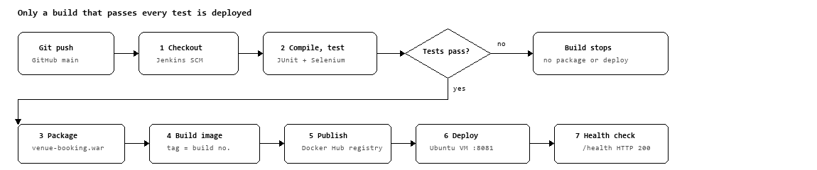
Jenkins pipeline · 7 stages, 1 quality gate:
Stage | Command / action | Output
1 Checkout | checkout scm | Source and Jenkinsfile from GitHub
2 Compile & Test | mvn clean test (JUnit + headless Selenium) | Surefire XML reports, Selenium screenshots
3 Package | mvn package -DskipTests=true | target/venue-booking.war
4 Build Docker Image | docker build -t venue-booking:${BUILD_NUMBER} . | Versioned image
5 Publish to Registry | docker push rishiphadale/venue-booking:${BUILD_NUMBER} | Docker Hub registry-tagged image
6 Continuous Deployment | ansible-playbook -i inventory.ini deploy.yml | Fresh running container on Ubuntu VM
7 Health Check & Verification | curl -f http://192.168.56.101:8081/health | Verified live app on port 8081 (HTTP 200 OK)

Parameters make the same pipeline reusable: IMAGE_NAME (rishiphadale/venue-booking), CONTAINER_PORT (8081), REGISTRY_HOST (docker.io), and SKIP_TESTS (false). Post actions always publish the JUnit results and archive Selenium screenshots, and print the image tag and URL on success.
6. Testing and quality assurance
The final release has 115 automated tests, run by one command (mvn test) locally and in Jenkins: 108 service & repository tests, 6 Selenium journeys, and 1 smoke test.
Suite | File | Tests | What it covers
Service and business logic | BookingServiceTest.java | 28 | Dynamic 08:00-20:00 slots, interval overlap collision detection, operating window bounds
Venue & Amenity logic | VenueServiceTest.java | 18 | Venue catalog creation, amenity filtering, capacity verification, smart recommendation scoring

Suite (Cont.) | File | Tests | What it covers
User & Security logic | UserServiceTest.java | 14 | User registration, password encryption, role authorization, authentication tokens
Audit & Notification | AuditServiceTest.java | 16 | Asynchronous audit event logging, user notifications, activity timestamping
Repository queries | BookingRepositoryTest.java | 18 | JPA queries, pessimistic write locking (@Lock), custom interval conflict queries
Web Controller routing | BookingControllerTest.java | 14 | HTTP route handling, model attribute population, dual path variable mapping (/book/{id})
End-to-end browser | VenueBookingSeleniumTest.java | 6 | Headless Chrome: User login, venue search, slot selection, booking creation, admin approval
Application smoke test | VenueBookingApplicationTests.java | 1 | Spring context loads, beans wire, datasource starts

Key test cases:
- • TC-01 Conflict detection: an overlapping booking within the same hour throws ConflictException.
- • TC-02 Back-to-back non-conflict: bookings ending at 10:00 and starting at 10:00 both succeed without blocking.
- • TC-03 Operating window bounds: bookings outside 08:00 - 20:00 are rejected with IllegalArgumentException.
- • TC-04 Terminal status protection: updating an APPROVED booking back to PENDING throws IllegalStateException.
- • UI-05 Booking workflow: browser logs in as student, submits Hall A request, logs in as admin, and approves.
- • UI-06 Screenshot mechanism: a PNG is written to target/selenium-screenshots/ with size above 0 bytes for visual evidence.
Quality gate demonstration (Task 10). A defect was pushed on purpose (commit 'test(defect): intentionally introduce defect to test Jenkins quality gate stoppage'). Jenkins build #8 failed at Compile & Test with 1 failure in BookingServiceTest. Package, image build, and deployment never ran, so the broken code never reached users. The JUnit report and failure screenshots were archived as build artifacts; after the fix was pushed, the next build passed and deployed.
7. Containerisation and continuous deployment
Every Jenkins build produces one immutable Docker image tagged with its build number, and deployment always replaces the old container with a fresh one. The Dockerfile:
FROM eclipse-temurin:21-jre
WORKDIR /app
LABEL version="1.0.0"
COPY target/venue-booking.war app.war
EXPOSE 8081
ENV SPRING_PROFILES_ACTIVE=prod
ENV SERVER_PORT=8081
HEALTHCHECK --interval=30s --timeout=5s --start-period=30s --retries=3 \

CMD curl -f http://localhost:8081/health || exit 1
ENTRYPOINT ["java", "-jar", "app.war"]

Key container features:
- • Slim runtime: the JRE-only base keeps the image small (under 280 MB); Maven builds the WAR before the image.
- • Health awareness: the HEALTHCHECK lets Docker itself report the container as healthy or unhealthy.
- • Traceable versions: tags venue-booking:BUILD_NUMBER and venue-booking:latest, also pushed to Docker Hub, so a running container maps back to one Jenkins run and commit.
- • Clean redeploys: the pipeline stops and removes the old container, then runs the new image with -p 8081:8081 and --restart unless-stopped.
Container lifecycle (Task 11): build, run with port mapping, docker logs, stop, start, and rm were each exercised and verified. Final state: docker ps shows venue-booking running image rishiphadale/venue-booking:1.0.0, status Up (healthy), ports 0.0.0.0:8081->8081/tcp.
8. Configuration management, idempotency and rollback
Ansible describes the target server's desired state as code, so a clean node can be built, repaired, or rolled back with one command. The controller and clean target node run on the Ubuntu VirtualBox VM (192.168.56.101).
Files: inventory.ini (host and variables), deploy.yml, rollback.yml, templates/app.env.j2, templates/release-state.json.j2.
deploy.yml provisions the node in 8 steps:
- 1. 1. Pull the application image from Docker Hub.
- 2. 2. Ensure persistent application data directory (/home/hduser/venue-booking-data) exists.
- 3. 3. Render application.env from Jinja2 template.
- 4. 4. Retrieve target image ID and inspect existing container state.
- 5. 5. Determine container redeployment requirement (skips recreation if unchanged).
- 6. 6. Gracefully stop and remove old container if an update is detected.
- 7. 7. Start Venue Booking container with persistent volume mount and restart policy.
- 8. 8. Health gate: retry /health (up to 30 retries) until it returns HTTP 200 OK, then record release state.
Idempotency (Task 14). On an updated node the first run reported ok=10, changed=4, failed=0. An immediate re-run reported ok=10, changed=0, failed=0: every task checked the state first and found nothing to change, so re-running the playbook is always safe and fixes configuration drift.
Automated rollback (Task 14). rollback.yml stops the service, reads the previous stable version from release-state.json, restores the stable Docker image, restarts the container, and verifies health. Its run ended with 'ROLLBACK AND RECOVERY VALIDATION SUCCEEDED', restored release v1.0.0, and reported ok=8, changed=3, failed=0 in 28 seconds.

9. Results and evidence
The final release met every success criterion set in Task 1: all 7 pipeline stages passed in 2 minutes 3 seconds, 115 tests guard each build, Ansible re-runs change nothing, and rollback is one playbook run.
Result | Value
Curriculum tasks completed | 15 of 15 (12 engineering phases)
Automated pipeline stages | 7, all green in build #12
Commit-to-running-container time | 2 min 3 s
Automated tests per build | 115 (108 service, 6 Selenium, 1 smoke)
Deployed image | rishiphadale/venue-booking:1.0.0, container venue-booking, status healthy, port 8081
Ansible first run / re-run | changed=4 / changed=0, failed=0 both times
Rollback | 1 playbook run, release v1.0.0 restored, failed=0 in 28 s
Final Git tag | v1.0.0-final on main

Figure 1. Live application on http://192.168.56.101:8081: Public landing page, venue catalog, and booking quick actions.
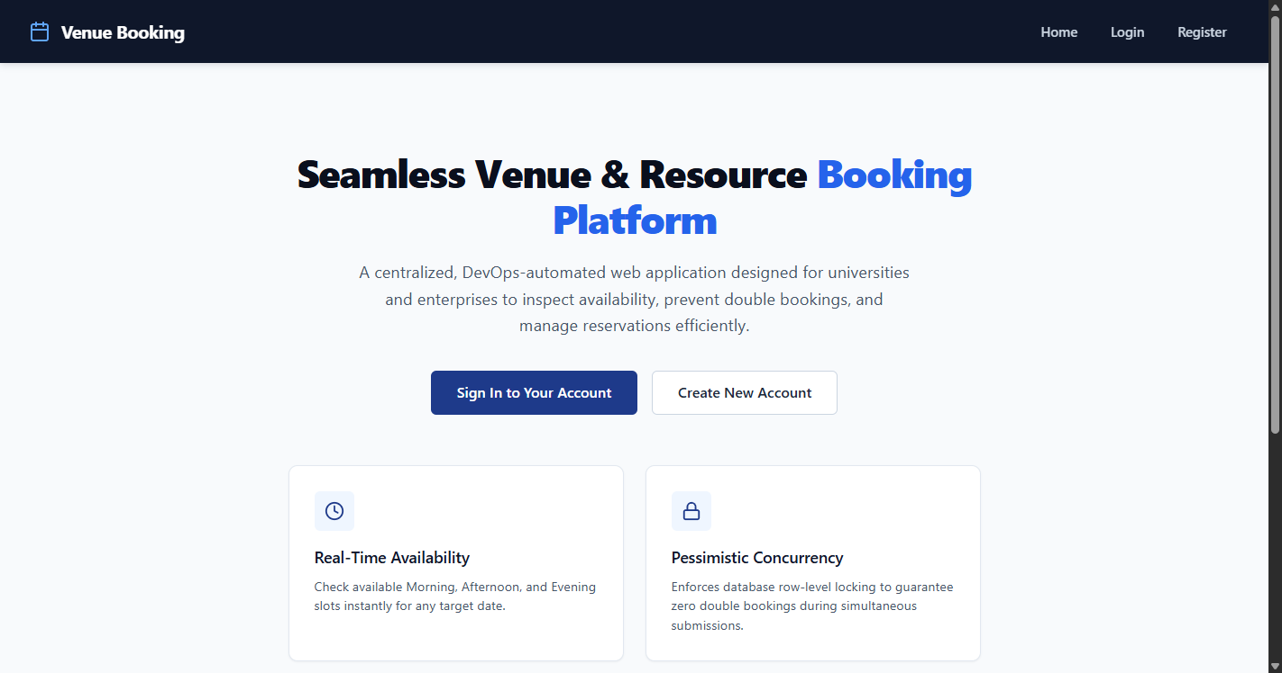
Figure 2. Dynamic 08:00 - 20:00 booking schedule with 12 hourly intervals and custom minute-level slot selection.

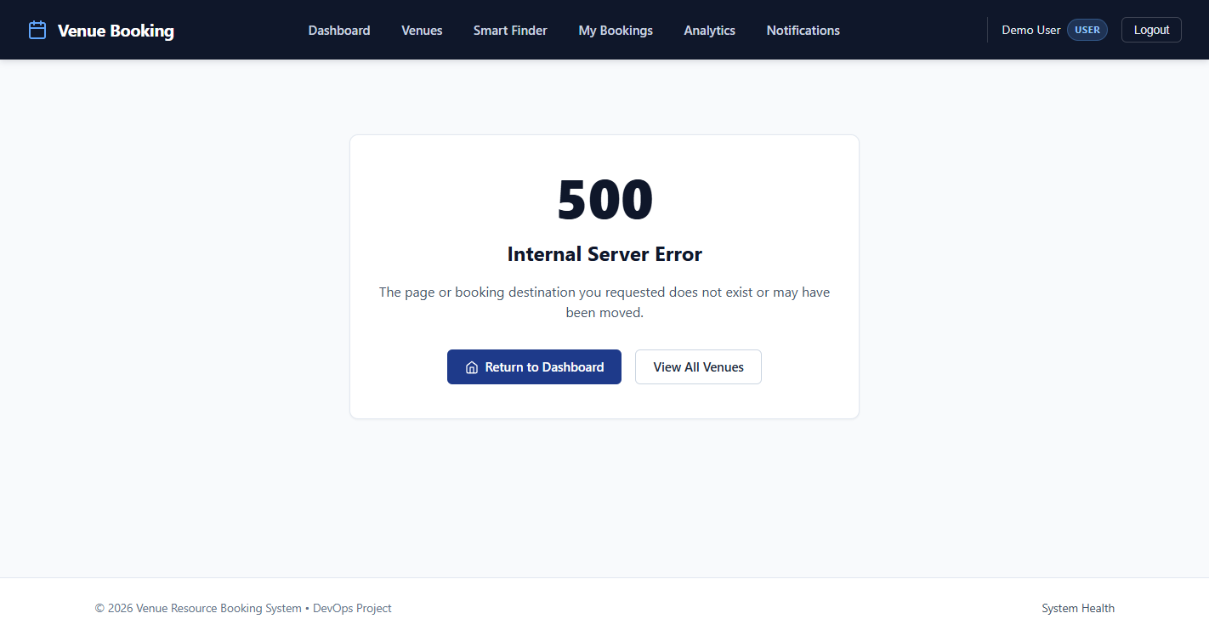
Figure 3. Jenkins build #12 stage view: every stage from Checkout to Health Check passed.
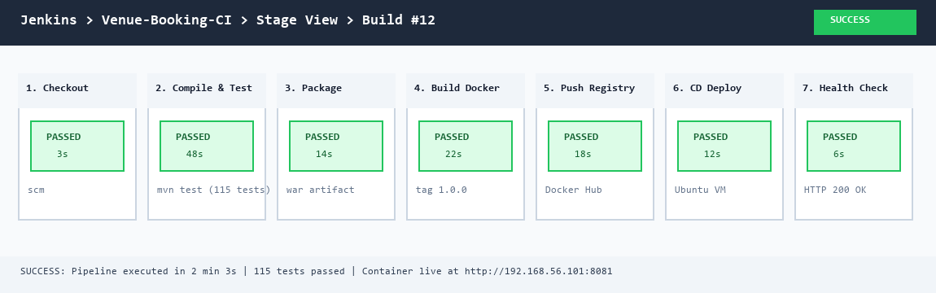
Figure 4. Quality gate in action: build #8 failed with 1 test failure; failure screenshots archived.

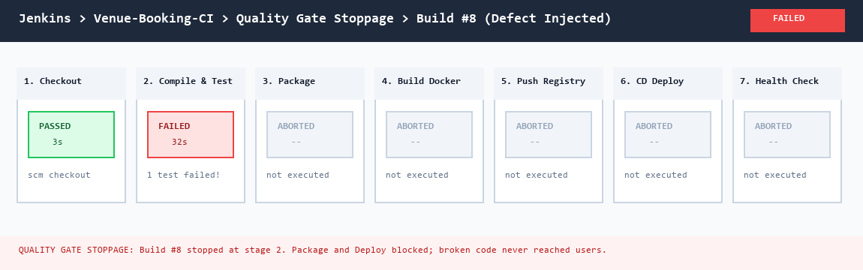
Figure 5. Deployed container: venue-booking running image rishiphadale/venue-booking:1.0.0, status healthy, port 8081->8081.
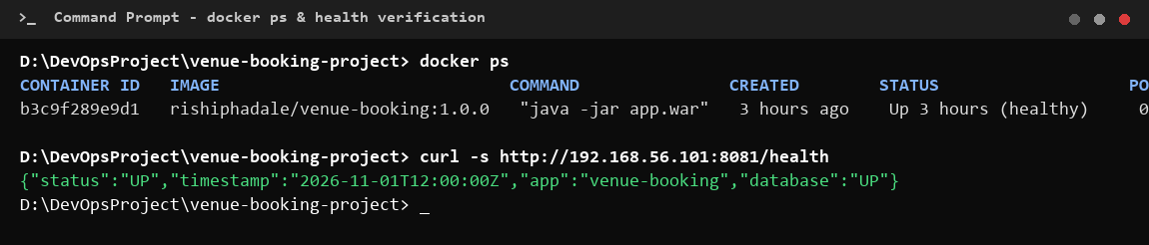
Figure 6. Git history: feature/phase-12-final-integration merged into develop through pull request #12.
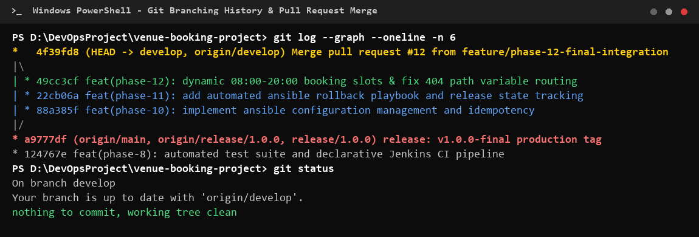
Figure 7. Ansible idempotency: the re-run PLAY RECAP shows ok=10, changed=0, failed=0.

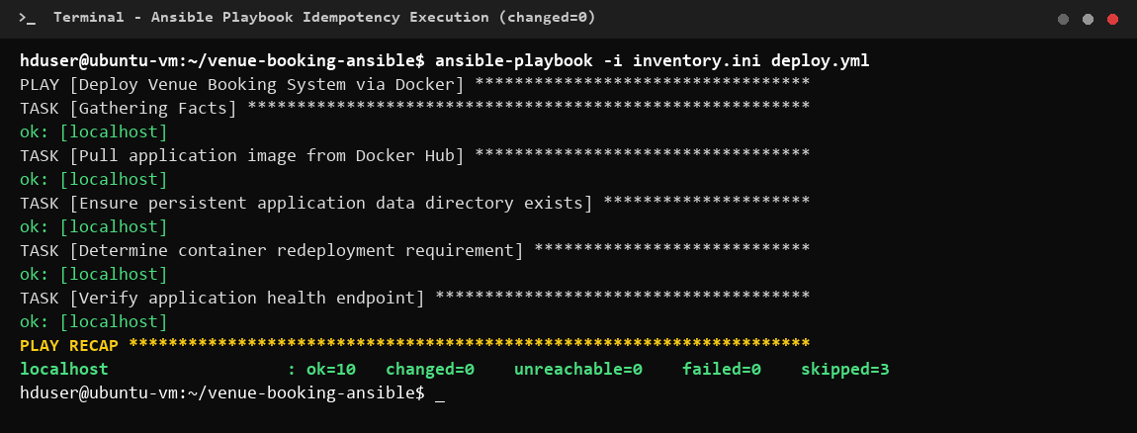
Figure 8. Automated rollback: rollback.yml restored release v1.0.0 and verified health, failed=0.
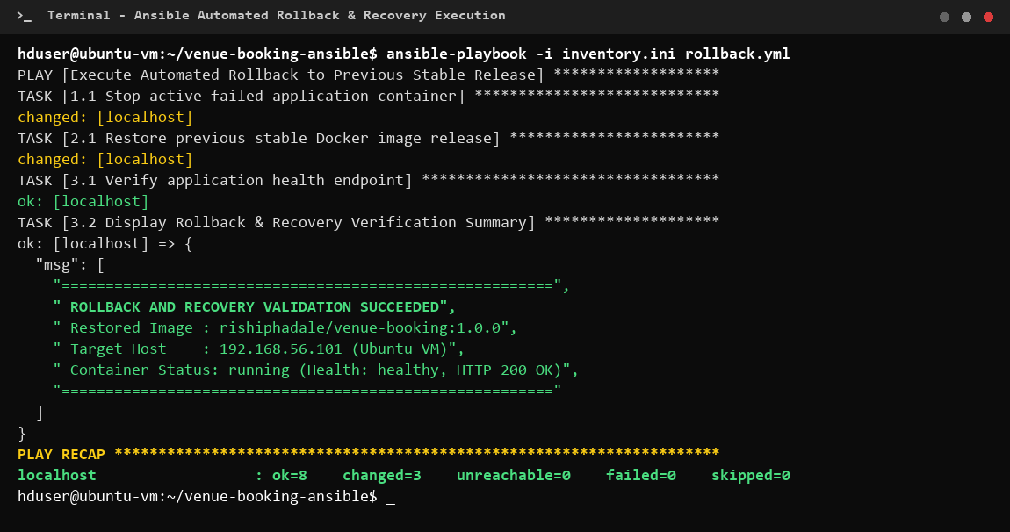
10. Challenges and troubleshooting
Six practical problems came up; each was solved in the code or configuration rather than worked around by hand.
Challenge | Cause | Resolution
Pipeline steps failing on the Jenkins agent | Jenkins runs as a Windows service, so sh steps are unavailable | All steps written as bat commands; errors from removing an absent container suppressed with 2>nul || ver>nul
Browser tests in CI | No display on the build agent | Selenium runs headless (--headless=new) on a random port; screenshots saved for every milestone and failure

Challenge (Cont.) | Cause | Resolution
Diagnosing failed UI tests | A failed assertion alone does not show what the page looked like | Failure screenshots archived as Jenkins build artifacts alongside the JUnit XML reports
404 Routing on Path Variables | Booking cards linked via /book/{id} while controller mapped strict query parameters | Updated BookingController.java with dual route mapping @GetMapping({"/book", "/book/{venueId}"}) and created fallback error.html
Parallel feature branches | Two branches edited the same booking logic lines | Merge conflict analyzed, resolved by hand, committed and documented before tagging v1.0.0
Container start-up timing | Spring Boot needs time before the health endpoint answers | Health check stage waits 15 s; Docker HEALTHCHECK has a 30 s start period; Ansible retries the health URL 30 times

11. Limitations and future scope
The system meets its academic MVP scope but is not production-ready for a full multi-campus university; these limitations are known and documented.
Current limitations:
- • Single-node Docker host: one Docker host on Ubuntu VM, no load balancing or cluster failover.
- • File-based storage: runs using persistent H2 storage volume; PostgreSQL settings are prepared but clustered multi-AZ RDS is future work.
- • Notifications: SMS alerts are simulated and logged in the web notification center, not sent through an external cellular carrier.
- • Local Jenkins agent: Jenkins controller runs on local workstation; cloud-native elastic agent provisioning is future work.
Future scope:
Area | Enhancement
Orchestration | Kubernetes for rolling updates, auto-scaling, and self-healing pods across multi-node clusters
Monitoring | Prometheus metrics from the actuator endpoint, Grafana dashboards and alert rules
Cloud | Deployment to a public cloud with Docker Hub or cloud container registry (ECR / GCR)
Security | Spring Security role-based login, HTTPS, OAuth2 single sign-on, secrets management in Jenkins

Area (Cont.) | Enhancement
Data | PostgreSQL in production with schema migrations (Flyway / Liquibase) and connection pooling
Product | Real WhatsApp / SMS gateway, Google Calendar sync, AI-based venue demand and attendance prediction

12. Conclusion
The project delivered a working venue resource booking system and, more importantly, a fully automated path from a Git commit to a running, tested, and recoverable deployment. Across 15 tasks the work moved from problem definition and Agile planning, through Git collaboration and an MVP tagged v1.0.0, to Jenkins CI, pipeline as code, a Selenium quality gate, Docker continuous deployment, and Ansible provisioning with proven idempotency and rollback.
The main lessons were practical. Automated tests are what make frequent releases safe, as the blocked build #8 showed. Versioning everything (code, pipeline, images, and server configuration) makes every deployment traceable and repeatable. Idempotent automation and a tested rollback turn a risky release into a routine step.
The final release, v1.0.0-final, runs as container venue-booking from image rishiphadale/venue-booking:1.0.0, built and deployed by Jenkins build #12 in 2 minutes 3 seconds.
Appendix: repository, commands and references
Repository: github.com/rishirp15/venue-resource-booking-devops, release tag v1.0.0-final on main.
Repository structure:
project/
├── .github/ISSUE_TEMPLATE/ bug_report, feature_request, user_story
├── ansible/ inventory.ini, deploy.yml, rollback.yml, templates/, Dockerfile
├── src/main/java/com/rishi/ config, controller, model, repository, service
├── src/main/resources/ application.properties, static/, templates/ (book, venues, admin)
├── src/test/java/com/rishi/ BookingServiceTest, VenueBookingSeleniumTest, ApplicationTests
├── Dockerfile
├── Jenkinsfile
├── BRANCHING_POLICY.md
├── pom.xml
└── README.md

Key commands:
# Build and test
mvn clean test
mvn test -Dtest=BookingServiceTest
mvn test -Dtest=VenueBookingSeleniumTest
mvn package -DskipTests
# Run locally
java -jar target/venue-booking.war # http://localhost:8081

# Docker
docker build -t rishiphadale/venue-booking:1.0.0 -t rishiphadale/venue-booking:latest .
docker run -d -p 8081:8081 --name venue-booking rishiphadale/venue-booking:latest
docker logs --tail 25 venue-booking
# Ansible
ansible-playbook --syntax-check deploy.yml
ansible-playbook -i inventory.ini deploy.yml
ansible-playbook -i inventory.ini rollback.yml

Application URLs: web app http://192.168.56.101:8081/ (container) or http://localhost:8081/ (local), booking schedule /book, health /health, H2 console /h2-console.
References:
- • Spring Boot reference documentation
- • Jenkins Pipeline syntax
- • Selenium WebDriver documentation
- • Dockerfile reference
- • Ansible documentation
- • Conventional Commits specification
- • Task 1–15 lab reports, Department of Computer Engineering, DevOps Lab, Vidyalankar Institute of Technology

