**MNIST Recognition**

Train Data Hit Rate: 0.9995

Train Data Confusion Matrix:

[[372 0 0 0 0 0 0 0 0 0]

[ 0 453 0 0 0 0 0 0 0 0]

[ 0 1 434 0 0 0 0 0 0 0]

[ 0 0 0 403 0 0 0 0 0 0]

[ 0 0 0 0 393 0 0 0 0 0]

[ 0 0 0 0 0 361 0 0 0 0]

[ 0 0 0 0 0 0 373 0 0 0]

[ 0 0 0 0 0 0 0 407 0 0]

[ 0 0 0 0 0 0 0 0 390 0]

[ 0 0 0 0 1 0 0 0 0 412]]

Test Data Hit rate: 0.941

Test Data Confusion Matrix:

[[ 85 0 0 0 0 0 0 1 1 0]

[ 0 114 0 0 0 0 1 0 0 1]

[ 1 0 93 1 2 0 0 2 1 0]

[ 0 2 1 93 0 6 0 0 2 0]

[ 0 0 1 0 97 2 0 1 2 1]

[ 0 0 0 0 0 83 1 0 0 0]

[ 0 0 0 0 4 2 85 0 1 0]

[ 0 0 0 1 0 0 0 98 0 1]

[ 1 1 1 2 0 1 2 0 92 4]

[ 1 0 0 0 3 1 0 3 0 101]]

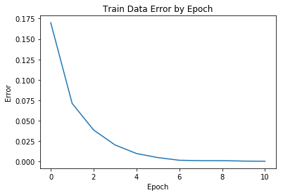

**MNIST Autoencoder**

Average Train Data Error: 33914.57885269375

Average Test Data Error: 33984.17275151927

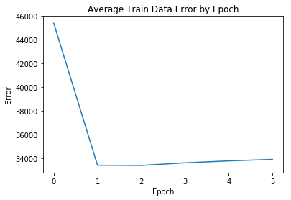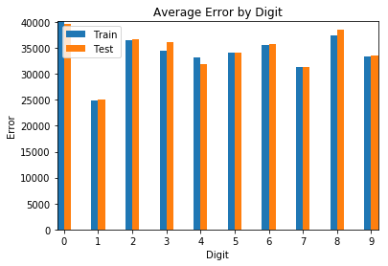

**MNIST Autoencoder with regularization**

Average Train Data Error: 33030.36697937061

Average Test Data Error: 33000.14005749674

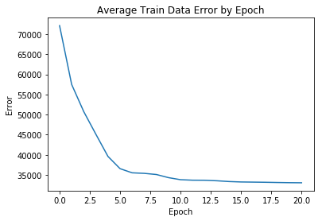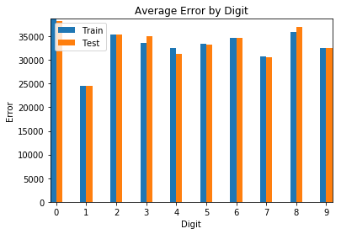

**MNIST Recognition with autoencoder features**

Train Data Hit Rate: 0.63625

Train Data Confusion Matrix:

[[318 0 17 7 1 12 23 2 8 8]

[ 0 421 19 11 1 5 5 10 22 9]

[ 18 10 277 35 9 9 42 25 44 13]

[ 2 4 17 244 1 49 8 9 61 14]

[ 2 1 5 8 238 9 9 14 15 69]

[ 8 2 12 24 15 196 12 10 52 19]

[ 13 5 27 14 23 11 249 8 16 13]

[ 5 2 24 14 22 18 12 298 18 43]

[ 3 9 21 27 21 26 10 14 119 39]

[ 3 0 15 19 63 26 3 17 35 185]]

Test Data Hit rate: 0.572

Test Data Confusion Matrix:

[[64 0 2 0 0 3 1 0 1 0]

[ 0 98 0 0 0 1 1 0 0 0]

[12 6 74 10 9 3 11 8 10 12]

[ 0 1 1 29 0 1 1 1 0 0]

[ 0 0 0 0 45 2 1 1 0 2]

[ 2 0 0 0 0 23 0 0 0 0]

[ 2 0 1 0 6 7 60 1 1 0]

[ 0 0 0 1 0 2 0 60 0 5]

[ 7 12 18 57 34 52 14 34 87 57]

[ 1 0 0 0 12 1 0 0 0 32]]

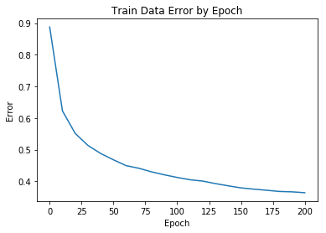

**MNIST recognition with regularized autoencoder features.**

Train Data Hit Rate: 0.86825

Train Data Confusion Matrix:

[[362 0 6 1 1 15 6 3 13 8]

[ 0 444 4 1 2 4 1 10 11 7]

[ 0 1 379 7 0 7 4 10 15 1]

[ 1 2 9 353 1 18 2 4 21 8]

[ 0 0 5 0 345 9 9 8 10 20]

[ 1 1 4 10 0 272 5 3 10 5]

[ 7 3 7 4 7 8 343 2 6 2]

[ 0 0 11 10 6 11 1 353 4 24]

[ 1 3 7 9 2 13 2 2 291 6]

[ 0 0 2 8 30 4 0 12 9 331]]

Test Data Hit rate: 0.845

Test Data Confusion Matrix:

[[ 81 0 0 0 2 2 3 1 3 1]

[ 0 115 0 1 4 4 0 3 1 2]

[ 3 0 92 5 3 2 14 9 7 7]

[ 0 2 1 84 0 7 0 1 3 2]

[ 1 0 1 0 82 8 0 1 2 0]

[ 1 0 0 1 0 65 1 1 1 0]

[ 0 0 0 0 1 0 70 0 2 0]

[ 0 0 0 2 0 1 0 82 0 1]

[ 2 0 2 3 1 3 1 0 80 1]

[ 0 0 0 1 13 3 0 7 0 94]]

