**TryHackMe Introductory Labs**  
**Name:** Rishikesh Rajendra Sagare  
**Date:** 18/04/2025

**1. Room: Hello World**

**🎯 Learning Objective:**  
Gain a basic understanding of what TryHackMe is and what it offers to users in terms of cybersecurity learning and lab practice.

**🛠 Key Tools/Commands Used:**

* Web Browser
* TryHackMe interface (task and answer panel)

**🧠 Concepts Learned:**

* Structure of a TryHackMe room (Tasks, Hints, Answer submission)
* General overview of the platform
* Purpose and goals of using TryHackMe

**🔍 Walkthrough / How You Solved It:**

* Opened the room link and read through the introduction
* Completed each task by reading and understanding the content
* Submitted answers in the provided input boxes
* Understood what to expect in future rooms

**💡 Reflections or Notes:**  
This room gave me a gentle and motivating start. It helped me get familiar with the platform layout and set the expectations for up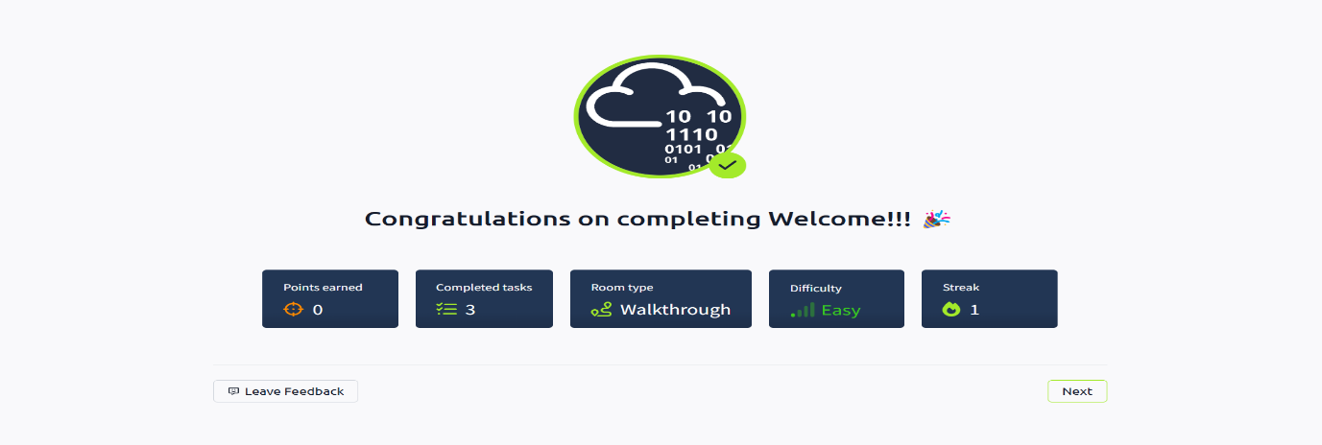coming labs.

**2. Room: How to Use TryHackMe**

**🎯 Learning Objective:**  
Learn how to navigate TryHackMe rooms, use virtual machines (VMs), and interact with the learning environment.

**🛠 Key Tools/Commands Used:**

* Answer Panel
* Virtual Machines (via deploy button)
* In-browser shell and VPN option

**🧠 Concepts Learned:**

* How to launch and interact with a virtual machine
* Use of in-browser terminal vs connecting through local VM
* Submitting correct answers and checking progress

**🔍 Walkthrough / How You Solved It:**

* Followed the instructions step-by-step to learn about deployment and interface
* Practiced launching and accessing machines
* Understood the use of hints, answer validation, and feedback

**💡 Reflections or Notes:**  
This room was crucial in learning the technical navigation of the platform. The step-by-step explanation made it very beginner-friendly.

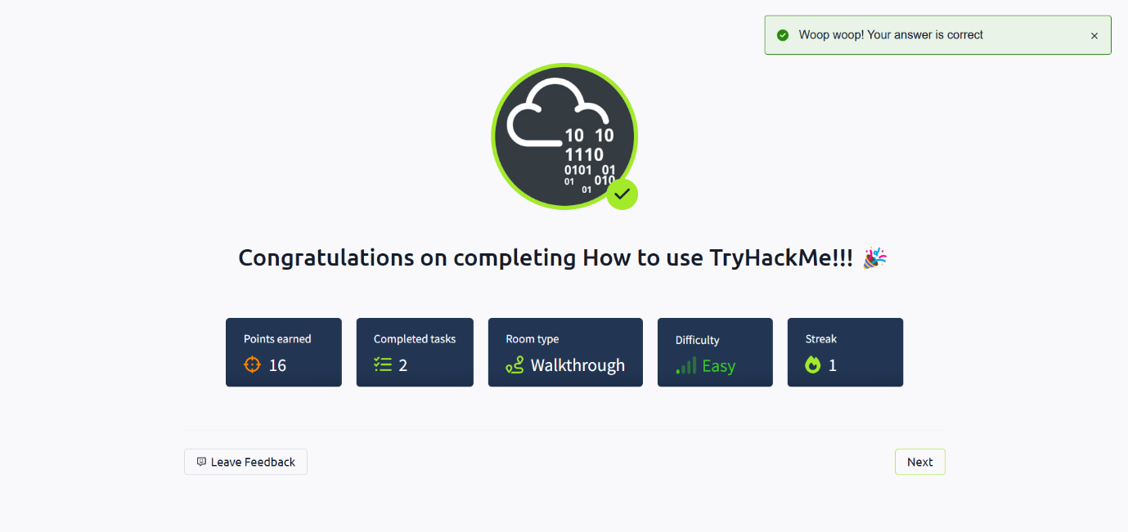

**3. Room: Getting Started**

**🎯 Learning Objective:**  
Introduce networking concepts and demonstrate how basic networking tools can be used for information gathering.

**🛠 Key Tools/Commands Used:**

* ping
* traceroute
* nslookup
* Command Line Interface (CLI)

**🧠 Concepts Learned:**

* The structure of IP addresses and domains
* DNS and its resolution process
* Basic network diagnosis and troubleshooting commands

**🔍 Walkthrough / How You Solved It:**

* Used commands in the browser terminal or personal system
* Observed how each command interacts with domains and IPs
* Answered questions based on command outputs
* 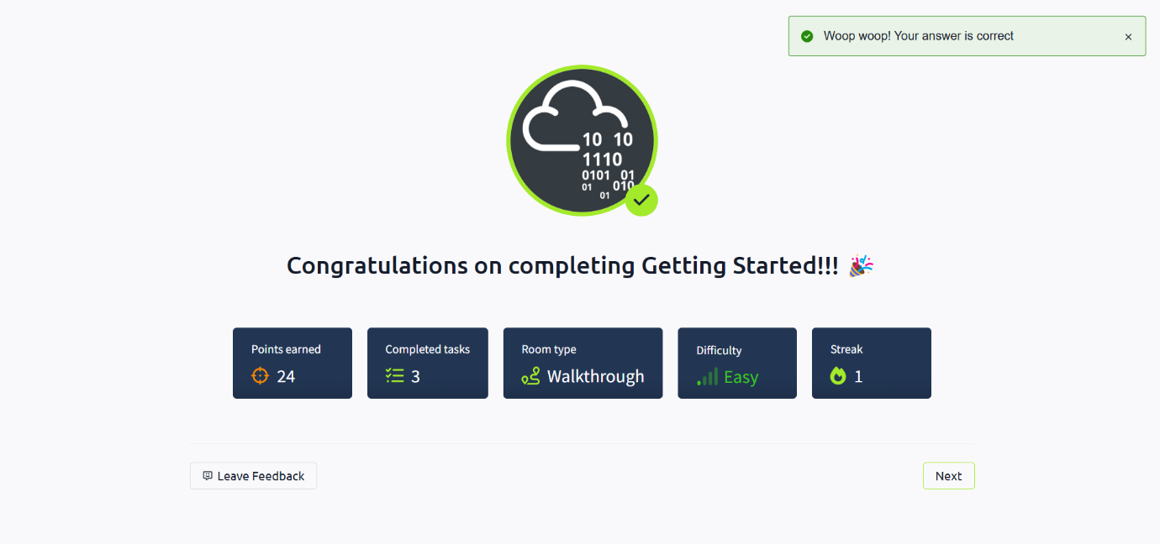

**💡 Reflections or Notes:**  
Very informative and helpful in getting comfortable with fundamental network concepts and tools used in cyber investigations.

**4. Room: Welcome**

**🎯 Learning Objective:**  
Get familiar with TryHackMe’s learning paths and the different types of rooms (theoretical, practical, mixed).

**🛠 Key Tools/Commands Used:**

* TryHackMe Path navigation
* Room launching tools

**🧠 Concepts Learned:**

* What to expect in various learning paths
* How rooms are structured and categorized
* How to approach different types of content

**🔍 Walkthrough / How You Solved It:**

* Explored room information and tasks
* Navigated to paths section to understand structured learning
* Read examples of skill-based progression

[Insert Screenshot Here]

**💡 Reflections or Notes:**  
Gave a clear view of how to structure my learning over time and which areas to focus on.

**5. Room: TryHackMe Tutorial**

**🎯 Learning Objective:**  
Learn basic Linux command-line skills required to interact with most TryHackMe labs.

**🛠 Key Tools/Commands Used:**

* ls, cd, cat, echo, pwd, touch, mkdir
* Terminal or web-based shell

**🧠 Concepts Learned:**

* Navigating file systems
* Viewing and editing files
* Directory and file creation

**🔍 Walkthrough / How You Solved It:**

* Entered commands into the terminal as instructed
* Observed the effects of each command
* Used output to solve tasks and submit correct answers

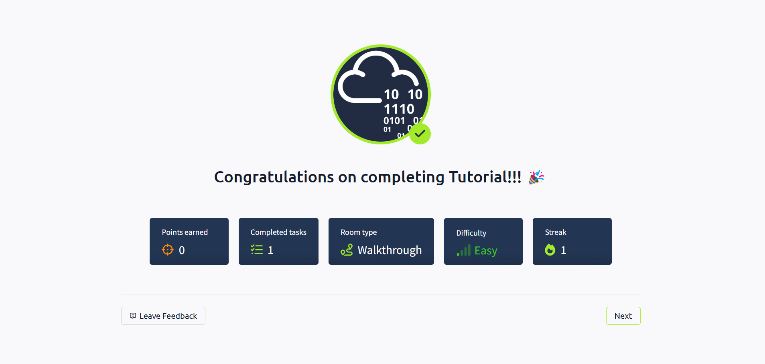**💡 Reflections or Notes:**  
This was an excellent introduction to Linux. It laid the groundwork for more advanced labs that rely on command-line interaction.

**6. Room: OpenVPN Configuration**

**🎯 Learning Objective:**  
Learn how to configure and use OpenVPN to securely connect to TryHackMe’s virtual network.

**🛠 Key Tools/Commands Used:**

* openvpn command
* .ovpn configuration file
* Command line terminal

**🧠 Concepts Learned:**

* VPN tunnel setup
* Connecting safely to remote environments
* Troubleshooting connection errors

**🔍 Walkthrough / How You Solved It:**

* Downloaded and configured my VPN connection file
* Ran sudo openvpn [filename].ovpn to connect
* Verified connection using ping and platform confirmation

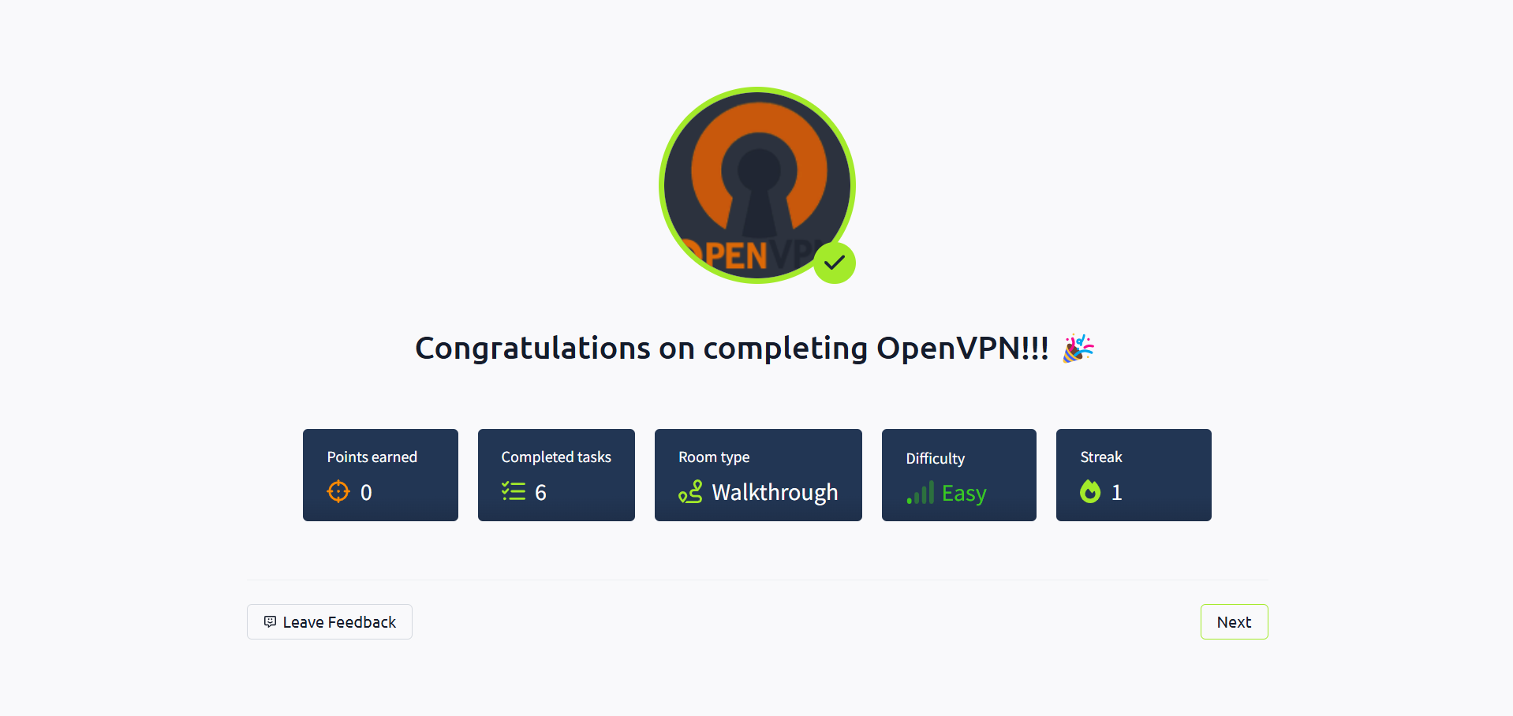**💡 Reflections or Notes:**  
Vital skill for hands-on practice. Once the VPN was configured, access to labs became seamless.

**7. Room: Beginner Path Introduction**

**🎯 Learning Objective:**  
Understand the structure of the Beginner Path and what to expect in the learning journey.

**🛠 Key Tools/Commands Used:**

* TryHackMe Learning Path panel
* Room navigation tools

**🧠 Concepts Learned:**

* Roadmap of upcoming topics
* Suggested order of room completion
* Skill categories for each phase

**🔍 Walkthrough / How You Solved It:**

* Reviewed each listed topic within the path
* Understood learning flow from basic to intermediate rooms
* Noted room categories and target skillsets

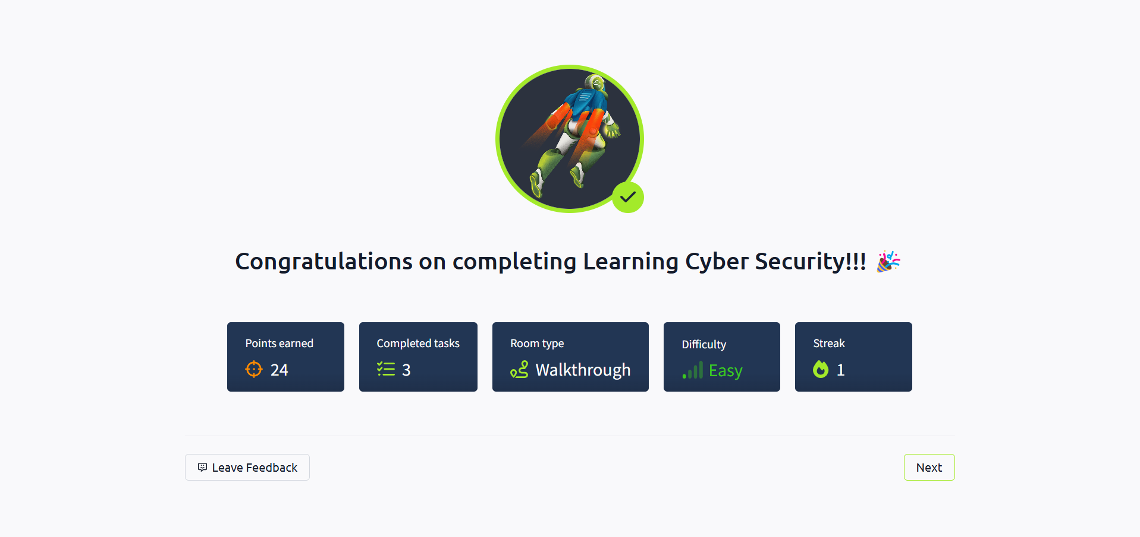**💡 Reflections or Notes:**  
Gave a good sense of direction and helped me plan my learning milestones effectively.

**8. Room: Starting Out in Cyber Security**

**🎯 Learning Objective:**  
Understand the fundamentals of cybersecurity, its importance, and potential career paths.

**🛠 Key Tools/Commands Used:**

* Web Interface
* Educational content review

**🧠 Concepts Learned:**

* Key cybersecurity concepts (CIA triad, threat models)
* Common job roles
* Skills and certifications in demand

**🔍 Walkthrough / How You Solved It:**

* Read and understood each task
* Answered multiple-choice and short-answer questions
* Reflected on career goals and relevant skills

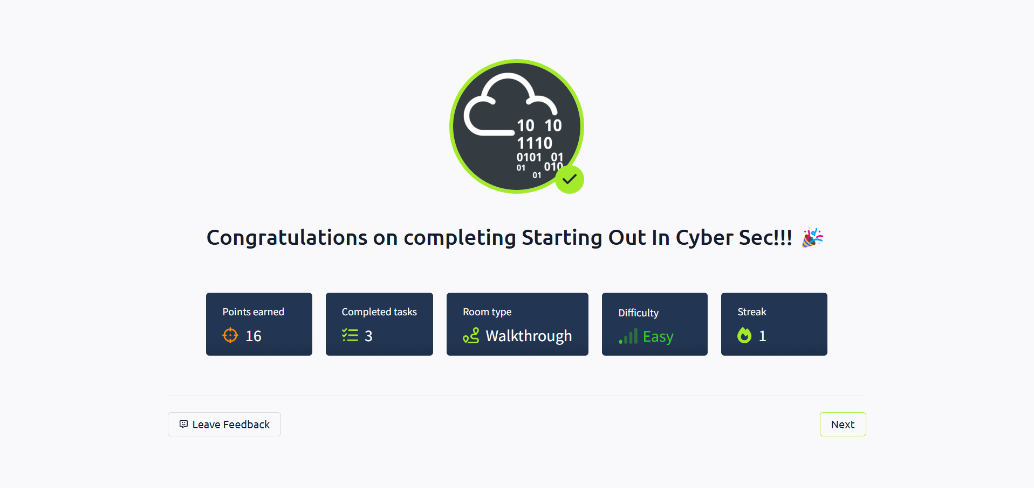**💡 Reflections or Notes:**  
Very motivational. Helped me clarify my interest areas within cybersecurity.

**9. Room: Introduction to Research**

**🎯 Learning Objective:**  
Learn how to do efficient and reliable research in cybersecurity topics using open-source intelligence (OSINT).

**🛠 Key Tools/Commands Used:**

* Search engines (Google, DuckDuckGo)
* WHOIS and domain lookup tools
* Browser-based research

**🧠 Concepts Learned:**

* What OSINT is and how it is used
* Techniques for finding information online
* Validating and verifying data sources

**🔍 Walkthrough / How You Solved It:**

* Followed instructions to research specific cyber concepts
* Used public tools to look up domains and IPs
* Completed all questions using research findings

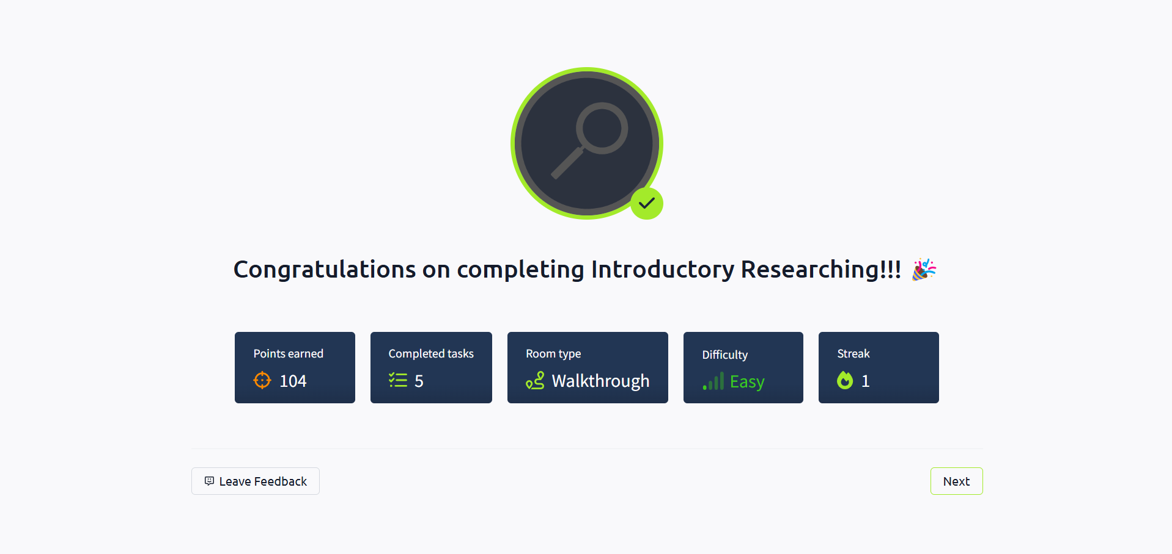**💡 Reflections or Notes:**  
This room showed how powerful public data can be. Research is a fundamental skill every cybersecurity enthusiast must develop.

**📌 Final Notes:**

* Be sure to replace placeholders with actual screenshots from your progress.
* Customize this report with your full name and submission date.
* Submit your final report as a PDF or DOCX file named: YourName_TryHackMeIntro_Report

**End of Report**