Name – Rishi Sankhla

Student No. -**200102874**

**UNIVERSITY OF LONDON**

Mid-term Coursework 1 submission [001]

Cm-2010-Software Design and Development

Midterm Question paper Version: 20201008

Part 2: Unit testing activity

**Test 1(set-1):** this test is to calculate the mean of list, here we are comparing our algorithm output with the statistic library of python using assert-equal function the first test was failed because it can calculate mean only for list of size 4. Whereas in second algorithm we do the summation of whole list and then divide it by its length.

**Test 2(set-1):** this test is to calculate the mode of list, then compare it with statistic library output using assert-true function, here my approach was to build a frequency table of each element using dictionary object and then extracts the highest frequency element, the first test was failed because of dictionary attribute-error (happened because of spelling mistake).

**Test 3(set-1):** this test is to find the maximum number in our list, then compare it with numpy library output using assert-true function, here the first approach is to compare numbers with each other and keeping the record of highest element but it was not scalable therefore in second approach we iterate over each element and compare it with our maximum stored so far.

**Set 1 Failed Screenshot:**

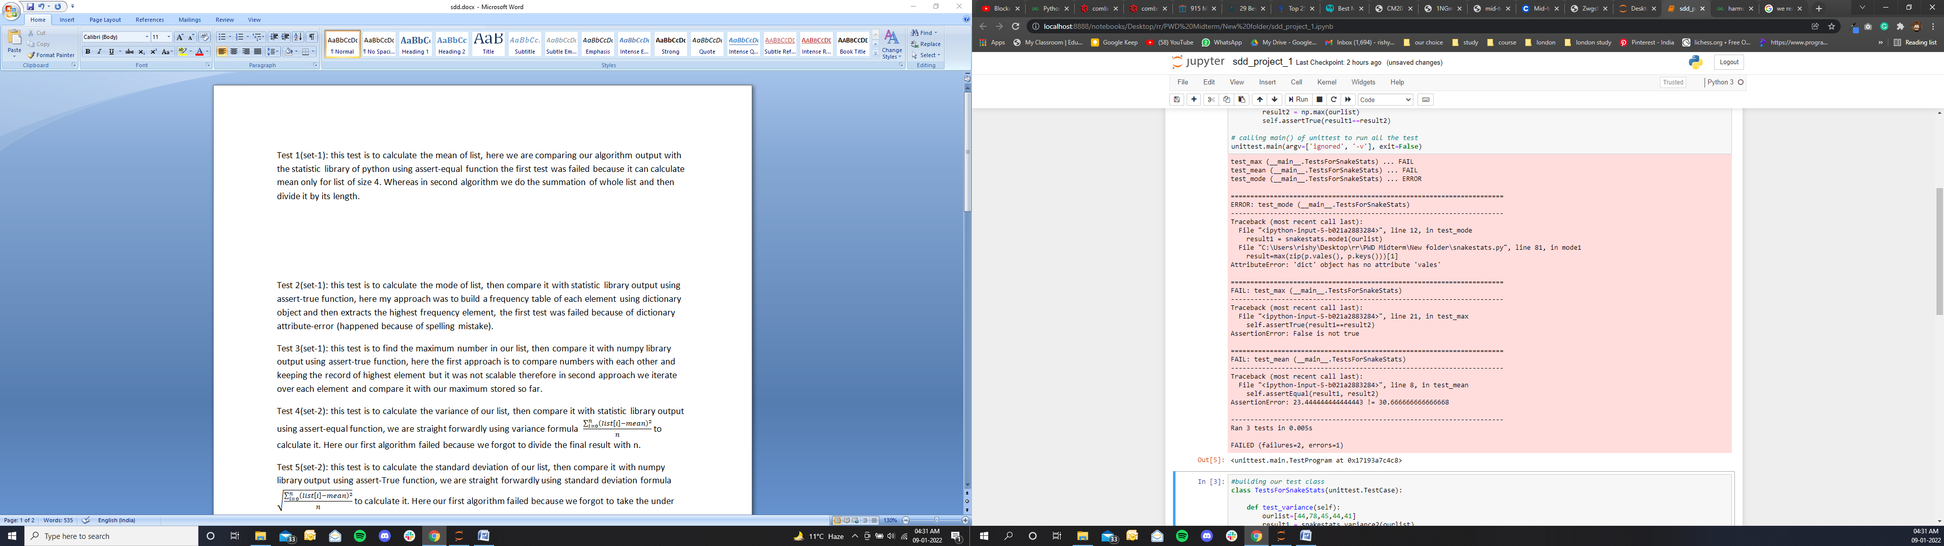

**Set 1 passed Screenshot:**

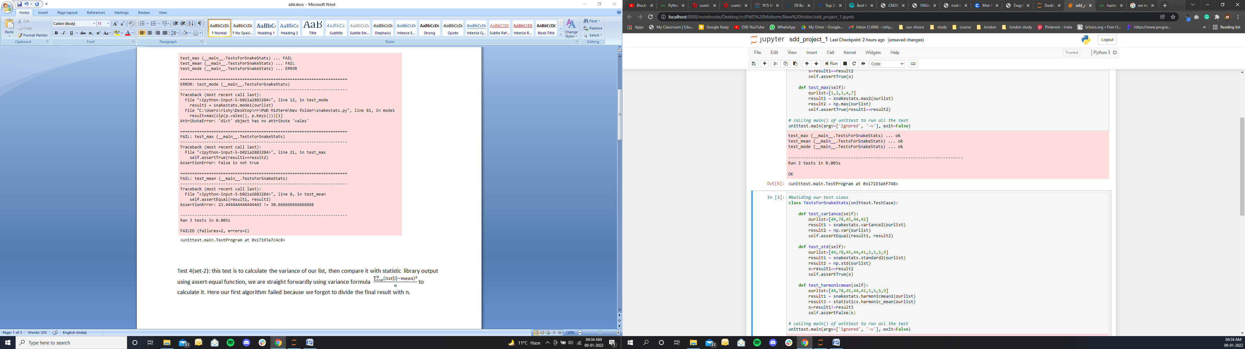

**Test 4(set-2):** this test is to calculate the variance of our list, then compare it with statistic library output using assert-equal function, we are straight forwardly using variance formula to calculate it. Here our first algorithm failed because we forgot to divide the final result with n.

**Test 5(set-2):** this test is to calculate the standard deviation of our list, then compare it with numpy library output using assert-True function, we are straight forwardly using standard deviation formula to calculate it. Here our first algorithm failed because we forgot to take the under root of our final result.

**Test 6(set-2):** this test is to calculate the harmonic mean of our list, then compare it with statistic library output using assert-False function, we are straight forwardly using harmonic mean formula to calculate it. Here our first algorithm failed because we miscalculated the length of our list( using counter variable).

**Set 2 Failed Screenshot:**

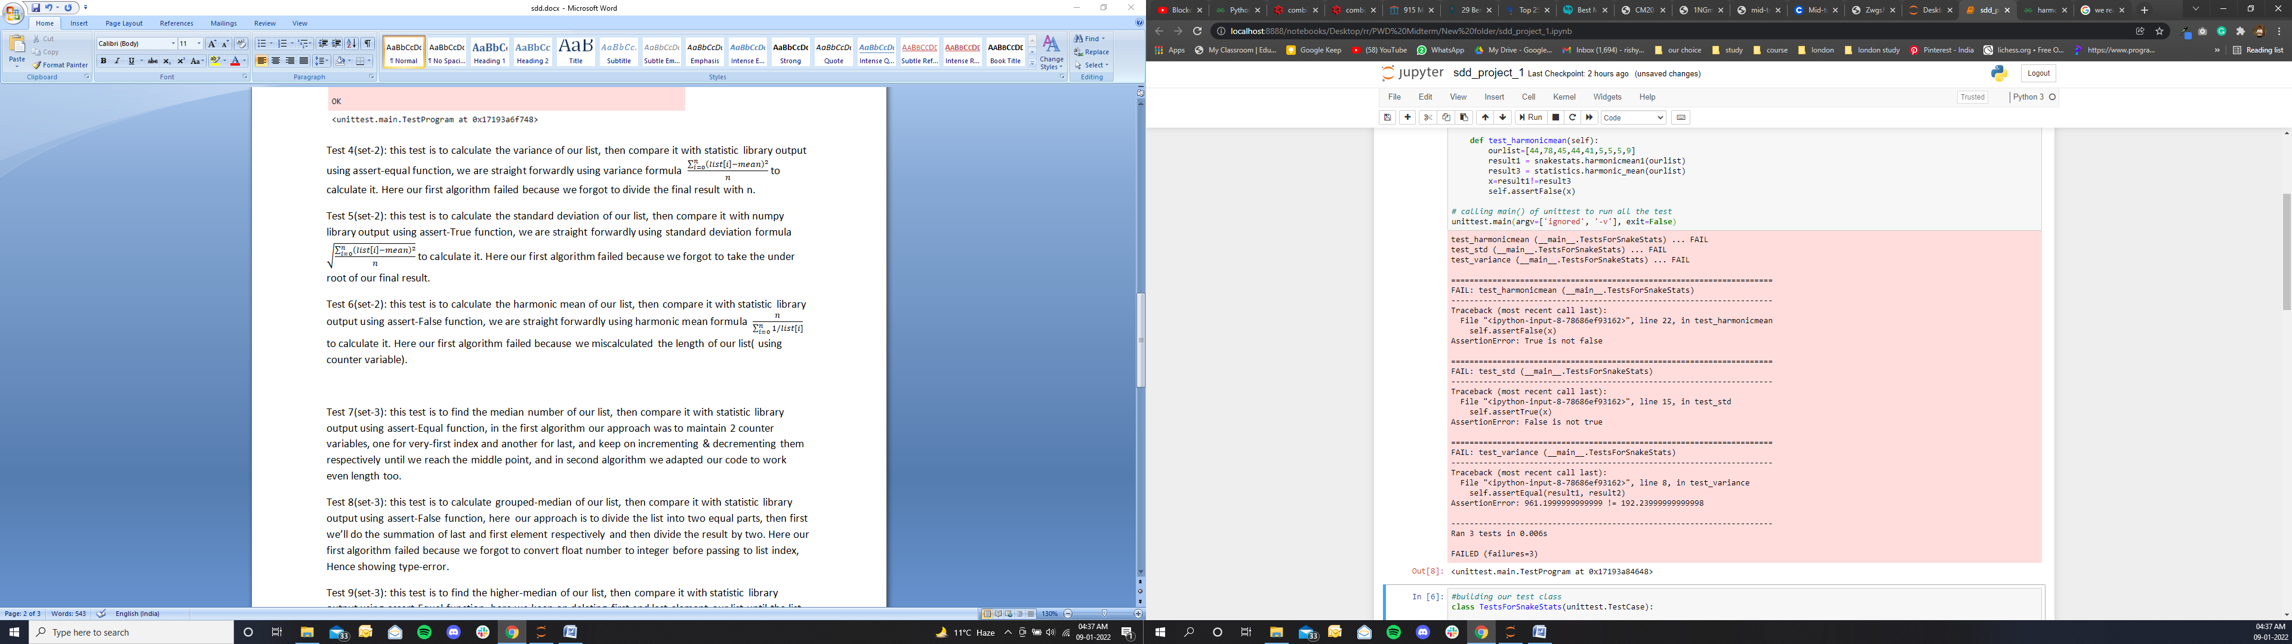

**Set 2 Passed Screenshot:**

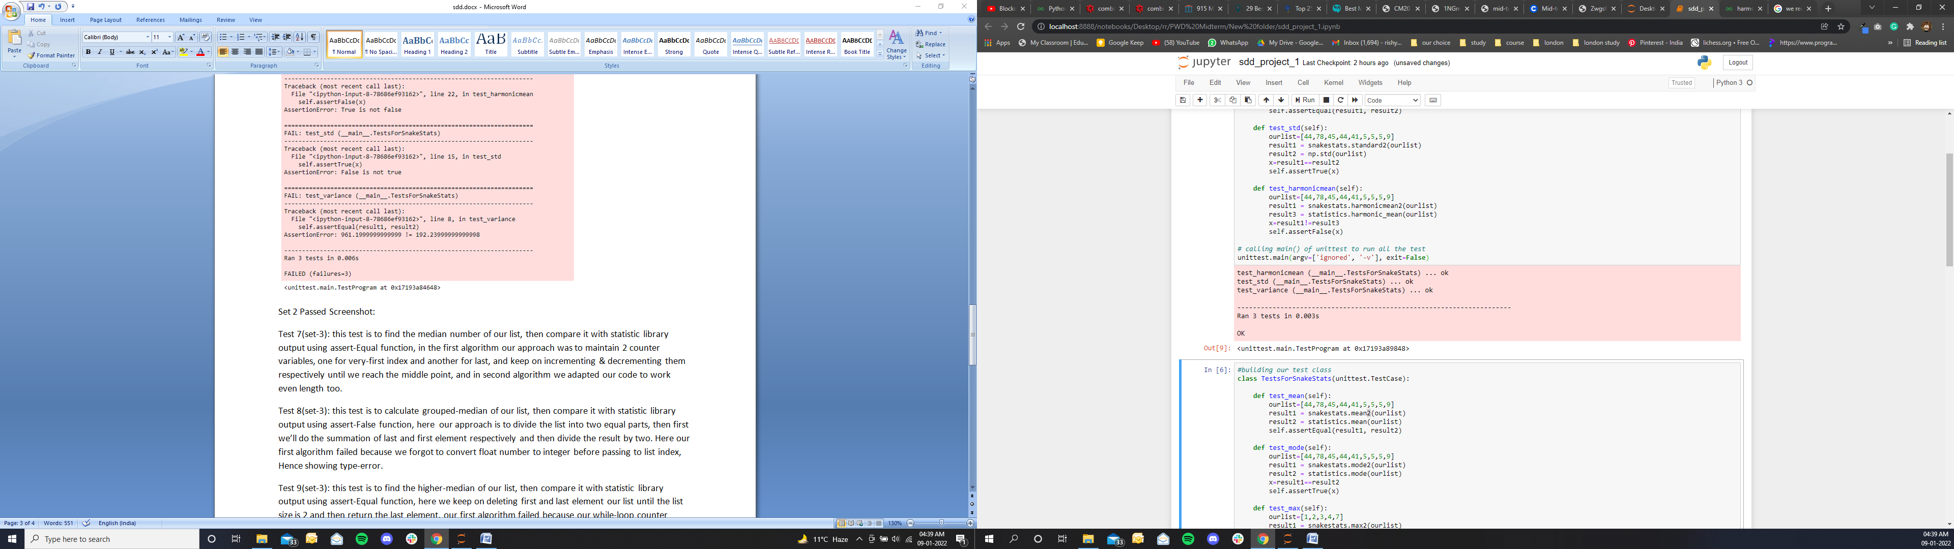

**Test 7(set-3):** this test is to find the median number of our list, then compare it with statistic library output using assert-Equal function, in the first algorithm our approach was to maintain 2 counter variables, one for very-first index and another for last, and keep on incrementing & decrementing them respectively until we reach the middle point, and in second algorithm we adapted our code to work even length too.

**Test 8(set-3):** this test is to calculate grouped-median of our list, then compare it with statistic library output using assert-False function, here our approach is to divide the list into two equal parts, then first we’ll do the summation of last and first element respectively and then divide the result by two. Here our first algorithm failed because we forgot to convert float number to integer before passing to list index, Hence showing type-error.

**Test 9(set-3):** this test is to find the higher-median of our list, then compare it with statistic library output using assert-Equal function, here we keep on deleting first and last element our list until the list size is 2 and then return the last element, our first algorithm failed because our while-loop counter wasn’t able to alternate properly.

**Set 3 Failed Screenshot:**

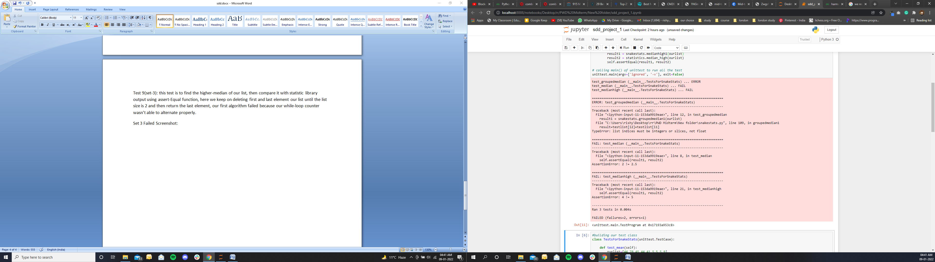

**Set 3 Passed Screenshot:**

